SUPPLEMENTARY MATERIALS

Supplementary Table 1. List of questions included in the Delphi procedure in Round 1 and 2.
 | QUESTIONS | STATEMENTS | RESPONSES
Clinical context of use | 1  Agreement | Social cognition should be routinely included in the neuropsychological assessment battery of every patient attending memory clinics for diagnostic framing | Totally agree/ Somewhat agree/ Neutral  Somewhat disagree/Totally disagree
Clinical context of use | 2  Agreement | Social cognition should be included in the follow-up neuropsychological evaluation (e.g. clinical management or treatment efficacy evaluation) of every patient attending memory clinics | Totally agree/ Somewhat agree/ Neutral  Somewhat disagree/Totally disagree
Clinical context of use | 2r  Agreement | Social cognition should be included in the follow-up neuropsychological evaluation of selected patients based on the presence of socio-cognitive deficits at first neuropsychological assessment and/or based on symptoms reported by caregiver/patient/clinician at the follow-up visit. | Totally agree/ Somewhat agree/ Neutral  Somewhat disagree/Totally disagree
Clinical context of use | 3  Multiple choice | In your opinion, when social cognition should be assessed in major neurocognitive disorder in the diagnostic framing? | At the baseline evaluation/ At the second-level evaluation/ Never in major NCD
Clinical context of use | 4  Multiple choice | In your opinion, when social cognition should be assessed in mild neurocognitive disorder in the diagnostic framing? | At the baseline evaluation/ At the second-level evaluation/ Never in mild NCD
Clinical context of use | 5  Agreement | When a social cognition deficit is suspected, the neuropsychological assessment should include at least two tests evaluating different facets of social cognition (e.g., emotion recognition and theory of mind; emotion recognition and empathy; self-monitoring and theory of mind) | Totally agree/ Somewhat agree/ Neutral  Somewhat disagree/Totally disagree
Clinical context of use | 6  Agreement | The neuropsychological assessment in major and mild neurocognitive disorder should include a measure of social cognitive domain functioning and a measure to quantify changes in social behavior | Totally agree/ Somewhat agree/ Neutral  Somewhat disagree/Totally disagree
Relevance of socio-cognitive testing in the diagnostic framework | 7  Relevance | Based on your professional experience, expert opinion from clinicians, and evidence from literature, rate the relevance of assessing the following social cognition facets in major neurocognitive disorder. | Very important/ Important/ Neutral/  Not important/ Not important at all
 | 8  Relevance | Based on your professional experience, expert opinion from clinicians, and evidence from literature, rate the relevance of assessing the following social cognition facets in mild neurocognitive disorder. | Very important/ Important/ Neutral/  Not important/ Not important at all
 | 9  Agreement | The Ekman-60 Faces test is a valid and reliable tool to assess emotion recognition in major and mild neurocognitive disorders | Totally agree/ Somewhat agree/ Neutral  Somewhat disagree/Totally disagree
 | 10  Agreement | Faux-pas test is a valid and reliable tool to assess mentalizing abilities in major and mild neurocognitive disorders | Totally agree/ Somewhat agree/ Neutral  Somewhat disagree/Totally disagree
 | 11  Agreement | The Reading the Mind in the Eye Test, the Story-based Empathy Task, and the MINI-Socio-Emotional Assessment battery are valid and reliable tools to assess social cognition deficits in in major and mild neurocognitive disorders | Totally agree/ Somewhat agree/ Neutral  Somewhat disagree/Totally disagree
 | 12  Agreement | The Interpersonal Reactivity Index (IRI) is a valid and reliable tool to assess both cognitive and affective empathy in major and mild neurocognitive disorders | Totally agree/ Somewhat agree/ Neutral  Somewhat disagree/Totally disagree
 | 12r  Agreement | Empathic Concern and Perspective Taking subscales of the Interpersonal Reactivity Index (IRI) are valid and reliable measures to assess cognitive and affective empathy in neurocognitive disorders | Totally agree/ Somewhat agree/ Neutral  Somewhat disagree/Totally disagree
 | 13  Agreement | The revised version of the Self-Monitoring Scale (r-SMS) is a valid and reliable tool to assess self-monitoring and awareness in social context in major and mild neurocognitive disorders | Totally agree/ Somewhat agree/ Neutral  Somewhat disagree/Totally disagree
Facilitators & Obstacles | 14a,14b,14c  Open questions | In your opinion, which are the facilitators for the use of social cognition testing in memory clinics?  In your opinion, which are the obstacles preventing the use of social cognition testing in memory clinics?  In your opinion, what is required to improve the translation of social cognition tools from research to clinics? | Open Text
Facilitators & Obstacles | 14r  Relevance | Based on your professional experience and evidence from literature, rate the relevance of these factors in social cognition testing in memory clinics | Very important/ Important/ Neutral/  Not important/ Not important at all
Future priorities | 15  Agreement | The social cognition assessment in memory clinics should include a subset of cognitive screening tests administrable remotely by phone or digital tools if needed | Totally agree/ Somewhat agree/ Neutral  Somewhat disagree/Totally disagree
Future priorities | 15r  Agreement | The social cognition assessment in memory clinics should include a subset of cognitive screening tests administrable remotely by digital tools, if in-person assessment is not possible | Totally agree/ Somewhat agree/ Neutral  Somewhat disagree/Totally disagree
Future priorities | 16  Relevance | Based on your professional experience and evidence from literature, rate the relevance of these digital test scenarios for the assessment of social cognition domain in memory clinics. | Very important/ Important/ Neutral/  Not important/ Not important at all
Future priorities | 17  Relevance | Based on your professional experience and evidence from literature, rate the relevance of these digital tools for the assessment of social cognition domain in the diagnostic framework of memory clinics. | Very important/ Important/ Neutral/  Not important/ Not important at all
Future priorities | 18  Relevance | Based on your professional experience and evidence from literature, rate the relevance of these digital tools for the assessment of social cognition domain in the follow-up neuropsychological evaluation. | Very important/ Important/ Neutral/  Not important/ Not important at all

Note. The “r” suffix indicates questions asked in Round 2. Agreement, multiple choice, relevance and open text questions were used to assess consensus assumptions.

Supplementary Table 2. Search strings for the literature review in mild (A) and major (B) neurocognitive disorders
 | PubMed Search String
Mild Neurocognitive Disorders | ("emotion recognition" OR "emotion processing" OR "emotion understanding" OR "theory of mind" OR "mentalizing" OR ToM OR "perspective taking" OR "affective empathy" OR "cognitive empathy" OR empathy) AND ("mild cognitive impairment" OR "minor neurocognitive disorder" OR "mild neurocognitive disorder" OR MCI OR naMCI OR aMCI OR “na-MCI” OR “a-MCI” OR “non amnestic MCI” OR “amnestic MCI” OR "mild behavioural impairment" OR "mild behavioral impairment" OR "MBI" OR “MBCI-FTD” OR MBCIFTD OR prodromal) AND (accuracy OR ROC OR “receiver operating characteristic” OR "diagnostic performance" OR sensitivity OR specificity OR predict OR "predictive value" OR "true positive" OR "true negative")
Major Neurocognitive Disorders | ("emotion recognition" OR "emotion processing" OR "emotion understanding" OR "theory of mind" OR ToM OR "perspective taking" OR "affective empathy" OR "cognitive empathy" OR empathy) AND (dementia OR "major neurocognitive disorder" OR "Alzheimer*" OR frontotemporal OR “frontotemporal dementia” OR FTD OR AD OR “behavioral variant” OR PPA OR "primary progressive aphasia" OR "atypical parkinsonism" OR “Lewy-body” OR “Lewy body” OR “LBD” OR “corticobasal syndrome” OR CBS OR “progressive supranuclear palsy” OR PSP) AND (accuracy OR ROC OR "diagnostic performance" OR sensitivity OR specificity OR predict OR "predictive value" OR "true positive" OR "true negative")

Supplementary Table 3. Papers showing accuracy measures in early and differential diagnosis of mild and major NCDs.

 | Study Group |  |  | Social Cognition Measures |  |  | Accuracy Measures
Paper | Group 1  (n; age; MMSE) | Group 2  (n; age; MMSE) | Diagnostic Criteria | Social Measure | Social Skill | Stimuli | Sensitivity | Specificity | AUC | Accuracy
Garcia-Casal et al., 2019 | 59 amnestic MCI  77.6±5.0  24.0±2.4 | 84 HC  73.1±6.3  28.4±1.3 | Winblad 2004 | Digital Tablet-based Tool named Affect-GRADIOR | Emotion Recognition | Photos | 67.6%  correct answers 56.3%  processing speed | 66.7%  correct answers  87.7%  processing speed | 0.717  correct answers  0.748  processing speed | -
Amlerova et al., 2022 | 43 amnestic MCI due to AD  74.5±6.1  26.6±2.6 | 23 HC  67.0±6.7  29.5±0.7 | Petersen 1999 | Emotion Prosody Recognition Test | Emotion Recognition | Sounds | 73.9% | 74.4% | 0.80 | -
Diehl-Schmid et al., 2007 | 25 bvFTD  63.2±10.6  25.3±3.1 | 33 HC  60.9±10.8  29±1.2 | Neary 1998 | Ek60F | Emotion Recognition | Photos | 94% | 100% | 0.97 | -
Gleichgerrcht et al., 2010 | 35 bvFTD  68.5±7.2  26.9±2.9 | 14 HC  65.5±6.5  29.2±1 | Neary 1998 | IGT  MIE  FAUX | Affective Decision  Making  Affective ToM  Cognitive ToM | Photos Stories | - | - | 0.914 IGT  0.835 MIE  0.919 FAUX | -
Funkiewiez et al., 2012 | 22 bvFTD  65.5±10.3  25.8±2.5 | 30 HC  66.2±10.0  29.0±0.8 | Neary 1998 | SEA | Emotion Recognition Cognitive ToM | Photos Stories | 100% | 100% | 1 | -
Downey et al., 2013 | 20 bvFTD  64.0±9.3 | 20 HC  65.0±8.5  - | Rascovsky 2011 | Mentalizing  Music Task | Affective ToM | Music | - | - | 0.88 | 85%
Bertoux et al., 2013 | 20 bvFTD  69.1±10.6  23.5±4.5 | 30 HC  67.2±8.6  28.9±0.8 | Neary 1998  Rascovsky 2011 | Mini-SEA | Emotion Recognition Cognitive ToM | Photos Stories | - | - | - | 88%
Schroeter et al., 2018 | 86 bvFTD  63.9±9.6  - | 43 HC  66.1±10.1  - | Rascovsky 2011 | RME | Affective ToM | Photos | - | - | 0.895 | -
Teichmann et al., 2019 | 22 bvFTD  66.8±8.2  24.0±3.05 | 45 HC  66.9±16.6  > 27 | Rascovsky 2011 | MEA | Moral Cognition | Stories | 82% | 87% | 0.88 | -
Dodich et al., 2021 | 32 bvFTD  68.2±8.3  23.6±3.9 | 40 HC  69.7±5.7  28.6±0.8 | Rascovsky 2011 | Ek60F  SET  ERA index | Emotion Recognition  Cognitive ToM  Affective ToM | Photos  Vignettes | 84% Ek60F  75% SET  94% ERA | 93% Ek60F  80% SET  73% ERA | 0.92 Ek60F  0.83 SET  0.83 ERA | 89% Ek60F  83% SET  82% ERA
Garcia-Casal et al., 2019 | 84 AD  78.3±5.8  21.6±3.6 | 69 HC  73.1±6.3  28.4±1.3 | Dubois 2007 | Digital Tablet-based Tool named Affect-GRADIOR | Emotion Recognition | Photos | 76%  correct answers 77%  processing speed | 75%  correct answers  78%  processing speed | 0.79  correct answers  0.829  processing speed | -
Amlerova et al., 2022 | 36 AD  74.4±6.5  22.7±2.5 | 23 HC  67.0±6.7  29.5±0.7 | - | Emotion Prosody Test | Emotion Recognition | Sounds | 87% | 83.3% | 0.91 | -
Bertoux et al., 2013 | 20 bvFTD  69.1±10.6  23.5±4.5 | 20 AD  69.8±11.3  24.0±1.8 | Neary 1998  Rascovsky 2011  Dubois 2007 | Mini-SEA | Emotion Recognition  Cognitive ToM | Photos  Stories | - | - | 0.93 | 82.5%
Buhl et al., 2013 | 11 bvFTD  67 [54-76]  28 [25-30] | 10 AD  66 [51-72]  28 [25-30] | Rascovsky 2011  McKhann 1984 | EHex  RME  TASIT-EET  TASIT-SIM | Emotion Recognition  Affective ToM  Social inference | Photos  Videos | - | - | 0.79 EHex  0.86 RME  0.79 TASIT-EET  0.88 TASIT-SIM | 71% EHex  81% RME  71% TASIT-EET  76% TASIT-SIM
Bertoux et al., 2016 | 38 bvFTD  [19 a-bvFTD,  19 na-bvFTD]  66.6±9.3  23.4±3.4 | 28 AD  70.3±11.1  24.3±2.7 | Rascovsky 2011  Dubois 2007 | Mini-SEA | Emotion Recognition  Cognitive ToM | Photos  Stories | - | - | 0.94 | 85.1%  [a-bvFTD] 93.9%  [na-bvFTD]
Carr et al., 2017 | 12 bvFTD  62.3±9.6  - | 12 AD  59.2±4.7  - | Rascovsky 2011  McKhann 2011 | EQ | Emotional Intelligence | Questionnaire | 91% | 66% | 0.77 | -
Teichmann et al., 2019 | 22 bvFTD  66.8±8.2  24.0±3.05 | 15 AD  71.1±6.3  23.6±3.1 | Rascovsky 2011  Dubois 2010 | MEA | Moral Cognition | Stories | 82% | 73% | 0.83 | -
Mariano et al., 2020 | 22 bvFTD  65.6±8.9  25.4±2.7 | 20 AD  71.3±9.0  24.7±2.0 | Rascovsky 2011  Albert 2011  McKhann 2011 | Mini-SEA  FAUX  FERT | Emotion Recognition  Cognitive ToM | Photos  Stories | - | - | 0.87 Mini-SEA  0.91 FAUX  0.77 FERT | 78.6% Mini-SEA
Custodio et al., 2021 | 18 bvFTD  64.8±5.4  - | 33 AD  72.2±3.5  - | Rascovsky 2011  McKhann 2011 | Mini-SEA  IRI-EC  IRI-PT  r-SMS | Emotion Recognition  Cognitive ToM  Affective Empathy  Cognitive Empathy  Socio-Emotional Sensibility | Photos  Stories  Questionnaire | 100% Mini-SEA  87.8% IRI-EC  93.9% IRI-PT  100% r-SMS | 83.3% Mini-SEA  66.6% IRI-EC  88.8% IRI-PT  72.2% r-SMS | 0.96 Mini-SEA  0.89 IRI-EC  0.97 IRI-PT  0.95 r-SMS | 94.1% Mini-SEA  80.3% IRI-EC  92.1% IRI-PT  90.2% r-SMS
Dodich et al., 2021 | 32 bvFTD  68.2±8.3  23.6±3.9 | 26 AD  74.3±6.2  23.6±4.2 | Rascovsky 2011 Albert 2011 McKhann 2011 | Ek60F  SET-EA  ERA index | Emotion Recognition  Affective ToM | Photos  Vignettes | 66% Ek60F  56% SET-EA  63% ERA | 85% Ek60F  81% SET-EA  85% ERA | 0.78 Ek60F  0.67 SET-EA  0.74 ERA | 74% Ek60F  67% SET-EA  72% ERA
Moura et al., 2021 | 21 bvFTD  [8 dysexec]  [13 no dysexec]  65.8±9.1  25.3±2.7 | 20 AD  [5 dysexec]  [15 no dysexec]  74±9  24±2 | Rascovsky 2011 McKhann 2011 | Mini-SEA  FAUX  FERT | Emotion Recognition  Cognitive ToM | Photos  Stories | - | - | Mini-SEA:  0.95  [bvFTD vs AD dysexec]  0.88  [bvFTD vs AD no dysexec]  FAUX:  0.87  [bvFTD vs AD dysexec]  0.96  [bvFTD vs AD no dysexec]  FERT:  0.99  [bvFTD vs AD dysexec]  0.65  [bvFTD vs AD no dysexec] | -
Dodich et al., 2021 | 32 bvFTD  68.2±8.3  23.6±3.9 | 16 PPA  68.5±6.9  28.6±0.8 | Gorno-Tempini 2011 | Ek60F  SET-EA  ERA index | Emotion Recognition  Affective ToM | Photos  Vignettes | 75% Ek60F  56% SET-EA  63% ERA | 75% Ek60F  81% SET-EA  87% ERA | 0.80 Ek60F  0.70 SET-EA  0.76 ERA | 77% Ek60F  65% SET-EA  71% ERA
Bertoux et al., 2012 | 37 bvFTD  [17 E-bvFTD  20 M-bvFTD]  63.1±9.1 E-bvFTD  27.1±2.3 M-bvFTD  66.7±8.3 E-bvFTD  23.3±3.9 E-bvFTD | 19 MDD  63.3±8.4  26.7±2.2 | Neary 1998  DSM-IV 1994 | SEA | Emotion Recognition Cognitive ToM | Photos  Stories | 91.9% [bvFTD]  94.1% [E-bvFTD]  90% [M-bvFTD] | 89.5% [bvFTD]  89.5% [E-bvFTD]  89.5% [M-bvFTD] | 0.97 [bvFTD] | -
 |  |  |  | Mini-SEA | Emotion Recognition Cognitive ToM | Photos  Stories | 89.2% [bvFTD]  94.1% [E-bvFTD]  85%v [M-bvFTD] | 100% [bvFTD]  100% [E-bvFTD]  100% [M-bvFTD] | 0.98 [bvFTD] | -
Chiu et al., 2016 | 25 bvFTD  66.1±9.1  24.8±3.4 | 21 MDD  62.7±12.9  28.4±1.6 | Rascovsky 2011  DSM-IV 1994 | ETS  NETS | Emotion Recognition | Photos | 91% ETS  91% NETS | 76% ETS  80% NETS | 0.91 ET  0.95 NET | -
Chiu et al., 2018 | 25 bvFTD  66.1±9.1  24.8±3.4 | 20 MDD  61.9±12.8  28.4±1.7 | Rascovsky 2011 DSM-IV 1994 | FEE | Emotion Recognition | Photos | - | - | 0.93-0.99 | -
Barbosa et al., 2023 | 18 bvFTD  65.0±8.8  26.1±1.9 | 20 BD-I  57.4±11.4  27.1±1.7 | Rascovsky 2011  - | Mini-SEA  FAUX  Mod-FAUX  FERT | Emotion Recognition  Cognitive ToM | Photos  Stories | 78% Mini-SEA  72% FAUX  78% Mod-FAUX  67% FERT | 34% Mini-SEA  78% FAUX  28% Mod-FAUX  12% FERT | 0.63 Mini-SEA  0.80 FAUX  0.61 Mod-FAUX  0.29 FERT | -
Lichtenstein et al., 2023 | 17 bvFTD  71.0 [65-76]  - | 16 MDD  54.0 [49.5-56]  - | Rascovsky 2011  Hyer 2014 | Combined Social Score (IRI+ER40) | Empathy  Emotion Recognition | Photos  Questionnaire | - | - | 0.973 | -
Garcia-Casal et al., 2019 | 84 AD  78.3±5.8  21.6±3.6 | 59 aMCI  77.6±5.01  24.0±2.4 | Dubois 2007  Winblad 2004 | Digital Tablet-based Tool named Affect-GRADIOR | Emotion Recognition | Photos | 66%  correct answers  66%  processing speed | 64%  correct answers  64%  processing speed | 0.64  correct answers  0.67  processing speed | -
NCDs = neurocognitive disorders; MCI = mild cognitive impairment; AD = Alzheimer’s disease; bvFTD = behavioral variant of frontotemporal dementia; AD = Alzheimer’s dementia; a-bvFTD = amnestic bvFTD; na-bvFTD = non amnestic bvFTD; dysexec = dysexecutive; no dysexec = non dysexecutive; E-BvFTD = early bvFTD; M-bvFTD = moderate bvFTD; PSP = progressive sopranuclear palsy; HC = healthy controls; PPA = primary progressive aphasia; MDD = major depressive disorder; BD-I = bipolar syndrome type I; PD = Parkinson’s disease; MMSE = Mini Mental State Examination; Ek60F = Ekman 60 Faces test; IGT = Iowa Gambling Task; MIE = Mind in the Eyes; FAUX = Faux-pas test; SEA = Socio-Emotional Assessment; Mini-SEA = Mini Socio-Emotional Assessment; RME = Reading the Mind in the Eyes Test; MEA = Moral Emotions Assessment; SET = Story-based Empathy Task; SET-EA = SET – Emotion Attribution; ERA = Emotion Recognition and Attribution; EHex = Emotion Hexagon Test; TASIT-EET = The Awareness of Social Inference Test - Emotion Evaluation Task ; TASIT-SIM = The Awareness of Social Inference Test - Social Inference Minimal Test; EQ = The Schutte Self Report Emotional Intelligence Test; FERT = Facial Emotion Recognition Task; IRI-EC = Interpersonal Reactivity Index Empathic Concern subscale; IRI-PT = Interpersonal Reactivity Index Perspective Taking subscale; r-SMS = revised Self-Monitoring Scale; ETS = Emotion Total Score; NES = Negative Emotion Total Score; FEE = Facial Expressions of Emotion; Mod-FAUX = modified faux-Pas; ER40 = The Penn Emotion Recognition Task; AUC= Area Under the (ROC) Curve

Supplementary Table 4. Quality Assessment of Diagnostic Accuracy Studies (QUADAS-2) Statement.

Study | Risk of Bias |  |  |  | Applicability Concerns
 | Patient Selection | Index Test | Reference Standard | Flow and Timing | Patient Selection | Index Test | Reference Standard
Amlerova et al, 2022 |  |  | 
Barbosa et al., 2023 | 
Bertoux et al., 2012
Bertoux et al., 2013
Bertoux et al., 2016 |  |  |  | 
Buhl et al., 2013
Carr et al., 2017
Chiu et al., 2016
Chiu et al., 2018
Custodio et al., 2021
Diehl-Schmid et al., 2007
Dodich et al., 2021
Downey et al., 2013
García-Casal et al., 2019
Glechgerrcht et al., 2010
Funkiewiez et al., 2012
Lichtenstein et al., 2023
Mariano et al., 2020
Moura et al., 2021
Schroeter et al., 2018
Teichmann et al., 2019
Low Risk Moderate Risk High Risk Unclear
Supplementary Figure 1. PRISMA Flow-chart
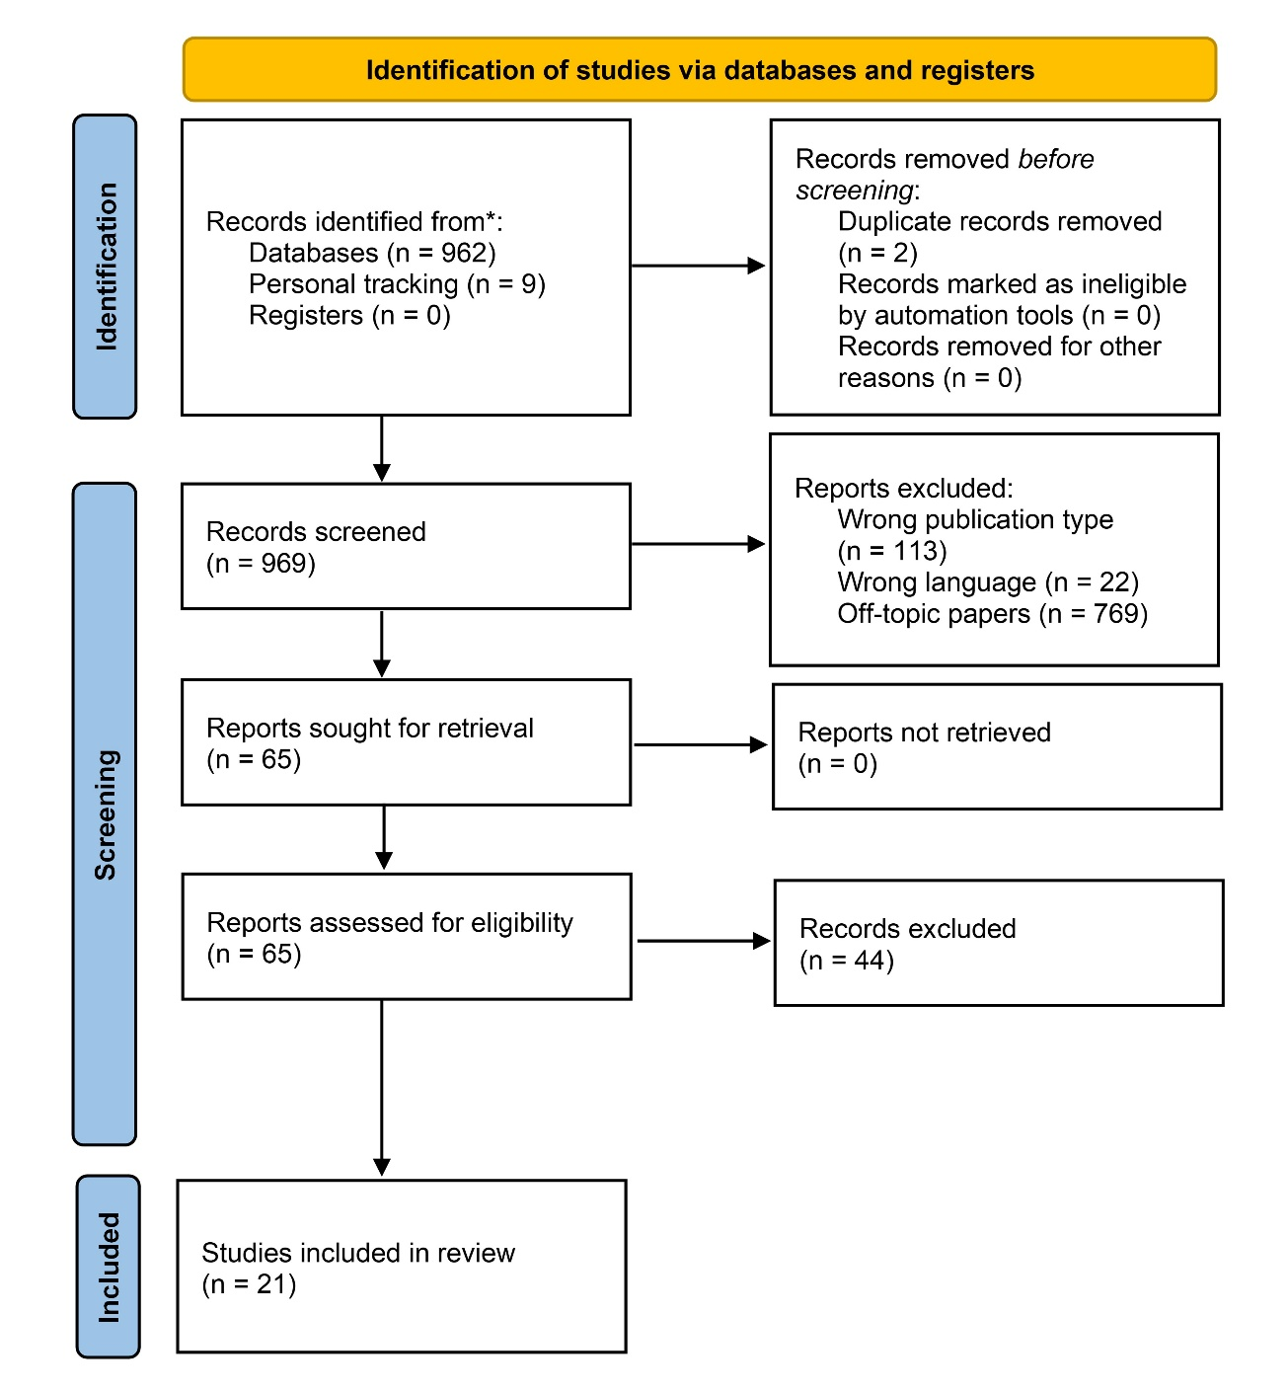

Supplementary Figure 2. Scores from agreement questions included in the Delphi procedure.
.

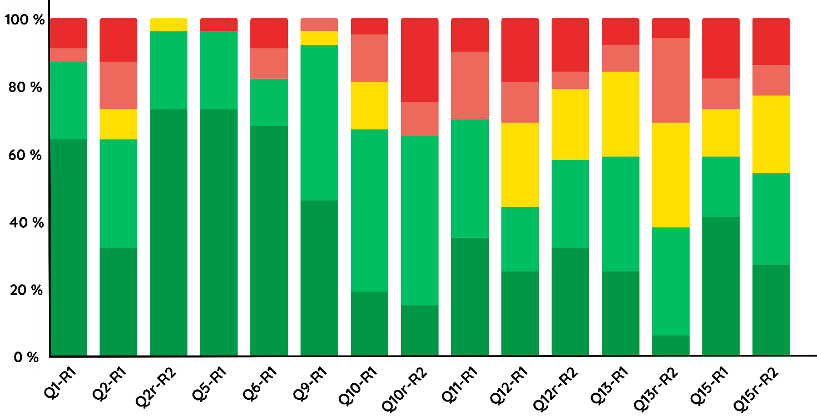

Note. Q indicate questions asked in Round 1, while Qr indicates questions asked in Round 2. Color bars report the percentage of agreement as follows: “totally agree” in green; “somewhat agree” in pale green; “neutral” in yellow; “somewhat disagree” in pale red; “totally disagree” in red.

