Appendix V Model Data: Model details
(See also table 2 for model predictor ranks)

Anser fabalis brood: top predictor 1-dimensional
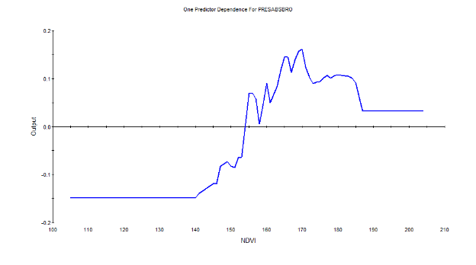

Anser fabalis brood: top predictor 2-dimensional
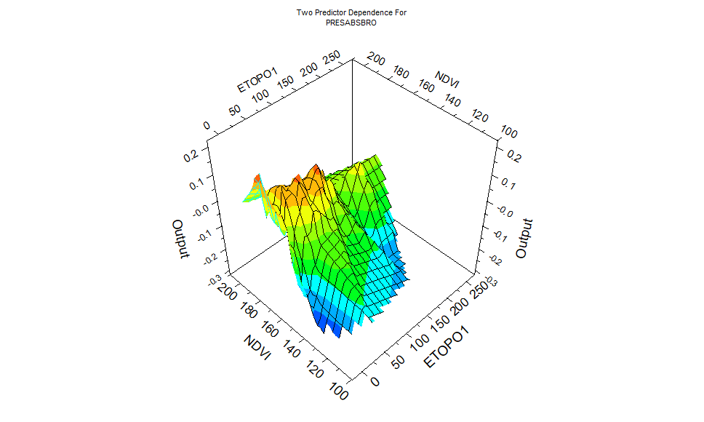

Anser fabalis non-breeder : top predictor 1-dimensional

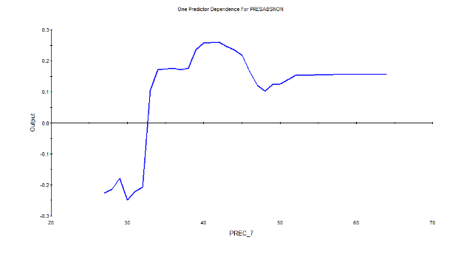

Anser fabalis non-breeder: top predictor 2-dimensional

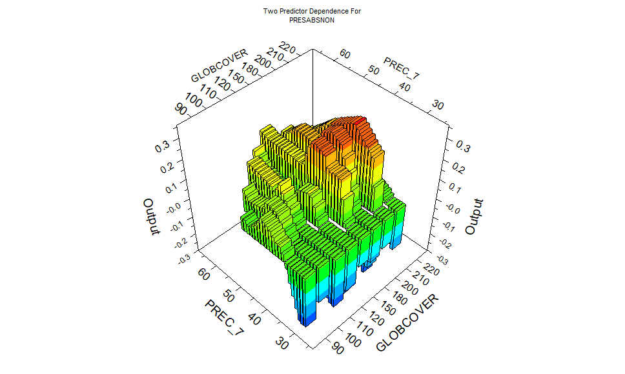
Anser albifrons brood: top predictor 1-dimensional

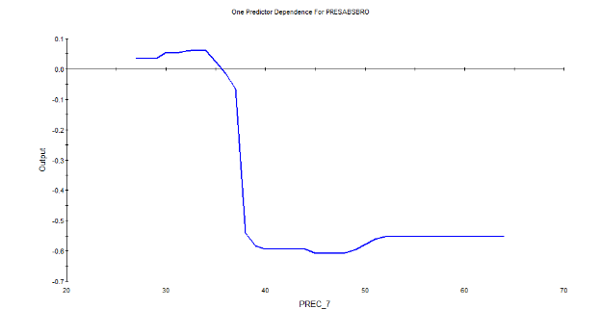
Anser albifrons brood: top predictor 2-dimensional

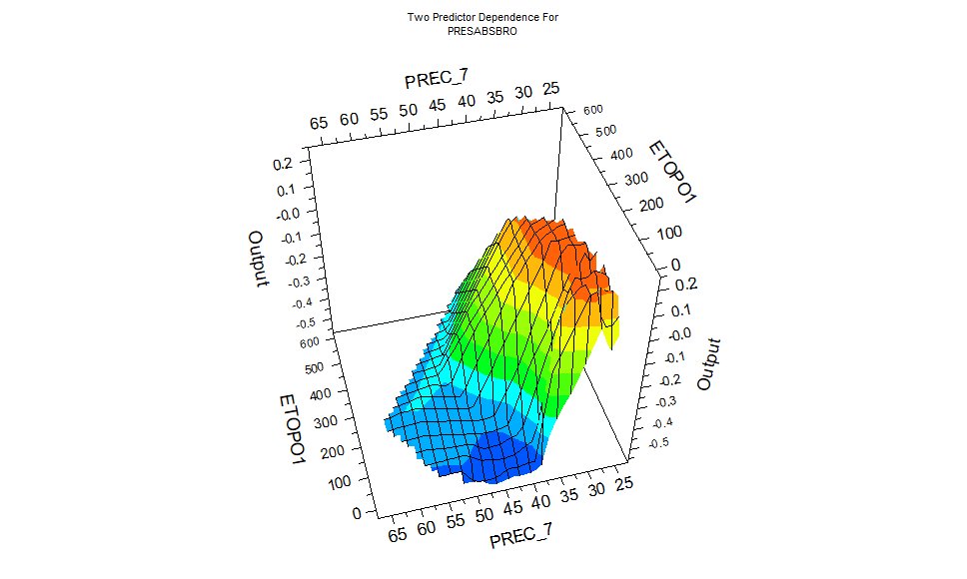

Anser albifrons non-breeder : top predictor 1-dimensional

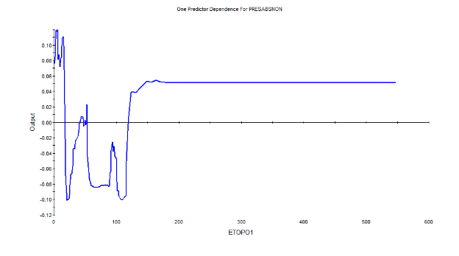
Anser albifrons non-breeder: top predictor 2-dimensional

