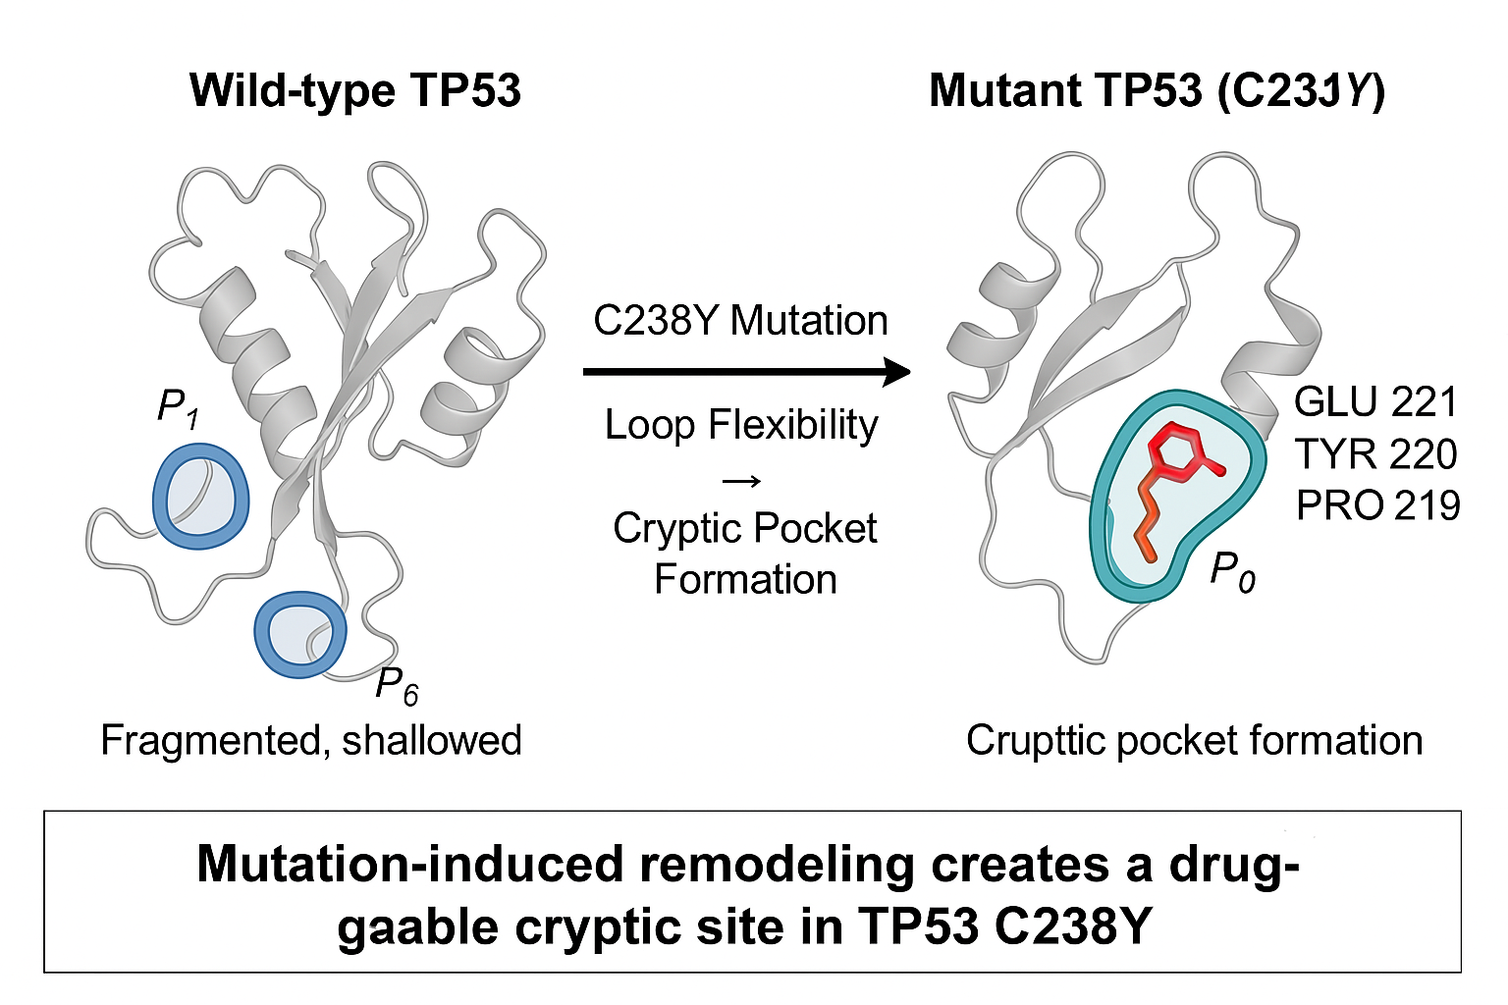
Graphical Abstract: Mutation-induced remodeling of TP53 C238Y leads to the formation of a cryptic, druggable pocket centered on GLU 221, TYR 220, and PRO 219. This transformation challenges the classical notion of TP53 as an undruggable target

