Extended data

Methods

Table ED_M1. Regional climate projections used in the impact analyses (except for air quality analysis) and corresponding years of exceeding 1.5, 2, 3 and 4°C global warming levels.
RCM (R) | Driving GCM (G) | RCP4.5 | RCP8.5 | RCP4.5 | RCP8.5 | RCP4.5 | RCP8.5
RCM (R) | Driving GCM (G) | 1.5 °C |  | 2 °C |  | 3 °C
CCLM4.8-17 | CNRM-CERFACS-CNRM-CM5 | 2035 | 2029 | 2057 | 2044 | - | 2067
CCLM4.8-17 | ICHEC-EC-EARTH | 2033 | 2026 | 2056 | 2041 | - | 2066
CCLM4.8-17 | MPI-M-MPI-ESM-LR | 2034 | 2028 | 2064 | 2044 | - | 2067
HIRHAM5 | ICHEC-EC-EARTH | 2032 | 2028 | 2054 | 2043 | - | 2065
WRF331F | IPSL-IPSL-CM5A-MR | 2023 | 2021 | 2042 | 2035 | - | 2054
RACMO22E | ICHEC-EC-EARTH | 2032 | 2026 | 2056 | 2042 | - | 2065
RCA4 | CNRM-CERFACS-CNRM-CM5 | 2035 | 2029 | 2057 | 2044 | - | 2067
RCA4 | ICHEC-EC-EARTH | 2033 | 2026 | 2056 | 2041 | - | 2066
RCA4 | IPSL-IPSL-CM5A-MR | 2023 | 2021 | 2042 | 2035 | - | 2054
RCA4 | MOHC-HadGEM2-ES | 2021 | 2018 | 2037 | 2030 | 2069 | 2051
RCA4 | MPI-M-MPI-ESM-LR | 2034 | 2028 | 2064 | 2044 | - | 2067

Table ED_M2. Aggregation of 37 impacts on people, ecosystems and economy based on the different impact analyses.
Impacts on people
Human mortality |  | Human exposure
Mortality from non-optimal temperatures |  | Exposure to river flooding
Mortality from poor air quality |  | Exposure to coastal flooding
 |  | Exposure to windstorms
 |  | Exposure to wildfires
 |  | Exposure to water scarcity
Economic impacts
Agriculture |  | Residential (buildings)
Damage from river flooding |  | Damage from river flooding
Damage from coastal flooding |  | Damage from coastal flooding
Losses due to drought |  | Damage due to soil-induced drought subsidence
Damage from windstorms |  | Damage from windstorms
Damage from wildfires |  | Damage from wildfires
Industry and commerce |  | Transport
Damage to assets from river flooding |  | Heat impacts on rail and road infrastructure
Damage to assets from coastal flooding |  | Damage to infrastructure from river flooding
Losses due to drought (lack of water) |  | Damage to infrastructure from coastal flooding
Damage to assets due to soil-induced drought subsidence |  | Navigation impacts from drought
Damage to assets from windstorms |  | Damage to infrastructure from windstorms
Damage to assets from wildfires |  | Damage to infrastructure from wildfire
Ecosystems |  | Labour
Loss ecosystem services from coastal erosion |  | Reduced labour productivity due to heat
Energy
Losses energy production due to drought
Impacts on ecosystems
Habitat suitability |  | Forest disturbances
Alpine tundra habitats |  | Forest disturbances from wildfires
Mediterranean habitats |  | Forest disturbances from windstorms
 |  | Forest disturbances from insect outbreaks

Table ED_M3. Aggregation of economic impacts per driving climate hazard based on the different impact analysis.
Driving hazard of economic impact
Wet |  | Sea level rise
Damage from river flooding |  | Damage from coastal flooding
 |  | Loss ecosystem services due to coastal erosion
Dry |  | Wind
Economic losses from drought  Damages from wildfires (50%) |  | Damages from wind storm  Damages from wildfires (20%)
Heat
Damages from wildfires (30%)
Heat-damage to transport infrastructure
Labour productivity loss

Table ED_M4. Number of NUTS3 regions falling in different income and age classes used to calculate the statistics displayed in Figure 5 of the main manuscript.
Income class (average regional disposable annual income per capita in €) | Number of NUTS3 regions per class |  |  | Age class  (% of population younger than 75 years) | Number of NUTS3 regions per class
<15,000 | 255 |  | <80 |  | 241
15-20,000 | 261 |  | 80-82 |  | 260
20-25,000 | 329 |  | 82-84 |  | 359
25-30,000 | 287 |  | 84-86 |  | 305
>30,000 | 234 |  | >86 |  | 201

Results

Tables

Human mortality
Table ED_HM1. Expected annual human mortality from air quality and non-optimal temperature (heat and cold) over the domain (EU27, CH, NO and UK). Mortality is expressed as the number of deaths per year. Values represent mean estimates, with 90% confidence interval between brackets.
mortality cause | 1.5°C | 2°C | 3°C
air quality | 56,308  (42,099 - 198,814) | 233,873  (170,084 - 320,875) | 271,195  (196,862 - 360,966)
non-optimal temperature | 502,386  (318,789 - 696,108) | 503,025  (312,142 - 713,122) | 521,055  (315,918 - 735,197)
heat | 70,888  (37,476 - 114,692) | 92,065  (46,448 - 152,282) | 151,306  (77,003 - 235,080)
cold | 431,498  (281,312 - 581,416) | 410,960  (265,694 - 560,840) | 369,749  (238,915 - 500,117)
total | 558,694  (360,888 - 894,922) | 736,898  (482,226 - 1,033,997) | 792,250  (512,780 - 1,096,163)

Human exposure
Table ED_HE1. Expected annual human exposure to climate hazards (coastal flooding, river flooding, water scarcity, wildfire danger and windstorms) over the domain (EU27, CH, NO and UK). Exposure is expressed as millions of people exposed per year. Values represent mean estimates, with 90% confidence interval between brackets.
climate hazard | 1.5°C | 2°C | 3°C
coastal flooding | 0.8  (0.1 - 1.8) | 0.9  (0.3 - 2) | 1.0  (0.3 - 2)
river flooding | 0.3  (0.2 - 0.4) | 0.4  (0.2 - 0.6) | 0.6  (0.4 - 0.8)
water scarcity | 54.2  (35.3 - 69.9) | 56.8  (35.6 - 73.2) | 60.6  (48.2 - 72.8)
wildfire danger | 45.0  (31.1 - 59.9) | 48.1  (35.4 - 61.9) | 54.1  (41.6 - 64.2)
windstorms | 0.6  (0.5 - 0.7) | 0.6  (0.4 - 0.7) | 0.6  (0.4 - 0.7)

Economic impact
Table ED_EI1. Expected annual damage to sectors (agriculture, ecosystems, energy, industry & commerce, labour, residential and transport) over the domain (EU27, CH, NO and UK). Economic damage is expressed in billion € per year. Values represent mean estimates, with 90% confidence interval between brackets.
sector | 1.5°C | 2°C | 3°C
agriculture | 11  (4.9 - 29.3) | 13  (4.7 - 31.9) | 17  (6.2 - 35.9)
ecosystems | 6  (1.8 - 10.9) | 7  (3.0 - 11.5) | 7  (3.2 - 11.9)
energy | 3  (1.4 - 6.5) | 3  (1.3 - 7.0) | 4  (1.7 - 7.6)
industry & commerce | 27  (11.2 - 58.8) | 31  (10.8 - 70.5) | 40  (17.5 - 77.9)
labour | 35  (13.6 - 63.9) | 44  (18.0 - 85.9) | 71  (30.1 - 129.1)
residential | 28  (10.5 - 62.0) | 31  (10.5 - 71.6) | 39  (16.3 - 77.9)
transport | 4  (1.1 - 8.9) | 5  (1.7 - 12.2) | 10  (3.3 - 20.6)
total | 114  (44.5 - 240.2) | 136  (49.9 - 290.5) | 188  (78.9 - 360.9)

Figures

Human mortality

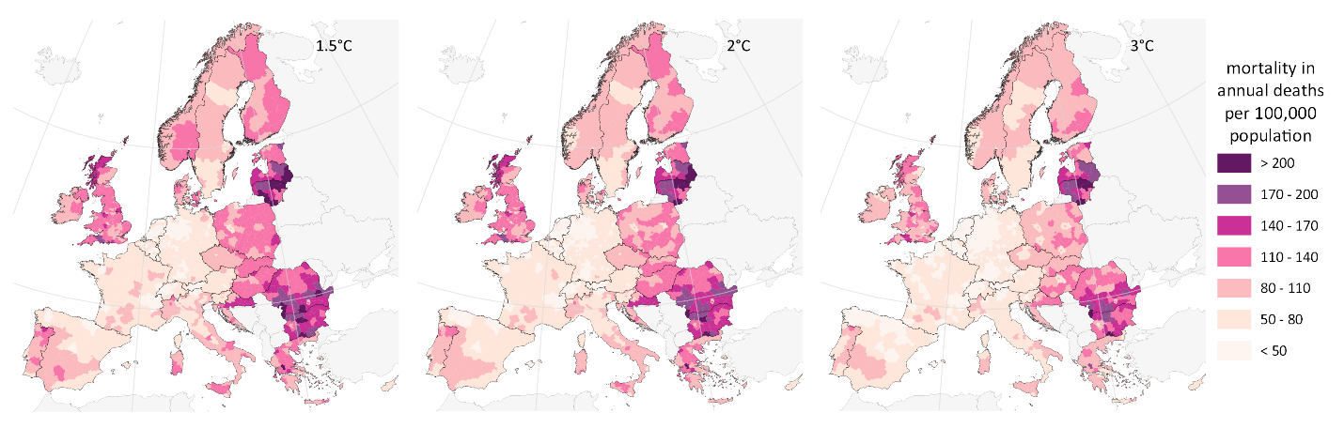
Figure ED_HM1. Human mortality from below non-optimal temperatures (cold) in 2050 for 1.5, 2 and 3°C global warming. Mortality rate is expressed as the number of deaths per 100,000 population and mapped for 1366 NUTS3 regions. Results displayed represent the mean estimates.

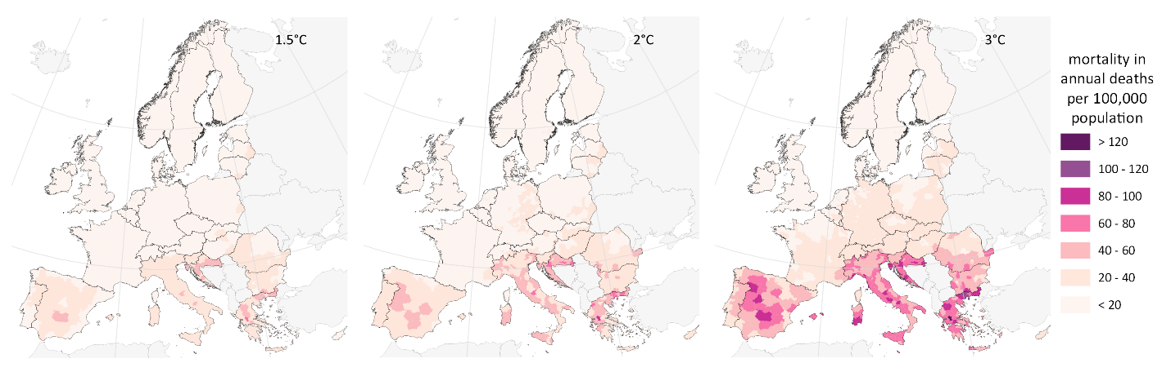
Figure ED_HM2. Human mortality from above non-optimal temperatures (heat) in 2050 for 1.5, 2 and 3°C global warming. Mortality rate is expressed as the number of deaths per 100,000 population and mapped for 1366 NUTS3 regions. Results displayed represent the mean estimates.

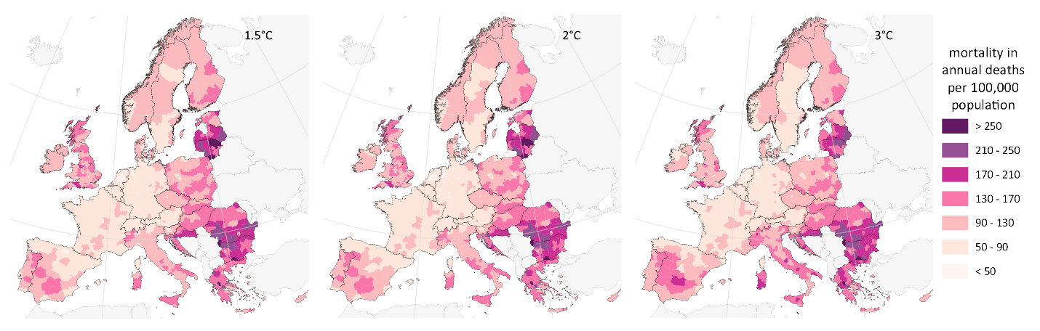
Figure ED_HM3. Human mortality from non-optimal temperatures (cold and heat) in 2050 for 1.5, 2 and 3°C global warming. Mortality rate is expressed as the number of deaths per 100,000 population and mapped for 1366 NUTS3 regions. Results displayed represent the mean estimates.

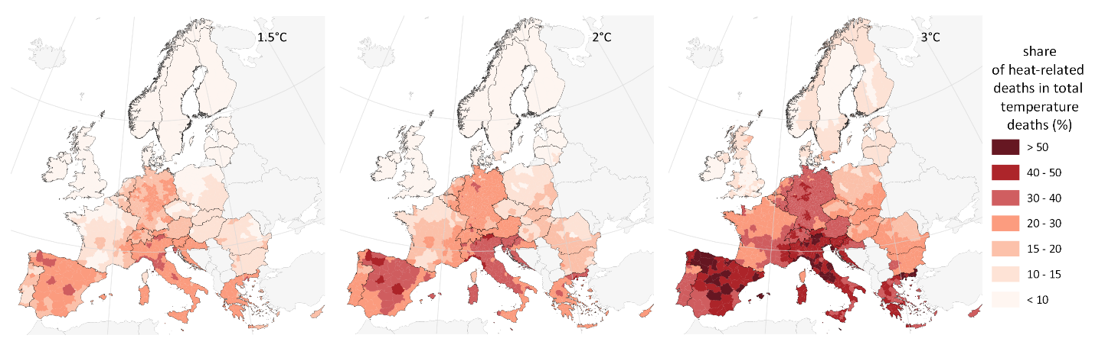
Figure ED_HM4. Share of heat-related deaths in total deaths from non-optimal temperatures in 2050 for 1.5, 2 and 3°C global warming, expressed in percentage of total and mapped for 1366 NUTS3 regions.

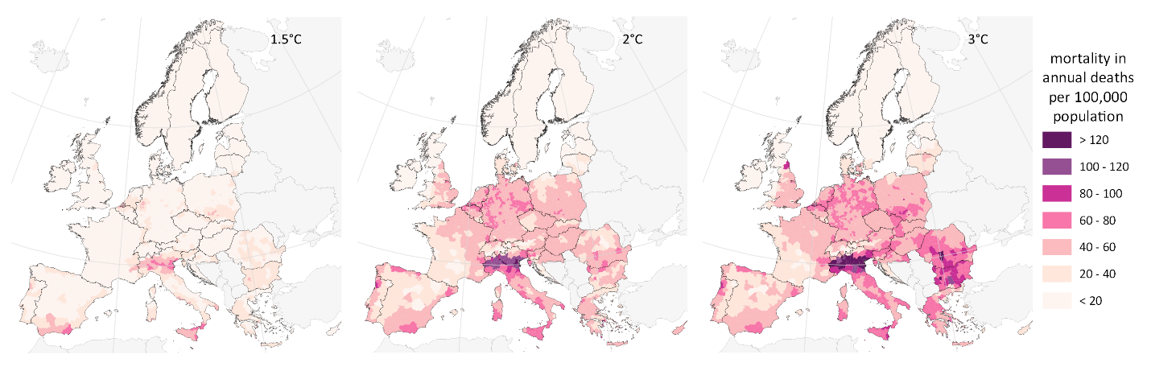
Figure ED_HM5. Human mortality from air quality in 2050 for 1.5, 2 and 3°C global warming. Mortality rate is expressed as the number of deaths per 100,000 population and mapped for 1366 NUTS3 regions. Results displayed represent mean estimates.

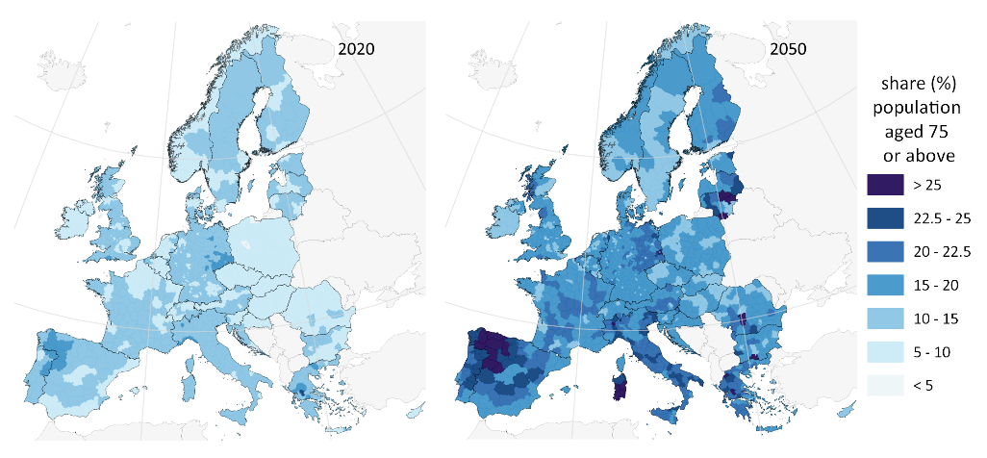
Figure ED_HM6. Share of population aged 75 or above in 2020 and 2050 based on the 2021 Ageing Report projections.

Population exposure
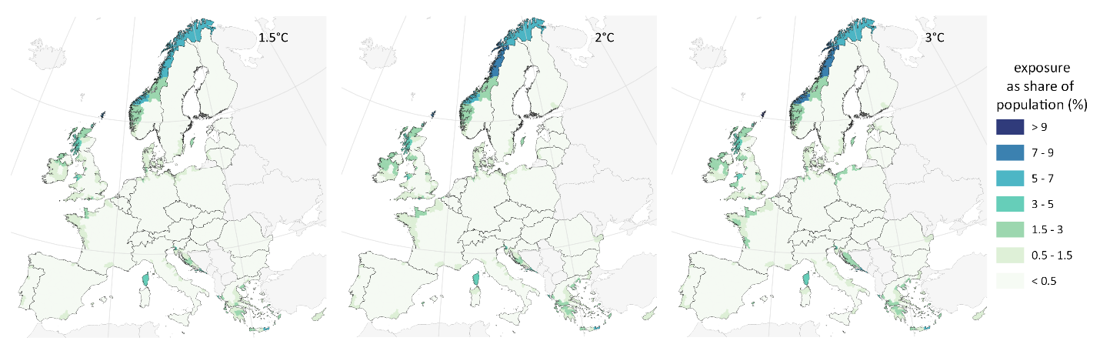
Figure ED_HE1. Human exposure to coastal flooding in 2050 for 1.5, 2 and 3°C global warming. Human exposure to climate hazards is expressed as a share (%) of population and mapped for 1366 NUTS3 regions. Results displayed represent the mean estimates.

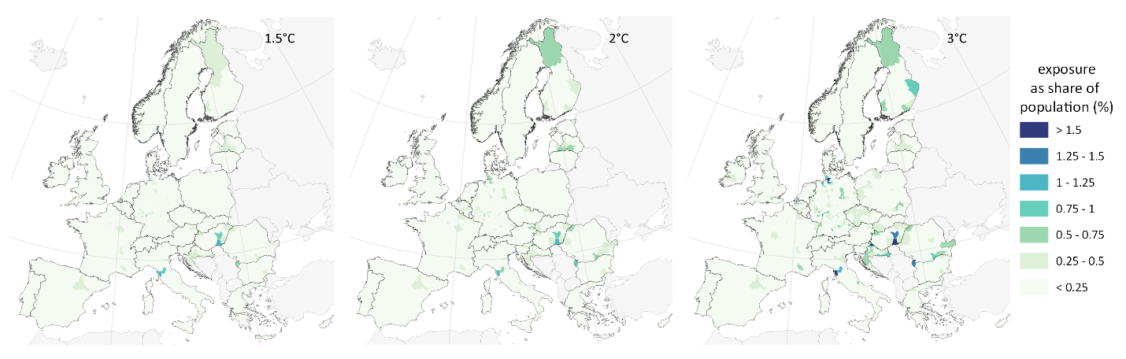
Figure ED_HE2. Human exposure to river flooding in 2050 for 1.5, 2 and 3°C global warming. Human exposure to climate hazards is expressed as a share (%) of population and mapped for 1366 NUTS3 regions. Results displayed represent the mean estimates.

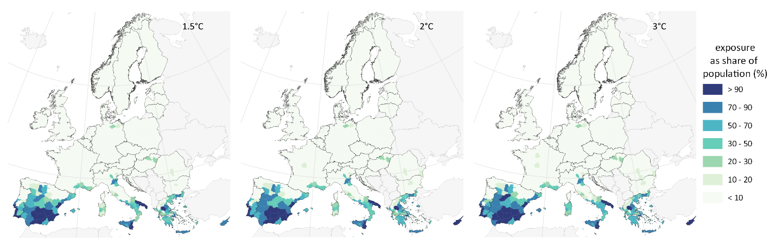
Figure ED_HE3. Human exposure to water scarcity in 2050 for 1.5, 2 and 3°C global warming. Human exposure to climate hazards is expressed as a share (%) of population and mapped for 1366 NUTS3 regions. Results displayed represent the mean estimates.

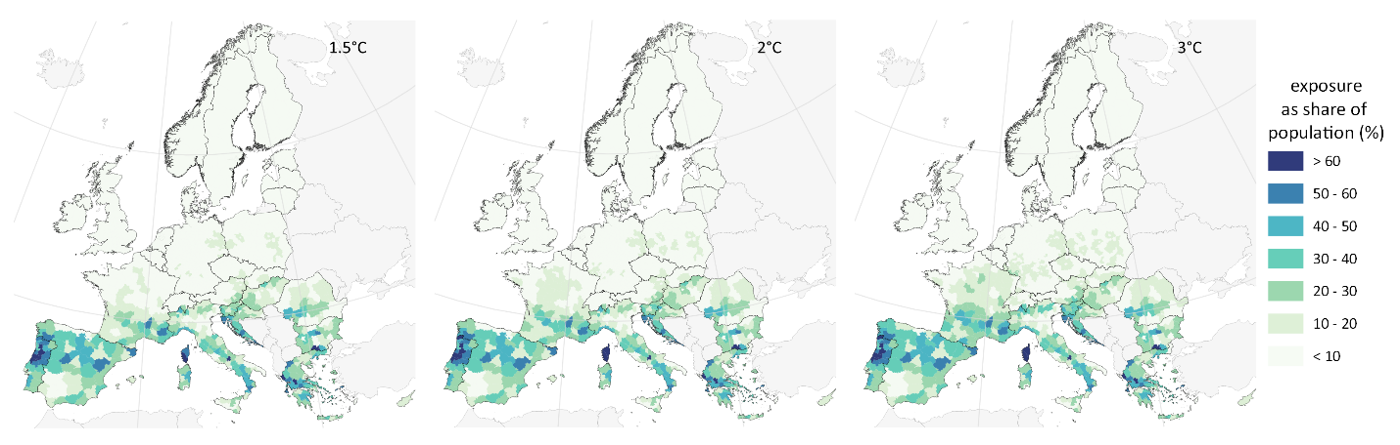
Figure ED_HE4. Human exposure to wildfire danger in 2050 for 1.5, 2 and 3°C global warming. Human exposure to climate hazards is expressed as a share (%) of population and mapped for 1366 NUTS3 regions. Results displayed represent the mean estimates.

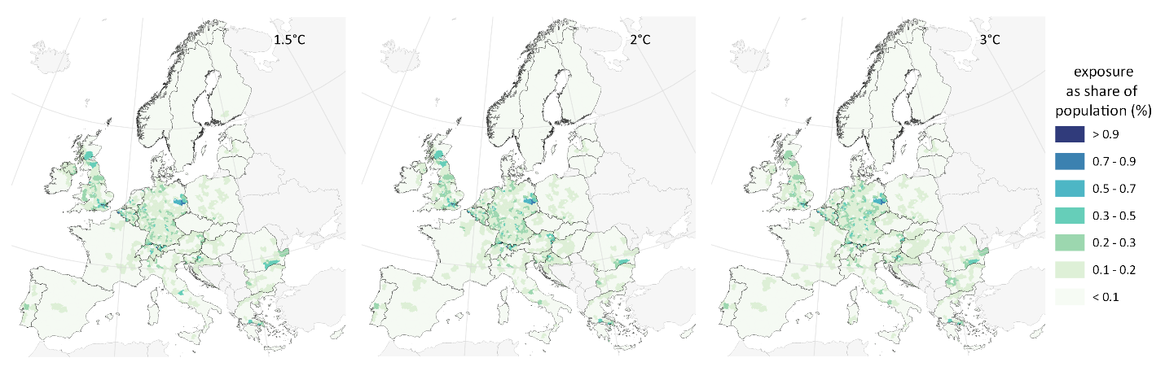
Figure ED_HE5. Human exposure to windstorms in 2050 for 1.5, 2 and 3°C global warming. Human exposure to climate hazards is expressed as a share (%) of population and mapped for 1366 NUTS3 regions. Results displayed represent the mean estimates.

Economic impact

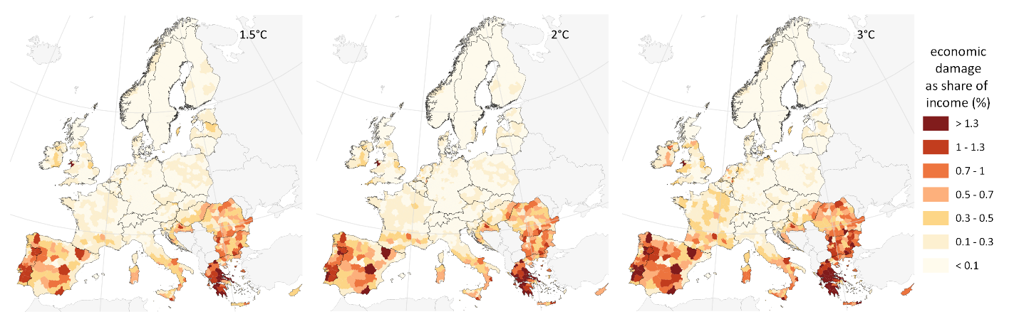
Figure ED_EI1. Economic damage to agriculture in 2050 for 1.5, 2 and 3°C global warming. Economic damage is expressed as a share (%) of regional average disposable income and mapped for 1366 NUTS3 regions. Results displayed represent the mean estimates.

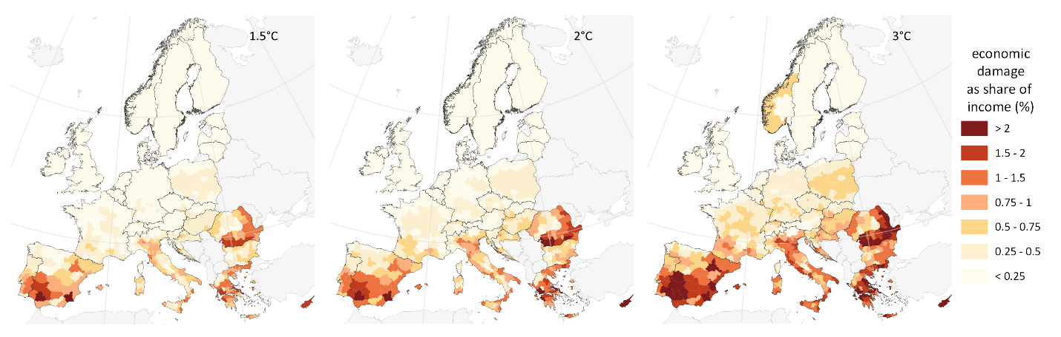
Figure ED_EI2. Economic damage from loss of labour productivity in 2050 for 1.5, 2 and 3°C global warming. Economic damage is expressed as a share (%) of regional average disposable income and mapped for 1366 NUTS3 regions. Results displayed represent the mean estimates.

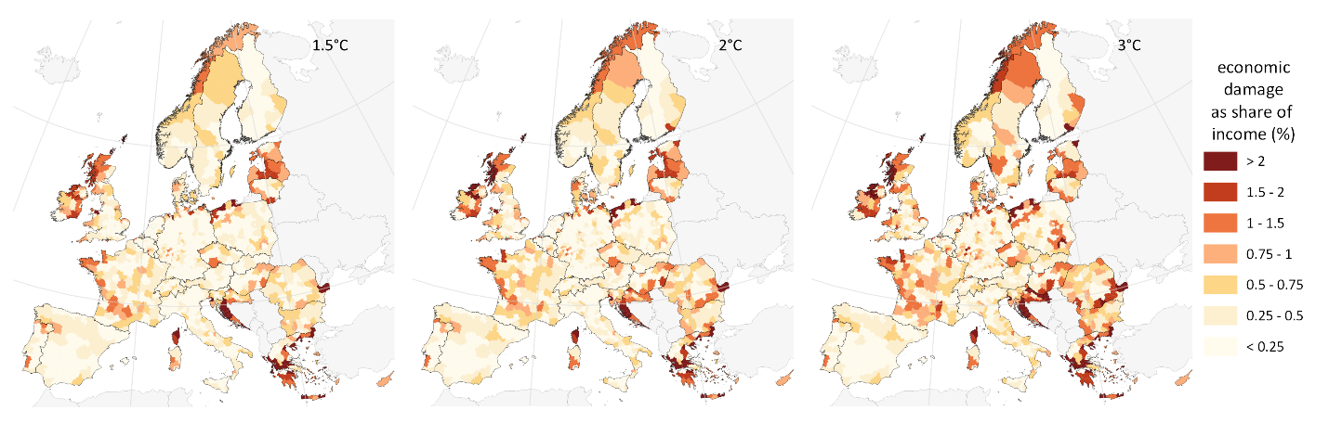
Figure ED_EI3. Economic damage to residential sector in 2050 for 1.5, 2 and 3°C global warming. Economic damage is expressed as a share (%) of regional average disposable income and mapped for 1366 NUTS3 regions. Results displayed represent the mean estimates.

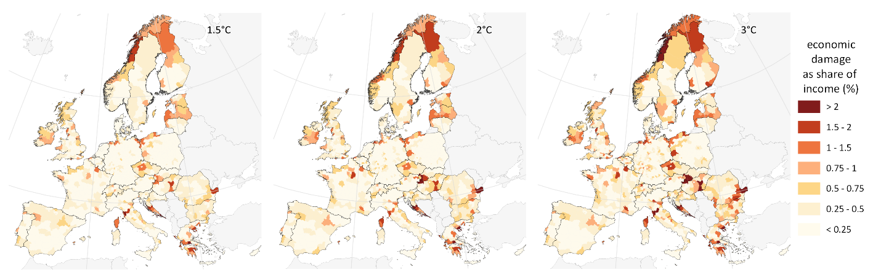
Figure ED_EI4. Economic damage to industrial and commercial sector in 2050 for 1.5, 2 and 3°C global warming. Economic damage is expressed as a share (%) of regional average disposable income and mapped for 1366 NUTS3 regions. Results displayed represent the mean estimates.

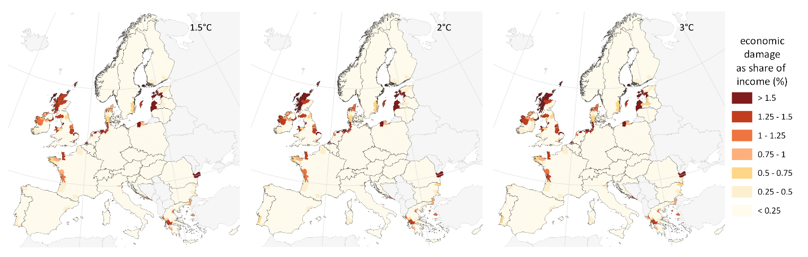
Figure ED_EI5. Economic damage to coastal ecosystems in 2050 for 1.5, 2 and 3°C global warming. Economic damage is expressed as a share (%) of regional average disposable income and mapped for 1366 NUTS3 regions. Results displayed represent the mean estimates.

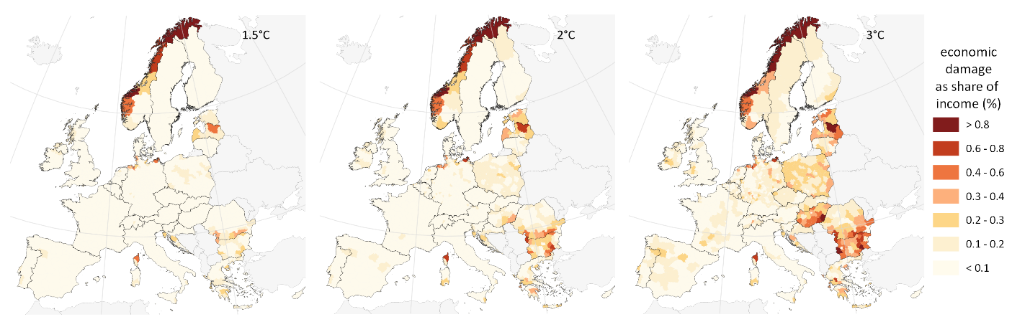
Figure ED_EI6. Economic damage to transport sector in 2050 for 1.5, 2 and 3°C global warming. Economic damage is expressed as a share (%) of regional average disposable income and mapped for 1366 NUTS3 regions. Results displayed represent the mean estimates.

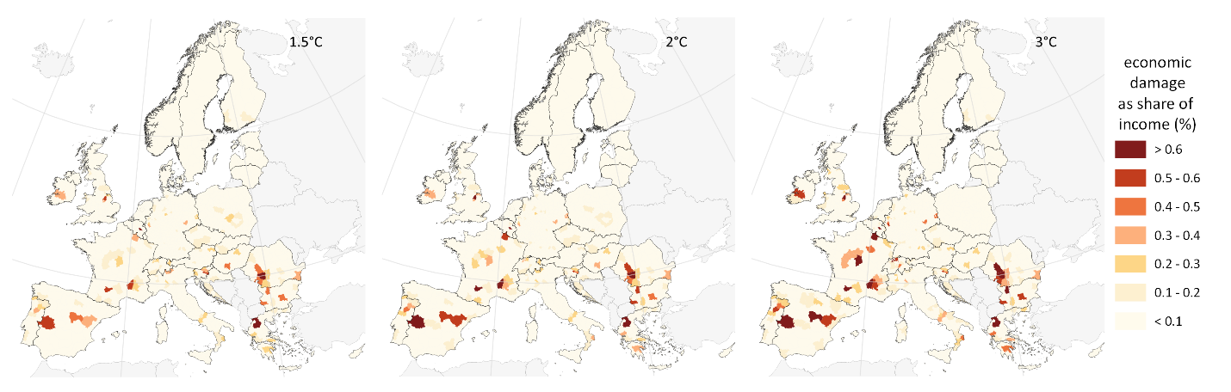
Figure ED_EI7. Economic damage to energy sector in 2050 for 1.5, 2 and 3°C global warming. Economic damage is expressed as a share (%) of regional average disposable income and mapped for 1366 NUTS3 regions. Results displayed represent the mean estimates.

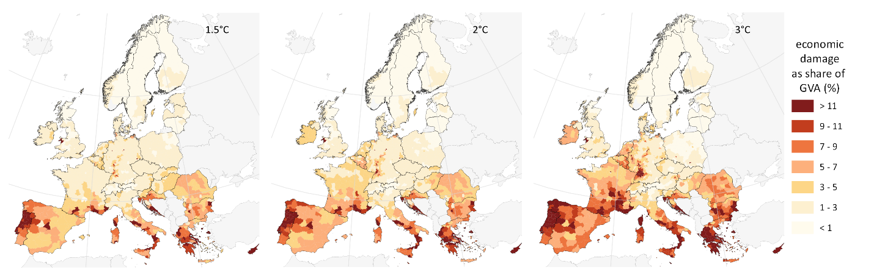
Figure ED_EI8. Economic damage to agriculture sector in 2050 for 1.5, 2 and 3°C global warming. Economic damage is expressed as a share (%) of regional gross value added of the agriculture sector and mapped for 1366 NUTS3 regions. Results displayed represent the mean estimates.

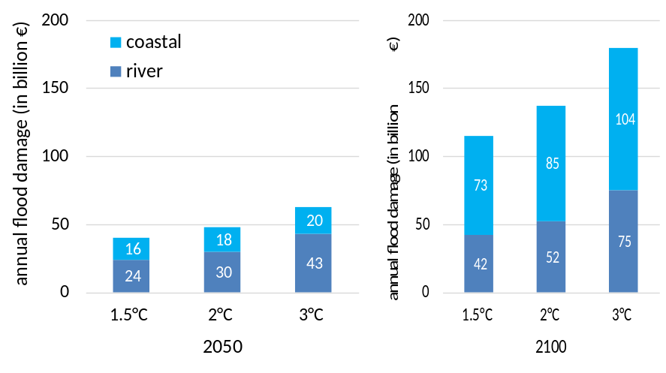
Figure ED_EI9. Contribution of coastal and river flooding to total flood damage in 2050 and 2100 for 1.5, 2 and 3°C global warming. The increase in river flood impacts relates only to increasing exposure value with socioeconomic growth. The increase in coastal flood impacts is the combination of increasing exposure value and continuing SLR for stabilized global warming (exemplifying the delayed effects of sea level rise to global warming).

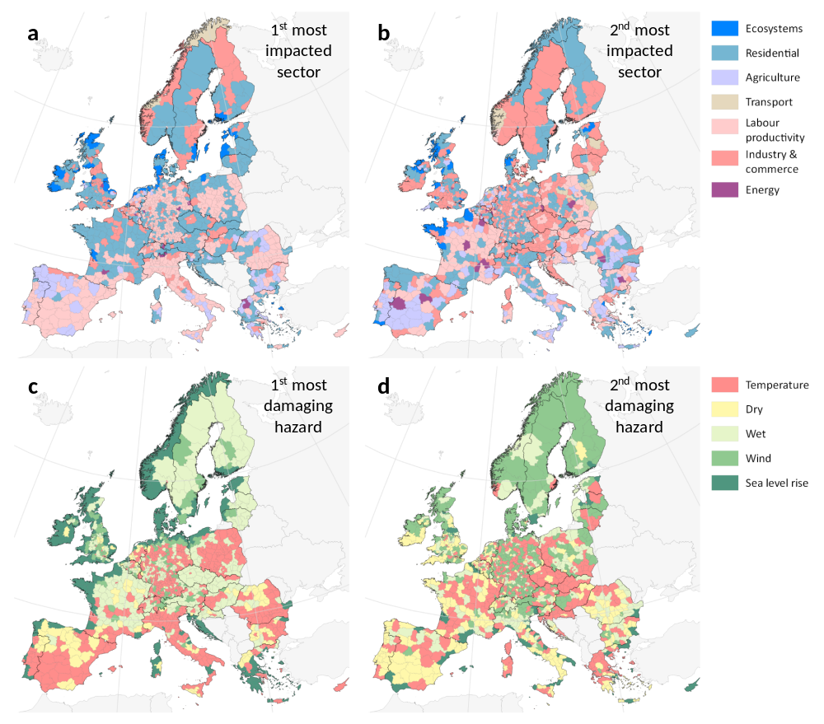
Figure ED_EI10. Most impacted sectors and most damaging climate hazards in 2050 for 2°C global warming. a and b show in each NUTS3 the sector with the highest and second highest economic damage, respectively. c and d show in each NUTS3 the climate hazard that induces the highest and second highest economic damage, respectively. The sector and hazard aggregation are presented in Table SM2 and SM3. Corresponding maps for 1.5°C global warming scenario are presented in Figure 4 of the main text.

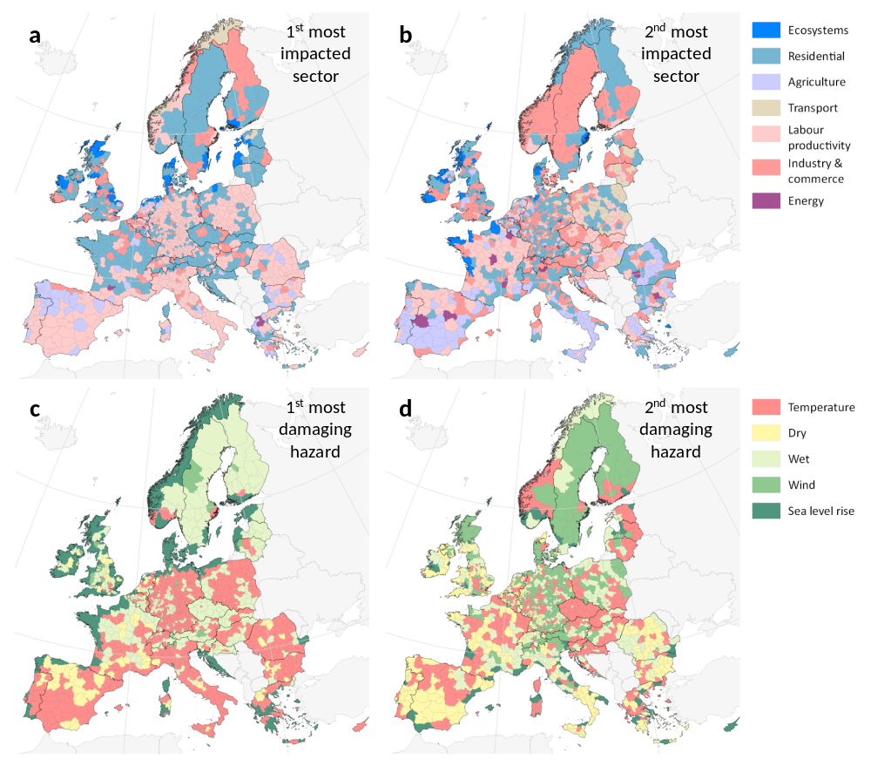
Figure ED_EI11. Most impacted sectors and most damaging climate hazards in 2050 for 3°C global warming. a and b show in each NUTS3 the sector with the highest and second highest economic damage, respectively. c and d show in each NUTS3 the climate hazard that induces the highest and second highest economic damage, respectively. The sector and hazard aggregation are presented in Table SM2 and SM3. Corresponding maps for 1.5°C global warming scenario are presented in Figure 4 of the main text.

Non-economic risks

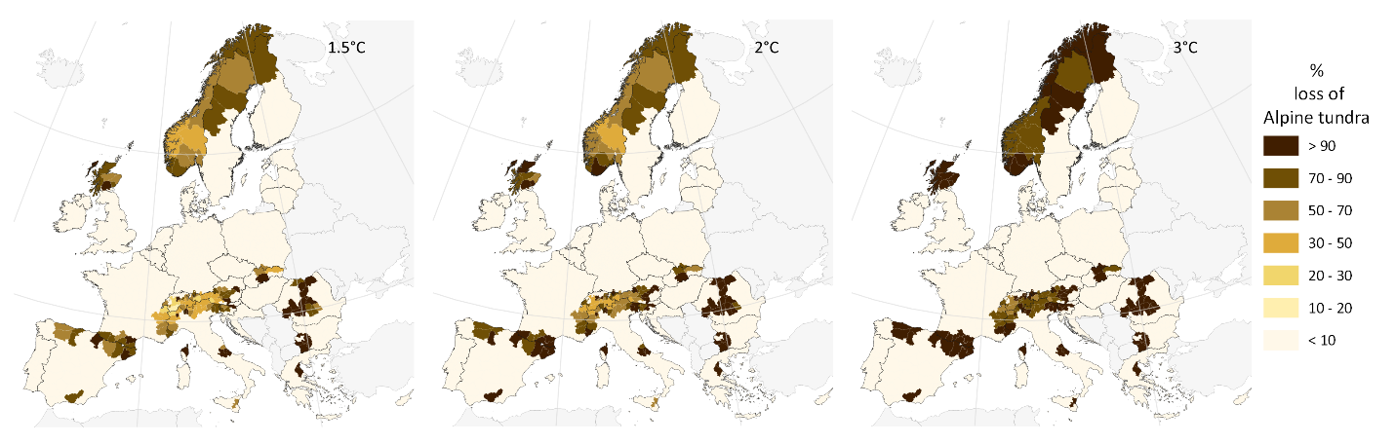Figure ED_NER1. Loss of Alpine tundra by NUTS3 region for 1.5, 2 and 3°C global warming. Loss is expressed as share (%) of present (2020) Alpine tundra extent in each region. Results displayed represent the mean estimates.

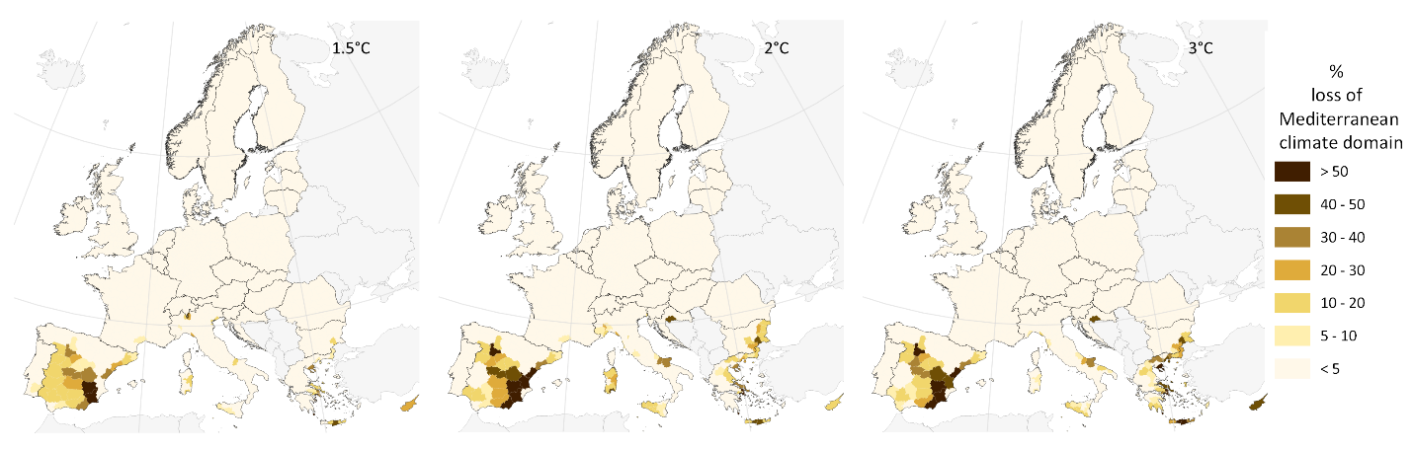Figure ED_NER2. Encroachment of arid into Mediterranean climate domain by NUTS3 region for 1.5, 2 and 3°C global warming. Encroachment is expressed as share (%) of present Mediterranean habitat lost to arid climate domain by NUTS3 region. Results displayed represent the mean estimates.

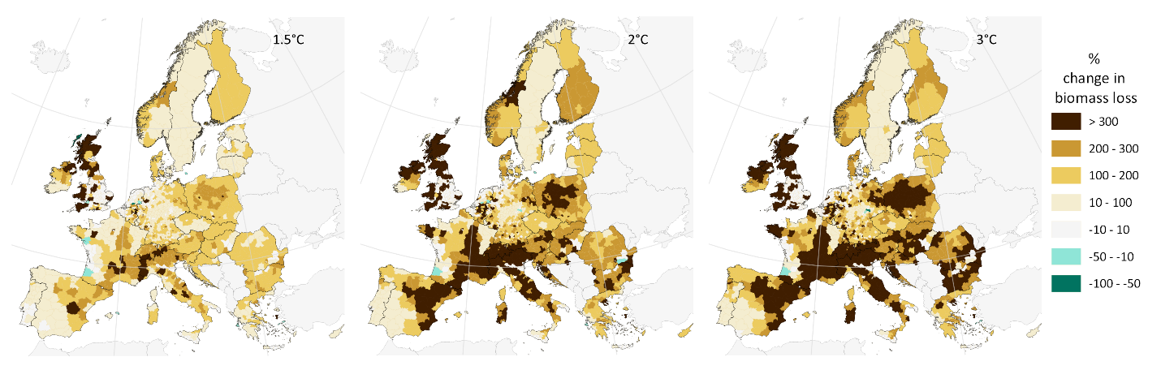Figure ED_NER3. Projected change in biomass loss (in %) from forest disturbances (fires, windstorms and insect outbreaks) by 2050 compared to 2020, for different levels of global warming. Positive values indicate an increase in biomass loss.

