The function role of ubiquitin proteasome pathway in the ER stress-induced AECII apoptosis during hyperoxia exposure
Yue Zhu†, Huimin Ju†, Hongyan Lu* , Wei Tang, Junying Lu and Qiuxia Wang
Department of Pediatrics, Affiliated Hospital of Jiangsu University, Zhenjiang, Jiangsu 212000, P.R.China
† These authors contributed equally to this work
* Correspondence: lhy5154@163.com; Tel.: +86-0511-8508-2260

Supplementary information
Supplementary Materials:
Supplementary Figure S1 Uncropped Western blots for Figure 1C.
Supplementary Figure S2 Uncropped Western blots for Figure 2B.
Supplementary Figure S3 Uncropped Western blots for Figure 3A.
Supplementary Figure S4 Uncropped Western blots for Figure 4D.
Supplementary Figure S5 Uncropped Western blots for Figure 5B.
Supplementary Figure S6 Uncropped Western blots for Figure 6A.

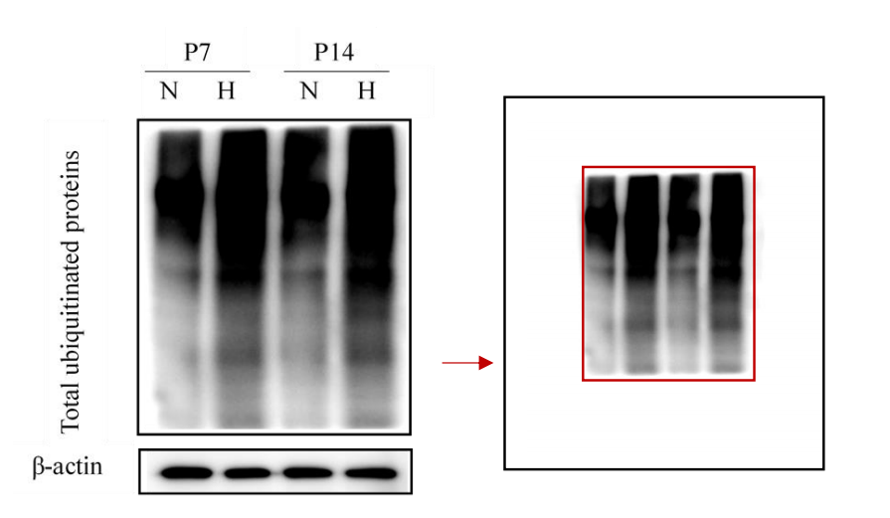
Supplementary Figure S1 Uncropped Western blots for Figure 1C

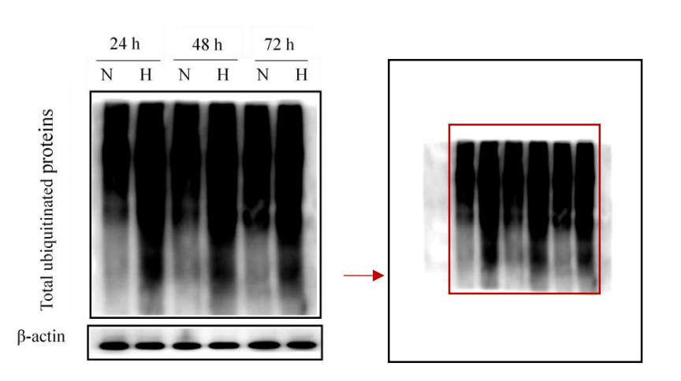

Supplementary Figure S2 Uncropped Western blots for Figure 2B

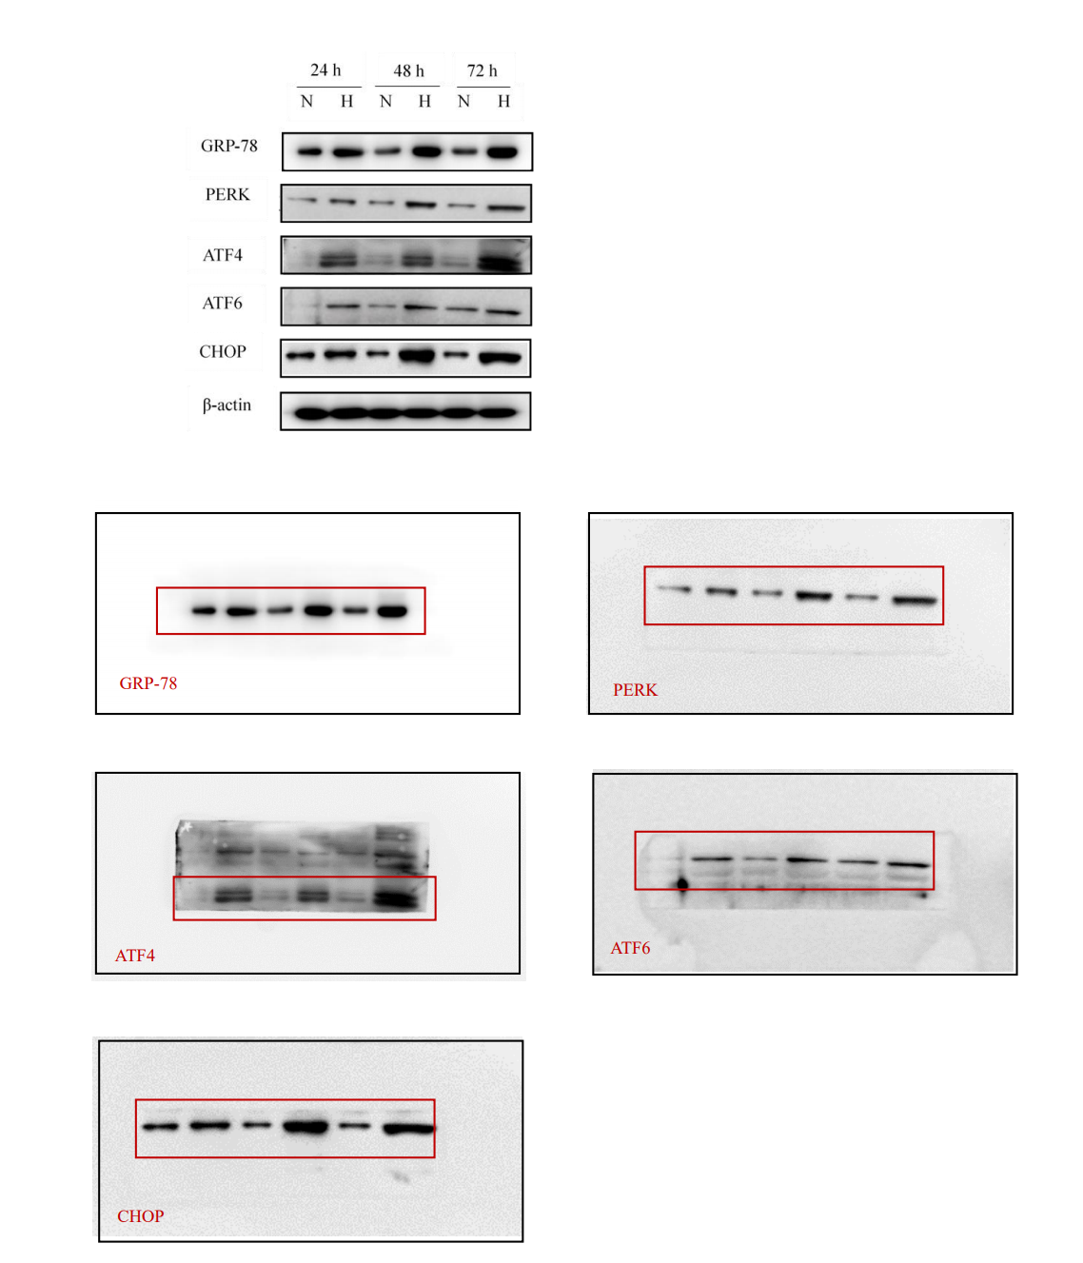
Supplementary Figure S3 Uncropped Western blots for Figure 3A

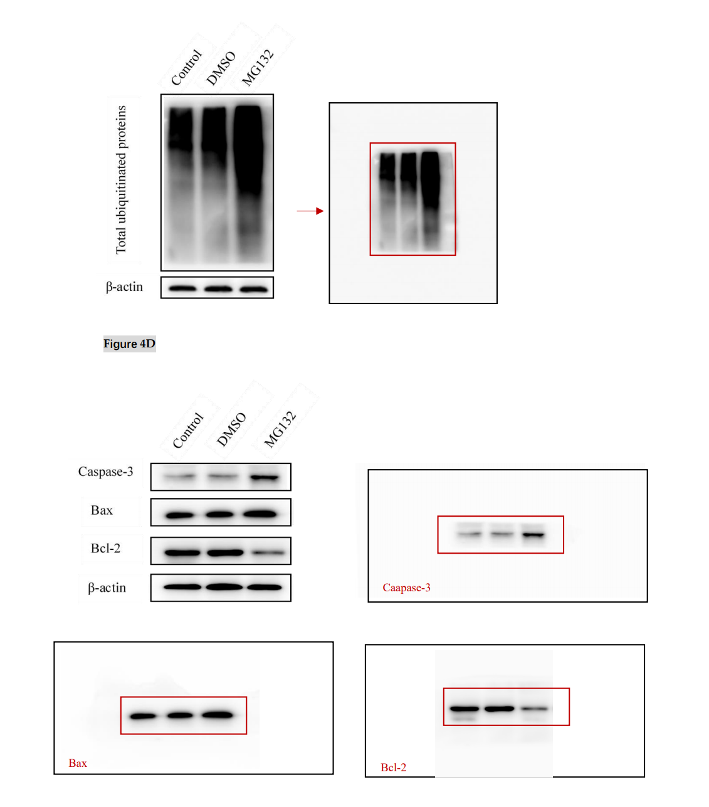
Supplementary Figure S4 Uncropped Western blots for Figure 4D

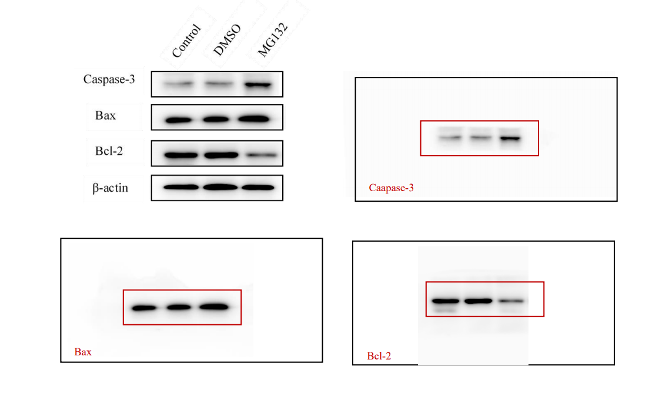
Supplementary Figure S5 Uncropped Western blots for Figure 5B

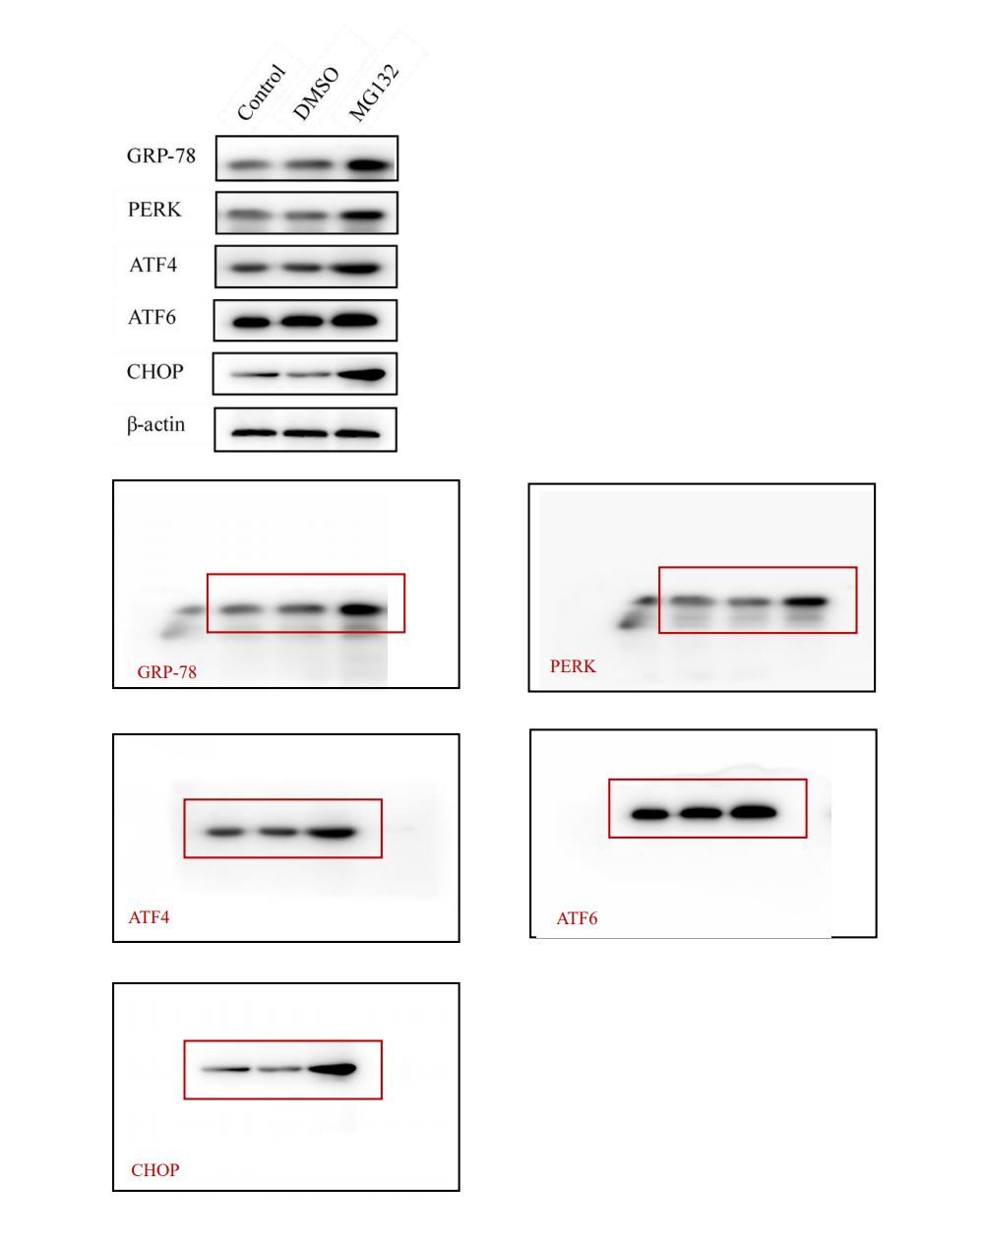
Supplementary Figure S6 Uncropped Western blots for Figure 6A

