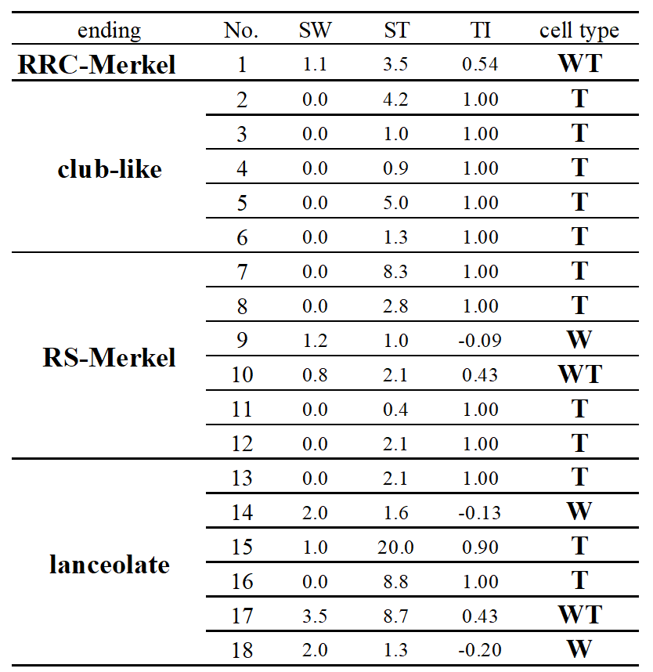

Extended Data. Table 1 | Touch index and spikes per whisk of all 18 neurons.
Extended Data Table 1 | Selectivity of cell types during active touch and
number of spikes per whisk of the last 50 whisking touchs.
Sw: spike number during whisking in air. ST: spike number during whisking against object. TI: touch index. WT, T and WT: Wisking cell, Touch cell, Wisking/Touch cell.

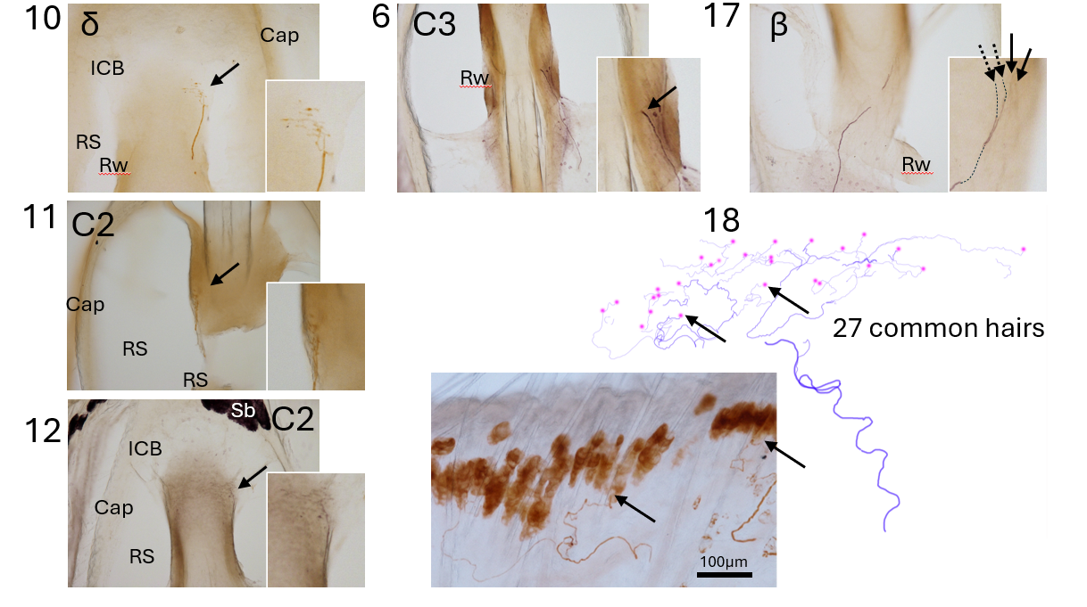
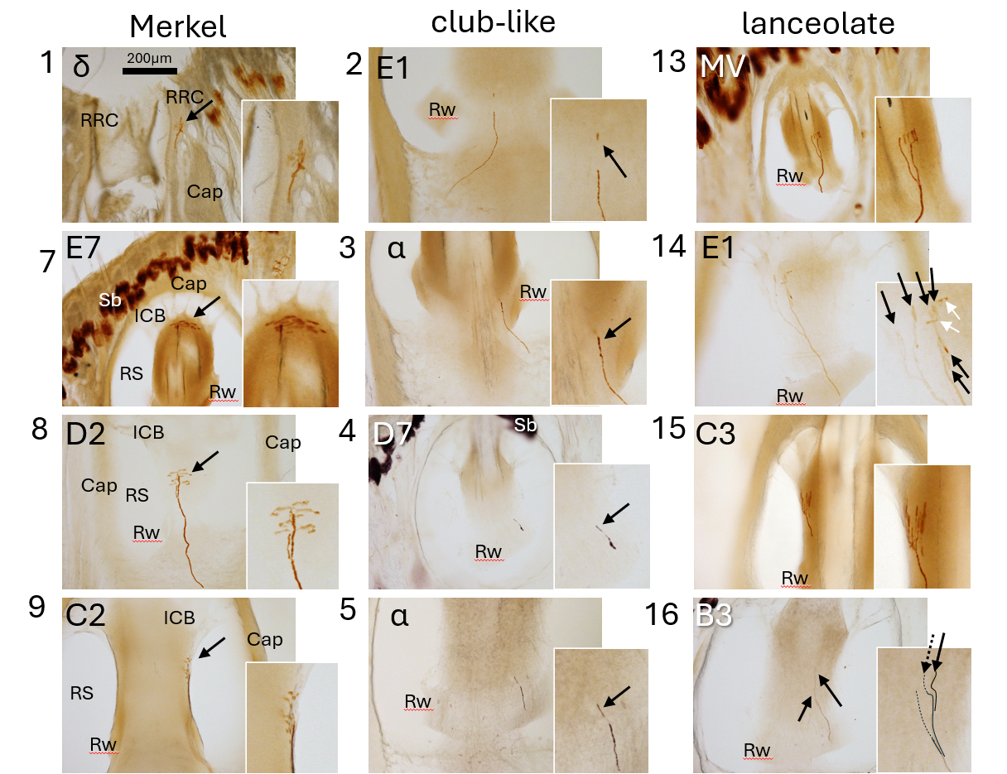
Extended Data. Fig. 1 | Labeled mechanoreceptors.
All 18 neurons identified mechanoreceptor types by morphology of labeled endings on the responded vibrissal follicles. Only No.18 was on 27 common hairs around 2 whiskers.
Next to each figure is a 4x magnified photograph of the traced receptor (arrows). Dashed arrows indicate a part of mechanoreceptors that were on the next serial sections. White arrows were deposits. Cap: capsule, Sb: sebaceous gland.

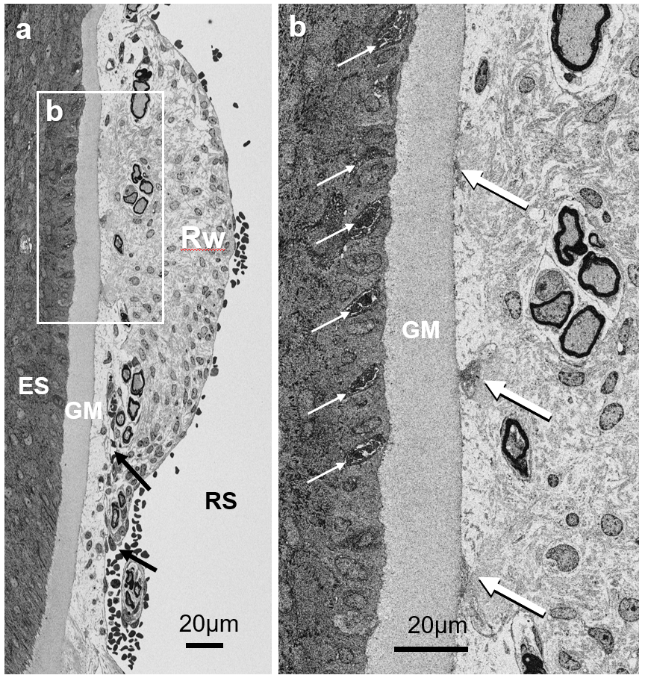
Extended Data. Fig. 2 | Ultrastructure of the cat Rw.
a: The Rw of the cat is flat and not very thick, there is no curve in the ES, and the continuation of the RS is not visible from below (arrows). The GM is thick and flat, and the Rw shows no thick collagen bundles. b: Enlarged picture shows three club-like endings (large white arrows) attached to the thick GM. The endings are enclosed fine collagen fibers. Remarkably, Merkel terminal disks (small white arrows) on Merkel cells also were observed at the level of the Rw.

