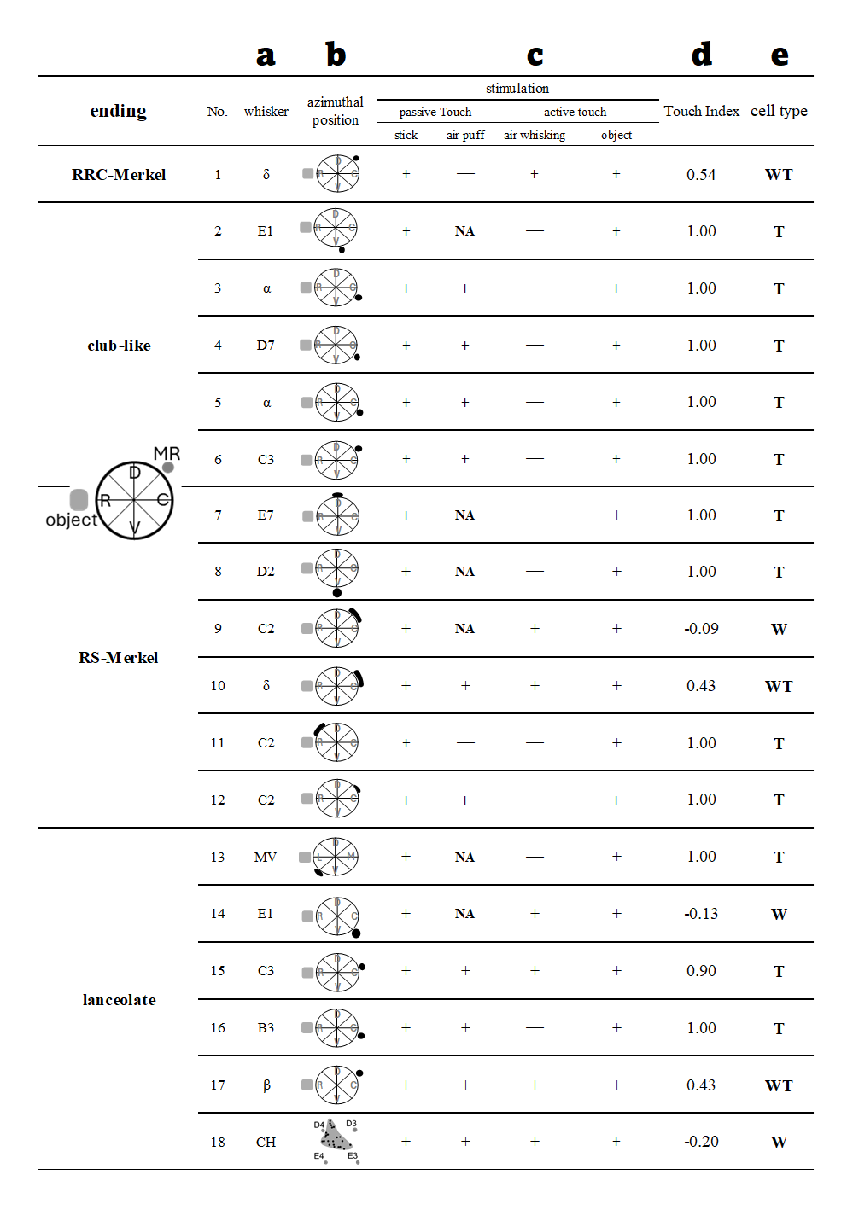

Table 1 | Profiles of all neurons.
a. Whisker label. MV, micro vibrissa; CH, common hair; Latin letter, straddler; Xn, whisker in row X and column n. b. Azimuthal position of the receptors. D, dorsal; R, rostral; V, ventral; C, caudal; L, lateral; M, medial. Black dot or elongated shape indicate the location of the endings. Gray square indicates object azimuth. c. Responses of the cell; +, responded; -, did not respond; NA, not available. d, e. Cell types as identified by the Touch Index (TI). WT, Whisking / Touch cell; T, Touch cell; W, Whisking cell. (See Methods).

