Change and Variability in Antarctic Coastal Exposure, 1979-2020

Reid, P. A.^{1,2*}, and R. A. Massom^{3,2}

¹Australian Bureau of Meteorology, Hobart, Tasmania, Australia
²Australian Antarctic Program Partnership, Hobart, Tasmania, Australia
³Australian Antarctic Division, Kingston, Tasmania, Australia

* Corresponding author address: Phillip Reid, Australian Bureau of Meteorology, GPO Box 727, Hobart, Tasmania 7000, Australia. E-mail: phillip.reid@bom.gov.au

Supplementary
Data
The main CEL method, and a subsidiary Coastal Exposure Index or CEI (both described below), are based on daily sea-ice concentration products for the period 1979 through 2020. These products are derived from the multi-satellite passive-microwave brightness temperature time series using the NASA Team algorithm¹, mapped at 25 km x 25 km resolution and obtained from the NASA National Snow and Ice Data Center (NSIDC) Distributed Active Archive Center (DAAC). Both algorithms are designed to be adaptable for different resolution data. Complete coverage of the entire Antarctic coastal and sea-ice zones is obtained on a daily basis, except for 1979-July 1987 (once every two days). Missing single days during this period are interpolated from the adjoining day's sea-ice concentration values. Averages and climatologies are based on the period 1979-2020, unless otherwise stated. The continental land mask used (gsfc_25s.msk) is also obtained from NSIDC, and includes ice shelves (the seaward extremities of which are taken here to be coastline). Coastline grid points are defined from the continental land mask as any ocean grid point that has land/ice sheet adjacent to it. The South Shetland Islands (at a longitude of ~60°W) and Mill Island (~101°E) are neglected in the calculations of coastal exposure since they permanently block the calculation of CEI from the continental edge.

Analysis methods
For this study, we developed and evaluated two new but different algorithms for quantifying and monitoring coastal exposure: the Coastal Exposure Index (CEI) and a more complex Coastal Exposure Length (CEL) method. The CEI technique is based on the detection of sea ice presence/absence radially out (northwards) from the coastline along each meridian (at one degree longitudinal spacing), following masking of the ice sheet (e.g., Extended Data Fig. 1a). As such, the CEI is simply defined as the number of longitudes with no sea ice (threshold set to < 15% following convention) to the north of the continent, and hence runs from zero to 360. The delineation of regional sectors follows the widely-used delineation for sea-ice analysis of², and the total length of the Antarctic coastline comes from³. Austral spring is taken to be September through November, summer is December through February, autumn is March through May, and winter is June through August.

While the relatively-simple CEI algorithm provides reasonable broad-scale assessment of coastal exposure (see the daily example in Extended Data Fig. 1a) and is computationally inexpensive, it fails to categorise certain coastal areas as exposed when they clearly are. As a result, it tends to underestimate total exposure in terms of both its physical length and duration. Specifically, the application of CEI is limited where the (exposed) coastline being assessed: (1) is N-S trending (e.g., the Antarctic Peninsula); (2) has a zonal-trending promontory of land/ice sheet to its north; and/or (3) is semi-enclosed by a zonally-extending sea ice tongue offshore. An example of the latter, across the Amundsen Sea at ~105-115°W, is given in Extended Data Fig. 1a; such features tend to be common though sporadic and ephemeral, particularly during the late annual sea-ice retreat season (December-January).

For this reason, the more sophisticated CEL algorithm was developed, and the output from this is used in the main analysis as it does not have the disadvantages of the CEI. Here, CEL is defined as the length (in kms) of the Antarctic coastal perimeter with no adjacent sea ice anywhere offshore (i.e. total exposure of the coast to the open Southern Ocean with no intervening sea ice), but excluding coastal polynyas (recurrent areas of persistent open water/thin ice enclosed by sea ice⁴) e.g. Extended Data Fig. 1b. By this method, we use the land mask to determine if each coastal grid point has an immediately-adjacent ocean grid point that is ice-free (i.e. has a sea-ice concentration of <15%). If this criterion is met, then a nearest (adjoining) neighbour-testing technique is used to determine whether that ocean grid point is either exposed in some way to the wider open ocean or is bound by neighbouring sea ice offshore. If any of the neighbouring grid points are classified as “exposed”, or if the total area of neighbouring ice-free grid points exceeds an arbitrary cut-off of 500,000 km², then that coastal grid point is classified as “exposed”. Otherwise, the neighbouring grid points are deemed to be bounded by sea ice and the coastal grid point is classified as (being part of) a coastal polynya. The length of individual exposed adjacent ocean grid points is estimated by taking the square root of the respective pixel area. These values are then summed to derive the total length of coastal exposure. Values of annual net Antarctic coastal exposure length are then obtained by summing each individual day's coastal exposure within a year.

Although the CEL algorithm is computationally more expensive than the CEI technique (especially where large coastal polynyas are present), it provides more complete coverage of coastal exposure at greater detail. Moreover, and as a by-product, the CEL method readily detects, maps and monitors regions of low (<15%) sea ice concentration that are bounded by higher-concentration sea ice, i.e. coastal polynyas, as shown in orange at ~80°W and ~90°E in Extended Data Fig. 1b. This additional information on polynya size and distribution (not provided here as it is outside the scope of this study) is also important from a coastal-exposure perspective in that Antarctic coastal polynyas make a regionally-important contribution to the seasonal melt-back of sea ice to the coast each austral summer⁵. The CEL method also has wider geographic applicability i.e. around the Arctic sea-ice regions, and a follow-up analysis of change and variability in Arctic coastal exposure is planned.

Strictly speaking, the presence/absence of coastal sea ice in this study refers to both moving pack ice and stationary fast ice that is attached (in certain places⁶) to the coast and icebergs grounded on near-coastal shoals <450 m deep⁷. However, the coarse spatial resolution of the passive microwave-based indices precludes resolution (specific detection) of the fast ice or its accurate distinction from pack ice - as Antarctic fast ice where present typically occurs in a relatively narrow coastal band⁶. Fine-scale analysis of coastal exposure involving lack/loss of fast ice therefore requires finer-scale satellite data and analysis techniques, which are beyond the scope of this broad-scale study. Having said this, there is some correspondence between loss/lack of pack ice and loss/lack of adjacent sea ice, due to the susceptibility of coastal fast ice to breakup by ocean swells in the absence of a protective pack ice “buffer”^{8,9}.

Throughout the main text, trends and associated significance are calculated using the IDL trend subroutine. Error estimates associated with mean values are presented as one standard deviation of the entire time series.

Detailed comparison of CEL versus CEI
Here, we carry out a more detailed comparative assessment of the CEL and CEI methods for our Antarctic application, by replicating the CEL results shown in the main analysis in Figures 1 to 4 using the CEI method i.e., Extended Data Figures 2 to 5. This comparison confirms the wider applicability of the CEL method. Notably, the frequency of occurrence of CEL (Fig. 2a) is slightly higher than that of CEI (Extended Data Fig. 3a), and CEL exposure has an earlier onset than CEI-derived exposure at the same longitude (Fig. 2b versus Extended Data Fig. 3b), although timings of exposure cessation are very similar. These differences are further highlighted by comparison of the statistics of CEL versus CEI results shown in Extended Data Tables 1 and 2, respectively. Generally speaking, however, the magnitude, seasonality and regional distribution of both climatology and trends obtained from CEL (Figures 1 to 4) and CEI (Extended Data Figures 2 to 5) are quite similar in their overall patterns. In summary, CEL is better suited to more detailed analyses of coastal exposure requiring higher accuracy (and hence it was chosen for this study), while CEI is more suited to the assessment and analysis of model output regarding current and future climate scenarios.
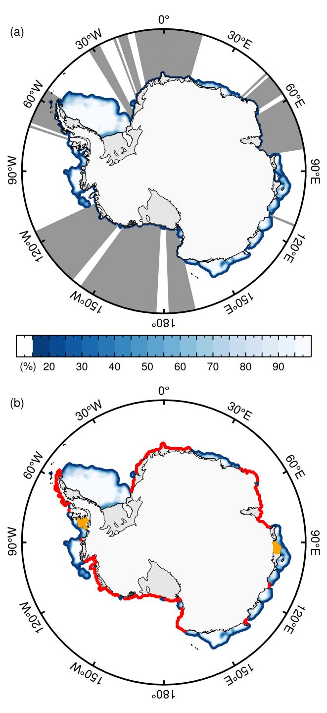
Extended Data Fig. 1 Examples of the two methods of representing Antarctic coastal exposure, from 14 February 2017. (a) CEI, where the dark grey shows each longitude of coastal exposure; and, (b) CEL, where red dots represent each coastal pixel unbounded by any sea ice and orange dots represent bounded pixels. The blue gradient on each map represents the sea-ice concentration (%) for that day.
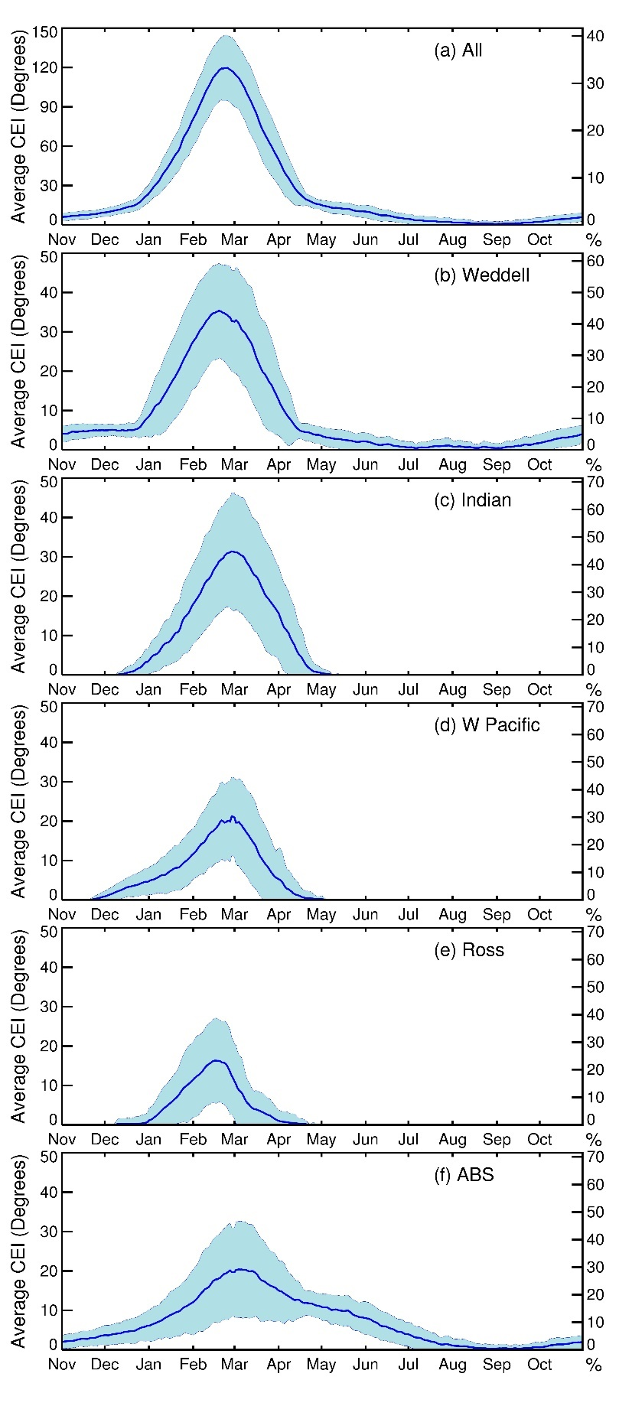
Extended Data Fig. 2 Plots of the average (1979-2020) coastal exposure index for each day (degrees) using the CEI method. (a) Total Antarctic coastline, (b) Weddell Sea, (c) Indian Ocean, (d) W Pacific Ocean, (e) Ross Sea, and (f) ABS. Shaded blue lines represent ±1 standard deviation above and below the mean value.
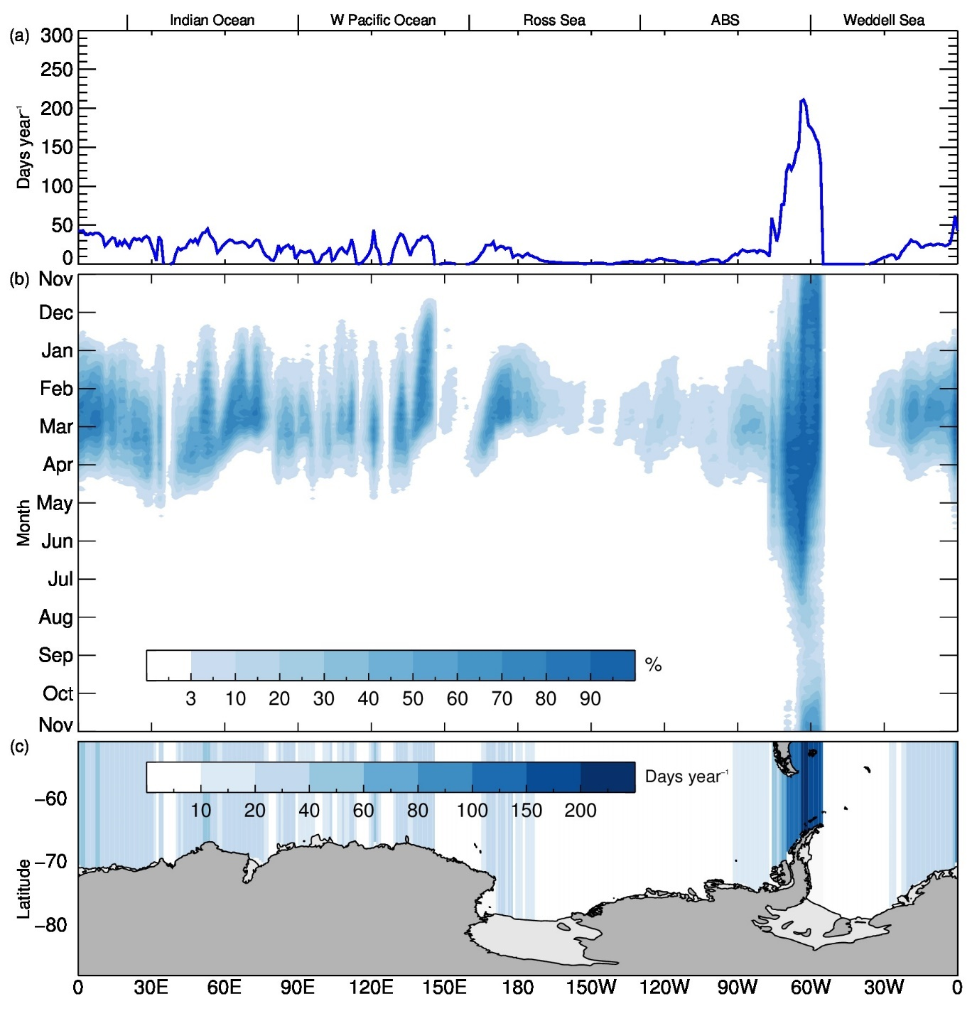
Extended Data Fig. 3 Climatology (1979-2020) of CEI. (a) Each longitude (average days year⁻¹), (b) coastal exposure occurrence expressed as a percentage of frequency for each day and longitude (%), and (c) each grid point (days year⁻¹).
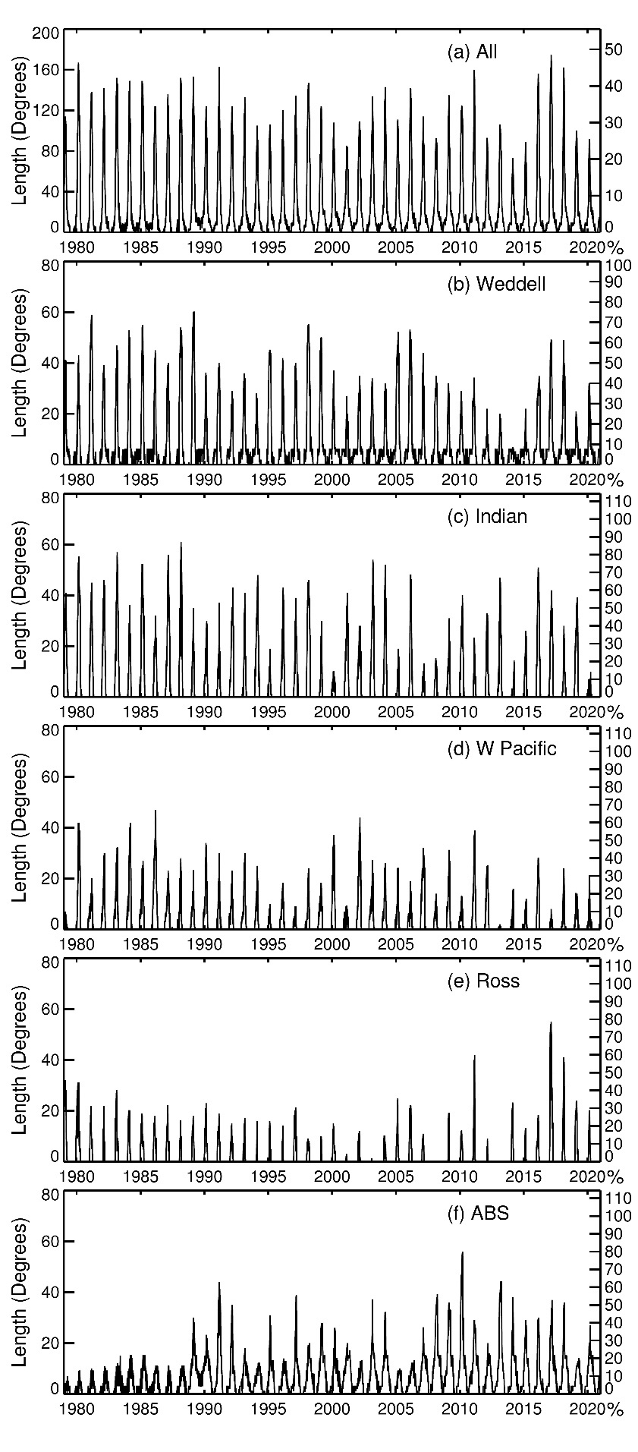
Extended Data Fig. 4 Time series plots of monthly-mean coastal exposure index for 1979-2020. (a) Total Antarctic coastline, (b) Weddell Sea, (c) Indian Ocean, (d) W Pacific Ocean, (e) Ross Sea, and (f) ABS.
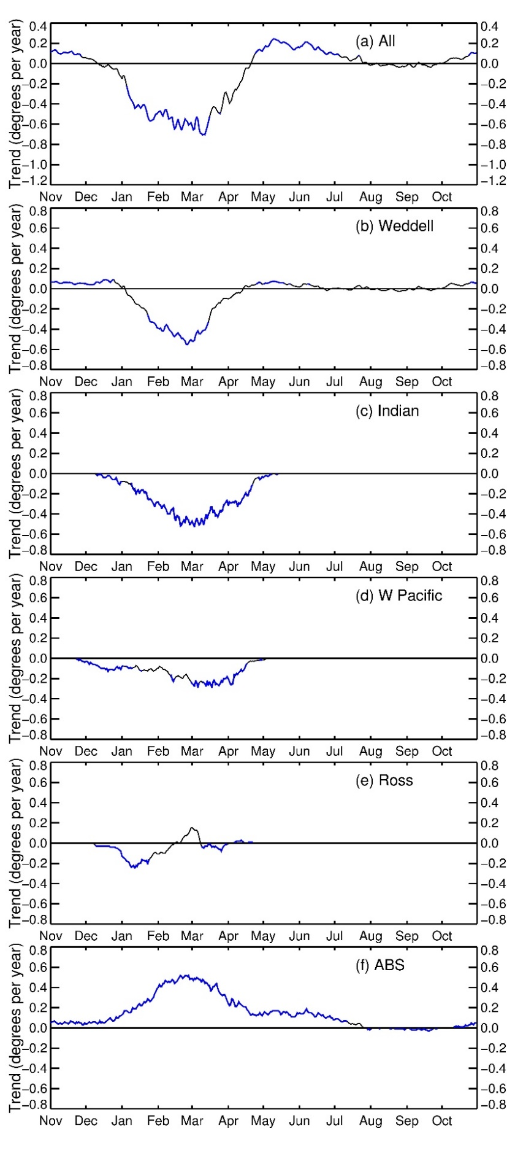
Extended Data Fig. 5 Plots of the trends (1979-2020) in CEI for each day (degrees year⁻¹). (a) Total Antarctic coastline, (b) Weddell Sea, (c) Indian Ocean, (d) W Pacific Ocean, (e) Ross Sea, and (f) ABS. Statistically-significant values (>95% confidence) are highlighted in blue.
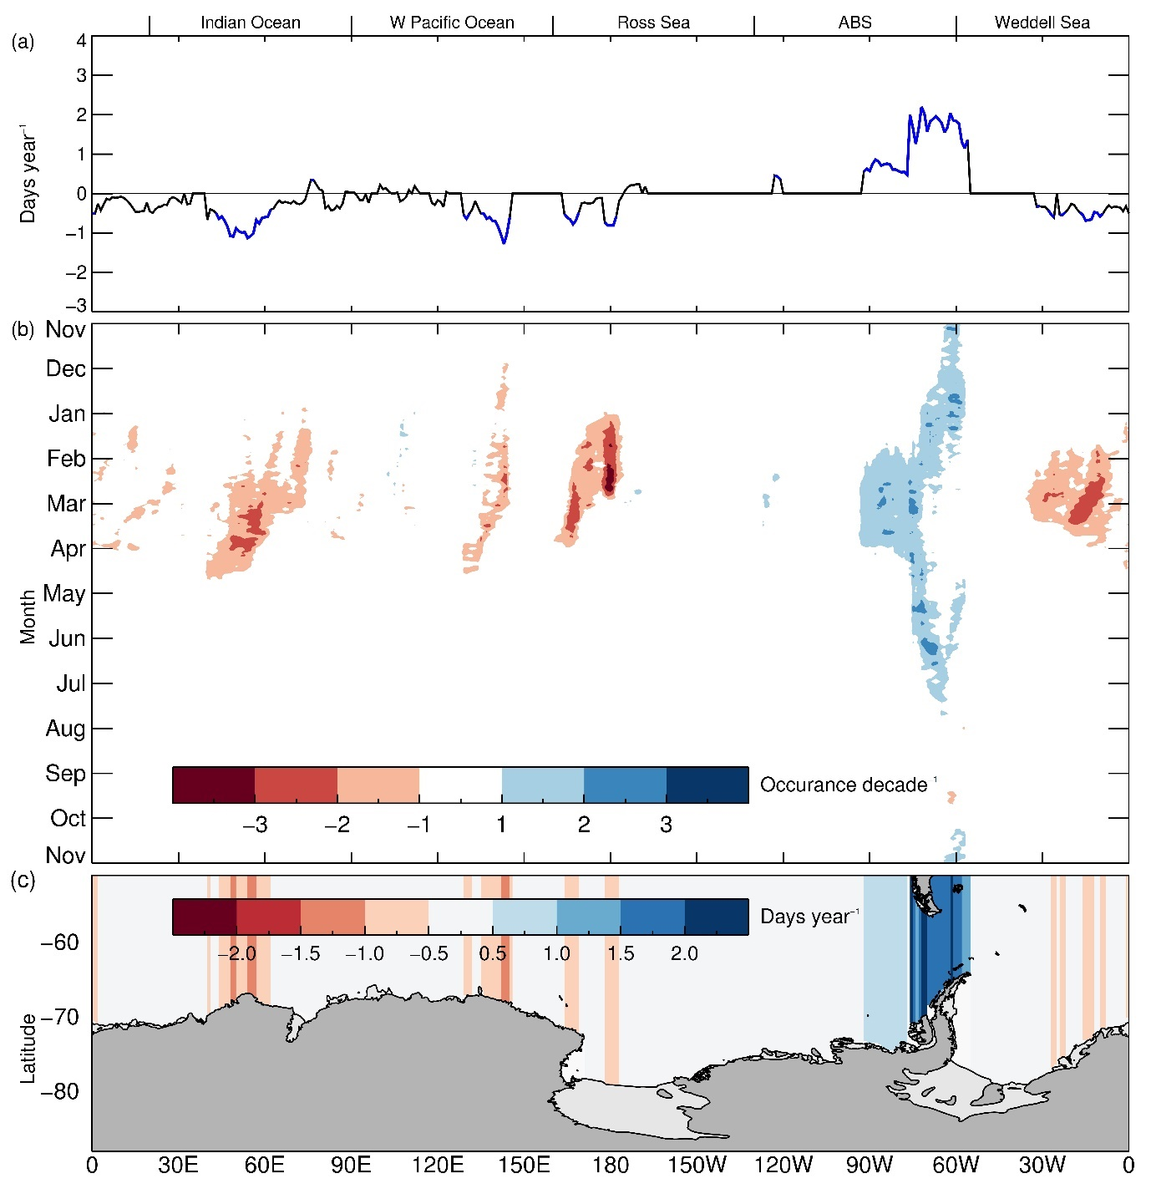
Extended Data Fig. 6 Trends (1979-2020) of annual coastal exposure index for CEI. (a) Each longitude (days year⁻¹); (b) each longitude and day (occurrence per decade); and (c) each grid point (days year⁻¹). Statistically-significant values (>95% confidence) for (a) are in blue. Only statistically-significant values (>95% confidence) are plotted on (b) and (c). For (c), grid points with higher magnitude of trends are plotted over those with lower magnitude.
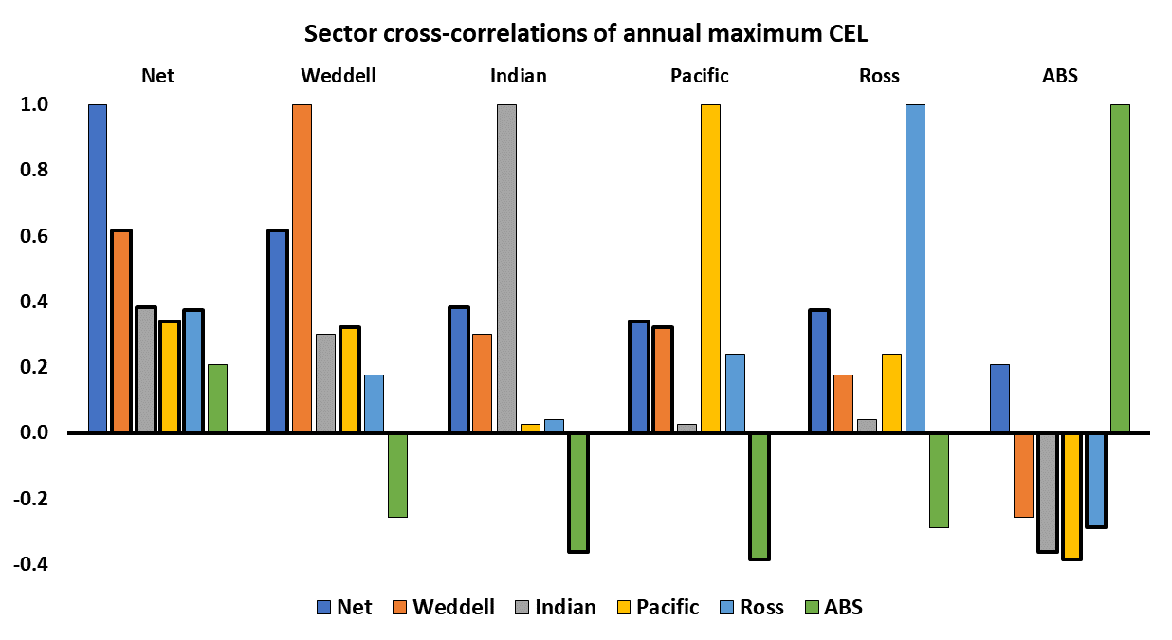
Extended Data Fig. 7 Sector cross-correlations of annual maximum CEL. Statistically-significant values (>95% confidence) are shown as bold.
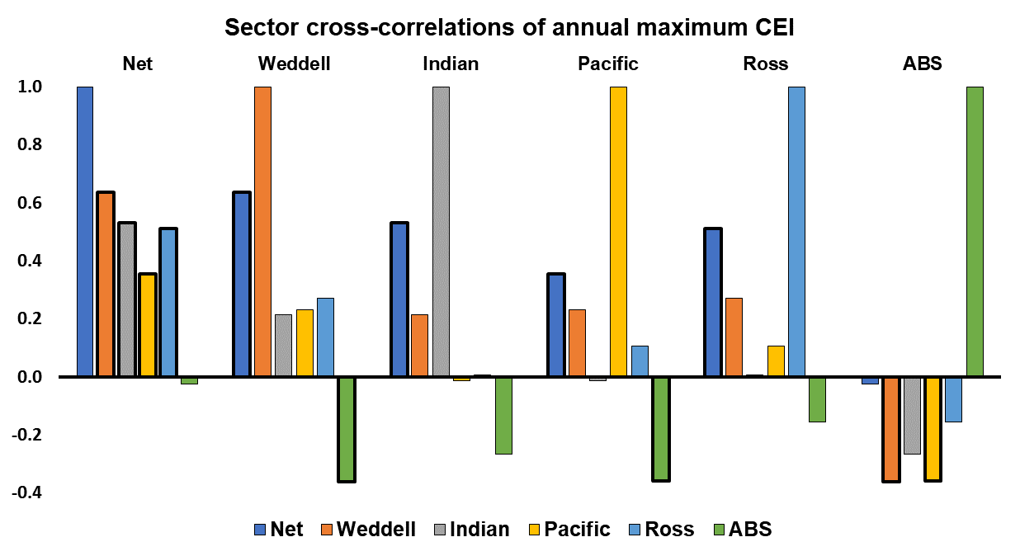
Extended Data Fig. 8 Sector cross-correlations of annual maximum CEI. Statistically-significant values (>95% confidence) are shown as bold.

 | Total length of coastline (kms) | Date of average maximum exposure (day of year) | Length of average maximum exposure (kms) | Length of average maximum exposure as percentage of length of coastline (%) | Length (km) and date of highest maximum exposure | Length (km) and date of lowest maximum exposure | Trend (km year⁻¹) in annual maximum exposure
Total | 17,850 | 23 Feb | 8,950 | 50 | 11,180 (3/3/1993) | 6,850  (28/2/2019) | -30
Weddell | 3,750 | 16-20 Feb | 2,130 | 57 | 3,100 (28/2/1993) | 1,030  (9/2/2014) | -22
Indian | 3,300 | 29 Feb | 1,920 | 58 | 3,180  (3/3/1987) | 570  (several) | -22
Pacific | 3,350 | 29 Feb | 1,670 | 50 | 2,940  (several) | 590  (several) | -18
Ross | 2,600 | 12-18 Feb | 1,520 | 58 | 2,340 (several) | 180  (several) | -6
ABS | 4,850 | 5 March | 2,190 | 45 | 4,610  (4/3/2010) | 890  (several) | +36
Extended Data Table 1 Statistics of coastal exposure length (CEL) for the period 1979-2020.

 | Length of coastline (degrees) | Date of average maximum exposure (day of year) | Length of average maximum exposure (degrees) | Length of average maximum exposure as percentage of length of coastline (%) | Length (degrees) and date of highest maximum exposure | Length (degrees) and date of lowest maximum exposure | Trend (degrees  year⁻¹) in annual maximum exposure
Total | 360 | 24 Feb | 120 | 33 | 175 (24/2/2017) | 73 (several) | -0.67
Weddell | 80 | 18-20 Feb | 35 | 44 | 60 (8/3/1989) | 7 (20/2/2014) | -0.48
Indian | 70 | 24-25 Feb | 31 | 49 | 61 (4/3/1988) | 10 (several) | -0.48
Pacific | 70 | 21 Feb | 24 | 34 | 47 (5/3/1986) | 2 (several) | -0.29
Ross | 70 | 13-24 Feb | 16 | 21 | 55 (24/2/2017) | 0 (several) | -0.01
ABS | 70 | 25 Feb - 15 March | 21 | 30 | 56 (18/3/2010) | 7 (15/4/1979) | +0.53
Extended Data Table 2 Statistics of coastal exposure index (CEI) for the period 1979-2020.

 | Net | Weddell | Indian | Pacific | Ross | ABS
Net | 1.00 | 0.62 | 0.38 | 0.34 | 0.37 | 0.21
Weddell | 0.62 | 1.00 | 0.30 | 0.32 | 0.18 | -0.26
Indian | 0.38 | 0.30 | 1.00 | 0.03 | 0.04 | -0.36
Pacific | 0.34 | 0.32 | 0.03 | 1.00 | 0.24 | -0.39
Ross | 0.37 | 0.18 | 0.04 | 0.24 | 1.00 | -0.29
ABS | 0.21 | -0.26 | -0.36 | -0.39 | -0.29 | 1.00
Extended Data Table 3 Sector cross-correlations of annual maximum CEL for 1979-2020. Bold figures are those correlations with 95% confidence.
 | Net | Weddell | Indian | Pacific | Ross | ABS
Net | 1.00 | 0.64 | 0.53 | 0.36 | 0.51 | -0.03
Weddell | 0.64 | 1.00 | 0.22 | 0.23 | 0.27 | -0.36
Indian | 0.53 | 0.22 | 1.00 | -0.01 | 0.01 | -0.27
Pacific | 0.36 | 0.23 | -0.01 | 1.00 | 0.11 | -0.36
Ross | 0.51 | 0.27 | 0.01 | 0.11 | 1.00 | -0.16
ABS | -0.03 | -0.36 | -0.27 | -0.36 | -0.16 | 1.00
Extended Data Table 4 Sector cross-correlations of annual maximum CEI for 1979-2020. Bold figures are those correlations with 95% confidence.

1. Cavalieri, D. J., Parkinson, C. L., Gloersen, P. & Zwally, H. J. Sea Ice Concentrations from Nimbus-7 SMMR and DMSP SSM/I-SSMIS Passive Microwave Data, Version 1. Boulder, Colorado USA. NASA National Snow and Ice Data Center Distributed Active Archive Center (1996). doi:https://doi.org/10.5067/8GQ8LZQVL0VL
2. Zwally, H. et al. Antarctic Sea Ice, 1973-1976: Satellite Passive-Microwave Observations. NASA SP459. NASA Special Publication (1983).
3. Bindschadler, R. et al. Getting around Antarctica: new high-resolution mappings of the grounded and freely-floating boundaries of the Antarctic ice sheet created for the International Polar Year. Cryosph. 5, 569–588 (2011).
4. Barber, D. G. & Massom, R. A. Chapter 1 The Role of Sea Ice in Arctic and Antarctic Polynyas. in Polynyas: Windows to the World (eds. Smith, W. O. & Barber, D. G. B. T.-E. O. S.) 74, 1–54 (Elsevier, 2007).
5. Massom, R. A. et al. An anomalous late-season change in the regional sea ice regime in the vicinity of the Mertz Glacier Polynya, East Antarctica. J. Geophys. Res. Ocean. 108, (2003).
6. Fraser, A. et al. High-resolution mapping of circum-Antarctic landfast sea ice distribution, 2000–2018. Earth Syst. Sci. Data Discuss. 15, 1–18 (2020).
7. Massom, R. A. et al. Fast ice distribution in Adélie Land, East Antarctica: interannual variability and implications for emperor penguins Aptenodytes forsteri. Mar. Ecol. Prog. Ser. 374, 243–257 (2009).
8. Langhorne, P. J., Squire, V. A., Fox, C. & Haskell, T. G. Lifetime estimation for a land-fast ice sheet subjected to ocean swell. Ann. Glaciol. 33, 333–338 (2001).
9. Massom, R. A. et al. Antarctic ice shelf disintegration triggered by sea ice loss and ocean swell. Nature 558, 383–389 (2018).

