Supporting Information

Bio-Based Impact-Resistant Materials: Luffa Sponge as a Sustainable Solution

Yuanzheng Lin ¹; Chaobin Yang ¹; Zhiyang Pei ¹; Hengyue Xu ²; Yu Zhang ¹; Jiaxing Ma ³; Neven Ukrainczyk ⁴; Y.X. Zhang ⁵; Eduardus Koenders ⁴; Wenjie Xie ⁶; Anke Weidenkaff ⁶; Zhouhong Zong^{1*}; Jingming Cai^{1,4*}

The processing of luffa sponge.
The luffa sponge presented in this study involves several processing steps, as shown in Fig. S1. The luffa sponge is sourced from Hunan, China. Initially, mature luffa gourds are harvested at peak ripeness and subjected to natural sun-drying for several days under warm, dry conditions to ensure optimal fiber preservation. Subsequently, the outer epidermal layer is carefully removed to reveal the internal fibrous matrix. The exposed fibers are then thoroughly washed to eliminate residual seeds and impurities, employing a mild alkaline solution to enhance the cleaning efficacy and ensure uniformity of the fibers. Bleaching is not performed to maintain the natural properties of the fibers. Post-cleaning, the luffa sponge is subjected to a secondary drying phase, which involves either natural sun-drying or mechanical drying, to inhibit microbial growth and prevent mold formation. Finally, the luffa sponge is cut into cylindrical sections of a specific height for practical use.
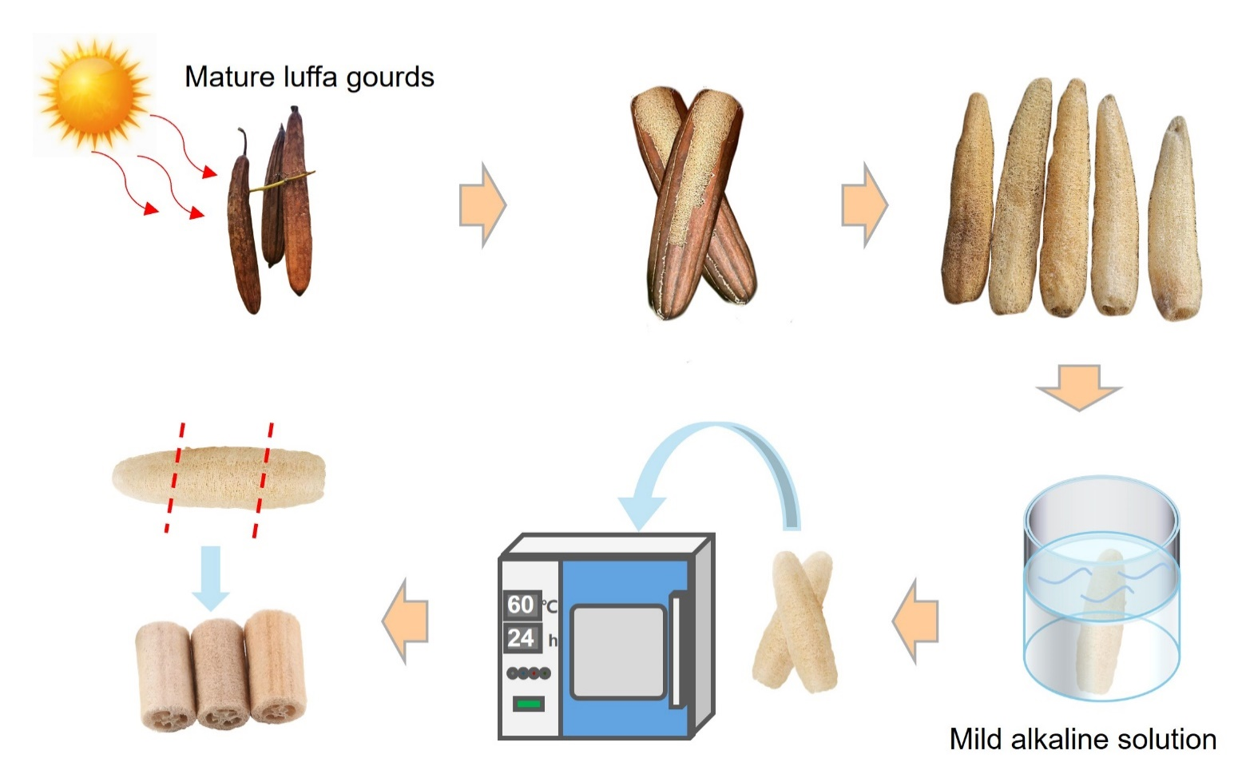
Fig. S1. Processing procedure of luffa sponge.
Preparation and characterization of LSRCC specimens.
Table S1 presents the basic information of the LSRCC specimens, including the diameter, mass, and normal density of the luffa sponges, as well as the mass and fiber ratio of the LSRCC specimens. The processed luffa sponges are cylindrical, and after cutting, all luffa sponges have the same height of 35 mm. Since luffa grows naturally, the cross-sectional dimensions vary, and the selected specimen diameters range from 45 to 62 mm. The mass of the processed luffa sponges ranges from 2.4 to 4.4 g, resulting in a calculated nominal density of 31 to 52 kg/m³. The LSRCC specimens are cylindrical, with a diameter of 75 mm and a height of 35 mm. After casting and curing the LSRCC specimens, the mass of each specimen was measured, and the weight ratio of the luffa sponge in the LSRCC specimens was found to be approximately 0.74% to 1.41%. Fig. S2 illustrates the physical characteristics of the processed luffa sponge specimens and their distribution.
Table S1. The physical characteristics of the luffa sponge used in the present study.
Specimen number | Diameter (mm) | Luffa sponge mass (g) | Norminal density (kg/m³) | LSRCC mass (g) | Fiber ratio (wt. %)
1 | 48.60 | 3.2 | 49.29 | 320.0 | 1.000
2 | 47.91 | 2.9 | 45.97 | 330.0 | 0.879
3 | 49.00 | 3.4 | 51.52 | 331.7 | 1.025
4 | 50.88 | 3.0 | 42.15 | 327.1 | 0.917
5 | 51.55 | 3.6 | 49.29 | 322.8 | 1.115
6 | 52.13 | 3.1 | 41.49 | 327.7 | 0.946
7 | 53.55 | 3.8 | 48.21 | 309.7 | 1.227
8 | 54.17 | 4.1 | 50.83 | 308.7 | 1.328
9 | 49.42 | 3.4 | 50.65 | 318.1 | 1.069
10 | 50.20 | 3.0 | 43.30 | 317.0 | 0.946
11 | 54.47 | 3.7 | 45.36 | 315.7 | 1.172
12 | 52.72 | 3.0 | 39.26 | 327.2 | 0.917
13 | 45.66 | 2.8 | 48.86 | 330.0 | 0.848
14 | 55.79 | 4.1 | 47.92 | 326.0 | 1.258
15 | 54.12 | 3.8 | 47.20 | 322.5 | 1.178
16 | 58.11 | 3.6 | 38.79 | 322.3 | 1.117
17 | 53.01 | 2.4 | 31.07 | 325.0 | 0.738
18 | 58.62 | 4.2 | 44.46 | 318.0 | 1.321
19 | 46.31 | 2.5 | 42.41 | 325.9 | 0.767
20 | 55.91 | 3.6 | 41.90 | 325.9 | 1.105
21 | 56.24 | 3.8 | 43.71 | 321.5 | 1.182
22 | 59.23 | 3.0 | 31.11 | 319.7 | 0.938
23 | 54.89 | 2.6 | 31.39 | 323.4 | 0.804
24 | 59.97 | 3.5 | 35.40 | 323.2 | 1.083
25 | 61.48 | 3.5 | 33.69 | 324.6 | 1.078
26 | 60.98 | 3.7 | 36.19 | 320.9 | 1.153
27 | 59.16 | 4.0 | 41.57 | 320.0 | 1.250
28 | 58.36 | 3.6 | 38.88 | 314.2 | 1.158
29 | 59.63 | 3.9 | 40.51 | 305.1 | 1.298
30 | 53.75 | 2.8 | 35.38 | 317.9 | 0.884
31 | 59.25 | 3.6 | 37.31 | 311.4 | 1.156
32 | 57.23 | 3.8 | 42.23 | 322.9 | 1.177
33 | 58.89 | 4.4 | 46.18 | 311.1 | 1.414
34 | 58.36 | 3.6 | 38.90 | 314.2 | 1.158
35 | 59.63 | 3.9 | 40.53 | 305.1 | 1.298
36 | 56.77 | 2.8 | 31.85 | 319.1 | 0.884
37 | 54.75 | 2.8 | 34.12 | 317.9 | 0.884
38 | 57.51 | 2.9 | 32.24 | 315.1 | 0.930
39 | 57.72 | 3.1 | 34.41 | 321.7 | 0.979
40 | 50.90 | 2.8 | 39.34 | 316.2 | 0.886
41 | 51.27 | 2.9 | 40.16 | 316.2 | 0.917
42 | 57.23 | 3.8 | 42.24 | 322.9 | 1.177
43 | 59.25 | 3.6 | 37.32 | 311.4 | 1.156
44 | 58.36 | 3.6 | 38.90 | 314.2 | 1.158
45 | 59.63 | 3.9 | 40.53 | 305.1 | 1.298
46 | 53.75 | 2.8 | 35.40 | 317.9 | 0.884
47 | 59.25 | 3.6 | 37.32 | 311.4 | 1.156

Fig. S2. Physical characteristics of the processed luffa sponge. a) Diameter of luffa sponge. b) Norminal density of luffa sponge. c) Fiber mass ratio of LSRCC.

Setup of impact tests.
To investigate the impact behavior of LSRCC, a drop hammer testing apparatus (CEAST-9350, Instron Co., Ltd, United States) was employed to apply impact loads to LSRCC specimens at different energy levels. The total mass of the impact tup, including the holder and additional weights, was configured to be 10.8 kg. The target input energy levels were 300 J, 500 J, and 700 J, which would theoretically require free-fall heights of 2820 mm, 4701 mm, and 6581 mm, respectively. Given the height limitations of the testing machine, these energy levels were achieved using an auxiliary energy system, which imparted initial velocities to the tup holder via a spring-driven accelerator. This ensured that the resulting impact velocities upon contact with the specimens were consistent with the desired energy inputs.
Prior to testing, the LSRCC specimens were positioned on a stable foundation, and a flat-head tup insert with a diameter of 78 mm was employed to contact the specimen surfaces. A built-in sensor with a sampling rate of 4 MHz was used to automatically record the impact forces generated during testing. Following the impact event, key parameters such as velocity ($v_{t}$), displacement ($δ_{t}$), and absorbed energy ($E_{a}$) were determined using the following equations:
$$\begin{aligned}v_{t}=v_{0}+gt-\int_{0}^{t}{\frac{F\left(t\right)}{m}dt}\#( LISTNUM NumberDefault \end{aligned}$$
$$\begin{aligned}δ_{t}=δ_{0}+v_{0}t+\frac{gt^{2}}{2}-\iint_{0}^{t}{\frac{F\left(t\right)}{m}d^{2}t}\#( LISTNUM NumberDefault \end{aligned}$$
$$\begin{aligned}E_{a}=\frac{m\left[v_{0}^{2}-v^{2}\left(t\right)\right]}{2}+mgδ\left(t\right)\#( LISTNUM NumberDefault \end{aligned}$$
where $v_{0}$ and $δ_{0}$ are velocity and position during the initial stage, respectively. $g$ is the acceleration of gravity and $m$ is the total mass of the tup.

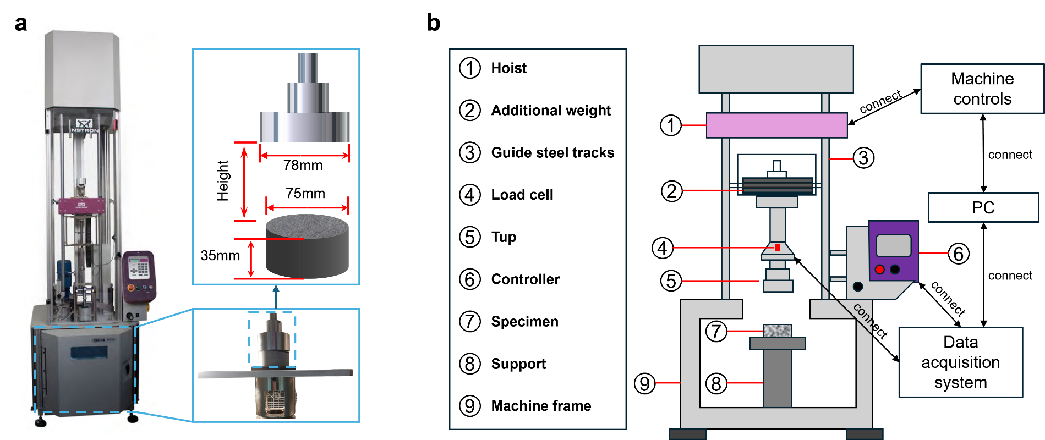
Fig. S3. Dropping hammer test machine: (a) test instrument and (b) schematic diagram.

Specimen preparation using FIB.
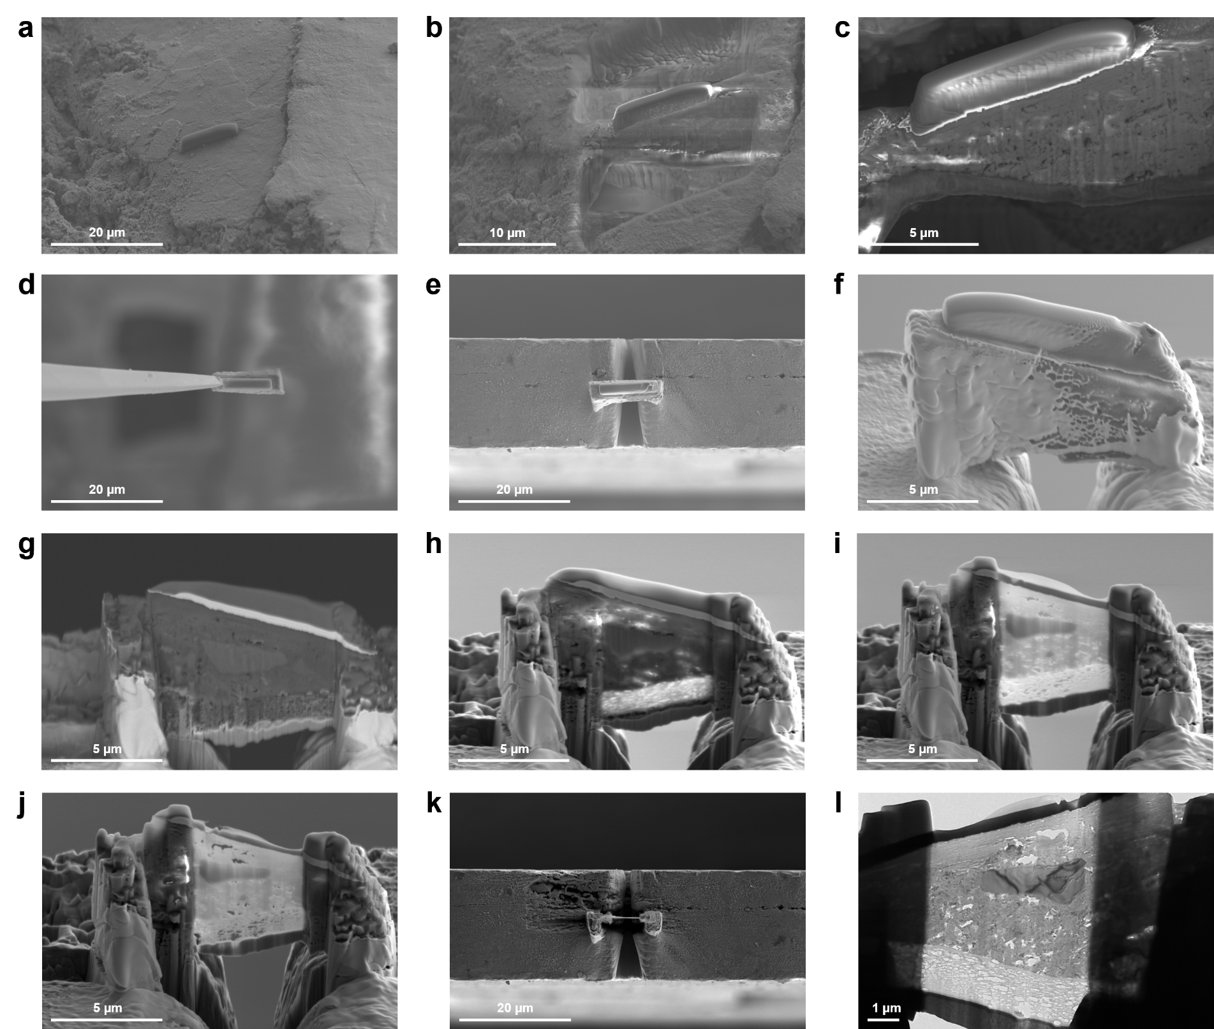
Fig. S4. Preparation of the interfacial transition zone (ITZ) specimen using the FIB technique. a) Select an ITZ of interest and coating with platinum as cover. b, c) Cut the matrix on both sides of the platinum cover slowly by focused-ion-beam (FIB), using Ga⁺ ion. d) Extract the slice beneath the platinum cover from the matrix. e) Transfer the extracted slice to a Cu support (top view). f) Side view of (e). g, h, i, j) Employ focused Ga+ ions to further thin the extracted slice until the thickness of the slice is approximately 100 nm. k) Top view of (j) indicating the thickness of the slice. l) The final obtained slice for transmission electron microscopy (TEM) analysis.

Video S1. LSRCC specimen under quasi-static compression.
Video S2. LSRCC specimen under 300 J repeated impacts with ambient condition.
Video S3. LSRCC specimen under 700 J repeated impacts with ambient condition.
Video S4. LSRCC specimen under 300 J repeated impacts at -196℃.
Video S5. LSRCC specimen under 700 J repeated impacts at -196℃.
Video S6. LSRCC specimen under 700 J repeated impacts at 200℃.

