Supplementary Information
Table S1 Overview of probiotic functions and safety of bacteria and yeast used for protective efficacy evaluation
Aspect | L. plantarum  TBRC-15420 | B. amyloliquefaciens TBRC-15434 | S. cerevisiae  TBRC-19857
Acid tolerance (pH3) | High (100.00%) | High (115.05%) | High (127.38%)
Bile tolerance | High (100.00%) | High (75.16%) | High (139.94%)
Auto-aggregation | High (69.74%) | High (65.99%) | High (90.09%)
Hydrophobicity | Strong (70.14%) | Moderate (34.13%) | High (59.21%)
Biofilm formation | Biofilm producer | Biofilm producer | ND
Adhesion to Caco-2 | Low (9.31%) | Low (2.0%) | Intermediate (43.18%)
Antibacterial activity* | Yes | Yes | No activity
Co-aggregation | EHEC (74.09%)  EPEC (60.83%)  ST (64.37%) | EHEC (40.96%)  EPEC (34.52%)  ST (34.76%) | EHEC (55.37%)  EPEC (57.91%)  ST (56.62%)
Hemolytic activity | γ-hemolytic | γ-hemolytic | γ-hemolytic
Antibiotic test | Sensitive** | Sensitive*** | ND
Enzyme production | ND | cellulase, xylanase, pectinase | xylanase, phytase
Signs of toxicity | No signs | No signs | No signs
Histopathological  analysis | No tissue damages  or abnormalities | No tissue damages  or abnormalities | No tissue damages  or abnormalities
Effect on gut microbiome | increase beneficial bacteria | enhanced beneficial bacteria and reduced harmful bacteria | enhanced beneficial bacteria and reduced harmful bacteria

ND = Not determined; * Inhibit EHEC, EPEC, and S. Typhimurium (ST); **Susceptible to ampicillin, chloramphenicol, gentamicin, and streptomycin; ***Susceptible to norfloxacin, ciprofloxacin, gentamicin, erythromycin, tetracycline, chloramphenicol, cephalothin, ampicillin, streptomycin, and vancomycin
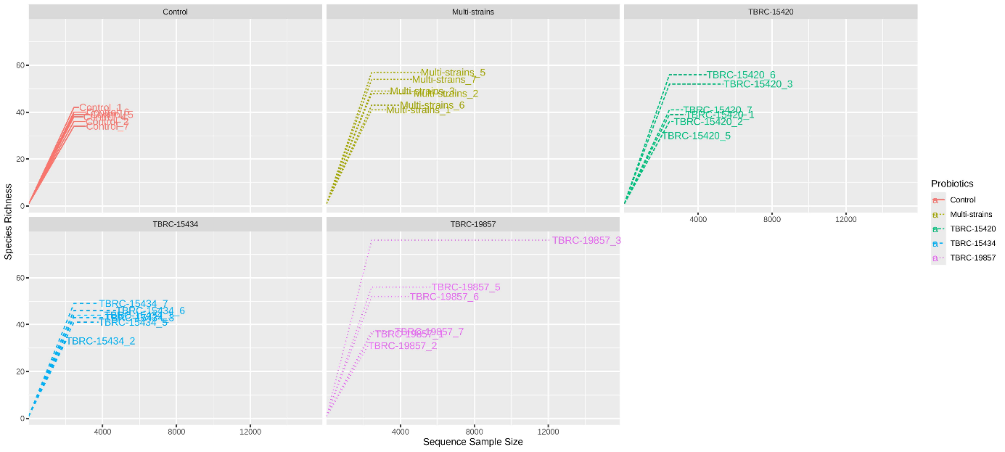
Fig. S1 Rarefaction curve of gut microbiome species richness in probiotic and control mice

