Supporting information

Iron and oxygen vacancies co-modulated adsorption evolution and lattice oxygen dual-path mechanism for enhanced ampere-level freshwater/seawater oxidation

Xiwen Tao¹, Li Hou ^{1, *}, Xinyi Wang¹, Jing Jin¹, Huana Li¹ and Faming Gao^{1, 2, *}
¹ Hebei Key Laboratory of Applied Chemistry, State Key Laboratory of Metastable Materials Science and Technology, Yanshan University, Qinhuangdao 066004, China
² College of Chemical Engineering and Materials Science, Tianjin University of Science and Technology, Tianjin 300457, China
* Corresponding authors.
E-mail address: holy@ysu.edu.cn; fmgao@ysu.edu.cn

Supplementary Notes
Preparation of Fe-Ni₂P
The treated NF was directly immersed in the 40 mL mixed solution containing 0.8 mmol Ni(NO₃)₂·6H₂O, 1.2 mmol C₆H₅Na₃O₇ and 0.5 mmol K₃Fe(CN)₆ to synthesize the NiFe PBA. The Fe-Ni₂P was obtained via the low-temperature phosphorization process under identical conditions.
Preparation of MoNi₄
The as-prepared NiMoO₄·xH₂O was heated at 400 °C for 2 h in a H₂/Ar (5:95) atmosphere, to synthesize the MoNi₄ catalyst for HER.
Preparation of Pt/C and RuO₂ benchmarked catalysts
20 mg commercial Pt/C or RuO₂ powder was dispersed in a 2 mL mixture solution composed of 1.45 mL absolute ethanol, 0.5 mL isopropanol, and 0.05 mL Nafion solution. The homogeneous ink was obtained under ultrasonication for 2 h, and dropped upon two clean NF, respectively. Then, the Pt/C and RuO₂ catalysts loading on NF were prepared after drying in a vacuum oven at 60 °C for 12 h.
Material characterizations
The crystalline phase of all catalysts was measured via powder XRD using a D/Max-2500/PC X-ray diffractometer with Cu Kα radiation (λ = 1.5418 Å) over an angle (2θ) range from 5 to 80 degree under the scanning rate of 5 °/min. Raman spectra were recorded on a Renishaw inVia laser Raman spectrometer with a laser excitation of 532 nm. XPS test was performed on the ESCALab MKII X-ray photoelectron spectrometer equipped with Al Kα X-ray radiation as the excitation source. The morphology and microstructure of the samples were characterized via Field-emission Scanning Electron Microscopy (FESEM, Zeiss SUPRA 55), Transmission Electron Microscopy (TEM, Hitachi-7700), High-Resolution Transmission Electron Microscopy (HRTEM, FEI TALOS F200) combined with High-angle annular darkfield-scanning transmission electron microscopy (HAADF-STEM) and energy-dispersive X-ray spectroscopy (EDS).
Electrochemical measurements
Unless specified, all electrochemical measurements were performed on the Corrtest CS310MA electrochemical workstation (Wuhan Corrtest Instruments Corp., Ltd) at room temperature, constructing a three-electrode system in 1 M KOH, 1 M KOH + 0.5 M NaCl (simulated alkaline seawater), and 1 M KOH + seawater (alkaline seawater) electrolyte. The as-prepared catalysts were directly applied as the working electrode with 1 × 1 cm² immersing area in the electrolyte. A standard Hg/HgO electrode and a graphite rod (purity: 99%) were used as the reference electrode and the counter electrode, respectively. Linear sweep voltammetry (LSV) was operated under a scanning rate of 5 mV s⁻¹. All the potentials in LSV were iR-compensated (compensation level: 90%), and the resistance (R_{s}) for iR-compensation was tested at the open circuit potential (OCP). The in-situ electrochemical impedance spectroscopy (EIS) was operated from 100 kHz to 0.01 Hz at a serious voltage with a small amplitude (30 mV). The durability tests were performed by chronopotentiometry (CP) at the current density of 1.0 A cm⁻². Cyclic voltammetry (CV) was operated at the potential range of 0.30 to 0.40 V vs. Hg/HgO with a series scanning rate of 20, 40, 60, 80, and 100 mV s⁻¹. The electric double-layer capacitance (C_{dl}) was calculated by the current density difference (Δj/2) in the center of the potential range under different scanning rates. ECSA was established by the following equation:
$$\begin{aligned}ECSA={C_{dl}}/{C_{s}}×A\#\left(1\right)\end{aligned}$$
Where the specific capacity $C_{s}$ is 0.04 mF cm⁻² in 1 M KOH electrolyte, and $A$ is the geometric area of working electrode soaking in the electrolyte (1 × 1 cm²).
All measured potentials vs. Hg/HgO were converted to reversible hydrogen electrode (RHE) by the Nernst equation in addition to special note:
$$\begin{aligned}E \left(V vs. RHE\right)=E \left(V vs.{Hg}/{HgO}\right)+0.098+0.0592×pH\#\left(2\right)\end{aligned}$$
Overall water splitting (OWS) measurements were tested under a two-electrode system. The as-synthesized Fe-Ni₂P/NiMoO₄ was used as the anode for OER, while the MoNi₄ served as the cathode for HER. For the performance comparison, the as-prepared commercial Pt/C and RuO₂ catalysts were employed as cathodes for HER and anode for OER, respectively. LSV curves of OWS were measured in 1 M KOH, 1 M KOH + 0.5 M NaCl, and 1 M KOH + seawater electrolyte at a sweeping rate of 5 mV s⁻¹ with 90% IR compensation. The durability of the catalyst was tested via chronopotentiometry (CP) at a constant current density of 1.0 A cm⁻².
In-situ Raman measurements
The in-situ Raman spectra were collected by a Renishaw inVia laser Raman spectrometer with a laser excitation of 532 nm. The as-prepared catalysts were used as the work electrodes, with an Ag/AgCl and a graphite rod as the reference and counter electrodes, respectively. The N₂-saturated 0.1 M KOH was employed as the electrolyte to slow down the gas bubble production under OER potentials. The Raman spectra were obtained on the multi-potential steps test, which was conducted on CHI 760E electrochemical workstation (Shanghai Chenhua Instrument Co., Ltd), with the potential windows from 1.20 to 1.50 V vs. RHE.
In-situ ATR-SEIRAS measurements
The surface-enhanced infrared absorption spectroscopy (SEIRAS) with attenuated total reflection (ATR) was employed to detect the intermediates of the OER process. The electrochemical ATR-SEIRAS measurements were used on the Thermo Nicolet 8700 spectrometer equipped with the mercury-cadmium-telluride detector cooled by liquid nitrogen. Utilizing the two-step wet chemical method, Au thin film (~60 nm) was deposited on the surface of the Si prism for IR reflection enhancement. Before the chemical deposition of Au, the Si prism was polished with Al₂O₃ and SiO₂ suspension, respectively, and cleaned in DI water with ultrasonication. Then the Si prism was immersed in a mixed solution of 98% H₂SO₄ and 30% H₂O₂ (volumetric ratio = 7:3) for 30 min. After rinsing off the residual acid solution with DI water, the Si prism was soaked in the quartz crucible containing 40% NH₄F aqueous solution and Au plating bath for 3 min, respectively, to prepare Au film on the IR reflection surface. 10 mg catalyst powder was dispersed in the 1 mL mixture solution comprised of 975 μL DI water and isopropanol (volumetric ratio = 1:1), and 25 μL Nafion solution under ultrasonication for 2 h to obtain catalyst ink. 30 μL ink was dropped and dried on the Au-coated prism as the working electrode. The saturated Ag/AgCl electrode (reference electrode) and Pt foil (counter electrode, 1 × 1 cm²) were assembled into a spectroelectrochemical cell with the Au-film prism. The N₂-saturated 0.1 M KOH was employed as the electrolyte to slow down the gas bubble production under OER potentials. The electrochemical ATR-SEIRAS was obtained on the multi-potential steps test, which was conducted on CHI 760E electrochemical workstation (Shanghai Chenhua Instrument Co., Ltd), with the open circuit potential and potential windows from 1.20 to 1.50 V vs. RHE. The spectral resolution was 4 cm⁻¹ for all the measurements. The spectra were obtained via the built-in processing program by equation:
$$\begin{aligned}A=-\log\left({R_{Es}}/{R_{ER}}\right)\#\left(3\right)\end{aligned}$$
Where $A$ is absorbance, $R_{Es}$ is reflection under potentials range, and $R_{ER}$ is reflection at open circuit potential.
In-situ isotope-labelled DEMS measurements
Isotope-labeled DEMS measurements were performed on a QAS 100 device (Linglu Instruments, Shanghai). The H₂¹⁸O (¹⁸O abundance: 98%) was purchased from Beijing InnoChem Science & Technology Co., Ltd. The as-prepared catalysts were used as the work electrodes, with an Hg/HgO and a graphite rod as the reference and counter electrodes, respectively. Firstly, the samples were labelled with ¹⁸O-isotopes by the LSV activation for six times in the 0.2 - 0.8 V vs. Hg/HgO potential window in 1 M KOH solution with H₂¹⁸O (scan rate: 5 mV s⁻¹), while recording the DEMS signal. Subsequently, the ¹⁸O-isotope labelled samples were carefully rinsed with H₂¹⁶O several times to remove the residual H₂¹⁸O. Finally, LSV tests were performed for the labelled catalysts in 1 M KOH with H₂¹⁶O from 0.2 to 0.8 V vs. Hg/HgO, and the produced oxygen with different molecular weights during OER was detected in real time by mass spectroscopy.
AEMWE measurements
Anion exchange membrane (AEM) water electrolyzers with serpentine flow channel were used to test practical applications of Fe-Ni₂P/NiMoO₄ electrocatalyst. The AEM was purchased from the Anhui Mainz Experimental Equipment Co., Ltd. The as-synthesized Fe-Ni₂P/NiMoO₄ and MoNi₄ on NF were directly used as the anode and cathode, respectively. The AEMWE measurements were operated at 25 °C with a peristaltic pump pumping 1 M KOH at a flow rate of 30 mL·min⁻¹. The electrochemical measurements were conducted on the Corrtest CS310MA electrochemical workstation (Wuhan Corrtest Instruments Corp., Ltd).
DFT calculations
In Density Functional Theory (DFT) calculations, structural optimizations were performed under the scheme of generalized gradient approximation (GGA) using the Perdew-Burke-Ernzerhof (PBE) functional¹, as embedded in the Vienna Ab-initio Simulation Package (VASP)^{2,3}. The projector augmented-wave (PAW) method was employed to treat interactions between ion cores and valence electrons^{4,5}. The plane-wave cutoff energy was fixed to 450 eV. The Van der Waals interactions were considered by grime's DFT-D3 method^{6,7}. The self-consistent calculations applied a convergence energy threshold of 10⁻⁵ eV. The equilibrium geometries and lattice constants were optimized with maximum stress on each atom within 0.02 eV Å⁻¹. During the relaxation, the Brillouin zone with a 3 × 2 × 1 Gamma centered grid was used. Spin polarized calculations were performed for this calculation.
For each elementary step, the Gibbs reaction free energy ΔG is defined as the difference between free energies of the initial and final states and is given by the expression:
$ΔG=ΔE+ΔE_{ZPE}\text{ - T}ΔS$
where $ΔE$ is the reaction energy of reactant and product molecules adsorbed on catalyst surface, obtained from DFT calculations; $ΔE_{ZPE}$ and $ΔS$ are the change in zero point energies and entropy due to the reaction.

Supporting Figures

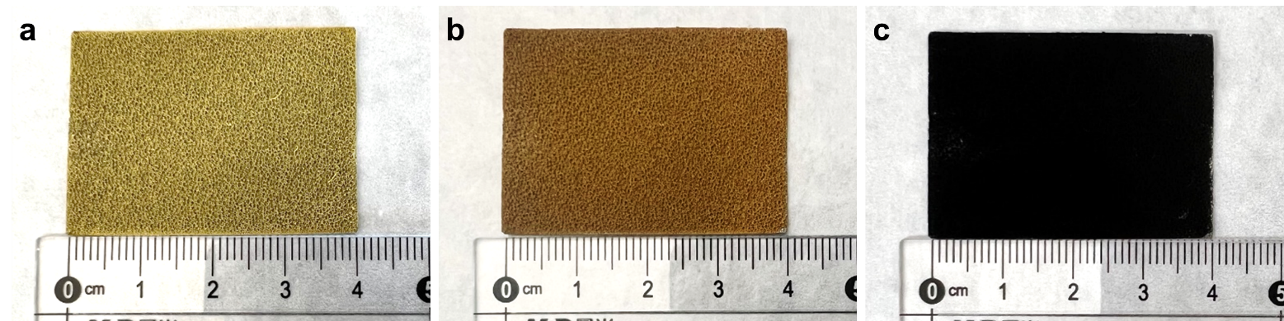
Supplementary Fig. 1. Digital photograph of as-prepared catalysts for a NiMoO₄·xH₂O, b PBA@NiMoO₄, and c Fe-Ni₂P/NiMoO₄ on nickel foams.

Supplementary Fig. 2. XRD pattern of NiMoO₄/NF and PBA@NiMoO₄/NF.

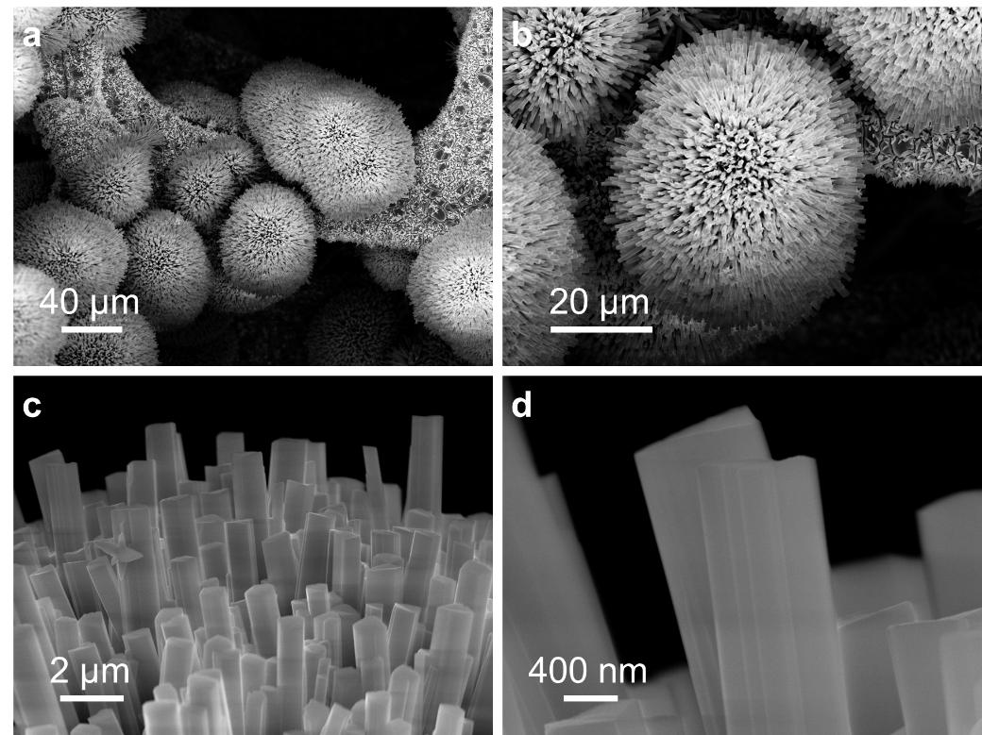
Supplementary Fig. 3. a-d FESEM images of NiMoO₄ at different magnifications.

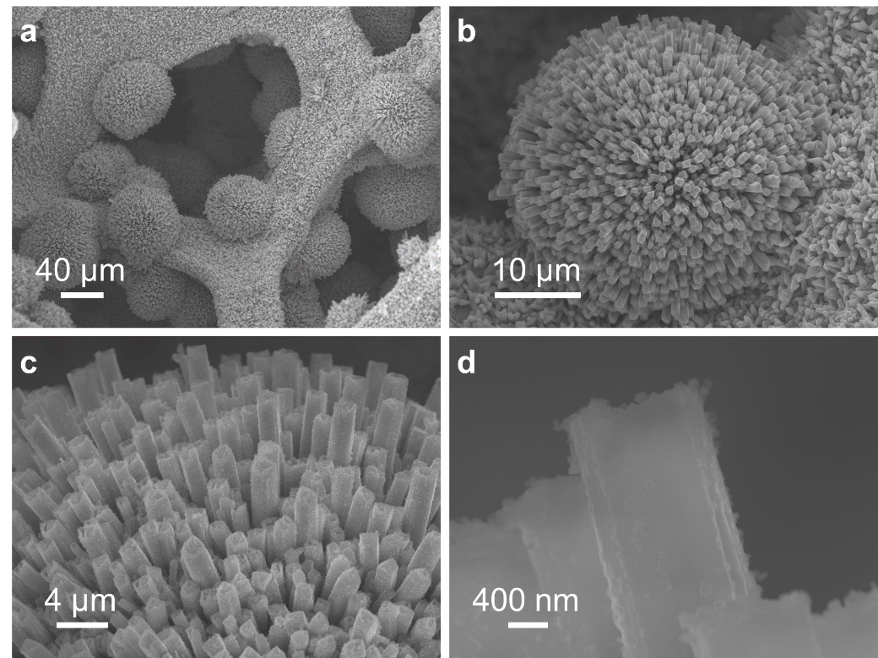
Supplementary Fig. 4. a-d FESEM images of PBA@NiMoO₄ at different magnifications.

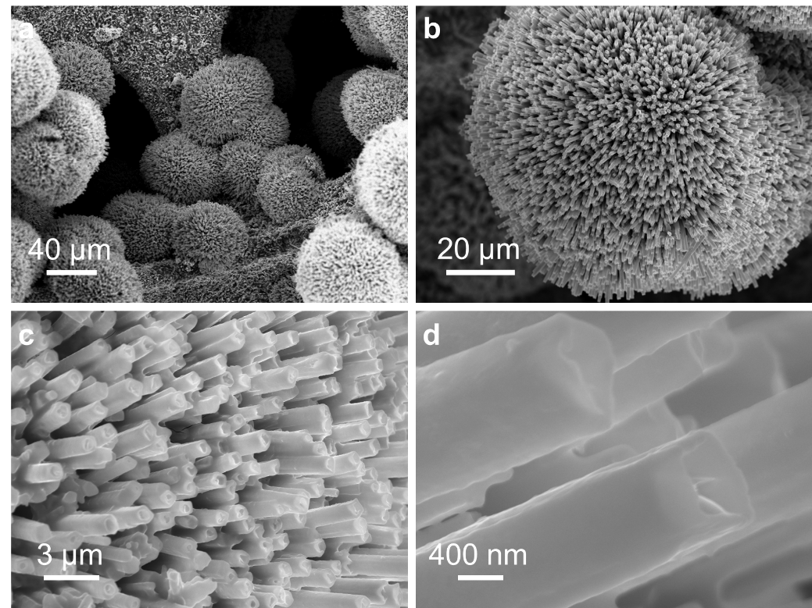
Supplementary Fig. 5. a-d FESEM images of Fe-Ni₂P/NiMoO₄ at different magnifications.

Supplementary Fig. 6. XRD pattern of 0-PBA@NiMoO₄, 1.2-PBA@NiMoO₄, and 2.4-PBA@NiMoO₄.

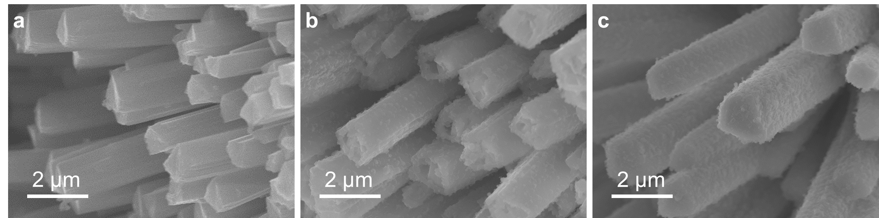
Supplementary Fig. 7. FESEM images of a 0-PBA@NiMoO₄, b 1.2-PBA@NiMoO₄, and c 2.4-PBA@NiMoO₄.

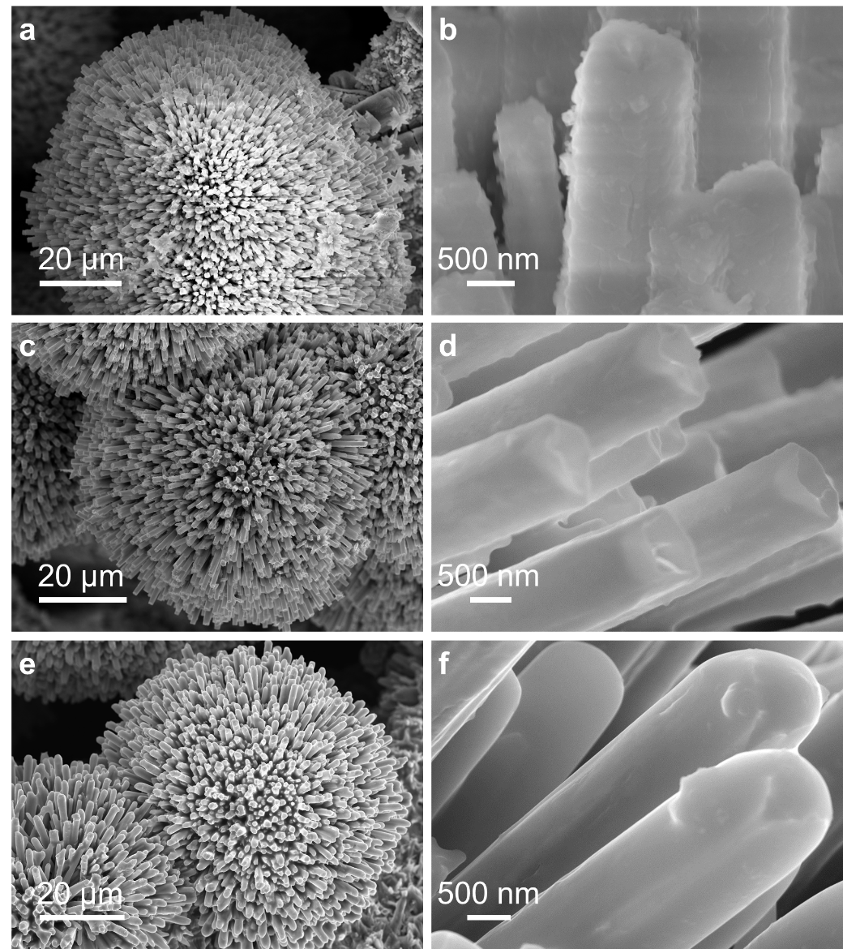
Supplementary Fig. 8. FESEM images of Fe-Ni₂P/NiMoO₄ with different phosphorus source usage for a, b 0.9 g, c, d 1.8 g, and e, f 2.7 g.

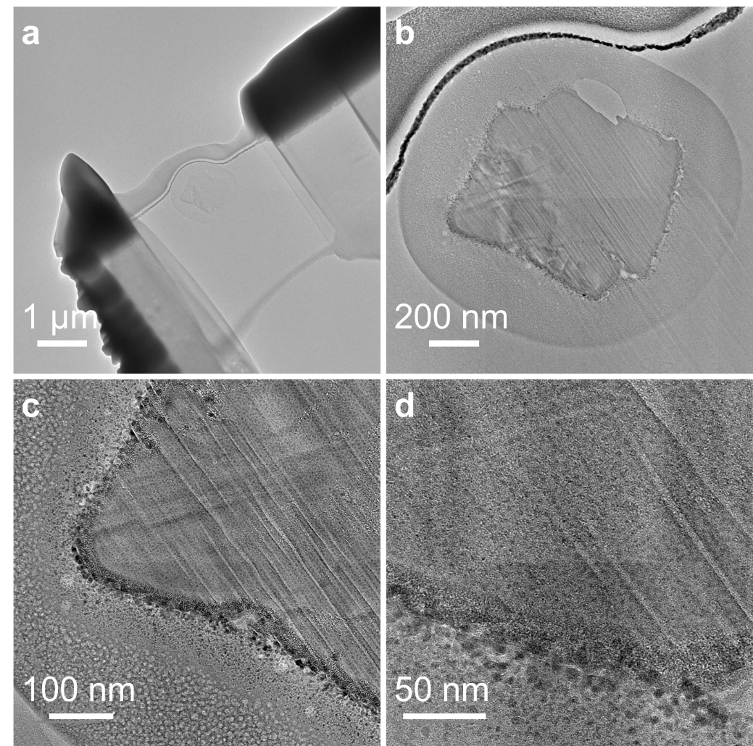
Supplementary Fig. 9. a-d The cross-sectional TEM images of Fe-Ni₂P/NiMoO₄ at different magnifications.

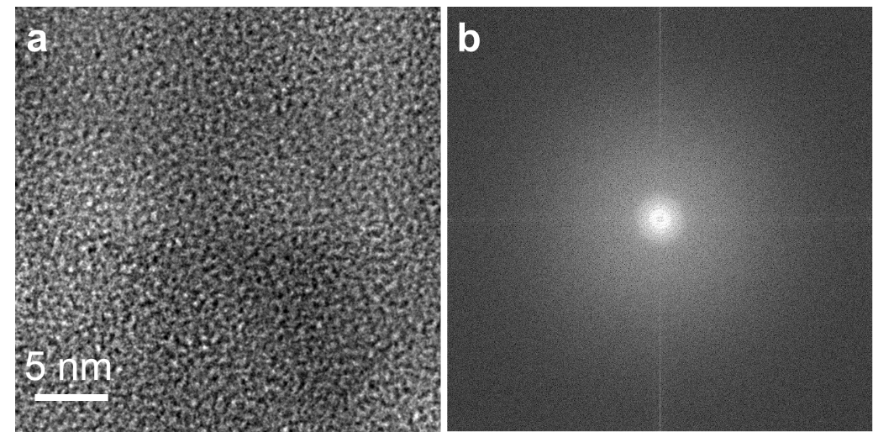
Supplementary Fig. 10. a HRTEM image, and b corresponding SAED pattern of the amorphous region for Fe-Ni₂P/NiMoO₄.

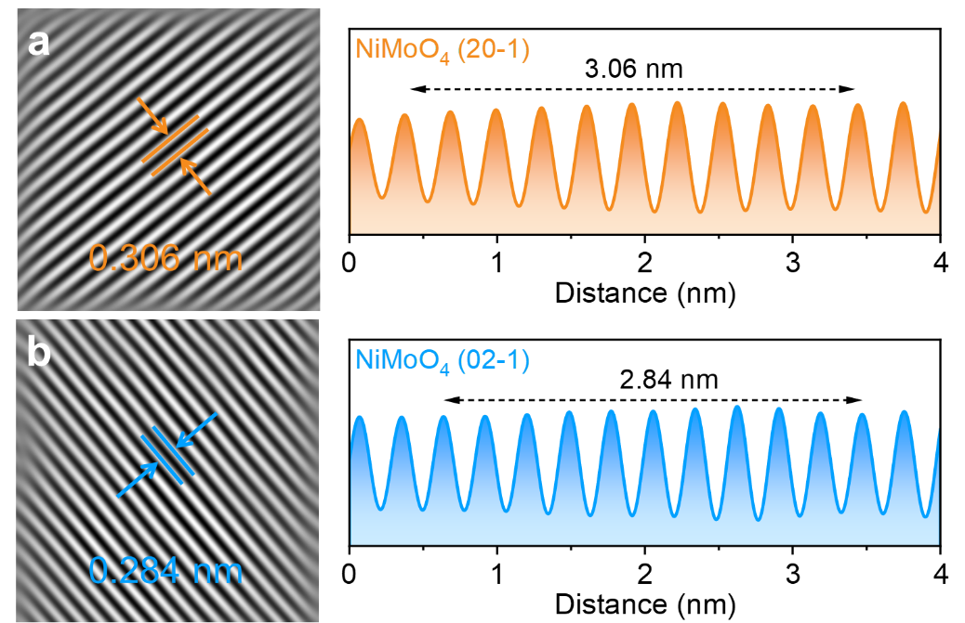
Supplementary Fig. 11. The two-dimensional lattice fringes obtained by inverse Fourier Transform and the corresponding intensity-distance images of a (20-1) facet, and b (02-1) facet.

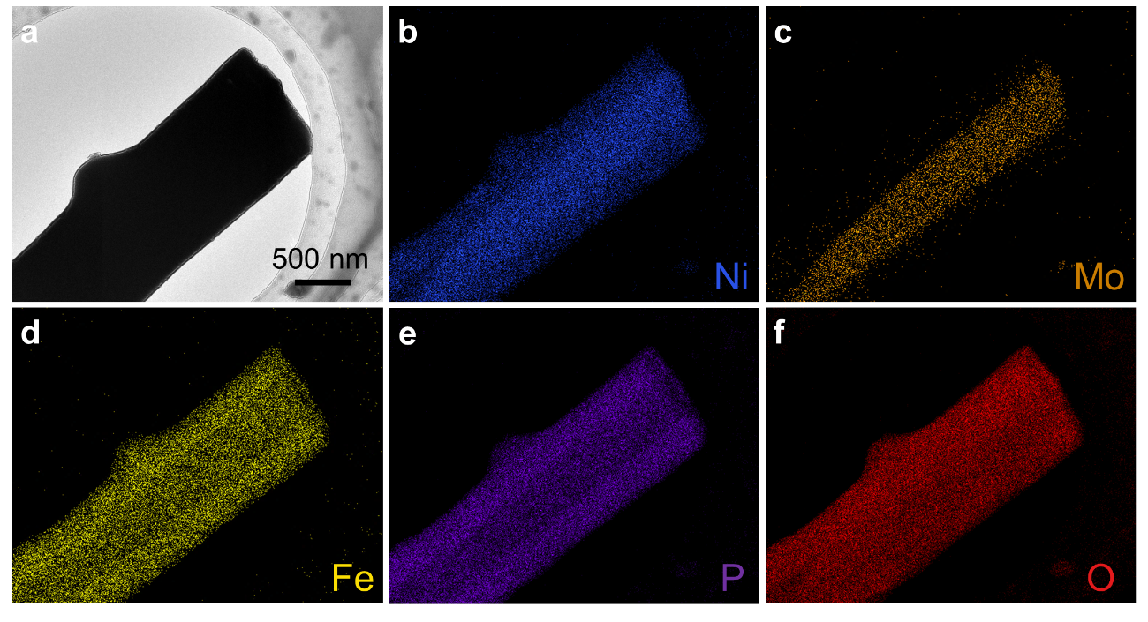
Supplementary Fig. 12. a HAADF-STEM image, and b-f corresponding EDS element mapping images of Fe-Ni₂P/NiMoO₄.

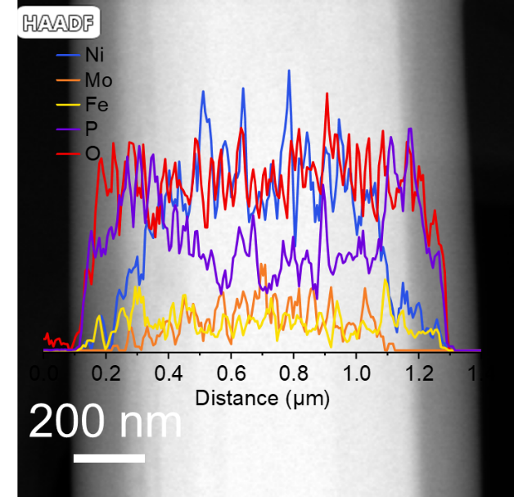
Supplementary Fig. 13. Line scan of Fe-Ni₂P/NiMoO₄.

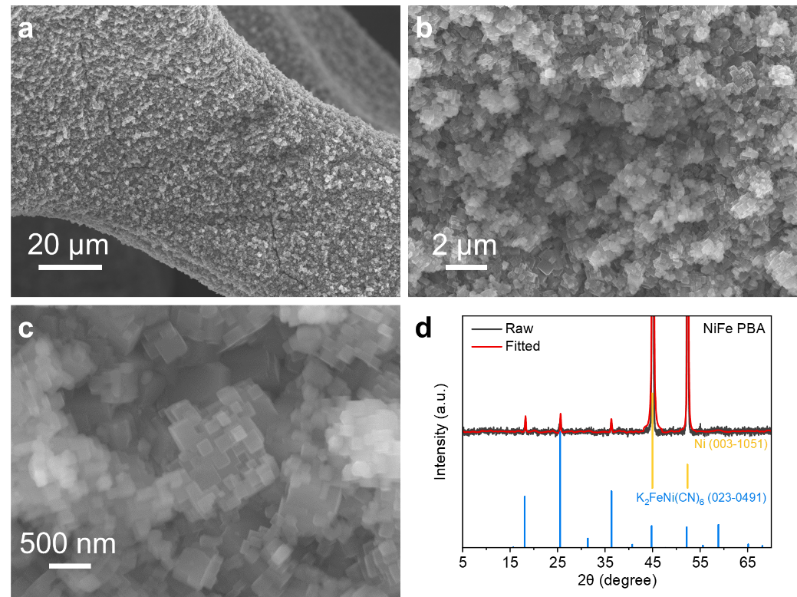
Supplementary Fig. 14. a-c FESEM images of NiFe PBA/NF at different magnifications. d XRD pattern of NiFe-PBA.

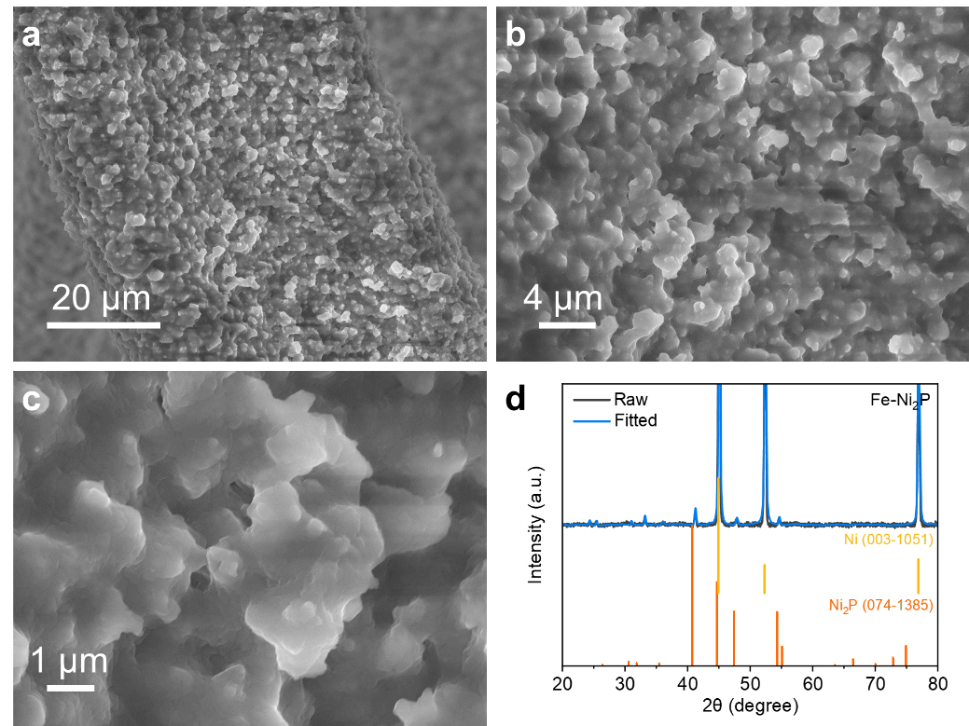
Supplementary Fig. 15. a-c FESEM images of Fe-Ni₂P/NF at different magnifications. d XRD pattern of Fe-Ni₂P.

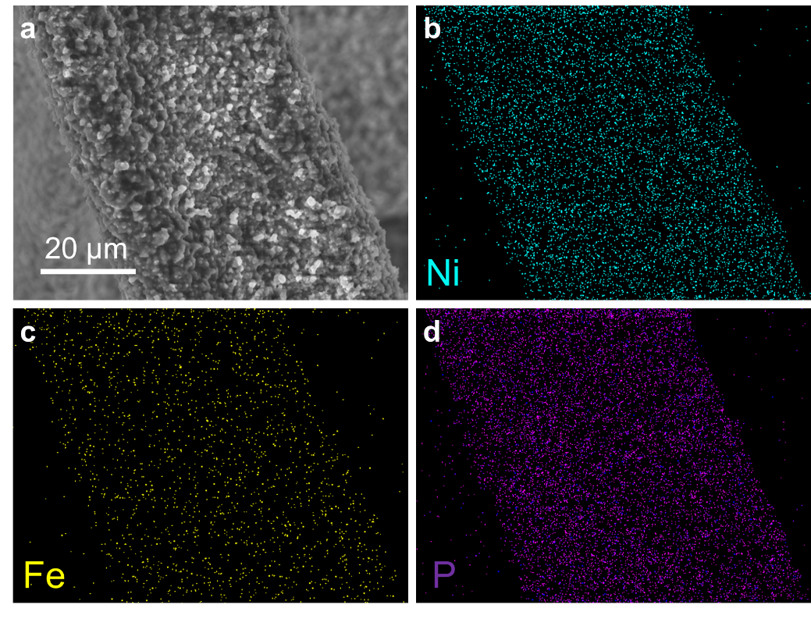
Supplementary Fig. 16. a SEM images, and b-d corresponding EDS element mapping images of Fe-Ni₂P.

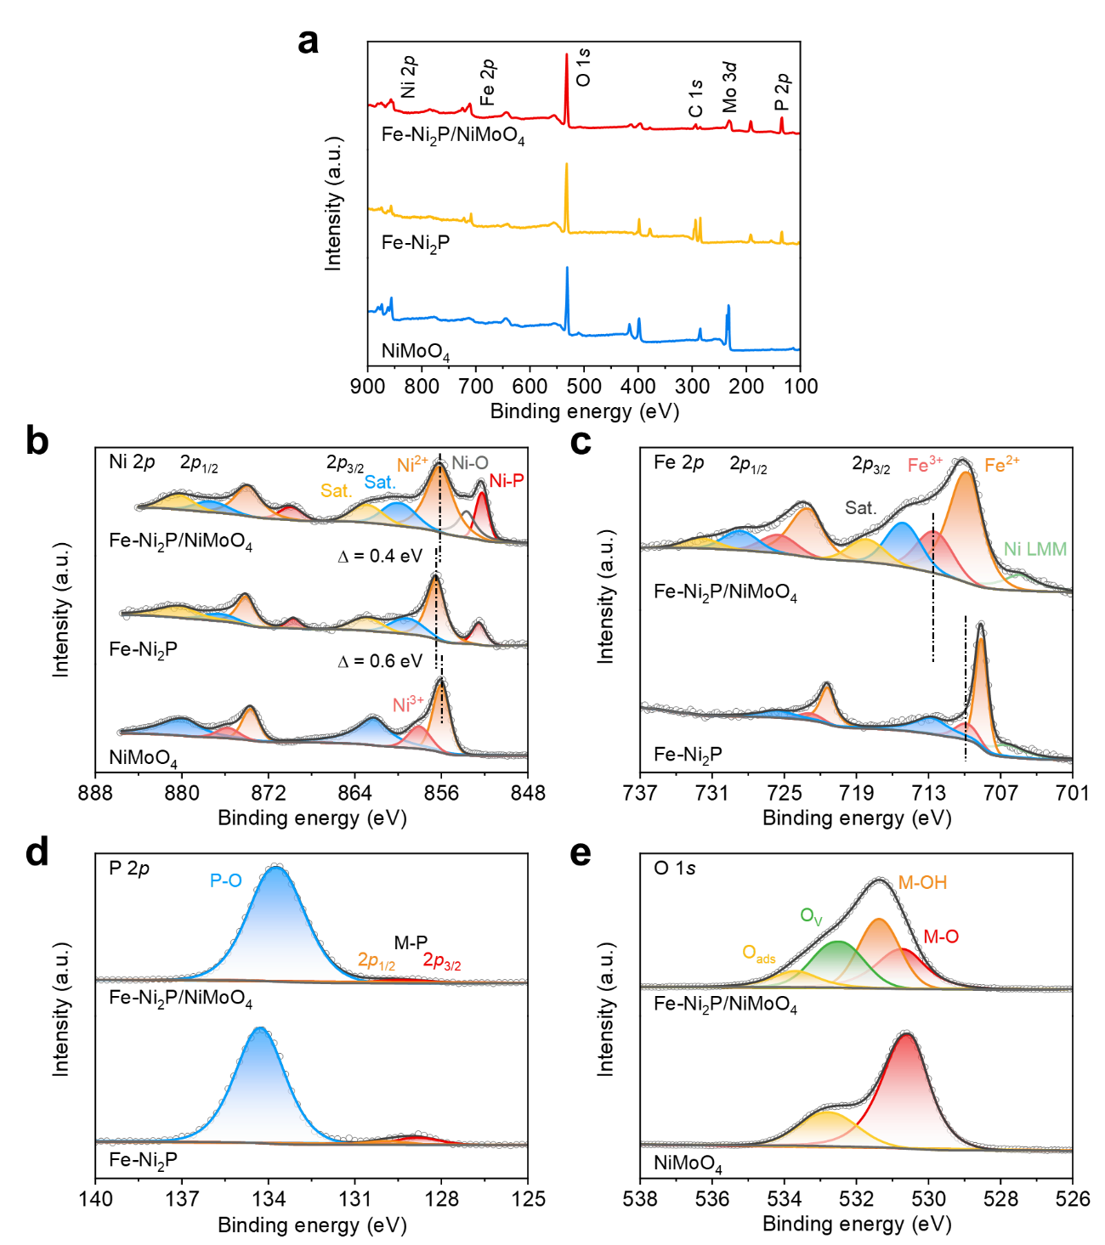
Supplementary Fig. 17. The high-resolution XPS spectra of a Survey pattern, b Ni 2p, c Fe 2p, d P 2p, and e O 1s for obtained samples.
As illustrated in Supplementary Fig. 17d, the P 2p spectrum of Fe-Ni₂P/NiMoO₄ and Fe-Ni₂P exhibits two peaks at 129.1 and 133.7 eV, which is corresponding to the Ni-P and P-O bonds, respectively, further confirming the formation of nickel phosphides. The high-resolution O 1s spectrum (Supplementary Fig. 17e) of Fe-Ni₂P/NiMoO₄ can be deconvoluted into four peaks located at 530.6, 531.4, 532.5, and 533.7 eV, which can be assigned to lattice oxygen (M-O), M-OH, oxygen vacancy (O_{V}), and adsorbed water (O_{ads}), respectively. In contrast, the O 1s spectrum of pristine NiMoO₄ displays only two peaks corresponding to M-O and O_{ads}. These observations indicate that the incorporation of Fe-Ni₂P into the composite introduces additional oxygen species, such as hydroxyl groups and oxygen vacancies, which may play a significant role in modulating the electronic structure and surface properties of the materials.

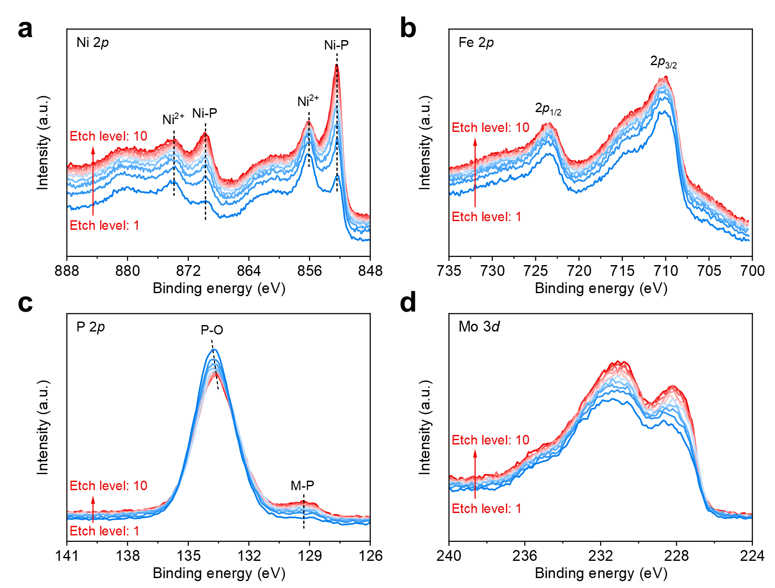
Supplementary Fig. 18. The high-resolution XPS depth profile of Fe-Ni₂P/NiMoO₄ for a Ni 2p, b Fe 2p, c P 2p, and d Mo 3d.
As shown in Supplementary Fig. 18a, the signal intensity of the Ni-P peaks gradually increases with the augment of etch level (~30 nm for each level). This trend indicates that the Fe-Ni₂P species are predominantly located within the interior of the composite. Especially, the absence of Fe-P peaks in Supplementary Fig. 18b suggests that iron phosphide-related species are not present in the Fe-Ni₂P/NiMoO₄. Instead, the main presence of Fe dopants is the oxidation state. In the P 2p spectrum (Supplementary Fig. 18c), the intensity of the M-P peaks decreases as the increasing of Ni-P peaks, which is in good consistency with Ni 2p spectrum.

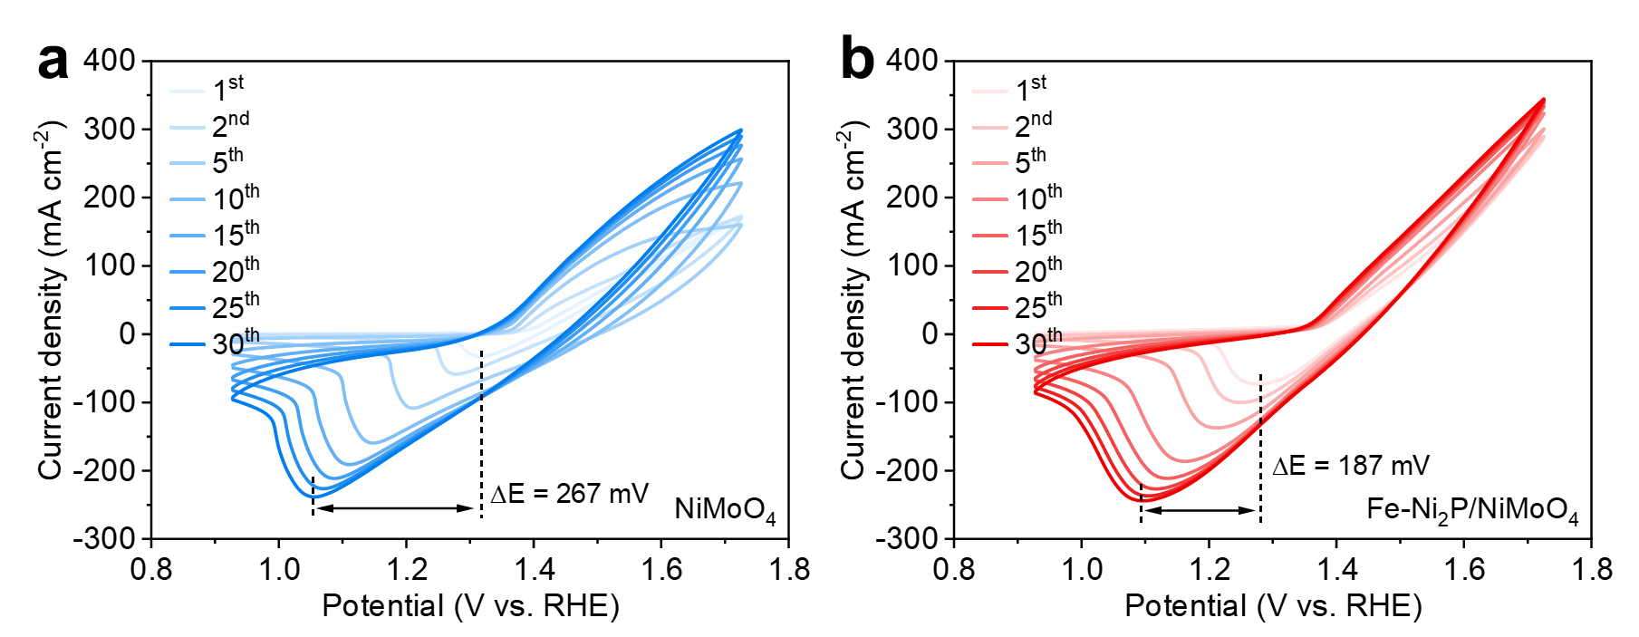
Supplementary Fig. 19. The CV curves during electrochemical activation without iR compensation for a NiMoO₄, and b Fe-Ni₂P/NiMoO₄ from the 1st to 30th cycle at 50 mV s⁻¹.
The CV activation was conducted from 0.0 to 0.8 V vs. Hg/HgO at a scan rate of 50 mV s⁻¹. As shown in the Supplementary Fig. 19, the cathodic peaks of Fe-Ni₂P/NiMoO₄ exhibit a negative shift of only 187 mV, which is significantly less than that of NiMoO₄ (267 mV), demonstrating the optimized redox kinetics of Ni sites in Fe-Ni₂P/NiMoO₄. Additionally, Fe-Ni₂P/NiMoO₄ catalyst achieves the maximum current density by the 10th cycle, whereas the CV curves of NiMoO₄ do not overlap even after 30th.

Supplementary Fig. 20. The chronopotentiometry (CA) curves during electrochemical activation without iR compensation for NiMoO₄ and Fe-Ni₂P/NiMoO₄ at 200 mA cm⁻².
The CA curves of pre-catalysts for NiMoO₄ and Fe-Ni₂P/NiMoO₄ at 200 mA cm⁻² exhibit a gradually stabilizing potential over time. Notably, only 14 min are required to reach the steady minimum potential for Fe-Ni₂P/NiMoO₄ catalyst, whereas the pristine NiMoO₄ necessitates 170 min for electrochemical activation.

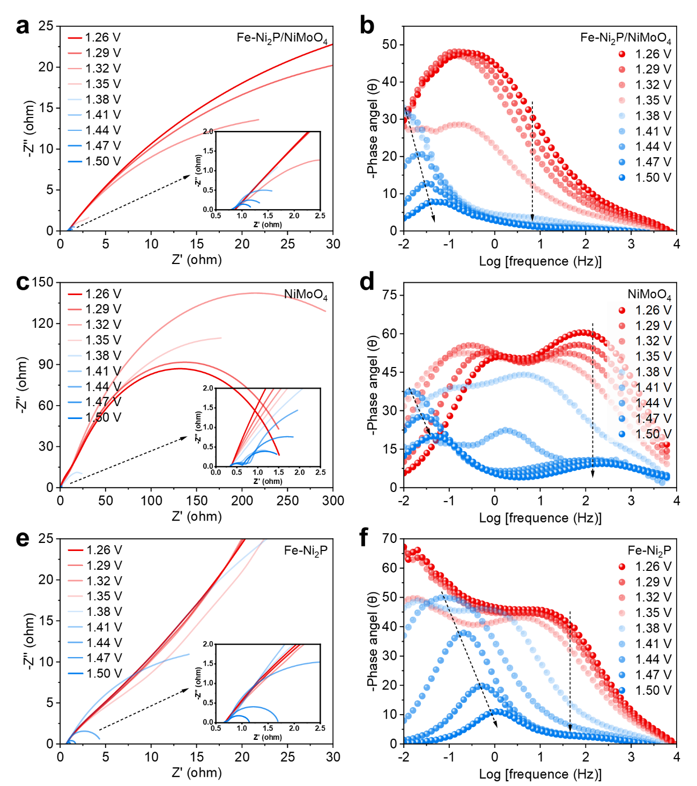
Supplementary Fig. 21. The Nyquist curves and bode phase plots at different potentials versus RHE of a, b Fe-Ni₂P/NiMoO₄, c, d NiMoO₄, and e, f Fe-Ni₂P.
As displayed in Supplementary Fig. 21a, c, and e, under the high applied potentials ranging from 1.38 to 1.50 V vs. RHE, the Nyquist plots of Fe-Ni₂P/NiMoO₄, NiMoO₄, and Fe-Ni₂P all exhibit the distinct semi-circular feature. Notably, the Fe-Ni₂P/NiMoO₄ composite consistently displays the smallest diameter across each potential, indicating a lower charge transfer resistance for OER. In addition, the phase angle peaks of NiMoO₄ and Fe-Ni₂P in the Bode plots (Supplementary Fig. 21b, d, and f) appear at 1.41 V vs. RHE, which is higher than that of Fe-Ni₂P/NiMoO₄ (1.38 V). Meanwhile, Fe-Ni₂P/NiMoO₄ consistently exhibits the smallest phase angle peak at low-frequency region from 1.38 to 1.50 V, indicating the superior OER performance. This observation is consistent with the results of the Nyquist plots.

Supplementary Fig. 22. The in-situ Raman spectroscopy analysis of catalyst reconstruction for NiMoO₄.

Supplementary Fig. 23. XRD pattern analysis of activated catalysts for R-Fe-Ni₂P/NiMoO₄ and R-NiMoO₄.

Supplementary Fig. 24. The ex-situ Raman spectroscopy analysis of activated catalysts for R-Fe-Ni₂P/NiMoO₄ and R-NiMoO₄.

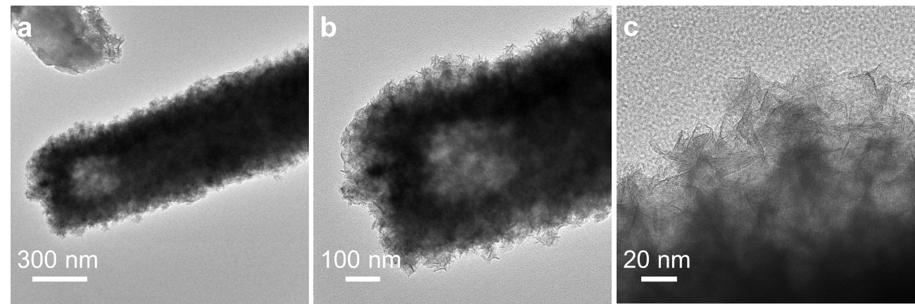
Supplementary Fig. 25. a-c The TEM images of activated catalyst for R-Fe-Ni₂P/NiMoO₄ at different magnifications.

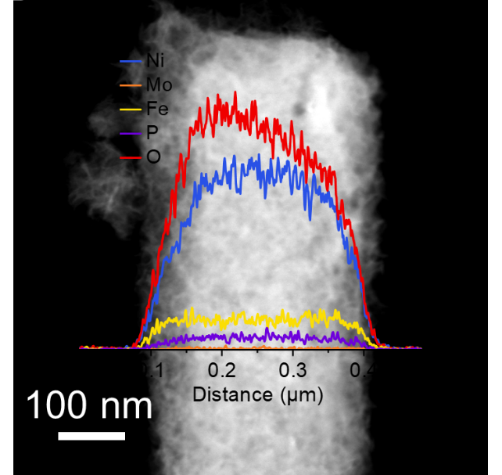
Supplementary Fig. 26. Line scan of the activated catalyst for R-Fe-Ni₂P/NiMoO₄.

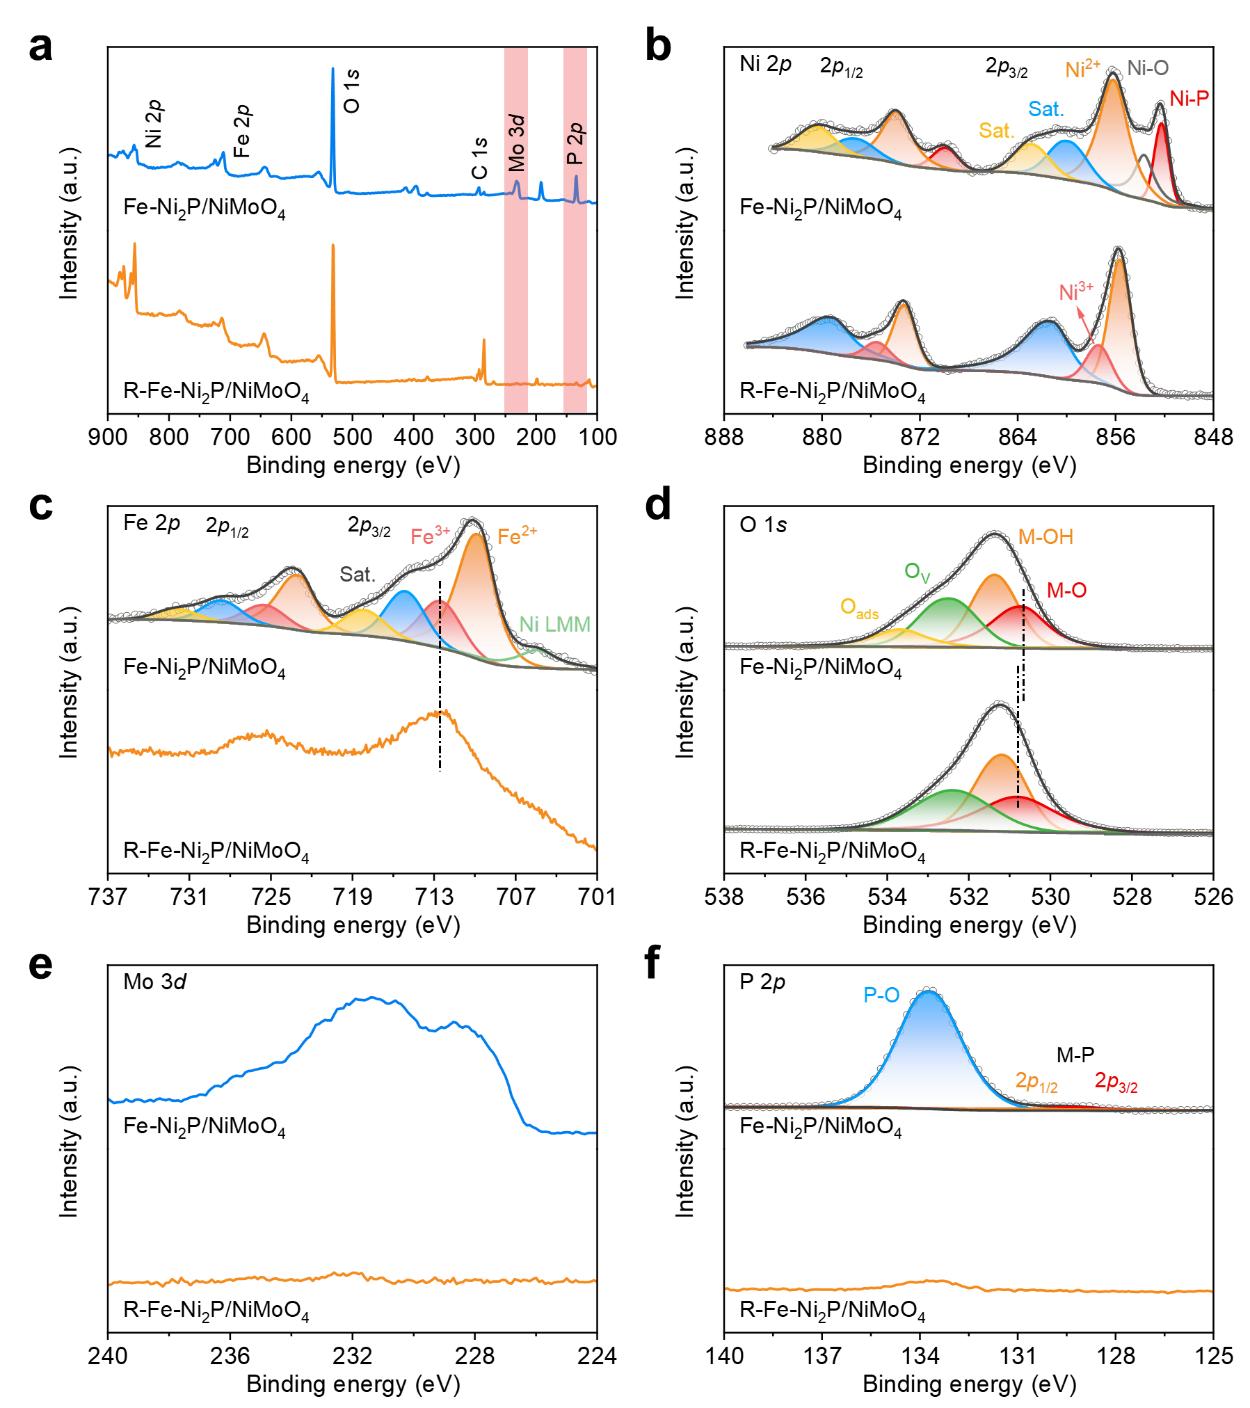
Supplementary Fig. 27. XPS spectra of Fe-Ni₂P/NiMoO₄ before and after reconfiguration for a survey pattern, b Ni 2p, c Fe 2p, d O 1s, e Mo 3d, and f P 2p.

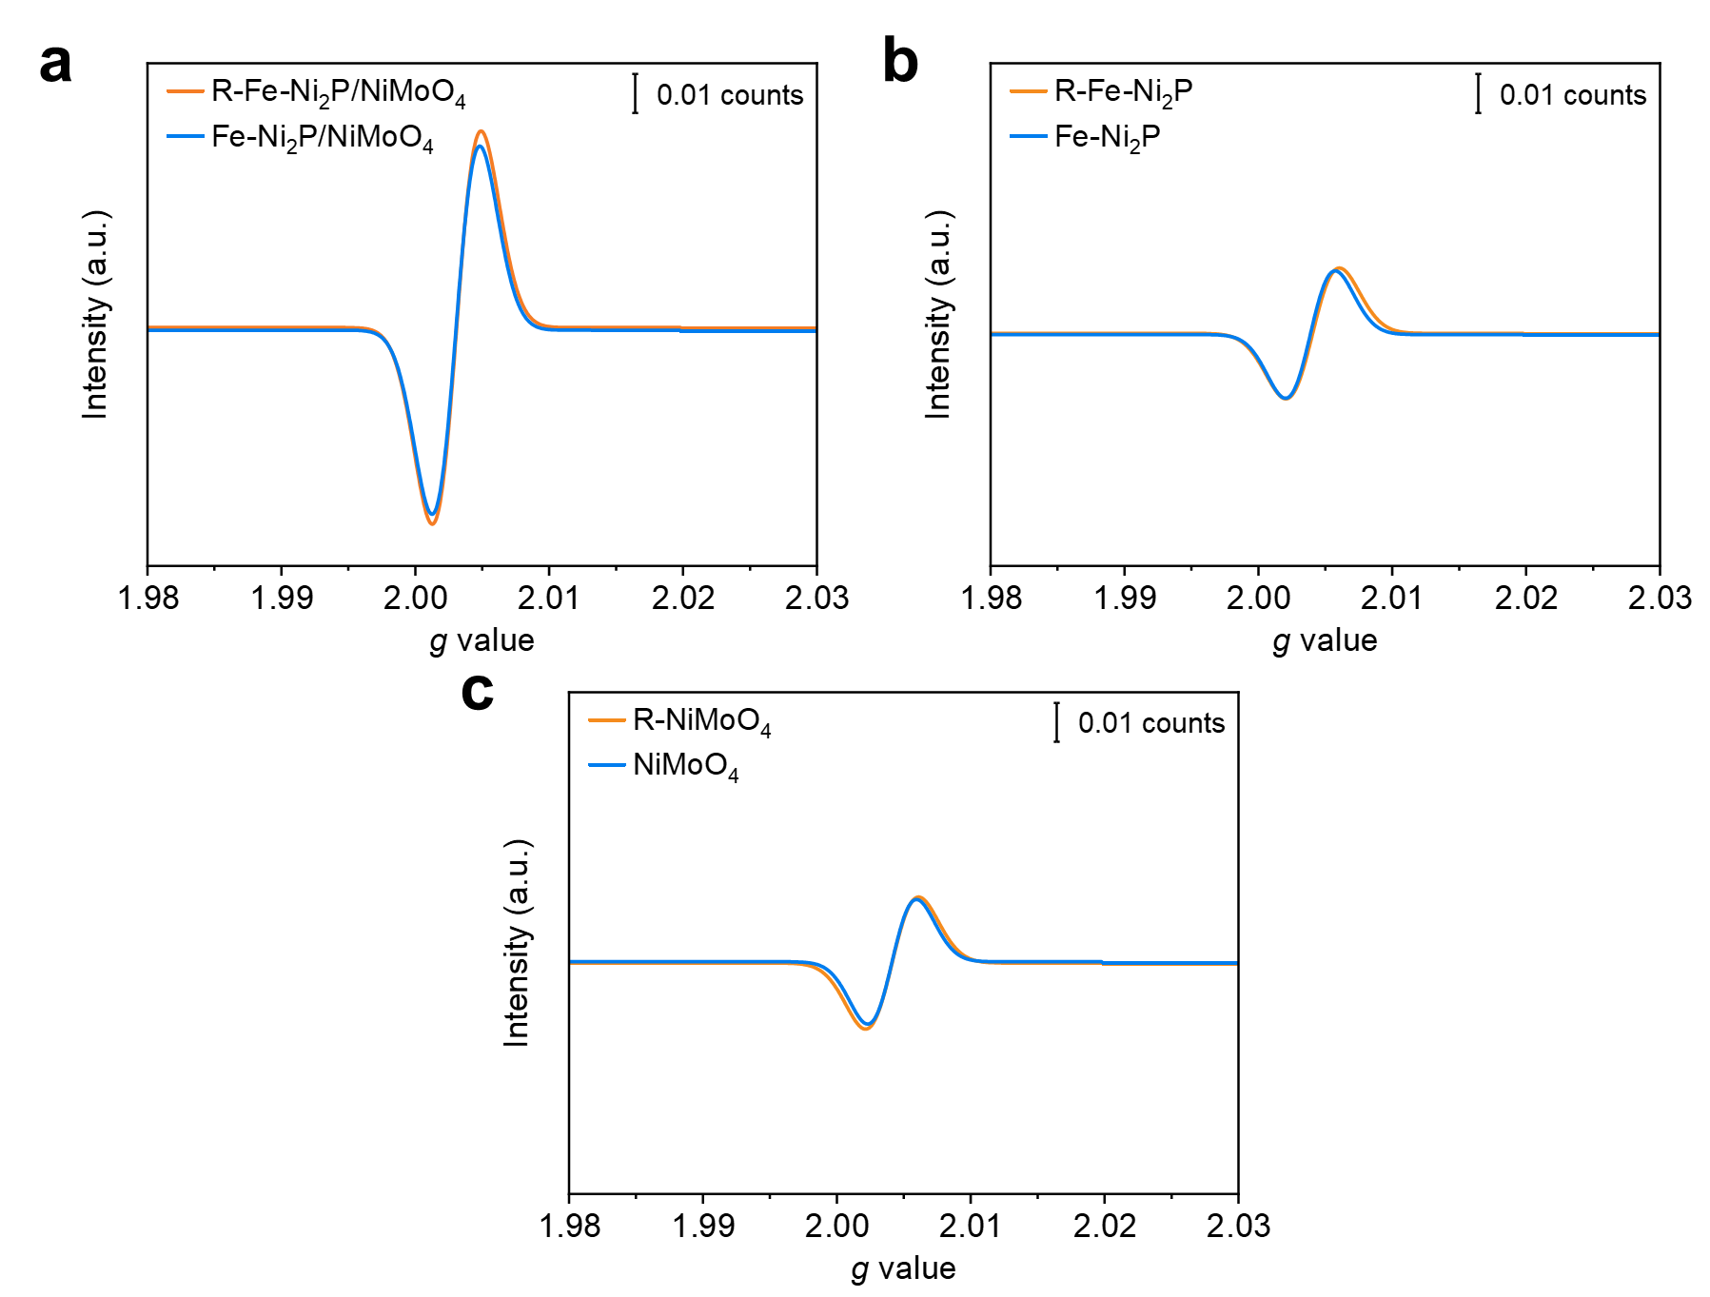
Supplementary Fig. 28. Electron paramagnetic resonance (EPR) spectra before and after reconfiguration for a Fe-Ni₂P/NiMoO₄, b Fe-Ni₂P, and c NiMoO₄.

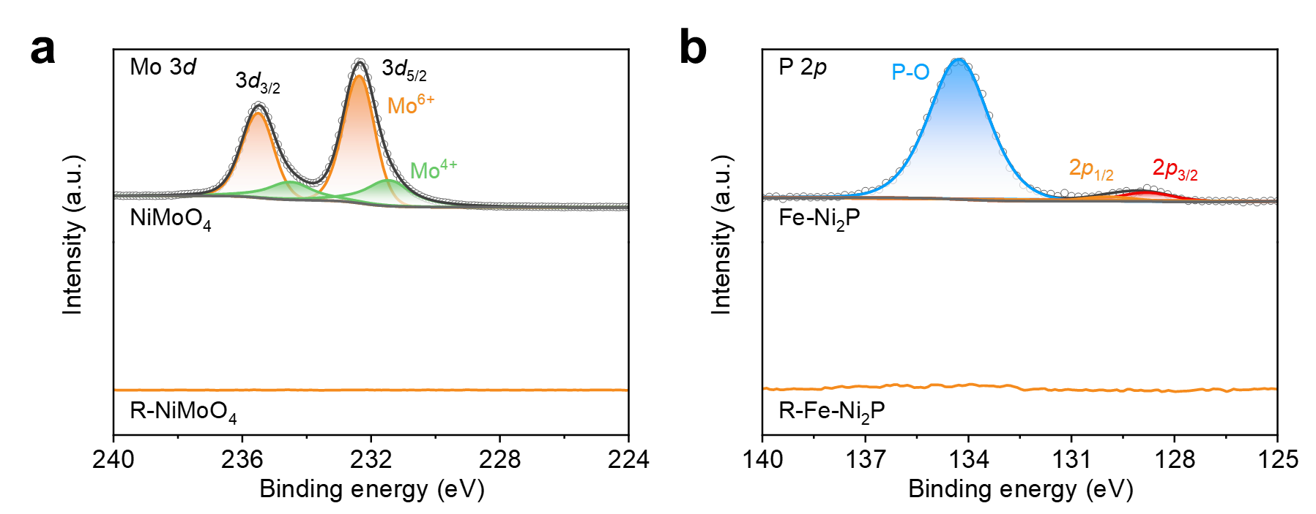
Supplementary Fig. 29. XPS spectra before and after reconfiguration for a Mo 3d of NiMoO₄, and b P 2p of Fe-Ni₂P.

Supplementary Fig. 30. The Tafel slopes of as-prepared samples.

Supplementary Fig. 31. The EIS curves of as-prepared samples.

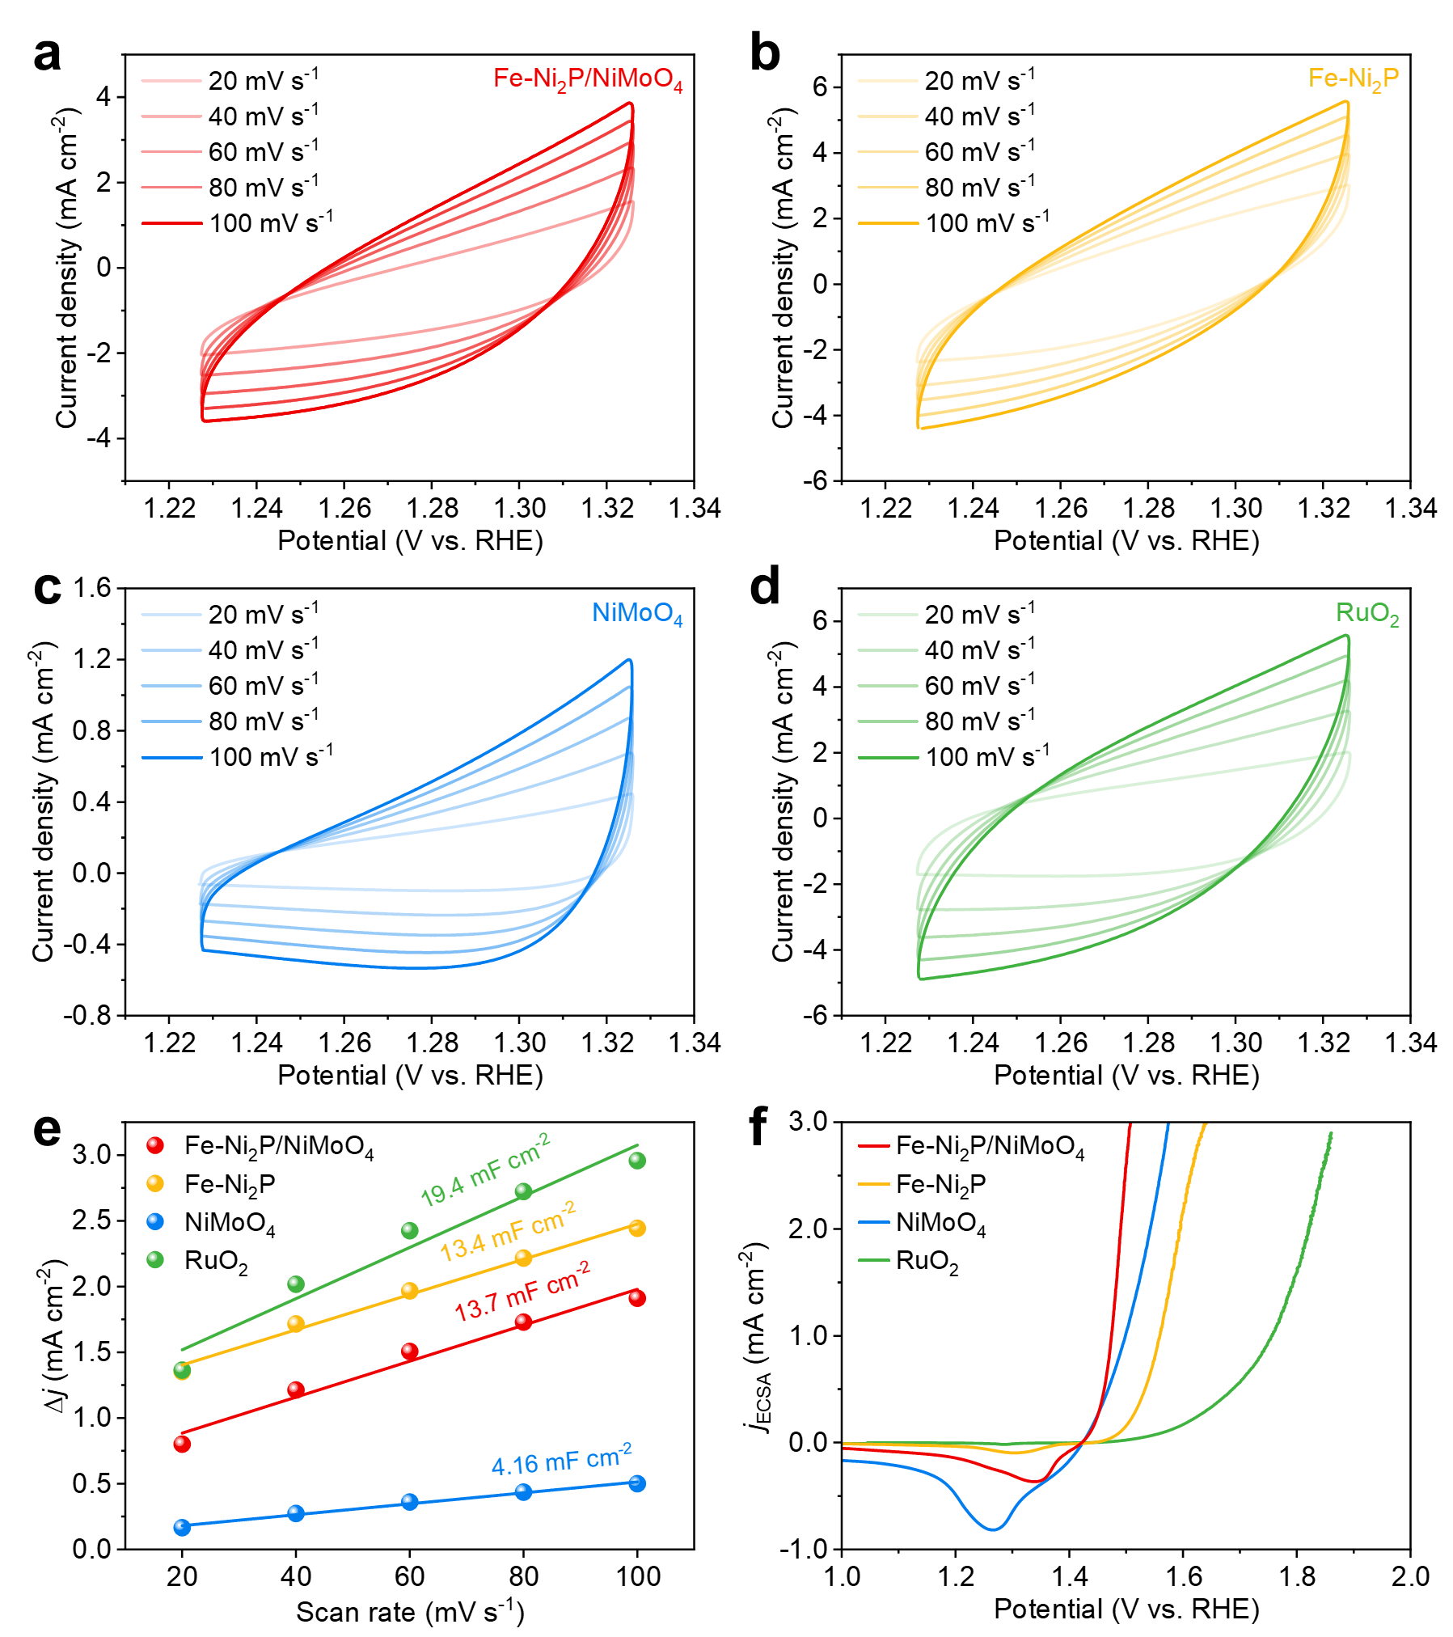
Supplementary Fig. 32. a-d CV curves in the region of 1.23 - 1.33 V vs. RHE at scan rates ranging from 20 to 100 mV s⁻¹. e Calculated C_{dl} values, and f LSV curves normalized by ECSA of as-prepared samples.

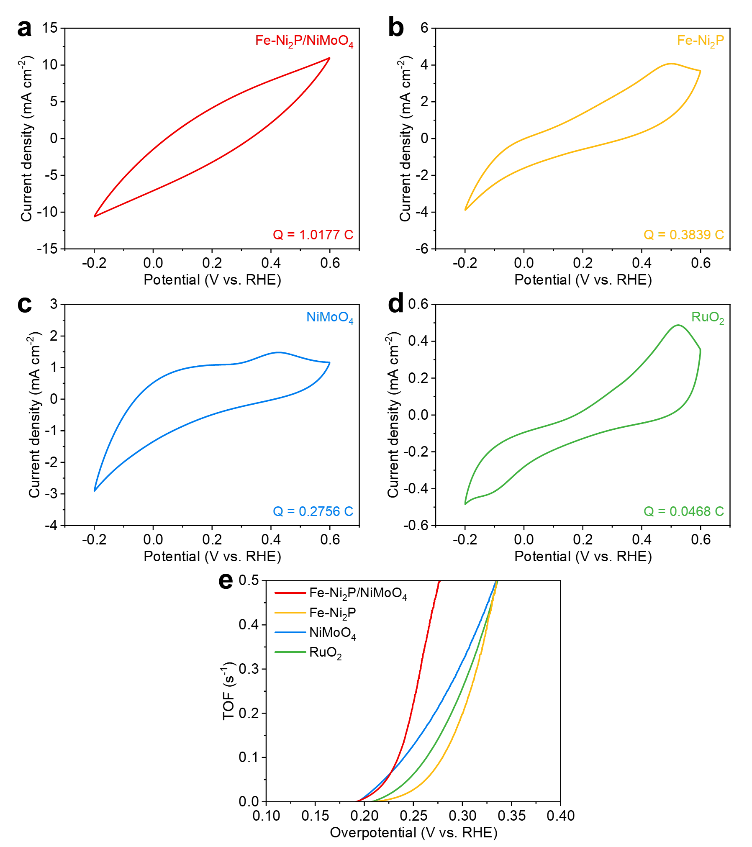
Supplementary Fig. 33. a-d CV curves from -0.2 to 0.6 V vs. RHE at the scan rate of 50 mV s⁻¹ in 1 M PBS solution and calculated Q values. e Calculated O₂ TOF values of as-prepared samples.
The number of voltametric charges is obtained from CV curves measured from -0.2 to 0.6 V vs. RHE at the scan rate of 50 mV s⁻¹ in 1 M phosphate buffer solution (PBS). The TOF values are calculated according to the following equation:
$$\begin{aligned}n=Q/{2F}\end{aligned}$$
$$\begin{aligned}TOF=I/{4Fn}\end{aligned}$$
Where $Q$ is the number of voltametric charges, $F$ is Faraday constant (96485 C mol⁻¹), $I$ is current (A) during the LSV test, $n$ is the number of active sites (mol), and the factor 4 corresponding to the four-electron process for O₂ formation.

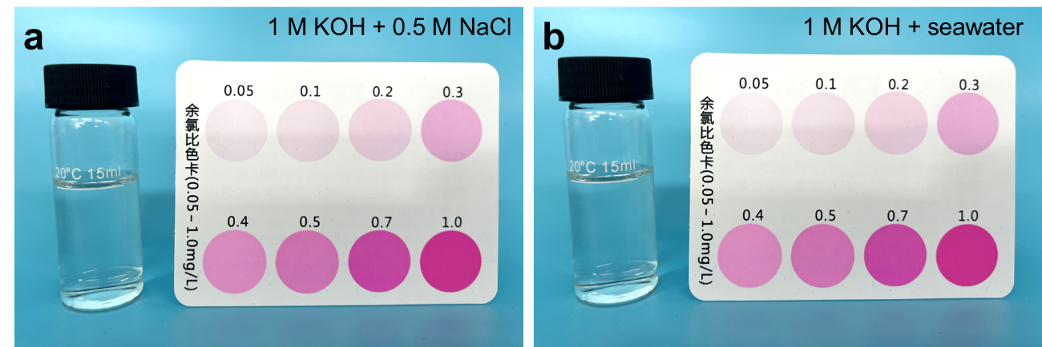
Supplementary Fig. 34. Detection results for ClO⁻ generation in a 1 M KOH + 0.5 M NaCl, and b 1M KOH + seawater electrolytes after stability test under a current density of 1.0 A cm⁻².

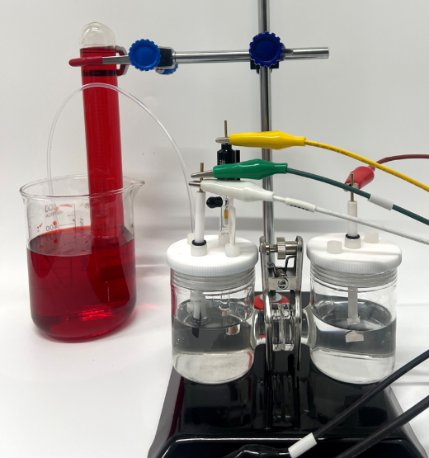
Supplementary Fig. 35. Digital photograph of home-made Faraday efficiency testing device.

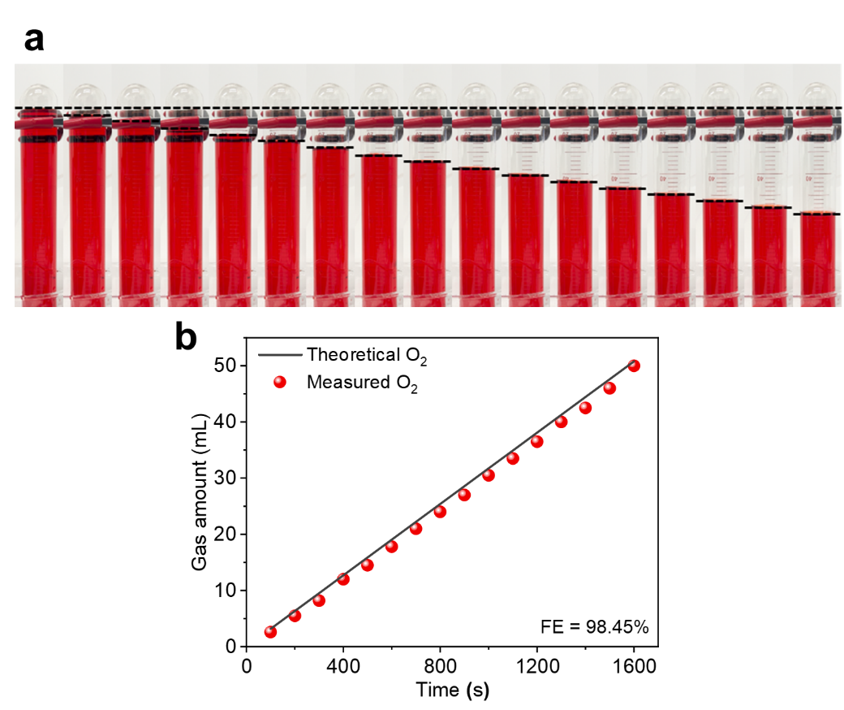
Supplementary Fig. 36. a Digital photograph of O₂ collection, and b Theoretical and measured volume of O₂ for Fe-Ni₂P/NiMoO₄ in 1 M KOH.

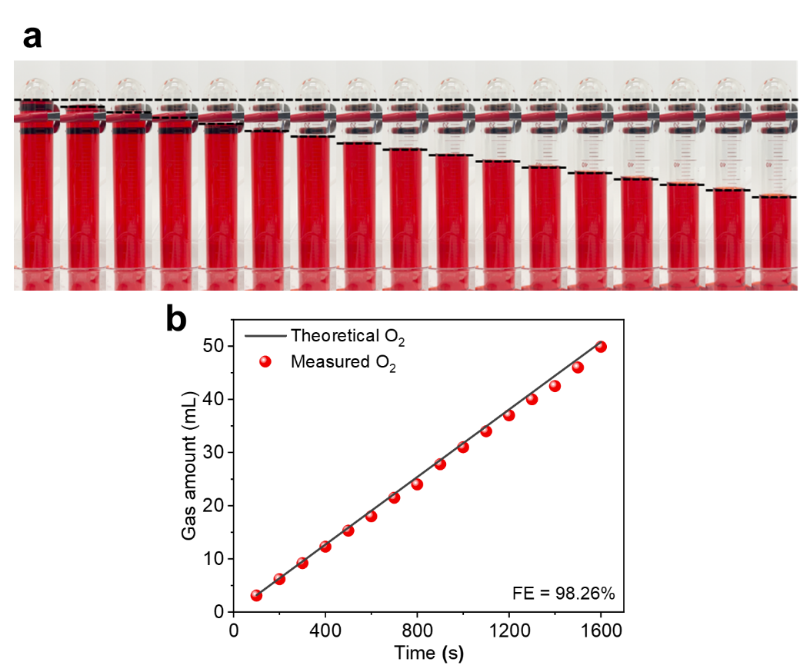
Supplementary Fig. 37. a Digital photograph of O₂ collection, and b Theoretical and measured volume of O₂ for Fe-Ni₂P/NiMoO₄ in 1 M KOH + seawater.

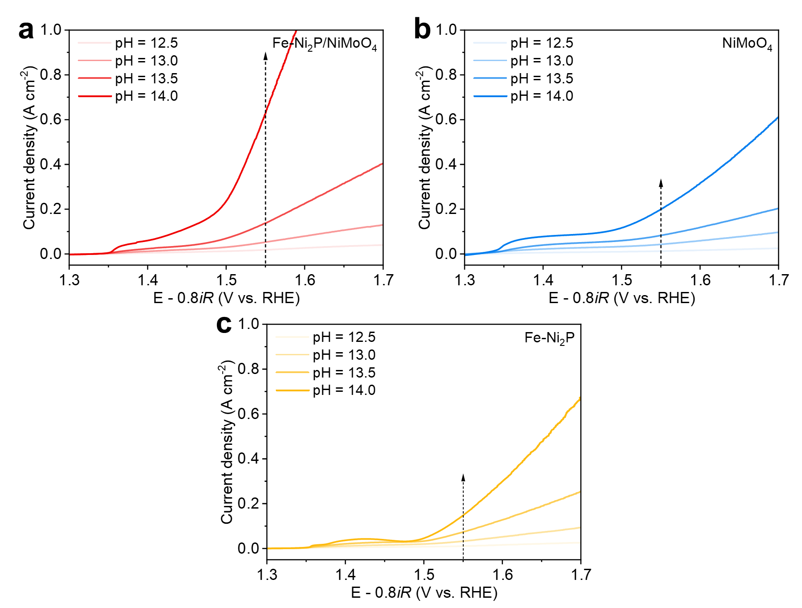
Supplementary Fig. 38. OER LSV curves with 80% iR compensation of a Fe-Ni₂P/NiMoO₄, b NiMoO₄, and c Fe-Ni₂P in the KOH electrolytes with pH = 12.5, 13.0, 13.5, and 14.0.

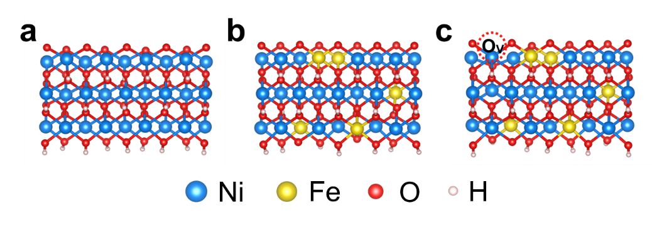
Supplementary Fig. 39. The theoretical structure models of a NiOOH, b Ni(Fe)OOH, and c O_{V}-Ni(Fe)OOH.

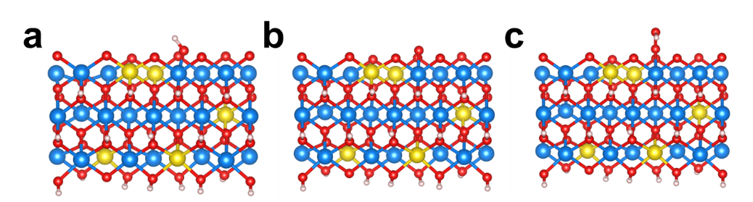
Supplementary Fig. 40. The theoretical structure models of AEM pathway on Ni site of O_{V}-Ni(Fe)OOH involved the adsorption of a *OH, b *O, and c *OOH.

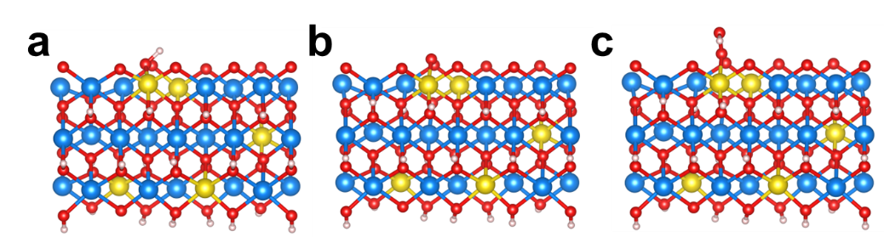
Supplementary Fig. 41. The theoretical structure models of AEM pathway on Fe site of O_{V}-Ni(Fe)OOH involved the adsorption of a *OH, b *O, and c *OOH.

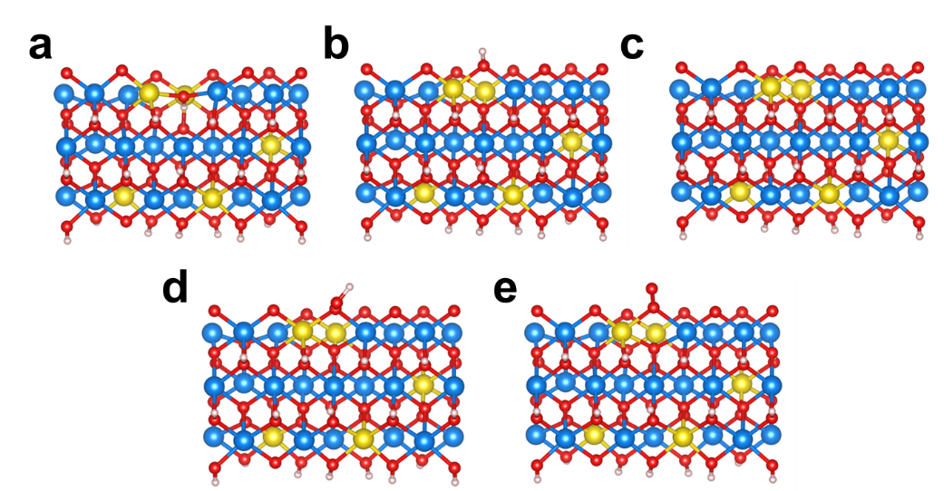
Supplementary Fig. 42. The theoretical structure models of LOM pathway on O site of O_{V}-Ni(Fe)OOH involved the adsorption of a *O_{V}, b *OH, c *O, d *OOH, and e *OO.

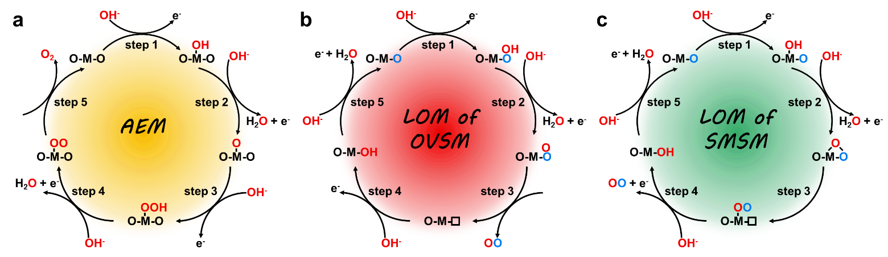
Supplementary Fig. 43. Schematic illustration of the a AEM, b LOM of oxygen-vacancy-site mechanism (OVSM), and c LOM of single-metal-site mechanism (SMSM).

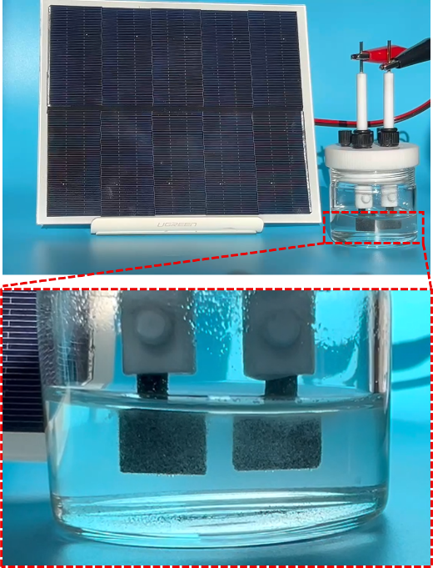
Supplementary Fig. 44. Digital photograph of the electrocatalytic powered by the solar panels (anode: Fe-Ni₂P/NiMoO₄, cathode: MoNi₄).

Supplementary Table 1. Quantitative analysis of different oxygen species of R-Fe-Ni₂P/NiMoO₄, R-Fe-Ni₂P, and R-NiMoO₄ based on the fitting results of O 1s XPS spectra in Fig. 2m.

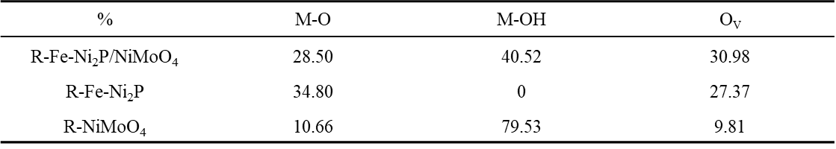

Supplementary Table 2. The fitted parameters of the EIS data of obtained samples in 1 M KOH solution.

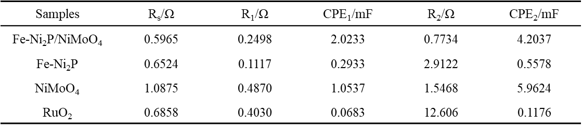

Supplementary Table 3. The fitted parameters of the EIS data of obtained samples in 1 M KOH + 0.5 M NaCl solution.

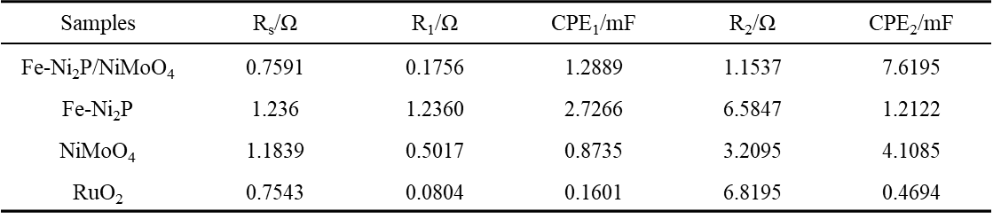

Supplementary Table 4. The fitted parameters of the EIS data of obtained samples in 1 M KOH + seawater solution.

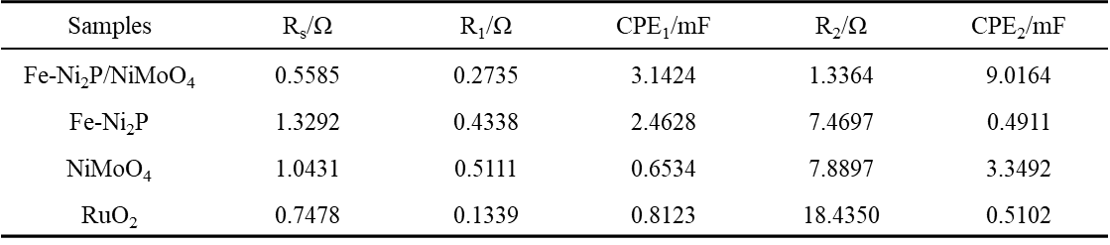

Supplementary Table 5. The calculated data of corrosion potential and corrosion current density for obtained samples.

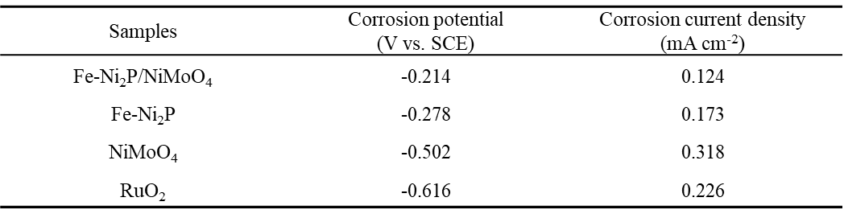

References
1. Perdew, J. P., Burke, K. & Ernzerhof, M. Generalized gradient approximation made simple. Phys. Rev. Lett. 77, 3865-3868 (1996).
2. Kohn, W. & Sham, L. J. Self-consistent equations including exchange and correlation effects. Physical Review. 140, A1133-A1138 (1965).
3. Raybaud, P., Hafner, J., Kresse, G., Kasztelan, S. & Toulhoat, H. Ab initio study of the H₂-H₂S/MoS₂ gas-solid interface: The nature of the catalytically active sites. J. Catal. 189, 129-146 (2000).
4. Kresse, G. & Joubert, D. From ultrasoft pseudopotentials to the projector augmented-wave method. Phys. Rev. B. 59, 1758-1775 (1999).
5. Blöchl, P. E. Projector augmented-wave method. Phys. Rev. B. 50, 17953-17979 (1994).
6. Grimme, S., Antony, J., Ehrlich, S. & Krieg, H. A consistent and accurate ab initio parametrization of density functional dispersion correction (DFT-D) for the 94 elements H-Pu. J. Chem. Phys. 132, 154104 (2010).
7. Grimme, S., Ehrlich, S. & Goerigk, L. Effect of the damping function in dispersion corrected density functional theory. J. Comput. Chem. 32, 1456-1465 (2011).

