Coherent oscillation in photocurrent through single-atom junctions at room temperature
Lijue Chen†, Jun-Rong Zheng†, Hao Zhang†, Zhixin Qiu, Yiqiang Jiang, Jueting Zheng, Yu Cao, Haojie Liu, Jia Shi, Junyang Liu*, Jun Yi*, Zhong-Qun Tian, Wenjing Hong*
State Key Laboratory of Physical Chemistry of Solid Surfaces, College of Chemistry and Chemical Engineering, Fujian Key Laboratory of Ultrafast Laser Technology and Applications, School of Electronic Science and Engineering, IKKEM, Xiamen University, Xiamen 361005, China
†These authors contributed equally.
*Corresponding Authors.
E-mail: whong@xmu.edu.cn (W. Hong); junyi@xmu.edu.cn (J. Yi); jyliu@xmu.edu.cn (J. Liu)

Contents:
Supplementary Notes 1-3
Supplementary Figures 1-16
Supplementary References

Supplementary Note 1. Theoretical model and simulation of quantum transport
The typical cross-section of a quantum point contact is shown in Figure.S1a, two contacts are bridged by a junction of a few atomic diameters wide (which exhibits discrete energy levels). Under adiabatic approximation (the geometry varies smoothly on the scale of Fermi wavelength), the transverse and longitudinal motion of electron can be separated, and the transverse energy E_{n}(x) will then play the role of a potential for the one-dimensional longitudinal motion. Electrons occupy different transverse energy states n and depending on whether the total energy of a given electronic state ε_{n} is larger or smaller than the transverse potential barrier E_{n}(0) at the narrowest part (the narrowest width of a junction is denoted as d), it is a transmitted or reflected state. The green circles in Figure S1b represent an electron at transmitted state as ε_{n} > E_{n}(0).
As long as the energy of the incident photon $ℏω$ matches the differences in energy of nearby transverse states ΔE(x) (wherever in the junction), electron at lower (upper) state can absorb (emit) a photon and transit to upper (lower) state. Depending on the relative relationship between the energy of initial electron, incident photon and barrier, the transport properties of the electron can be changed under some circumstances. Take the absorption process for example, as shown in Figure.1b, an initial electron at state n (green) is excited and transits to state n+1 (red), as ε_{n+1} =ε_{n} + ħω < E_{n+1}(0), the final state is reflected, the electron transits from a transmitted to a reflected state after absorbing a photon. As we always have ħω = ΔE(x) < ΔE(0), transition from reflected to transmitted state could never happen in the absorption process. In addition, although transition from transmitted to transmitted and reflected to reflected are allowed, since these can’t change the transport of the electron, we only have to consider the transition from transmitted to reflected state.
As the MCBJ chip is negligible in thickness, we can treat it as a 2D system. Breaking the junction is equivalent to narrowing the width of the knot, thus changing the energy of transverse states and energy gap between them, further influence both the d.c. conductance and photoconductance of the junction.
Due to the spill out effect of electron at metal interface¹⁻³, it’s quite hard to determine the accurate shape of potential barrier for metal junction with atomic diameters wide. Anyway, it can be treated as a mixture of an extreme soft (parabolic) confinement potential and an extreme hard (hard wall) confinement potential, both of which have been shown can exhibit similar photoresponse⁴. Here we take the laterally confining potential to be of the parabolic type for example, the transverse energy states can be expressed as:
$$\begin{aligned}E_{n}\left(x\right)=\frac{ℏ^{2}}{2m^{∗}}\frac{2n+1}{D^{2}\left(x\right)}\#\left(S1\right)\end{aligned}$$
where n is the mode number (0, 1, 2, 3$⋯$), $ℏ$ is the reduced Plank constant and $m^{∗}$ is the mass of the electron.
The differences in energy of nearby transverse states $∆E_{TM}$ are:
$$\begin{aligned}∆E\left(x\right)=\frac{ℏ^{2}}{2m^{∗}}\frac{2}{D^{2}\left(x\right)}\#\left(S2\right)\end{aligned}$$
When the energy of incident photon $ℏω$ matches $∆E$, optical absorption will happen and since $D\left(x\right)$ reached its minimum at x = 0 (denoted as d), we always have:
$$\begin{aligned}ℏω=∆E\left(x\right)≤∆E\left(0\right)=\frac{ℏ^{2}}{2m^{∗}}\frac{2}{d^{2}}\#\left(S3\right)\end{aligned}$$
which means d should be small enough to allow the absorption process.
Still considering the absorption case, there are three possible relationships between the energy of electron $E$ and the highest transverse barrier $E_{n}\left(0\right)$ (as shown in Figure. S1d): (1) if ε_{n} < E_{n}(0) and ε_{n+1} = ε_{n} + ħω < E_{n+1}(0), the initial and final states are both reflected and will not change the transport of the electron; (2) conversely, if ε_{n} > E_{n}(0)and ε_{n+1} = ε_{n} + ħω > E_{n+1}(0), both of the states are transmitted and also can’t change the transport process; (3) if ε_{n} > E_{n}(0) and ε_{n+1} = ε_{n} + ħω < E_{n+1}(0), the initial state is transmitted and the final state is reflected, thus give a negative contribution to the net current. It can easily be shown in a similar way that for the emission case, when ε_{n-1} = ε_{n} - ħω > E_{n-1}(0)and ε_{n} < E_{n}(0), the initial state is reflected and the final state is transmitted, thus enhancing the net current (Figure.S1e). The two processes give opposite contribution to the final net current, which brings oscillations to the total conductance of the junction. Introducing the intermediate variable $k={\sqrt{2m^{∗}E}}/ℏ$ and considering three nearest energy levels, Figure. S1c summarize the conditions for the suppression and enhancement of photocurrent when changing width of the junction. With the increase of $k^{2}d^{2}$, when it equals to 2n + 1 (that is, $ε_{n}=\frac{ℏ^{2}}{2m^{∗}}\frac{2n+1}{d^{2}}$), the absorption process leads to a suppression of photocurrent, and followed by an enhancement attributed from the emission process. The two contributions overlap partially and cancel with each other. Further increasing $k^{2}d^{2}$ leads to repeated processes until reaching the critical condition set by eq. S3. Since the dark conductance of the junction is determined by the mode number below Fermi level:
$$\begin{aligned}E_{F}>\frac{ℏ^{2}}{2m^{∗}}\frac{2n+1}{d^{2}}\#\left(S4\right)\end{aligned}$$
we have
$$\begin{aligned}{k_{F}}^{2}d^{2}>2n+1\#\left(S5\right)\end{aligned}$$
where n =0, 1, 2, 3$⋯$, so the odd number of ${k_{F}}^{2}d^{2}$ is equivalent to the transition of integer multiples of G₀ (Figure. S2b, black line).
The formula derivation of photoconductance in quantum point contact is well described in Refs ^{4, 5} by Grincwajg et al, we shall only outline their final expression and the improvement we have made. Their expression for the photoconductance near zero temperature is:
$$\begin{aligned}G=&\frac{e^{2}}{2ℏ}{\left(\frac{eE_{0}}{ℏω}\right)}^{2}\int{\frac{∂f}{∂E}}\sum_{n}{\frac{Θ\left[1−Ω\left(n+\frac{1}{2}\right)\right]}{k\sqrt{1−Ω\left(n+\frac{1}{2}\right)}}\left|\frac{D\left(x^{∗}\right)}{D^{'}\left(x^{∗}\right)}\right|} \\ &×\{nΘ\left[\left(2n+1\right)−k^{2}d^{2}\right]Θ\left[k^{2}d^{2}\left(1−Ω\right)−\left(2n−1\right)\right]\# \\ &−\left(n+1\right)Θ\left[k^{2}d^{2}−\left(2n+1\right)\right]Θ\left[2n+3−k^{2}d^{2}\left(1+Ω\right)\right]\}dE\#(S6)\#\end{aligned}$$
where $Ω=ℏω/E$, $E_{0}$ is the amplitude of the electric field of incident light, f is the Fermi-Dirac distribution function and $\left|{D\left(x^{∗}\right)}/{D^{'}\left(x^{∗}\right)}\right|$ is the geometry factor ($x^{∗}$ is where the electron transition between different transverse states occurs). The four Heaviside functions $Θ$ (Figure. S2a, black dashed line) in the curly brackets express the criterion for determining whether the mode is transmitted or reflected.
Under adiabatic approximation, the geometry factor can be always expressed as
$$\begin{aligned}\left|\frac{D\left(x^{∗}\right)}{D^{'}\left(x^{∗}\right)}\right|=\frac{L}{\sqrt{ln\left(\frac{2}{Ωk^{2}d^{2}}\right)}}\#\left(S7\right)\end{aligned}$$
For gold, $E_{F}=5.5 eV$ and supposing $ℏω=1.46 eV$(corresponding to wavelength of 850 nm), $L=1μm$, $E_{0}=70 V/m$, the photoconductance with varying minimum width d of the junction is shown in Figure.S2b. As explained earlier, it shows sharp oscillations around odd number of ${k_{F}}^{2}d^{2}$ and vanishes around 4G₀. We also plot the positive and negative contributions around G₀ separately (Figure. S2c), which is consistent with the mechanism illustrated in Figure. S1c. It’s noted that due to the step transition at $Θ(0)$, the obtained photoconductance also shows step-like transitions
When move to room temperature, it has been shown that the mixture of quantum modes (that is, the modes are not fully open or closed) due to inelastic processes should be considered to match the experimental results^{6, 7}. Here, the criterion for determining the transport properties of mode is not strictly through a Heaviside function anymore (through which the transmission probability can only be 0 or 1), we replaced it by a smoothly-changing function $F\left(x\right)$ to include the half-open states:
$$\begin{aligned}F\left(x\right)=\frac{1}{exp\left(−Ax\right)+1}\#\left(S8\right)\end{aligned}$$
where A is a fitting parameter to indicate the degree of mode broadening. To get insight into the physical meaning of the replacement from $Θ$ function to $F$ function, we plot $Θ$ and $F$ with different choice of A as a function of $∆E$(in unit of ${k_{F}}^{2}d^{2}$, Figure. S2a). For $Θ$ function, a new transmission channel fully opens at odd number of ${k_{F}}^{2}d^{2}$, while for $F$ function, the channel gradually opens around odd number of ${k_{F}}^{2}d^{2}$ and the transmission probability is 0.5 at odd number of ${k_{F}}^{2}d^{2}$.The calculated photoconductance for different choice of A is shown in Figure. S2d. With the decrease of A, both of the dark conductance and photoconductance showing a smoother trend and we found that A = 20 fits the experimental results well.
When changing the wavelength of incident light, photoconductance calculated by eq.4 shows almost same trend except near the final oscillation (Figure. S2e, which can be attributed to the cut-off condition set by eq.3). As illustrated in Figure. S1c, the widths of the negative and positive contributions are determined by the photon energy $ℏω$, with the increase of wavelength (decrease of $ℏω$), the overlap suppression region broadens, but maintain the same strength (Figure. S2f). In eq.4, the absorption intensity of the junction is determined by $E_{0}$ and since it only change the absolute amplitude of the photoconductance, we assumed it’s constant under different wavelength of excitation here.
Supplementary Note 2. Simulation of electromagnetic field and thermal effects.
To include the wavelength-dependent absorption of MCBJ, we calculated the absorption spectrum of the used MCBJ as shown in Fig. S3a by commercial software COMSOL Multiphysics. The exact geometry of the junction is difficult to determine due to the potential random configurations formed during each stretch. The geometry of the MCBJ selected in Fig. S3 closely aligns with its SEM image, and the absorption spectrum displays a double-peak feature that mirrors the experimental photocurrent spectrum.
The electric field distribution of MCBJ with varied bridge widths upon illumination of incident field with polarization along the transport direction was obtained by employing a quantum corrected semi-classical model known as the quantum hydrodynamic model (QHT), The results obtained using this method have been demonstrated shown excellent agreement with TD-DFT predictions, while substantially reducing computational costs and allowing for the analysis of larger structures. The detailed procedure of this method can be found in Ref^{1, 8-10}. The ground-state electron density distribution n₀ of each structure is shown in Fig. S3d (upper), where n_{b} is the electron density of bulk Au. As the junction width narrows, the electron density within it progressively decreases, accompanied by a gradual increase in electric field enhancement factor ⏐E⏐/⏐E₀⏐(bottom of Fig. S3d). The average electric field enhancement factor within the ±2 nm region along the central axis is shown in Fig. S3e, which can provide an enhancement in photocurrent by four to five orders of magnitude.
The steady-state temperature of MCBJ upon excitation of continuous wave light with power density of 3.68 W/cm² at wavelength of 700 nm was obtained by solving Fourier heat conduction equation through commercial software COMSOL Multiphysics (Fig. S3b), which indicate an increased temperature on the order of 0.1 mK. When the pulse duration is shorter than 1 ns (like the laser used in this work with duration of 150 fs), the electron and lattice temperatures remain out of equilibrium. The electrons are rapidly heated to a high temperature and subsequently transfer heat to the lattice through electron-phonon coupling. This non-equilibrium energy transfer process cannot be captured by the classical Fourier heat conduction equation, necessitating the development of a two-temperature model to describe the localized thermal imbalance between the electron and lattice temperatures:
$$C_{e}\frac{∂T_{e}}{∂t}+∇∙\left(−k_{e}∇T_{e}\right)= −G\left(T_{e}−T_{l}\right)+S$$
$$C_{l}\frac{∂T_{l}}{∂t}+∇∙\left(−k_{l}∇T_{l}\right)= −G\left(T_{e}−T_{l}\right)$$
where C, T and k are the heat capacity, temperature and thermal conductivity, respectively. The subscripts e and l represent electrons and the lattice, respectively. The valuables of above parameters can be obtained from Ref ¹¹. We performed time-dependent simulation of above model with excitation of Gaussian pulse with duration of 150 fs, repetition frequency of 80 MHz and time averaged power density 7.36 W/cm². As shown in Fig. S3c, upon the pulse's arrival, the electron temperature quickly spikes to 0.1 K, and approximately 1 ns later, thermal equilibrium is established between the electrons and the lattice with temperature around 1 mK. Following this, both temperatures gradually drop to 0.1 mK as heat is dissipated into the environment. Even such a temperature change causes a temperature difference between source and drain, the expected thermoelectric current is ~0.05 fA by lattice temperature and ~0.33 fA by electron temperature (Estimated by using Seebeck coefficient of ~-4 μV/K¹²).
Supplementary Note 3. Stokes and anti-Stokes photoluminescence spectroscopy
A Chameleon Ultra II laser (Coherent) outputs an ultrafast laser beam with a pulse duration of 140 fs and a repetition rate of 80 MHz at a wavelength of 680 nm, which is used as the excitation light. The laser beam is split using a 10:90 beam splitter. The high-power beam is focused on the MCBJ sample through a 50X long working distance objective (M Plan Apo 50X, Mitutoyo) with a numerical aperture (NA) of 0.55 to excite the Raman signal. The other beam, equipped with a variable ND filter, is used to regulate and detect the optical power.
Stokes and anti-Stokes signal acquisition is achieved by switching filters with Filter Wheels. A 650 nm short-pass filter is used for anti-Stokes, while a 700 nm long-pass filter, equipped with an optical density filter (OFR1-40M, JCOPTIX), is used for Stokes. The signal light is then received by a spectrometer (Omni-λ3028i, Zolix) with a tunable slit and a grating of 150 lines/mm, which accommodates the large range of simultaneous Stokes and anti-Stokes acquisitions. The acquisition mode is set to Accumulate Mode with an acquisition time of 2 seconds and a count of 5. The final result is captured by a camera equipped with a thermoelectric CCD (iDUS416, ANDOR Technology) for signal collection.

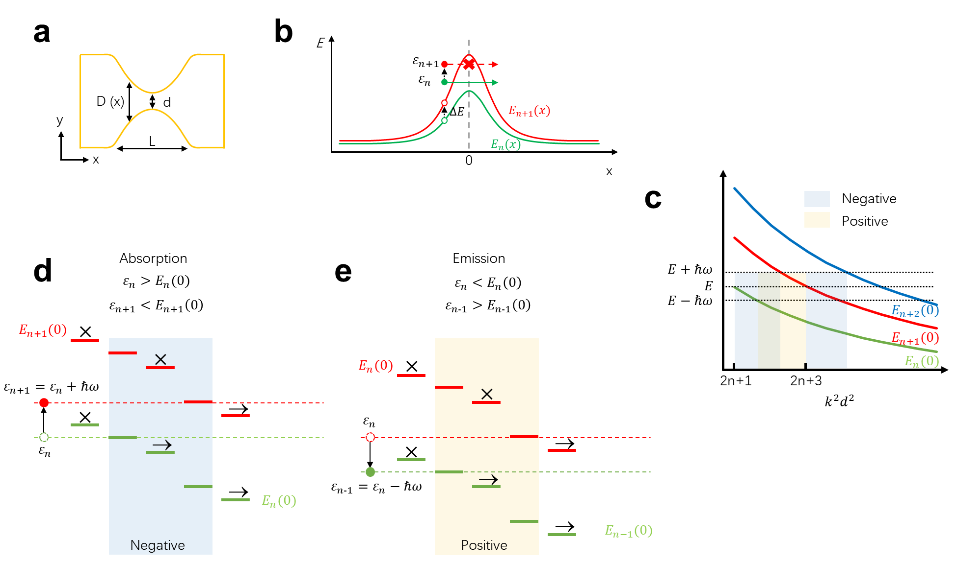
Fig. S1 Illustration of theoretical model. (a) Typical geometry of a quantum point contact, the length and width of the junction are L and D (x), respectively. The narrowest part of the junction is defined as the origin of x axis and the width is defined as d. (b) Transverse mode states diagram of the junction and typical electron transition process. (c) Schematics of photoconductance evolutes with d. The transvers energies indicate the cases at x=0. (d-e) Three possible relationships between the total energy of electron and transverse energy states at each side of the junction.

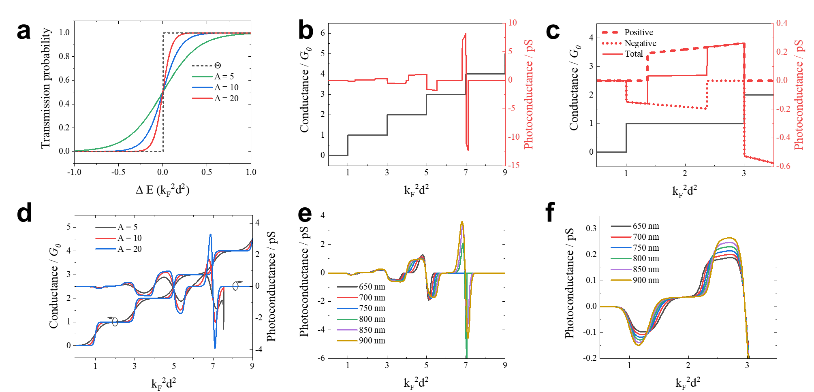
Fig. S2 Simulation of photoconductance. (a) $Θ$ function and F function with different choices of A. (b) Calculated photoconductance and conductance as a function of the width of nano-constriction near 0K. (c) An enlarged view of (b) near G₀, the red dashed and dotted lines are separated contributions to the total photoconductance. (d) Calculated photoconductance and conductance as a function of the width of nano-constriction at 298.15K with different choices of A. (e) Calculated photoconductance with A = 20 under different wavelength of excitation. (f) An enlarged view of (e) near G₀

Fig. S3 a.c. current vs. bias voltage at 1 G₀. The bias-law exponent of reference signal is ~1.1, suggesting the reference signal is dominated by the flicker noise. The bias-law exponent of photocurrent is ~1.38.

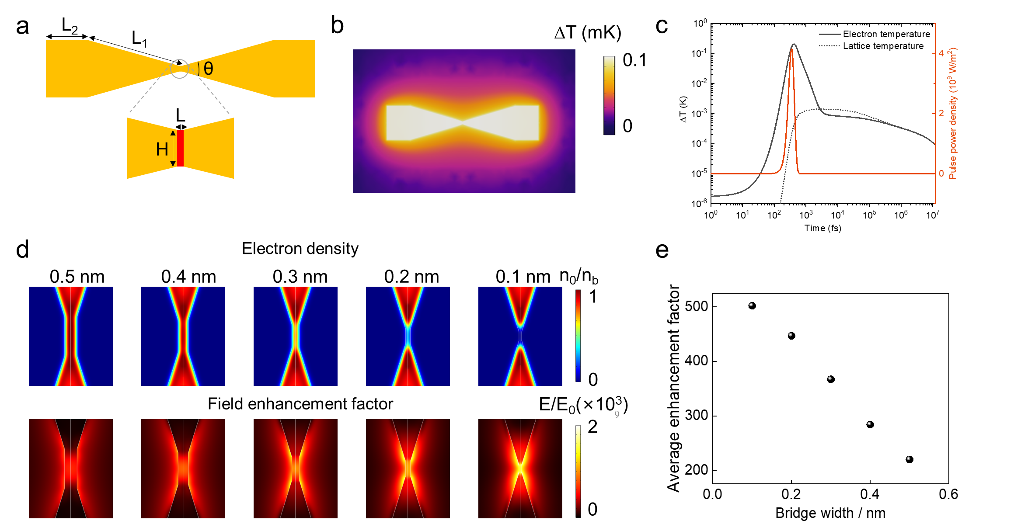
Fig. S4 Geometry for modeling and results. (a) Geometry and parameters of MCBJ chip. (b) Real space distribution of averaged temperature change induced by laser pulse. (c) Simulated electron (solid black line) and lattice (dashed black line) temperature as a function of time. The orange line is the temporal power density of laser pulse. (d) Calculated electron density and field enhancement factor at different bridge width. (e) Field enhancement factor as a function of bridge width.

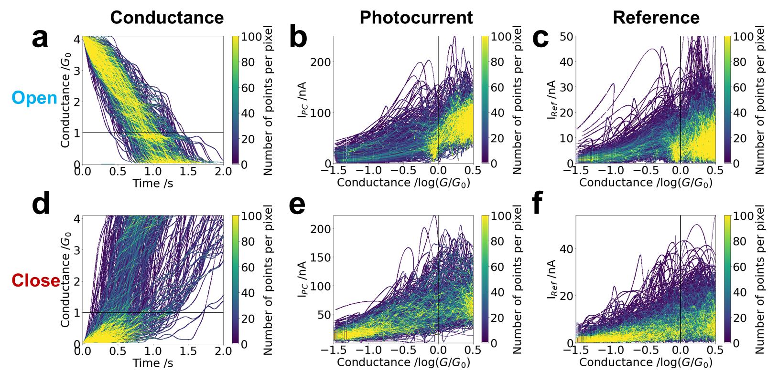
Fig. S5 Density plot of conductance, photocurrent and references for Figure. 2a-c. (a) Conductance traces during open processes. (b-c) Correlated density plot of real-time photocurrent(b)/reference(c) versus d.c. conductance of a. (d) Conductance traces during close processes. (e-f) Correlated density plot of real-time phocurrent(e)/reference current(f) versus d.c. conductance of d.

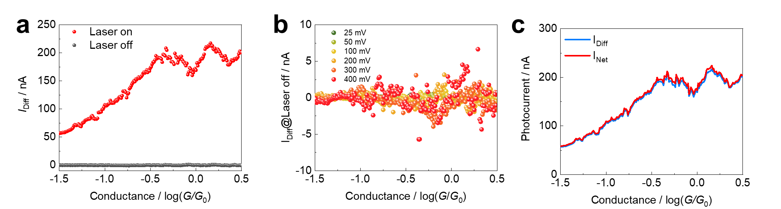
Fig. S6 Demonstration of exctracting net photocurrent. (a) I_{Diff} at laser on and laser off. (b) I_{Diff} at different bias voltage. (c) Comparison of I_{Diff} (=I_{PC} – I_{Ref}) and I_{Net} (=I_{PC@LaserOn}-I_{PC@LaserOff}).
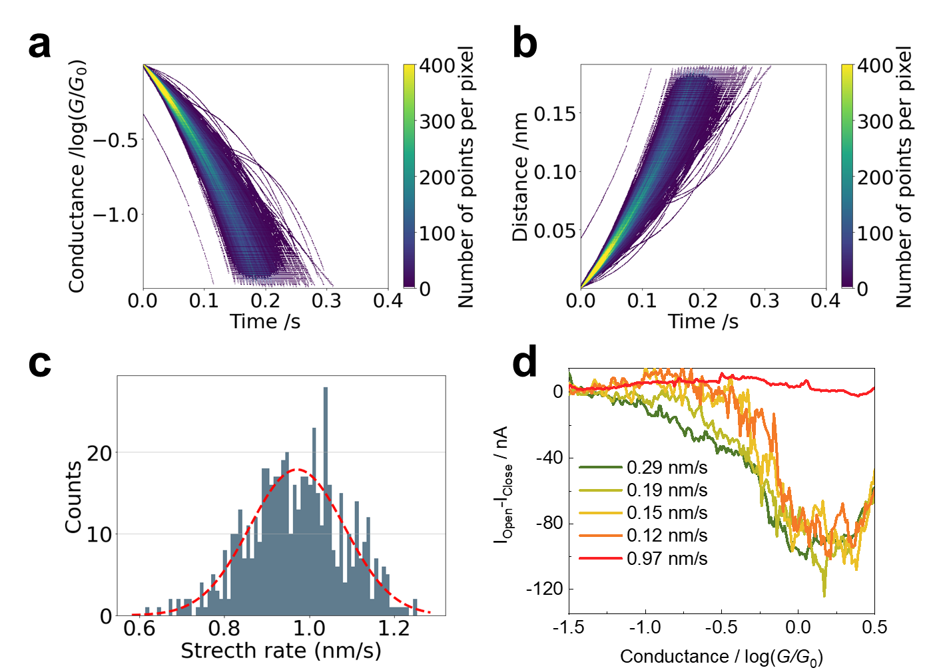
Fig. S7 Stretch rate calibration and photocurrent at different stretch rate. (a) 2D histogram of conductance versus time at tunneling regime. (b) 2D histogram of nanogap distance versus time. (c) 1D histogram of stretch rate. Red dashed line represents Gaussian fitting showing a stretch rate of 0.97±0.11 nm/s.

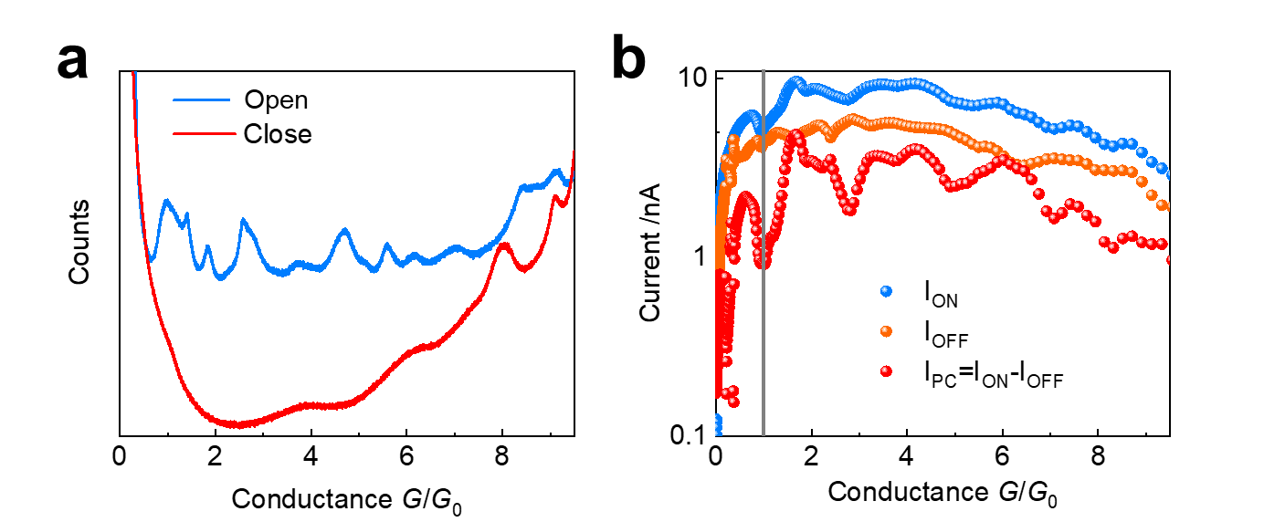
Fig. S8 Typical case of multiple conductance quantum observed. (a) Conductance histogram of Open and Close. (b) Mutiple suppression feature in photocurrent at integer conductance quantum. ION indicates the a.c. current (983 Hz) of laser on. IOFF indicates the a.c. current (983 Hz) of laser off.

Fig. S9 One-dimensional conductance histogram of -3.5 to -1.5 log(G/G0).

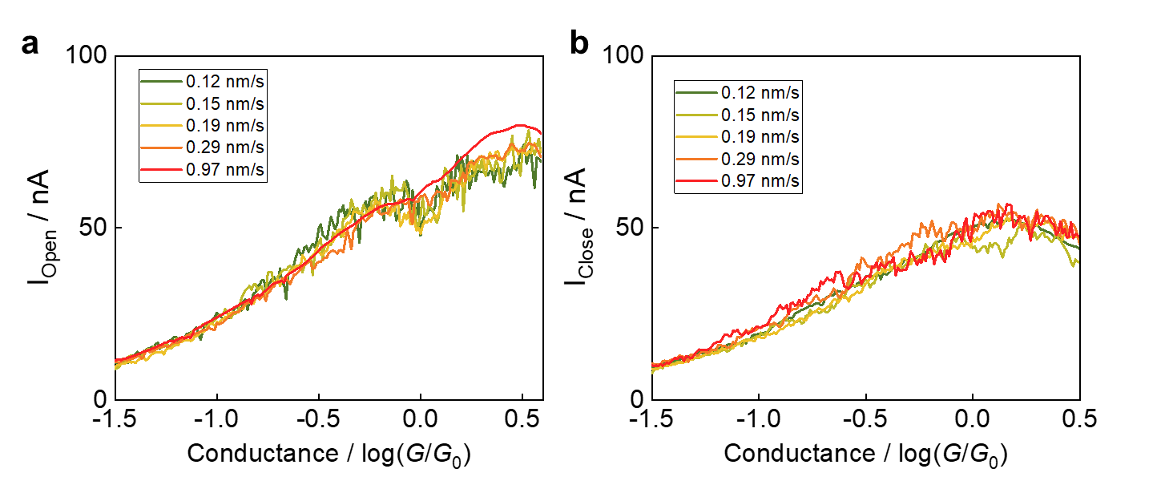
Fig. S10 Influence of stretch rate on photocurrent of Open (a) and Close (b) processes.

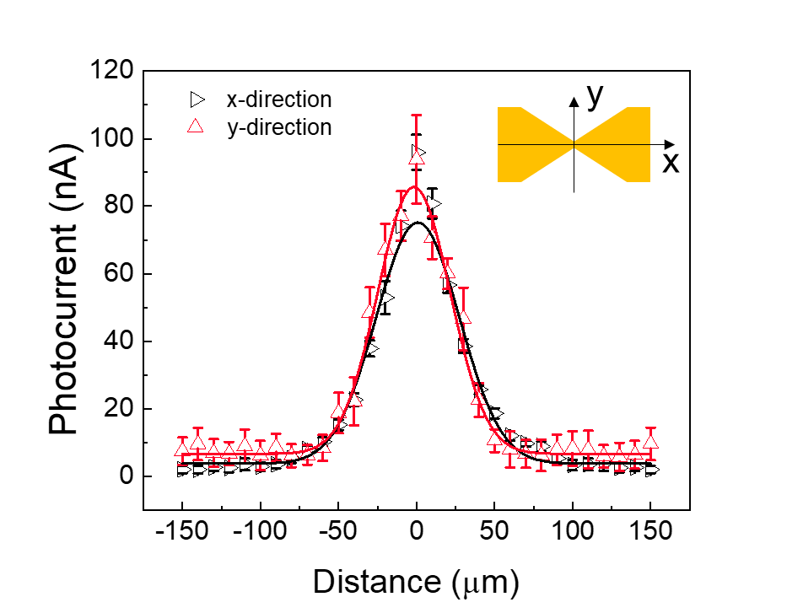
Fig. S11 Spatial distribution of photocurrent. The solid curves are Gaussian fitting. The fitted centers for x-direction and y-direction are 0.81±0.88 μm and -1.62±0.64 μm. The measurements are carried out at conductance of 0.7 log(G/G₀).

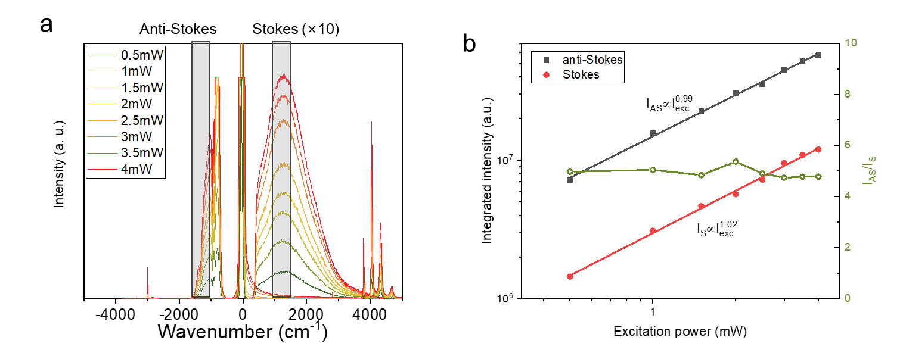
Fig. S12 Stokes and anti-Stokes photoluminescence. (a) Spectra at different excitation power. (b) Integrated intensity and ratio of anti-Stokes/Stokes signals. The power independence of anti-Stokes/Stokes indicates that no significant change occurs in the junction temperature.

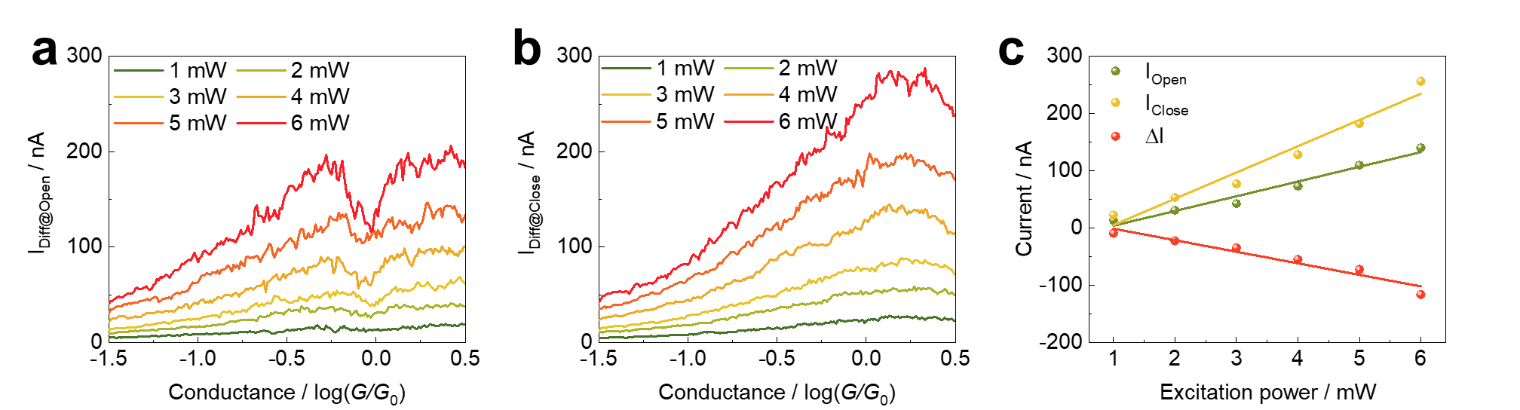
Fig. S13 Raw data for Figure. 3d,e. Photocurrent curves of open (a) and close (b) processes at different excitation power. (c) Photocurrent of 1 G₀ at different excitation power. The solid curve represents the linear fitting.
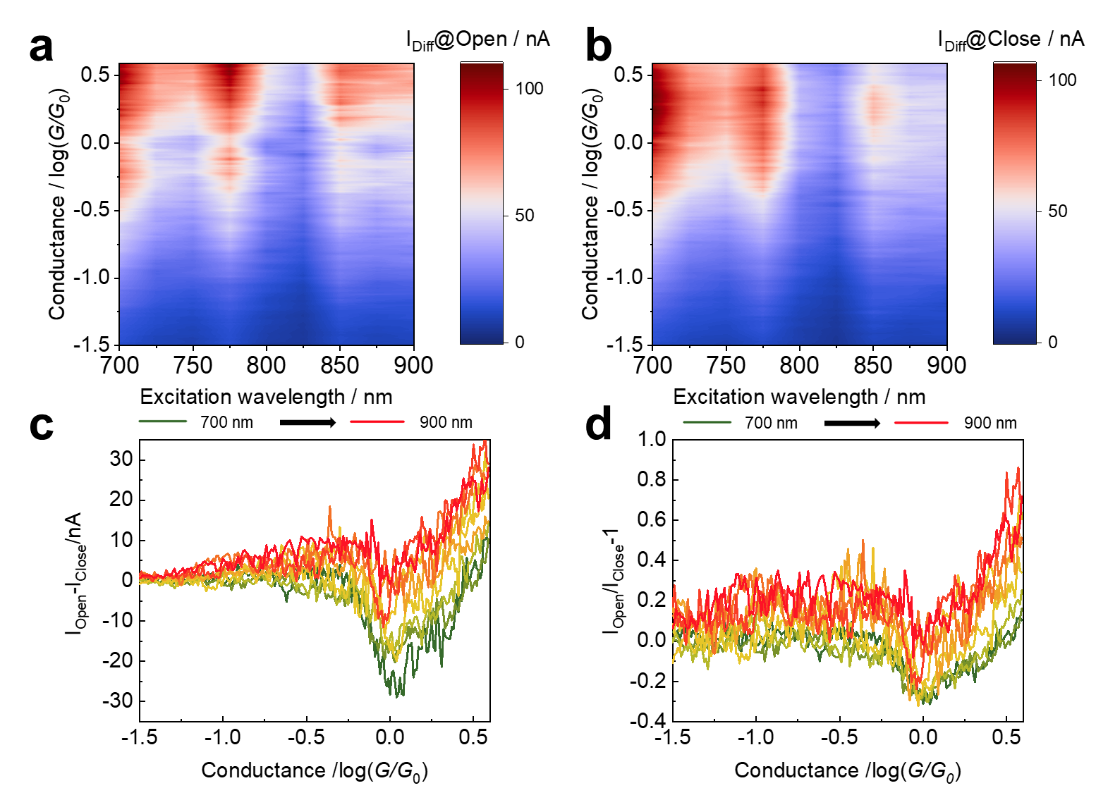

Fig. S14 Wavelength-dependence of photocurrent. (a,b) Photocurrent curves of open (a) and close (b) processes. (c) Suppressed photocurrent. (d) Suppression ratio.
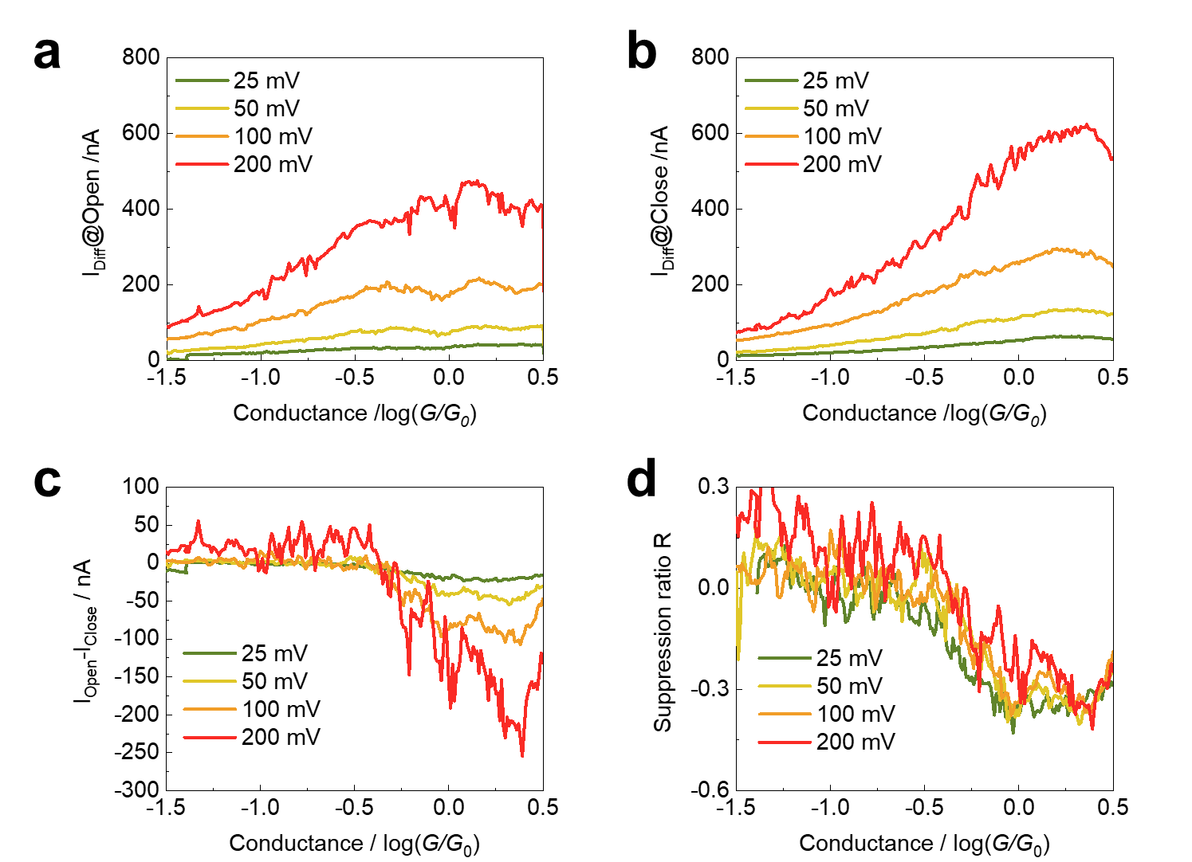
Fig. S15 Bias-dependence of photocurrent suppression. (a,b)Photocurrent curves of open (a) and close (b) processes at different bias voltage. (c,d) The suppression photocurrent (c) and suppression ratio (d) at different bias voltage.
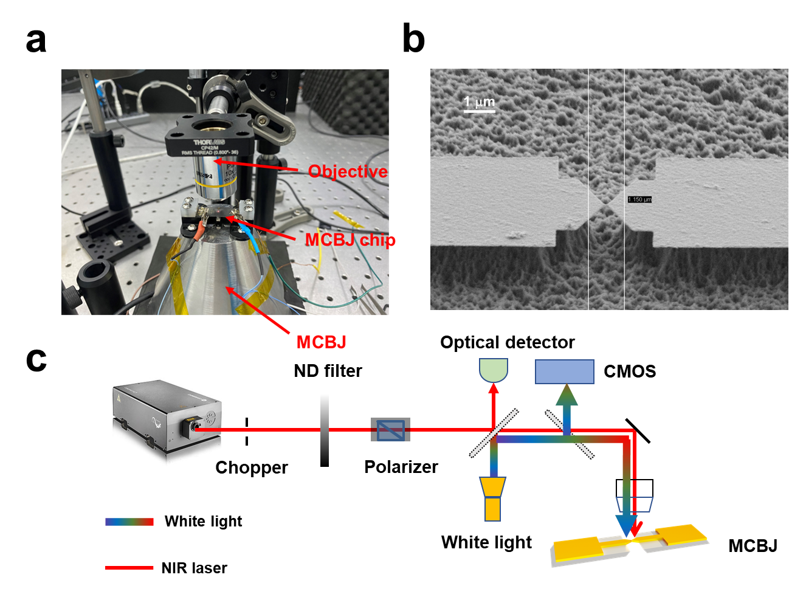
Fig. S16 MCBJ setup. (a) Image of MCBJ. (b) SEM of MCBJ chip. (c) Optical path.

References
1. Ding K., Chan C. T. Plasmonic modes of polygonal rods calculated using a quantum hydrodynamics method. Phys. Rev. B 96, 125134 (2017).
2. Skjolstrup E. J. H., Sondergaard T., Pedersen T. G. Quantum spill-out in few-nanometer metal gaps: Effect on gap plasmons and reflectance from ultrasharp groove arrays. Phys. Rev. B 97, 115429 (2018).
3. Yang Y., Zhu D., Yan W., Agarwal A., Zheng M. J., Joannopoulos J. D., et al. A general theoretical and experimental framework for nanoscale electromagnetism. Nature 576, 248 (2019).
4. Grincwajg A., Gorelik L. Y., Kleiner V. Z., Shekhter R. I. Photoconductance oscillations in a two-dimensional quantum point contact. Phys. Rev. B Condens. Matter 52, 12168 (1995).
5. Grincwajg A., Jonson M., Shekhter R. I. Optical absorption in a two-dimensional quantum point contact. Phys. Rev. B 49, 7557 (1994).
6. Chen R. Y., Wheeler P. J., Natelson D. Excess noise in stm-style break junctions at room temperature. Phys. Rev. B 85, 235455 (2012).
7. Kumar M., Avriller R., Yeyati A. L., van Ruitenbeek J. M. Detection of vibration-mode scattering in electronic shot noise. Phys. Rev. Lett. 108, 146602 (2012).
8. Ciracì C., Della Sala F. Quantum hydrodynamic theory for plasmonics: Impact of the electron density tail. Phys. Rev. B 93, 205405 (2016).
9. Ciracì C. Current-dependent potential for nonlocal absorption in quantum hydrodynamic theory. Phys. Rev. B 95, 245434 (2017).
10. Zhou Q., Li W. C., He Z., Zhang P., Chen X. W. Quantum hydrodynamic model for noble metal nanoplasmonics. Phys. Rev. B 107, 205413 (2023).
11. Chen J. K., Latham W. P., Beraun J. E. The role of electron–phonon coupling in ultrafast laser heating. J. Laser Appl. 17, 63 (2005).
12. Tsutsui M., Morikawa T., Arima A., Taniguchi M. Thermoelectricity in atom-sized junctions at room temperatures. Sci. Rep. 3, 3326 (2013).

