Supplementary Information

for

CRISPR-Cas-amplified urine biomarkers for multiplexed and portable cancer diagnostics

Authors: Liangliang Hao^{1,2}, Renee T. Zhao², Chayanon Ngambenjawong^{1,2}, Henry Ko^{1,2}, Heather E. Fleming^{1,6}, Sangeeta N. Bhatia¹⁻⁶ *.

Affiliations:
¹Koch Institute for Integrative Cancer Research, Massachusetts Institute of Technology,
Cambridge, MA 02139, USA.
²Institute for Medical Engineering and Science, Massachusetts Institute of Technology,
Cambridge, MA 02139, USA.
³Department of Electrical Engineering and Computer Science, Massachusetts Institute of
Technology, Cambridge, MA 02139, USA.
⁴Department of Medicine, Brigham and Women’s Hospital and Harvard Medical School, Boston,
MA 02115, USA.
⁵Broad Institute of Massachusetts Institute of Technology and Harvard, Cambridge, MA 02139,
USA.
⁶Howard Hughes Medical Institute, Cambridge, MA 02139, USA.

*Correspondence to: Sangeeta N. Bhatia. sbhatia@mit.edu

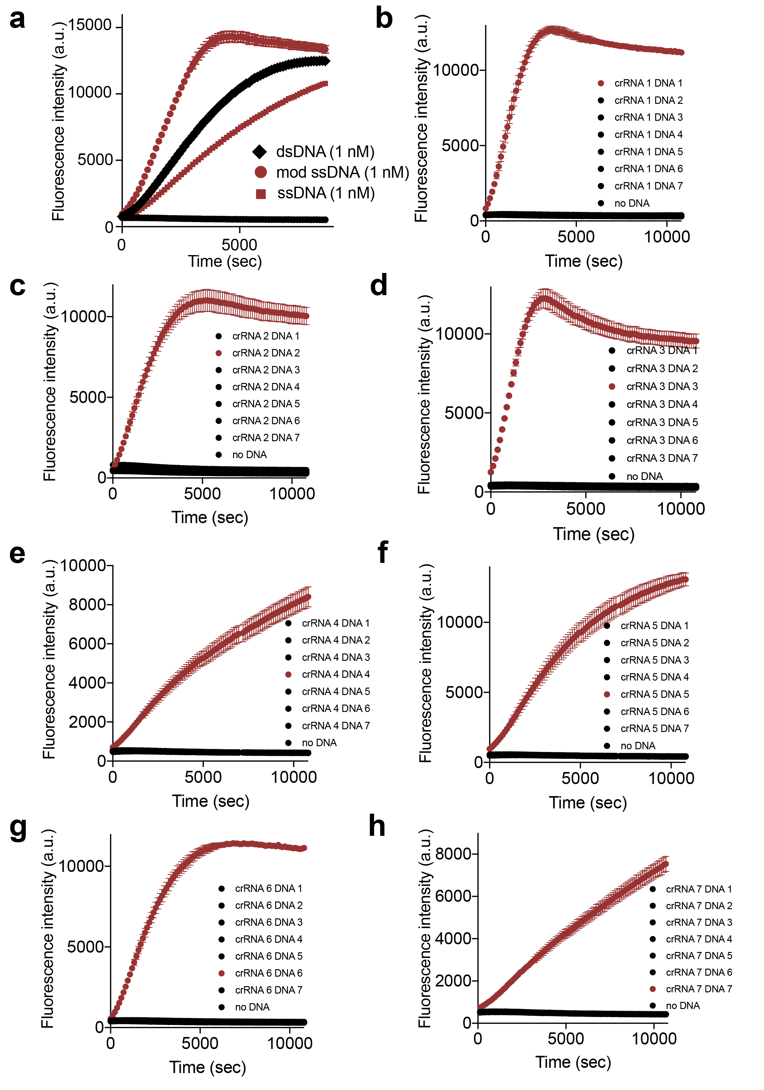Supplementary Figure 1. Collateral activity of LbaCas12a activated by different types of DNA activators. (a) The urine signal after systemic administration of modified and native 20-mer DNAs showing amplification kinetics of modified DNA that surpassed the steady-state concentration of its native DNA counterpart. Signal maximized at 1 hour after administration of DNAs. Image shows urine samples on 384-well plate visualized on the LI-COR Odyssey CLx system. Urine fluorescence was normalized to that of the first timepoint of Cy5-modified DNA injected animal (30 min after DNA injection; n=3 per condition). (b-h) Trans-cleavage rates of Cas12a upon activation of different modified ssDNA activator-crRNA pairs were determined in the Cas12a fluorescent cleavage assay. Assays were performed with urine samples collected from mice injected with 1 nmol of modified ssDNA activator after 1 h of i.v. administration. The initial reaction velocity (V₀) is determined from the slope of the curve at the beginning of a reaction and plotted in Fig. 2d.

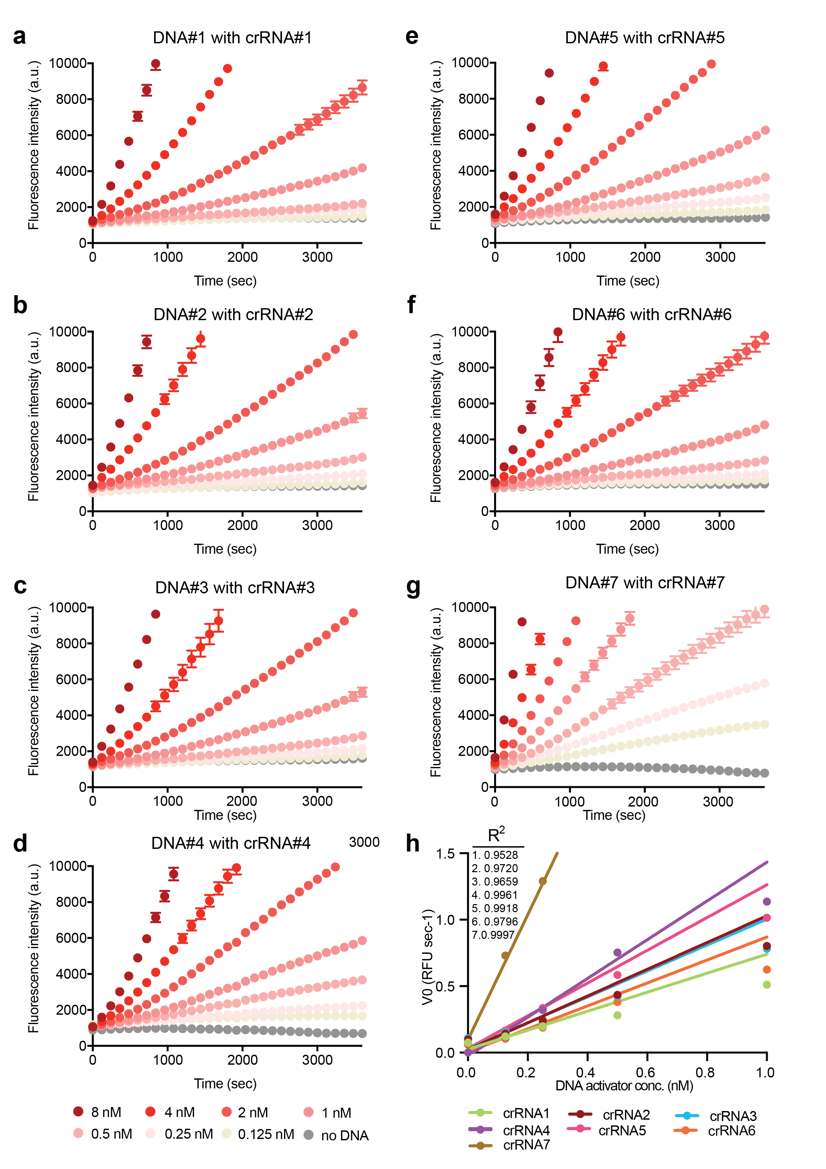

Supplementary Figure 2. Dose dependence of LbaCas12a activation by DNA activators. (a-g) LbaCas12a catalyzed ssDNA trans-cleavage using phosphorothioate-modified 20- mer ssDNA activators. Trans-cleavage rates of Cas12a upon activation of different modified ssDNA activator-crRNA pairs were determined in the Cas12a fluorescent cleavage assay. Assays were performed with different concentration of modified ssDNA activator (8 nM, 4 nM, 2 nM, 1 nM, 0.5 nM, 0.25 nM, 0.125 nM or 0 nM). (H) The initial reaction velocity (V₀) is determined from the slope of the curve at the beginning of a reaction in (a-g) and plotted to determine the linear range of assay performance. Linear regions were shown in V₀ of reactions for all modified ssDNA activator-crRNA pairs within 1 nM of DNA activators. DNA activator 1, 2, 3, 5, 6 were selected for construction of in vivo sensors because of their similarity in assay performance. Sequences of oligonucleotides were shown in Supplementary Table 1.

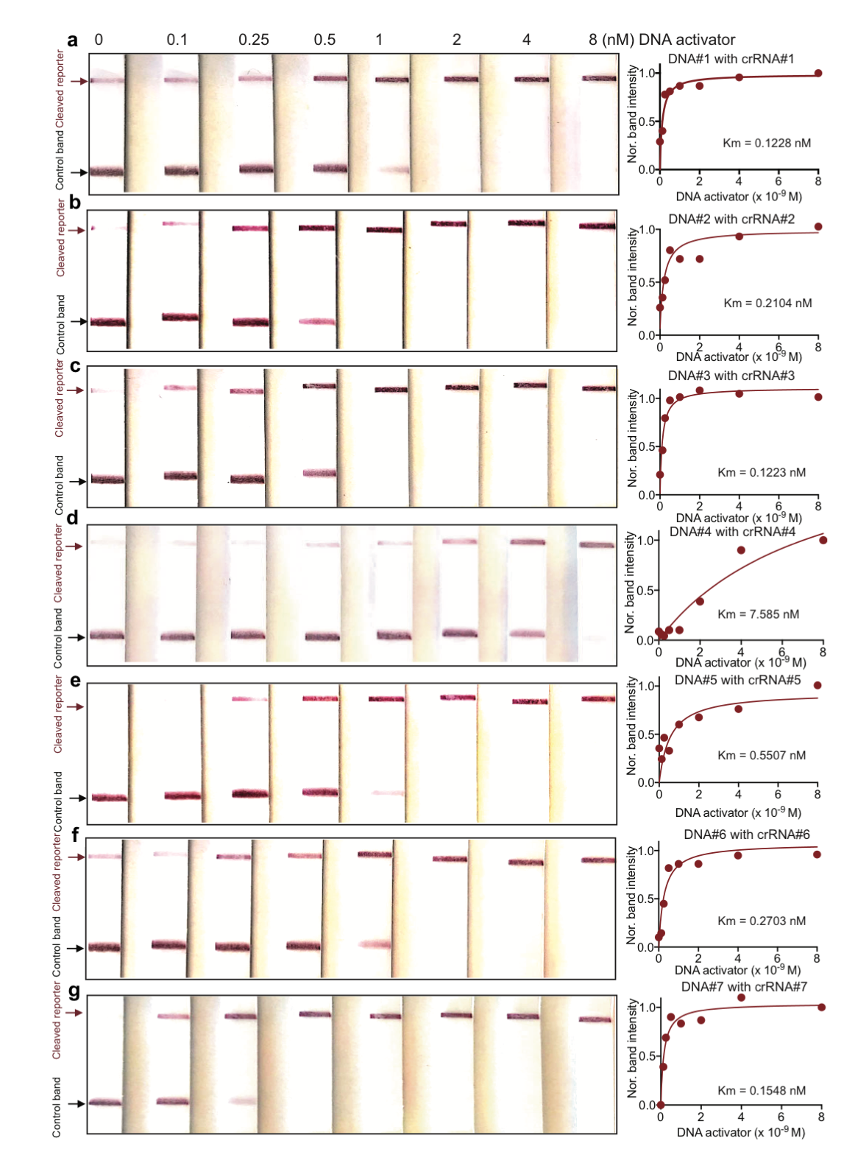Supplementary Figure 3. Dose dependence of LbaCas12a activation by DNA activators in the paper-based lateral flow assays. LbaCas12a catalyzed ssDNA trans cleavage using phosphorothioate-modified 20-mer ssDNA activators. Trans-cleavage rates of Cas12a upon activation of different modified ssDNA activator-crRNA pairs were determined in the Cas12a lateral flow assay. Assays were performed with different concentration of modified ssDNA activator (8 nM, 4 nM, 2 nM, 1 nM, 0.5 nM, 0.25 nM, 0.1 nM or 0 nM) and dual labeled FAM-T₁₀-Biotin reporter. Resulting solution was mixed with HybriDetect 1 assay buffer. HybriDetect 1 lateral flow strips were dipped into solution and intensity of cleaved reporter bands was quantified in ImageJ and plotted to fit Michaelis-Menten kinetics. Consistent with the Cas12a fluorescent cleavage assays shown in Supplementary Fig. 2, linear regions were found within 1 nM of DNA activators for all modified ssDNA activator-crRNA pairs tested. Sequences of oligonucleotides were shown in Supplementary Table 1.

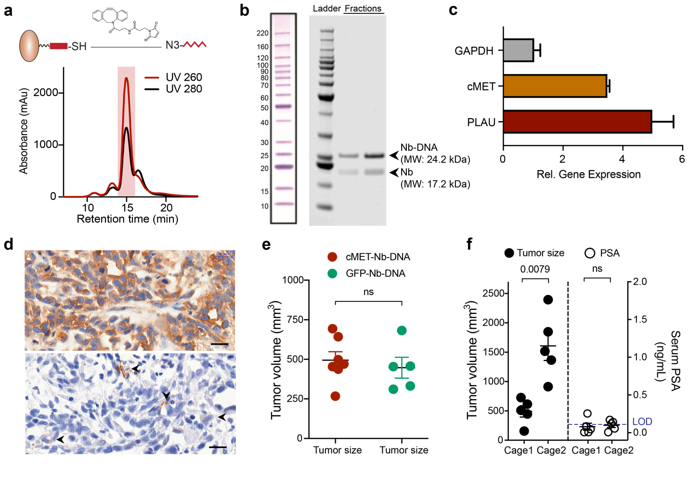
Supplementary Figure 4. Characterizations of DNA-conjugated nanobody in vitro and in vivo. (a) Separation of DNA-conjugated cMET nanobody in a size exclusion chromatography. UV 260 nm (red), the elution curve of oligonucleotides; UV 280 nm (red), the elution curve of proteins. Red shed indicates the elution of the DNA-nanobody conjugate that has significant absorbance at both 260 nm and 280 nm. (b) SDS-PAGE analysis of the DNA-nanobody conjugate showing predicted molecular weight. (c) Increased expression of cMET, the biomarker that the nanobody targets and PLAU, the protease triggers the DNA barcode release, in prostate cancer line PC-3 compared with normal prostate epithelial line RWPE1. (d) Immunohistochemical staining of cMET and PLAU in PC-3 flank tumors. Brown, positive staining. Blue, nuclei. Scale bar = 200 μm. (e) Caliper quantification of tumor sizes of animals shown in Fig. 3d&e. Tumor-bearing mice were injected with different types of DNA-conjugated nanobodies. (f) Subcutaneously implanted PC3 tumors were sized (left half of the graph) and serum PSA collected from these tumor-bearing mice were measured by ELISA (the right half of the graph). Serum PSA concentration did not exceed the limit of detection (LOD) even till the total tumor volumes of two flanks of PC-3 tumors reached over 1,000 mm³ in one animal. Data are shown as mean ± S.E.M, n=5 mice per group, two-tailed unpaired t-test.

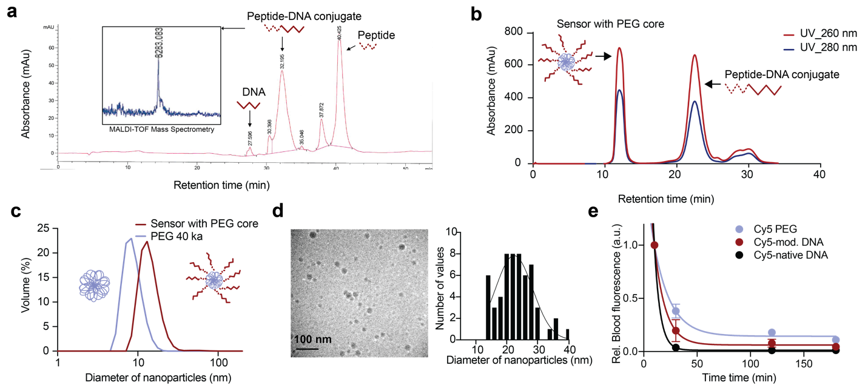

Supplementary Figure 5. Characterizations of DNA-encoded synthetic urine biomarker with a polymeric PEG core. (a) Characterization of the representative DNA-PAP7-SUB with a PEG core. HPLC purification of peptide-DNA (PAP7-DNA2) conjugate. The conjugate was analyzed in mass-spectrometry and showed expected molecular weight (8283 Da). (b) FPLC purification of sensor showed separation of functionalized sensor and unbounded peptide-DNA conjugate. (c) Dynamic light scattering analysis showed the increase of particle size when PEG core (8.3±2.5 nm) was functionalized as DNA-SUB sensors (13.1±4 nm). (d) Cryogenic transmission electron microscopy (cyro-TEM) image of the 5-plex DNA-SUB cocktail (0.5 mg/mL by DNA concentration) for particle sizing. The histogram shows particle size distribution (n= 60 particles). The average diameter of the sensor cocktail was 23.5±6.4 nm. The solid line represents the Gaussian fit of the size distribution. (e) Plasma half-life shows rapid clearance of native DNA molecules and prolonged half-life of the modified DNA and PEG scaffold in healthy Balb/c mice.

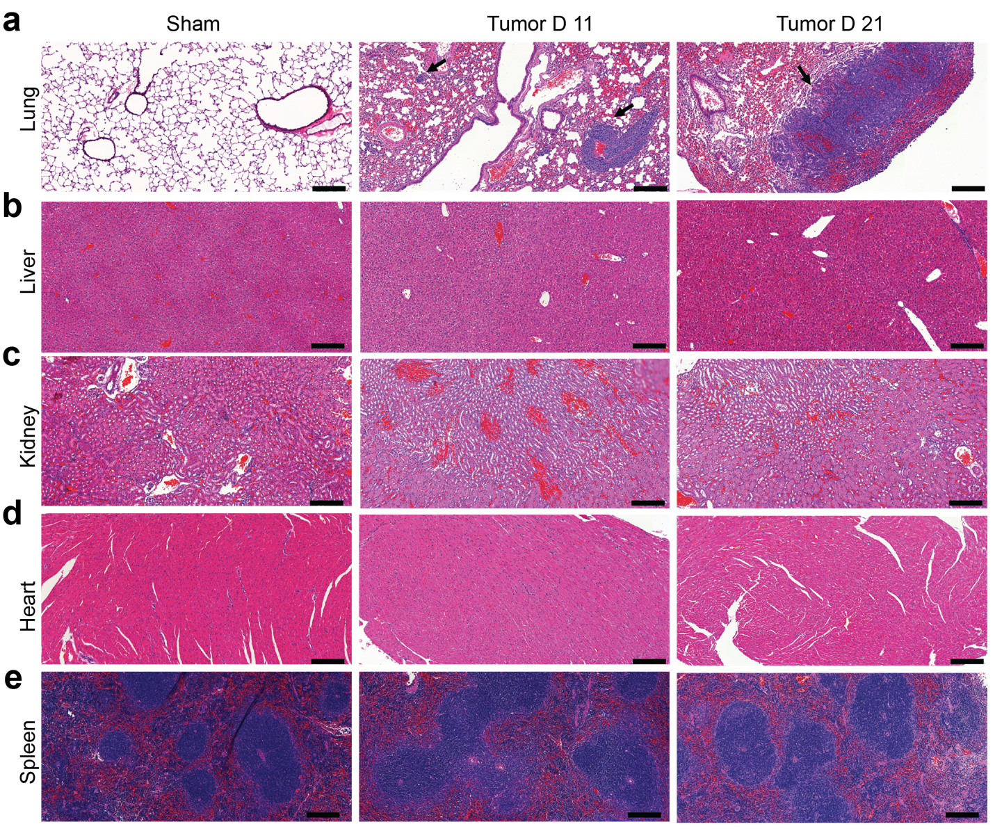

Supplementary Figure 6. Histology of major organs of CRC lung metastasis model. Immunocompetent Balb/c mice were injected with MC26-Fluc cells (tumor) or saline (sham) intravenously. (a-e) Organs (lung, liver, kidney, heart and spleen) were collected at 11 and 21 days after administration. Organs were fixed, embedded in paraffin, and stained with hematoxylin & eosin. Study was done with n=3 mice per time point and images from a representative animal are shown. Scale bar = 100 µm. Arrows, tumor nodules in the lung.

Supplementary Figure 7. Identification of deregulated proteases in CRC to select peptide substrates for in vivo sensors. (a) Analysis of differentially expressed proteases in CRC samples and normal adjacent tissues. Data available from TCGA. (b) RT-qPCR validation of proteases in the tumor-bearing lung from Balb/c mice injected with MC26-Fluc cells in comparison of normal lung from Balb/c mice injected with saline. Details of each qPCR probe can be found in the Key Resources Table. (c) Typical proteases identified in the matrix of primary human colon cancer (CC) and their liver metastases (LM), in comparison of normal colon (Nor.) tissue. Pink, presence; white, absence. Data available from Matrisome project (http://matrisomeproject.mit.edu/). (d) Immunofluorescence staining of proteases in the tumor bearing lung tissue sections. Staining of MMP3, MMP7, MMP9 and CTSD is shown in red. Nuclei are counterstained blue with DAPI. Scale bar = 100 μm. (e) 16 FRET-paired protease substrates, each consisting of a peptide sequence flanked by a FAM fluorophore and a CPQ-2 quencher, were screened against 22 recombinant proteolytic enzymes. Details of each enzyme can be found in the Key Resources Table. Lower, FRET signal was monitored by kinetic plate reader and the z-scored cleavage rate were subjected to heatmap and Hierarchical Clustering on Morpheus (https://software.broadinstitute.org/morpheus). Asterisk, peptide substrates selected for construction of in vivo sensors because of their broad coverage of metallo, serine and aspartic protease activities.

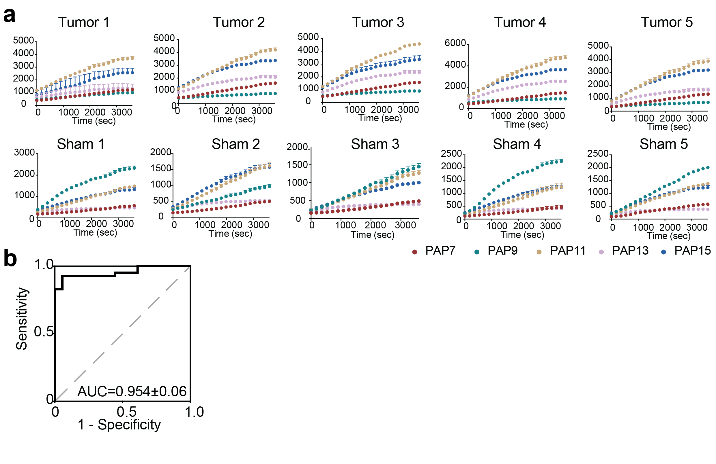
Supplementary Figure 8. Classification power of selected peptide substrates in differentiating tumor from normal tissue. (a) Selected FRET-paired protease substrates (PAP 7, PAP 9, PAP 11, PAP 13, PAP 15) were incubated against tissue lysates from tumor bearing lung (tumor, upper) or normal lung (sham, lower) of Balb/c mice (n=5). (b) ROC curve showing the classification power of the 5 substrates to differentiate tumor vs normal tissue. The area under the curve (AUC) was calculated (P<0.0001). Dashed line represents an AUC of 0.5, and a perfect AUC is 1.0.

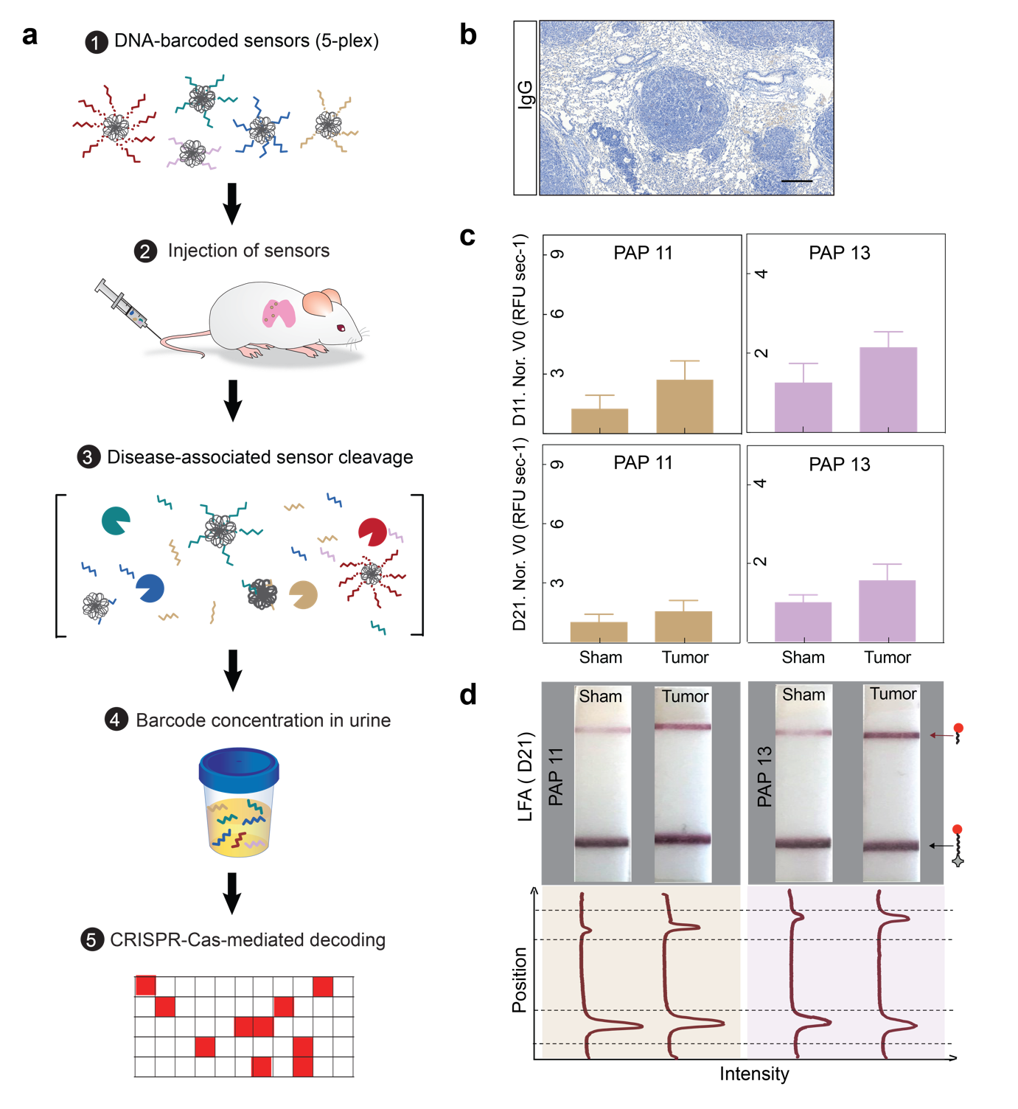
Supplementary Figure 9. DNA-encoded synthetic urine biomarkers for multiplexed disease monitoring. (a) Scheme of the workflow for longitudinal disease monitoring with the multiplexed DNA-encoded synthetic urine biomarkers. (b) Immunohistochemistry staining of lung sections of Balb/c mice bearing CRC lung tumor nodules with epitope control antibody. (c) 5-plex DNA-SUBs were pooled and administered to Balb/c mice bearing CRC lung tumor nodules and control animals at day 11 or 21 after tumor initiation. All urine samples were collected at 1 h after sensor administration. Two sensors (DNA-PAP11-SUB, DNA-PAP11-SUB) showed an increase in the sets of tumor-bearing mice generated urine signals that were elevated relative to control animals. (d) Representative paper strips of the paper based LFA of Cas12a activated by mouse urine samples collected in (c). Band intensities were quantified using ImageJ. The top peak of the curve shows the presence of the “cleaved reporter” and the bottom peak shows the presence of the “control band”.
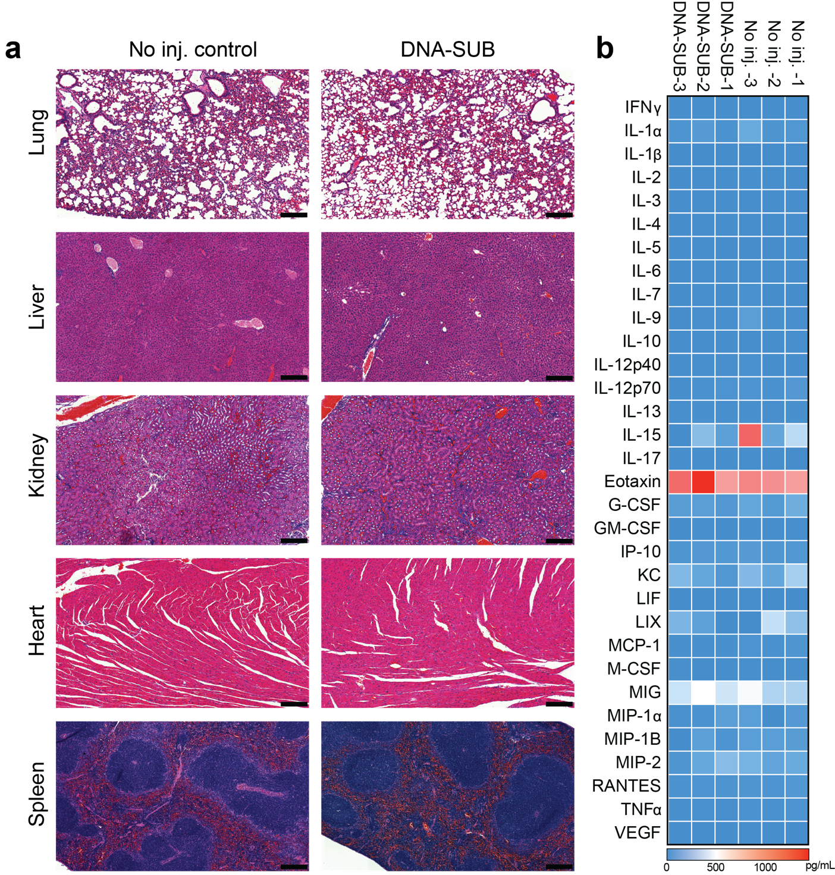

Supplementary Figure 10. In vivo toxicity of DNA-SUBs (a). Immunocompetent Balb/c mice were intravenously injected with multiplexed sensors at the same dose as in Fig 4. Organs (lung, liver, kidney, heart and spleen) were collected after 1 week of sensor administration. Organs were fixed, embedded in paraffin, and stained with hematoxylin & eosin. Study was done with n=3 mice per time point and images from a representative animal are shown. Scale bar = 200 µm. (b) Blood samples collected from mice with or without sensor injection (n=3 mice per group) were analyzed with the mouse Cytokine/Chemokine 32-plex array (Eve Technologies). Legend, numeric concentration of assayed proteins (pg/mL).

Supplementary Table 1. Nucleic acid sequences used in this study.
Name of oligo | Sequence (5’ 3’)
crRNA 1 | UAAUUUCUACUAAGUGUAGAUCGUCGCCGUCCAGCUCGACC
crRNA 2 | UAAUUUCUACUAAGUGUAGAUGAUCGUUACGCUAACUAUGA
crRNA 3 | UAAUUUCUACUAAGUGUAGAUCCUGGGUGUUCCACAGCUGA
crRNA 5 | UAAUUUCUACUAAGUGUAGAUCTGTGTTTATCCGCTCACAA
crRNA 6 | UAAUUUCUACUAAGUGUAGAUUGAAGUAGAUAUGGCAGCAC
crRNA 7 | UAAUUUCUACUAAGUGUAGAUACAAUAUGUGCUUCUACACA
ssDNA | TAGCATTCCACAGACAGCCCTCATAGTTAGCGTAACGATCTAAAGTTTTGTCGTC
Mod ssDNA | T*A*G*C*A*T*T*C*C*A*C*A*G*A*C*A*G*C*C*C*T*C*A*T*A*G*T*T*A*G*C*G*T*A*A*C*G*A*T*C*T*A*A*A*G*T*T*T*T*G*T*C*G*T*C
dsDNA- strand 1 | TAGCATTCCACAGACAGCCCTCATAGTTAGCGTAACGATCTAAAGTTTTGTCGTC
dsDNA- strand 2 (complementary) | GACGACAAAACTTTAGATCGTTACGCTAACTATGAGGGCTGTCTGTGGAATGCTA
Mod DNA 1 | G*G*T*C*G*A*G*C*T*G*G*A*C*G*G*C*G*A*C*G
Mod DNA 2 | T*C*A*T*A*G*T*T*A*G*C*G*T*A*A*C*G*A*T*C
Mod DNA 3 | T*C*A*G*C*T*G*T*G*G*A*A*C*A*C*C*C*A*G*G
Mod DNA 4 | G*A*G*T*A*A*C*A*G*A*C*A*T*G*G*A*C*C*A*T*C*A*G
Mod DNA 5 | T*T*G*T*G*A*G*C*G*G*A*T*A*A*A*C*A*C*A*G
Mod DNA 6 | G*T*G*C*T*G*C*C*A*T*A*T*C*T*A*C*T*T*C*A
Mod DNA 7 | T*G*T*G*T*A*G*A*A*G*C*A*C*A*T*A*T*T*G*T
Dye- DNA 2 | /Cy5/TCATAGTTAGCGTAACGATC
Dye- Mod DNA 2 | /Cy5/T*C*A*T*A*G*T*T*A*G*C*G*T*A*A*C*G*A*T*C
10 mer | CGTAACGATC
15 mer | GTTAGCGTAACGATC
20 mer | TCATAGTTAGCGTAACGATC
24 mer | TCATAGTTAGCGTAACGATCTAAA
26 mer | CAGCCCTCATAGTTAGCGTAACGATC
30 mer | CAGCCCTCATAGTTAGCGTAACGATCTAAA
34 mer | GACAGCCCTCATAGTTAGCGTAACGATCTAAAGT
Mod 10 mer | C*G*T*A*A*C*G*A*T*C
Mod 15 mer | G*T*T*A*G*C*G*T*A*A*C*G*A*T*C
Mod 20 mer | T*C*A*T*A*G*T*T*A*G*C*G*T*A*A*C*G*A*T*C
Mod 24 mer | T*C*A*T*A*G*T*T*A*G*C*G*T*A*A*C*G*A*T*C*T*A*A*A
Mod 26 mer | C*A*G*C*C*C*T*C*A*T*A*G*T*T*A*G*C*G*T*A*A*C*G*A*T*C
Mod 30 mer | C*A*G*C*C*C*T*C*A*T*A*G*T*T*A*G*C*G*T*A*A*C*G*A*T*C*T*A*A*A
Mod 34 mer | G*A*C*A*G*C*C*C*T*C*A*T*A*G*T*T*A*G*C*G*T*A*A*C*G*A*T*C*T*A*A*A*G*T
Mod DNA 1 3’-DBCO | G*G*T*C*G*A*G*C*T*G*G*A*C*G*G*C*G*A*C*G\DBCO
Mod DNA 2 3’-DBCO | T*C*A*T*A*G*T*T*A*G*C*G*T*A*A*C*G*A*T*C\DBCO
Mod DNA 3 3’-DBCO | T*C*A*G*C*T*G*T*G*G*A*A*C*A*C*C*C*A*G*G\DBCO
Mod DNA 4 3’-DBCO | G*A*G*T*A*A*C*A*G*A*C*A*T*G*G*A*C*C*A*T*C*A*G\DBCO
Mod DNA 5 3’-DBCO | T*T*G*T*G*A*G*C*G*G*A*T*A*A*A*C*A*C*A*G\DBCO
Mod DNA 6 3’-DBCO | G*T*G*C*T*G*C*C*A*T*A*T*C*T*A*C*T*T*C*A\DBCO
Mod DNA 7 3’-DBCO | T*G*T*G*T*A*G*A*A*G*C*A*C*A*T*A*T*T*G*T\DBCO
Mod DNA 2 3’- Azide | T*C*A*T*A*G*T*T*A*G*C*G*T*A*A*C*G*A*T*C\Azide

*, phosphorothioate modification
DBCO, Dibenzocyclooctyne
Cy5, Cyanine 5 dye

Supplementary Table 2. Activation of Cas12a with native and modified DNA oligos in vitro and in vivo.
Activation of Cas12a with native and modified DNA oligos were quantified in the Cas12a fluorescent cleavage assay. For ‘DNA in vitro’, 4 nM of DNA activators with different length were added in each reaction. For ‘DNA in vivo’, 1 nmol of DNA activators, native or modified, with different length were injected into healthy Balb/c mice and urine samples collected after 1 h of injection were added in each reaction. *The initial reaction velocity (V₀) refers to the slope of the curve at the beginning of a reaction.

Oligo | Modified DNA in vitro (V₀)* | Modified DNA in vivo (V₀) | Native DNA in vitro (V₀) | Native DNA in vivo (V₀)
10 mer | 0.01 | 0.01 | 0.00 | 0.00
15 mer | 0.01 | 0.01 | 0.00 | 0.00
20 mer | 6.29 | 1.82 | 7.67 | 0.02
24 mer | 8.91 | 0.92 | 10.94 | 0.00
26 mer | 5.25 | 0.60 | 6.09 | 0.01
30 mer | 4.65 | 0.34 | 4.98 | 0.00
34 mer | 4.55 | 0.38 | 3.32 | 0.01

Supplementary Table 3. Peptide and protein sequences used in this study.

Name of peptide | Sequence (N C)
Q7-click | K(N3)-ANP-GGPLGVRGKGGC
Q9-click | K(N3)-ANP-GG-DPhe-PRSGGC
PQ2-click | K(N3)-ANP-GGGSGRSANAKGGC
PQ12-click | K(N3)-ANP-GGVPRGGC
PQ19-click | K(N3)-ANP-GPVPLSLVMGGC
FRET-PAP1 | 5FAM-GGPQGIWGQK(CPQ2)-PEG2-GC
FRET-PAP2 | 5FAM-GGLVPRGSGK(CPQ2)-PEG2-GC
FRET-PAP3 | 5FAM-GGPVGLIGK(CPQ2)-PEG2-GC
FRET-PAP4 | 5FAM-GGPWGIWGQGK(CPQ2)-PEG2-GC
FRET-PAP5 | 5FAM-GGPVPLSLVMK(CPQ2)-PEG2-GC
FRET-PAP6 | 5FAM-GGPLGLRSWK(CPQ2)-PEG2-GC
FRET-PAP7 | 5FAM-GGPLGVRGKK(CPQ2)-PEG2-GC
FRET-PAP8 | 5FAM-GGf-Pip-RSGGGK(CPQ2)-PEG2-GC
FRET-PAP9 | 5FAM-GGfPRSGGGK(CPQ2)-PEG2-GC
FRET-PAP10 | 5FAM-GGf-Pip-KSGGGK(CPQ2)-PEG2-GC
FRET-PAP11 | 5FAM-GGGSGRSANAKG-K(CPQ2)-PEG2-GC
FRET-PAP12 | 5FAM-GILSRIVGGG-K(CPQ2)-PEG2-GC
FRET-PAP13 | 5FAM-GGVPRGG-K(CPQ2)-PEG2-GC
FRET-PAP14 | 5FAM-GSGSKIIGGG-K(CPQ2)-PEG2-GC
FRET-PAP15 | 5FAM-GPVPLSLVMG-K(CPQ2)-PEG2-GC
FRET-PAP16 | 5FAM-GGLGPKGQTGK(CPQ2)-kk-PEG2-C
cMET nanobody | MEVQLVESGGGLVQPGGSLRLSCAASGFILDYYAIGWFRQAPGKEREGVLCIDASDDITYYADSVKGRFTISRDNAKNTVYLQMNSLKPEDTGVYYCATPIGLSSSCLLEYDYDYWGQGTLVTVSSGSHHHHHHSPSTPPTPSPSTPPGSGRSANAKGGGSC (Clone 4E09, sequence is available from https://patents.google.com/patent/WO2012042026A1/en)
GFP nanobody | MAQVQLVESGGRLVQAGDSLRLSCAASGRTFSTSAMAWFRQAPGREREFVAAITWTVGNTILGDSVKGRFTISRDRAKNTVDLQMDNLEPEDTAVYYCSARSRGYVLSVLRSVDSYDYWGQGTQVTVSGSHHHHHHSPSTPPTPSPSTPPGSGRSANAKGGGSC (Clone LaG-16) (Fridy et al., 2014)

Upper case, L-form amino acid;
Lower case, D-form amino acid;
Underlined, rigid linker sequence
N3, Azide side chain; ANP, photocleavable linker; 5FAM, N-terminal Fluorescein fluorophore

Supplementary Table 4. Sequences of DNA-barcoded synthetic urine biomarkers.

Name of sensors | Sequence (nucleotides 5’3’, peptides N C)
Q7-DNA2 | T*C*A*T*A*G*T*T*A*G*C*G*T*A*A*C*G*A*T*C-ANP-GGPLGVRGKGGC-PEG40k (maleimide)
Q9-DNA1 | G*G*T*C*G*A*G*C*T*G*G*A*C*G*G*C*G*A*C*G-ANP-GG-DPhe-PRSGGC- PEG40k (maleimide)
PQ2-DNA3 | T*C*A*G*C*T*G*T*G*G*A*A*C*A*C*C*C*A*G*G-ANP-GGGSGRSANAKGGC- PEG40k (maleimide)
PQ12-DNA6 | G*T*G*C*T*G*C*C*A*T*A*T*C*T*A*C*T*T*C*A-ANP-GGVPRGGC-PEG40k (maleimide)
PQ19-DNA5 | T*T*G*T*G*A*G*C*G*G*A*T*A*A*A*C*A*C*A*G-ANP-GPVPLSLVMGGC- PEG40k (maleimide)
cMET nanobody-DNA | MEVQLVESGGGLVQPGGSLRLSCAASGFILDYYAIGWFRQAPGKEREGVLCIDASDDITYYADSVKGRFTISRDNAKNTVYLQMNSLKPEDTGVYYCATPIGLSSSCLLEYDYDYWGQGTLVTVSSGSHHHHHHSPSTPPTPSPSTPPGSGRSANAKGGGSC-(3’) C*T*A*G*C*A*A*T*G*C*G*A*T*T*G*A*T*A*C*T*(5’)
GFP nanobody-DNA | MAQVQLVESGGRLVQAGDSLRLSCAASGRTFSTSAMAWFRQAPGREREFVAAITWTVGNTILGDSVKGRFTISRDRAKNTVDLQMDNLEPEDTAVYYCSARSRGYVLSVLRSVDSYDYWGQGTQVTVSGSHHHHHHSPSTPPTPSPSTPPGSGRSANAKGGGSC-(3’) C*T*A*G*C*A*A*T*G*C*G*A*T*T*G*A*T*A*C*T*(5’)

Underlined, rigid linker sequence
ANP, photocleavable linker;
*, phosphorothioate modification
Supplementary Table 5. List of all primary antibodies.
Antibody | Cat# | Manufacturer | Application | Dilution
CTSD | ab75852 | Abcam | IF | 1:100
MMP3 | ab194717 | Abcam | IF | 1:200
MMP7 | ab5706 | Abcam | IF | 1:100
MMP9 | ab38898 | Abcam | IHC, IF | 1:200
PEG | ab190652 | Abcam | IHC | 1:200
PLAU | ab24121 | Abcam | IHC | 1:100
c-Met | ab51067 | Abcam | IHC | 1:100
Cyanine | sc-166895 | Santa Cruz | IF | 1:100

Supplementary Table 6. List of buffers for proteolytic cleavage assays.
Enzyme | Manufacturer | Buffer
MMPs | Enzo | 50mM TRIS, 10 mM CaCl₂, 300 mM NaCl, 20 µM ZnCl2, 0.02% Brij-35, 1% BSA, pH 7.5
ADAMs | Enzo | 10 mM HEPES, 100 mM NaCl, 0.01% Brij-35, 1% BSA,  pH 7.4
Cathepsin B | R&D | 25 mM MES, 5 mM DTT, pH 5.0
Cathepsin D | R&D | 0.1 M NaOAc, 0.2 M NaCl, pH 3.5
Cathepsin E | R&D | 0.1 M NaOAc, 0.5 M NaCl, pH 3.5
Cathepsin K | Enzo | 50mM NaOAc, 1mM DTT, pH 5.5
Cathepsin L | R&D | 50 mM MES, 5 mM DTT, 1 mM EDTA, 0.005% (w/v) Brij-35, pH 6.0
Cathepsin S | R&D | 50 mM NaOAc, 5 mM DTT, 250 mM NaCl, pH 4.5
uPA/PLAU | R&D | 50 mM Tris, 0.01% Tween 20, 1% BSA, pH 7.4,

