Supporting Information
High-performance gas-phase chiral enantiomer detectors based on chiral-induced spin selectivity effect
Xiaocheng Wu†‡, Junjie Liu†‡, Fan Ni†‡, Longlong Jiang†‡, Shiyu Wei†‡, Xiaohong Wang*†‡, Longzhen Qiu*†‡
†National Engineering Lab of Special Display Technology, State Key Lab of Advanced Display Technology, Academy of Opto-Electronic Technology, Hefei University of Technology, Hefei 230009, P. R. China
‡Intelligent Interconnected Systems Laboratory of Anhui, Anhui Province Key Laboratory of Measuring Theory and Precision Instrument, School of Instrument Science and Optoelectronic Engineering, Hefei University of Technology, Hefei 230009, P. R. China
*Corresponding author.
E-mail: xhwang11@hfut.edu.cn (X. Wang); lzhqiu@hfut.edu.cn (L. Qiu)

Appendix 1
Some of the materials used in the study have been commercialized, including polymethyl methacrylate (M_{w} ≈ 996 kDa, Sigma-Aldrich), CYTOP (AGC Asahi Glass).
Preparation of polymers: Polymers were prepared by the one-pot method, which has been reported previously¹⁻⁵.
P3HT₈₀: A 50 mL polymerization tube was fully dried and 500 mg (1.53 mmol) of 2,5-dibromo-3-hexylthiophene monomer was injected into it within argon filled inert environment, to which 6 mL pre-dried tetrahydrofuran (THF) was added as the solvent. After stirring for 10 min at 0 °C, 0.75 mL of THF solution of isopropyl magnesium chloride (2.0 mol in THF) was slowly injected into it and stirred for another 2 h. After recovering to room temperature, 10.39 mg of 1,3-Bis(diphenylphosphino)propane nickel(II) chloride (Ni(dppp)Cl₂) was added into the above mixture to catalyze the polymerization process. Then the reaction temperature was carried out at 35 °C. After 2 h, the mixture was quenched by adding 5 mL of anhydrous methanol, and then dropped into 200 mL of methanol. After thorough stirring, the solid and liquid phases were separated using a high-speed centrifuge, slightly dried and rinsed with a small amount of chloroform, and then centrifuged again by adding methanol. The process was repeated three times. The precipitate was dried in vacuum at room temperature to obtain 182.5 mg of a purple-black solid with a high yield of 73%.

PPI₃₀: A 25 mL polymerization tube was fully dried and 80 mg of phenyl isocyanide monomer was poured into it. Phenyl isocyanide monomer was freshly synthesized by the previously reported methods. ^{4, 5} Argon was used to replace air three times. 6 mL of pre-dried THF was added as the solvent. After stirring for 10 min at 35 °C, 4.03 mg of Ni(dppp)Cl₂ was added into the solution to catalyze the polymerization process, and the reaction was carried out at 35 °C for another 2 h. The mixture was then quenched by adding 5 mL of anhydrous methanol, while subsequent processing steps were the same as procedures for P3HT80. The obtained product was a yellow solid with a mass of 60.8 mg in a yield of 76%. The M_{n,SEC} and PDI of the polymer were 26.8 kDa and PDI = 1.11, respectively (calibrated using polystyrene standards).

P3HT₈₀-PPI₁₀: A 50 mL polymerization tube was fully dried and 500 mg of 2,5-dibromo-3-hexylthiophene monomer was injected into it under an inert argon environment, to which 6 mL of pre-dried THF was added as the solvent. After stirring for 10 min at 0 °C, 0.75 mL of THF solution of isopropyl magnesium chloride (2.0 mol in THF) was slowly injected into it and stirred well for 2 h to combine isopropyl magnesium chloride with the 2,5-dibromo-3-hexylthiophene monomer. After returning to room temperature, 10.39 mg of Ni(dppp)Cl₂ was rapidly injected into it to catalyze the polymerization process, and the reaction was carried out at 35 °C for 2 h. Within argon based inert atmosphere, 68.6 mg of phenyl isocyanide monomer was dissolved in 6 mL of dry THF. It was then injected into the reaction system and stirred for 4 h. The mixture was quenched by adding 5 mL of anhydrous methanol, while the subsequent processing steps were the same as for P3HT80. The obtained product was a 238.9 mg purple-black solid, with a 75% yield.

The preparation of P3HT₈₀-PPI₃₀ and P3HT₈₀-PPI₅₀ was similar to that for P3HT₈₀-PPI₁₀, where P3HT₈₀-PPI₃₀ and P3HT₈₀-PPI₅₀ were prepared by adding 30 and 50 times more phenyl isocyanide monomers than their corresponding catalysts, respectively.

Appendix 2
Device Fabrication: Gas phase enantiomer detectors based on P3HT₈₀-PPI_{n} active layer were fabricated and the corresponding performances were studied. The semiconductor polymer and polymethylmethacrylate (PMMA) were dissolved in 1,2-dichlorobenzene, heated for 2 h and then mixed. A final concentration solution with a semiconductor concentration of 0.75 mg mL⁻¹ and a PMMA mass fraction of 3 wt% was obtained. The silicon substrate was sequentially cleaned with piranha solution, deionised water and then dried with a nitrogen stream. The mixed solution was rotationally coated on the silicon substrate in a glove box at 2000 rpm for 60 s. It was then placed in a vacuum oven and dried overnight at room temperature to remove the solvent. The film on the silicon substrate was immersed in deionised water, peeled off from the silicon surface, then transferred to a SiO₂/Si substrate modified by poly(perfluoroalkenyl vinyl ether) (Cytop). The film was etched with acetone to remove the PMMA. Self-assembled helical structure of the film was achieved by PMMA co-blending. Finally, gold was thermally evaporated onto the organic layer through a mask plate to form two-terminal electrodes, where the channel length and width were kept at 4500 µm and 40 µm, respectively.
For non-helical self-assembled-based devices, the semiconductor was dissolved in 1,2-dichlorobenzene and heated for 2 hours, and then the solution was directly spin-coated onto silica/silicon modified with Cytop. Finally, gold electrode preparation was completed as described above to obtain the corresponding devices.

Appendix 3
Device Characterization: The morphology and thickness of the semiconductor film were characterized in tapping mode using atomic force microscopy (AFM) (Nanoscope, Veeco Instruments Inc). Electron spin polarisation was obtained by testing the I−V curves of the material films under a magnetic field using a magnetically guided atomic force microscope (AFM). Target chiral gas concentrations of 450 to 1,800 ppm were obtained by adjusting the volume ratio between the saturated vapor concentration and pure N₂ from the gas cylinder. Gas composition and relative concentrations were characterized using gas chromatography-mass spectrometry (GC-MS). The electrical and response characteristics of the detector were measured using a Keithley 4200-SCS instrument. The contact angle of water and diiodomethane on the material surface was tested using a contact angle meter (SCA20). All measurements were made at room temperature unless otherwise stated.

Surface energy calculation:
The magnitude of the contact angle is closely related to the surface tension of the various surfaces in the system and can be quantitatively analyzed by Young's equation:
$cosθ=(γ_{sv}-γ_{sl})/γ_{lv}$ (1)
where $γ_{lv}$ denotes the liquid surface tension, $γ_{sv}$ denotes the solid surface energy, and $γ_{sl}$ denotes the solid-liquid interfacial energy.
Fowkes proposed a method for measuring the surface energy $γ_{s}$ of a solid and decomposing the surface energy into a dispersive component $γ_{s}^{d}$ and a polar component $γ_{s}^{p}$, which is described below:
$γ_{s}=γ_{s}^{p}+γ_{s}^{d}$ (2)
When only the dispersion component is considered, there is:
$γ_{sl}=γ_{l}+γ_{s}-2\sqrt{γ_{s}^{d}}×\sqrt{γ_{l}^{d}}$ (3)
Bringing equations (1) and (2) into (3) gives:
$cosθ=\frac{2}{γ_{l}}×\left[{\left(γ_{l}^{d}γ_{s}^{d}\right)}^{\frac{1}{2}}+{\left(γ_{l}^{p}γ_{s}^{p}\right)}^{\frac{1}{2}}\right]-1$ (4)
In the equation, $γ_{l}^{p}$ and $γ_{l}^{d}$ are the polar and dispersive components of the free energy of the liquid surface, respectively; $γ_{s}^{p}$ and $γ_{s}^{d}$ are the polar and dispersive components of the free energy of the solid surface, respectively.
Distilled water and diiodomethane (CH₂I₂) were used as standard liquids ($γ_{l}$、$γ_{l}^{p}$, and $γ_{l}^{d}$ were known for DI-water and CH₂I₂) to measure the contact angle during the testing process, which in turn was used to construct a system of equations based on Eq. (4) to solve for the surface energy.

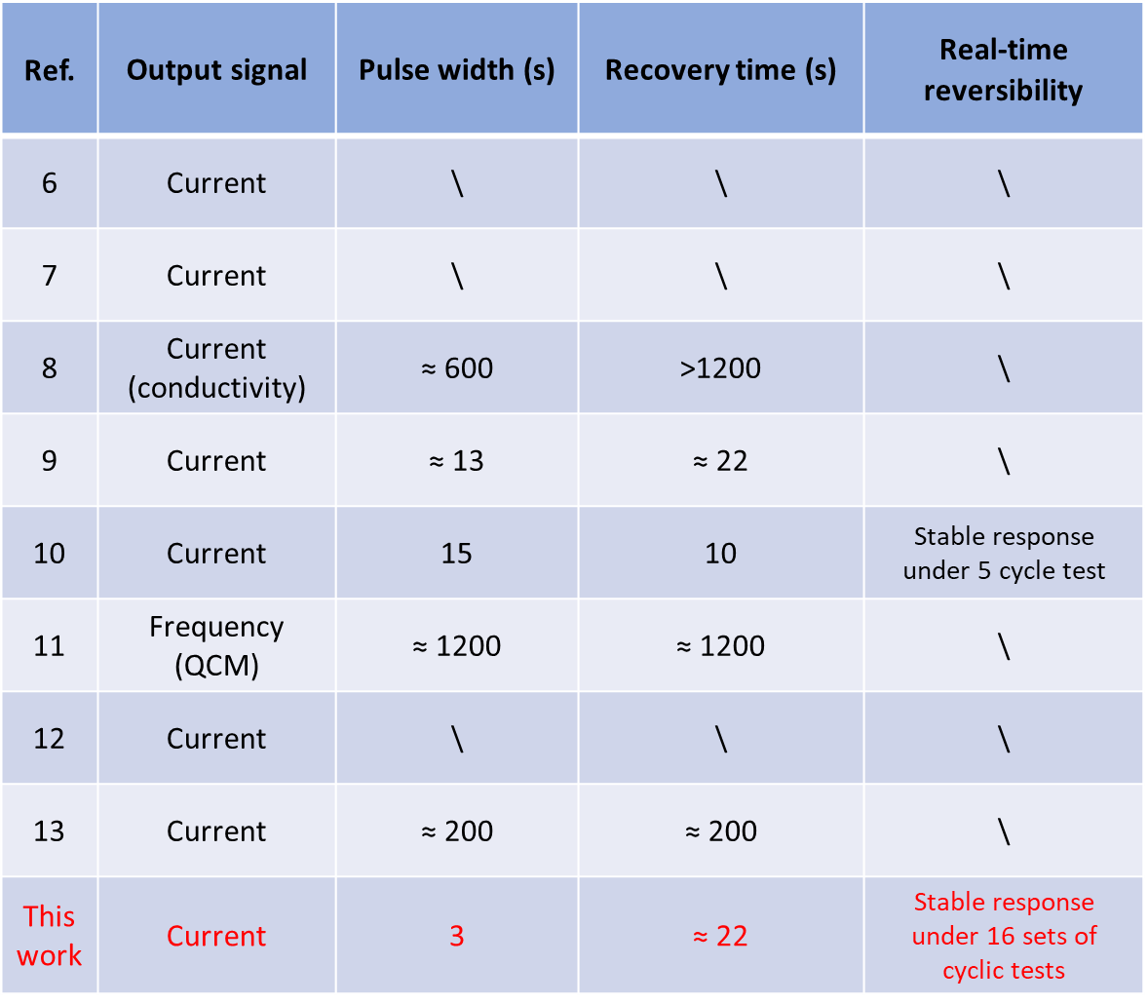
Table S1. Statistics on pulse width (response time), recovery time, and data related to real-time cycling tests that have been reported in the field of chiral gas-phase detection. “\” indicates that this type of data characterization is not available in the literature.

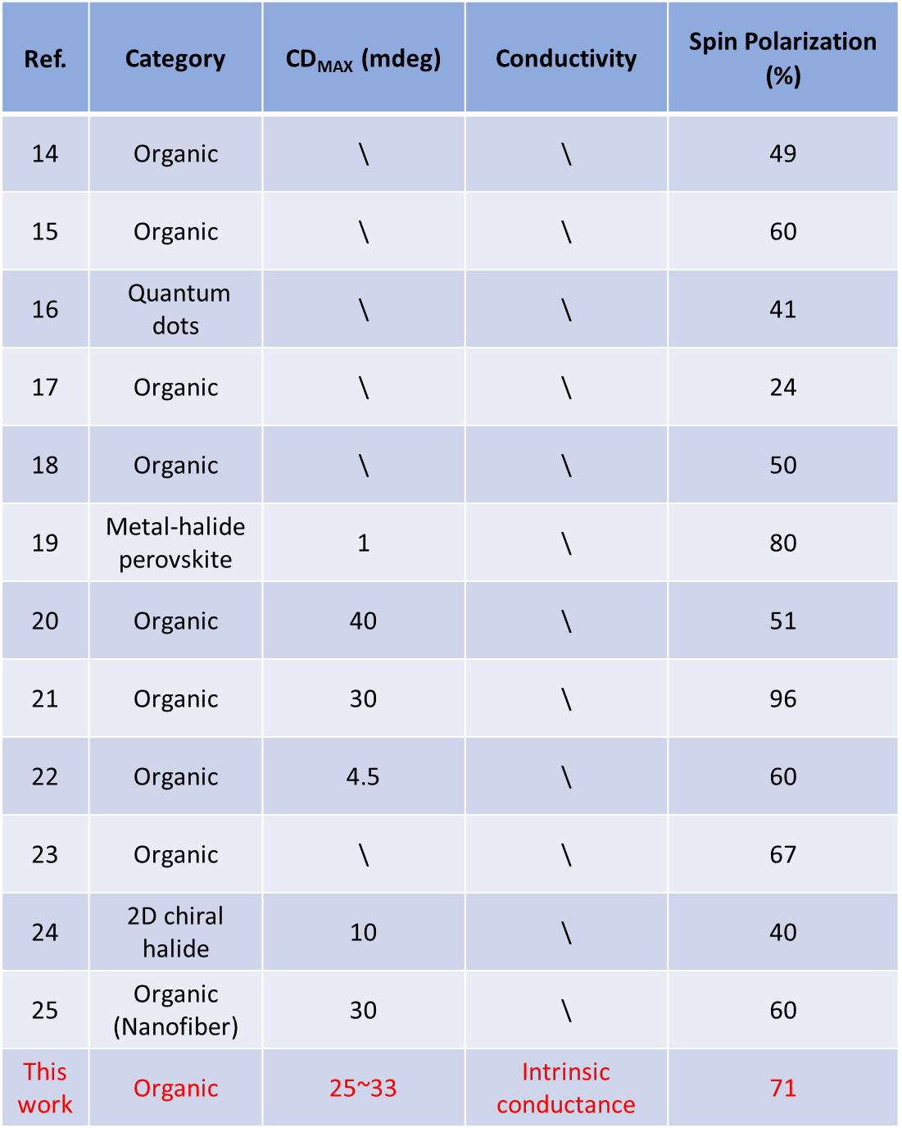
Table S2. Statistics of reported literature data on chiral optical signatures (CD), conductivity, spin polarizability.

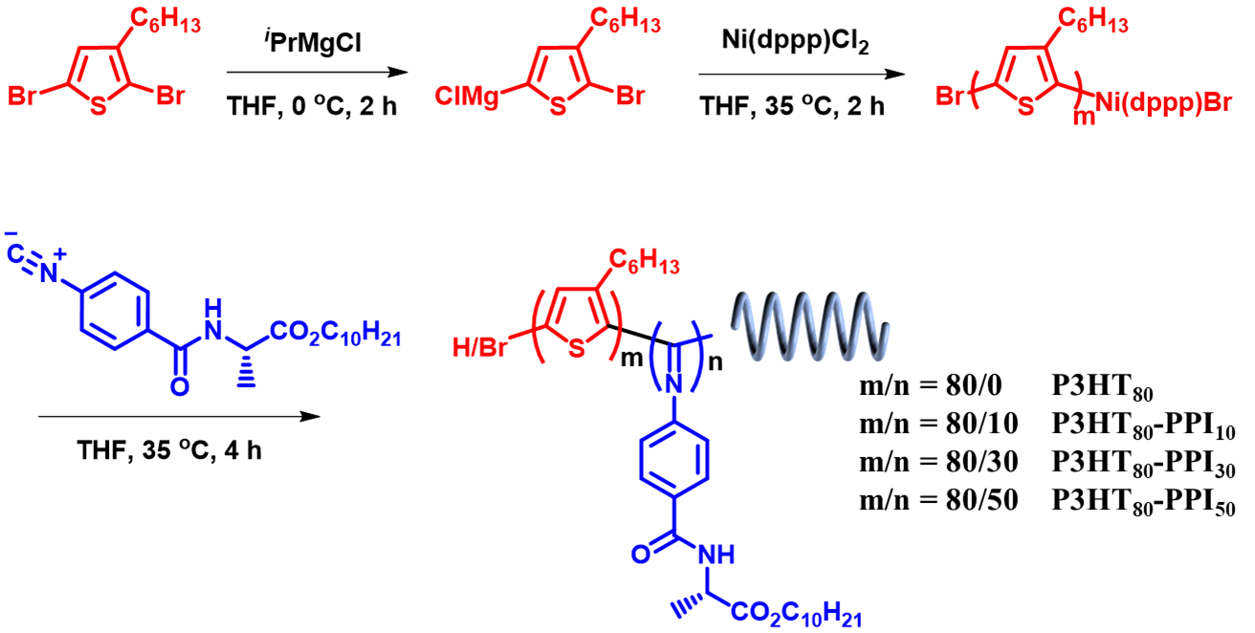
Figure S1. Synthesis of P3HT_{m}-PPI_{n} copolymers.

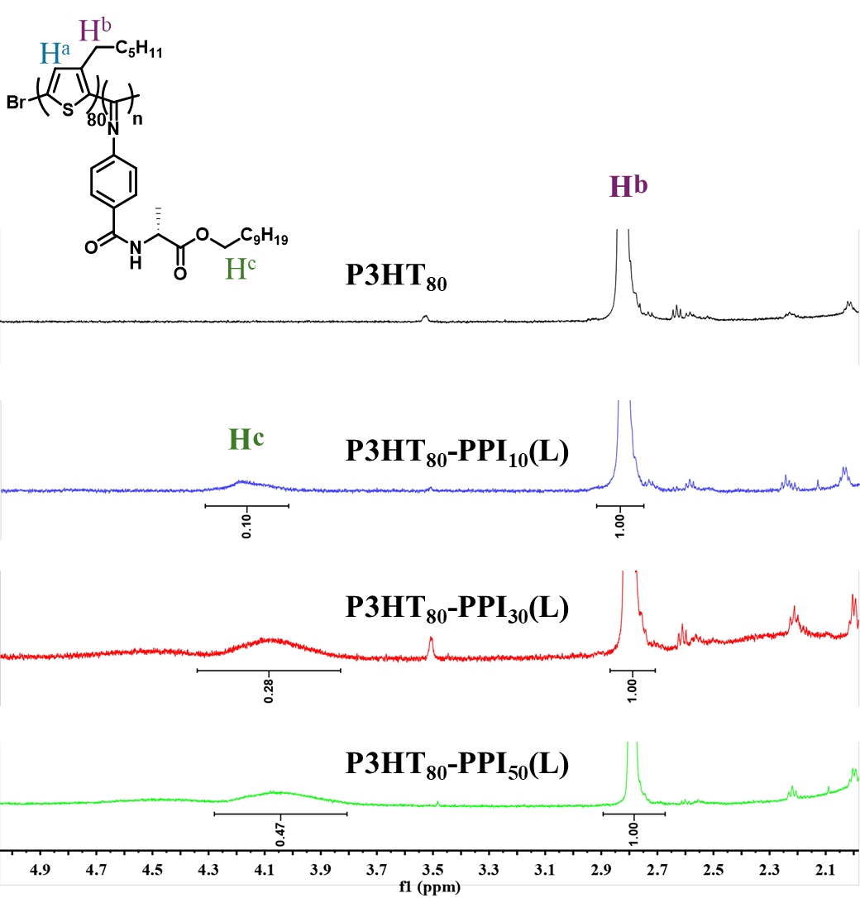
Figure S2. Comparison of ¹H NMR (600 MHz) spectra of copolymers with different block ratios.
As shown in Figure S2, resonances for both the P3HT₈₀ portion represented by peak H^{b} and the PPI portion represented by peak H^{c} at around 4.09 ppm are observed in P3HT₈₀-PPI_{n}. Normalizing the H^{b} integral area to 1, the H^{c} peak integrals in the diblock copolymer are close to the ratios of 10:30:50, indicating the precise synthesis of these copolymers.

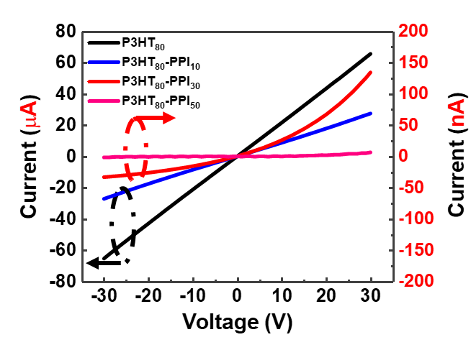
Figure S3. Electrical performance of detectors with different chiral source (PPI(L)) ratios of block polymers as the active layer in atmospheric environment. Unless otherwise noted, P3HT-PPI copolymer films appearing herein are self-assembled films after blending with PMMA.

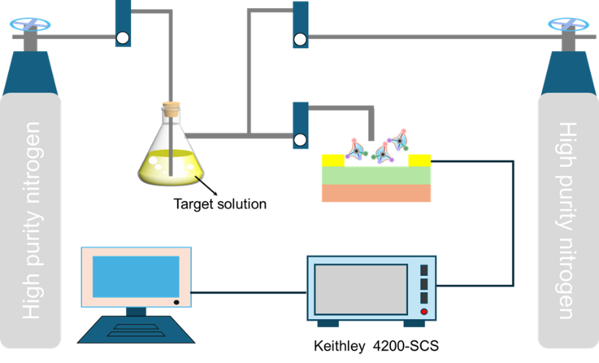

Figure S4. Acquisition of target gas by saturated vapor pressure method and device test schematic.
The saturated vapor concentration of limonene was calculated to be 1,800 ppm in the presence of nitrogen as a background gas, which is calculated and converted to units the equation C = PM/(RT). Where C is the saturated mass concentration, T is the temperature, M is the molar mass, R is the gas constant and P is the saturated vapor pressure ( the saturated vapor pressure of limonene at 25 °C is 1.54 mmHg).

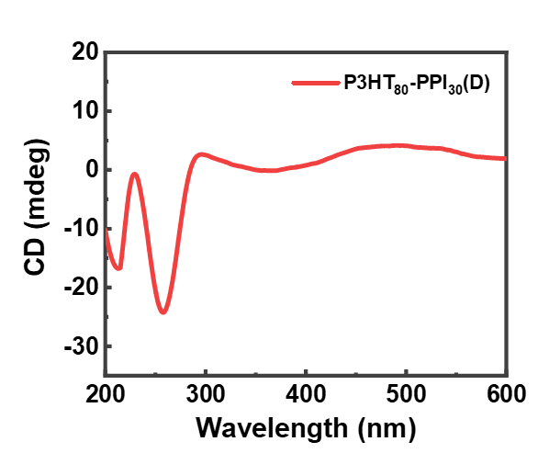

Figure S5. CD spectra of P3HT₈₀-PPI₃₀(D) films.

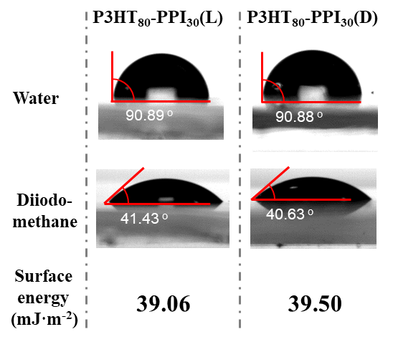
Figure S6. Water contact angle test and surface energy calculation for P3HT₈₀-PPI₃₀(L) and P3HT₈₀-PPI₃₀(D) films.

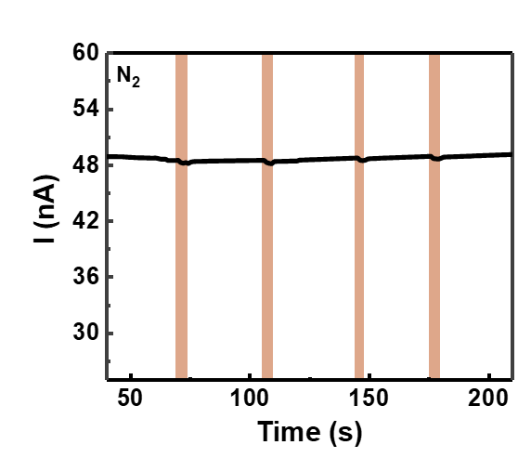
Figure S7. The real-time response curve of the P3HT₈₀-PPI₃₀(L) active layer gas phase detector under pulses of high-purity nitrogen (yellow markers).

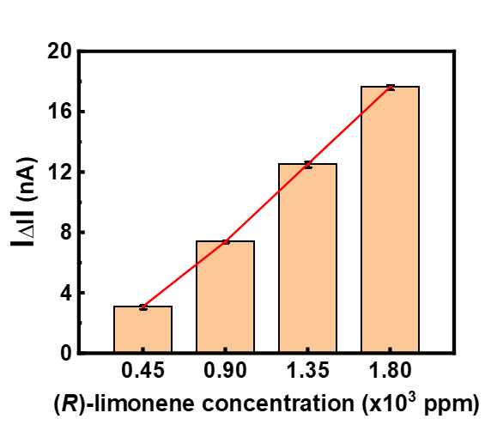
Figure S8. Statistical plots of L-type device response current values for different (R)-limonene gas concentrations. The red curve is plotted by connecting the response values at different concentrations to measure the linearity between the device response values and the gas concentration.

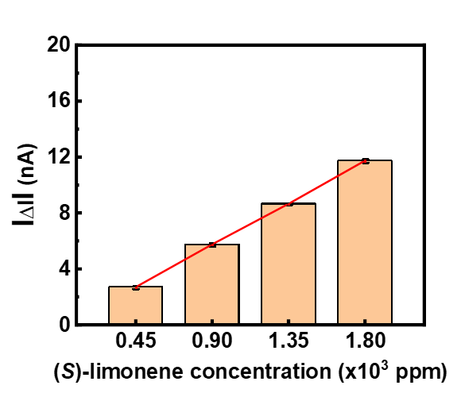
Figure S9. Statistical plots of L-type device response current values for different (S)-limonene gas concentrations.

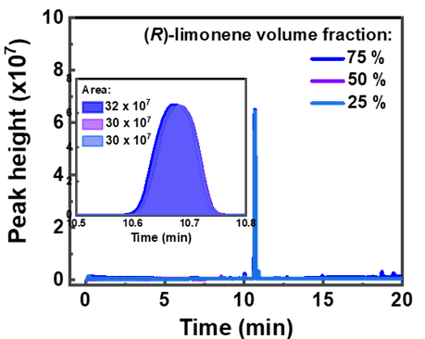
Figure S10. Gas chromatography-mass spectrometry (GC-MS) testing of the relative concentration of the (R/S)-limonene gas mixture used for the test.

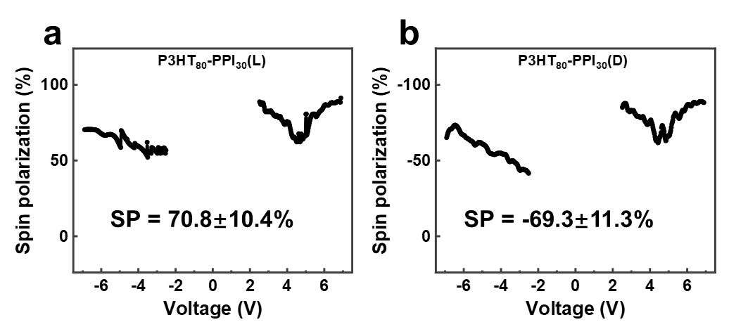
Figure S11. Electron spin polarizability by self-assembly of a) P3HT₈₀-PPI₃₀ (L) and b) P3HT₈₀-PPI₃₀(D) active layer materials with helical structures.

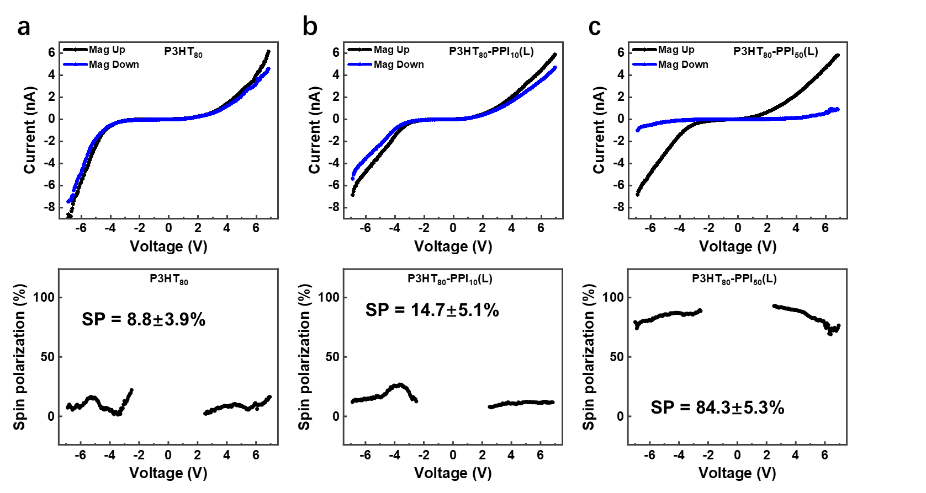
Figure S12. I−V curves and electron spin polarizability calculations after self-assembly of different block polymers. a) P3HT₈₀, b) P3HT₈₀-PPI₁₀(L), and c) P3HT₈₀-PPI₅₀(L) as tested by magnetically conductive atomic force (mc-AFM).

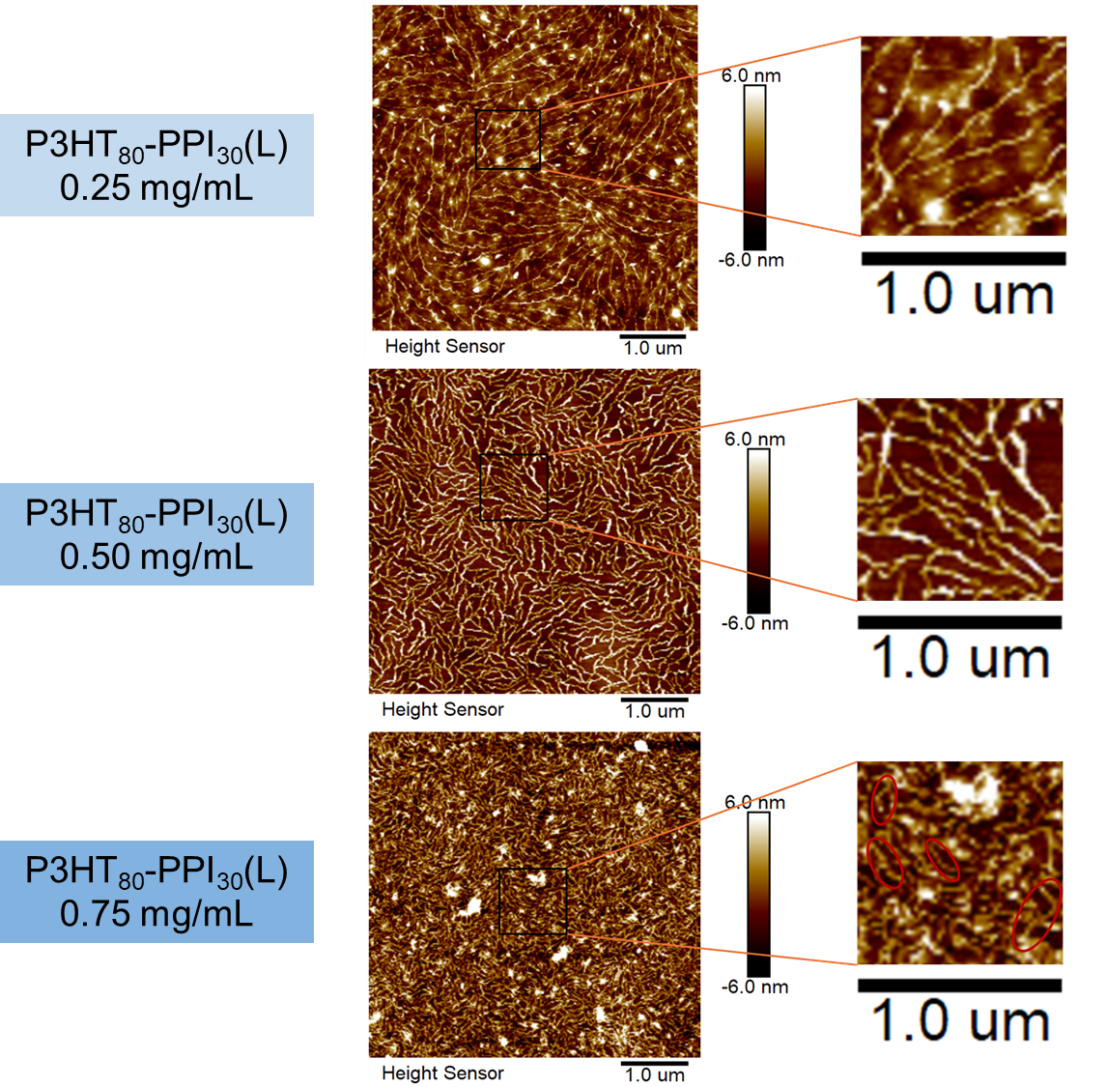
Figure S13. Microscopic morphology of P3HT₈₀-PPI₃₀(L) after self-assembly in different concentration solutions scanned by atomic force microscopy (AFM).

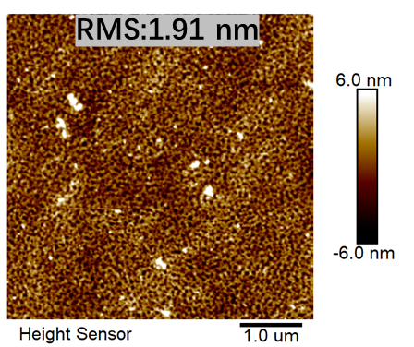
Figure S14. Two-dimensional surface morphology of thin films after spin-coating of P3HT₈₀ and PPI₃₀(L) blends observed by AFM.

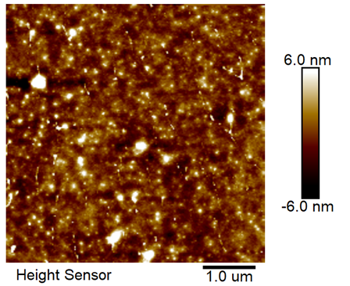
Figure S15. Microscopic morphology of directly dissolved spin-coated P3HT₈₀-PPI₃₀(L) (unmixed self-assembled with PMMA) films observed by atomic force microscopy.
Compared to the films that have been self-assembled by blending with PMMA, the direct spin-coated films have no helical structure.

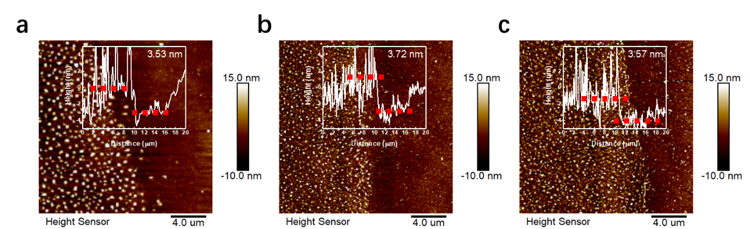
Figure S16. AFM measurements of the thickness of the active layer obtained by a) mixing of P3HT₈₀ with PPI₃₀(L), b) direct spin-coating of P3HT₈₀-PPI₃₀(L) and c) self-assembly of P3HT₈₀-PPI₃₀(L) mixed with 1,2-dichlorobenzene.
To ensure a single experimental variable, the molar ratio of P3HT₈₀ to PPI₃₀(L) during blending was 1:1, and all polymer solutions had a final concentration of 0.75 mg/mL.

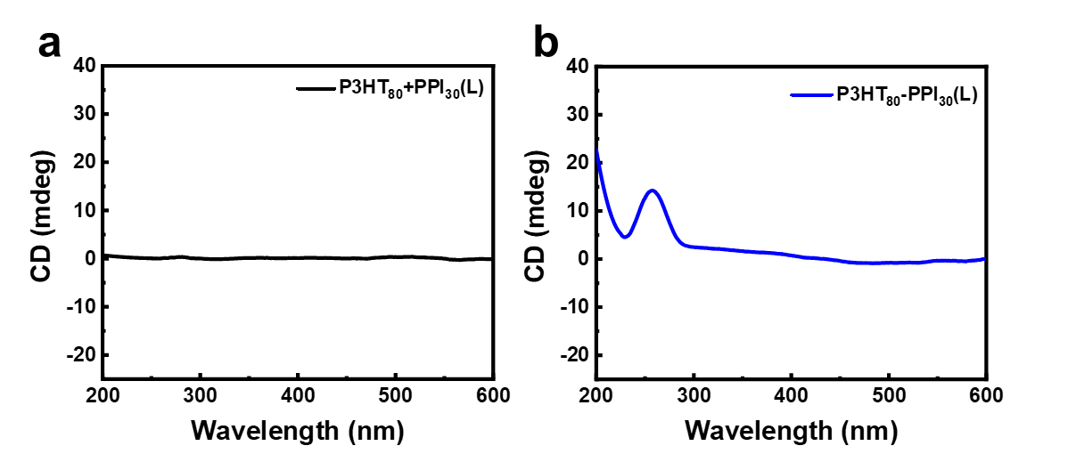
Figure S17. CD spectra of films of a) P3HT₈₀ mixed with PPI₃₀(L), b) directly spin-coated P3HT₈₀-PPI₃₀(L) (without self-assembly).

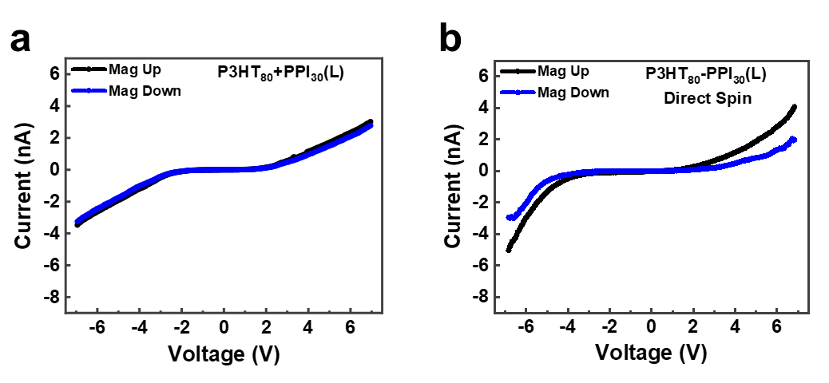
Figure S18. I-V curves of a) P3HT₈₀ mixed with PPI₃₀(L), b) directly spin-coated P3HT₈₀-PPI₃₀(L) (without self-assembly) semiconductor layers tested by mc-AFM at room temperature.

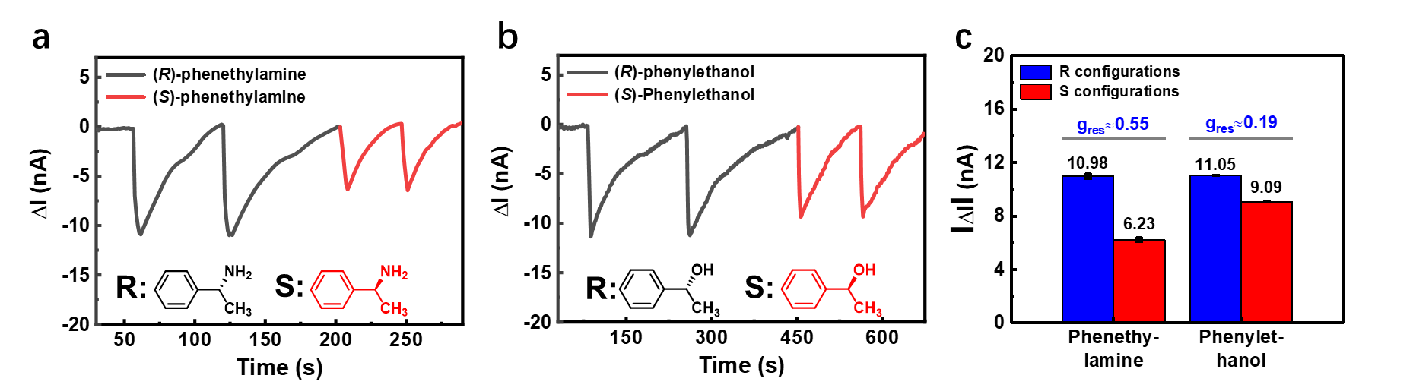
Figure S19. Real-time response of a) gas-phase chiral phenylethylamine enantiomer, b) gas-phase chiral phenylethanol enantiomer, using self-assembled P3HT₈₀-PPI₃₀(L) as the active layer L-type detector. Tests were performed with a voltage of 15 V at both ends. c) Statistics and discrimination calculations for the device response values in a) and b).

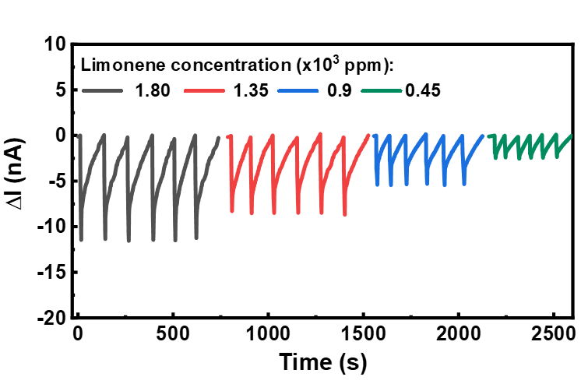
Figure S20. Real-time response test of a non-chiral detector with commercially available P3HT as the active layer to different concentrations of limonene gas (V = 15 V)

References
1. Li W, et al. Fabrication of a multi-charge generable poly(phenyl isocyanide)-block-poly(3-hexylthiophene) rod-rod conjugated copolymer. Polym Chem 6, 2348-2355 (2015).
2. Liu W-B, et al. Bottlebrush Polymers Carrying Side Chains on Every Backbone Atom: Controlled Synthesis, Polymerization-Induced Emission, and Circularly Polarized Luminescence. Macromolecules 54, 3158-3168 (2021).
3. Xu L, et al. Crystallization‐Driven Asymmetric Helical Assembly of Conjugated Block Copolymers and the Aggregation Induced White‐light Emission and Circularly Polarized Luminescence. Angew Chem Int Ed 59, 16675-16682 (2020).
4. Xu L, Xu X-H, Liu N, Zou H, Wu Z-Q. A Facile Synthetic Route to Multifunctional Poly(3-hexylthiophene)-b-poly(phenyl isocyanide) Copolymers: From Aggregation-Induced Emission to Controlled Helicity. Macromolecules 51, 7546-7555 (2018).
5. Yu Z-P, Liu N, Yang L, Jiang Z-Q, Wu Z-Q. One-Pot Synthesis, Stimuli Responsiveness, and White-Light Emissions of Sequence-Defined ABC Triblock Copolymers Containing Polythiophene, Polyallene, and Poly(phenyl isocyanide) Blocks. Macromolecules 50, 3204-3214 (2017).
6. Maity A, Rapoport S, Haick H. Gate‐Controlled Chiral Recognition and Spin Assessment with All‐Electric Hybrid Quantum Wire‐Based Transistors. Small 19, 2205038 (2022).
7. Torsi L, et al. A sensitivity-enhanced field-effect chiral sensor. Nat Mater 7, 412-417 (2008).
8. Yamazaki Y, et al. Enantioselective Detection of Gaseous Odorants with Peptide–Graphene Sensors Operating in Humid Environments. ACS Appl Mater Interfaces 16, 18564-18573 (2024).
9. Maity A, Hershkovitz‐Pollak Y, Gupta R, Wu W, Haick H. Spin‐Controlled Helical Quantum Sieve Chiral Spectrometer. Adv Mater 35, 2209125 (2023).
10. Shang X, Park CH, Jung GY, Kwak SK, Oh JH. Highly Enantioselective Graphene-Based Chemical Sensors Prepared by Chiral Noncovalent Functionalization. ACS Appl Mater Interfaces 10, 36194-36201 (2018).
11. Okur S, et al. An Enantioselective e‐Nose: An Array of Nanoporous Homochiral MOF Films for Stereospecific Sensing of Chiral Odors. Angew Chem Int Ed 60, 3566-3571 (2020).
12. Mulla MY, et al. Capacitance-modulated transistor detects odorant binding protein chiral interactions. Nat Commun 6, 6010 (2015).
13. Kybert NJ, Lerner MB, Yodh JS, Preti G, Johnson ATC. Differentiation of Complex Vapor Mixtures Using Versatile DNA–Carbon Nanotube Chemical Sensor Arrays. ACS Nano 7, 2800-2807 (2013).
14. Kiran V, Mathew SP, Cohen SR, Hernández Delgado I, Lacour J, Naaman R. Helicenes—A New Class of Organic Spin Filter. Adv Mater 28, 1957-1962 (2016).
15. Aragonès AC, et al. Measuring the Spin‐Polarization Power of a Single Chiral Molecule. Small 13, 1602519 (2016).
16. Bloom BP, Kiran V, Varade V, Naaman R, Waldeck DH. Spin Selective Charge Transport through Cysteine Capped CdSe Quantum Dots. Nano Lett 16, 4583-4589 (2016).
17. Tassinari F, Banerjee-Ghosh K, Parenti F, Kiran V, Mucci A, Naaman R. Enhanced Hydrogen Production with Chiral Conductive Polymer-Based Electrodes. The Journal of Physical Chemistry C 121, 15777-15783 (2017).
18. Mishra S, et al. Spin Filtering Along Chiral Polymers. Angew Chem Int Ed 59, 14671-14676 (2020).
19. Jiate L, J HP. Chiral-induced spin selectivity in the formation and recombination of radical pairs: cryptochrome magnetoreception and EPR detection. New J Phys 23, 043032 (2021).
20. Singh Bisht P, Garg R, Nakka N, Mondal AK. Spin Filtering and Amplification in Self-Assembled Nanofibers Based on Chiral Asymmetric Building Blocks. The Journal of Physical Chemistry Letters 15, 6605-6610 (2024).
21. Zhu Q, et al. Multistate Switching of Spin Selectivity in Electron Transport through Light‐Driven Molecular Motors. Adv Sci 8, (2021).
22. Qian Q, et al. Chiral molecular intercalation superlattices. Nature 606, 902-908 (2022).
23. Aizawa H, et al. Enantioselectivity of discretized helical supramolecule consisting of achiral cobalt phthalocyanines via chiral-induced spin selectivity effect. Nat Commun 14, 4530 (2023).
24. Abhervé A, et al. Chirality Versus Symmetry: Electron's Spin Selectivity in Nonpolar Chiral Lead–Bromide Perovskites. Adv Mater 35, 2305784 (2023).
25. Mondal AK, et al. Spin Filtering in Supramolecular Polymers Assembled from Achiral Monomers Mediated by Chiral Solvents. Journal of the American Chemical Society 143, 7189-7195 (2021).

