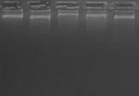
4

1 2 3 4 5

GENOMIC DNAGELIMAGE

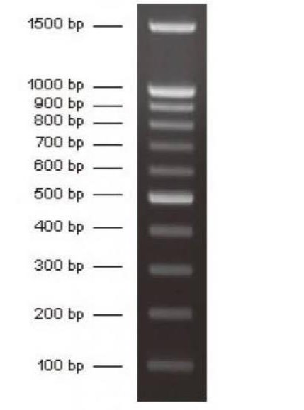
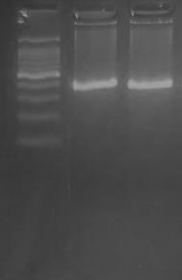

L 1 2

PCR AMPLIFIEDGEL IMAGE

