Supplemental information for

Bayesian Optimization of Biodegradable Polymers via Machine Learning Driven Features from Low-Field NMR Data

Ryo Fujita¹, Yoshifumi Amamoto^{2,3}, Jun Kikuchi^{1,2,4}*

¹Graduate School of Medical Life Science, Yokohama City University, 1–7–29 Suehiro–cho, Tsurumi–ku, Yokohama 230–0045, Japan
²RIKEN Center for Sustainable Resource Science, 1–7–22 Suehiro–cho, Tsurumi–ku, Yokohama 230–0045, Japan
³Institute for Materials Chemistry and Engineering, Kyushu University, 744 Motooka, Nishi-ku, Fukuoka 819-0395, Japan
⁴Graduate School of Bioagricultural Sciences, Nagoya University, 1 Furo–cho, Chikusa–ku, Nagoya 464–8601, Japan

Table of contents
Table S1 List of molding conditions 3
Fig. S1 Results of low-field NMR measurements, wide-angle X-ray scattering measurements, and polarized light microscopic observations of PLA samples. 5
Fig. S2 NMR Relaxation curves of PLA at different concentrations of nucleating agent. 6
Fig. S3 NMR relaxation curves of PLA at different crystallization times. 7
Fig. S4 CNN architecture. 8
Fig. S5 Results of denoising for simulation curves. 9
Fig.S6 Denoised NMR relaxation curves of PLLA at different concentrations of nucleating agent. 10
Fig.S7 Denoised NMR Relaxation curves of PLA shown by different crystallization time. 11
Fig.S8 Parity plot for RFR predictions after noise removal. (continued) 12
Fig. S8 Parity plot for RFR predictions after noise removal. 13
Fig.S9 Feature importance distribution of RFR after denoising (continued) 14
Fig.S9 Feature importance distribution of RFR before and after denoising. 15
Fig. S10 Correspondence between nine material properties and GAP values. 16
Fig. S11 Material properties and corresponding feature maps. 17
Fig. S12 Bayesian optimization. 18

Table S1 List of molding conditions

Sample No. | Crystallize Temperature  (T_{c} / ºC) | Time for  Crystallization  (t_{c} / min) | Concentration of Nucleating Agents  (C_{NA})
1 | 75 | 5 | 0
2 | 75 | 10 | 0
3 | 75 | 20 | 0
4 | 75 | 40 | 0
5 | 75 | 5 | 0.167
6 | 75 | 10 | 0.167
7 | 75 | 20 | 0.167
8 | 75 | 40 | 0.167
9 | 75 | 5 | 0.5
10 | 75 | 10 | 0.5
11 | 75 | 20 | 0.5
12 | 75 | 40 | 0.5
13 | 75 | 5 | 1.5
14 | 75 | 10 | 1.5
15 | 75 | 20 | 1.5
16 | 75 | 40 | 1.5
17 | 90 | 5 | 0
18 | 90 | 10 | 0
19 | 90 | 20 | 0
20 | 90 | 40 | 0
21 | 90 | 5 | 0.167
22 | 90 | 10 | 0.167
23 | 90 | 20 | 0.167
24 | 90 | 40 | 0.167
25 | 90 | 5 | 0.5
26 | 90 | 10 | 0.5
27 | 90 | 20 | 0.5
28 | 90 | 40 | 0.5
29 | 90 | 5 | 1.5
30 | 90 | 10 | 1.5
31 | 90 | 20 | 1.5
32 | 90 | 40 | 1.5
33 | 105 | 5 | 0
34 | 105 | 10 | 0
35 | 105 | 20 | 0
36 | 105 | 40 | 0
37 | 105 | 5 | 0.167
38 | 105 | 10 | 0.167
39 | 105 | 20 | 0.167
40 | 105 | 40 | 0.167
41 | 105 | 5 | 0.5
42 | 105 | 10 | 0.5
43 | 105 | 20 | 0.5
44 | 105 | 40 | 0.5
45 | 105 | 5 | 1.5
46 | 105 | 10 | 1.5
47 | 105 | 20 | 1.5
48 | 105 | 40 | 1.5
49 | 120 | 5 | 0
50 | 120 | 10 | 0
51 | 120 | 20 | 0
52 | 120 | 40 | 0
53 | 120 | 5 | 0.167
54 | 120 | 10 | 0.167
55 | 120 | 20 | 0.167
56 | 120 | 40 | 0.167
57 | 120 | 5 | 0.5
58 | 120 | 10 | 0.5
59 | 120 | 20 | 0.5
60 | 120 | 40 | 0.5
61 | 120 | 5 | 1.5
62 | 120 | 10 | 1.5
63 | 120 | 20 | 1.5
64 | 120 | 40 | 1.5

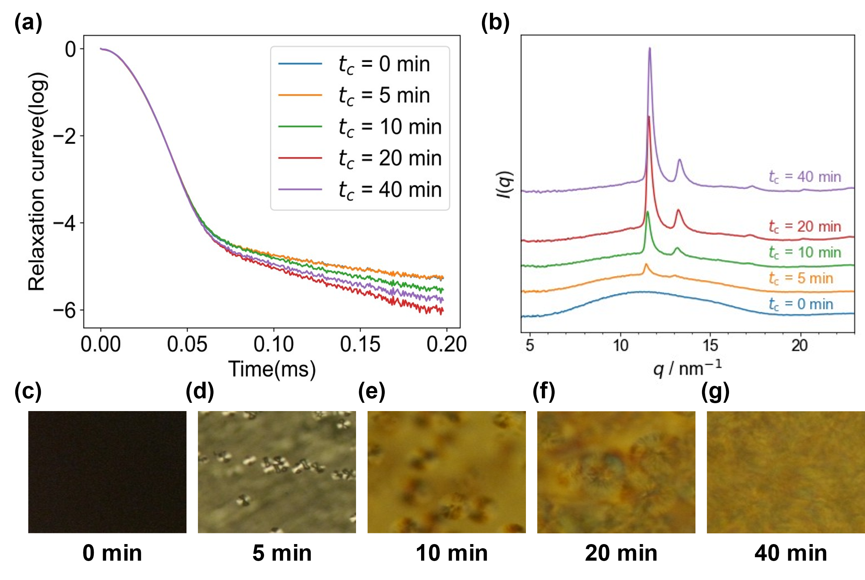

Fig. S1 Results of low-field NMR measurements, wide-angle X-ray scattering measurements, and polarized light microscopic observations of PLA samples.
Polylactic acid film melted at 200 ºC was placed at 90 ºC for 0 min, 5 min, 10min, 20 min, 40 min without adding nucleating agent to allow crystallization to proceed. After the crystallization time elapsed, the temperature was lowered with cold water to complete the crystallization process. (a) Low-field NMR measurements of the molded polylactic acid film were then taken. The crystals were observed by (b) wide-angle X-ray scattering measurements and (c)-(g) polarized light microscopic (POM) observation. The times in POM images correspond to crystallization times.

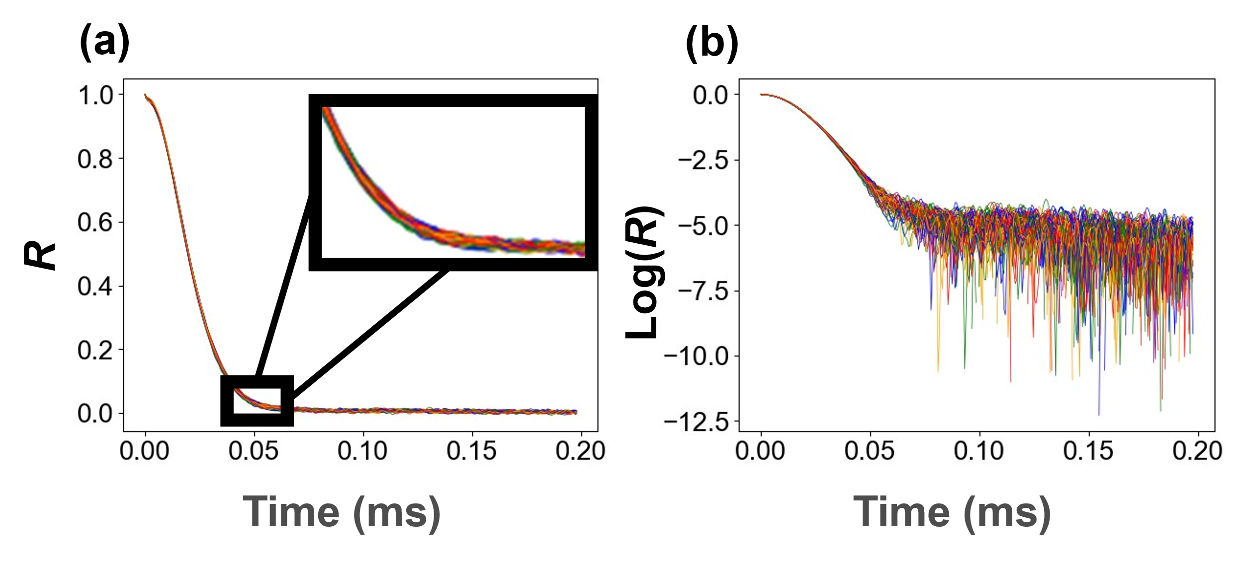

Fig. S2 NMR Relaxation curves of PLA at different concentrations of nucleating agent.
Vertical scale “R” represents Relaxation Rate. The color of the curve corresponds to the nucleating agent concentration. Blue 0%, green 0.167%, orange 0.5%, red 1.5%.

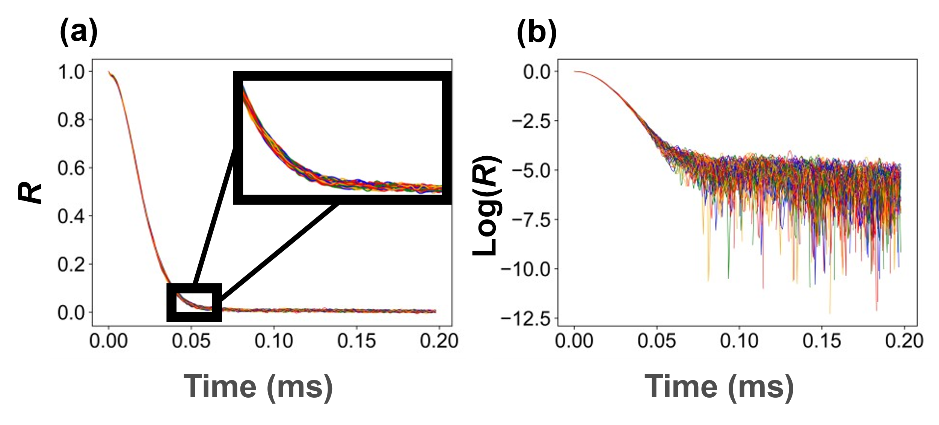

Fig. S3 NMR relaxation curves of PLA at different crystallization times.
The color of the curve corresponds to the crystallization time. Blue 5 min, green 10 min, orange 20 min, red 40 min.

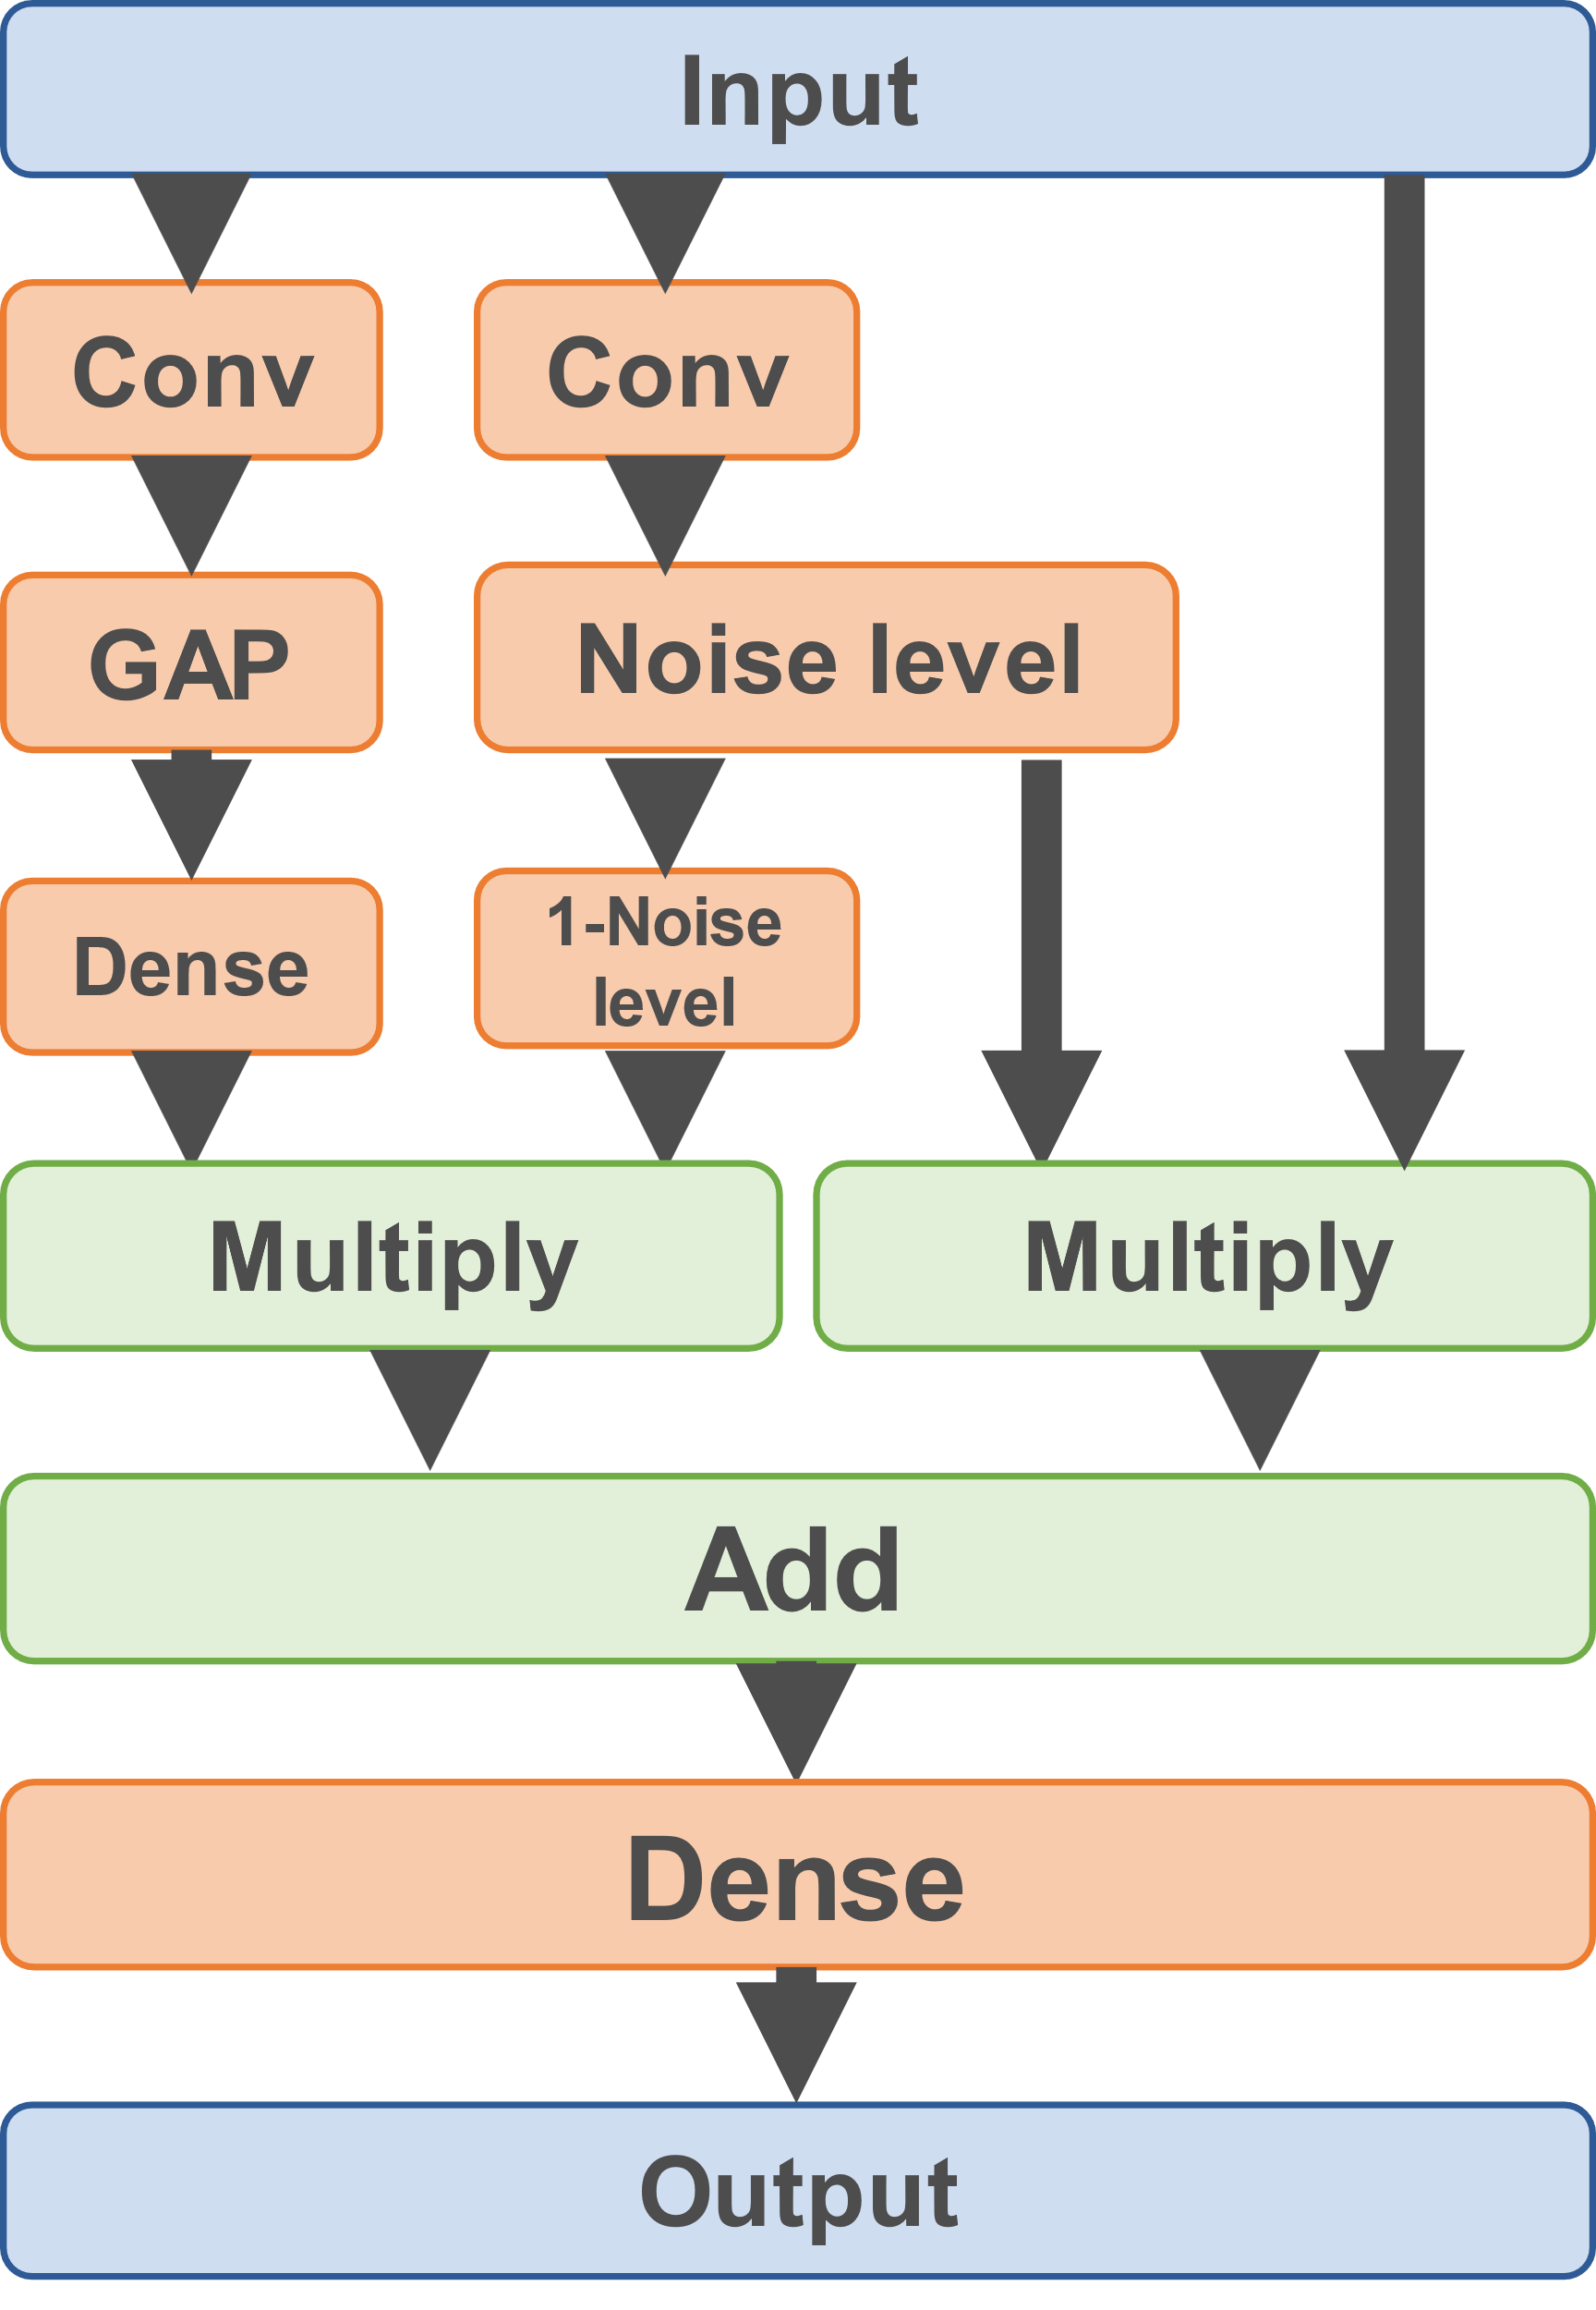

Fig. S4 CNN architecture.
This model performs two types of convolutional layers on input. One is a general implementation of convolution that extracts information from the signal and denoising, and the other is a convolution that assigns a noise intensity to each data point of the input, designed for a denoising task. In general, data processing methods based on denoising tasks are effective for strong noise, but risk distorting the signal in regions where the noise is weak. In this model, the area indicated by $Conv→GAP→Dense$ in Fig. S4 creates the denoising curve, and the area indicated by $Conv→Noise level →1-Noise level$ on the right controls the degree to which the denoising result is reflected in the output based on the noise intensity of the input. This layer handles simple operations and creates a modified denoising curve based on the result of the noise intensity determination. The last layer, Dense, is a layer that performs a slight modification to cancel out the noise derived from the input curve, which is generated by directly reflecting a part of the input curve in the denoising curve.

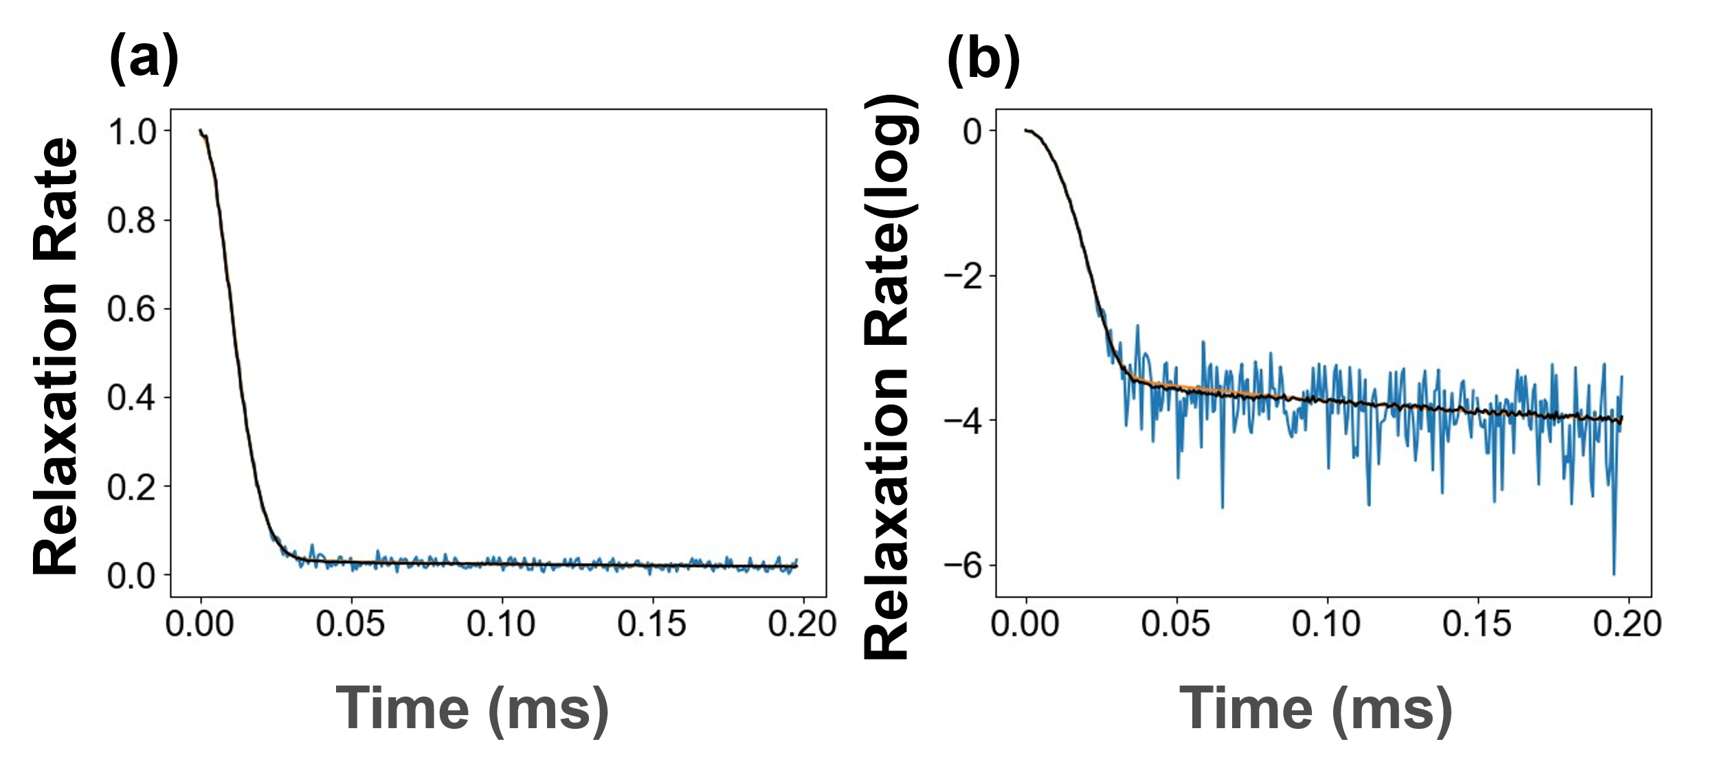

Fig. S5 Results of denoising for simulation curves.

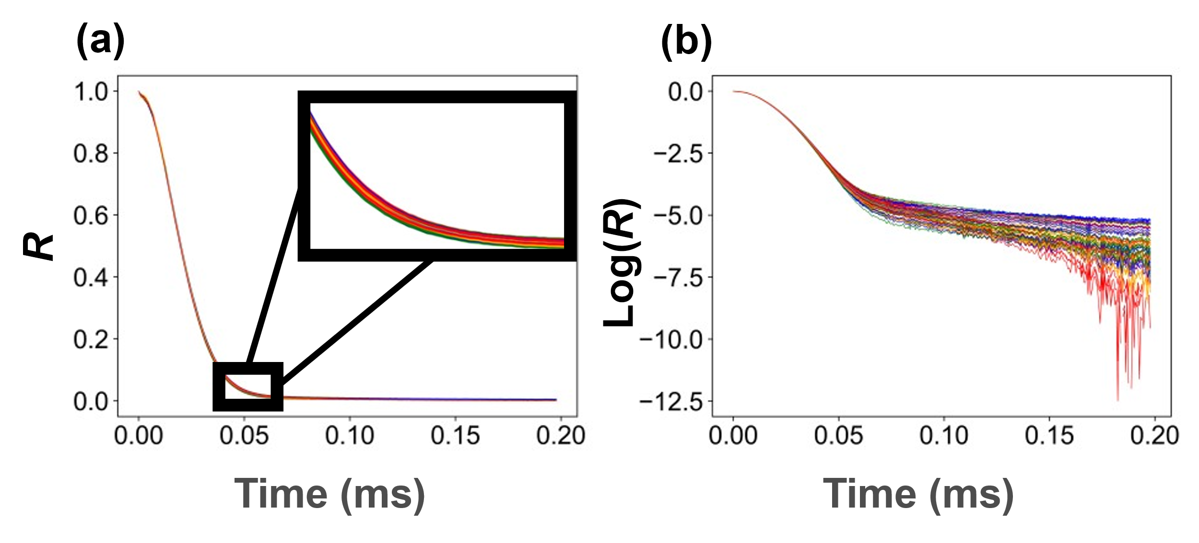

Fig.S6 Denoised NMR relaxation curves of PLLA at different concentrations of nucleating agent.
Relaxation curve after denoising in (a) real number scale, and (b) in log scale. The color of the curve corresponds to the concentration of nucleating agent. Blue 0wt%, green 0.167wt%, orange 0.5wt%, red 1.5wt%.

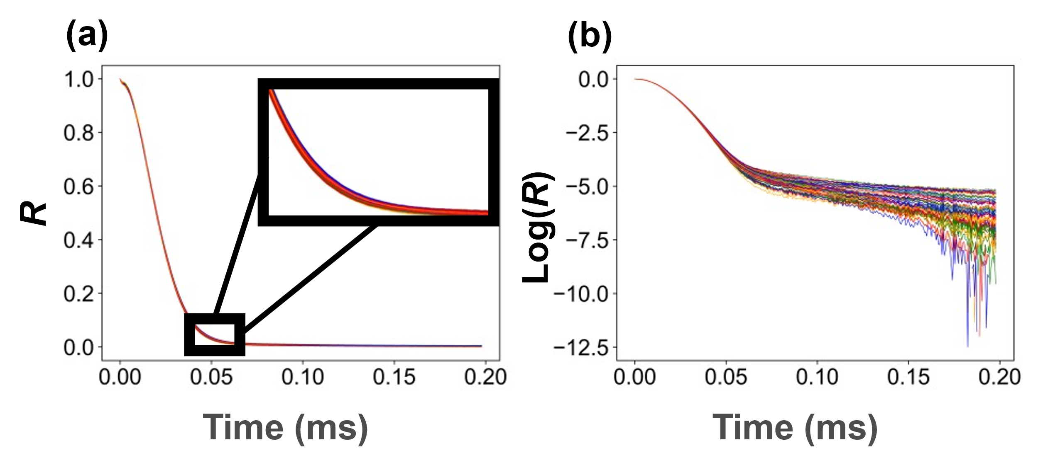

Fig.S7 Denoised NMR Relaxation curves of PLA shown by different crystallization time.
Relaxation curve after denoising in (a) real number scale and) and (b) log scale. The color of the curve corresponds to the crystallization time. Blue 5 min, green 10 min, orange 20 min, red 40 min.

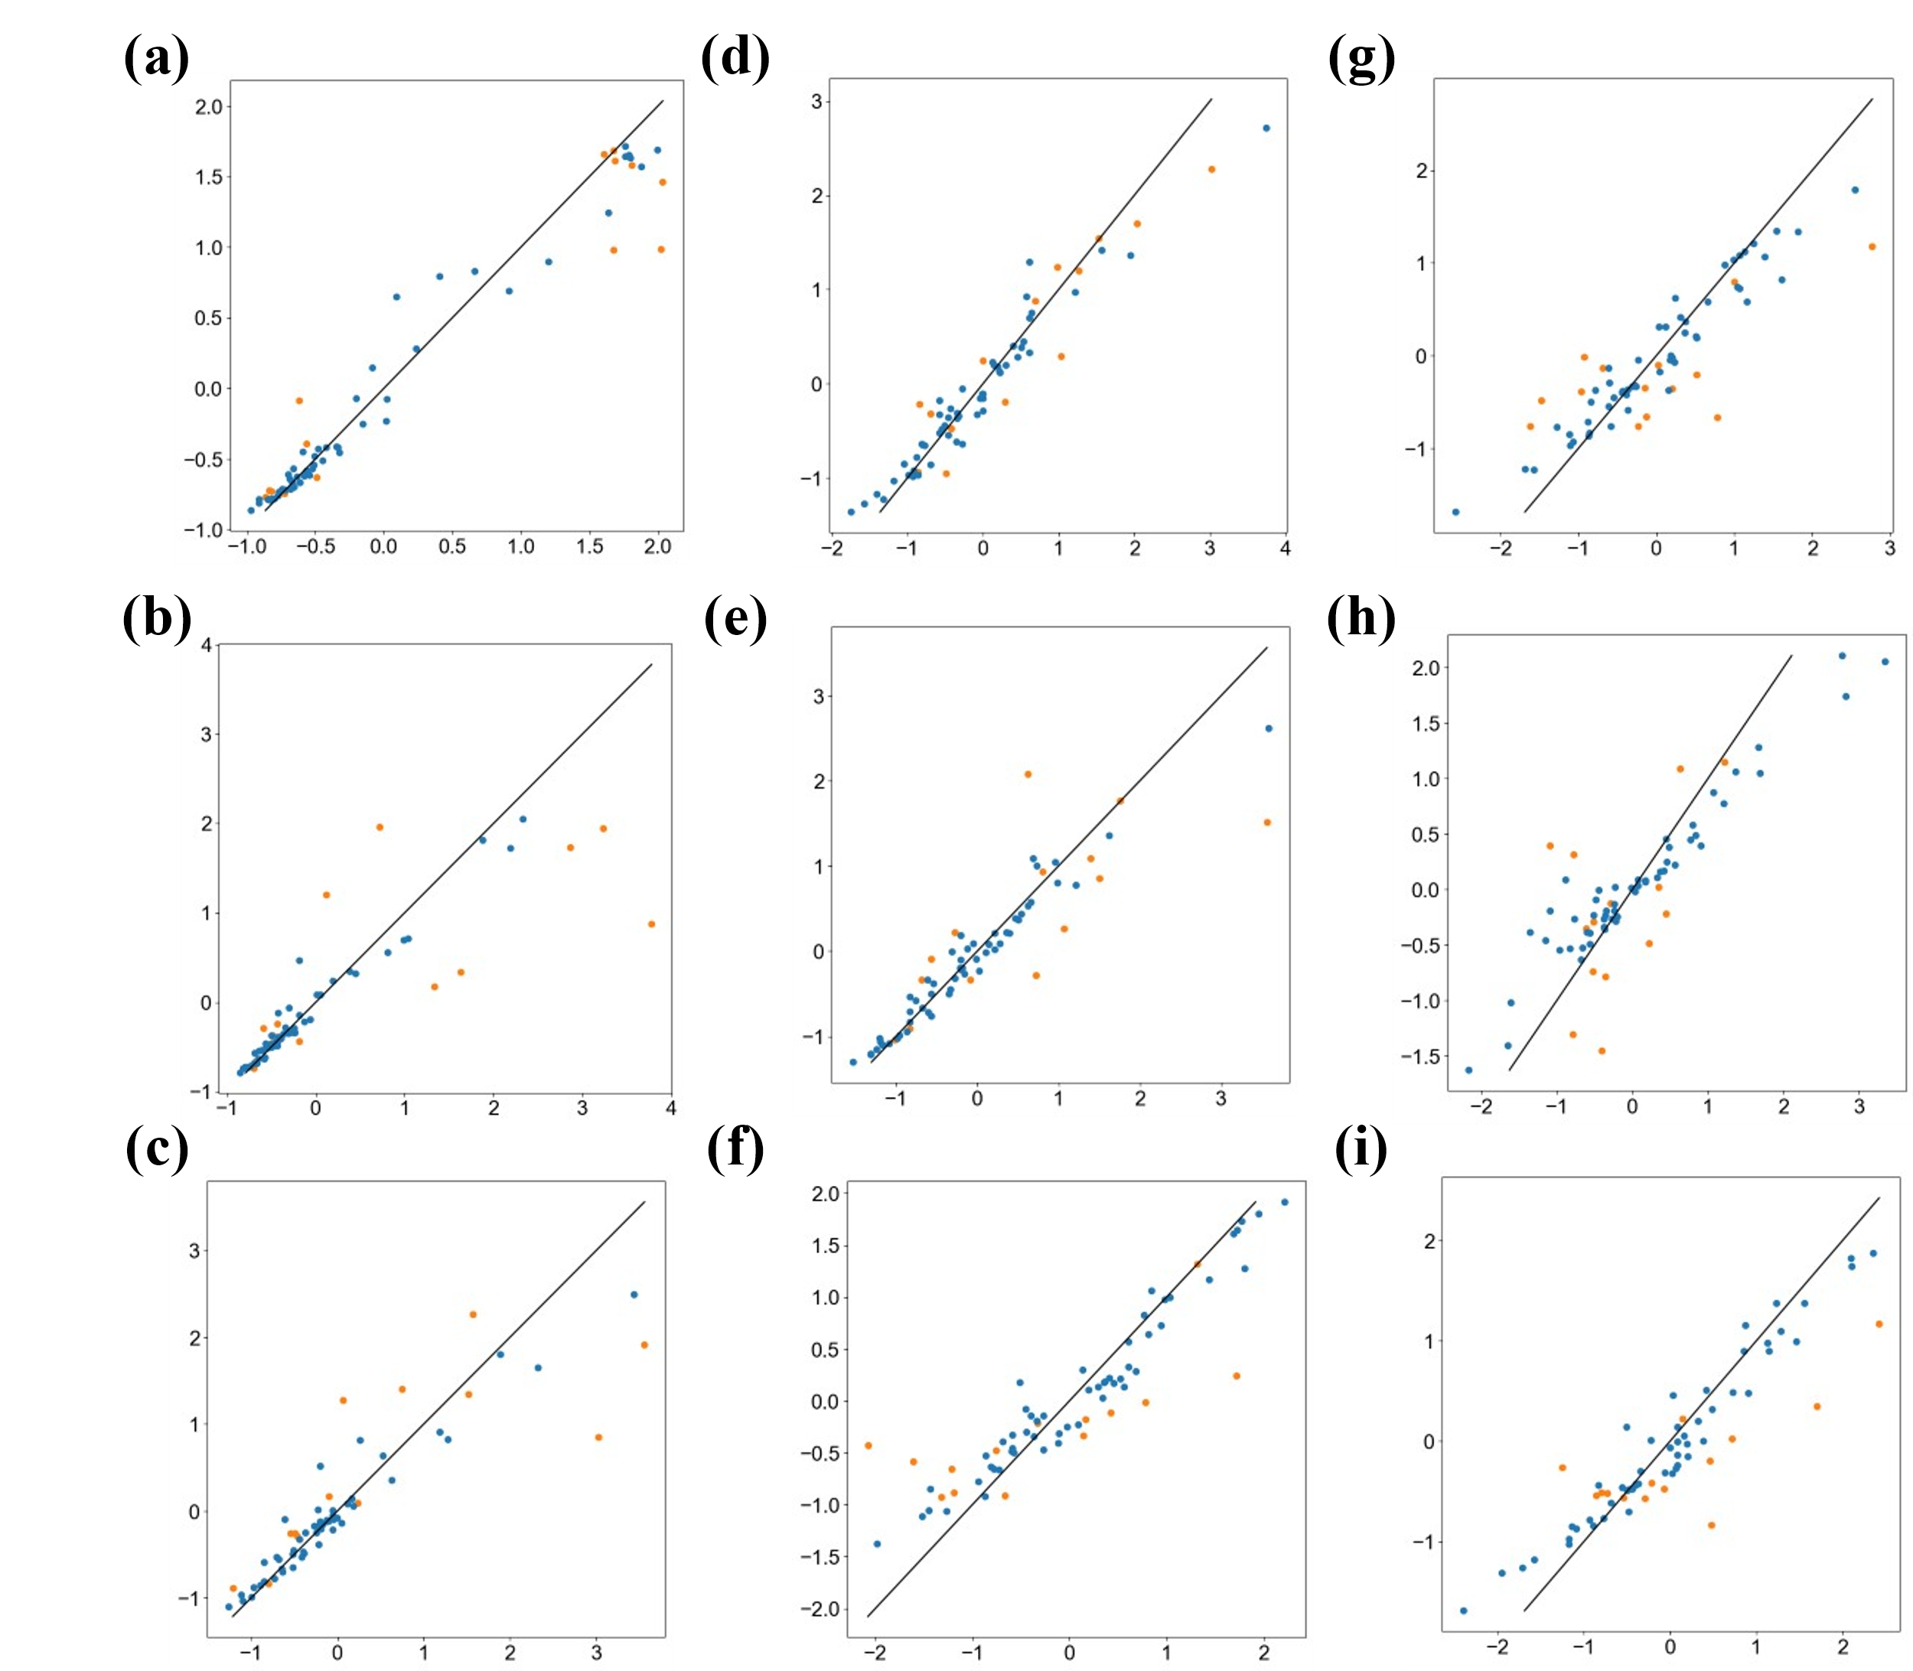

Fig.S8 Parity plot for RFR predictions after noise removal. (continued)

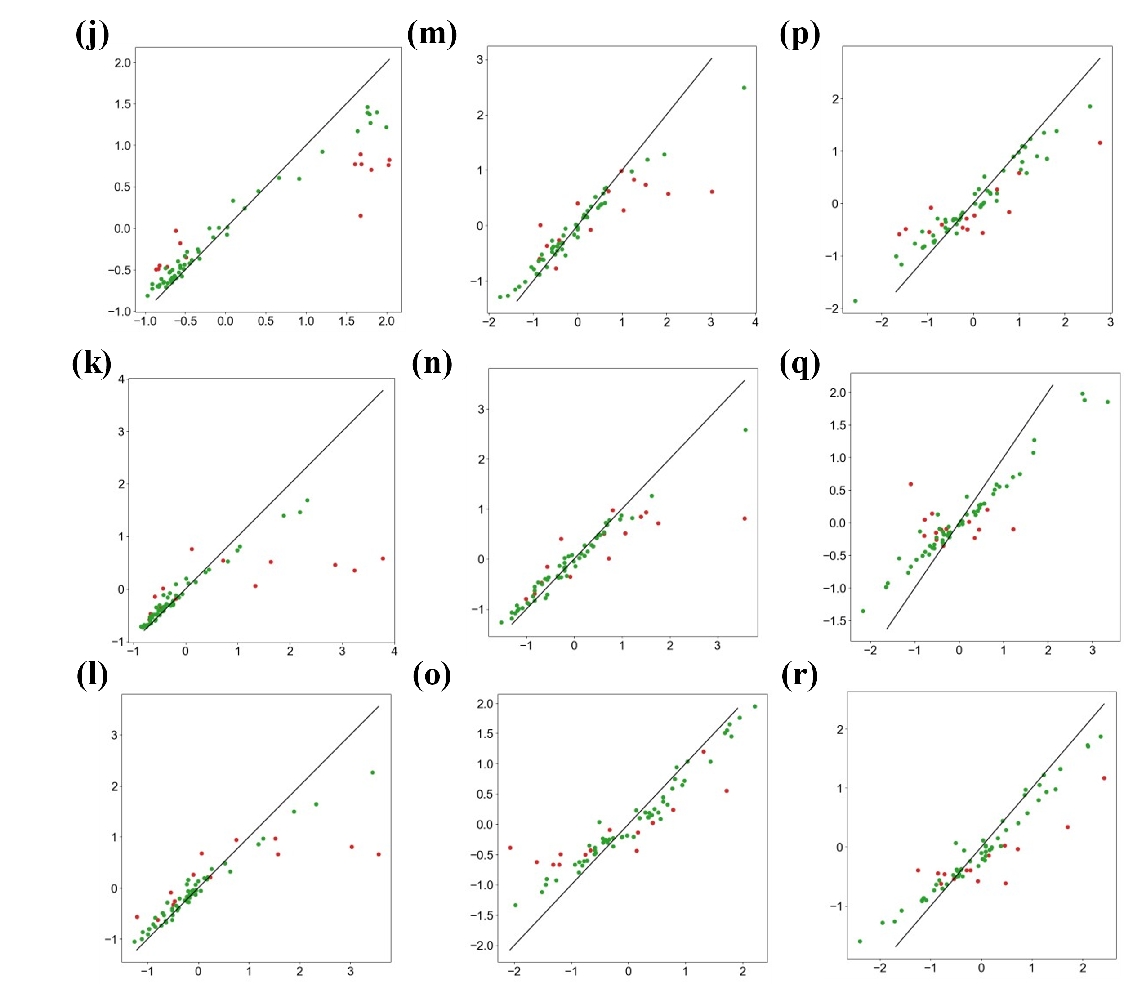

Fig. S8 Parity plot for RFR predictions after noise removal.
Parity Plot of (a) Y1 prediction, (b) Y2 prediction, (c) Y3 prediction, (d) Y4 prediction, (e) Y5 prediction, (f) Y6 prediction, (g) Y7 prediction, (h) Y8 prediction, and (i) Y9 prediction models with denoising curves. Parity Plot of (j) Y1 prediction, (k) Y2 prediction, (l) Y3 prediction, (m) Y4 prediction, (n) Y5 prediction, (o) Y6 prediction, (p) Y7 prediction, (q) Y8 prediction, and (r) Y9 prediction models with unprocessed curves. Vertical axis: Predicted values, Horizontal axis: Actual values. Color of bar chart plot (green: raw_train, red: raw_test)

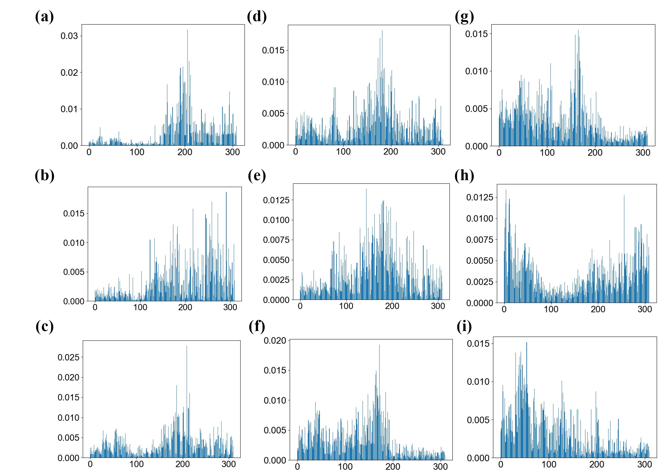

Fig.S9 Feature importance distribution of RFR after denoising (continued)

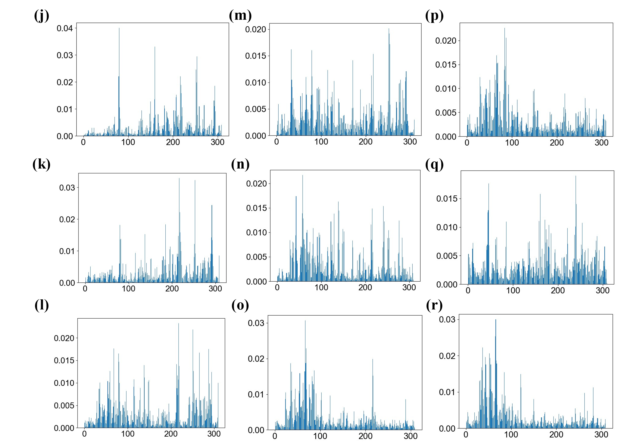

Fig.S9 Feature importance distribution of RFR before and after denoising.
Feature Importance distribution of (a) Y1 prediction, (b) Y2 prediction, (c) Y3 prediction, (d) Y4 prediction, (e) Y5 prediction, (f) Y6 prediction, (g) Y7 prediction, (h) Y8 prediction, and (i) Y9 prediction models with denoising curves. Feature Importance distribution of (j) Y1 prediction, (k) Y2 prediction, (l) Y3 prediction, (m) Y4 prediction, (n) Y5 prediction, (o) Y6 prediction, (p) Y7 prediction, (q) Y8 prediction, and (r) Y9 prediction models using the raw curve. Vertical axis: Feature Importance, Horizontal axis: corresponds to the time axis of the relaxation curve.

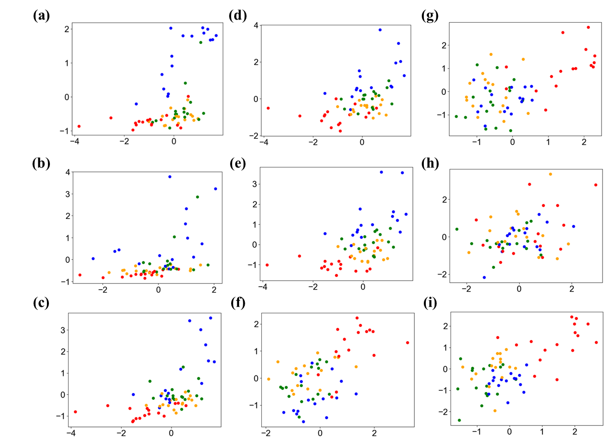

Fig. S10 Correspondence between nine material properties and GAP values.
GAP values versus material properties for (a) Y1, (b) Y2, (c) Y3, (d) Y4, (e) Y5, (f) Y6, (g) Y7, (h) Y8, and (i) Y9. Vertical axis: material properties. Horizontal axis: GAP values most strongly correlated with material properties. The colors of the plots correspond to the crystallization temperatures: blue 75 °C, green 90 °C, orange 105 °C, and red 120 °C.

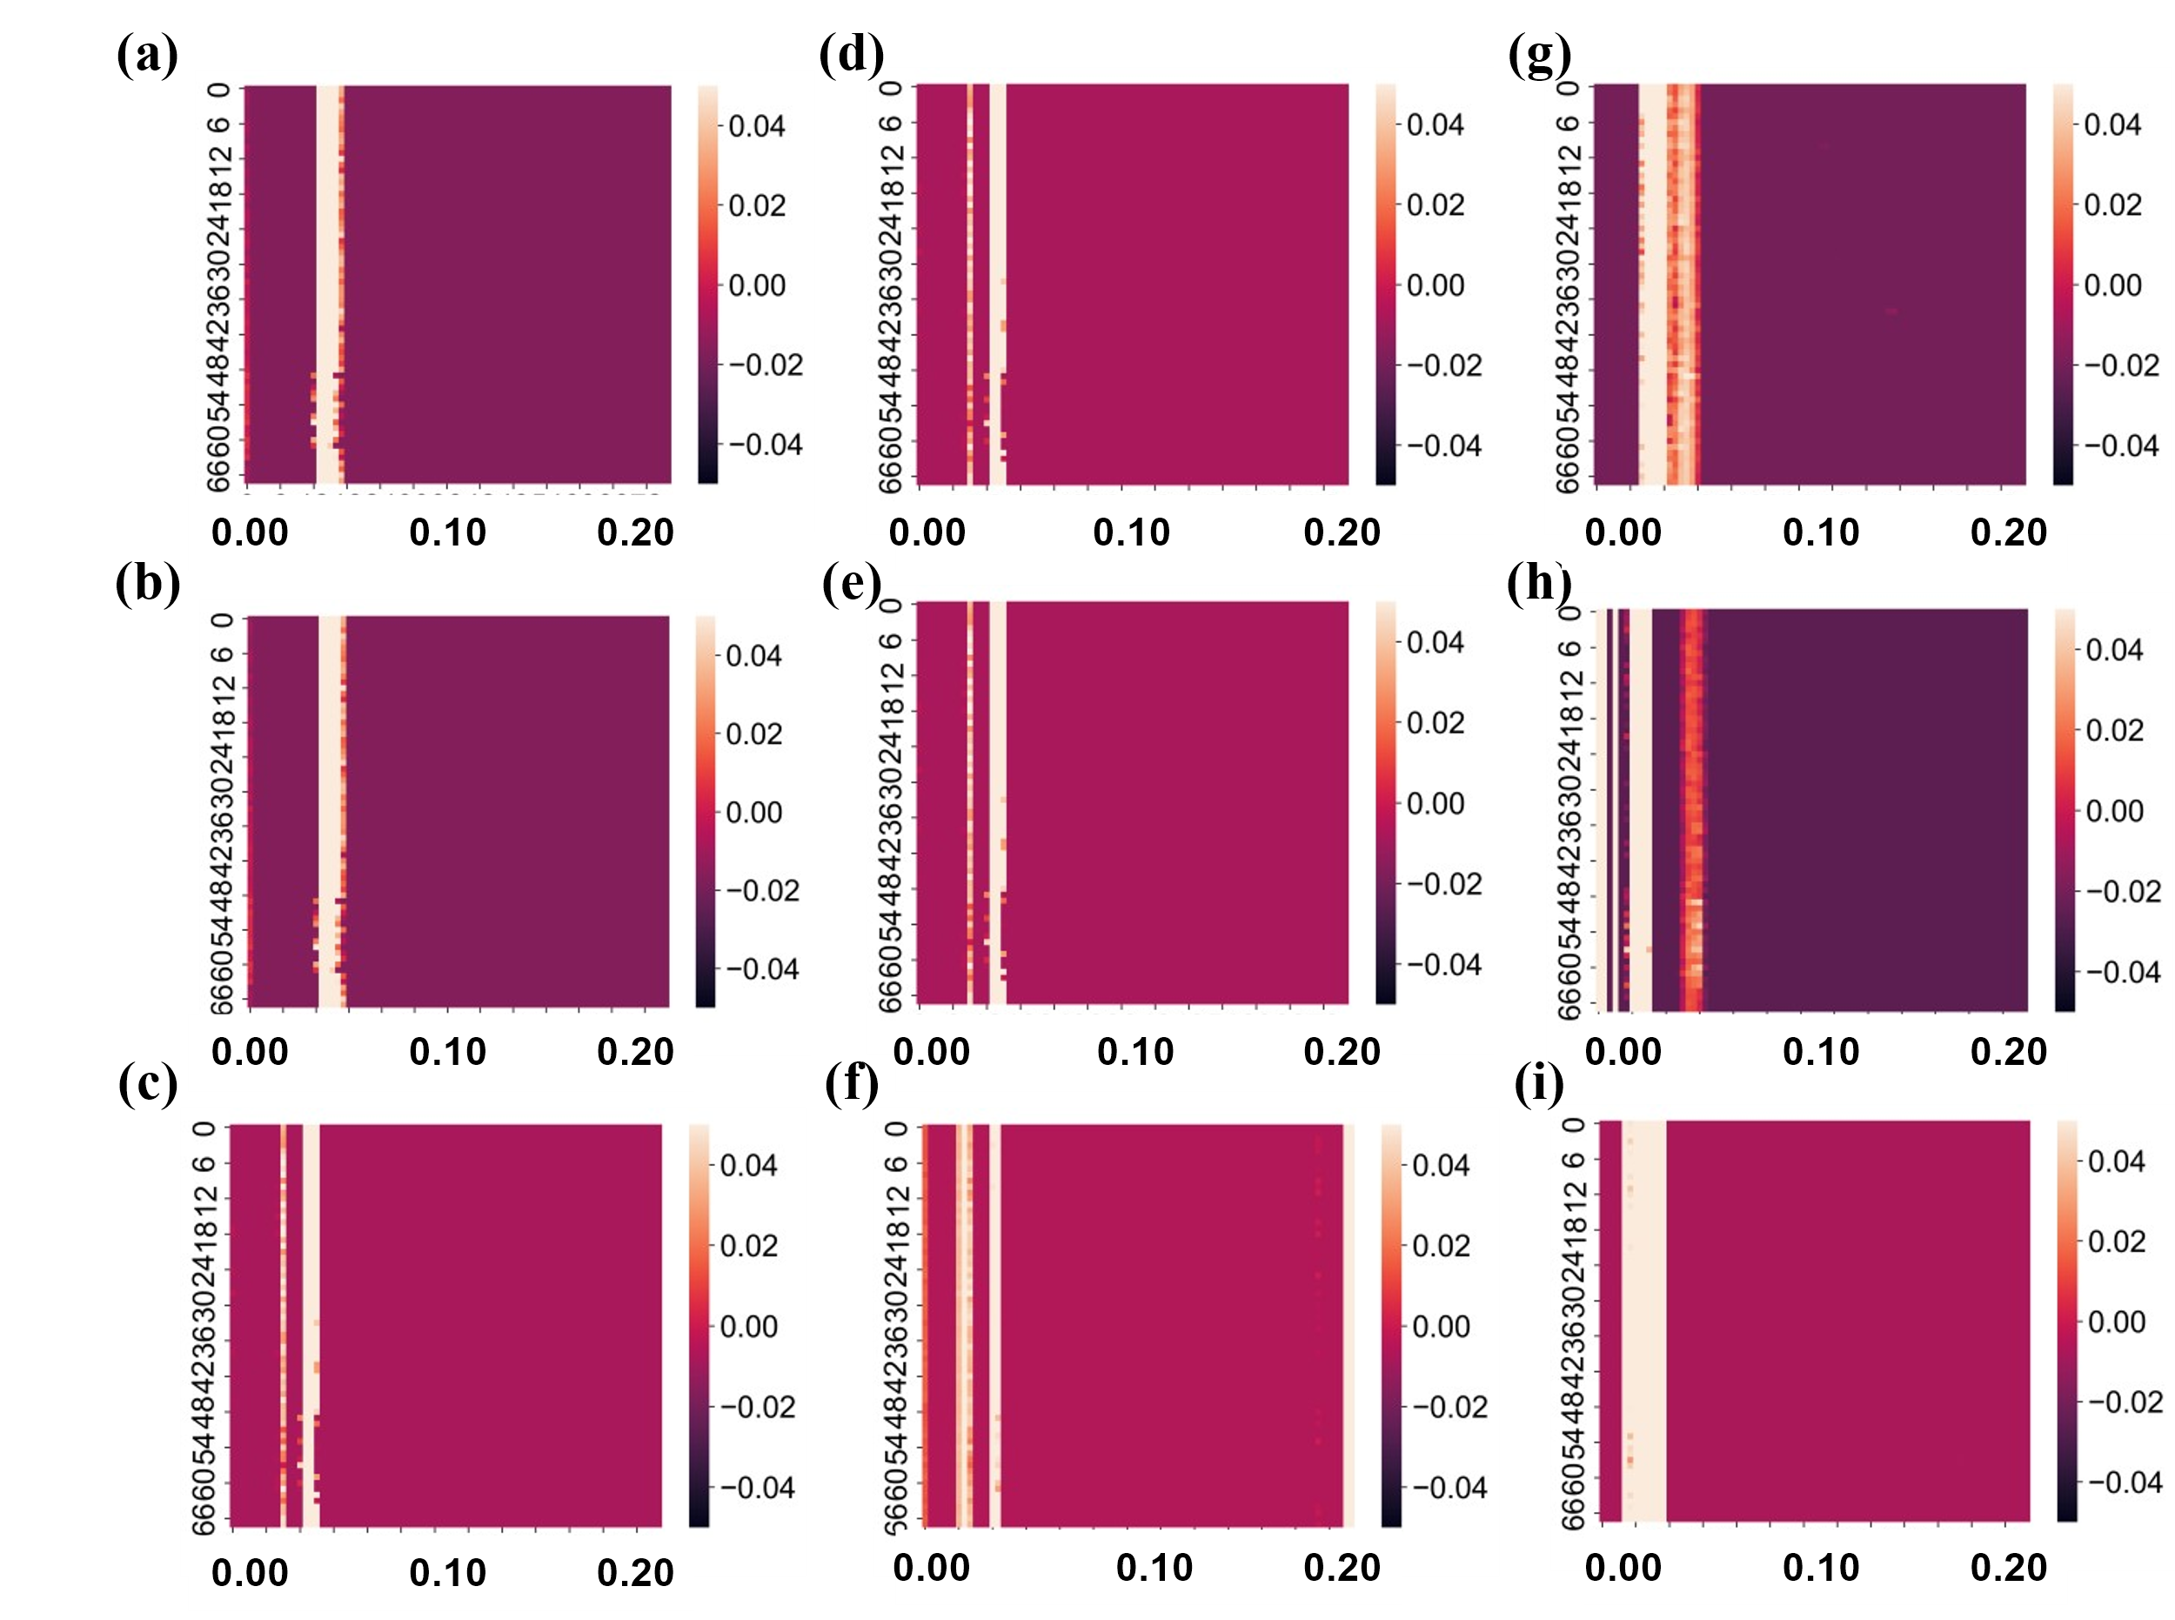

Fig. S11 Material properties and corresponding feature maps.
(a) Feature map forming the GAP value corresponding to (a) Y1, (b) Y2, (c) Y3, (d) Y4, (e) Y5, (f) Y6, (g) Y7, (h) Y8, and (i) Y9. Vertical axis: sample number. Horizontal axis: time axis of the relaxation curve. The feature maps have a time axis nature, and the heat map shows the time region that contributes to the composition of the GAPs correlated with the material properties.

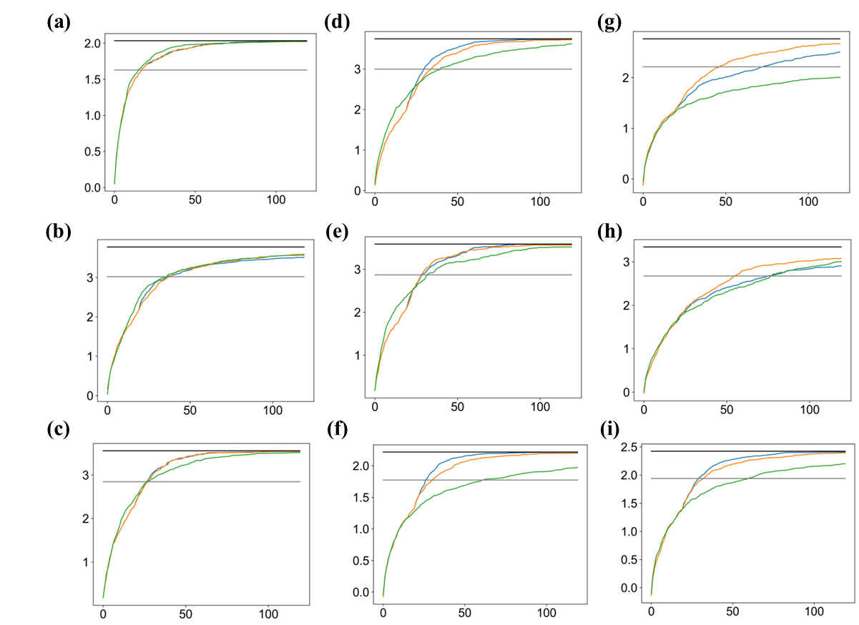

Fig. S12 Bayesian optimization.
Vertical axis: material properties. Horizontal axis: number of trials. Blue: direct Bayesian optimization for material properties, orange: Bayesian optimization for GAP values correlated with material properties, green: random search. Black line: maximum value of material properties. Gray line: 80% line of maximum value of material properties.

