Supplementary Information

Enhancing stability by trapping palladium inside N-heterocyclic carbene-functionalized hypercrosslinked polymers for heterogeneous C-C bond formations

Yue et al.

Supplementary Figures
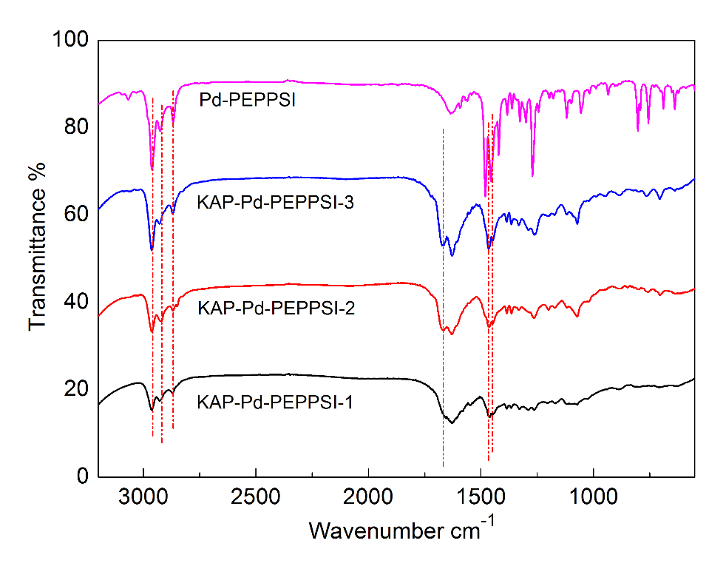
Supplementary Figure 1. FT-TR spectrum of KAP-Pd-PEPPSI. The characteristic peaks are labelled in the spectra (from left to right: 2959, 2918, 2867, 1667, 1465 and 1447 cm⁻¹).

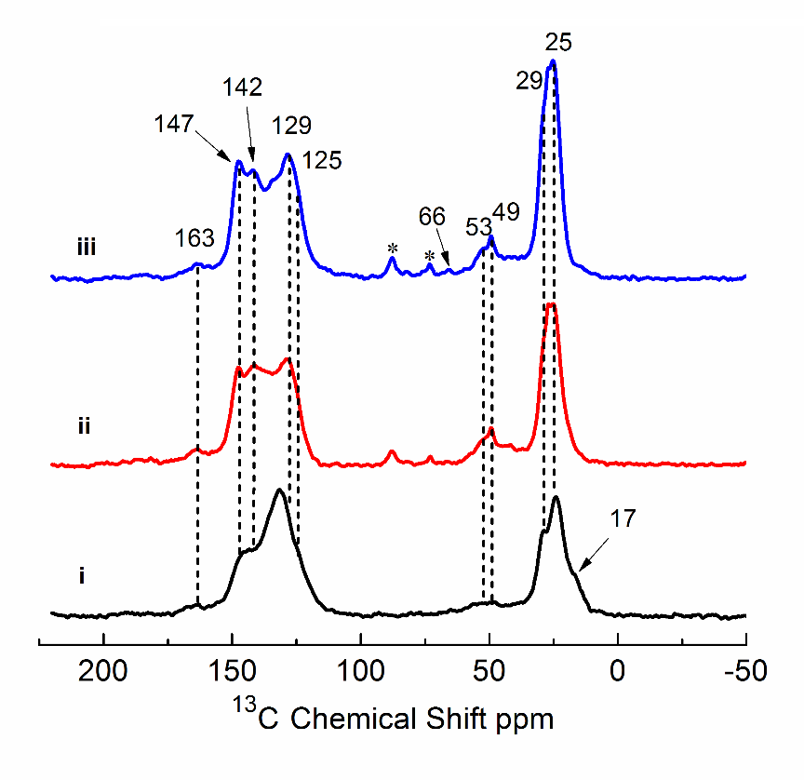
Supplementary Figure 2. Solid-state ¹³C CP/MAS NMR spectrum of KAP-Pd-PEPPSI. The characteristic peaks are labelled in the spectra.
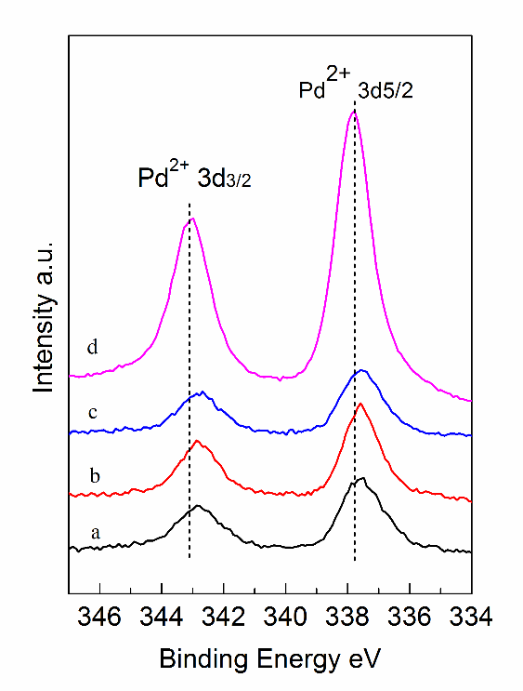
Supplementary Figure 3. Pd 3d XPS spectra of KAP-Pd-PEPPSI. (a) KAP-Pd-PEPPSI-1, (b) KAP-Pd-PEPPSI-2, (c) KAP-Pd-PEPPSI-3, and (d) molecular Pd-PEPPSI.
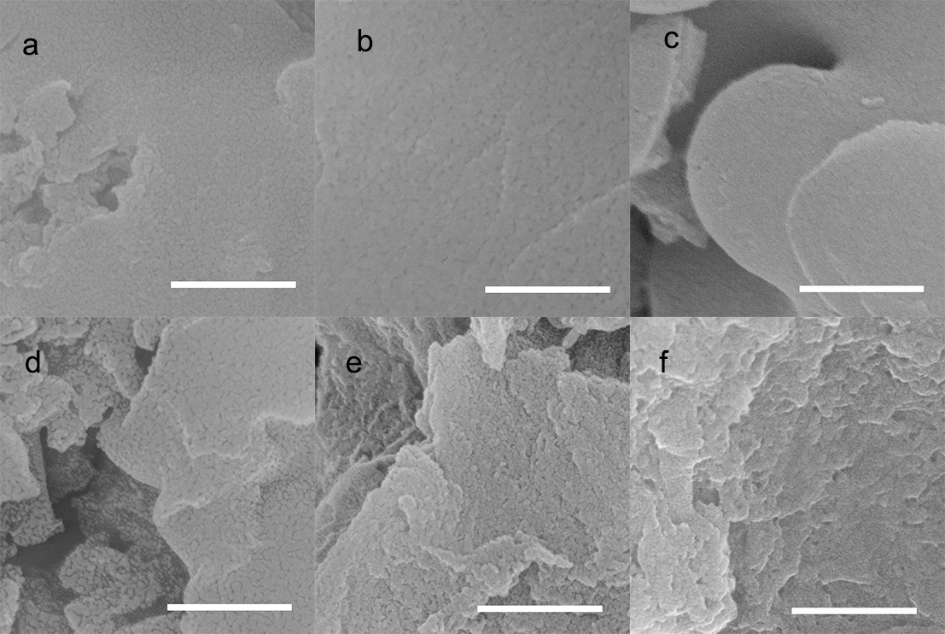
Supplementary Figure 4. SEM images of KAP-Pd-PEPPSI. (a, d) KAP-Pd-PEPPSI-1, (b, e) KAP-Pd-PEPPSI-2 and (c, f) KAP-Pd-PEPPSI-3. (a-c): KAP-Pd-PEPPSI. (d-f): KAP-Pd-PEPPSI after swelling in DMF. Scale bars: 500 nm

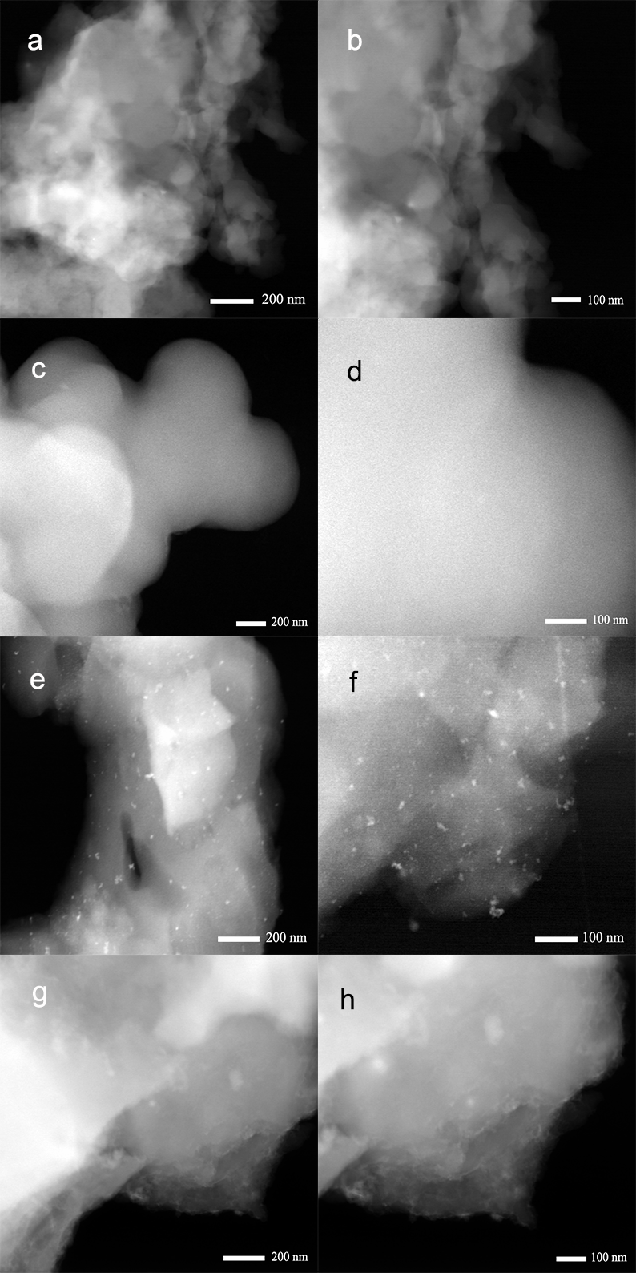
Supplementary Figure 5. STEM images of KAP-Pd-PEPPSI. (a-b) KAP-Pd-PEPPSI-1, (c-d) KAP-Pd-PEPPSI-2, (e-f) KAP-Pd-PEPPSI-2 after being reduced by NaBH₄ and (g-h) KAP-Pd-PEPPSI-3.
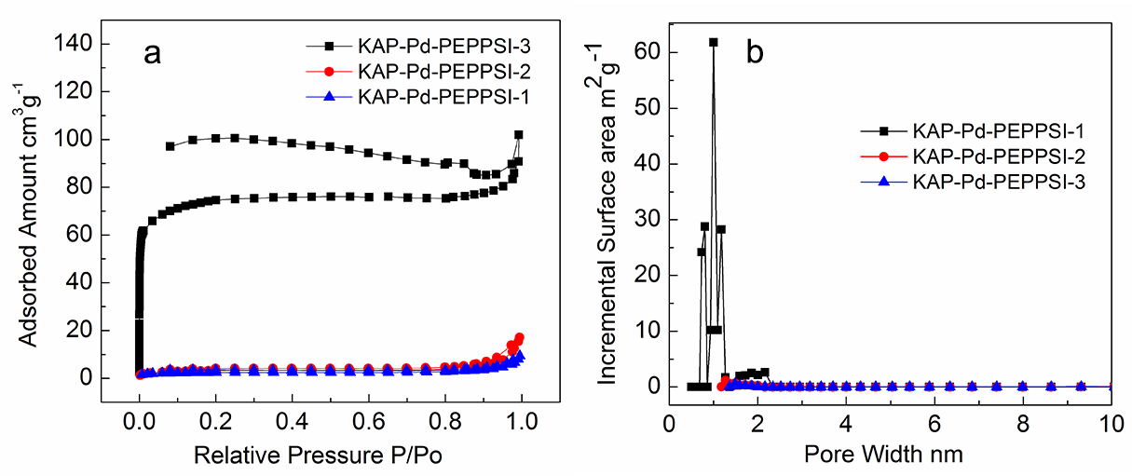
Supplementary Figure 6. Textural properties of catalysts. (a) N₂ sorption isotherms collected at 77 K and (b) pore size distributions of KAP-Pd-PEPPSI. The BET surface area in KAP-Pd-PEPPSI-1 is 227 cm³ g⁻¹, which decreases to 10 cm³ g⁻¹ and 7 cm³ g⁻¹, respectively, in KAP-Pd-PEPPSI-2 and KAP-Pd-PEPPSI-3.

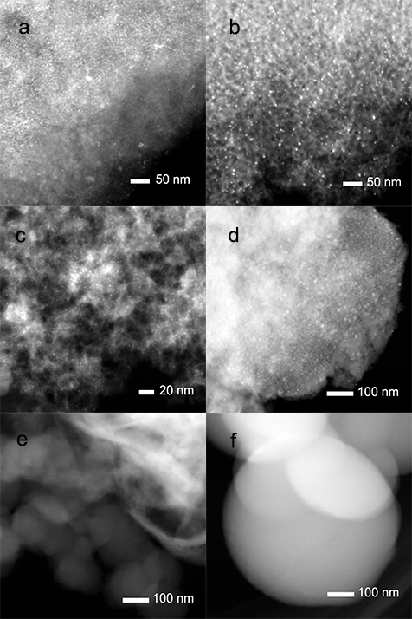
Supplementary Figure 7. STEM images of reference catalysts. (a) Fresh Pd@C, (b) Pd@NC, (c) Pd@PC, (d) Pd@SiO₂, (e) KAP-Pd-PPh₃ and (f) POP-Pd-PEPPSI. The STEM morphologies of fresh Pd@C, Pd@NC, Pd@PC, Pd@SiO₂ (a-d, supported Pd catalysts) show uniform distributed nanoparticles with sizes ranging from several nanometers to tens of nanometers, whereas KAP-Pd-PPh₃ and POP-Pd-PEPPSI (e-f, polymer supported Pd complex precatalysts) show even more uniform distributed Pd species without formation of nanoparticles.

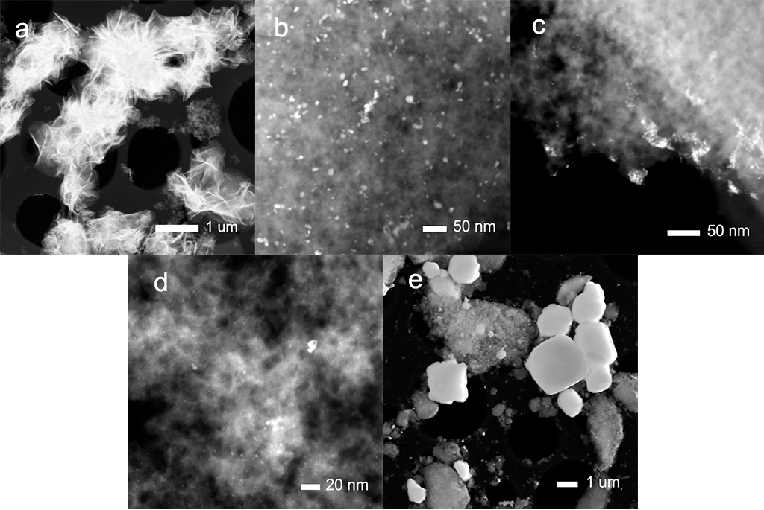
Supplementary Figure 8. STEM images of different catalysts after a single cycle. (a) Pd-PEPPSI, (b) Pd@C, (c) Pd@NC, (d) Pd@PC, (e) Pd@SiO₂, (f) KAP-Pd-PEPPSI-1, (g) KAP-Pd-PEPPSI-2, (h) KAP-Pd-PEPPSI-3, (i) POP-Pd-PEPPSI, (j) KAP-Pd-PPh₃.

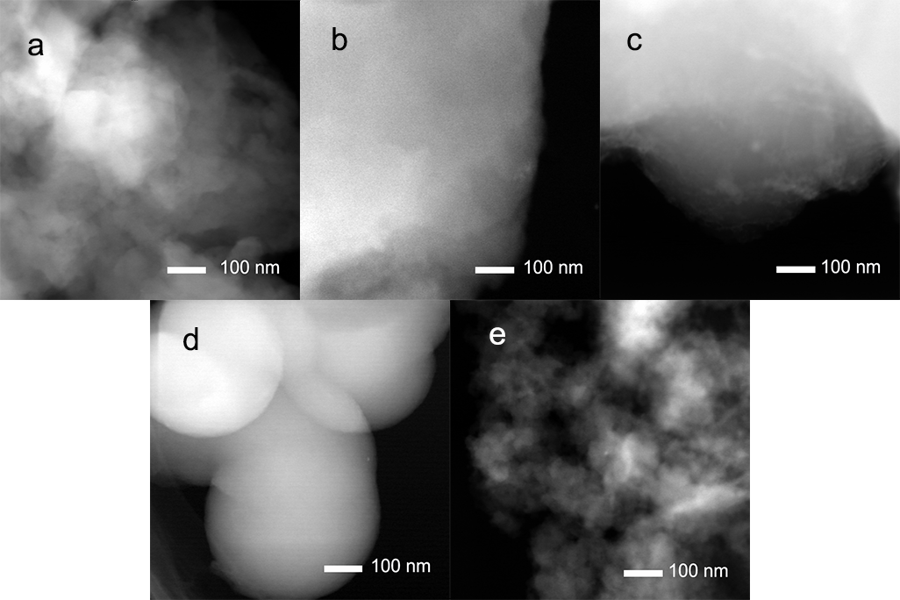
Supplementary Figure 9. STEM images of different catalysts after a single cycle. (a) KAP-Pd-PEPPSI-1, (b) KAP-Pd-PEPPSI-2, (c) KAP-Pd-PEPPSI-3, (d) POP-Pd-PEPPSI, (e) KAP-Pd-PPh₃.
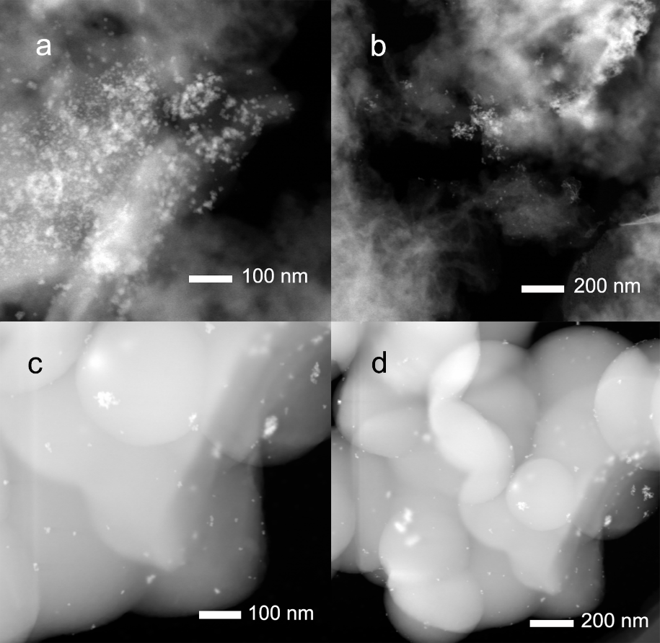
Supplementary Figure 10. STEM images of (a-b) KAP-Pd-PPh₃ after 5 cycles and (c-d) POP-Pd-PEPPSI after 5 cycles.
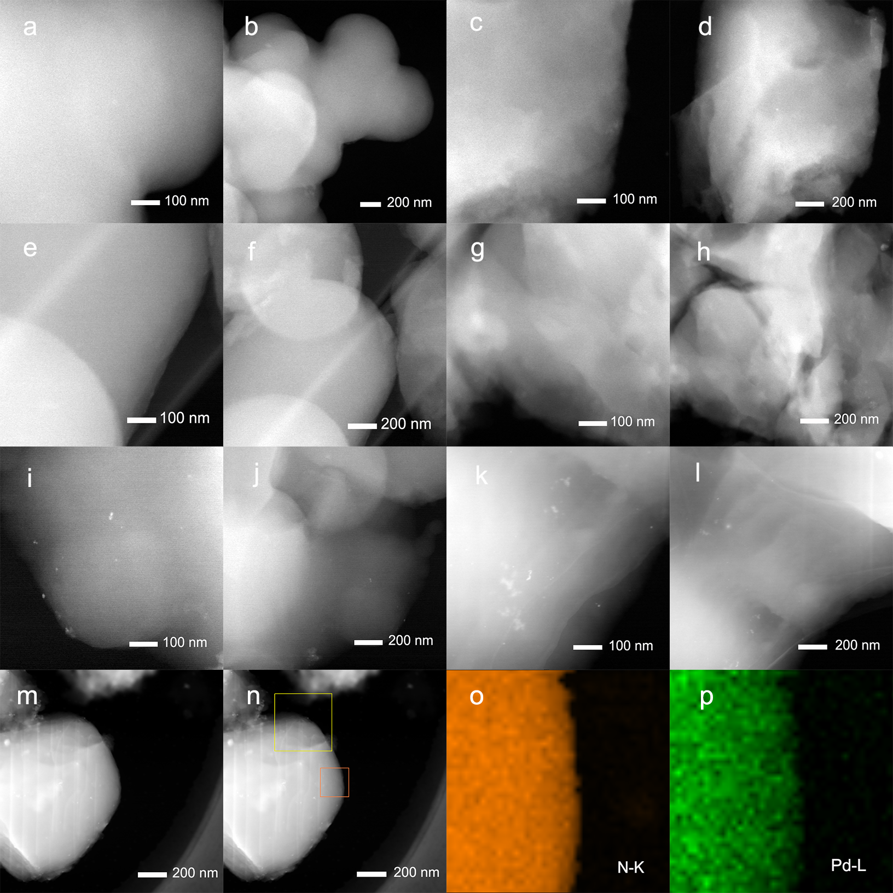
Supplementary Figure 11. STEM images of KAP-Pd-PEPPSI-2. (a-b) fresh catalyst, (c-d) after 1 cycles, (e-f) after 3 cycles, (g-h) after 5 cycles, (i-j) after 7 cycles, (k-l) after 9 cycles (m-p) STEM-EDS mapping of the catalyst after 5 cycles.
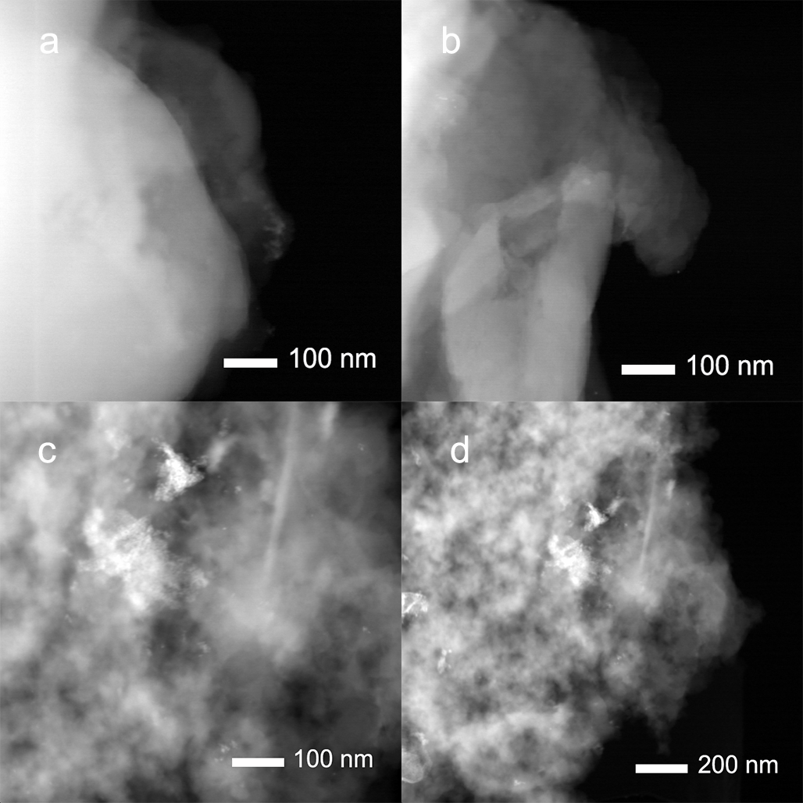
Supplementary Figure 12. STEM images of the spent catalysts in control experiment. (a-b) KAP-2/PdCl₂ and (c-d) KAP-4/PdCl₂.

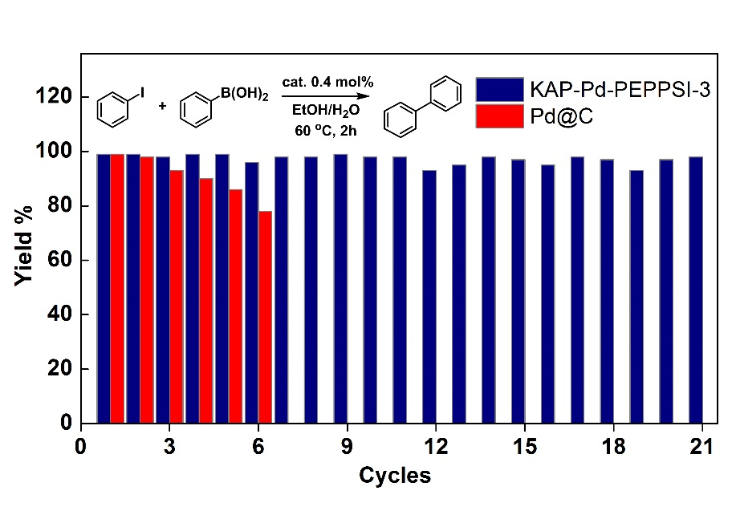
Supplementary Figure 13. Recyclability of KAP-Pd-PEPPSI-3 in Suzuki coupling reaction. Reaction conditions: catalyst 0.4 mol%, iodobenzene 1.0 mmol, phenylboronic acid 1.5 mmol, K₃PO₄ 3.0 mmol, EtOH/H₂O 4 mL, 60 ºC, 2 h.

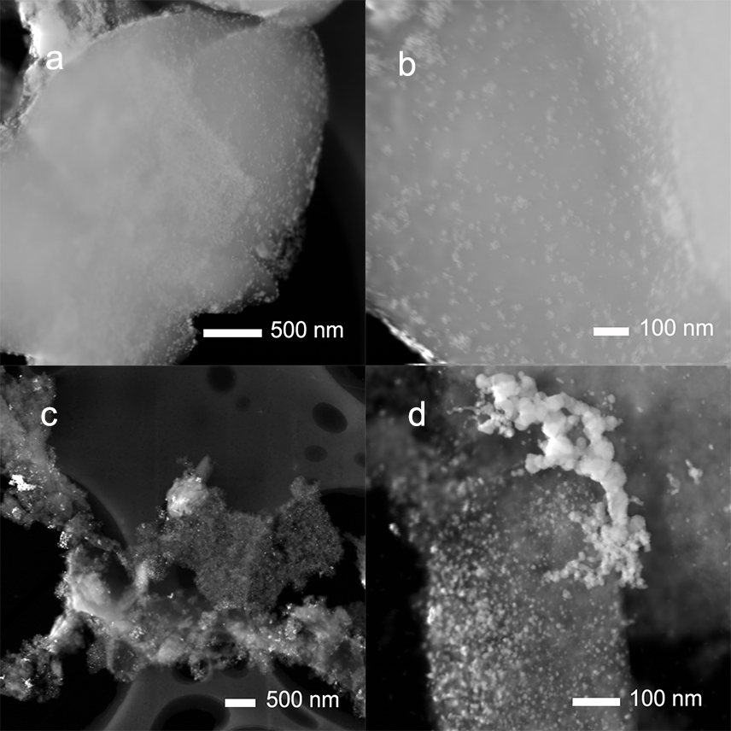
Supplementary Figure 14. STEM images of the spent catalysts in Suzuki coupling reaction. (a-b) Pd@C after 6 cycles and (c-d) KAP-Pd-PEPPSI-3 after 21 cycles in Suzuki coupling reaction.

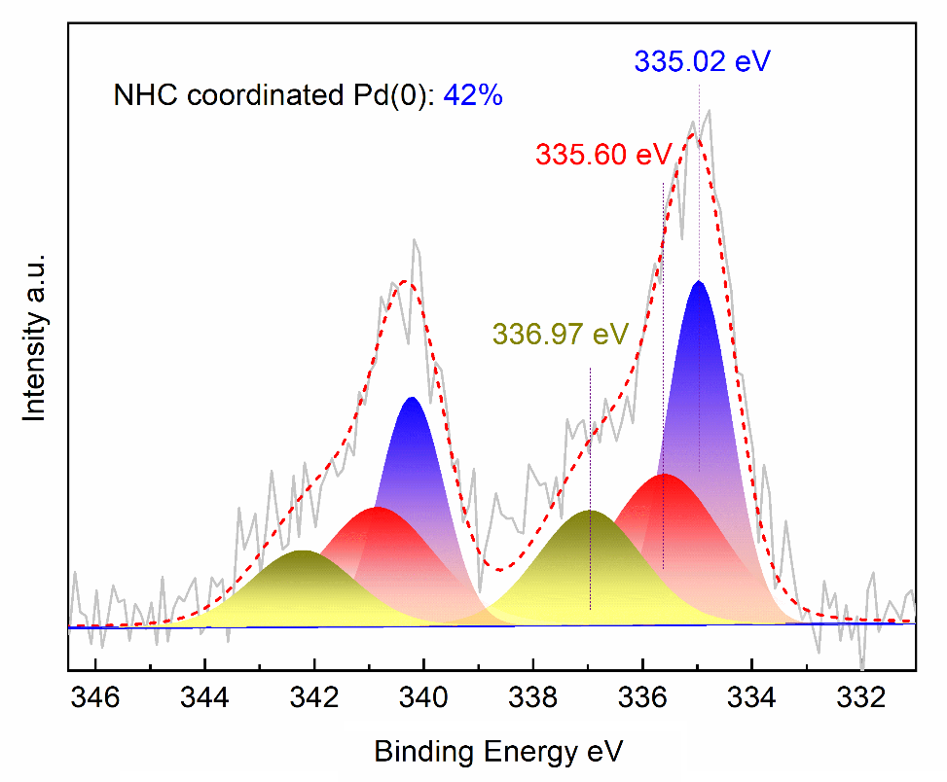
Supplementary Figure 15. Pd 3d XPS spectra of recycled KAP-Pd-PEPPSI-2 after the 21th cycle in Suzuki coupling reaction.

Supplementary Tables
Supplementary Table 1. Pd content in different catalysts and the corresponding ligand-to-metal ratio ª
Cat. | Pd loading wt% | L/Pd
Pd@C | 5.6 | -
Pd@NC | 2.1 | 56
Pd@PC | 1.2 | 19
Pd@SiO₂ | 2.1 | -
KAP-Pd-PPh₃ | 2.2 | 5.34
POP-Pd-PEPPSI | 2.5 | 4.22
KAP- Pd-PEPPSI-1 | 2.5 | 6.32
KAP- Pd-PEPPSI-2 | 2.4 | 5.79
KAP- Pd-PEPPSI-3 | 2.9 | 5.50
ª The Pd content in catalysts were determined by ICP-MS using In as a reference and ligand-to-metal ratios were calculated from the XPS results.

Supplementary Table 2. Optimization of fluorocarbonylation of indoles ª
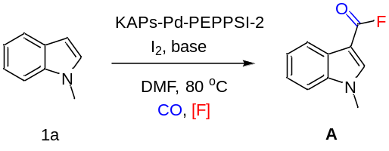
Entry | Solvent | [F⁻] | Base | Yield (%)
1 | DMF | CsF | Cs₂CO₃ | 24
2 | DMF | CsF | K₂CO₃ | 12
3 | DMF | CsF | K₃PO₄ | 8
4 | DMF | CsF | DBU | trace
5^{b} | DMF | CsF | DABCO | 89(79)
6 | DMF | KF | DABCO | 74
7 | DMF | NH₄F | DABCO | trace
8 | DMF | NBu₄F | DABCO | 32
9 | Toluene | CsF | DABCO | trace
10 | Dioxane | CsF | DABCO | trace
11^{c} | DMF | CsF | DABCO | trace
ª Conditions: 1a (0.25 mmol), CsF (1 mmol), catalyst (5 mol%), I₂ (0.5 mmol), base (0.5 mmol), DMF (2 mL), 80 ºC, 24 h. ^{b}Isolated yield in bracket. ^{c}Mecury test.

Supplementary Table 3. Pd leaching conditions of different catalyst in washing test ª
Entry | Catalyst | Pd leaching (%)
1 | Pd@C | 39.6
2 | Pd@NC | 19.6
3 | Pd@PC | 12.4
4 | Pd@SiO₂ | 27.4
5 | KAP-Pd-PPh₃ | 60.4
6 | POP-Pd-PEPPSI | 41.3
7 | KAP-Pd-PEPPSI-1 | 39.6
8 | KAP-Pd-PEPPSI-2 | 16.1
9 | KAP-Pd-PEPPSI-3 | 7.0
10^{b} | KAP-Pd-PEPPSI-3 | 5.5
11^{c} | KAP-Pd-PEPPSI-3 | 91.0
ª The washing test was performed to determine the extent of Pd leaching from the catalysts upon treatment with the reactants for 4 h at 80 ºC in the absence of CsF. ^{b}After reaction for 4 h in the presence of CsF (3% yield). ^{c}Catalyst 0.6 mol% (21% yield).

Supplementary Table 4. The time-course analyses of Pd distribution as well as the corresponding reaction activity in flurocarbonylation of indole
Time h | Pd@C |  | KAP-Pd-PEPPSI
Time h | Yield % | Pd in solution wt% | Yield % | Pd in solution wt%
2 | 45 | 37.3 | 0 | 2
4 | 67 | 40.7 | 3 | 5.5
6 | 74 | 35.1 | 55 | 1.9
8 | 81 | 28.8 | 69 | 0.6
10 | 84 | 16.4 | 78 | 0.5
24 | 89 | 2 | 86 | 0.2

Supplementary Table 5. Aminocarbonylation of indole with weakly nucleophilic aromatic amines using various catalyst systems ª
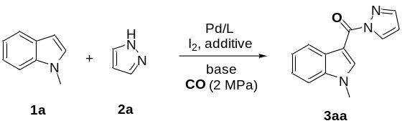
Entry | Reaction Conditions | Yield %
1 | (Arndtsen's Conditions)1a 0.37 mmol, 2a 0.25 mmol, Pd(PtBu₃)₂ 5 mol% EtN(iPr)₂ 0.74 mmol, I₂ 0.37 mmol, Bu₄NCl 0.25 mmol, CH₃CN 0.4 mL, 80 ºC, 24 h | 14
2 | (Manabe's Conditions)1a 0.25 mmol, 2a 0.37 mmol, Pd(OAc)₂ 5 mol% Xantphos 10 mol%, Et₃N 1 mmol, I₂ 0.47 mmol, KF 0.625 mmol, DMF 3 mL, 80 ºC, 24 h | 11
3 | (This Work)1a 0.25 mmol, 2a 1.25 mmol, KAPs-Pd-PEPPSI 5 mol%, DABCO 0.5 mmol, I₂ 0.5 mmol, CsF 1 mmol, DMF 2 mL, 80 ºC, 24 h | 74
ª Isolated yield.
Supplementary Table 6. Control reactions to investigate the role of fluoride ª
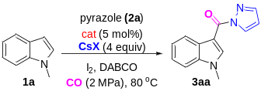 |  | 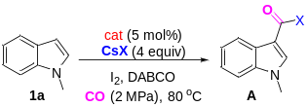 |  | 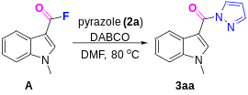
Halides | Yield % | Halides | Yield % | Yield %
- | n.d. | - | n.d. | 84
CsF | 78 | CsF | 89 | 84
CsCl | n.d. | CsCl | n.d. | 84
CsBr | n.d. | CsBr | n.d. | 84
CsI | n.d. | CsI | n.d. | 84
ª Conditions: 1a (0.25 mmol), CsX (1 mmol), KAP-Pd-PEPPSI-2 (5 mol%), I₂ (0.5 mmol), base (0.5 mmol), DMF (2 mL), 80 ºC, 24 h. HPLC yield.

Supplementary Note 1
Detailed Descriptions for Products
1-methyl-1H-indole-3-carbonyl fluoride
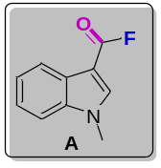Purified by column chromatography (10:1 PE/EA); white solid; 79% yield; Rf = 0.28 (5:1 PE/EA). ¹H NMR (400 MHz, CDCl₃) δ 7.99 – 7.97 (m, 1H), 7.70 (s, 1H), 7.29 – 7.23 (m, 3H), 3.75 (s, 3H). ¹³C NMR (100 MHz, CDCl₃) δ 156.3, 153.0, 137.8, 137.5, 136.5, 126.8, 123.9, 123.1, 121.1, 110.4, 109.9, 33.8, 33.6. The spectral data obtained agree with those reported in the literature.⁹
(1-methyl-1H-indol-3-yl)(1H-pyrazol-1-yl)methanone
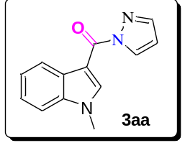Purified by column chromatography (10:1 PE/EA); light red solid; 74% yield; Rf = 0.36 (5:1 PE/EA). ¹H NMR (400 MHz, CDCl₃) δ 8.82 (s, 1H), 8.50 (s, 2H), 7.75 (s, 1H), 7.35 (s, 3H), 6.45 (s, 1H), 3.86 (d, J = 2.3 Hz, 3H). ¹³C NMR (100 MHz, CDCl₃) δ 160.9, 143.1, 140.1, 136.8, 129.7, 128.9, 123.4, 122.8, 122.4, 109.8, 108.0, 106.1, 33.7. HRMS (ESI) m/z: calculated for C₁₃H₁₁N₃ONa [M + Na]⁺ 248.0800, found 248.0797.
(1,4-dimethyl-1H-indol-3-yl)(1H-pyrazol-1-yl)methanone
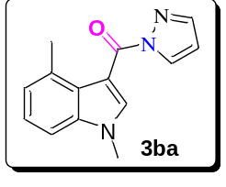Purified by column chromatography (10:1 then 5:1 PE/EA); light red solid; 83% yield; Rf = 0.29 (5:1 PE/EA). ¹H NMR (400 MHz, CDCl₃) δ 8.45 (d, J = 2.6 Hz, 1H), 8.12 (s, 1H), 7.75 (s, 1H), 7.18 (m, 3H), 6.48 (dd, J = 2.6, 1.5 Hz, 1H), 3.78 (s, 3H), 2.75 (s, 3H). ¹³C NMR (100 MHz, CDCl₃) δ 161.2, 143.2, 139.7, 137.6, 132.7, 129.9, 126.6, 124.6, 123.6, 108.5, 107.6, 107.2, 33.7, 22.0. HRMS (ESI) m/z: calculated for C₁₄H₁₃N₃ONa [M + Na]⁺ 262.0956, found 262.0954.
(1,5-dimethyl-1H-indol-3-yl)(1H-pyrazol-1-yl)methanone
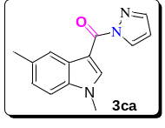Purified by column chromatography (10:1 PE/EA); light red solid; 81% yield; Rf = 0.38 (5:1 PE/EA). ¹H NMR (400 MHz, DMSO) δ 8.89 (s, 1H), 8.55 (dd, J = 2.7, 0.5 Hz, 1H), 8.12 (s, 1H), 7.94 (d, J = 0.8 Hz, 1H), 7.50 (d, J = 8.3 Hz, 1H), 7.18 (dd, J = 8.4, 1.3 Hz, 1H), 6.64 (dd, J = 2.7, 1.5 Hz, 1H), 3.93 (s, 3H), 2.47 (s, 3H). ¹³C NMR (100 MHz, DMSO) δ 160.1, 143.5, 140.5, 135.1, 131.5, 129.6, 128.3, 124.6, 121.0, 110.7, 108.5, 103.9, 33.4, 21.3. HRMS (ESI) m/z: calculated for C₁₄H₁₃N₃ONa [M + Na]⁺ 262.0956, found 262.0957.
(1,6-dimethyl-1H-indol-3-yl)(1H-pyrazol-1-yl)methanone
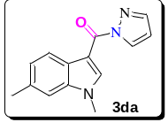Purified by column chromatography (10:1 PE/EA); light red solid; 91% yield; Rf = 0.40 (5:1 PE/EA). ¹H NMR (400 MHz, DMSO) δ 8.85 (s, 1H), 8.56 (d, J = 2.7 Hz, 1H), 8.18 (d, J = 8.1 Hz, 1H), 7.94 (d, J = 0.7 Hz, 1H), 7.40 (s, 1H), 7.15 (d, J = 8.1 Hz, 1H), 6.63 (dd, J = 2.7, 1.5 Hz, 1H), 3.91 (s, 3H), 2.46 (s, 3H). ¹³C NMR (100 MHz, DMSO) δ 160.1, 143.6, 140.2, 137.0, 132.6, 129.6, 125.9, 124.1, 120.9, 110.8, 108.5, 104.4, 33.3, 21.3. HRMS (ESI) m/z: calculated for C₁₄H₁₃N₃ONa [M + Na]⁺ 262.0956, found 262.0952.
(1,7-dimethyl-1H-indol-3-yl)(1H-pyrazol-1-yl)methanone
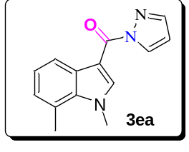Purified by column chromatography (10:1 then 5:1 PE/EA); light red solid; 69% yield; Rf = 0.31 (5:1 PE/EA). ¹H NMR (400 MHz, DMSO) δ 8.82 (s, 1H), 8.59–8.52 (m, 1H), 8.19 (d, J = 7.9 Hz, 1H), 7.98–7.88 (m, 1H), 7.16 (t, J = 7.6 Hz, 1H), 7.03 (d, J = 7.1 Hz, 1H), 6.63 (dd, J = 2.7, 1.5 Hz, 1H), 4.19 (s, 3H), 2.77 (s, 3H). ¹³C NMR (100 MHz, DMSO) δ 160.0, 143.5, 142.0, 135.2, 129.7, 129.2, 125.8, 122.6, 119.2, 108.5, 103.8, 37.5, 19.0. HRMS (ESI) m/z: calculated for C₁₄H₁₃N₃ONa [M + Na]⁺ 262.0956, found 262.0954.
(1,2-dimethyl-1H-indol-3-yl)(1H-pyrazol-1-yl)methanone
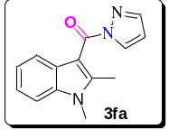Purified by column chromatography (10:1 then 5:1 PE/EA); light red solid; 57% yield; Rf = 0.13 (5:1 PE/EA). ¹H NMR (400 MHz, DMSO) δ 8.45 (d, J = 2.7 Hz, 1H), 7.86 (s, 1H), 7.56 (d, J = 8.2 Hz, 1H), 7.37 (d, J = 7.9 Hz, 1H), 7.22 (t, J = 7.6 Hz, 1H), 7.12 (t, J = 7.5 Hz, 1H), 6.64 (s, 1H), 3.78 (s, 3H), 2.47 (s, 3H). ¹³C NMR (100 MHz, DMSO) δ 163.3, 146.2, 143.1, 136.3, 130.2, 126.3, 122.0, 121.3, 120.0, 110.1, 109.0, 105.3, 29.9, 12.4. HRMS (ESI) m/z: calculated for C₁₄H₁₃N₃ONa [M + Na]⁺ 262.0956, found 262.0957.
(6-chloro-1-methyl-1H-indol-3-yl)(1H-pyrazol-1-yl)methanone
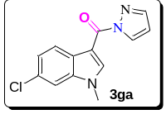Purified by column chromatography (10:1 PE/EA); light red solid; 69% yield; Rf = 0.35 (5:1 PE/EA). ¹H NMR (400 MHz, DMSO) δ 8.94 (s, 1H), 8.56 (d, J = 2.8 Hz, 1H), 8.27 (d, J = 8.5 Hz, 1H), 7.96 (s, 1H), 7.77 (d, J = 1.7 Hz, 1H), 7.33 (dd, J = 8.5, 1.8 Hz, 1H), 6.65 (dd, J = 2.7, 1.5 Hz, 1H), 3.95 (s, 3H). ¹³C NMR (100 MHz, DMSO) δ 160.0, 143.9, 141.4, 137.2, 129.7, 127.9, 126.7, 122.7, 122.5, 111.2, 108.8, 104.7, 33.6. HRMS (ESI) m/z: calculated for C₁₃H₁₀ClN₃ONa [M + Na]⁺ 282.0410, found 282.0408.
(6-bromo-1-methyl-1H-indol-3-yl)(1H-pyrazol-1-yl)methanone
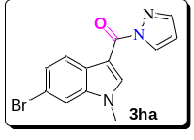Purified by column chromatography (10:1 PE/EA); light red solid; 64% yield; Rf = 0.34 (5:1 PE/EA). ¹H NMR (400 MHz, DMSO) δ 8.96 (s, 1H), 8.60 (dd, J = 2.8, 0.6 Hz, 1H), 8.25 (d, J = 8.5 Hz, 1H), 8.02–7.97 (m, 1H), 7.94 (d, J = 1.6 Hz, 1H), 7.49 (dd, J = 8.5, 1.8 Hz, 1H), 6.68 (dd, J = 2.8, 1.5 Hz, 1H), 3.98 (s, 3H). ¹³C NMR (100 MHz, DMSO) δ 160.0, 143.9, 141.3, 137.6, 129.7, 127.0, 125.4, 122.8, 115.9, 114.1, 108.8, 104.7, 33.6. HRMS (ESI) m/z: calculated for C₁₃H₁₀BrN₃ONa [M + Na]⁺ 325.9904, found 325.9912.
(5-methoxy-1-methyl-1H-indol-3-yl)(1H-pyrazol-1-yl)methanone
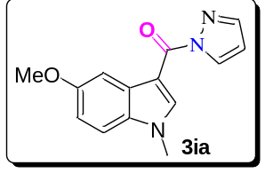Purified by column chromatography (10:1 then 5:1 PE/EA); white solid; 73% yield; Rf = 0.30 (5:1 PE/EA). ¹H NMR (400 MHz, DMSO) δ 8.89 (s, 1H), 8.55 (d, J = 2.7 Hz, 1H), 7.95 (d, J = 0.6 Hz, 1H), 7.83 (d, J = 2.5 Hz, 1H), 7.53 (d, J = 8.9 Hz, 1H), 6.98 (dd, J = 8.9, 2.5 Hz, 1H), 6.64 (dd, J = 2.4, 1.7 Hz, 1H), 3.93 (s, 3H), 3.84 (s, 3H). ¹³C NMR (100 MHz, DMSO) δ 160.1, 156.0, 143.6, 140.5, 131.6, 129.6, 129.1, 112.7, 111.9, 108.5, 104.0, 103.2, 55.3, 33.6. HRMS (ESI) m/z: calculated for C₁₄H₁₃N₃O₂Na [M + Na]⁺ 278.0905, found 278.0902.
(1-methyl-1H-pyrrolo[2,3-b]pyridin-3-yl)(1H-pyrazol-1-yl)methanone
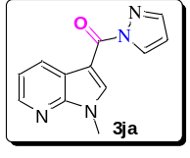Purified by column chromatography (10:1 then 5:1 PE/EA); light red solid; 70% yield; Rf = 0.16 (5:1 PE/EA). ¹H NMR (400 MHz, CDCl₃) δ 8.98 (s, 1H), 8.72 (dd, J = 7.9, 1.6 Hz, 1H), 8.49 (dd, J = 2.8, 0.5 Hz, 1H), 8.44 (dd, J = 4.7, 1.6 Hz, 1H), 7.78 (d, J = 0.7 Hz, 1H), 7.33–7.23 (m, 1H), 6.48 (dd, J = 2.8, 1.5 Hz, 1H), 4.00 (s, 3H). ¹³C NMR (100 MHz, CDCl₃) δ 160.5, 147.9, 144.6, 143.5, 140.0, 130.7, 129.6, 121.3, 118.7, 108.4, 104.8, 32.1. HRMS (ESI) m/z: calculated for C₁₂H₁₀N₄ONa [M + Na]⁺ 249.0752, found 249.0750.
(1-allyl-1H-indol-3-yl)(1H-pyrazol-1-yl)methanone
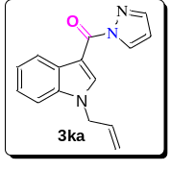Purified by column chromatography (10:1 PE/EA); light red solid; 56% yield; Rf = 0.47 (5:1 PE/EA). ¹H NMR (400 MHz, DMSO) δ 8.98 (s, 1H), 8.58 (d, J = 2.7 Hz, 1H), 8.40–8.28 (m, 1H), 7.96 (d, J = 0.7 Hz, 1H), 7.67–7.58 (m, 1H), 7.39–7.30 (m, 2H), 6.65 (dd, J = 2.7, 1.5 Hz, 1H), 6.08–6.04 (m, 1H), 5.24 (dd, J = 10.3, 1.3 Hz, 1H), 5.18–5.13 (m, 1H), 5.04 (d, J = 5.5 Hz, 2H). ¹³C NMR (100 MHz, DMSO) δ 160.2, 143.8, 139.8, 135.9, 133.4, 129.7, 128.2, 123.2, 122.6, 121.4, 117.9, 111.4, 108.7, 104.9, 48.8. HRMS (ESI) m/z: calculated for C₁₅H₁₃N₃ONa [M + Na]⁺ 274.0956, found 274.0956.
(1-benzyl-1H-indol-3-yl)(1H-pyrazol-1-yl)methanone
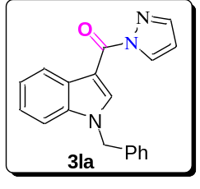Purified by column chromatography (10:1 PE/EA); white solid; 56% yield; Rf = 0.40 (5:1 PE/EA). ¹H NMR (400 MHz, CDCl₃) δ 8.97 (s, 1H), 8.52 (t, J = 5.1 Hz, 2H), 7.74 (s, 1H), 7.37–7.25 (m, 6H), 7.19–7.11 (m, 2H), 6.46 (dd, J = 2.5, 1.4 Hz, 1H), 5.41 (s, 2H). ¹³C NMR (100 MHz, CDCl₃) δ 160.9, 143.2, 139.8, 136.3, 135.8, 129.7, 129.1, 129.0, 128.1, 126.8, 123.6, 122.9, 122.5, 110.5, 108.1, 106.7, 51.1. HRMS (ESI) m/z: calculated for C₁₉H₁₅N₃ONa [M + Na]⁺ 324.1112, found 324.1111.
(1-methyl-1H-pyrrol-3-yl)(1H-pyrazol-1-yl)methanone
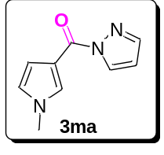Purified by column chromatography (10:1 PE/EA); light red solid; 62% yield; Rf = 0.49 (5:1 PE/EA). ¹H NMR (400 MHz, CDCl₃) δ 8.38 (d, J = 2.4 Hz, 1H), 7.80–7.63 (m, 2H), 6.96 (s, 1H), 6.46 (dd, J = 2.7, 1.5 Hz, 1H), 6.24 (dd, J = 4.2, 2.5 Hz, 1H), 4.01 (s, 3H). ¹³C NMR (100 MHz, CDCl₃) δ 157.7, 143.5, 132.3, 129.9, 124.6, 122.6, 109.0, 108.3, 37.7. HRMS (ESI) m/z: calculated for C₉H₉N₃ONa [M + Na]⁺ 198.0643, found 198.0632.
(1-methyl-1H-indol-3-yl)(3-methyl-1H-pyrazol-1-yl)methanone
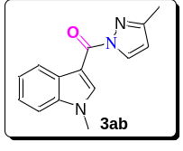Purified by column chromatography (10:1 PE/EA); white solid; 72% yield; Rf = 0.36 (5:1 PE/EA). ¹H NMR (400 MHz, CDCl₃) δ 8.84 (s, 1H), 8.54–8.45 (m, 1H), 8.39 (d, J = 2.5 Hz, 1H), 7.44–7.29 (m, 3H), 6.26 (d, J = 2.5 Hz, 1H), 3.89 (s, 3H), 2.40 (s, 3H). ¹³C NMR (100 MHz, CDCl₃) δ 160.8, 153.0, 139.8, 136.8, 130.4, 128.9, 123.3, 122.7, 122.4, 109.7, 108.6, 106.3, 33.7, 14.1. HRMS (ESI) m/z: calculated for C₁₄H₁₃N₃ONa [M + Na]⁺ 262.0956, found 262.0954.
(3,5-dimethyl-1H-pyrazol-1-yl)(1-methyl-1H-indol-3-yl)methanone
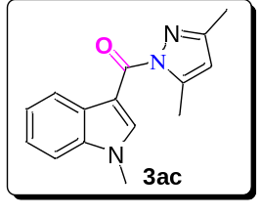Purified by column chromatography (10:1 PE/EA); light red solid; 63% yield; Rf = 0.35 (5:1 PE/EA). ¹H NMR (400 MHz, CDCl₃) δ 8.60 (s, 1H), 8.46 (dd, J = 6.1, 2.7 Hz, 1H), 7.33 (dt, J = 5.5, 3.9 Hz, 3H), 6.01 (s, 1H), 3.86 (s, 3H), 2.66 (s, 3H), 2.32 (s, 3H). ¹³C NMR (100 MHz, CDCl₃) δ 163.2, 150.9, 144.7, 139.7, 136.8, 128.9, 123.1, 122.5, 122.4, 110.0, 109.6, 107.6, 33.6, 14.7, 13.9. HRMS (ESI) m/z: calculated for C₁₅H₁₅N₃ONa [M + Na]⁺ 276.1112, found 276.1092.
(1H-imidazol-1-yl)(1-methyl-1H-indol-3-yl)methanone
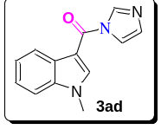Purified by column chromatography (2:1 PE/EA); white solid; 85% yield; Rf = 0.06 (2:1 PE/EA). ¹H NMR (400 MHz, CDCl₃) δ 8.19 – 8.02 (m, 2H), 7.55 (d, J = 26.8 Hz, 2H), 7.36 – 7.22 (m, 3H), 7.07 (s, 1H), 3.80 (s, 3H). ¹³C NMR (101 MHz, CDCl₃) δ 160.73 (s), 137.38 (d, J = 7.5 Hz), 136.05 (s), 130.31 (s), 127.29 (s), 124.26 (s), 123.10 (s), 121.72 (s), 118.02 (s), 110.22 (s), 107.94 (s), 33.86 (s). HRMS (ESI) m/z: calculated for C₁₃H₁₁N₃ONa [M + Na]⁺ 248.0800, found 248.0802.
(1H-benzo[d]imidazol-1-yl)(1-methyl-1H-indol-3-yl)methanone
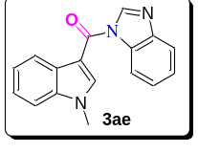Purified by column chromatography (2:1 PE/EA); white solid; 68% yield; Rf = 0.14 (2:1 PE/EA). ¹H NMR (400 MHz, CDCl₃) δ 8.39 (s, 1H), 8.08 (dd, J = 6.4, 2.5 Hz, 1H), 8.03 (d, J = 7.5 Hz, 1H), 7.75 (dd, J = 6.2, 2.3 Hz, 1H), 7.57 (s, 1H), 7.36–7.21 (m, 5H), 3.80 (s, 3H). ¹³C NMR (100 MHz, CDCl₃) δ 160.7, 143.1, 141.7, 136.4, 134.8, 131.5, 127.8, 124.1, 123.5, 123.1, 121.9, 120.5, 119.3, 113.9, 109.2, 107.7, 32.8. HRMS (ESI) m/z: calculated for C₁₇H₁₃N₃ONa [M + Na]⁺ 298.0956, found 298.0954.
(1H-benzo[d][1,2,3]triazol-1-yl)(1-methyl-1H-indol-3-yl)methanone
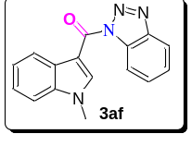Purified by column chromatography (10:1 then 5:1 PE/EA); white solid; 71% yield; Rf = 0.20 (5:1 PE/EA). ¹H NMR (400 MHz, CDCl₃) δ 8.76 (s, 1H), 8.57–8.52 (m, 1H), 8.49 (d, J = 8.3 Hz, 1H), 8.12 (d, J = 8.3 Hz, 1H), 7.63 (dd, J = 11.4, 4.0 Hz, 1H), 7.53–7.44 (m, 1H), 7.43–7.31 (m, 3H), 3.90 (d, J = 1.3 Hz, 3H). ¹³C NMR (100 MHz, CDCl₃) δ 160.9, 145.6, 139.8, 137.0, 132.6, 129.8, 128.6, 125.7, 123.8, 123.2, 122.3, 119.8, 115.1, 110.0, 106.4, 33.8. The spectral data obtained agree with those reported in the literature.¹⁰
(1H-indazol-1-yl)(1-methyl-1H-indol-3-yl)methanone
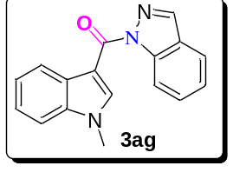Purified by column chromatography (10:1 PE/EA); light red solid; 67% yield; Rf = 0.30 (5:1 PE/EA). ¹H NMR (400 MHz, CDCl₃) δ 8.74 (s, 1H), 8.70 (dd, J = 8.5, 0.7 Hz, 1H), 8.63–8.57 (m, 1H), 8.18 (d, J = 0.5 Hz, 1H), 7.76 (d, J = 8.0 Hz, 1H), 7.58 (ddd, J = 8.3, 7.1, 1.1 Hz, 1H), 7.39–7.31 (m, 4H), 3.90 (s, 3H). ¹³C NMR (100 MHz, CDCl₃) δ 163.3, 140.4, 138.9, 138.7, 136.7, 129.1, 129.0, 125.6, 123.9, 123.2, 122.5 (two peaks overlapped), 120.7, 116.1, 109.7, 107.4, 33.6. HRMS (ESI) m/z: calculated for C₁₇H₁₃N₃ONa [M + Na]⁺ 298.0956, found 298.0956.
1-methyl-N-phenyl-1H-indole-3-carboxamide
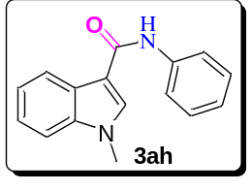Purified by column chromatography (10:1 then 5:1 PE/EA); white solid; 64% yield; Rf = 0.38 (2:1 PE/EA). ¹H NMR (400 MHz, CDCl₃) δ 8.05 (dd, J = 6.3, 2.5 Hz, 1H), 7.74 (d, J = 10.5 Hz, 2H), 7.66 (d, J = 7.7 Hz, 2H), 7.40–7.28 (m, 5H), 7.11 (t, J = 7.4 Hz, 1H), 3.80 (s, 3H). ¹³C NMR (100 MHz, CDCl₃) δ 163.2, 138.5, 137.4, 132.6, 130.9, 129.1, 128.9, 125.4, 123.9, 122.8, 121.8, 120.1 (two peaks overlapped), 111.1, 110.3, 33.4. The spectral data obtained agree with those reported in the literature.¹¹
N-(4-methoxyphenyl)-1-methyl-1H-indole-3-carboxamide
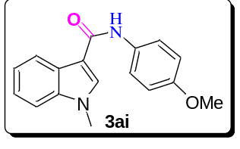Purified by column chromatography (10:1 then 5:1 PE/EA); white solid; 70% yield; Rf = 0.05 (5:1 PE/EA). ¹H NMR (400 MHz, CDCl₃) δ 8.05 (dd, J = 6.5, 1.9 Hz, 1H), 7.71 (s, 2H), 7.55 (d, J = 8.9 Hz, 2H), 7.44–7.27 (m, 3H), 6.93–6.86 (m, 2H), 3.80, 3.79 (6H). ¹³C NMR (100 MHz, CDCl₃) δ 163.3, 156.3, 137.3, 132.5, 131.5, 130.9, 128.9, 125.5, 122.8, 122.1, 121.7, 120.2, 114.2, 111.0, 110.2, 55.5, 33.3. The spectral data obtained agree with those reported in the literature.¹²
N-(4-chlorophenyl)-1-methyl-1H-indole-3-carboxamide
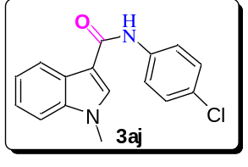Purified by column chromatography (10:1 then 5:1 PE/EA); white solid; 59% yield; Rf = 0.06 (5:1 PE/EA). ¹H NMR (400 MHz, CDCl₃) δ 8.03 (dd, J = 6.4, 2.0 Hz, 1H), 7.76–7.68 (m, 2H), 7.61 (d, J = 8.8 Hz, 2H), 7.42–7.37 (m, 1H), 7.37–7.28 (m, 4H), 3.82 (s, 3H). ¹³C NMR (100 MHz, CDCl₃) δ 163.1, 137.4, 137.1, 132.7, 130.9, 129.0, 128.9, 128.8, 125.3, 122.9, 121.9, 121.2, 120.1, 110.8, 110.3, 33.4. HRMS (ESI) m/z: calculated for C₁₆H₁₃ClN₂ONa [M + Na]⁺ 307.0614, found 307.0593.
1-methyl-1H-indole-3-carbonyl azide
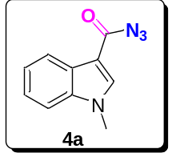Purified by column chromatography (10:1 PE/EA); light red solid; 86% yield; Rf = 0.30 (5:1 PE/EA). ¹H NMR (400 MHz, CDCl₃) δ 8.20–8.09 (m, 1H), 7.63 (s, 1H), 7.29–7.20 (m, 3H), 3.68 (s, 3H). ¹³C NMR (100 MHz, CDCl₃) δ 167.8, 137.6, 136.5, 126.5, 123.5, 122.7, 121.7, 110.1, 108.4, 33.6. The spectral data obtained agree with those reported in the literature.¹²
1,5-dimethyl-1H-indole-3-carbonyl azide
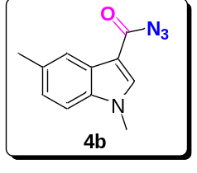Purified by column chromatography (10:1 PE/EA); light red solid; 85% yield; Rf = 0.35 (5:1 PE/EA). ¹H NMR (400 MHz, CDCl₃) δ 7.93 (s, 1H), 7.57 (s, 1H), 7.07 (dd, J = 26.7, 8.4 Hz, 2H), 3.64 (s, 3H), 2.39 (s, 3H). ¹³C NMR (100 MHz, CDCl₃) δ 167.8, 136.4, 136.0, 132.5, 126.7, 125.0, 121.4, 109.7, 107.9, 33.7, 21.6. HRMS (ESI) m/z: calculated for C₁₁H₁₁N₂O [M + H – N₂]⁺ 187.0871, found 187.0869.
1,6-dimethyl-1H-indole-3-carbonyl azide
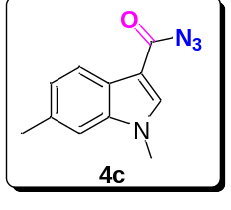Purified by column chromatography (10:1 PE/EA); light red solid; 68% yield; Rf = 0.31 (5:1 PE/EA). ¹H NMR (400 MHz, DMSO) δ 8.13 (s, 1H), 7.93 (d, J = 8.1 Hz, 1H), 7.37 (s, 1H), 7.12 (d, J = 8.1 Hz, 1H), 3.83 (s, 3H), 2.45 (s, 3H). ¹³C NMR (100 MHz, DMSO) δ 166.7, 137.9, 137.5, 132.6, 124.1, 123.6, 120.2, 110.9, 106.6, 33.2, 21.3. HRMS (ESI) m/z: calculated for C₁₁H₁₁N₂O [M + H – N₂]⁺ 187.0871, found 187.0868.
1,7-dimethyl-1H-indole-3-carbonyl azide
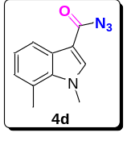Purified by column chromatography (10:1 PE/EA); light red solid; 92% yield; Rf = 0.38 (5:1 PE/EA). ¹H NMR (400 MHz, DMSO) δ 8.12 (s, 1H), 7.93 (d, J = 7.9 Hz, 1H), 7.12 (t, J = 7.6 Hz, 1H), 7.00 (d, J = 7.2 Hz, 1H), 4.10 (s, 3H), 2.72 (s, 3H). ¹³C NMR (100 MHz, DMSO) δ 166.6, 139.3, 136.1, 127.0, 125.7, 122.8, 122.6, 118.6, 106.1, 37.3, 18.8. HRMS (ESI) m/z: calculated for C₁₁H₁₁N₂O [M + H – N₂]⁺ 187.0871, found 187.0868.
1,2-dimethyl-1H-indole-3-carbonyl azide
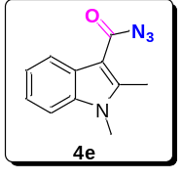Purified by column chromatography (10:1 PE/EA); light red solid; 71% yield; Rf = 0.39 (5:1 PE/EA). ¹H NMR (400 MHz, DMSO) δ 8.12–8.03 (m, 1H), 7.59–7.50 (m, 1H), 7.27–7.18 (m, 2H), 3.72 (s, 3H), 2.73 (s, 3H). ¹³C NMR (100 MHz, DMSO) δ 167.7, 147.9, 136.5, 125.5, 122.3, 122.0, 120.5, 110.4, 104.0, 29.8, 12.0. HRMS (ESI) m/z: calculated for C₁₁H₁₀N₂ONa [M + Na – N₂]⁺ 209.0690, found 209.0684.
5-methoxy-1-methyl-1H-indole-3-carbonyl azide
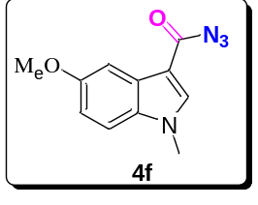Purified by column chromatography (10:1 PE/EA); light red solid; 66% yield; Rf = 0.23 (5:1 PE/EA). ¹H NMR (400 MHz, DMSO) δ 8.12 (s, 1H), 7.53 (d, J = 2.4 Hz, 1H), 7.47 (d, J = 8.9 Hz, 1H), 6.94 (dd, J = 8.9, 2.5 Hz, 1H), 3.83 (s, 3H), 3.81 (s, 3H). ¹³C NMR (100 MHz, DMSO) δ 166.7, 155.9, 137.8, 132.5, 126.7, 112.8, 112.1, 106.2, 102.3, 55.3, 33.4. HRMS (ESI) m/z: calculated for C₁₁H₁₁N₂O₂ [M + H – N₂]⁺ 203.0820, found 203.0809.
5-cyano-1-methyl-1H-indole-3-carbonyl azide
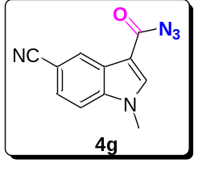Purified by column chromatography (10:1 PE/EA); light red solid; 49% yield; Rf = 0.11 (5:1 PE/EA). ¹H NMR (400 MHz, DMSO) δ 8.46 (s, 1H), 8.40 (d, J = 0.7 Hz, 1H), 7.82 (d, J = 8.6 Hz, 1H), 7.72 (dd, J = 8.6, 1.2 Hz, 1H), 3.93 (s, 3H). ¹³C NMR (100 MHz, DMSO) δ 166.9, 140.2, 139.2, 126.0, 125.4 (two peaks overlapped), 119.8, 112.9, 107.3, 104.7, 33.6. HRMS (ESI) m/z: calculated for C₁₁H₈N₃O [M + H – N₂]⁺ 198.0667, found 198.0662.
6-bromo-1-methyl-1H-indole-3-carbonyl azide
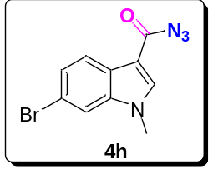Purified by column chromatography (10:1 PE/EA); light red solid; 61% yield; Rf = 0.43 (5:1 PE/EA). ¹H NMR (400 MHz, DMSO) δ 8.21 (s, 1H), 7.94 (d, J = 8.5 Hz, 1H), 7.85 (d, J = 1.5 Hz, 1H), 7.40 (dd, J = 8.5, 1.7 Hz, 1H), 3.85 (s, 3H). ¹³C NMR (100 MHz, DMSO) δ 166.8, 138.6, 138.4, 125.3, 124.7, 122.1, 115.9, 114.2, 106.8, 33.5. HRMS (ESI) m/z: calculated for C₁₀H₈BrN₂O [M + H – N₂]⁺ 250.9820, found 250.9821.
6-chloro-1-methyl-1H-indole-3-carbonyl azide
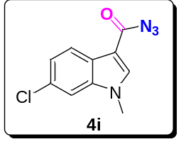Purified by column chromatography (10:1 PE/EA); light red solid; 68% yield; Rf = 0.30 (5:1 PE/EA). ¹H NMR (400 MHz, DMSO) δ 8.24 (s, 1H), 8.01 (d, J = 8.5 Hz, 1H), 7.73 (d, J = 1.4 Hz, 1H), 7.30 (dd, J = 8.5, 1.5 Hz, 1H), 3.86 (s, 3H). ¹³C NMR (100 MHz, DMSO) δ 166.8, 138.8, 138.0, 127.9, 124.4, 122.7, 121.8, 111.3, 106.8, 33.5. HRMS (ESI) m/z: calculated for C₁₀H₈BrN₂O [M + H – N₂]⁺ 207.0325, found 207.0316.
1-methyl-1H-pyrrolo[2,3-b]pyridine-3-carbonyl azide
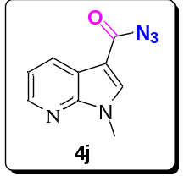Purified by column chromatography (10:1 PE/EA); light red solid; 69% yield; Rf = 0.15 (5:1 PE/EA). ¹H NMR (400 MHz, DMSO) δ 8.48–8.39 (m, 2H), 8.36 (dd, J = 7.9, 1.3 Hz, 1H), 7.35 (dd, J = 7.9, 4.7 Hz, 1H), 3.90 (s, 3H). ¹³C NMR (100 MHz, DMSO) δ 166.8, 148.0, 144.3, 138.1, 129.0, 118.6, 118.1, 105.2, 31.6. HRMS (ESI) m/z: calculated for C₉H₇N₃ONa [M + Na – N₂]⁺ 196.0487, found 196.0486.
1-allyl-1H-indole-3-carbonyl azide
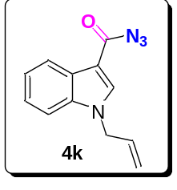Purified by column chromatography (10:1 PE/EA); light red solid; 66% yield; Rf = 0.6 (5:1 PE/EA). ¹H NMR (400 MHz, DMSO) δ 8.26 (s, 1H), 8.09 (dt, J = 5.0, 2.8 Hz, 1H), 7.59 (dd, J = 6.0, 2.8 Hz, 1H), 7.36–7.23 (m, 2H), 6.03 (dq, J = 10.5, 5.6 Hz, 1H), 5.22 (dd, J = 10.3, 1.3 Hz, 1H), 5.11 (dd, J = 17.1, 1.5 Hz, 1H), 4.95 (d, J = 5.5 Hz, 2H). ¹³C NMR (100 MHz, DMSO) δ 166.9, 137.2, 136.8, 133.2, 125.9, 123.2, 122.6, 120.7, 117.9, 111.6, 107.1, 48.7. HRMS (ESI) m/z: calculated for C₁₂H₁₁N₂O [M + H – N₂]⁺ 199.0871, found 199.0869.
1-allyl-5-methyl-1H-indole-3-carbonyl azide
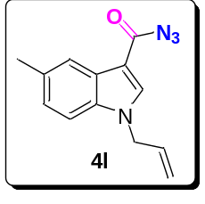Purified by column chromatography (10:1 PE/EA); light red solid; 83% yield; Rf = 0.34 (5:1 PE/EA). ¹H NMR (400 MHz, DMSO) δ 8.19 (s, 1H), 7.89 (s, 1H), 7.45 (d, J = 8.4 Hz, 1H), 7.12 (dd, J = 8.4, 1.2 Hz, 1H), 6.02 (m, 1H), 5.20 (dd, J = 10.3, 1.3 Hz, 1H), 5.09 (dd, J = 17.1, 1.4 Hz, 1H), 4.91 (d, J = 5.5 Hz, 2H), 2.43 (s, 3H). ¹³C NMR (100 MHz, DMSO) δ 166.8, 137.0, 135.2, 133.3, 131.6, 126.2, 124.7, 120.4, 117.7, 111.3, 106.7, 48.7, 21.2. HRMS (ESI) m/z: calculated for C₁₃H₁₃N₂O [M + H – N₂]⁺ 213.1028, found 213.1027.
1-allyl-6-bromo-1H-indole-3-carbonyl azide
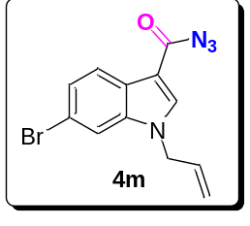Purified by column chromatography (10:1 PE/EA); light red solid; 61% yield; Rf = 0.44 (5:1 PE/EA). ¹H NMR (400 MHz, DMSO) δ 8.30 (s, 1H), 8.18 (d, J = 1.9 Hz, 1H), 7.57 (d, J = 8.8 Hz, 1H), 7.44 (dd, J = 8.8, 2.0 Hz, 1H), 6.02 (qd, J = 10.6, 5.5 Hz, 1H), 5.22 (dd, J = 10.3, 1.3 Hz, 1H), 5.09 (dd, J = 17.1, 1.4 Hz, 1H), 4.95 (d, J = 5.5 Hz, 2H). ¹³C NMR (100 MHz, DMSO) δ 166.9, 138.1, 135.6, 133.0, 127.5, 125.8, 122.8, 118.0, 115.4, 113.8, 106.7, 48.9. HRMS (ESI) m/z: calculated for C₁₂H₁₀BrN₂O [M + H – N₂]⁺ 276.9976, found 276.9971.
methyl 1-allyl-3-(azidocarbonyl)-1H-indole-5-carboxylate
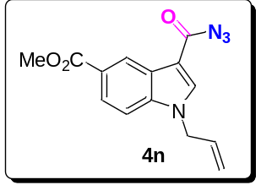Purified by column chromatography (10:1 then 5:1 PE/EA); light red solid; 47% yield; Rf = 0.29 (5:1 PE/EA). 1H NMR (400 MHz, DMSO) δ 8.76–8.70 (m, 1H), 8.38 (s, 1H), 7.90 (dd, J = 8.7, 1.7 Hz, 1H), 7.69 (d, J = 8.7 Hz, 1H), 6.04 (qd, J = 10.6, 5.5 Hz, 1H), 5.23 (dd, J = 10.3, 1.3 Hz, 1H), 5.11 (dd, J = 17.1, 1.4 Hz, 1H), 4.99 (d, J = 5.5 Hz, 2H), 3.89 (s, 3H). ¹³C NMR (100 MHz, DMSO) δ 167.0, 166.6, 139.2, 138.9, 133.0, 125.4, 123.9 (two peaks overlapped), 122.7, 118.1, 111.8, 108.2, 52.0, 48.9. HRMS (ESI) m/z: calculated for C₁₄H₁₃N₂O₃ [M + H – N₂]⁺ 257.0926, found 257.0923.
1-benzyl-1H-indole-3-carbonyl azide
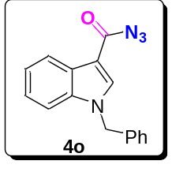Purified by column chromatography (10:1 PE/EA); light red solid; 81% yield; Rf = 0.42 (5:1 PE/EA). ¹H NMR (400 MHz, DMSO) δ 8.46 (s, 1H), 8.09 (dd, J = 6.4, 2.8 Hz, 1H), 7.60 (dd, J = 6.7, 2.6 Hz, 1H), 7.42–7.20 (m, 7H), 5.55 (s, 2H). ¹³C NMR (100 MHz, DMSO) δ 167.0, 137.4, 136.7, 136.6, 128.7, 127.8, 127.4, 126.1, 123.3, 122.6, 120.7, 111.7, 107.3, 49.8. The spectral data obtained agree with those reported in the literature.¹³
1-methyl-1H-indole-3-carbonyl cyanide
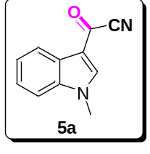Purified by column chromatography (10:1 then 5:1 PE/EA); light red solid; 82% yield; Rf = 0.24 (5:1 PE/EA). ¹H NMR (400 MHz, DMSO) δ 8.69 (s, 1H), 8.05 (d, J = 7.3 Hz, 1H), 7.67 (d, J = 7.9 Hz, 1H), 7.47–7.34 (m, 2H), 3.97 (s, 3H). ¹³C NMR (100 MHz, DMSO) δ 157.8, 144.2, 138.3, 124.9, 124.5, 124.2, 121.0, 115.0, 114.3, 111.9, 33.9. The spectral data obtained agree with those reported in the literature.¹⁴
1,4-dimethyl-1H-indole-3-carbonyl cyanide
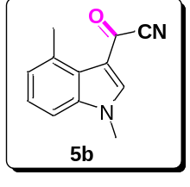Purified by column chromatography (10:1 then 5:1 PE/EA); light red solid; 81% yield; Rf = 0.23 (5:1 PE/EA). 1H NMR (400 MHz, CDCl₃) δ 8.06 (s, 1H), 7.29–7.20 (m, 1H), 7.14 (d, J = 8.2 Hz, 1H), 7.07 (d, J = 7.3 Hz, 1H), 3.84 (s, 3H), 2.78 (s, 3H). ¹³C NMR (100 MHz, CDCl₃) δ 158.2, 144.4, 139.4, 134.1, 126.3, 125.5, 124.4, 117.6, 115.0, 107.9, 34.4, 22.8. GCMS (EI): m/z for C₁₂H₁₀N₂O [M]⁺ 198.1.
1,5-dimethyl-1H-indole-3-carbonyl cyanide
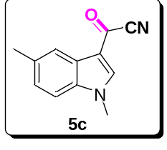Purified by column chromatography (10:1 PE/EA); light red solid; 85% yield; Rf = 0.25 (5:1 PE/EA). ¹H NMR (400 MHz, DMSO) δ 8.63 (s, 1H), 7.86 (s, 1H), 7.56 (d, J = 8.4 Hz, 1H), 7.26 (d, J = 8.3 Hz, 1H), 3.94 (s, 3H), 2.44 (s, 3H). ¹³C NMR (100 MHz, DMSO) δ 162.89 (s), 149.22 (s), 141.94 (s), 138.93 (s), 131.53 (s), 130.10 (s), 126.12 (s), 119.98 (s), 119.63 (s), 116.82 (s), 45.20 (s), 44.99 (s), 44.78 (s), 44.57 (s), 44.36 (s), 26.34 (s). GCMS (EI): m/z for C₁₂H₁₀N₂O [M]⁺ 198.1.
1,6-dimethyl-1H-indole-3-carbonyl cyanide
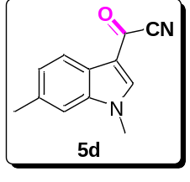Purified by column chromatography (10:1 then 5:1 PE/EA); light red solid; 71% yield; Rf = 0.27 (5:1 PE/EA). ¹H NMR (400 MHz, DMSO) δ 8.57 (s, 1H), 7.88 (d, J = 8.0 Hz, 1H), 7.44 (s, 1H), 7.19 (d, J = 8.0 Hz, 1H), 3.91 (s, 3H), 2.45 (s, 3H). ¹³C NMR (100 MHz, DMSO) δ 157.6, 143.8, 138.6, 134.6, 125.6, 122.3, 120.7, 115.0, 114.3, 111.6, 33.7, 21.3. GCMS (EI): m/z for C₁₂H₁₀N₂O [M]⁺ 198.1.
1,7-dimethyl-1H-indole-3-carbonyl cyanide
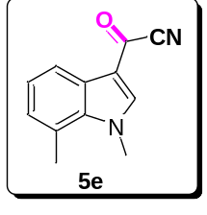Purified by column chromatography (10:1 then 5:1 PE/EA); light red solid; 83% yield; Rf = 0.22 (5:1 PE/EA). ¹H NMR (400 MHz, DMSO) δ 8.56 (s, 1H), 7.89 (d, J = 7.7 Hz, 1H), 7.21 (t, J = 7.6 Hz, 1H), 7.11 (d, J = 7.2 Hz, 1H), 4.18 (s, 3H), 2.73 (s, 3H). ¹³C NMR (100 MHz, DMSO) δ 157.5, 145.2, 136.8, 127.5, 125.7, 124.3, 123.6, 119.1, 114.5, 114.3, 37.8, 18.6. GCMS (EI): m/z for C₁₂H₁₀N₂O [M]⁺ 198.1.
1,2-dimethyl-1H-indole-3-carbonyl cyanide
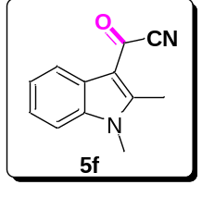Purified by column chromatography (10:1 then 5:1 PE/EA); light red solid; 60% yield; Rf = 0.17 (5:1 PE/EA). ¹H NMR (400 MHz, DMSO) δ 8.13 (dd, J = 5.9, 3.0 Hz, 1H), 7.67 (dd, J = 6.1, 2.9 Hz, 1H), 7.39–7.31 (m, 2H), 3.80 (s, 3H), 3.36 (s, 3H). ¹³C NMR (100 MHz, CDCl₃) δ 163.0, 157.0, 142.1, 130.2, 129.2, 129.1, 124.8, 120.8, 116.5, 35.6, 17.3. GCMS (EI): m/z for C₁₂H₁₀N₂O [M]⁺ 198.1.
5-methoxy-1-methyl-1H-indole-3-carbonyl cyanide
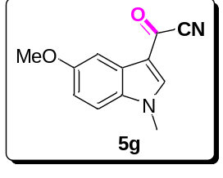Purified by column chromatography (10:1 then 5:1 PE/EA); light red solid; 79% yield; Rf = 0.16 (5:1 PE/EA). ¹H NMR (400 MHz, DMSO) δ 8.59 (s, 1H), 7.57 (d, J = 8.9 Hz, 1H), 7.49 (s, 1H), 7.03 (dd, J = 8.8, 1.6 Hz, 1H), 3.93 (s, 3H), 3.81 (s, 3H). ¹³C NMR (100 MHz, DMSO) δ 157.5, 157.1, 143.6, 133.0, 125.6, 114.8, 114.3, 114.2, 112.9, 103.1, 55.4, 34.0. GCMS (EI): m/z for C₁₂H₁₀N₂O₂ [M]⁺ 214.1.
6-bromo-1-methyl-1H-indole-3-carbonyl cyanide
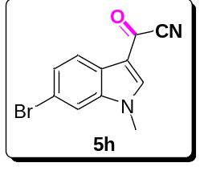Purified by column chromatography (10:1 then 5:1 PE/EA); light red solid; 63% yield; Rf = 0.23 (5:1 PE/EA). ¹H NMR (400 MHz, DMSO) δ 8.72 (s, 1H), 7.98–7.93 (m, 2H), 7.52 (dd, J = 8.4, 1.6 Hz, 1H), 3.96 (s, 3H). ¹³C NMR (100 MHz, DMSO) δ 158.0, 144.7, 139.1, 127.0, 123.5, 122.5, 117.5, 115.0, 114.8, 114.1, 34.0. GCMS (EI): m/z for C₁₁H₇BrN₂O [M]⁺ 262.0.
6-chloro-1-methyl-1H-indole-3-carbonyl cyanide
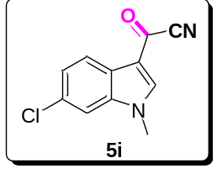Purified by column chromatography (10:1 then 5:1 PE/EA); light red solid; 71% yield; Rf = 0.20 (5:1 PE/EA). ¹H NMR (400 MHz, DMSO) δ 8.73 (s, 1H), 7.99 (d, J = 8.4 Hz, 1H), 7.84 (d, J = 1.7 Hz, 1H), 7.39 (dd, J = 8.4, 1.8 Hz, 1H), 3.95 (s, 3H). ¹³C NMR (100 MHz, DMSO) δ 158.0, 144.9, 138.8, 129.5, 124.4, 123.2, 122.2, 114.8, 114.1, 112.2, 34.0. GCMS (EI): m/z for C₁₁H₇ClN₂O [M]⁺ 218.0.
1-methyl-1H-pyrrolo[2,3-b]pyridine-3-carbonyl cyanide
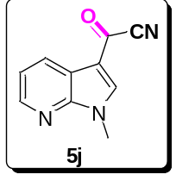Purified by column chromatography (10:1 then 5:1 PE/EA); light red solid; 55% yield; Rf = 0.12 (5:1 PE/EA). ¹H NMR (400 MHz, DMSO) δ 8.95 (s, 1H), 8.52 (dd, J = 4.7, 1.3 Hz, 1H), 8.39 (dd, J = 7.8, 1.3 Hz, 1H), 7.45 (dd, J = 7.8, 4.7 Hz, 1H), 3.98 (s, 3H). ¹³C NMR (100 MHz, DMSO) δ 158.4, 148.8, 145.9, 144.3, 129.7, 120.1, 117.1, 113.9, 113.1, 32.2. GCMS (EI): m/z for C₁₀H₇N₃O [M]⁺ 185.1.
1-allyl-1H-indole-3-carbonyl cyanide
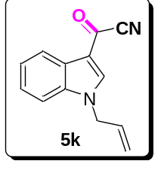Purified by column chromatography (10:1 PE/EA); light red solid; 67% yield; Rf = 0.36 (5:1 PE/EA). ¹H NMR (400 MHz, DMSO) δ 8.73 (s, 1H), 8.12–7.99 (m, 1H), 7.67 (d, J = 7.7 Hz, 1H), 7.42–7.38 (m, 2H), 6.11–6.04 (m, 1H), 5.31–5.16 (m, 2H), 5.06 (d, J = 5.6 Hz, 2H). ¹³C NMR (100 MHz, DMSO) δ 158.1, 143.4, 137.5, 132.7, 125.0, 124.7, 124.2, 121.2, 118.5, 115.4, 114.3, 112.3, 49.3. GCMS (EI): m/z for C₁₃H₁₀N₂O [M]⁺ 210.1.
1-allyl-5-methyl-1H-indole-3-carbonyl cyanide
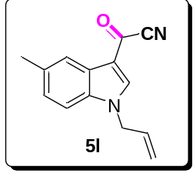Purified by column chromatography (10:1 PE/EA); light red solid; 75% yield; Rf = 0.34 (5:1 PE/EA). ¹H NMR (400 MHz, CDCl₃) δ 8.06, 8.02 (s, 2H), 7.33–7.18 (m, 2H), 6.07–6.00 (m, 1H), 5.40 (d, J = 10.2 Hz, 1H), 5.27 (d, J = 17.1 Hz, 1H), 4.81 (d, J = 5.6 Hz, 2H), 2.49 (s, 3H). ¹³C NMR (100 MHz, CDCl₃) δ 158.7, 140.5, 136.0, 134.6, 130.8, 126.8, 125.6, 122.4, 120.1, 116.6, 114.1, 110.6, 50.1, 21.5. GCMS (EI): m/z for C₁₄H₁₂N₂O [M]⁺ 224.1.
1-allyl-6-bromo-1H-indole-3-carbonyl cyanide
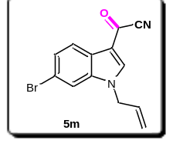Purified by column chromatography (10:1 PE/EA); light red solid; 57% yield; Rf = 0.40 (5:1 PE/EA). ¹H NMR (400 MHz, CDCl₃) δ 8.41 (d, J = 1.9 Hz, 1H), 8.06 (s, 1H), 7.49 (d, J = 8.8 Hz, 1H), 7.29 (dd, J = 8.8, 2.0 Hz, 1H), 6.07–6.00 (m, 1H), 5.44 (dd, J = 10.3, 1.3 Hz, 1H), 5.30 (dd, J = 17.1, 1.4 Hz, 1H), 4.83 (d, J = 5.6 Hz, 2H). ¹³C NMR (100 MHz, CDCl₃) δ 158.7, 140.7, 136.3, 130.4, 128.5, 126.8, 125.2, 120.5, 118.3, 116.3, 113.7, 112.3, 50.3. GCMS (EI): m/z for C₁₃H₉BrN₂O [M]⁺ 288.0.
1-benzyl-1H-indole-3-carbonyl cyanide
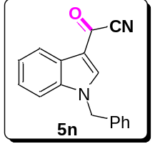Purified by column chromatography (10:1 PE/EA); light red solid; 77% yield; Rf = 0.36 (5:1 PE/EA). ¹H NMR (400 MHz, DMSO) δ 8.98 (s, 1H), 8.14–8.02 (m, 1H), 7.66 (dd, J = 6.2, 2.7 Hz, 1H), 7.42–7.28 (m, 7H), 5.66 (s, 2H). ¹³C NMR (100 MHz, DMSO) δ 158.3, 143.6, 137.4, 136.0, 128.8, 128.0, 127.5, 125.0, 124.9, 124.3, 121.3, 115.5, 114.3, 112.5, 50.3. GCMS (EI): m/z for C₁₇H₁₂N₂O [M]⁺ 260.1.
1H-indole-3-carbonyl cyanide
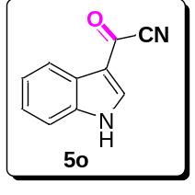Purified by column chromatography (10:1 then 5:1 PE/EA); light red solid; 59% yield; Rf = 0.51 (2:1 PE/EA). ¹H NMR (400 MHz, DMSO) δ 12.93 (s, 1H), 8.65 (s, 1H), 8.10–8.00 (m, 1H), 7.59 (d, J = 7.2 Hz, 1H), 7.39–7.32 (m, 2H). ¹³C NMR (100 MHz, CDCl₃) δ 163.8, 146.7, 142.8, 130.2, 129.4, 129.1, 126.2, 121.4, 119.6, 118.6. The spectral data obtained agree with those reported in the literature.¹⁴
Supplementary Note 2
¹H NMR and ¹³C NMR Copies of Products
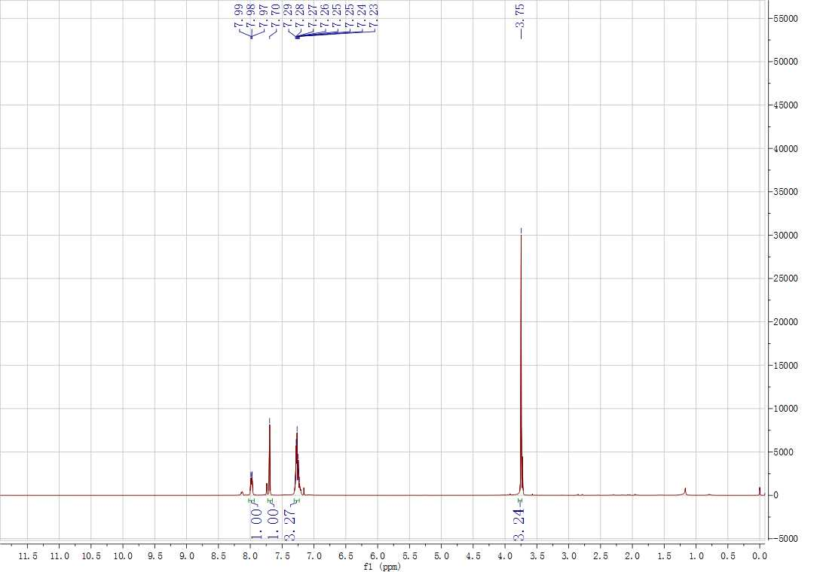
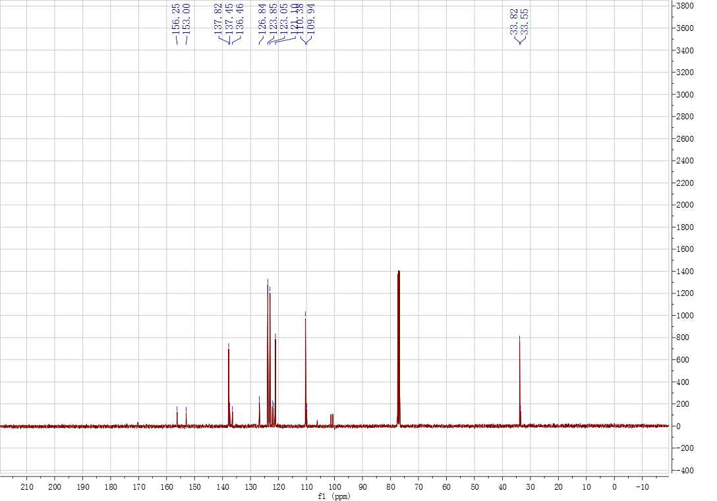
Supplementary Figure 15. ¹H and ¹³C NMR spectrum for A
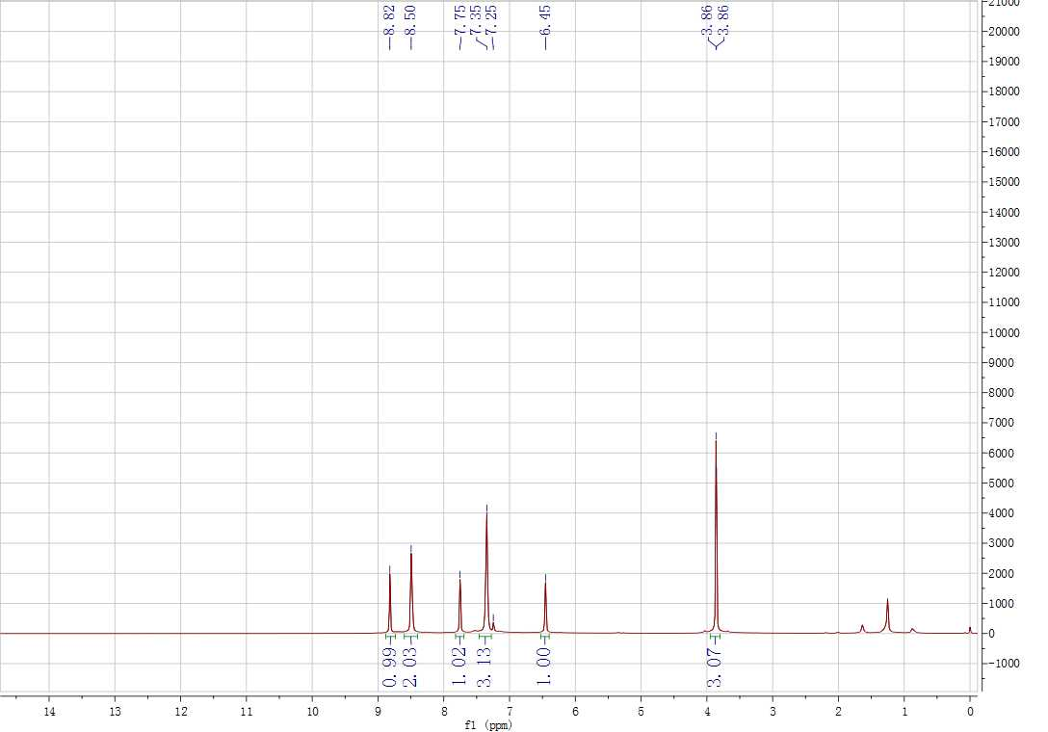
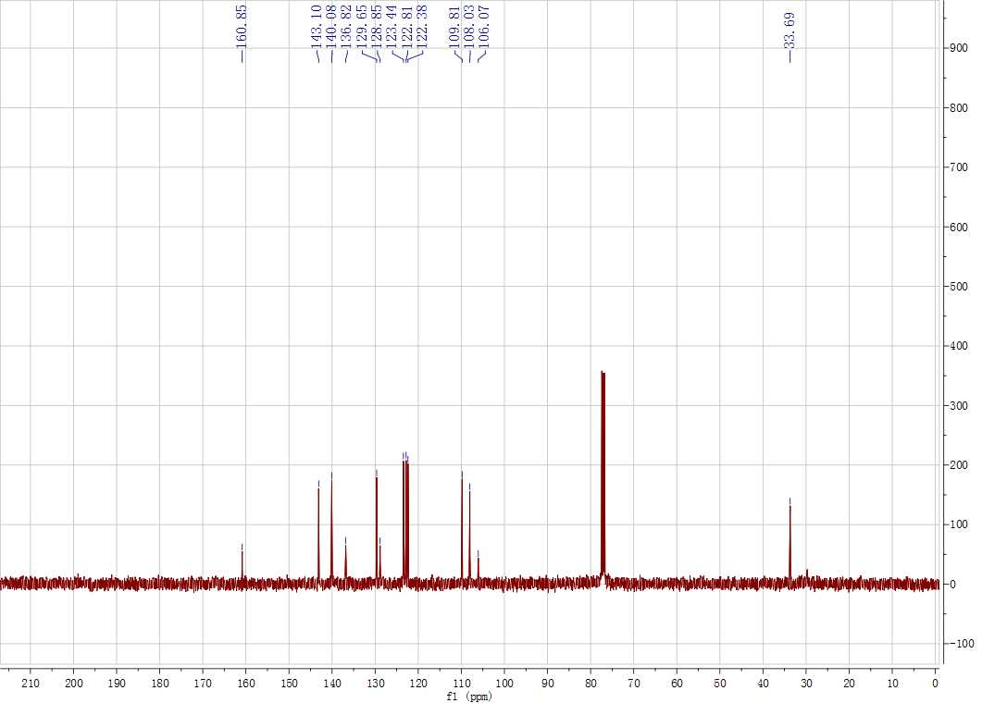
Supplementary Figure 16. ¹H and ¹³C NMR spectrum for 3aa
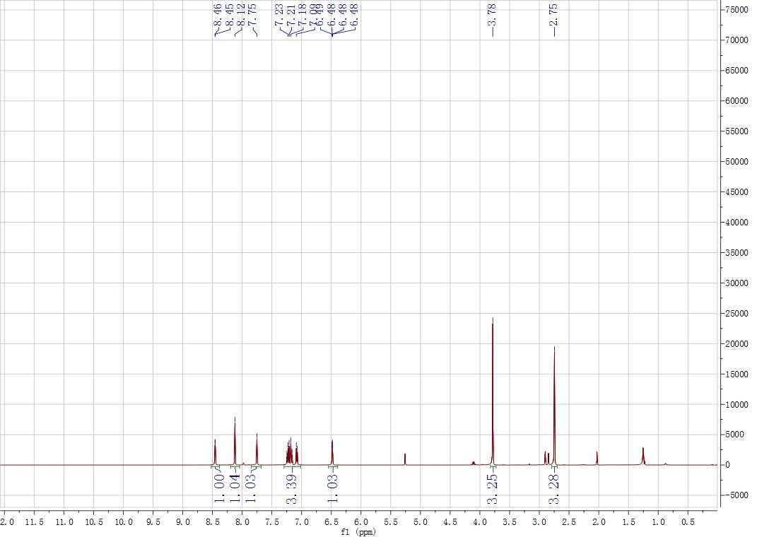
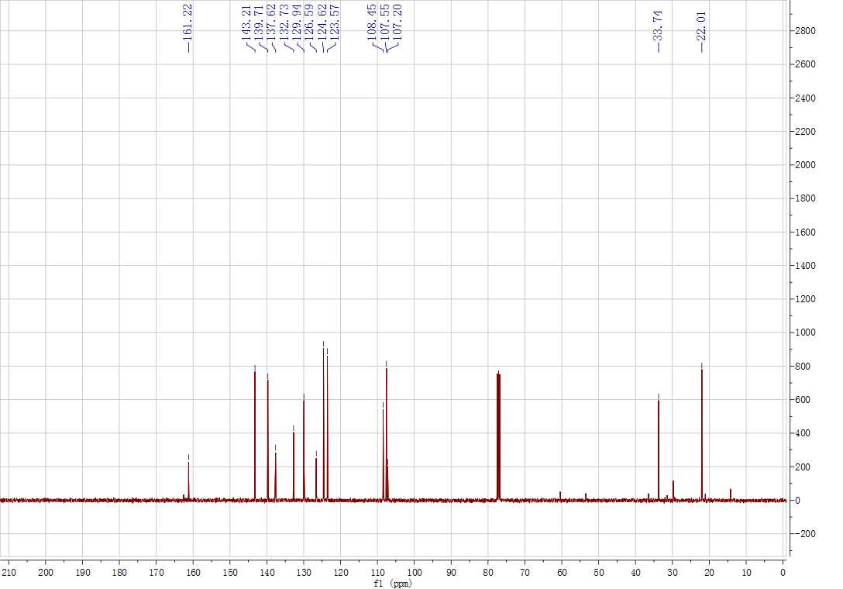
Supplementary Figure 17. ¹H and ¹³C NMR spectrum for 3ba
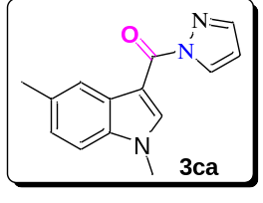
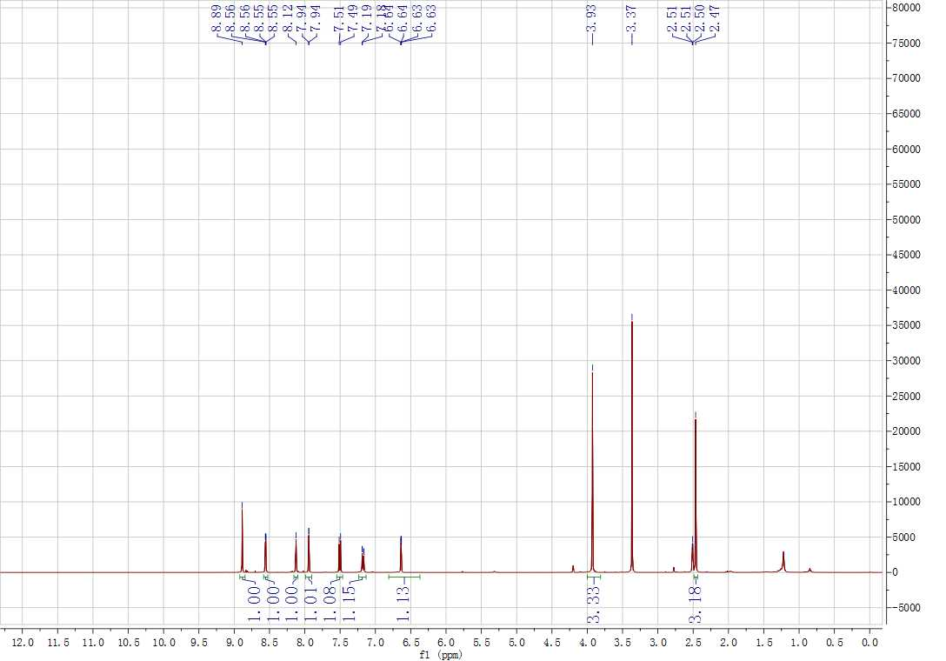
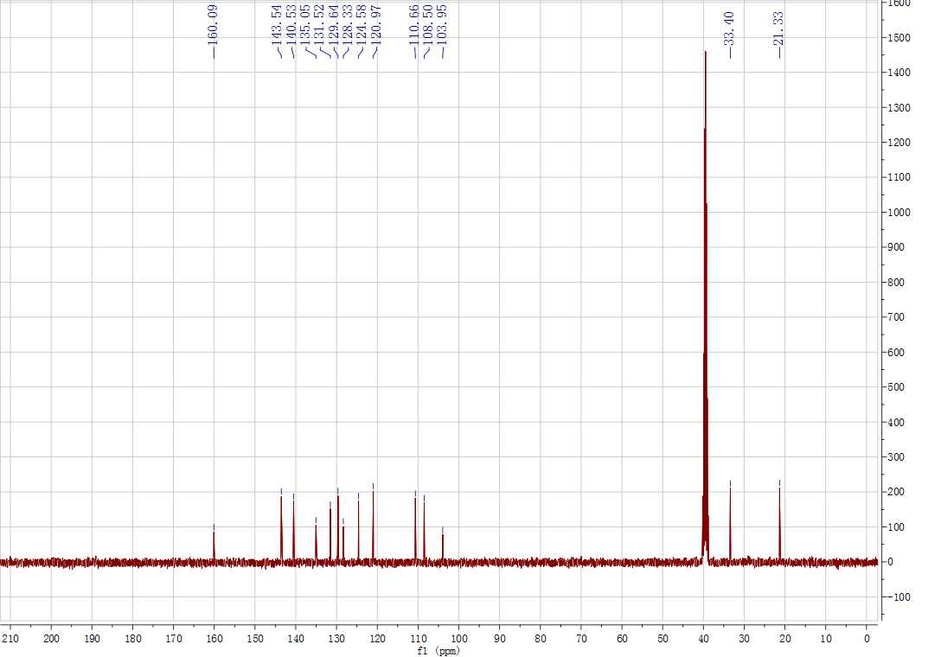
Supplementary Figure 18. ¹H and ¹³C NMR spectrum for 3ca
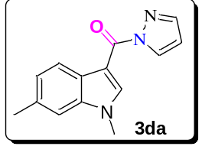
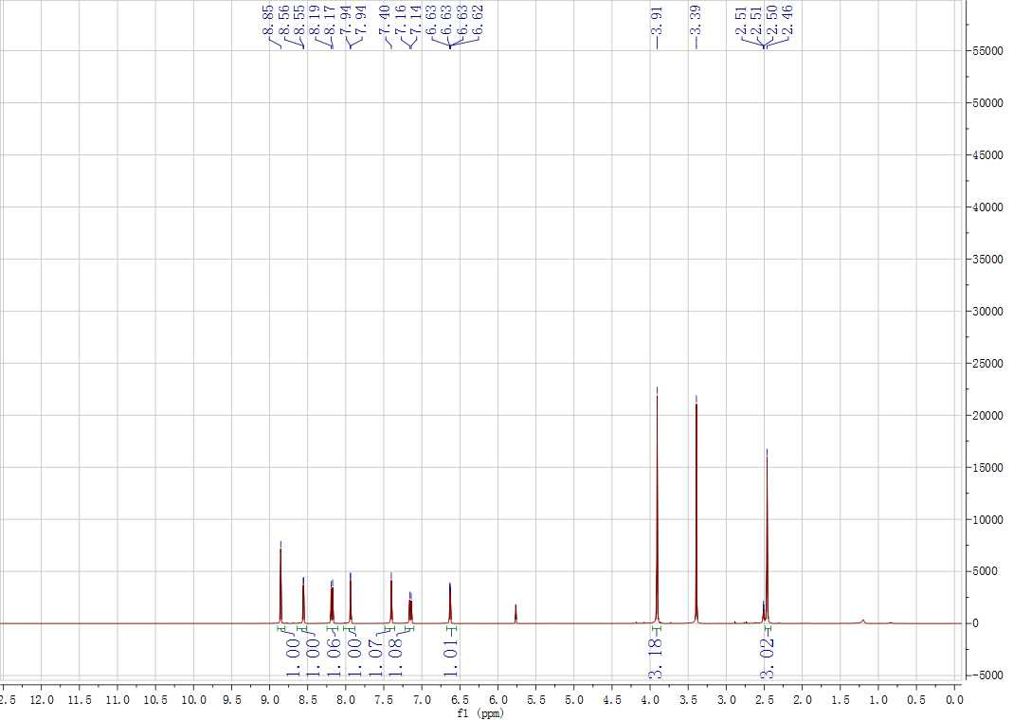
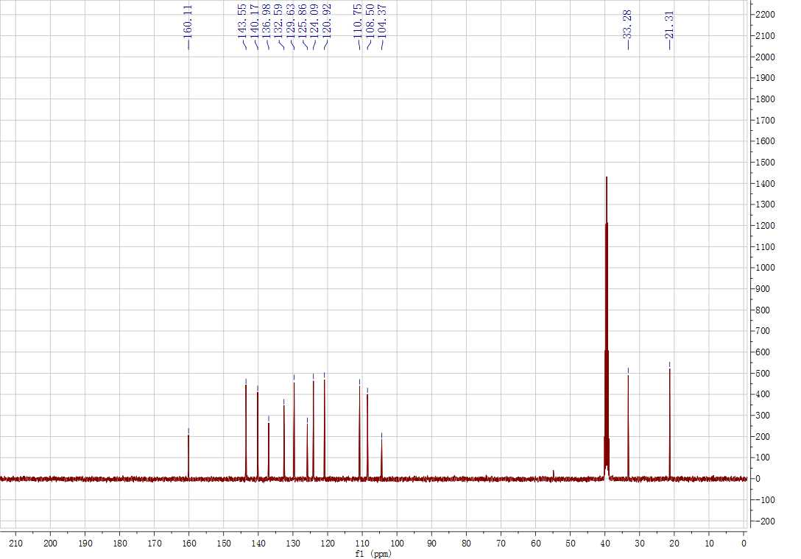
Supplementary Figure 19. ¹H and ¹³C NMR spectrum for 3da
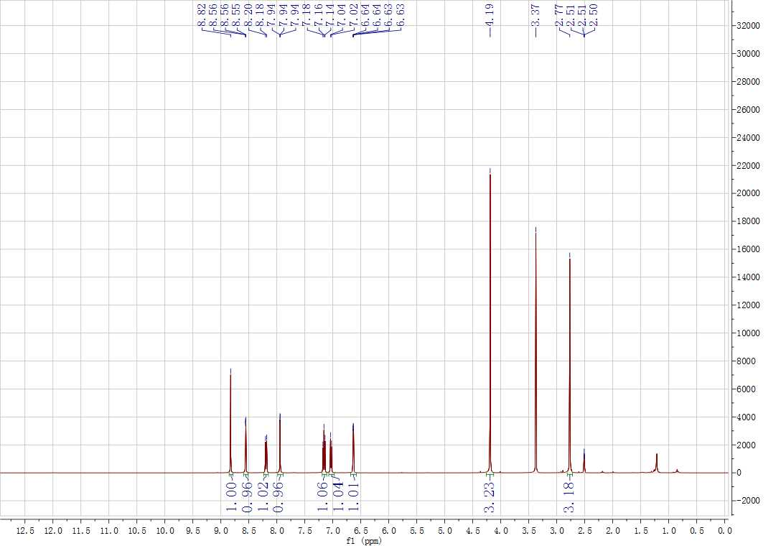
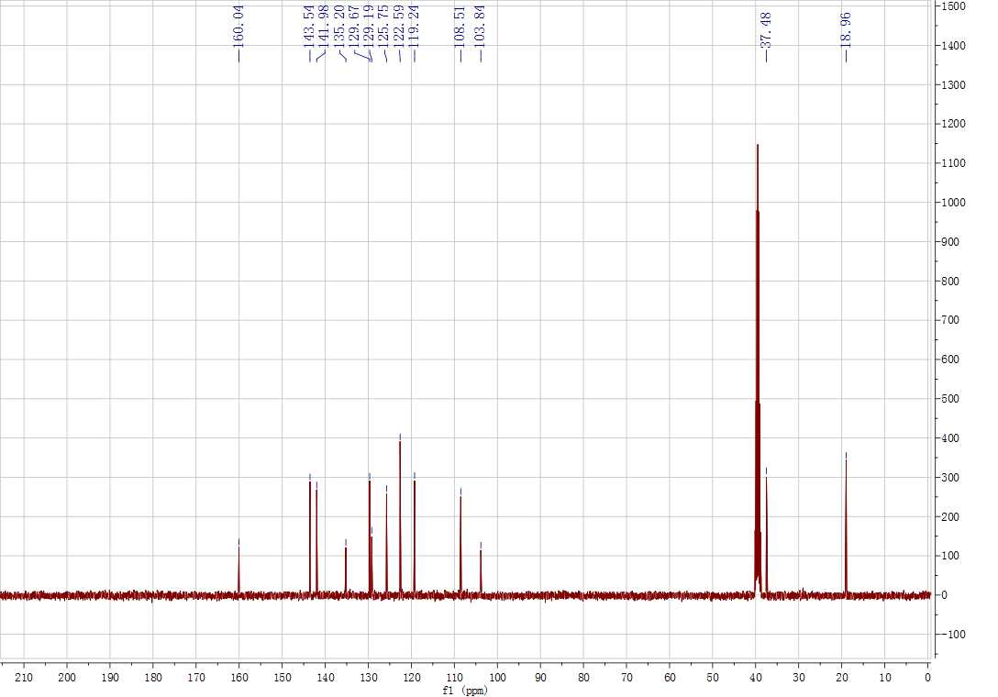
Supplementary Figure 20. ¹H and ¹³C NMR spectrum for 3ea

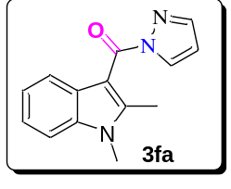
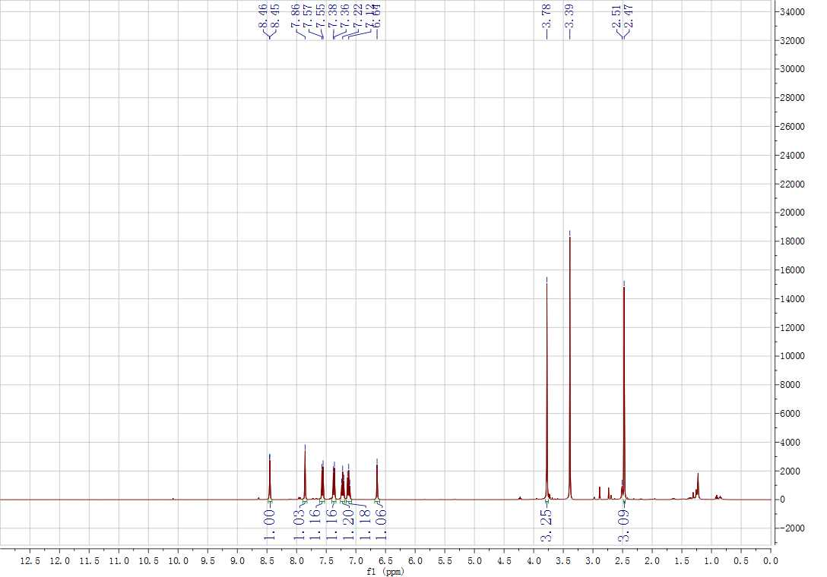
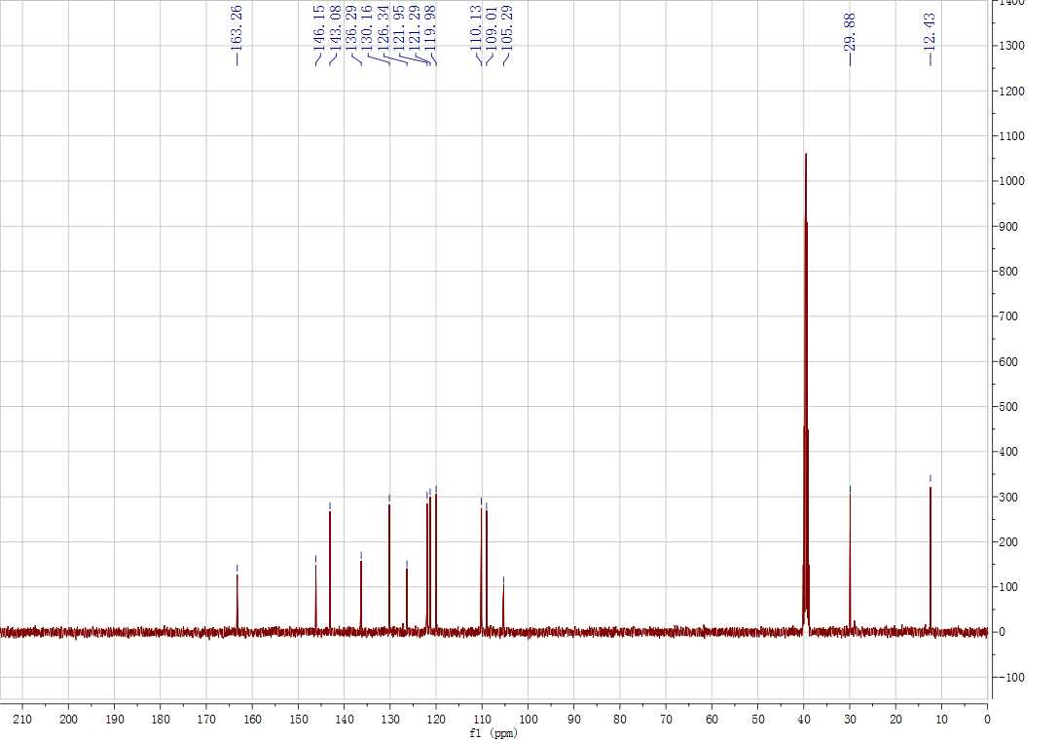
Supplementary Figure 21. ¹H and ¹³C NMR spectrum for 3fa
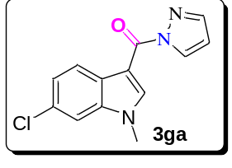
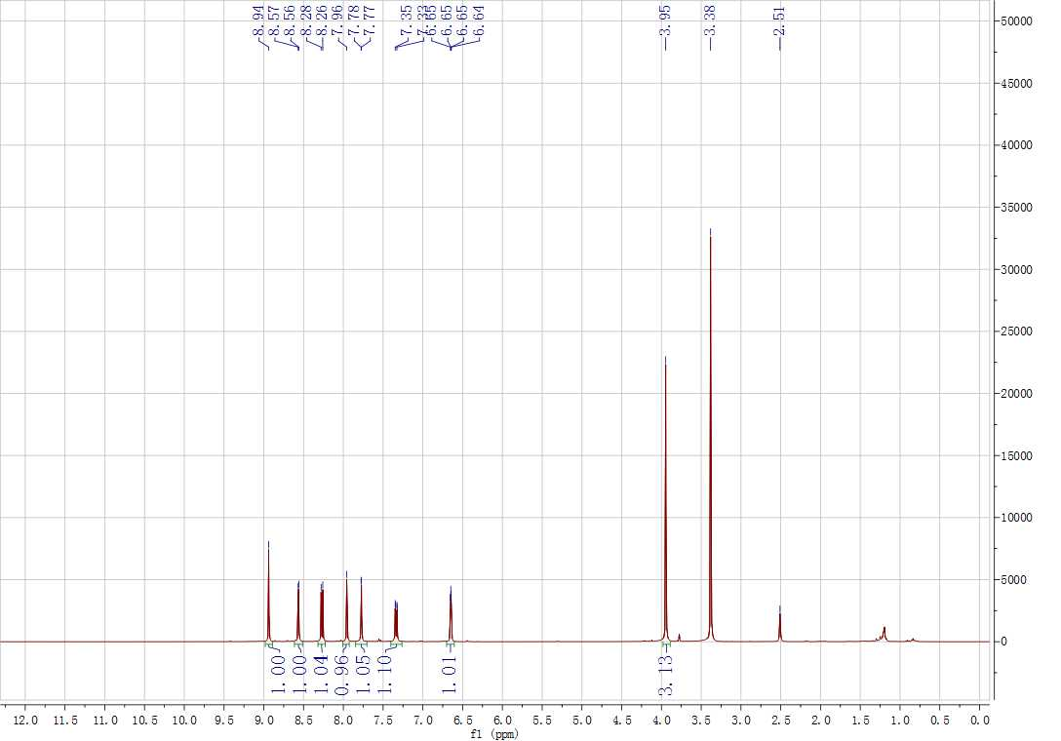
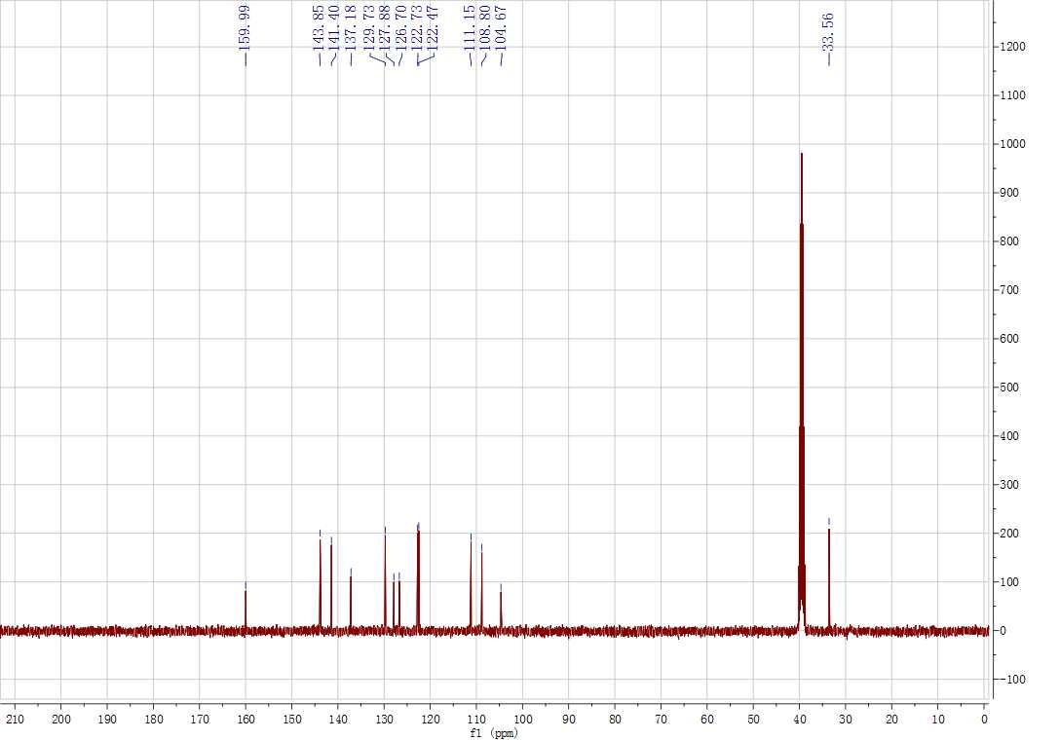
Supplementary Figure 22. ¹H and ¹³C NMR spectrum for 3ga
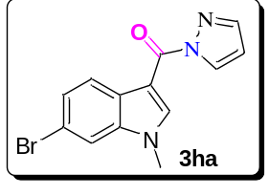
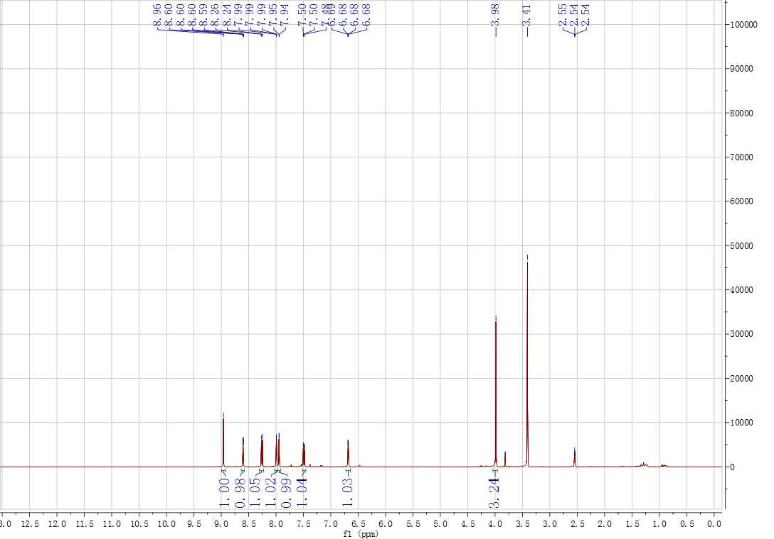
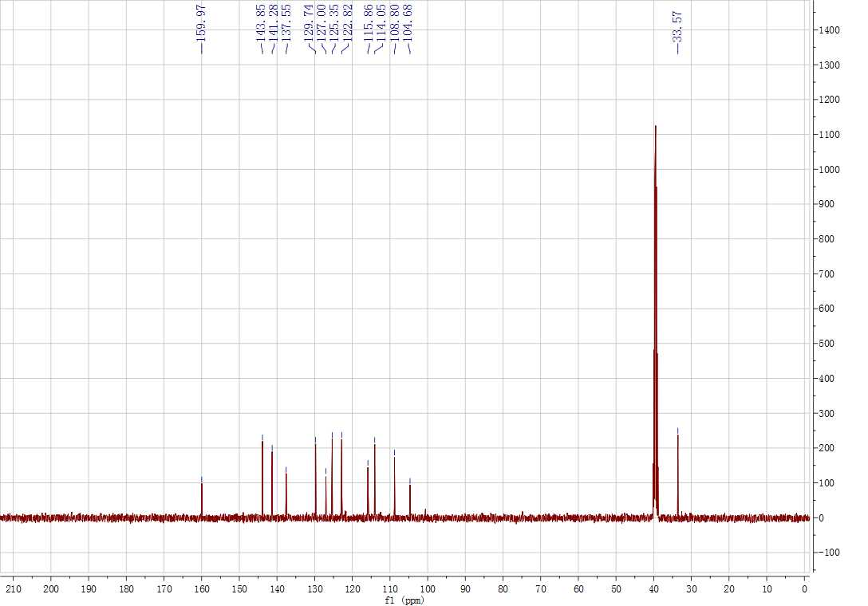
Supplementary Figure 23. ¹H and ¹³C NMR spectrum for 3ha
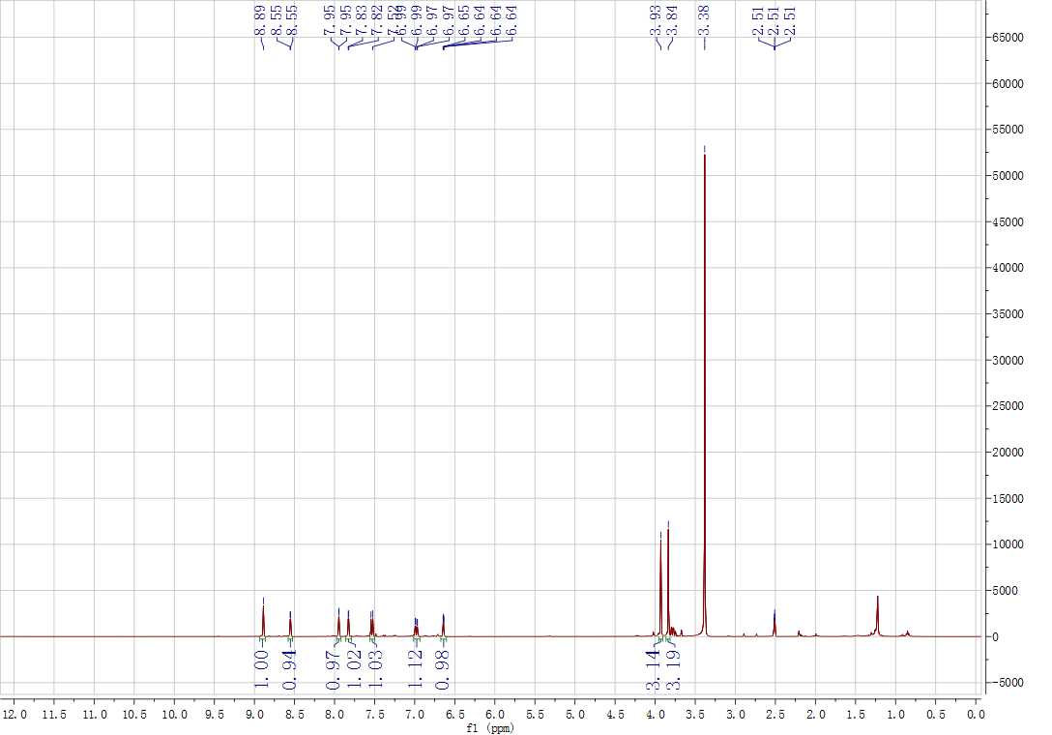
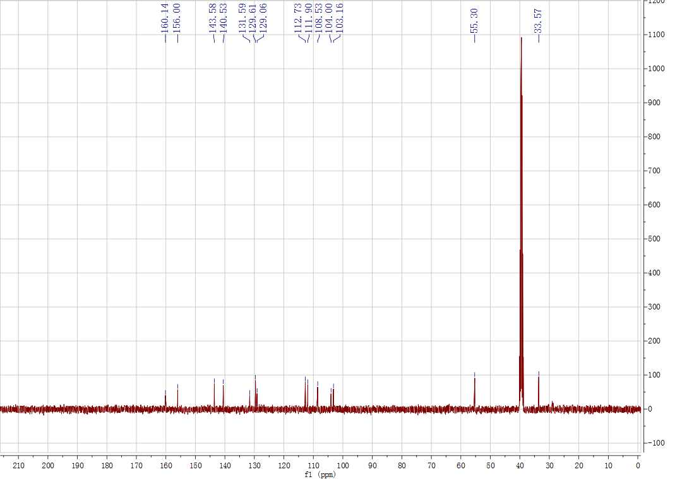
Supplementary Figure 24. ¹H and ¹³C NMR spectrum for 3ia
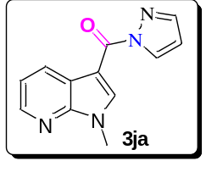
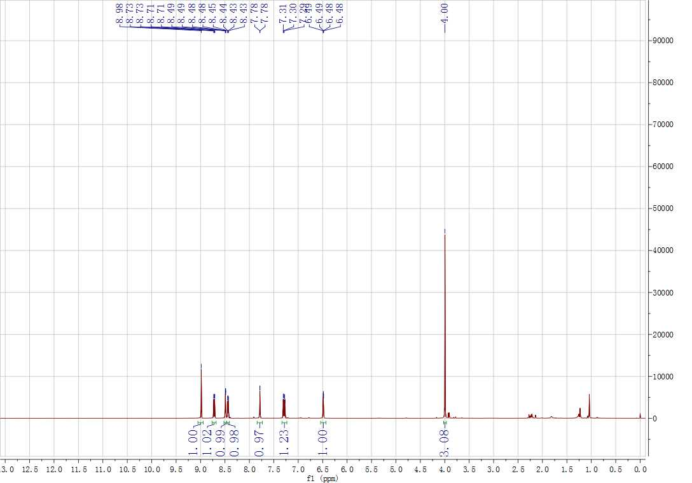
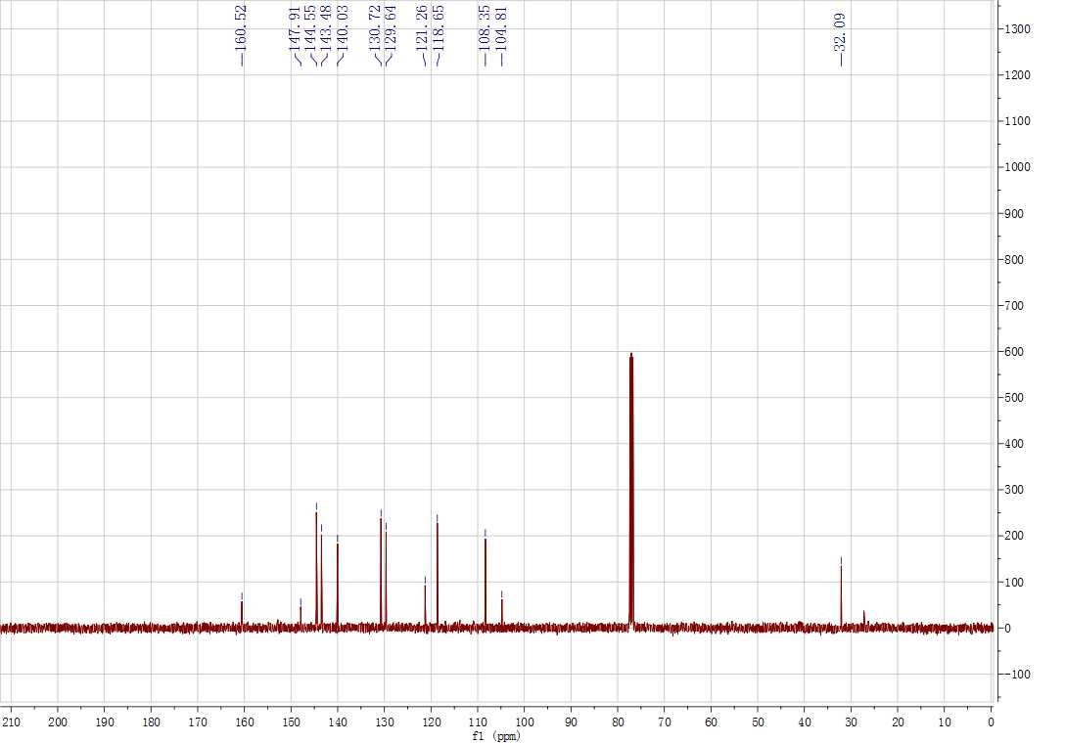
Supplementary Figure 25. ¹H and ¹³C NMR spectrum for 3ja
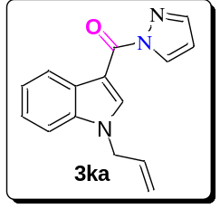
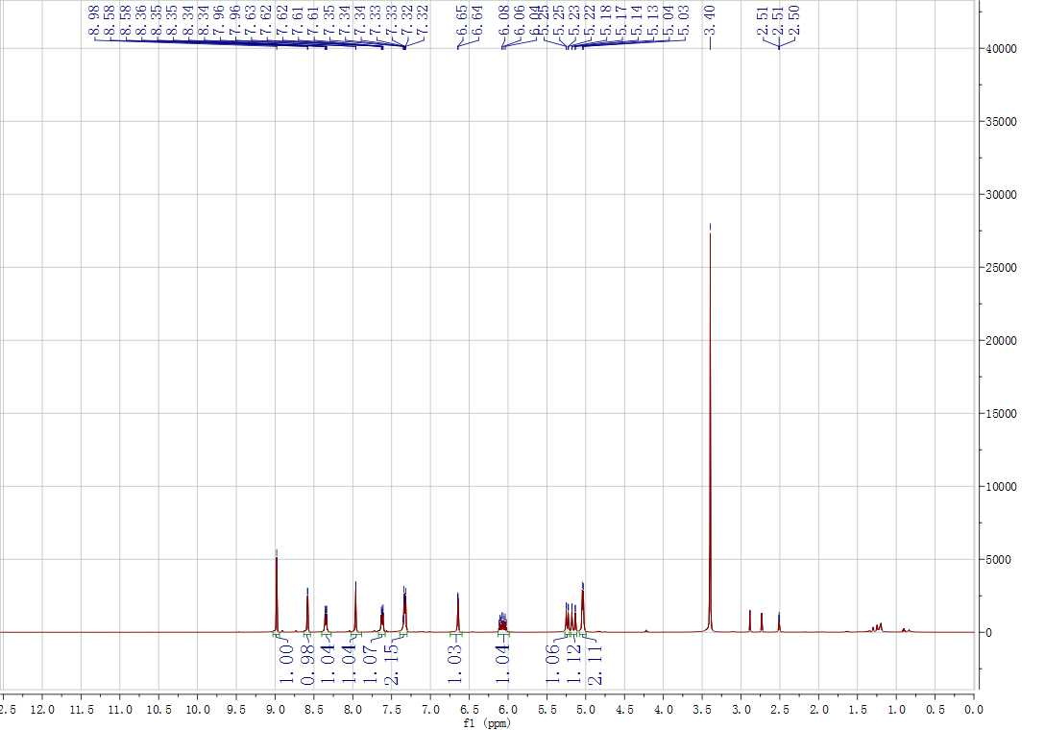
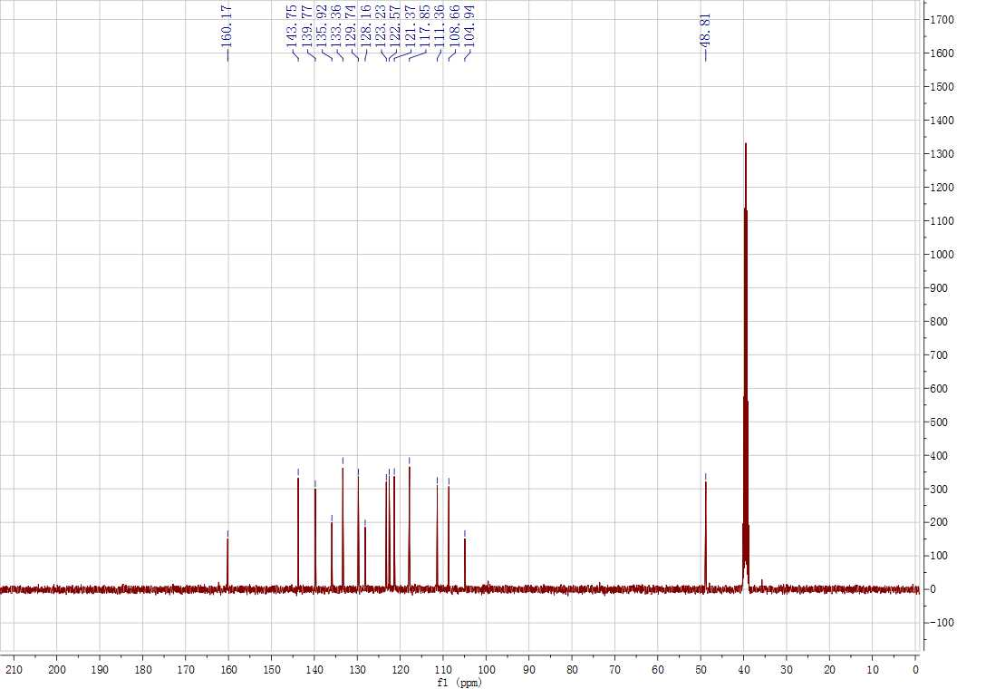
Supplementary Figure 26. ¹H and ¹³C NMR spectrum for 3ka
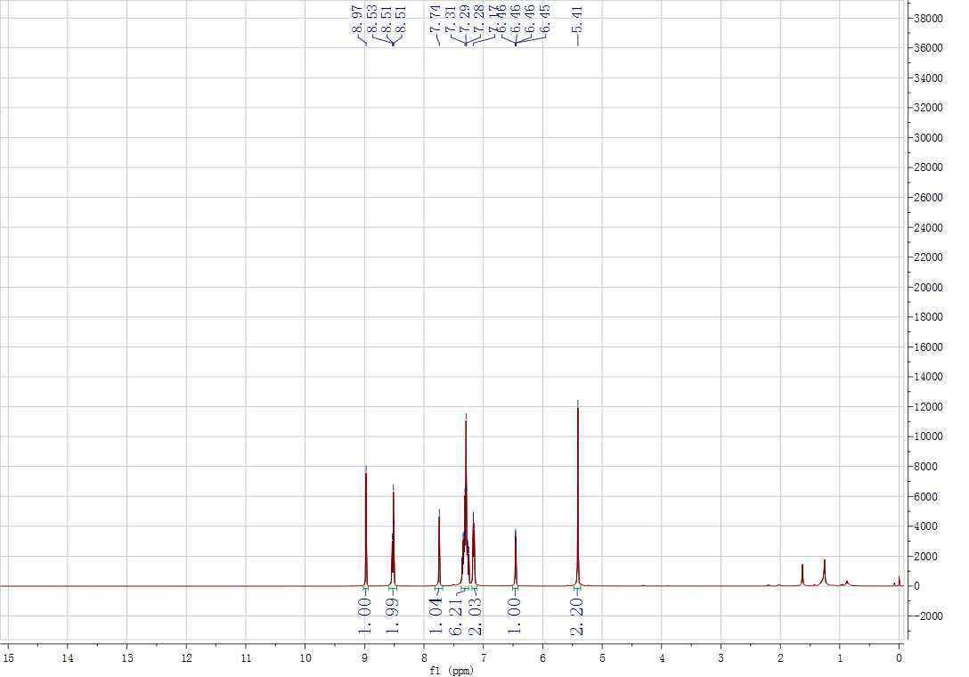
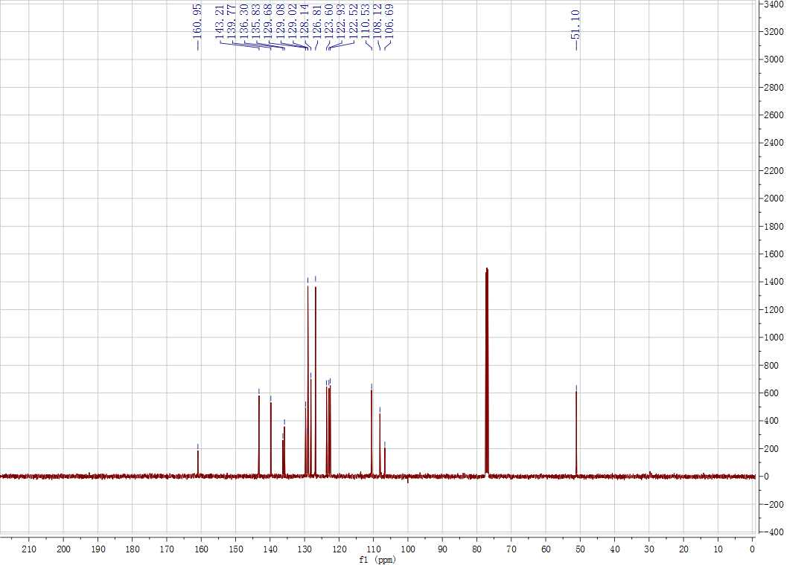
Supplementary Figure 27. ¹H and ¹³C NMR spectrum for 3la
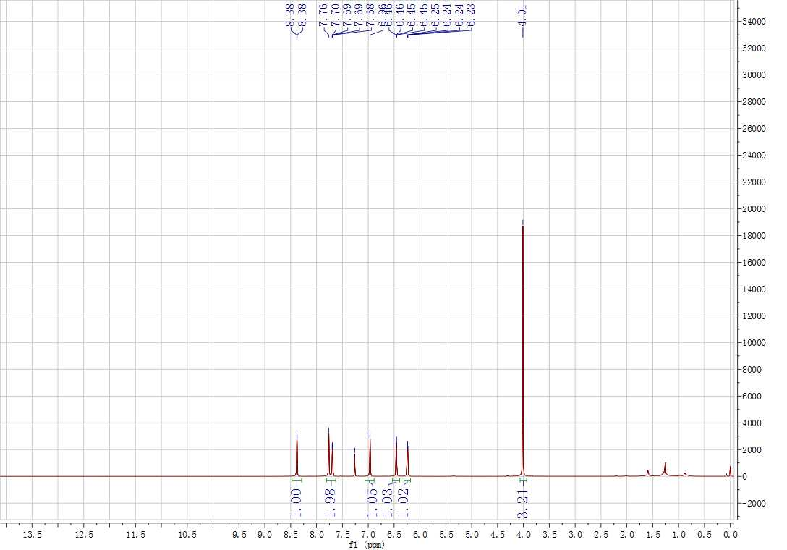
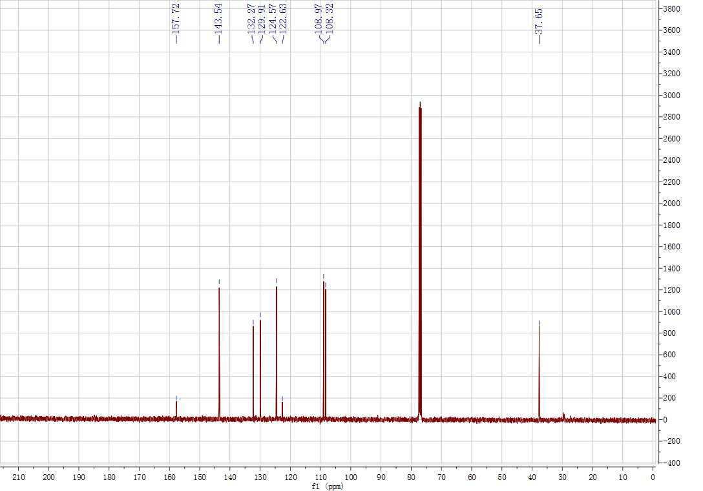
Supplementary Figure 28. ¹H and ¹³C NMR spectrum for 3ma
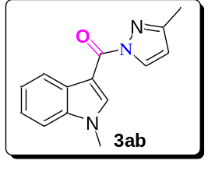
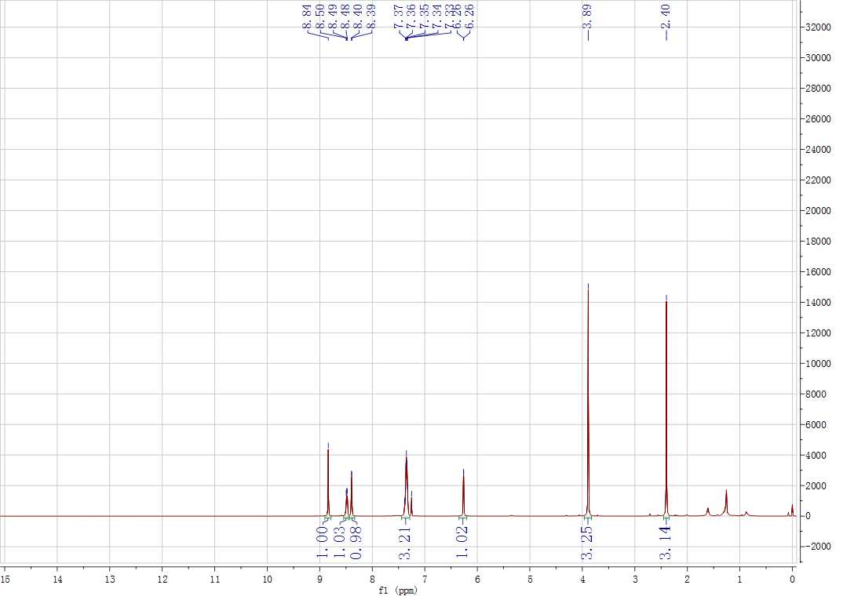
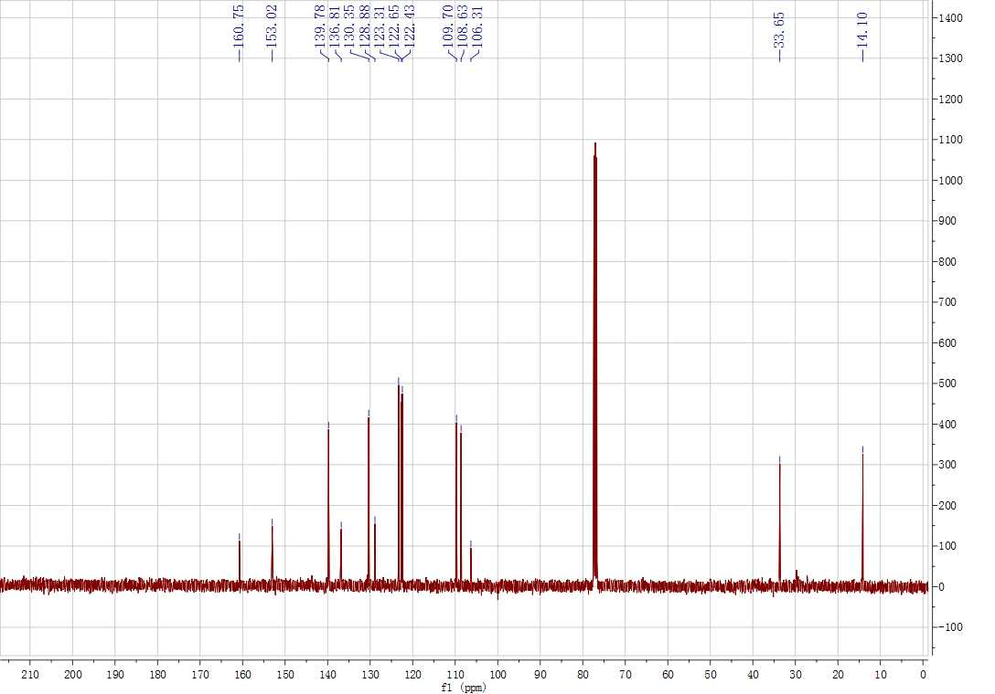
Supplementary Figure 29. ¹H and ¹³C NMR spectrum for 3ab
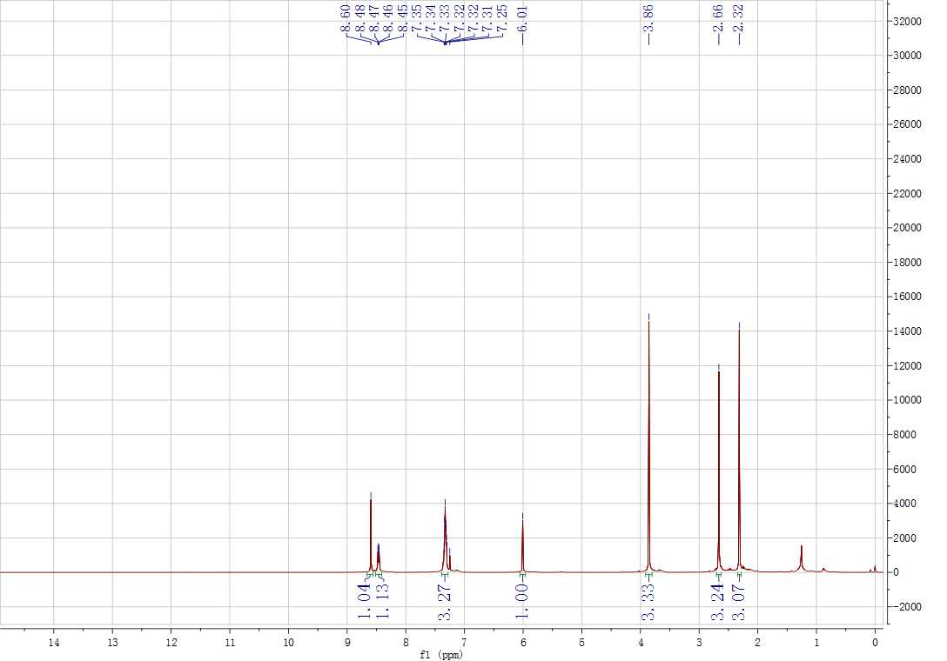
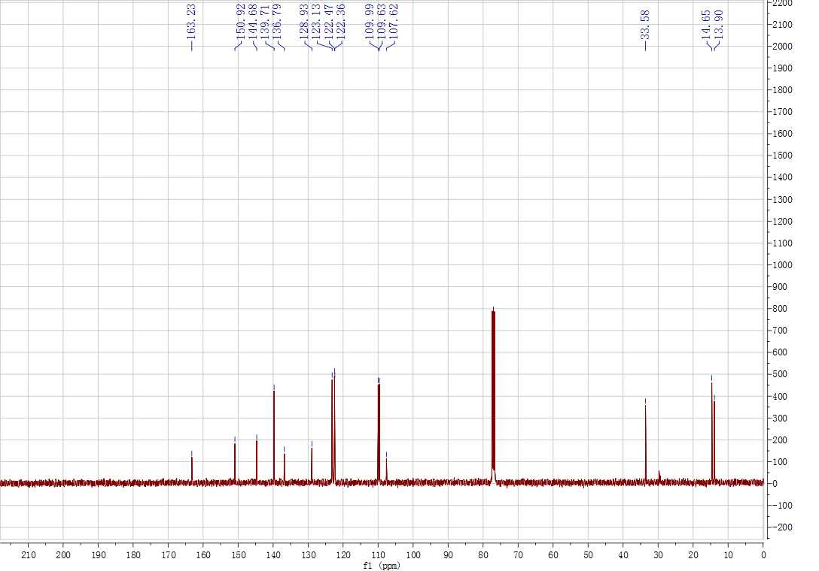
Supplementary Figure 30. ¹H and ¹³C NMR spectrum for 3ac
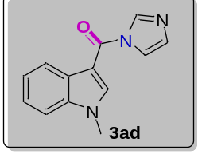
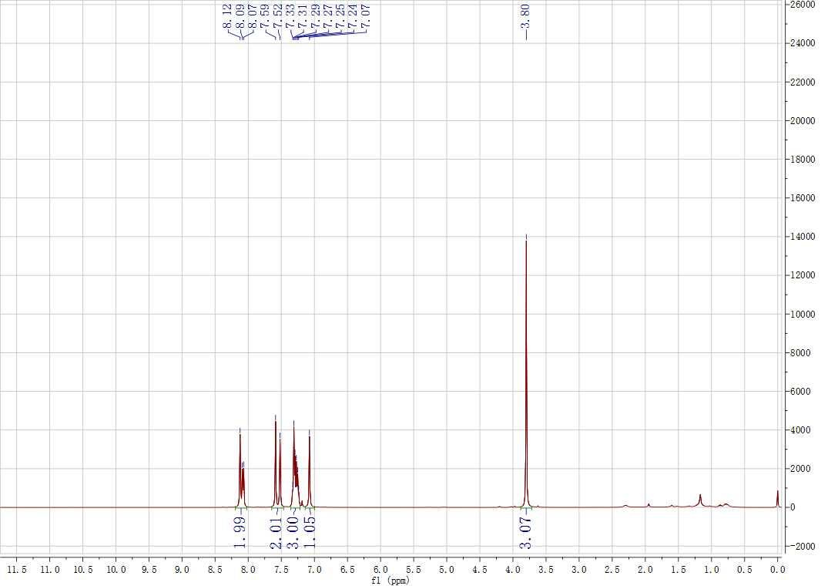
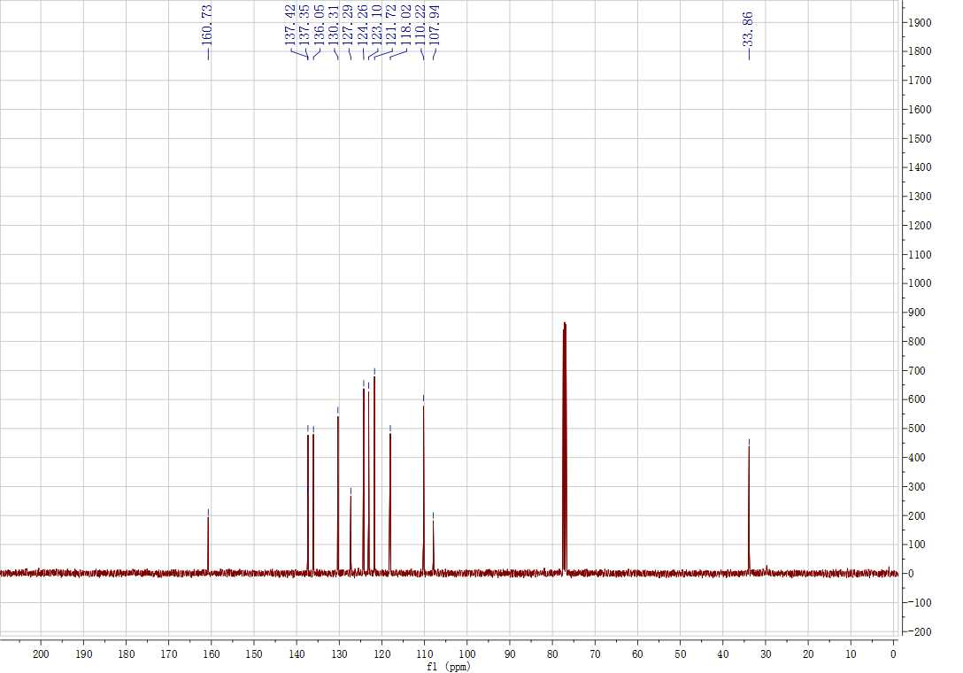
Supplementary Figure 31. ¹H and ¹³C NMR spectrum for 3ad
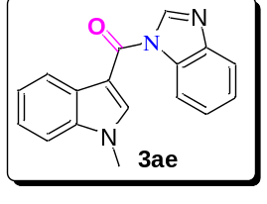
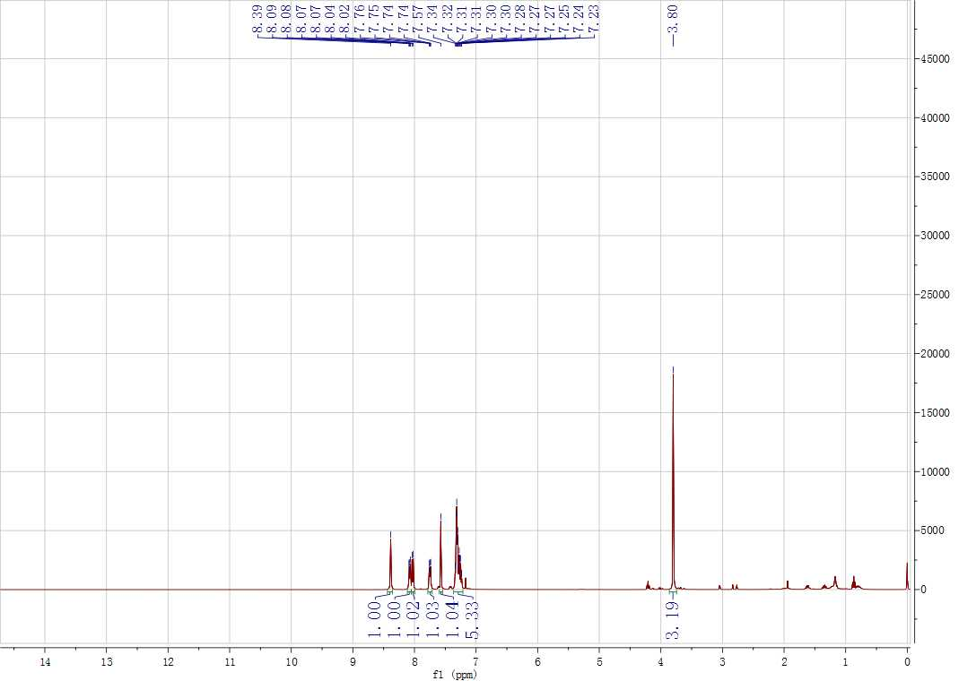
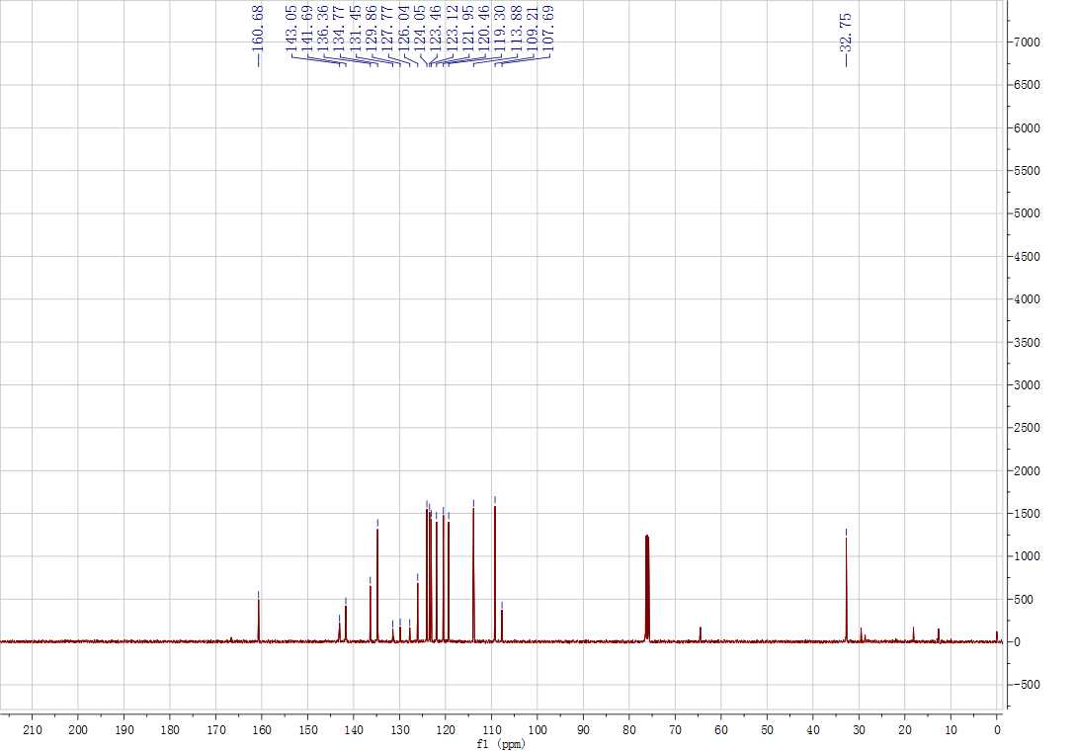
Supplementary Figure 32. ¹H and ¹³C NMR spectrum for 3ae
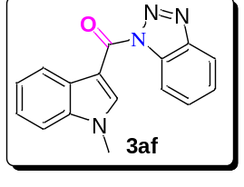
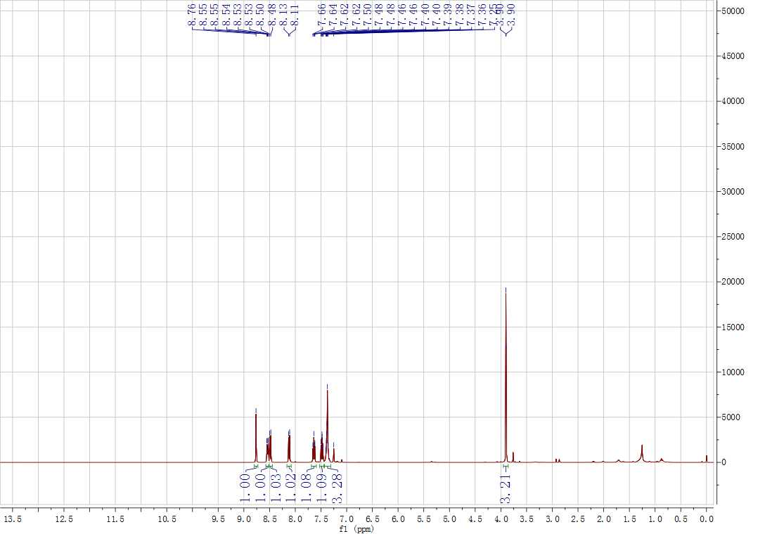
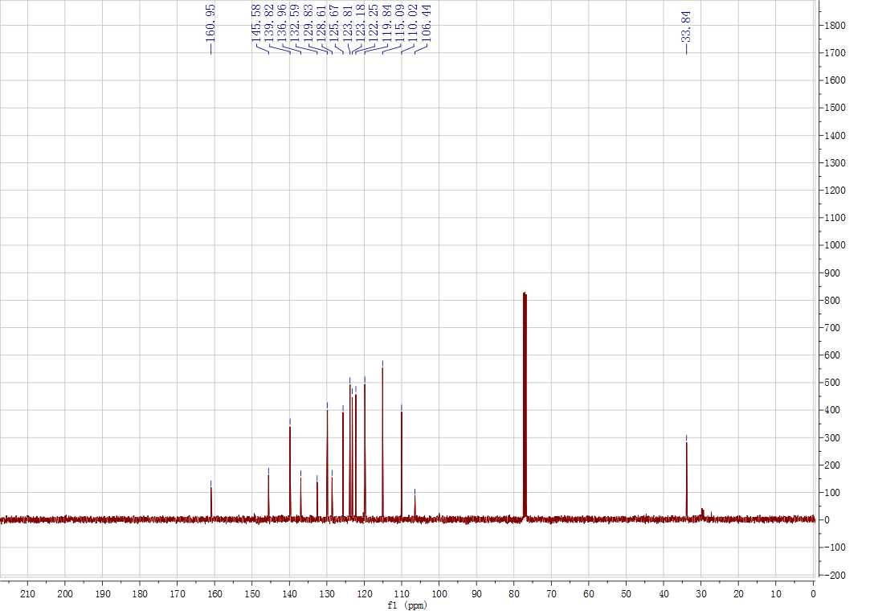
Supplementary Figure 33. ¹H and ¹³C NMR spectrum for 3af
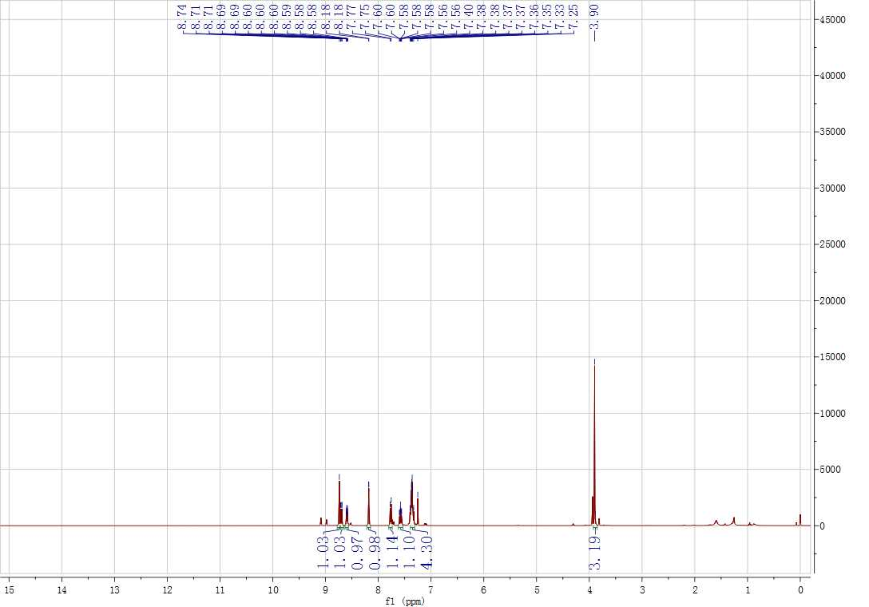
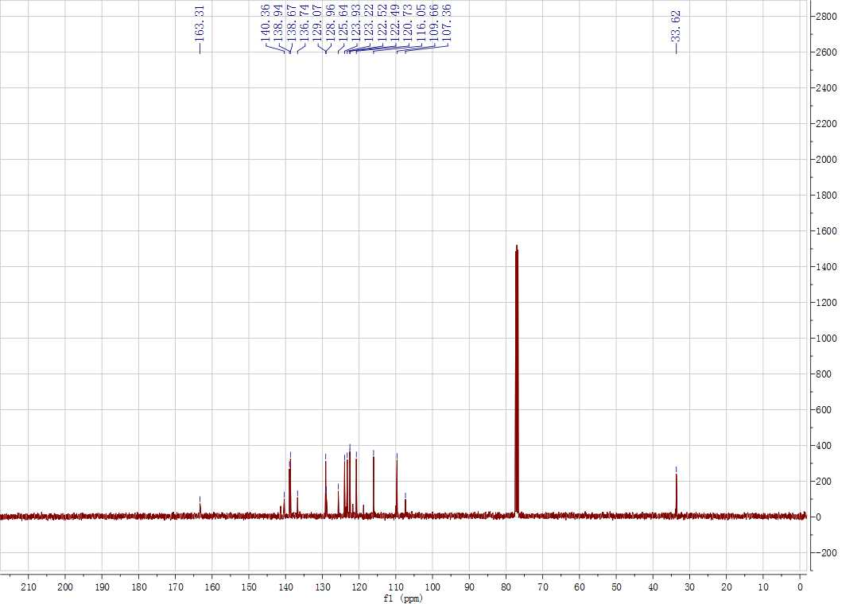
Supplementary Figure 34. ¹H and ¹³C NMR spectrum for 3ag
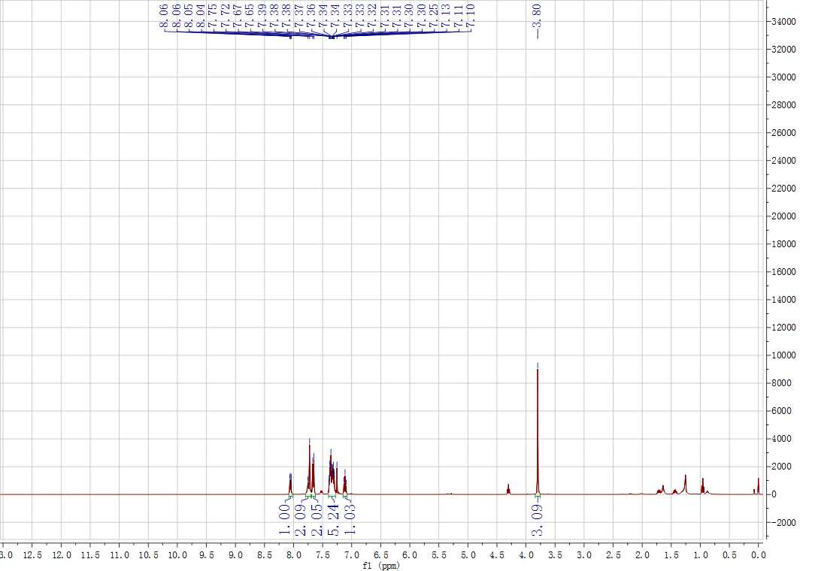
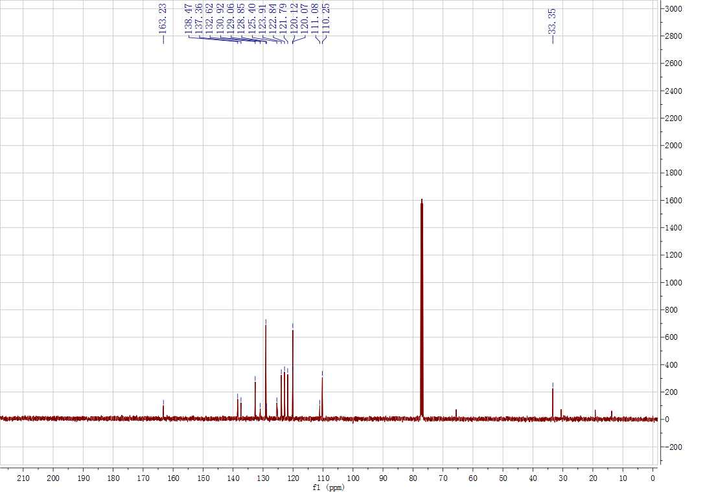
Supplementary Figure 35. ¹H and ¹³C NMR spectrum for 3ah
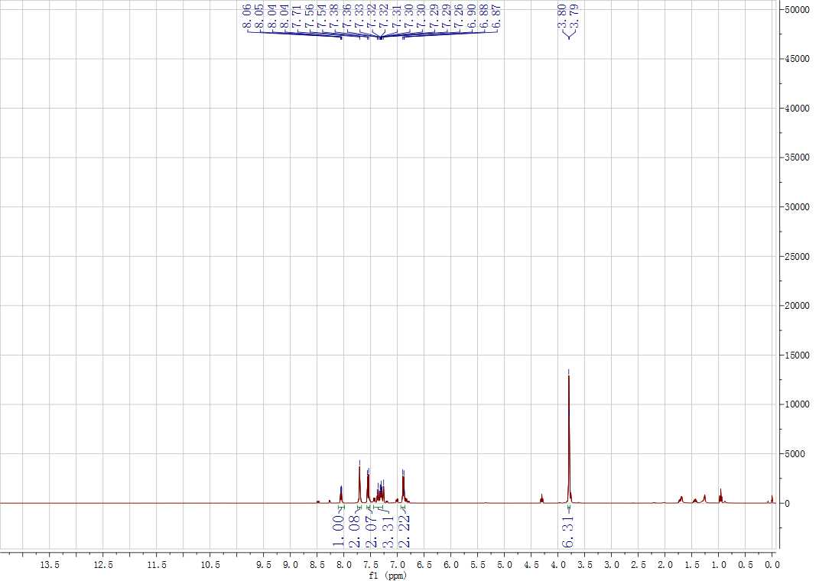
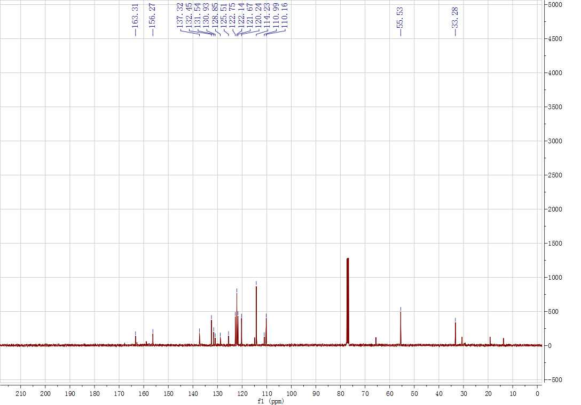
Supplementary Figure 36. ¹H and ¹³C NMR spectrum for 3ai
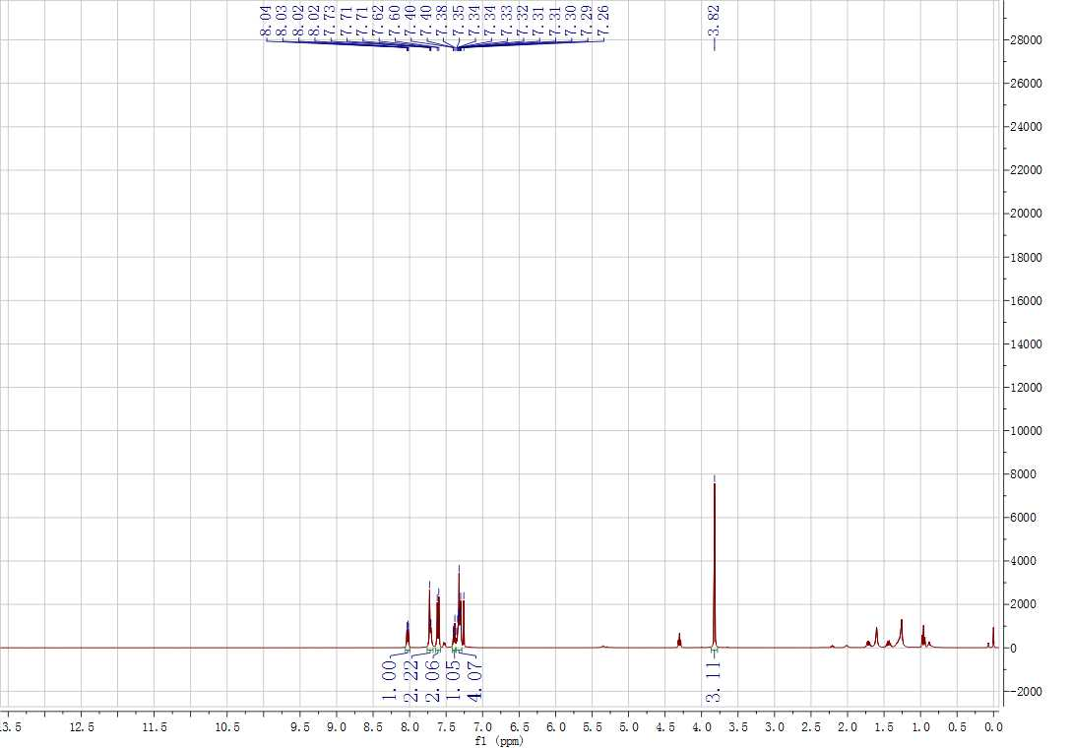
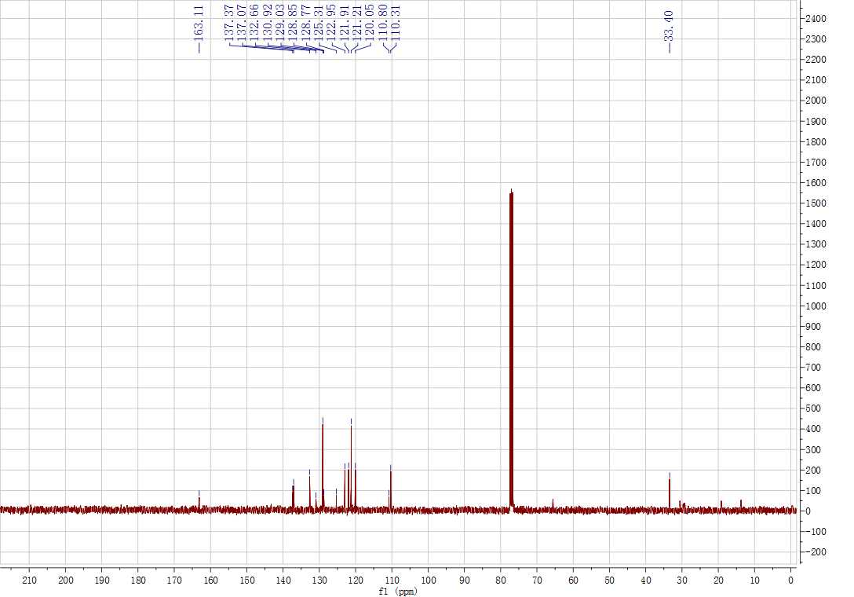
Supplementary Figure 37. ¹H and ¹³C NMR spectrum for 3aj
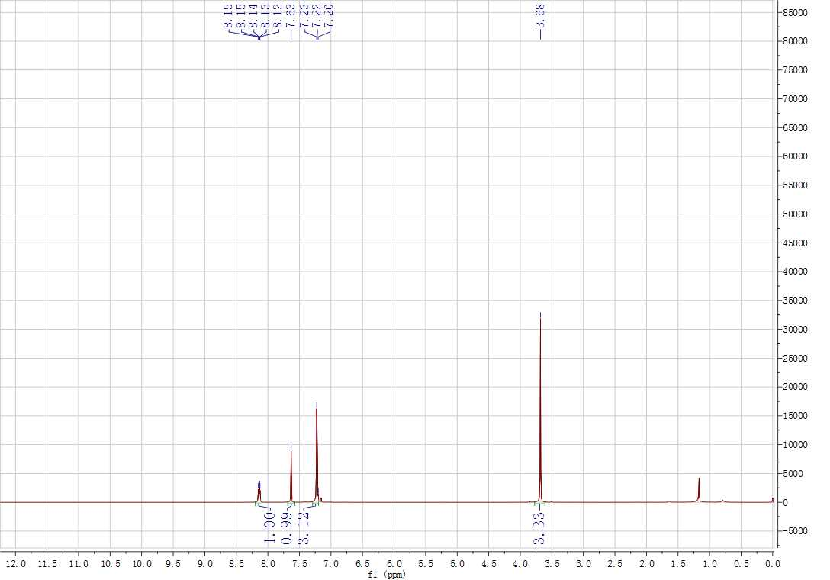
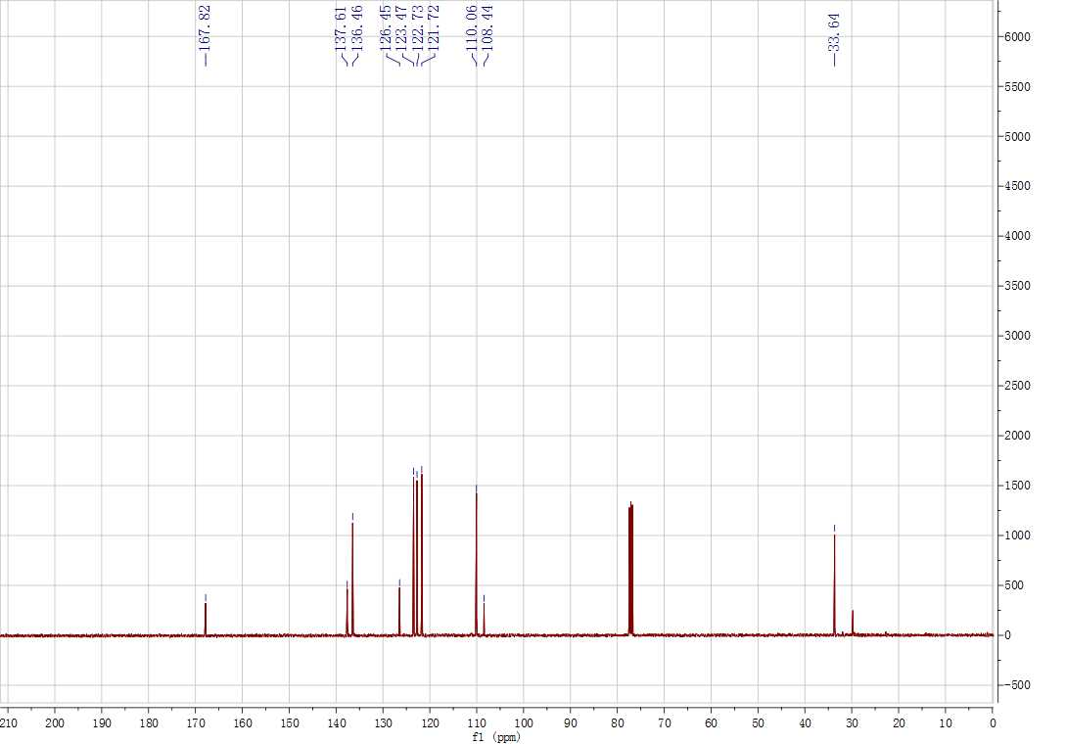
Supplementary Figure 38. ¹H and ¹³C NMR spectrum for 4a
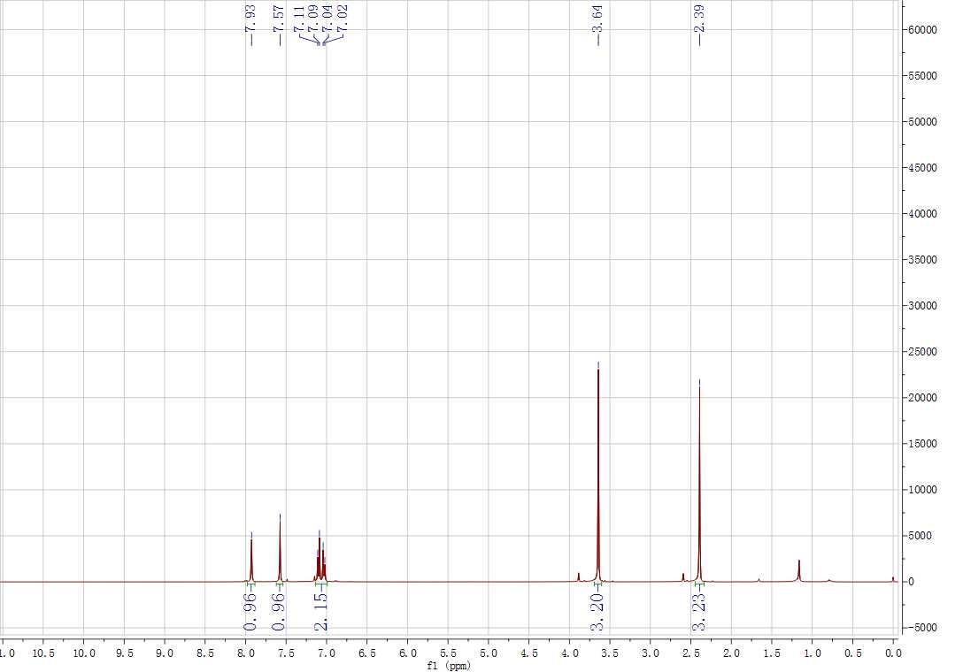
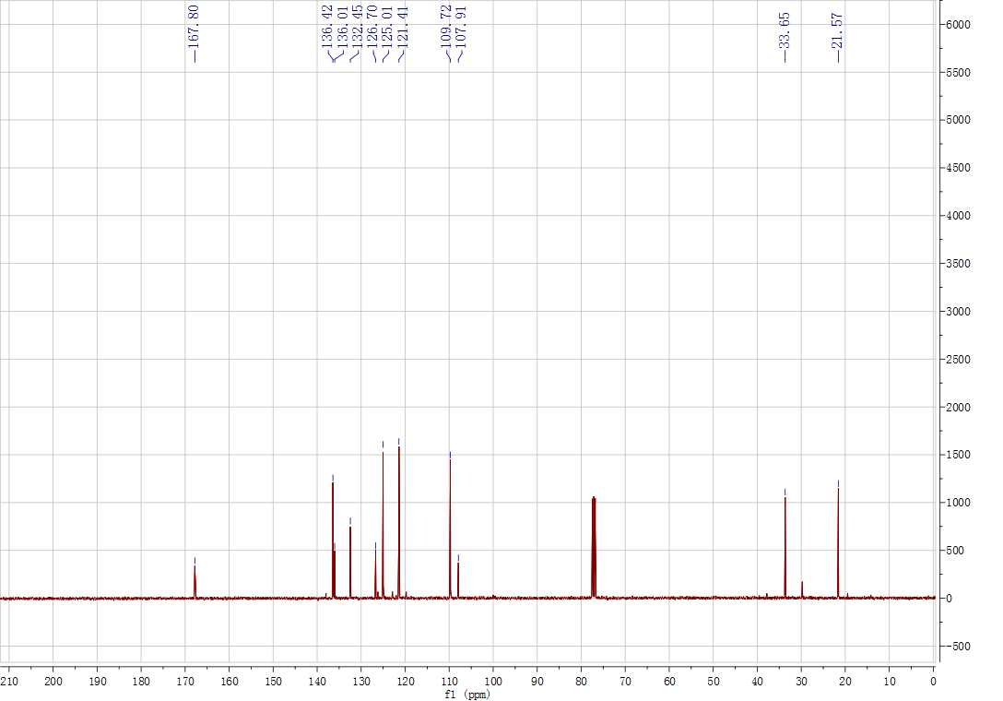
Supplementary Figure 39. ¹H and ¹³C NMR spectrum for 4b
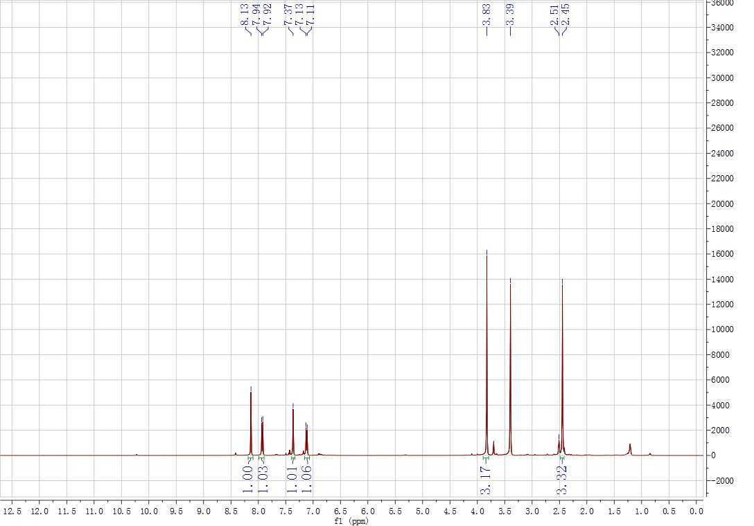
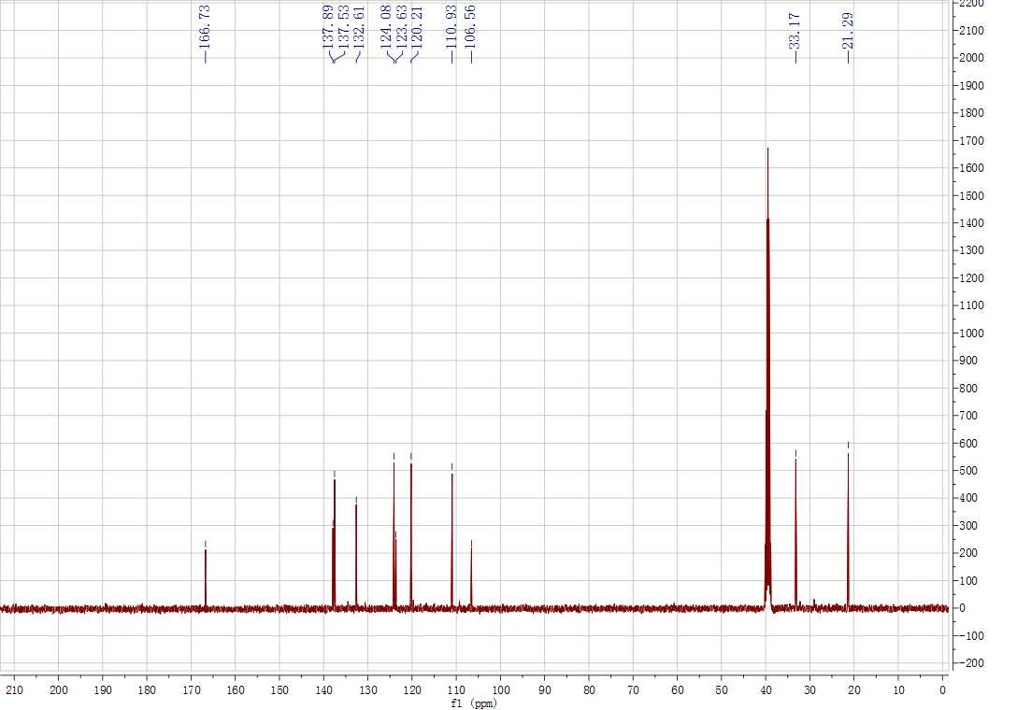
Supplementary Figure 40. ¹H and ¹³C NMR spectrum for 4c
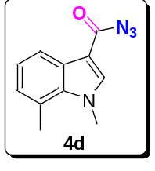
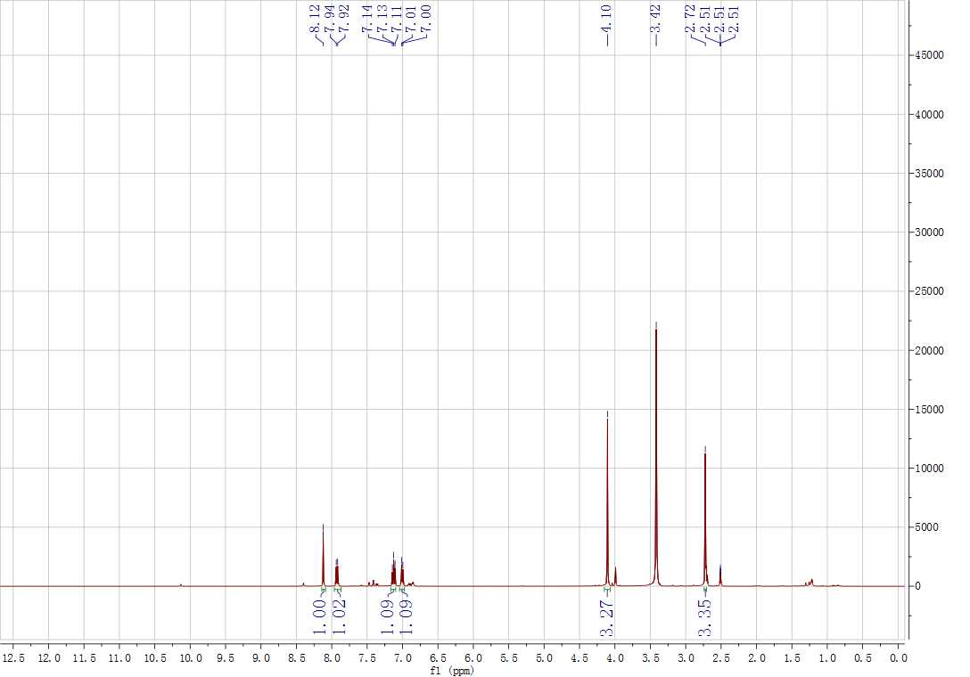
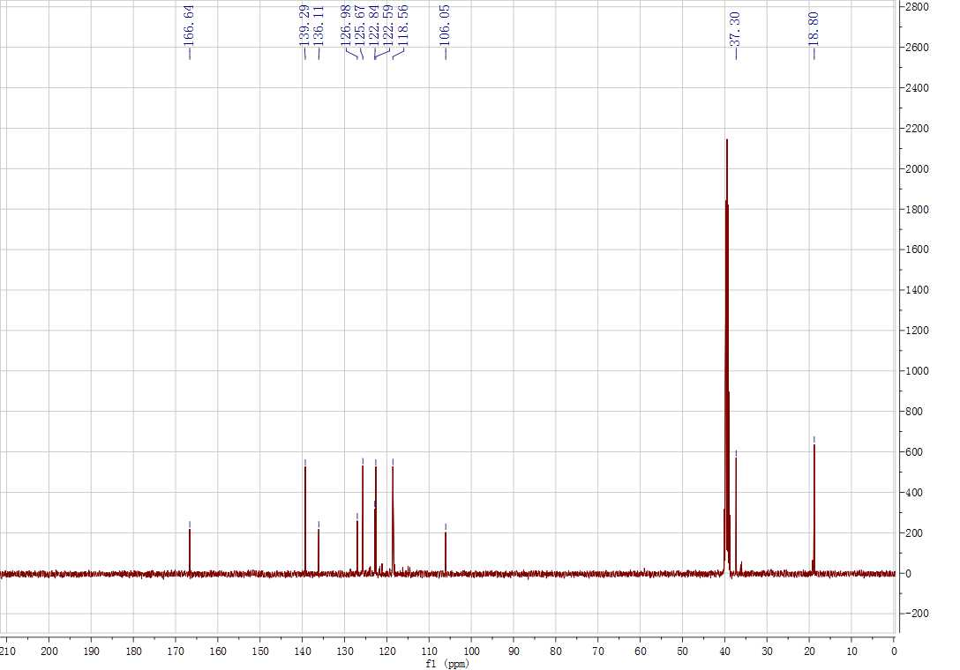
Supplementary Figure 41. ¹H and ¹³C NMR spectrum for 4d
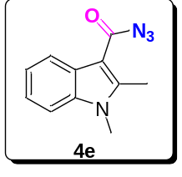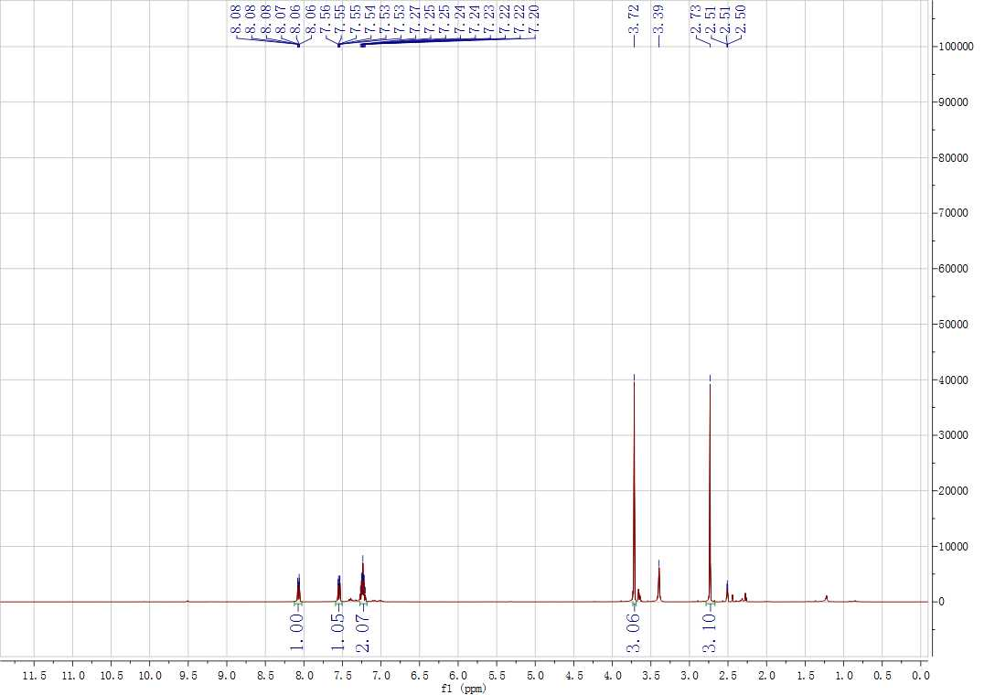
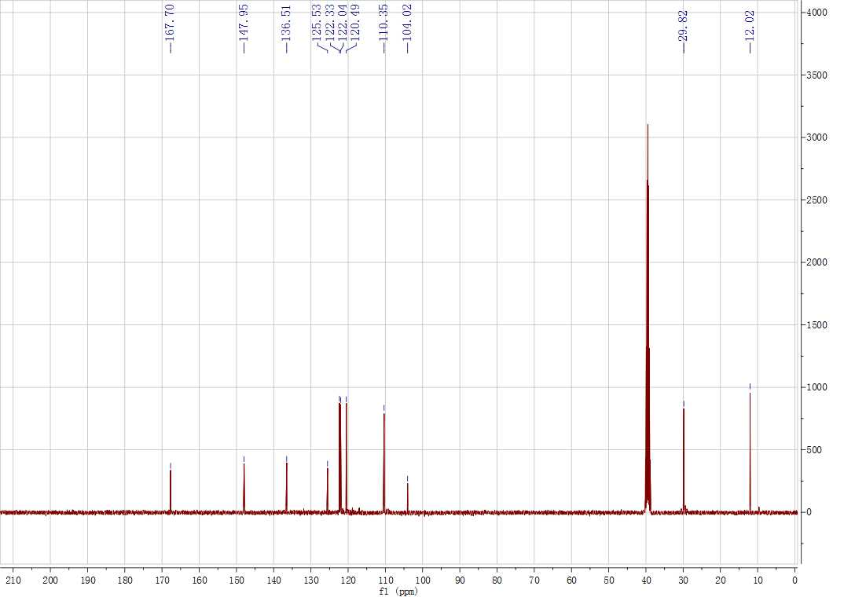
Supplementary Figure 42. ¹H and ¹³C NMR spectrum for 4e
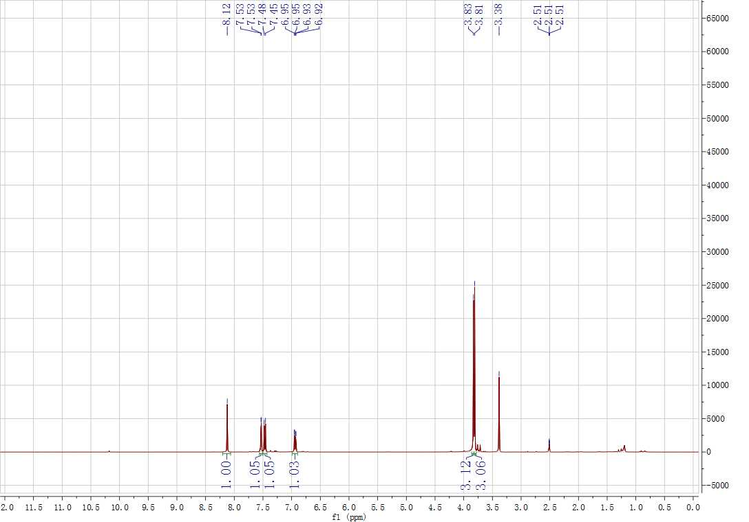
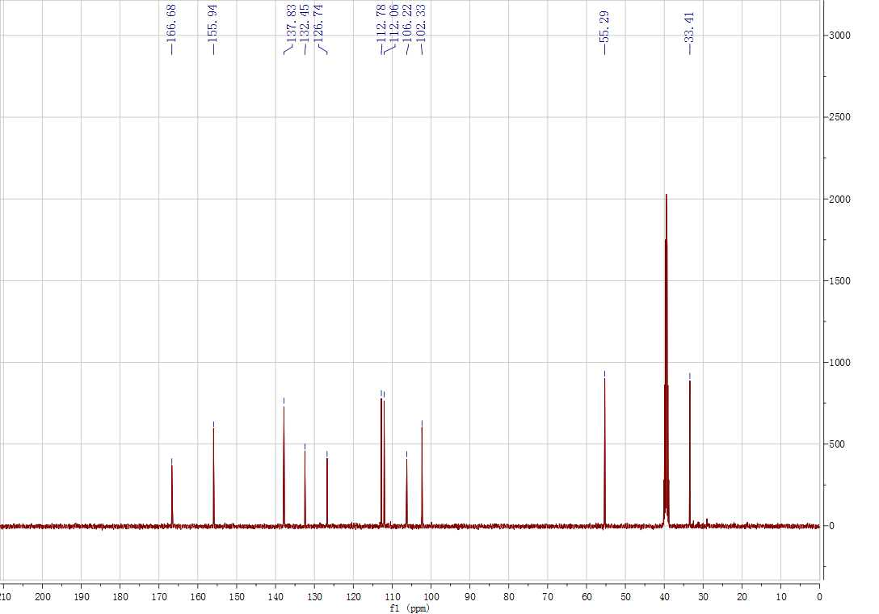
Supplementary Figure 43. ¹H and ¹³C NMR spectrum for 4f
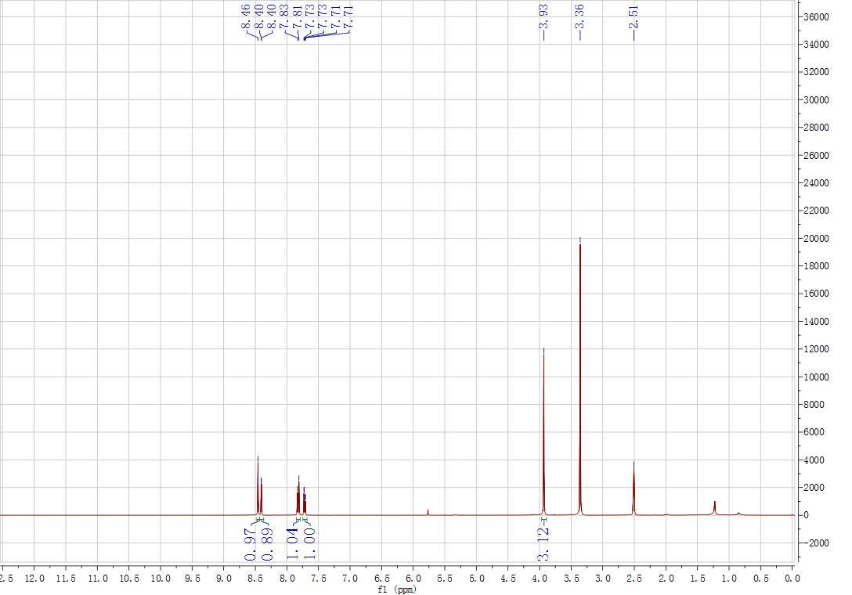
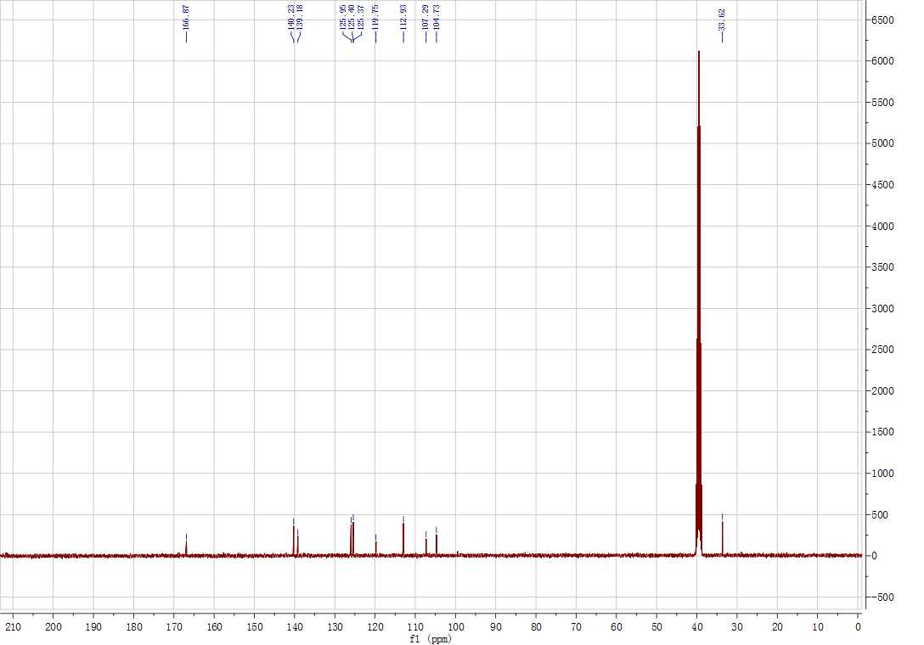
Supplementary Figure 44. ¹H and ¹³C NMR spectrum for 4g
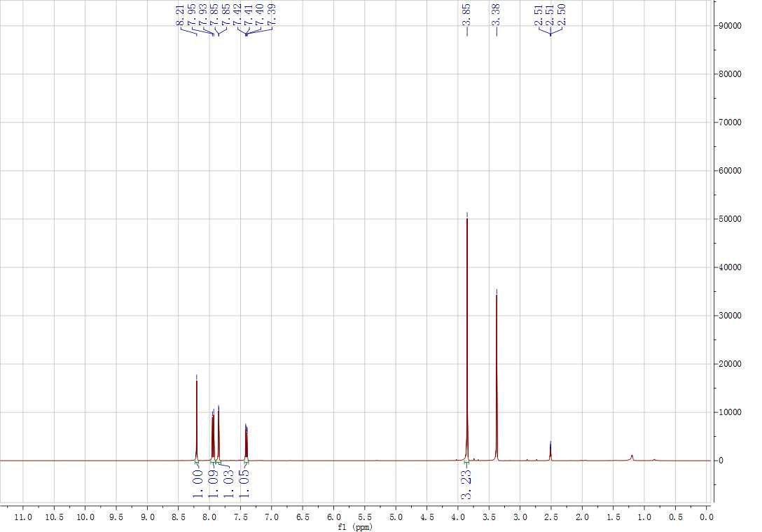
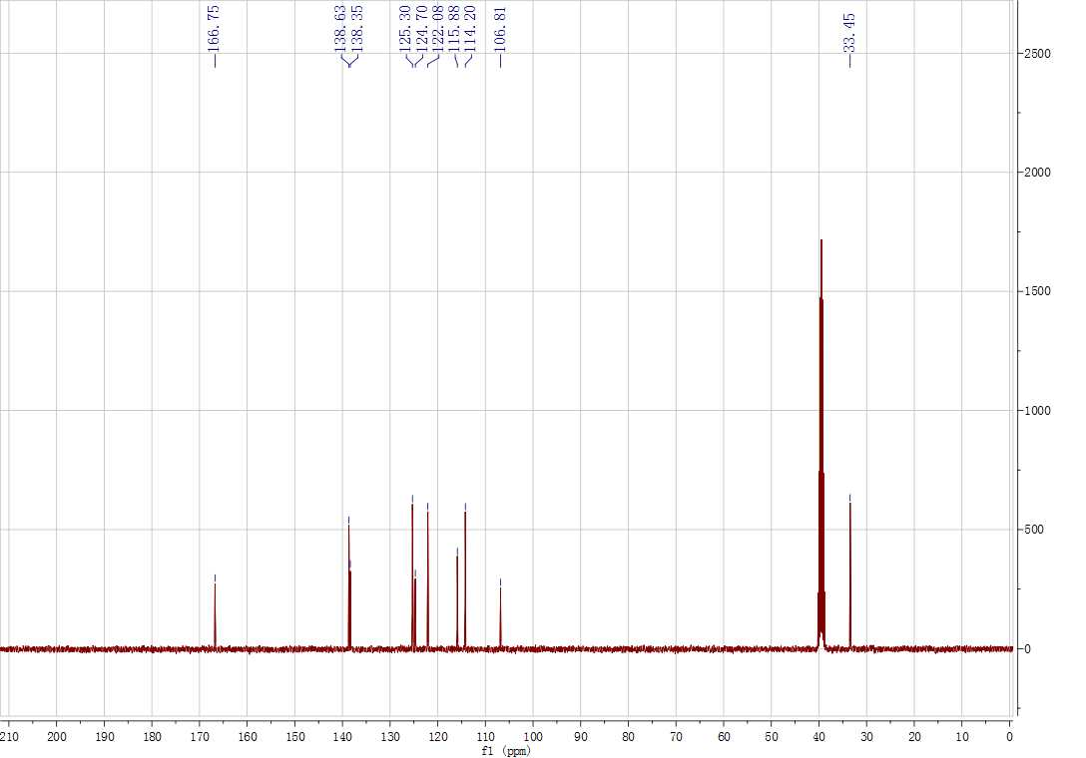
Supplementary Figure 45. ¹H and ¹³C NMR spectrum for 4h
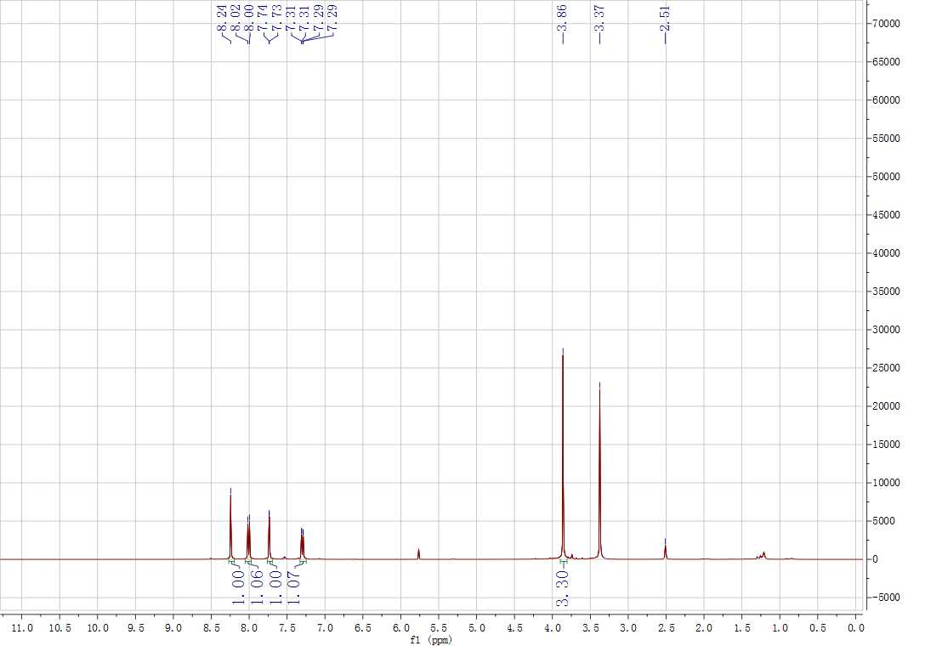
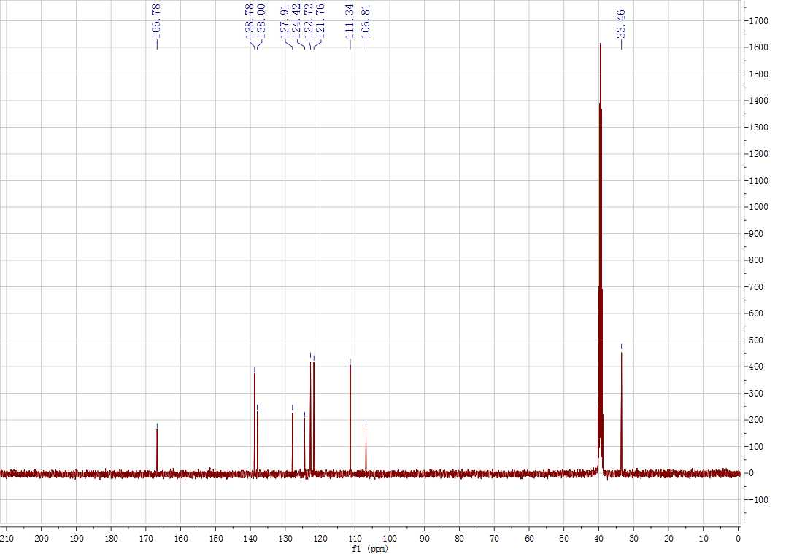
Supplementary Figure 46. ¹H and ¹³C NMR spectrum for 4i
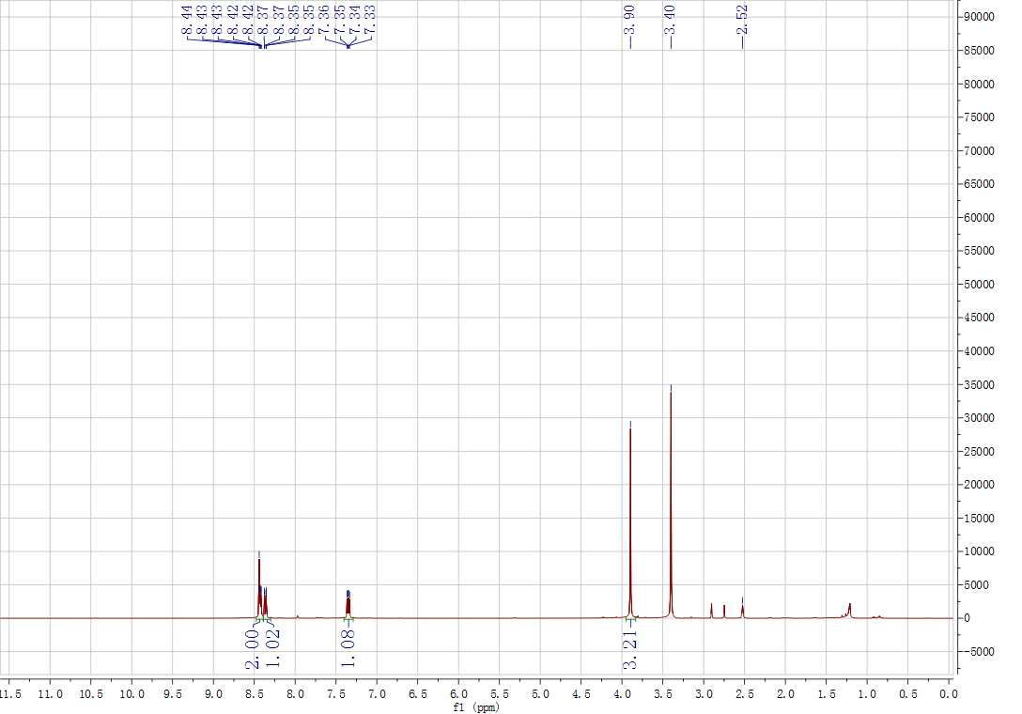
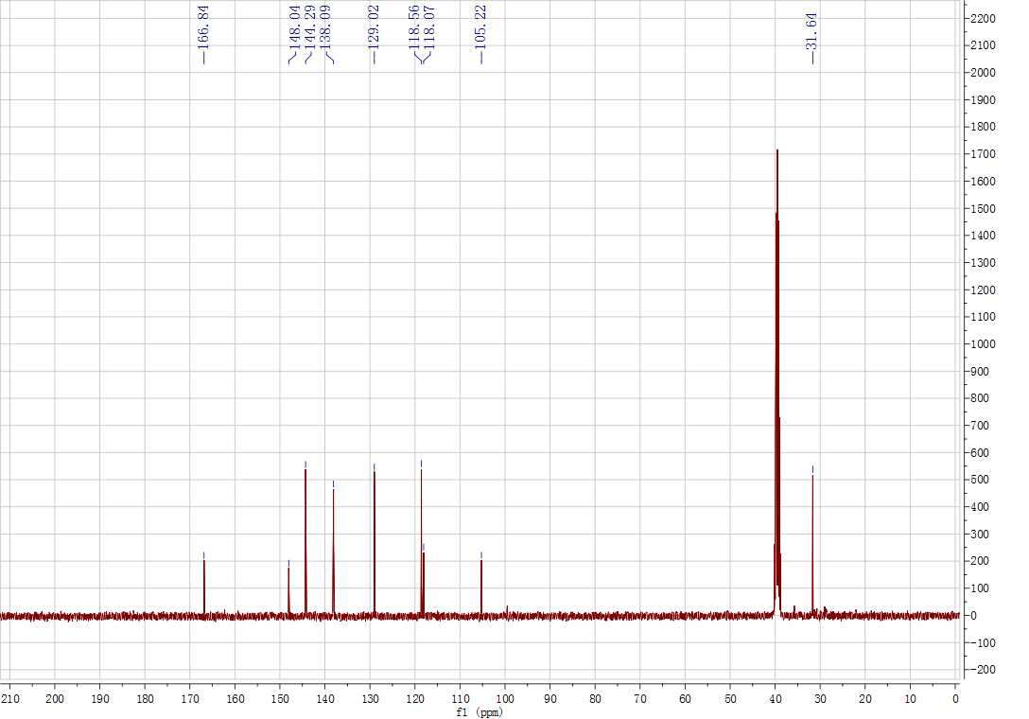
Supplementary Figure 47. ¹H and ¹³C NMR spectrum for 4j

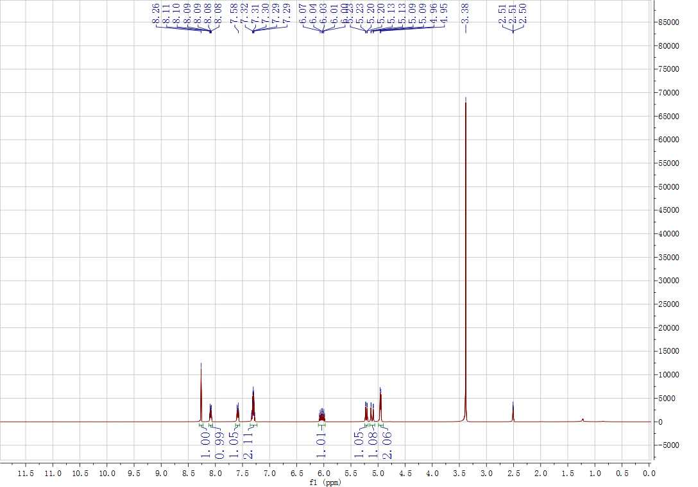
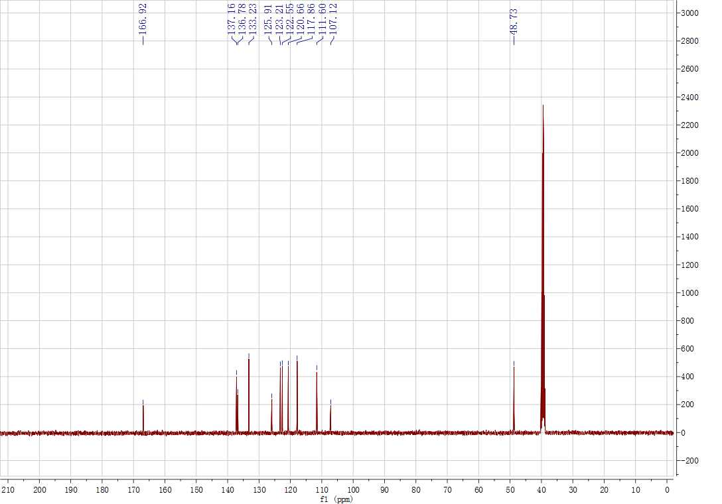
Supplementary Figure 48. ¹H and ¹³C NMR spectrum for 4k
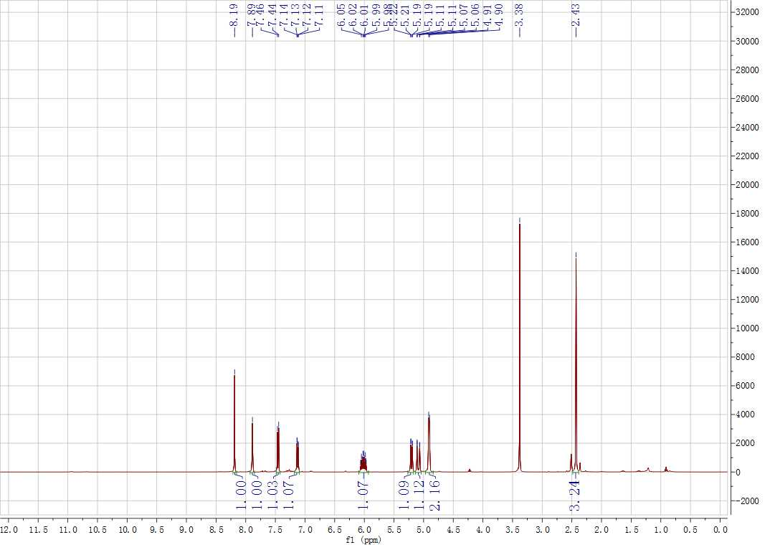
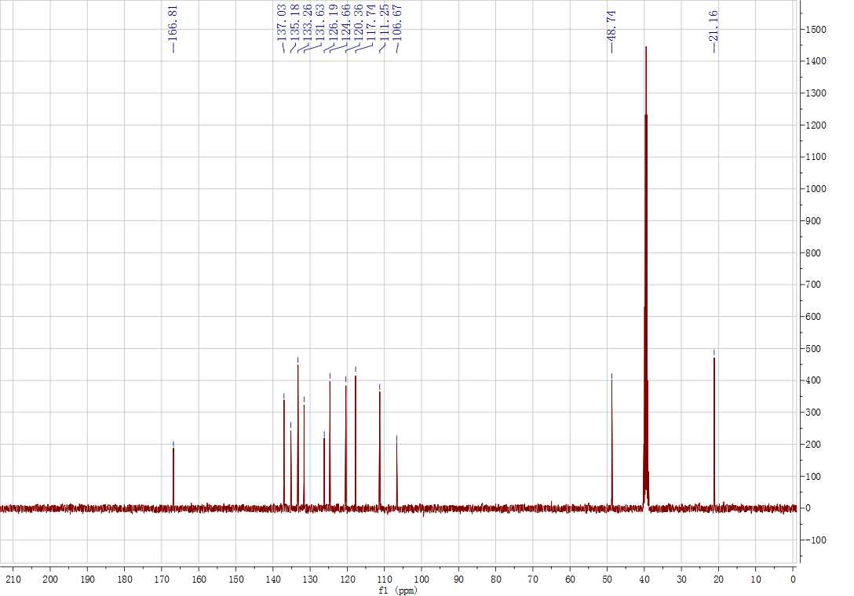
Supplementary Figure 49. ¹H and ¹³C NMR spectrum for 4l
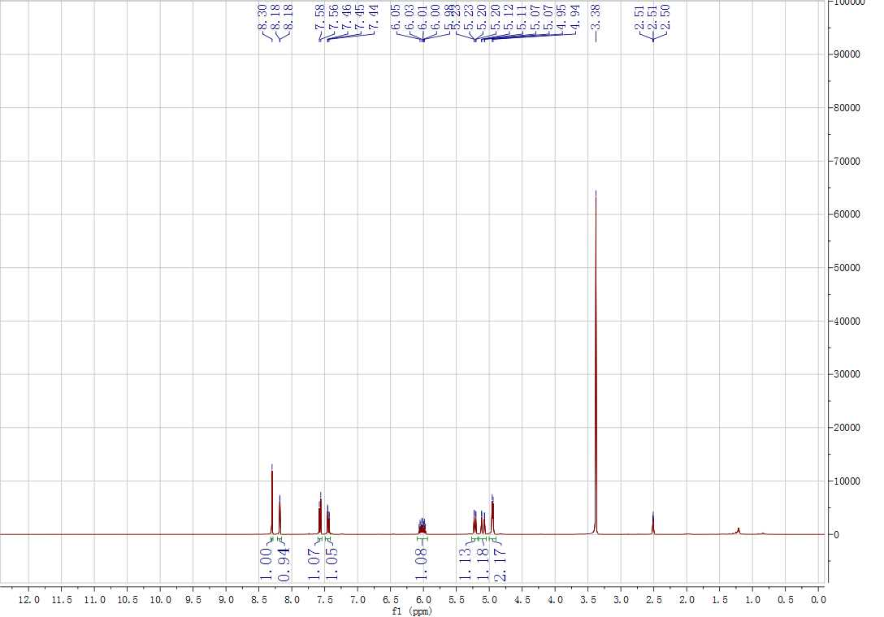
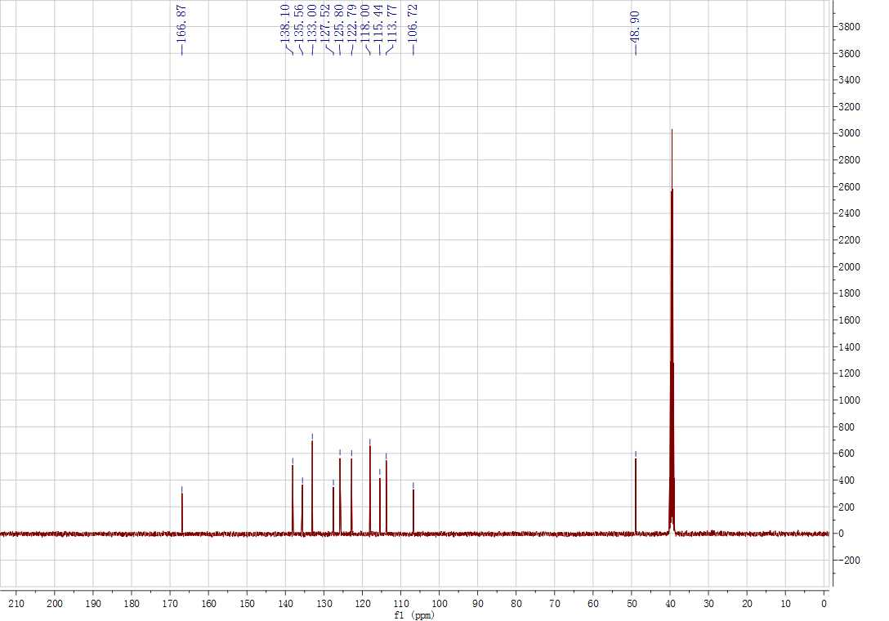
Supplementary Figure 50. ¹H and ¹³C NMR spectrum for 4m
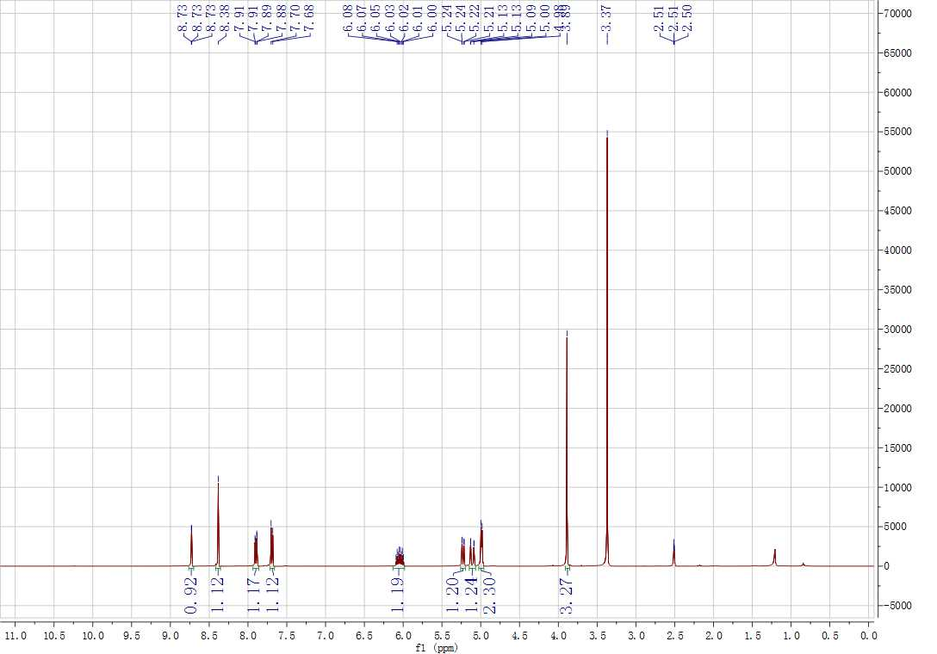
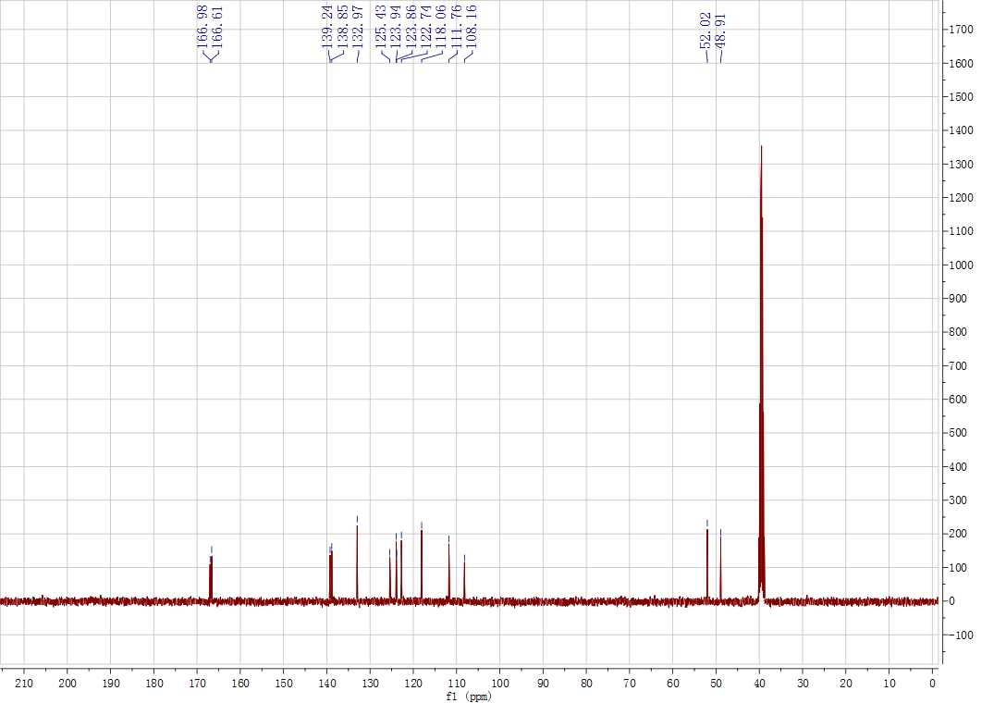
Supplementary Figure 51. ¹H and ¹³C NMR spectrum for 4n
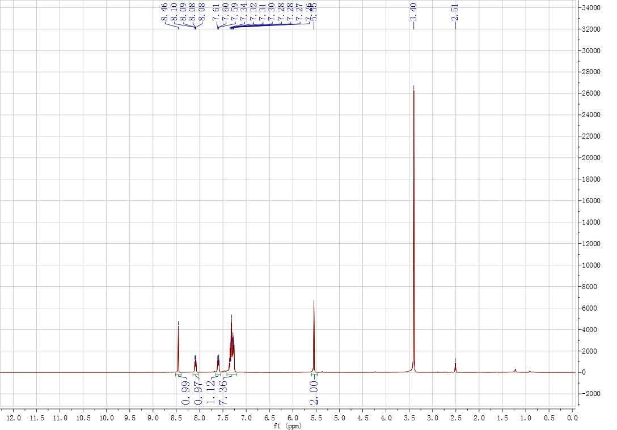
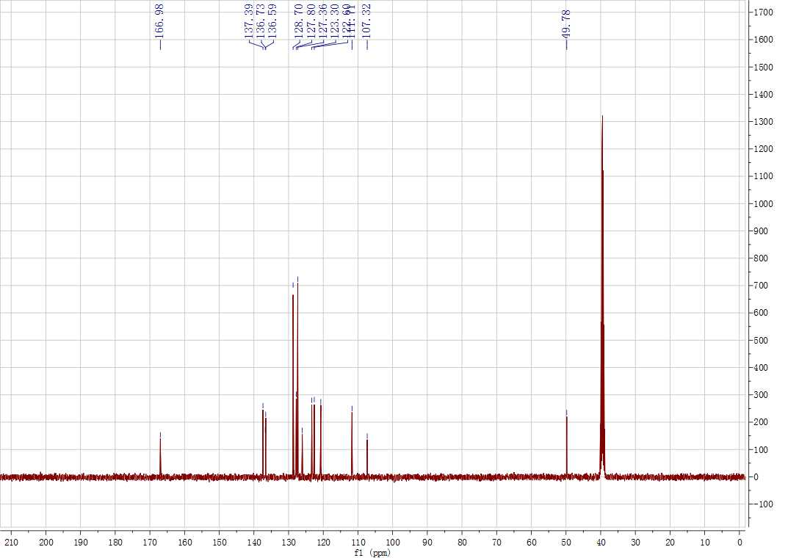
Supplementary Figure 52. ¹H and ¹³C NMR spectrum for 4o
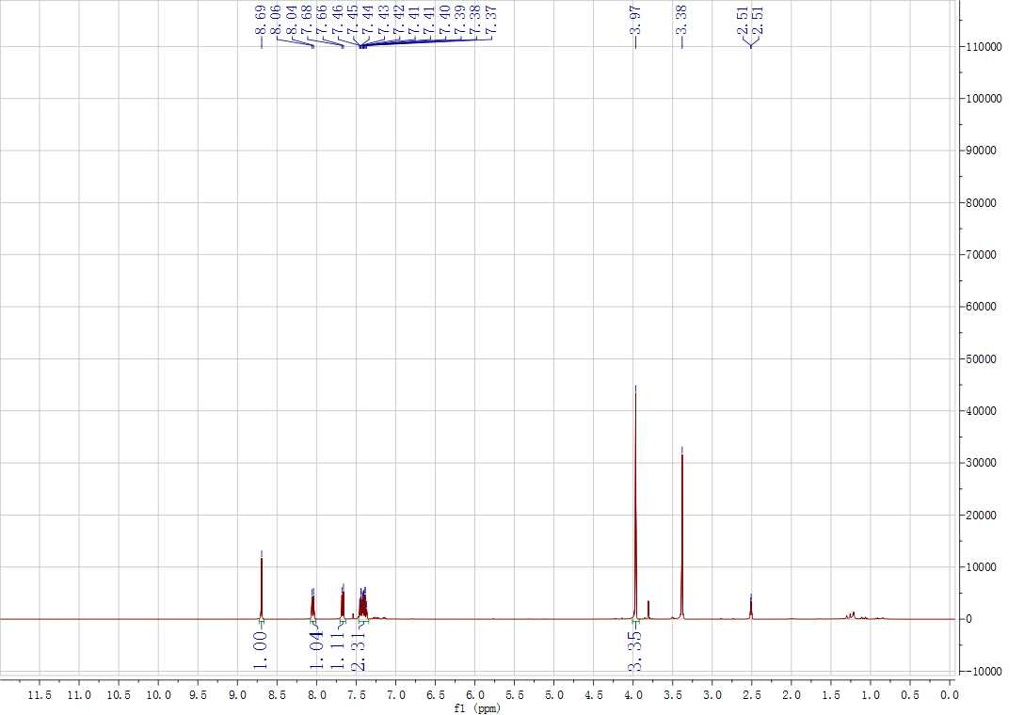
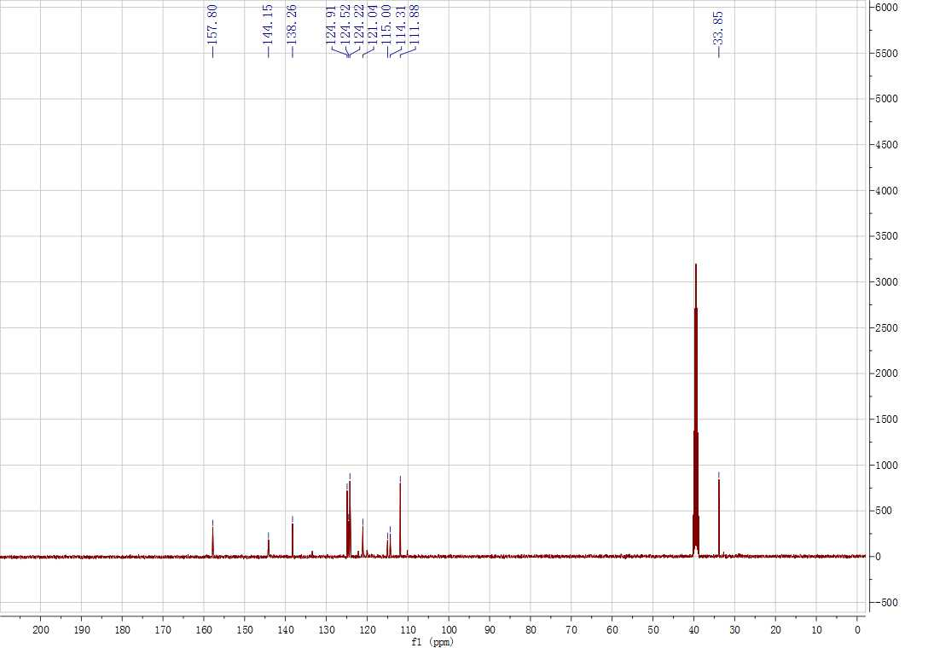
Supplementary Figure 53. ¹H and ¹³C NMR spectrum for 5a
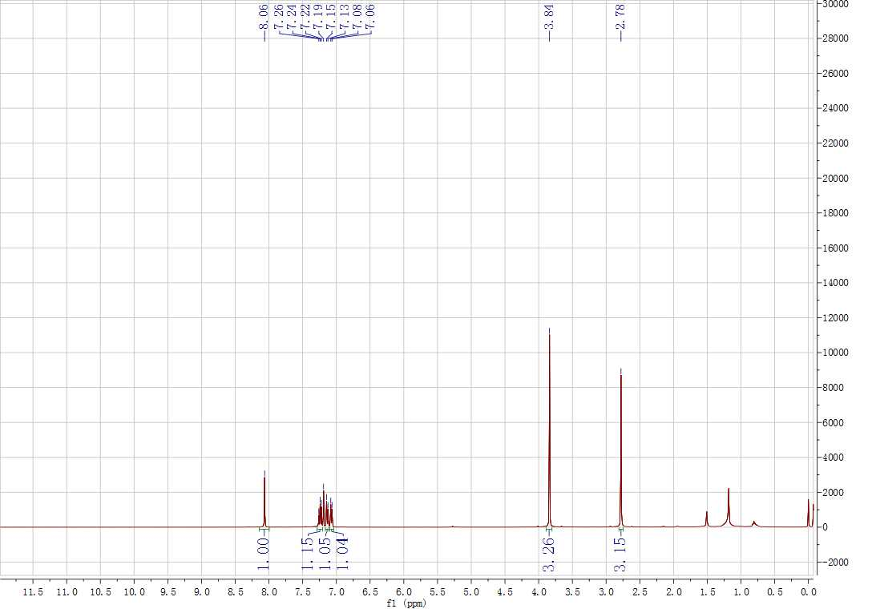
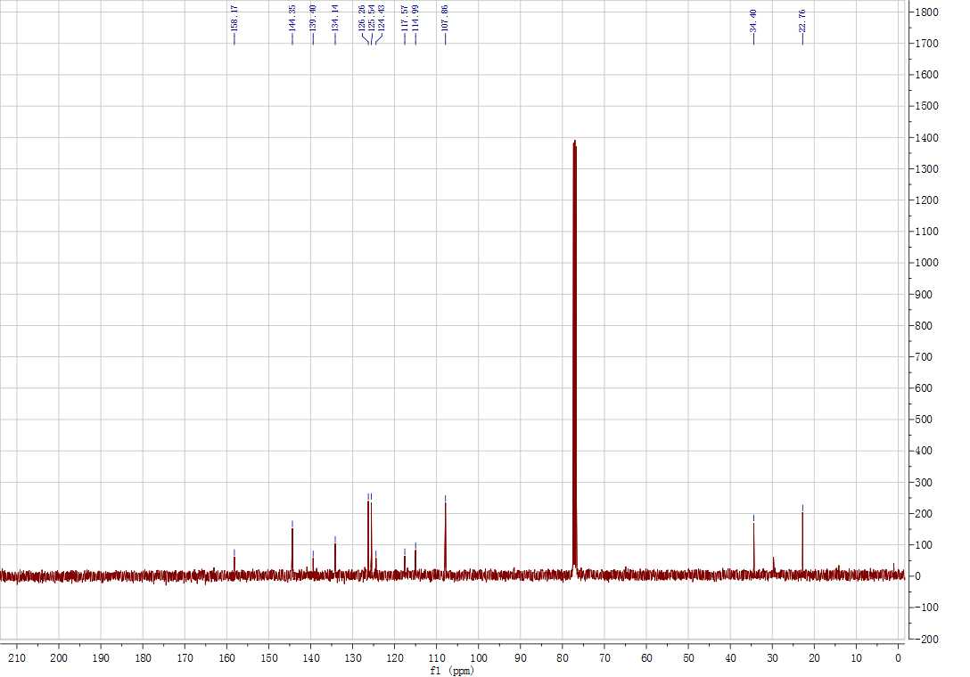
Supplementary Figure 54. ¹H and ¹³C NMR spectrum for 5b
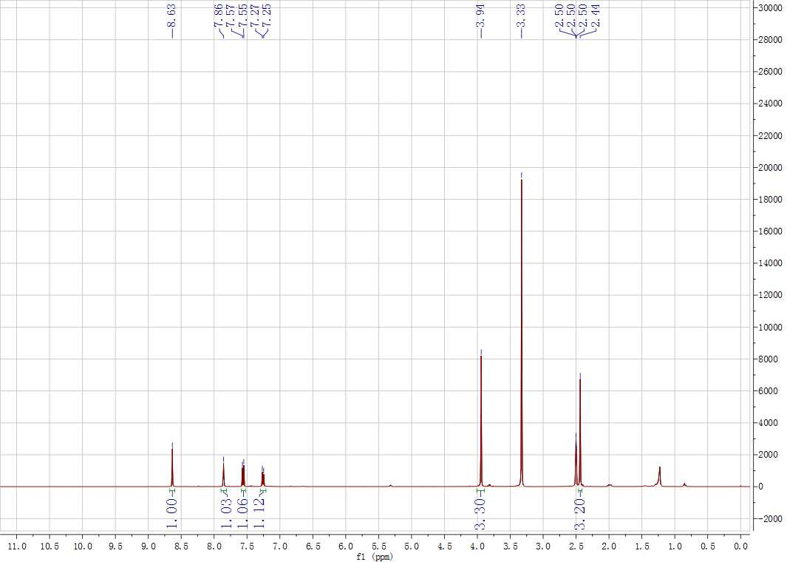
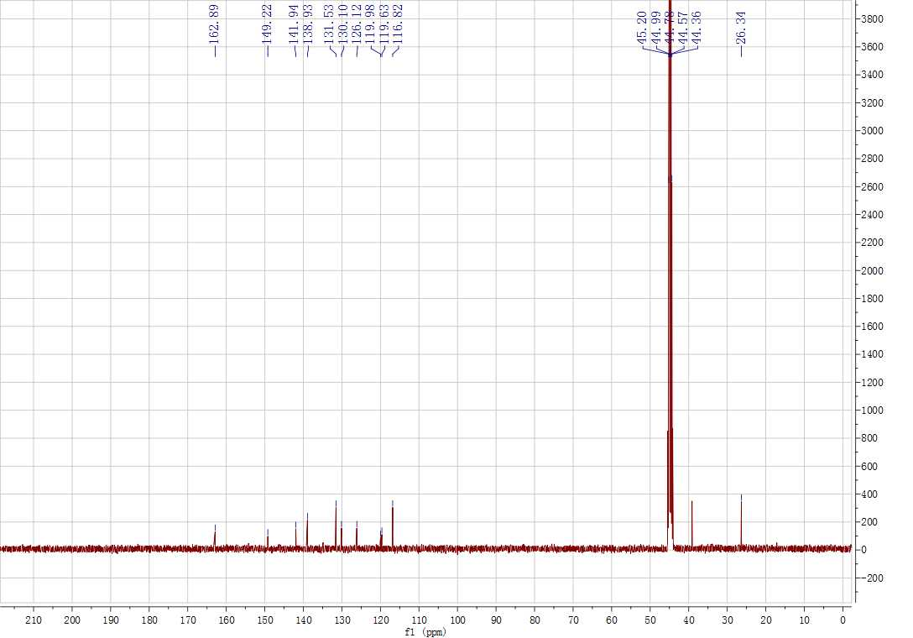
Supplementary Figure 55. ¹H and ¹³C NMR spectrum for 5c
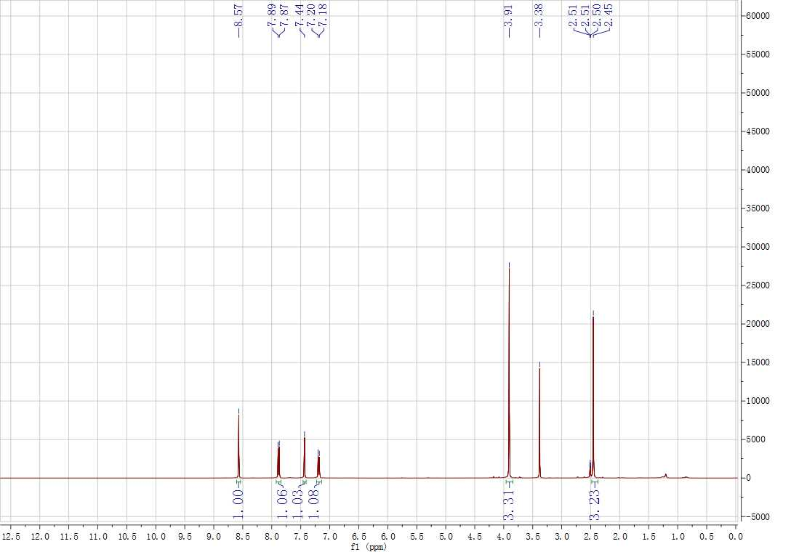
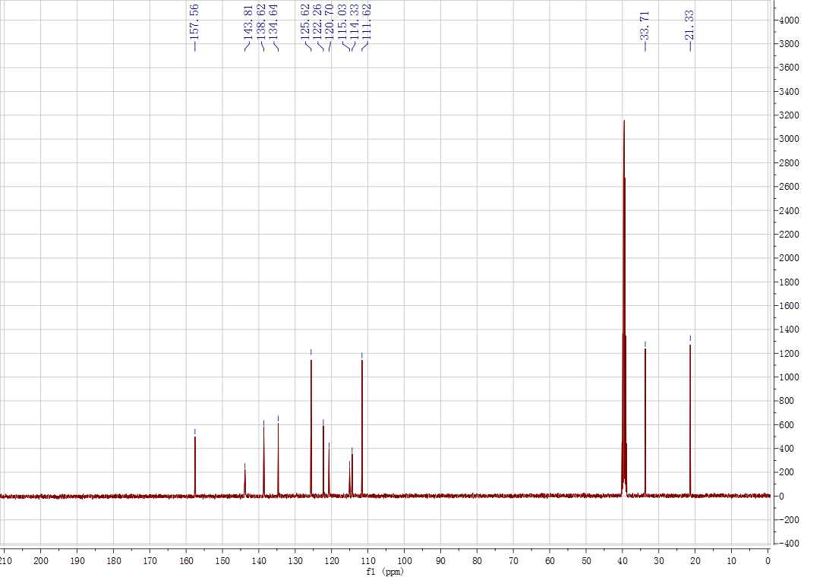
Supplementary Figure 56. ¹H and ¹³C NMR spectrum for 5d
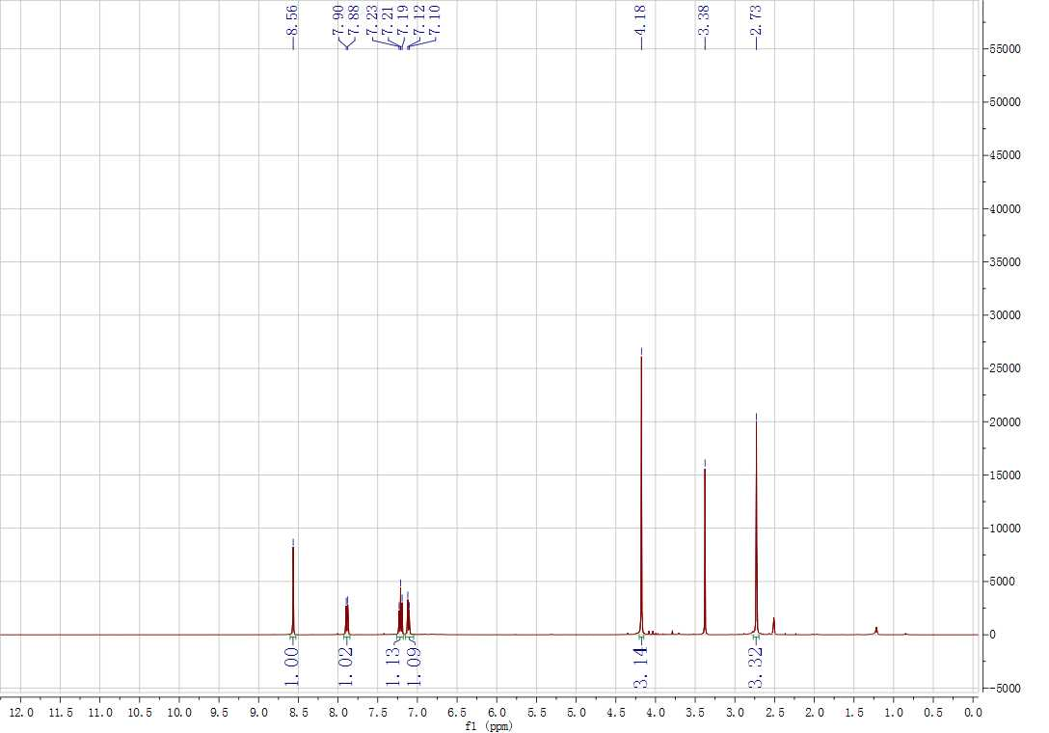
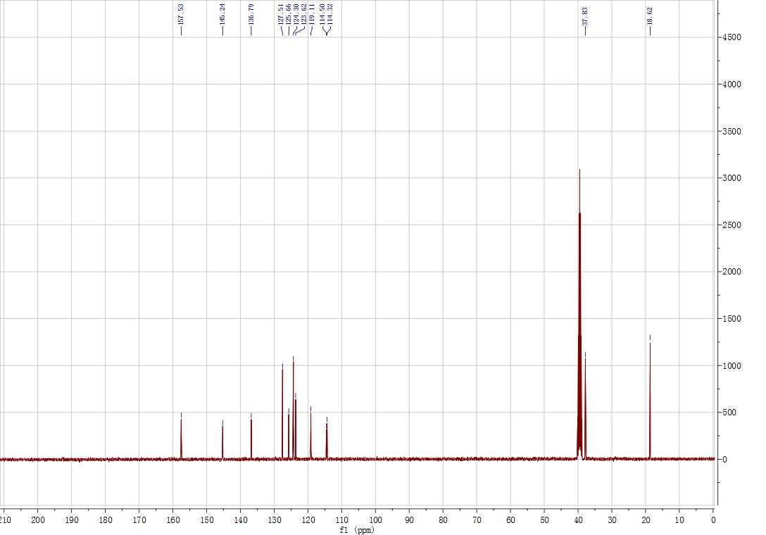
Supplementary Figure 57. ¹H and ¹³C NMR spectrum for 5e
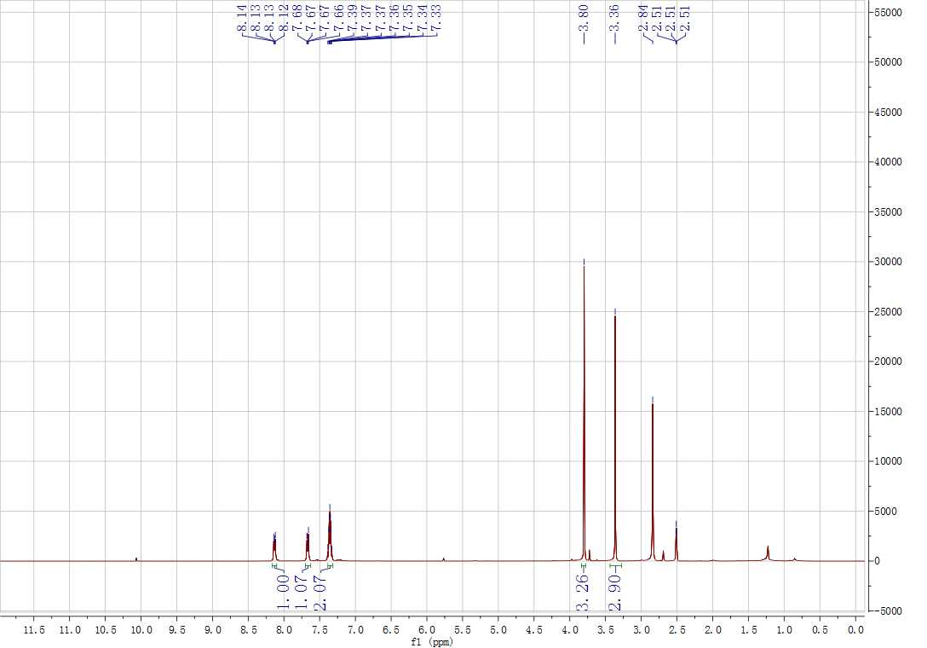
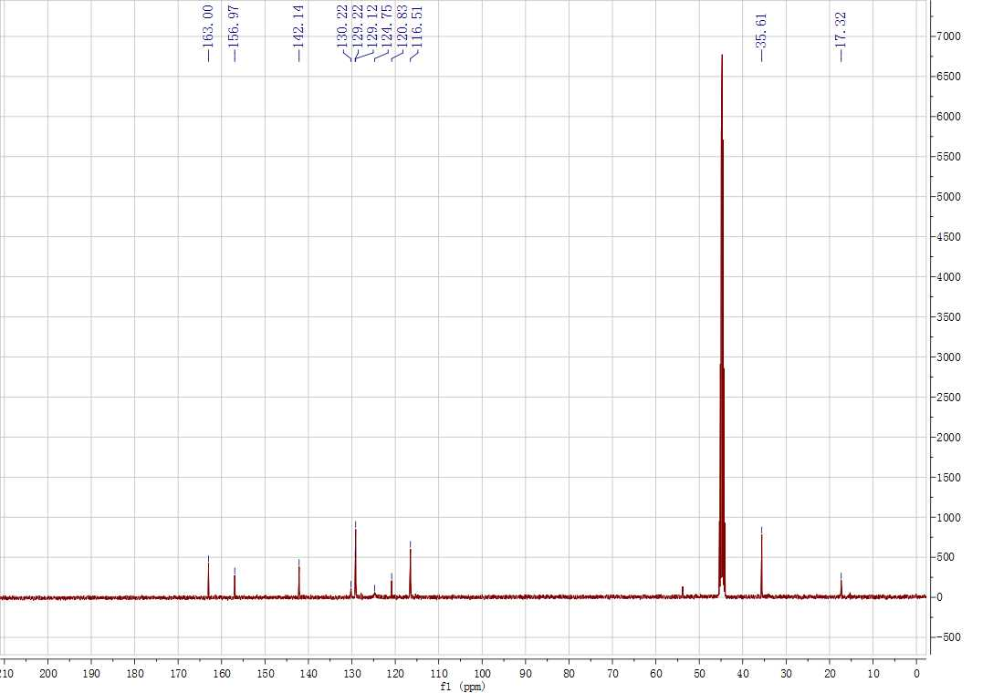
Supplementary Figure 58. ¹H and ¹³C NMR spectrum for 5f
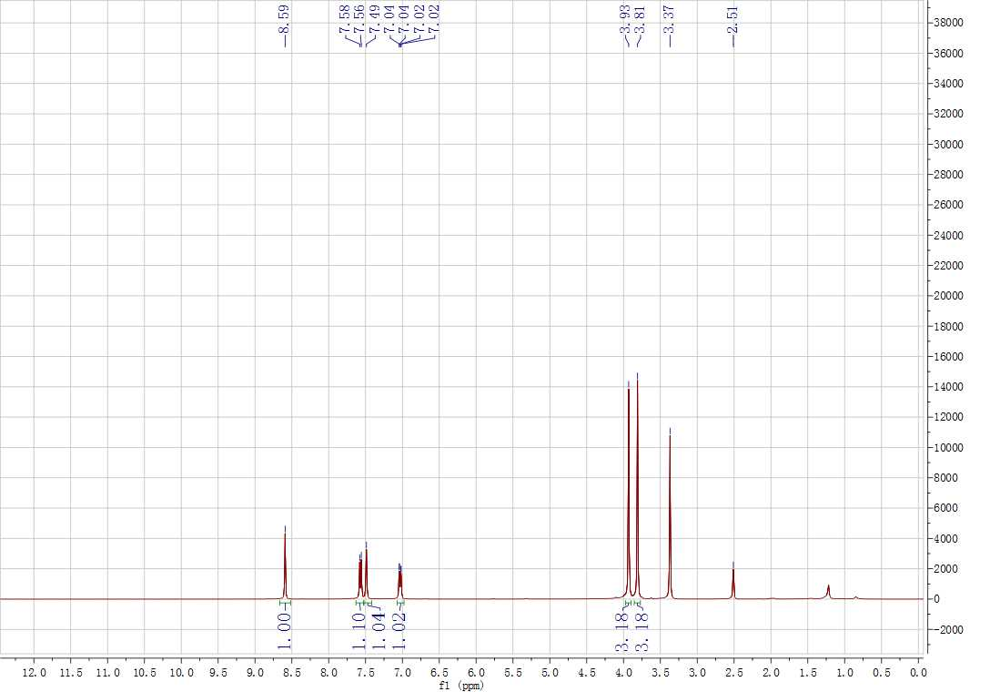
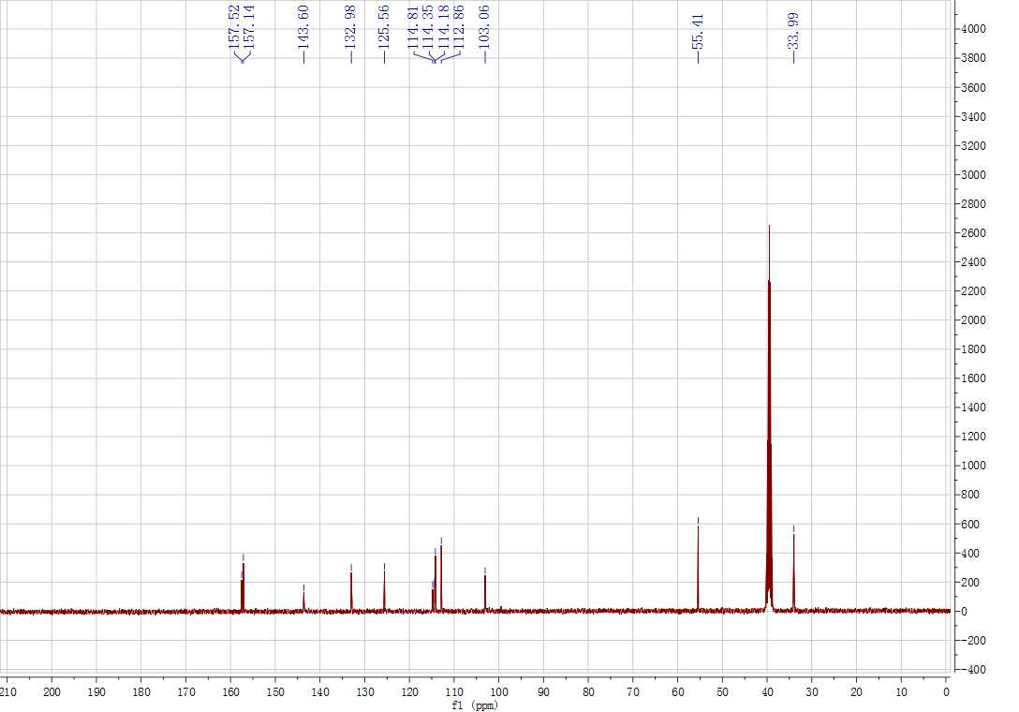
Supplementary Figure 59. ¹H and ¹³C NMR spectrum for 5g
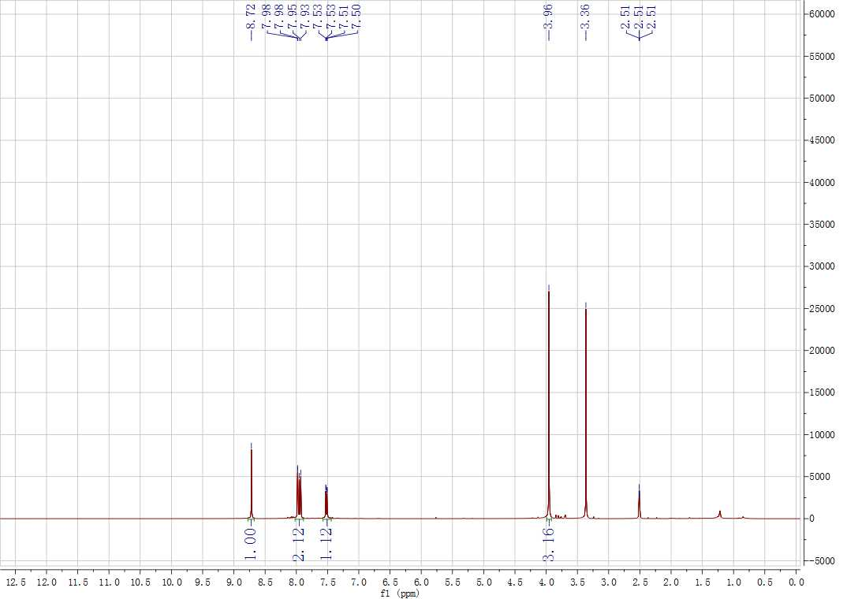
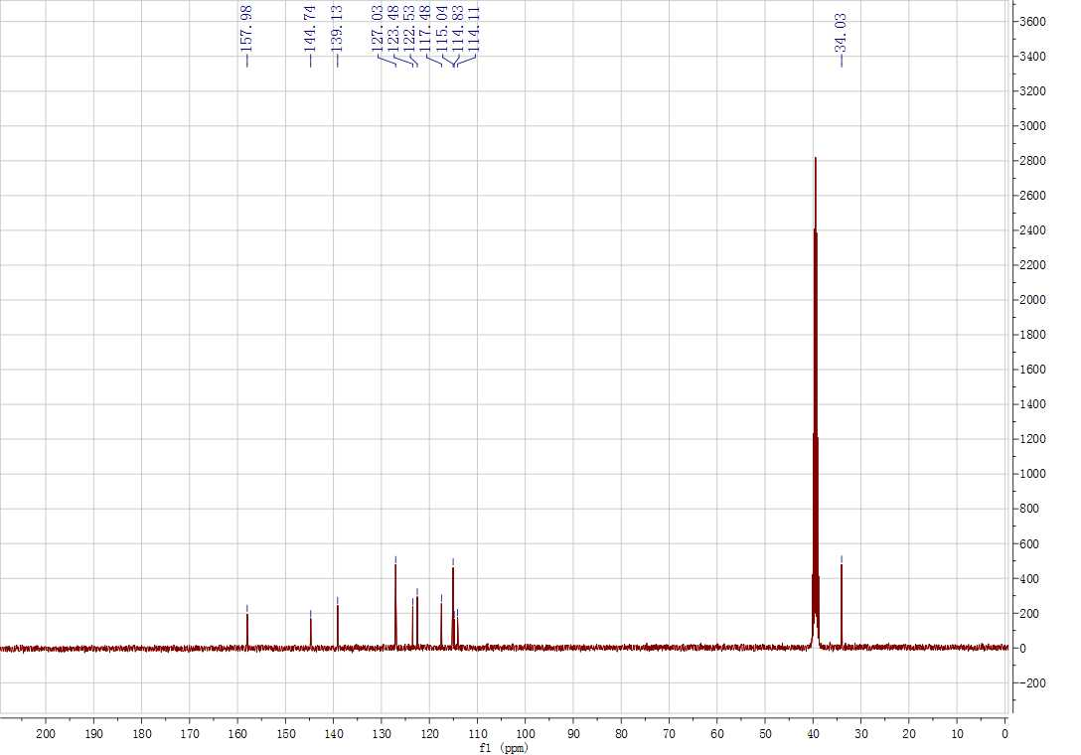
Supplementary Figure 60. ¹H and ¹³C NMR spectrum for 5h
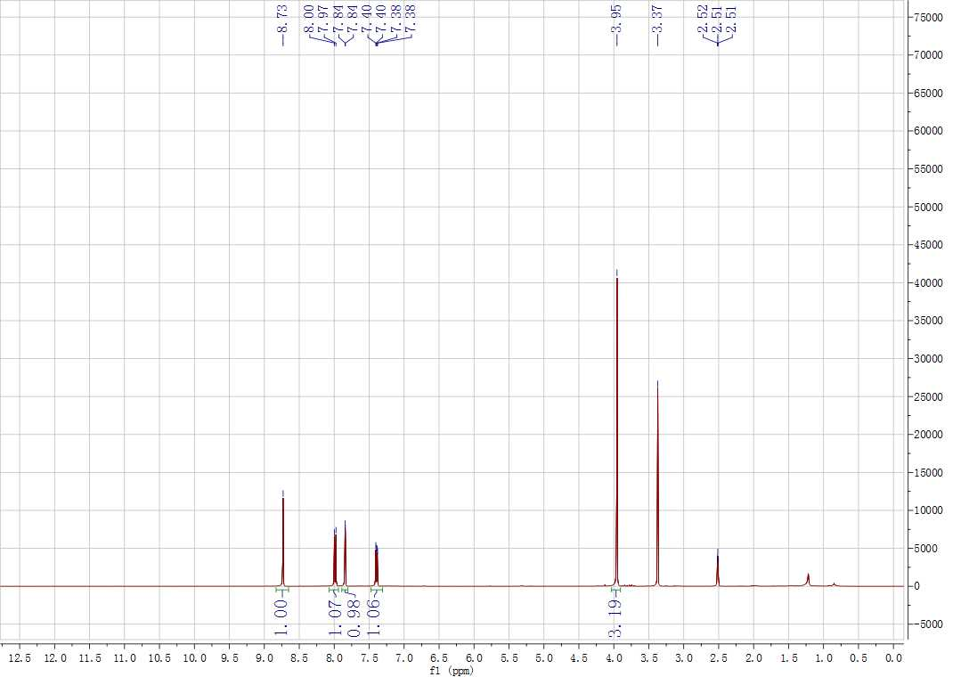
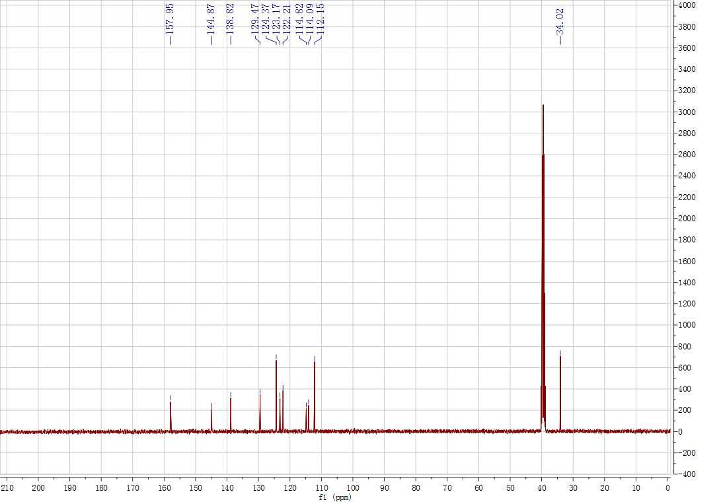
Supplementary Figure 61. ¹H and ¹³C NMR spectrum for 5i
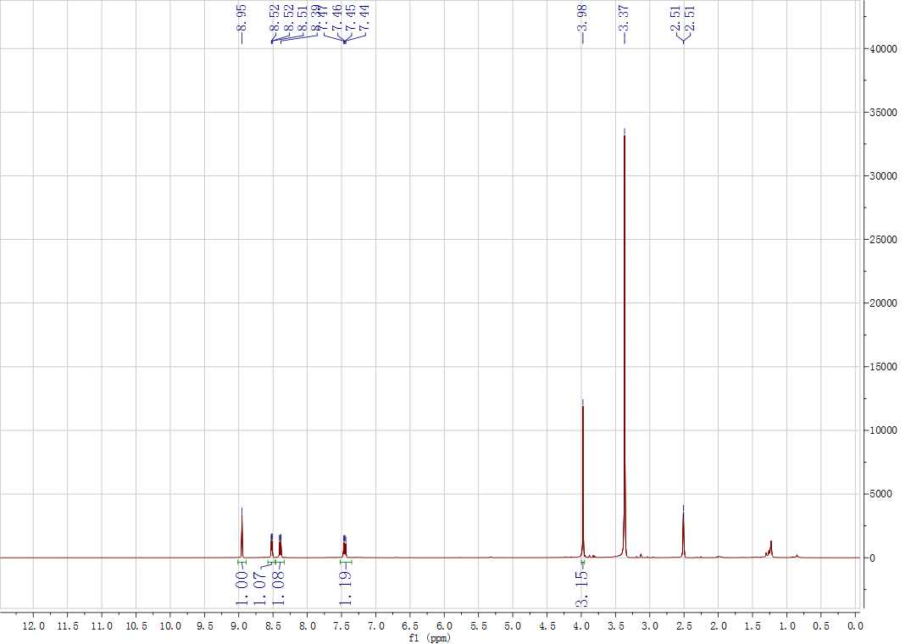
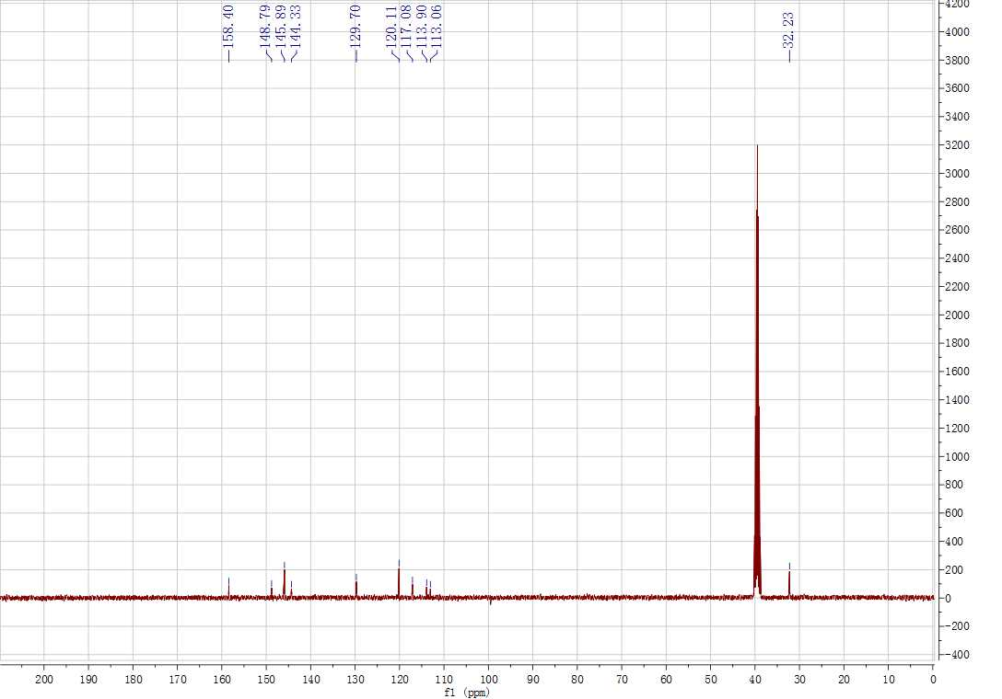
Supplementary Figure 62. ¹H and ¹³C NMR spectrum for 5j
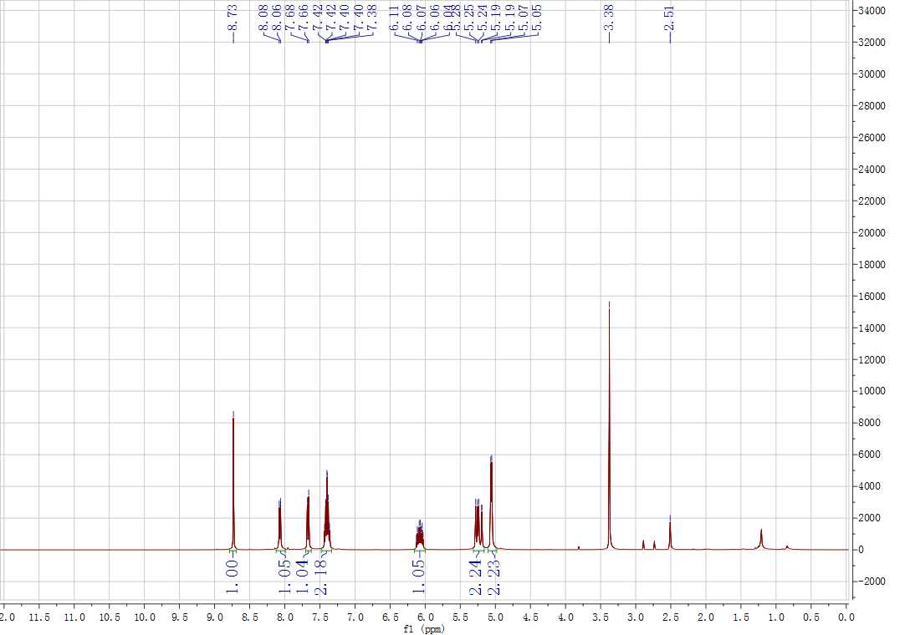
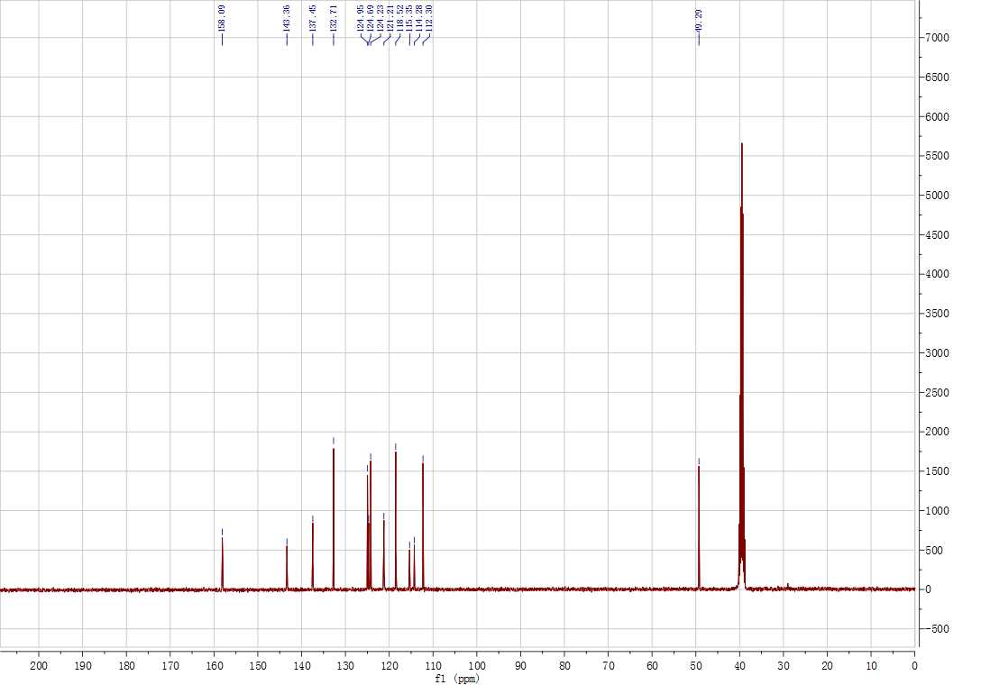
Supplementary Figure 63. ¹H and ¹³C NMR spectrum for 5k
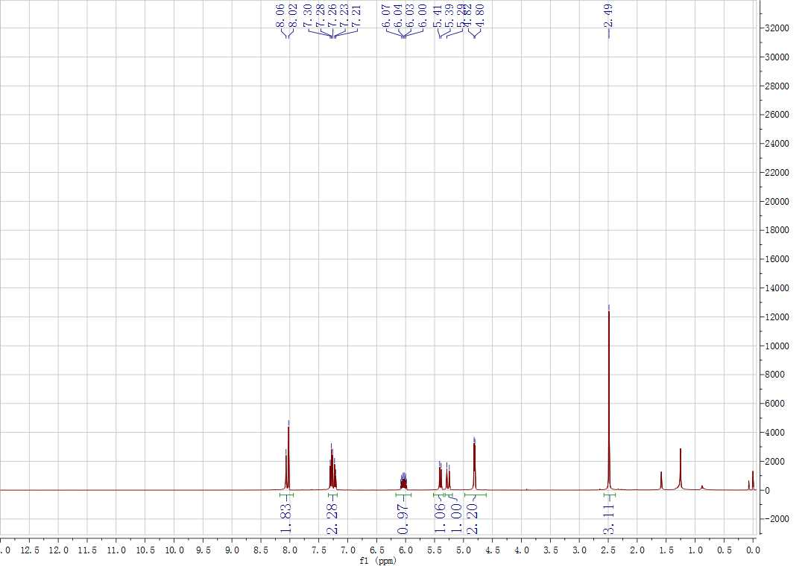
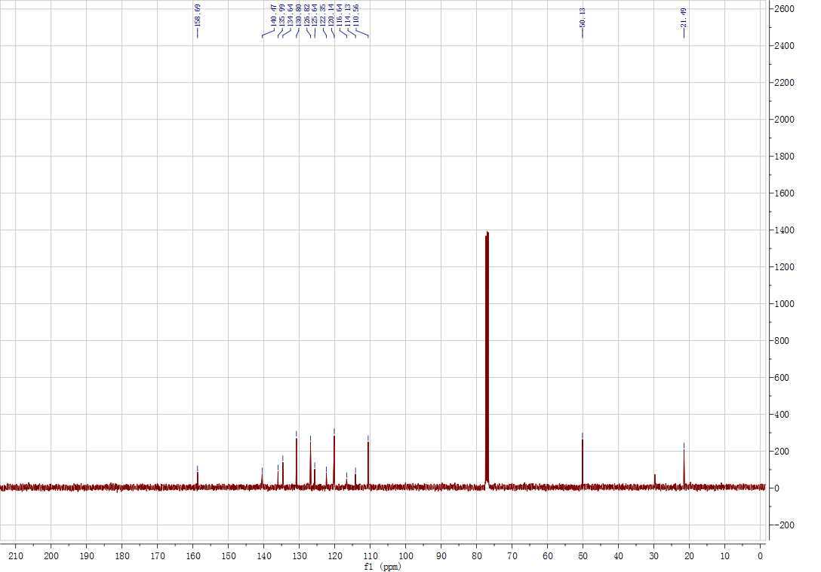
Supplementary Figure 64. ¹H and ¹³C NMR spectrum for 5l
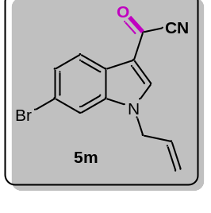
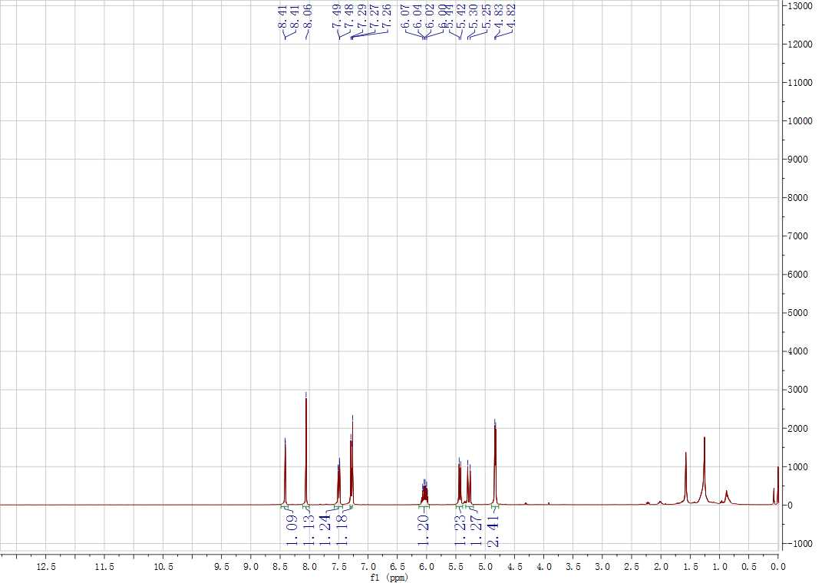
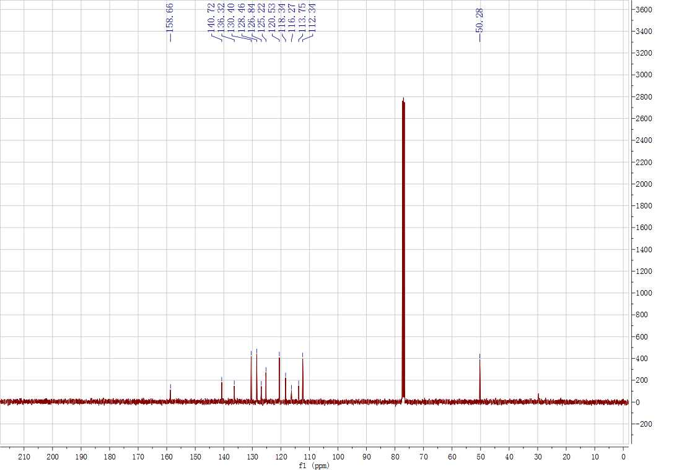
Supplementary Figure 65. ¹H and ¹³C NMR spectrum for 5m
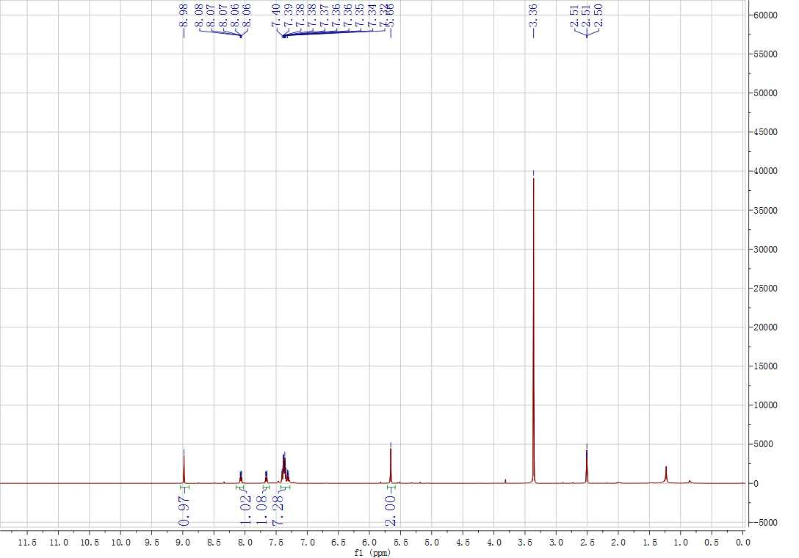
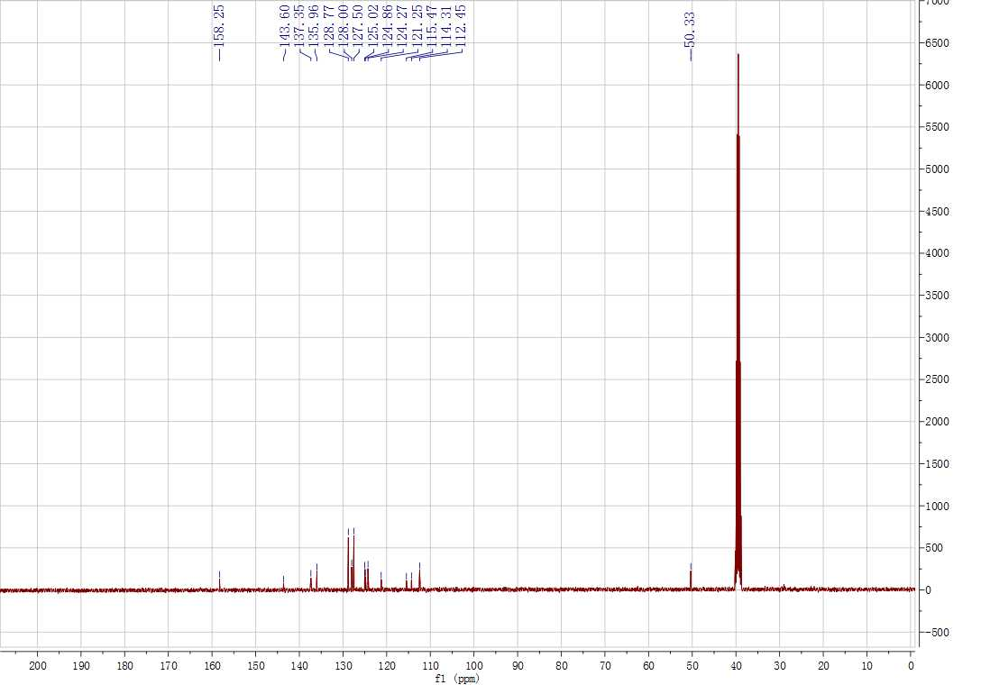
Supplementary Figure 66. ¹H and ¹³C NMR spectrum for 5n
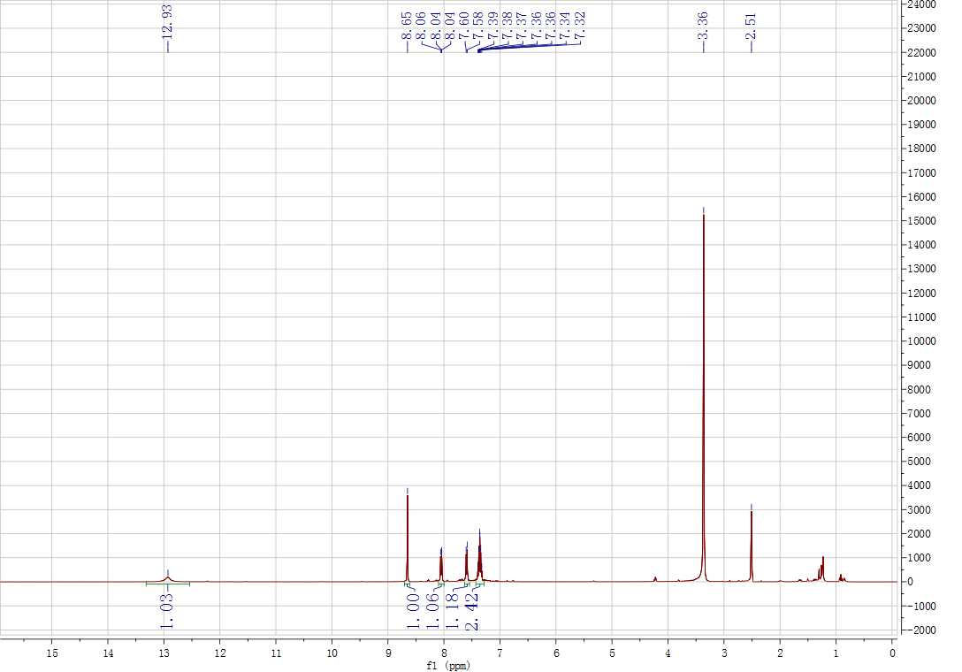
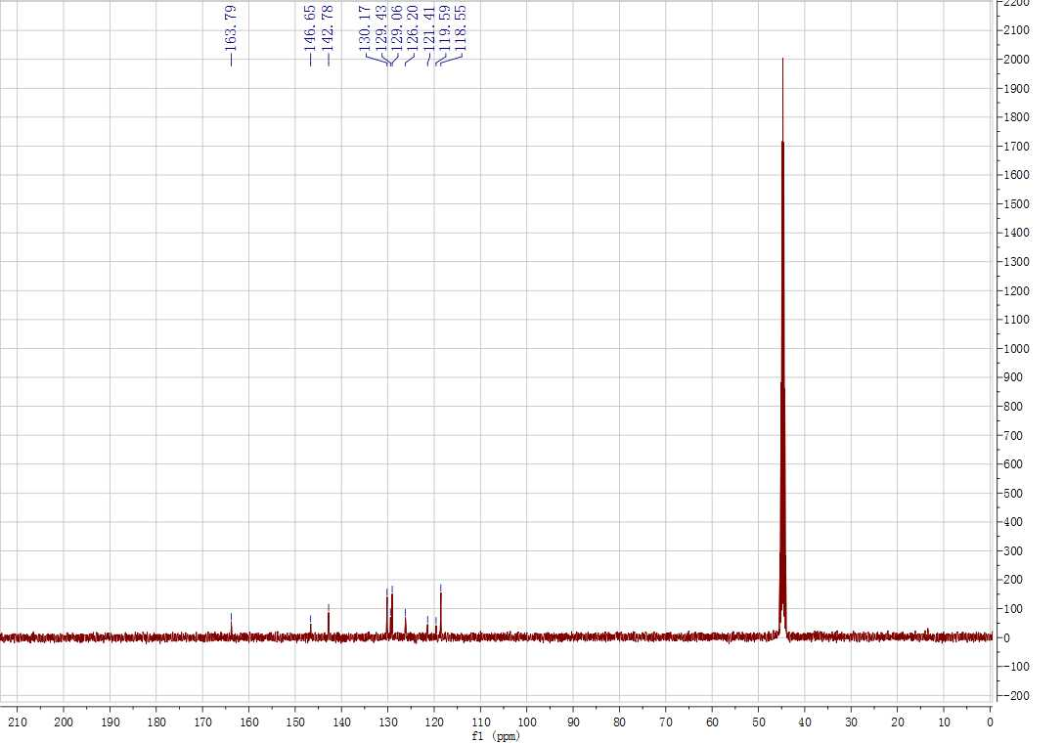
Supplementary Figure 67. ¹H and ¹³C NMR spectrum for 5o
References
- Li B, Guan Z, Wang W, Yang X, Hu J, Tan B, Li T. Highly Dispersed Pd Catalyst Locked in Knitting Aryl Network Polymers for Suzuki–Miyaura Coupling Reactions of Aryl Chlorides in Aqueous Media. Adv. Mater. 24, 3390-3395 (2012).
- Bukhryakov KV, Mugemana C, Vu KB, Rodionov VO. Palladium N-Heterocyclic Carbene Precatalyst Site Isolated in the Core of a Star Polymer. Org. Lett. 17, 4826-4829 (2015).
- Sashuk V, Schoeps D, Plenio H. Fluorophore Tagged Cross-Coupling Catalysts. Chem. Commun. 770-772 (2009).
- Wang W, Zheng A, Zhao P, Xia C, Li F. Au-NHC@Porous Organic Polymers: Synthetic Control and Its Catalytic Application in Alkyne Hydration Reactions. ACS Catal. 4, 321-327 (2014).
- Medri V, Martelli S, Landi E, Esposito L. Alkali Inorganic Binders for The Production of Fibre Based Foams. Ceram. Int. 40, 10131-10136 (2014).
- Patel MA, Luo F, Khoshi MR, Rabie E, Zhang Q, Flach CR, Mendelsohn R, Garfunkel E, Szostak M, He H. P-Doped Porous Carbon as Metal Free Catalysts for Selective Aerobic Oxidation with an Unexpected Mechanism. ACS Nano 10, 2305-2315 (2016).
- Koh K, Jeon M, Chevrier DM, Zhang P, Yoon CW, Asefa T. Novel Nanoporous N-Doped Carbon-Supported Ultrasmall Pd Nanoparticles: Efficient Catalysts for Hydrogen Storage and Release. Appl. Catal. B: Environ. 203, 820-828 (2017).
- Cheng T, Chen J, Cai A, Wang J, Liu H, Hu Y, Bao X, Yuan P. Synthesis of Pd/SiO₂ Catalysts in Various HCl Concentrations for Selective NBR Hydrogenation: Effects of H⁺ and Cl– Concentrations and Electrostatic Interactions. ACS Omega 3, 6651-6659 (2018).
- Ogiwara Y, Sakurai Y, Hattori H, Sakai N. Palladium-Catalyzed Reductive Conversion of Acyl Fluorides via Ligand-Controlled Decarbonylation. Org. Lett. 20, 4204-4208 (2018).
- Agarwal PK, Dathi MD, Saifuddin M and Kundu B. Engineering of indole-based tethered biheterocyclic alkaloid meridianin into β-carboline-derived tetracyclic polyheterocycles via amino functionalization/6-endo cationic π-cyclization. Beilstein J. Org. Chem. 8, 1901–1908 (2012).
- Sauer DR, Kalvin D, Phelan KM. Microwave-Assisted Synthesis Utilizing Supported Reagents: A Rapid and Efficient Acylation Procedure. Org. Lett. 5, 4721-4724 (2003).
- Reekie TA, Wilkinson SM, Law V, Hibbs DE, Ong JA, Kassiou M. Rapid access to N-(indol-2-yl)amides and N-(indol-3-yl)amides as unexplored pharmacophores. Org. Biomol. Chem. 15, 576-580 (2017).
- Abdel R, Farghaly AH. Synthesis, Reactions and Antimicrobial Activity of Some New Indolyl-1,3,4-Oxadiazole, Triazole and Pyrazole Derivatives. J. Chin. Chem. Soc. 51, 147-156 (2004).
- Veale CGL. A new synthesis of versatile indolyl-3-carbonylnitriles. Tetrahedron Lett. 56, 5287-5290 (2015).

