Supplementary Material

Genome-wide SNPs analysis unveils population structure of North Pacific blue whales (Balaenoptera musculus)

Kiemel K., Taguchi M., Autenrieth M., Goto M., Matsuoka K., Tiedemann R., Pastene L.A.

Table S1: Overview of samples used in this study: IDs marked with an asteriks indicate samples excluded during SNP filtering process of ddRAD samples. This table includes each samples collection site based on sampling location, method of SNP generation, inclusion in datasets (i.e., Dataset 1, Dataset 2), cluster assignment of dataset 1 (CLA1) and dataset 2 (CLA2) based on a 70% threshold, as well as haplotype assignment of dataset 1 (first number) and dataset 2 (second number). Asterisk indicate haplotype was only found in one of the datasets (/*: only dataset 1; */: only dataset 2). Grey numbers represent the haplotype to which the sample would have been assigned if it had been included in the dataset.
ID | Site | Method | Dataset 1 | Dataset 2 | CLA1 | CLA2 | HT (1/2)
11ENPSBL01 | WNP | ddRAD | x | x | 1 | 2 | 4/4
11ENPSBL02 | WNP | ddRAD | x | x | 1 | 2 | 3/3
12NPSBL01 | WNP | ddRAD | x |  | 1 |  | 3/3
13NPSBL01* | WNP | Fluidigm |  | x |  | 3 | 1/1
19NPSBL01 | WNP | ddRAD | x |  | 1 |  | 1/1
19NPSBL02 | WNP | ddRAD | x | x | 1 | 2 | 1/1
19NPSBL03 | WNP | Fluidigm |  | x |  | admixed | 11/11
19NPSBL04 | WNP | ddRAD | x | x | 1 | 2 | 10/10
19NPSBL05 | WNP | ddRAD | x | x | 1 | 2 | 1/1
20NPSBL01* | WNP | ddRAD | x | x | 2 | 2 | 1/1
23NPSBL01 | WNP | Fluidigm |  | x |  | 3 | 1/1
23NPSBL02 | WNP | Fluidigm |  | x |  | 1 | 1/1
23NPSBL03 | WNP | Fluidigm |  | x |  | 3 | */7
23NPSBL04 | WNP | Fluidigm |  | x |  | 3 | */7
B11NPBL01 | WNP | ddRAD | x | x | 1 | 2 | 1/1
B11NPBL02 | WNP | ddRAD | x | x | 1 | 2 | 1/1
B15NPBL01 | WNP | ddRAD | x | x | 2 | 2 | 1/1
B15NPBL02 | WNP | ddRAD | x |  | 1 |  | 1/1
B15NPBL04* | WNP | Fluidigm |  | x |  | 3 | 5/5
B15NPBL05 | WNP | ddRAD | x |  | 1 |  | 1/1
B15NPBL06* | WNP | Fluidigm |  | x |  | 3 | */9
B15NPBL07* | WNP | Fluidigm |  | x |  | 3 | 2/2
B15NPBL08* | WNP | Fluidigm |  | x |  | 1 | 1/1
B17NPBL01 | WNP | ddRAD | x | x | 1 | 2 | 2/2
B17NPBL02 | WNP | Fluidigm |  | x |  | 2 | 2/2
B17NPBL03 | WNP | ddRAD | x |  | 1 |  | 5/5
B17NPBL04 | WNP | ddRAD | x | x | 1 | 2 | 3/3
B17NPBL05 | WNP | ddRAD | x |  | 1 |  | 4/4
B18NPBL01* | WNP | Fluidigm |  | x |  | admixed | 1/1
PW10BL01* | WNP | Fluidigm |  | x |  | admixed | 5/5
PW18BL01 | WNP | Fluidigm |  | x |  | 3 | 2/2
PW18BL02 | WNP | Fluidigm |  | x |  | 3 | 3/3
PW18BL03 | WNP | Fluidigm |  | x |  | 3 | 3/3
PW18BL04 | WNP | Fluidigm |  | x |  | 3 | 1/1
PW18BL05 | WNP | Fluidigm |  | x |  | 3 | 3/3
PW18BL06 | WNP | Fluidigm |  | x |  | 3 | 4/4
PW20BL01 | WNP | ddRAD | x | x | 1 | 2 | 6/6
PW20BL02 | WNP | ddRAD | x | x | 2 | 2 | 1/1
PW20BL03 | WNP | ddRAD | x |  | 1 |  | 1/1
PW20BL04 | WNP | ddRAD | x |  | 1 |  | 2/2
PW20BL05 | WNP | ddRAD | x | x | 1 | admixed | 1/1
PW20BL06 | WNP | Fluidigm |  | x |  | admixed | 1/1
PW20BL07 | WNP | ddRAD | x | x | 1 | 2 | 1/1
PW20BL08 | WNP | ddRAD | x | x | 1 | 2 | 5/5
PW20BL09 | WNP | ddRAD | x |  | 1 |  | 4/4
PW20BL10 | WNP | ddRAD | x |  | 2 |  | 1/1
PW20BL11 | WNP | ddRAD | x |  | 1 |  | 1/1
PW20BL12* | WNP | Fluidigm |  | x |  | 3 | 4/4
PW20BL13 | WNP | ddRAD | x |  | 1 |  | 1/1
21NPSBL01 | WNP | ddRAD | x |  | 1 |  | 1/1
PW11BL01* | ENP | Fluidigm |  | x |  | 3 | 2/2
PW11BL02* | ENP | Fluidigm |  | x |  | 3 | 1/1
PW11BL03 | ENP | ddRAD | x | x | 1 | 2 | 2/2
PW11BL04 | ENP | ddRAD | x |  | 1 |  | 5/5
PW12BL01 | ENP | ddRAD | x | x | 1 | 2 | */7
PW14BL01 | ENP | ddRAD | x |  | 1 |  | 3/3
PW19BL01 | ENP | Fluidigm |  | x |  | 3 | 1/1
PW19BL02 | ENP | Fluidigm |  | x |  | 3 | */14
PW19BL03 | ENP | Fluidigm |  | x |  | 3 | 2/2
PW19BL04 | ENP | Fluidigm |  | x |  | 3 | 1/1
PW19BL05 | ENP | Fluidigm |  | x |  | 3 | 2/2
PW19BL06 | ENP | Fluidigm |  | x |  | admixed | */13
PW19BL07 | ENP | Fluidigm |  | x |  | 3 | */9
PW19BL08 | ENP | Fluidigm |  | x |  | 3 | 1/1
PW19BL09 | ENP | Fluidigm |  | x |  | 3 | 1/1
PW19BL10 | ENP | Fluidigm |  | x |  | admixed | 1/1
PW19BL11 | ENP | Fluidigm |  | x |  | 3 | */8
PW19BL12 | ENP | Fluidigm |  | x |  | 3 | */8
PW21BL01 | ENP | ddRAD | x | x | 1 | 2 | 2/2
PW21BL02* | ENP | Fluidigm |  | x |  | 3 | 6/6
PW21BL03 | ENP | ddRAD | x | x | 1 | 2 | 1/1
PW23BL01 | ENP | Fluidigm |  | x |  | admixed | 6/6
PW23BL02 | ENP | Fluidigm |  | x |  | admixed | */12
PW23BL03 | ENP | Fluidigm |  | x |  | 3 | 5/5
PW23BL04 | ENP | Fluidigm |  | x |  | admixed | 1/1
SW97PB01 | ESP | ddRAD | x |  | 3 |  | 7/*
SW97PB02 | ESP | ddRAD | x |  | 3 |  | 8/*
SW97PB04 | ESP | ddRAD | x |  | 3 |  | 12/*
SW97PB05 | ESP | ddRAD | x |  | 3 |  | 15/*
SW97PB06 | ESP | ddRAD | x |  | admixed |  | 9/*
SW97PB09 | ESP | ddRAD | x |  | 3 |  | 13/*
SW97PB10 | ESP | ddRAD | x |  | 3 |  | 7/*
SW97PB11 | ESP | ddRAD | x |  | 3 |  | 8/*
SW97PB12 | ESP | ddRAD | x |  | 3 |  | 1/1
SW97PB14 | ESP | ddRAD | x |  | admixed |  | 1/1
SW97PB15 | ESP | ddRAD | x |  | 3 |  | 7/*
SW97PB16 | ESP | ddRAD | x |  | 3 |  | 15/*
SW97PB17 | ESP | ddRAD | x |  | 3 |  | 1/1
SW97PB19 | ESP | ddRAD | x |  | 3 |  | 14/*
SW97PB20 | ESP | ddRAD | x |  | 3 |  | 15/*
SW97PB13 | ESP | ddRAD | - | - | - | - | -
SW97PB18 | ESP | ddRAD | - | - | - | - | -

Table S2: Estimated cross-validation values from ADMIXTURE analysis used to identify genetic clusters across ten K-values in dataset 1 and dataset 2.
 | Dataset 1 |  | Dataset 2
K | CV |  | CV
1 | 0.6534 |  | 0.5425
2 | 0.6687 |  | 0.5966
3 | 0.7826 |  | 0.5949
4 | 0.8534 |  | 0.5998
5 | 0.9808 |  | 0.6977
6 | 1.0872 |  | 0.6916
7 | 1.3412 |  | 0.7079
8 | 1.3283 |  | 0.7544
9 | 1.5424 |  | 0.7821
10 | 1.6096 |  | 0.8586

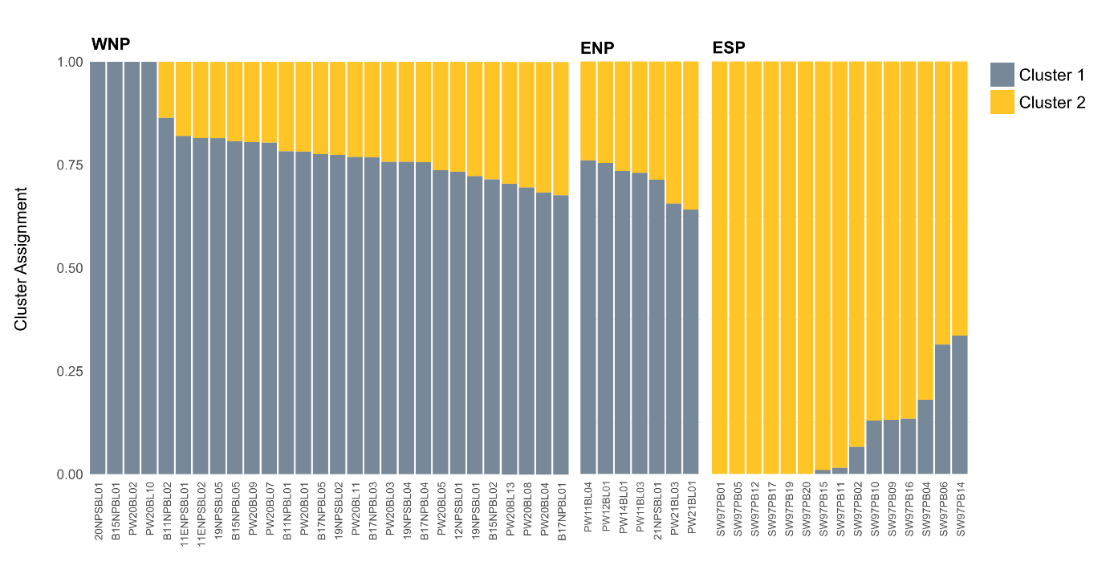
Figure S1: ADMIXTURE plot based on 12,951 SNPs and 50 samples across the Pacific using K = 2, showing three regions: West North Pacific (WNP), East North Pacific (ENP), and East South Pacific (ESP). The colour code represents cluster assignment proportions.

