Supplementary Material for: “Speckle-Driven Single-Shot Orbital Angular Momentum Recognition with Ultra-Low Sampling Density”

Zhiyuan Wang^{1,2,3,†}, Haoran Li^{1,2,3,†}, Tianting Zhong^{4,5}, Qi Zhao^{3,4}, Vinu R V^{1,2}, Huanhao Li^{3,4}, Zhipeng Yu^{3,4}, Jixiong Pu^{1,2}, Ziyang Chen^{1,2,*}, Xiaocong Yuan^{6,*}, and Puxiang Lai^{3,4,7,*}
1Huaqiao University, College of Information Science and Engineering, Xiamen, China, 361021
2Huaqiao University, Fujian Provincial Key Laboratory of Light Propagation and Transformation, Xiamen, China, 361021
3Hong Kong Polytechnic University, Department of Biomedical Engineering, Hong Kong, China
4Hong Kong Polytechnic University, Shenzhen Research Institute, Shenzhen, China
5The University of Hong Kong, Department of Electrical and Electronic Engineering, Hong Kong, China
6Shenzhen University, Nanophotonics Research Center, Shenzhen Key Laboratory of Micro-scale Optical Information Technology, Institute of Microscale Optoelectronics, Shenzhen, 518060, China
7Hong Kong Polytechnic University, Photonics Research Institute, Hong Kong, China

*Address all correspondence to Ziyang Chen at ziyang@hqu.edu.cn, Xiaocong Yuan at xcyuan@szu.edu.cn, and Puxiang Lai at puxiang.lai@polyu.edu.hk

†These authors contributed equally to this work.

Supplementary Note 1: Principle of spatially multiplexed points detection (SMPD)
1.1 Mechanism of transmission matrix
When an input light field passes through a random medium and generates its corresponding output light field, the input and the output can be related with a transmission matrix (TM). Each element of the TM connects a pair of elements that correspond to the input and output fields. As illustrated in Fig. S1, the entire input field can be divided into a variety of individual input fields, with their corresponding outputs generated according to the TM.
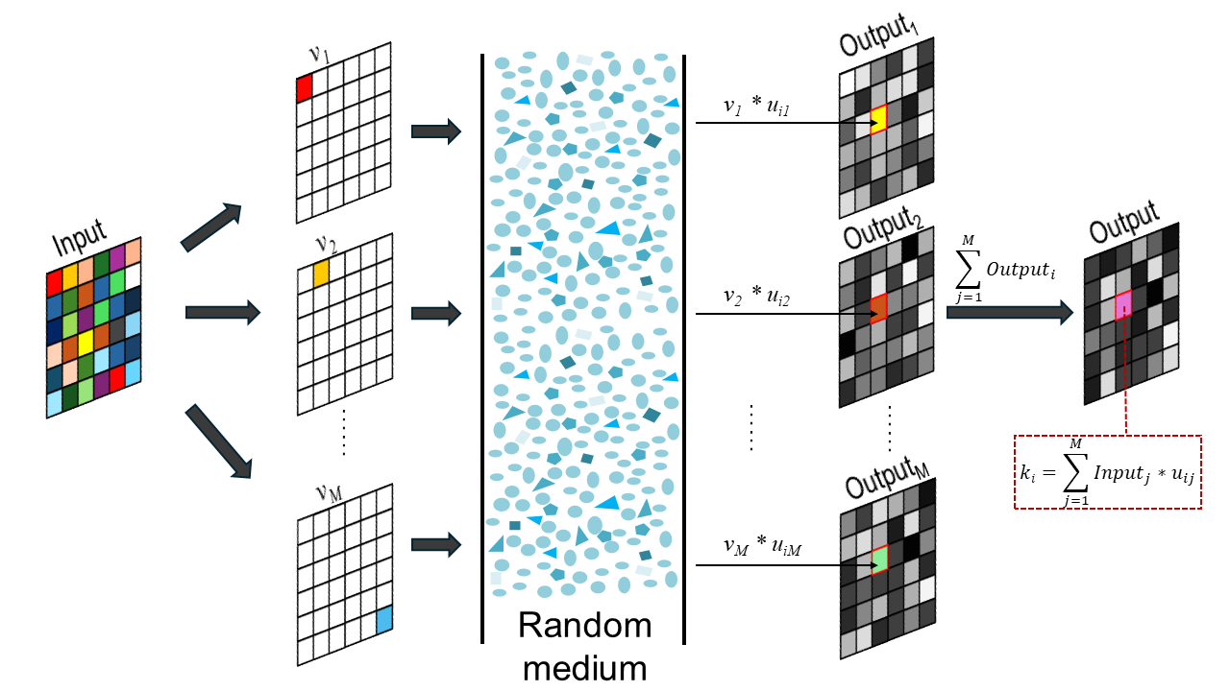
Fig. S1 The output field is the superposition of the entire input field when the input propagates through a random medium
Notably, for each input field containing only one element, its output includes all the elements due to the delocalization property of the scattering medium. This means that the information of each input element is extended across all elements of the output plane. For a specific element k_{i} in the output plane, each input has its own weight u_{ij}, and the final output of the k_{i} element is the sum of all the inputs multiplied by their corresponding weights. This provides the prerequisite for identifying input objects from any point in the output plane.
Mathematically, when the light from an object passes through a linear random medium, the resultant output field can be expressed as:
where E_{in} and E_{out} represent the input object and the output fields, respectively, and T denotes the transmission matrix. Assuming E_{out} contains N×1 pixels and E_{in} consists of M×1 pixels, then T is a matrix of N×M elements. Each element in matrix T connects the input and output field, thus Equation (1) can be rewritten as:
where k_{i} and v_{j} denote the i^{th} and j^{th} pixels on the output field and input field, respectively, and u_{ij} represents the element that connects the i^{th} pixel of the output field and the j^{th} pixels of the input field. Therefore, for an arbitrary element k_{i} in E_{out}, it can be expressed as:
If t_{i} is used to represent the elements of the i^{th} row of the TM, the equation can be written as:
Equation (4) illustrates that each pixel in the output field is a superposition of the entire input field, as dictated by the corresponding row t_{i} = (u_{i1} … u_{iM}) in the TM. Built upon this principle, one may extract the input’s information with a very small portion of the output field.
1.2 The underlying theory of the feasibility of SMPD
Since each pixel from the speckles in the output is a summation of the input due to the "delocalization" feature incurred by speckles, it is feasible to reconstruct the information of the input field using a small portion area of the output field. However, even under these conditions, existing physics-based approaches to measure the TM and recover the incident field from the speckles still requires information from quite many pixels (i.e., speckle grains), although they only account for a small portion of the output field of view based on the usage of 2D cameras. To overcome that, this study proposes the network-based SMPD method to obtain the input information from single-shot recognition based on a very limited number of pixels in the output. The explanation of the underlying theory of SMPD is as follows:
The decoding of a pixel can be viewed as a classification task. For an 8-bit depth encoded image that contains pixels belonging to 256 categories, each category ideally produces a unique intensity value at a stationary point in the output field after passing through a linear system. This would allow direct classification of the category by measuring the output intensity value using a single-pixel detector.
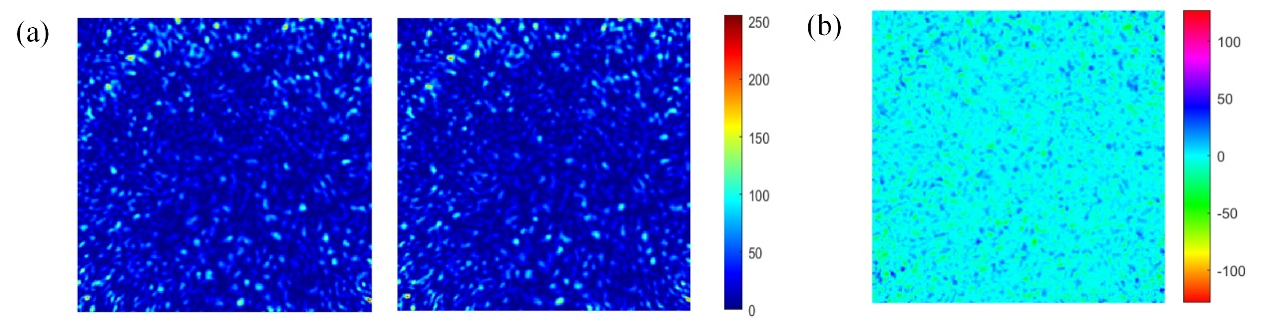
Fig. S2 Different categories presents similar intensity distribution in the output field: (a) the speckle pattern of two encoded pixels (gray value of 102 and 189, respectively); (b) the difference between the two speckle patterns.
However, in practice, different categories may produce similar or equal values at the same point (as observed in the intensity fluctuation in Fig. 5 of the manuscript). Therefore, it necessitates more detected intensities in different locations to differentiate and accurately describe the categories. Fig. S2 illustrates a significant overlap in gray values between the two distinct categories, indicating that detectors, whether placed randomly or artificially, may encounter instances where the intensity values are equal at different positions due to the chaotic distribution of the measured field. Consequently, a higher number of detectors or increased resolution is needed when dealing with similar objects.
Contrary to the prevailing understanding that a larger number of detectors or higher resolution is always required (which results in increased bandwidth usage and the transmission of complex, high-resolution images), it is essential to recognize that a moderate number of detected intensities can effectively represent a diverse range of categories. According to Shannon's information entropy theory (Bell System Technical Journal, 27(3): 379–423, 1948), information complexity can be quantified by the information entropy or Shannon entropy, given by:
For a system with 256 categories, each with an equal probability of 1/256, the calculated information entropy is 8 bits. This theory suggests that a minimum of 8 different intensity values need to be measured at different locations to distinguish each category when using a binary intensity detector.
When some measured intensities are close and the number of sampling detectors is less than 8, there is a potential risk of incorrect classification, as per the theory of Shannon entropy. In the case of utilizing 4 SPDs, certain intensity sequences exhibit similar trends. For instance, with the given sampling mask in Fig. 3 of the manuscript, the encoded gray values of 102 and 189 result in similar normalized intensity sequences ([0.79379 0.41861 0.60047 0.23150] and [0.80572 0.41861 0.60859 0.23627]), making it challenging to distinguish between them. Furthermore, to overcome environmental and device noise, more sampling points are required to accurately determine the correct category. Masks with fewer sampling points and smaller sizes may encounter challenges of limited category information and increased susceptibility to noise, leading to lower performance.
Traditional recognition methods usually require collecting full-field patterns to obtain more comprehensive features to figure out precise bear fruits due to the similar distribution of the output field for different categories and noise disturbances. However, SMPD has paved a new path towards achieving low-bit and high-accuracy recognition, suggesting that a large number of pixels are redundant. On the other hand, in practical implementations, moderate sampling points are required to address the issue of equal measured intensities for different categories and to overcome noise effects, compared to the number calculated by information entropy.

Supplementary Note 2: Network structure and the training process
A dual-path neural network is designed to extract the spatial association features in the light intensity sequence and the correlation among its elements, respectively, as illustrated in Fig. S1. The input sequence is fed into two paths: one is a convolution path, and the other is a fully connected path. In the convolution path, the sequence is processed by multiple one-dimensional convolution layers that stack spatially correlated high-dimensional features at the feature channels. The other path, namely the fully connected path, shoulders the responsibility for extracting the distributed characteristics of the original sequence. The high-dimensional features from the convolution path flow into a GlobalAveragePooling1D layer and then concatenate with the tensor from the fully connected path to form a feature tensor. Finally, the blended feature tensor is passed through the output modules and the output is generated by applying the softmax function to the separate tensors.
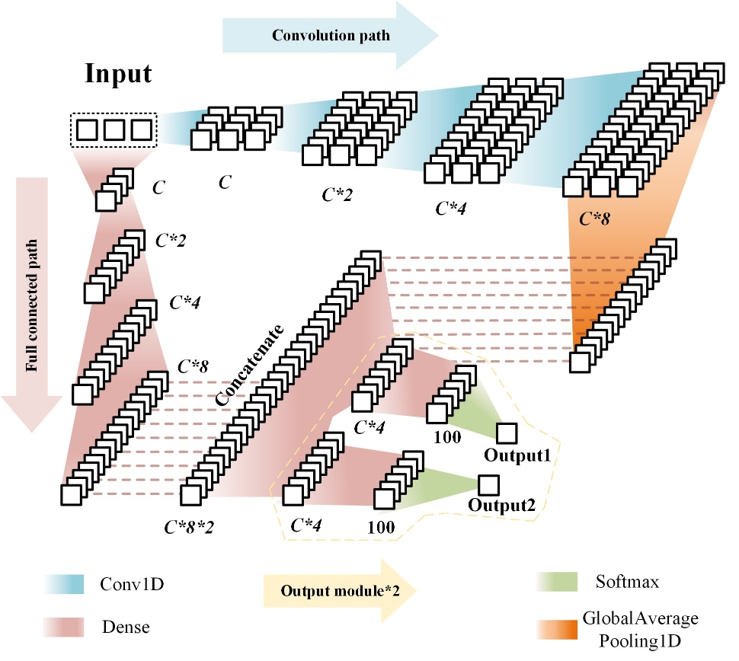
Fig. S3 Structure of the dual-path neural network. Conv1D, one-dimensional convolution layer; GlobalAveragePooling1D, global average pooling operation for temporal data. The number of channels (C) and output modules can be adjusted according to the object to be recognized.
One-hot encoding, which uses N-bit binary values to represent N categories that are mutually exclusive, is employed to encode the OAMs. To prevent the intensity-value sequence from being reduced during the convolution path, the padding value of the convolution layers is set to the “same”. This allows the network to process the intensity-value sequences of varying lengths that are generated by different numbers of SPDs without specific modifications to the neural network. The network is implemented based on Tensorflow 2.6, and the training and testing processes are carried out on a server equipped with a GPU (NVIDIA P620) for all groups. The dataset is randomly split into training and testing sets at an 8:2 ratio. The network is trained for different epochs based on the recognition object, using Adam¹ as the optimizer. The detailed training parameters are listed in Table S1. The initial learning rate of Adam, for different tasks, has a specific decay strategy as listed in Table S1. The binary cross-entropy loss function is chosen, and the network's performance is evaluated based on the accuracy of recognition defined by
where and denote the predictions from the network and encoded-OAMs, respectively; function Argmax(·) returns the position where the maximum value is located; function equal(·) determines whether two values are equal, and a Boolean value of 0 or 1 is returned, representing unequal or equal, respectively. Lastly, parameter n represents the total number of network predictions.
Table S1 Training paraments for recognition tasks in the manuscript
Recognition object | OAMs | Multiplexed-OAMs | Hand-written digits | Angle of axicons
C | 16 | 32 | 64 | 16
Training epochs | 120 | 50 | 40 | 120
Batch size | 16 | 256 | 32 | 32
Initial learning rate | 1e-3 | 2e-4 | 1e-3 | 1e-3
Decay rate | 0.1 | 0.6 | 0.1 | 0.1
Decay epoch | 60th & 100th | Every 5 epochs | 30th & 35th | 60th & 100th
Output modules | 2 | 1 | 1 | 1
Output units | 100 | 256 | 10 | 100
Table S2 Detailed recognition accuracies of the OAMs with different numbers and areas of SPDs
Number of SPDs | Areas (px) | 1² | 2² | 5² | 10² | 20² | 30²
Number of SPDs | OAMs | Accuracy (%)
16 | OAM1 | 85.17 | 96.13 | 97.67 | 99.26 | 99.45 | 99.70
16 | OAM2 | 79.91 | 93.70 | 94.94 | 96.88 | 98.56 | 99.06
9 | OAM1 | 66.02 | 84.42 | 90.87 | 95.14 | 96.83 | 96.63
9 | OAM2 | 61.51 | 74.31 | 77.78 | 80.56 | 85.27 | 87.05
8 | OAM1 | 61.76 | 81.60 | 85.57 | 87.25 | 90.53 | 90.97
8 | OAM2 | 52.03 | 69.74 | 70.78 | 68.20 | 72.32 | 75.94
7 | OAM1 | 56.50 | 76.59 | 82.59 | 83.78 | 85.66 | 87.35
7 | OAM2 | 55.65 | 70.44 | 74.80 | 69.79 | 70.98 | 73.36
6 | OAM1 | 45.98 | 66.32 | 70.63 | 70.34 | 74.36 | 81.00
6 | OAM2 | 42.46 | 56.05 | 60.12 | 64.14 | 65.58 | 65.08

As shown in Table S2, we present the detailed recognition results of Fig. 2 in the manuscript. Due to the limited figure size and to maintain clarity, the data for 7 and 8 SPDs were not included in the figure.
The evolution of losses and accuracies of ROAM-ANN for decoding multiplexed OAMs during the training process is shown in Fig. S4.
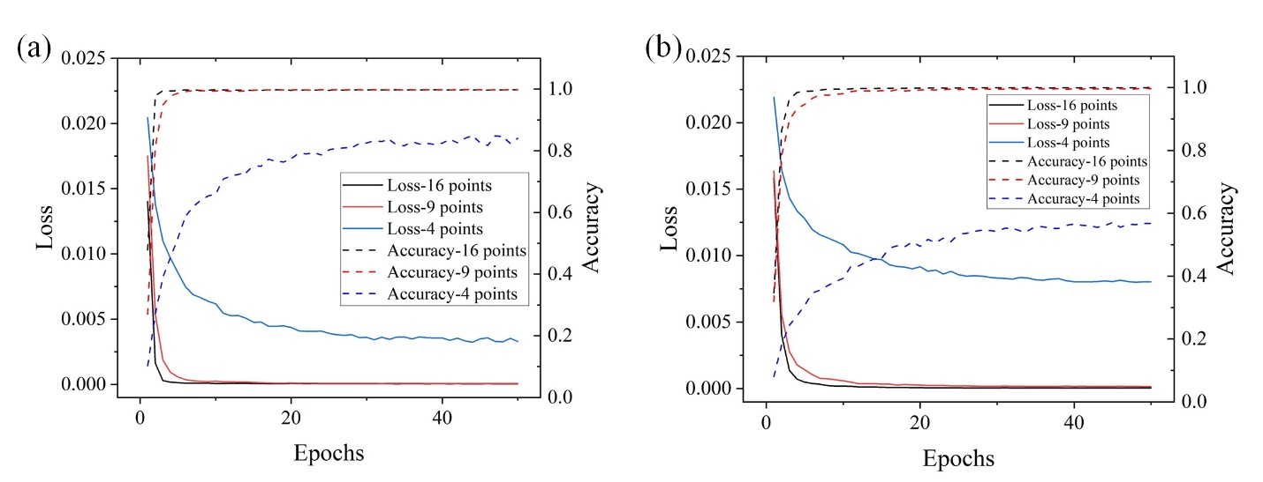
Fig. S4 The evolution of loss and accuracy of ROAM-ANN for decoding multiplexed OAMs during the training process with induvial SPD area of 10 × 10 px (a) and 1 × 1 px (b), respectively.

Supplementary Note 3: OAM multiplexing and complex modulation by DMD
During the encoding process of OAM multiplexing, an 8-bit binary grayscale value is encoded by the superposition of 8 OAM beams with topological charges 2.1-2.8. By expanding the binary representation, we can get whether the number at each position is “0” or “1”. During the process of encoding gray values using OAM, the coded value “0” or “1” at each position will be multiplied by the electromagnetic field of the corresponding OAM such as encode value in the first will be multiplied by OAM with topological charge 2.1 and encode value in the last will be multiplied by OAM with topological charge 2.8, and finally all the products will be added together. Therefore, the number “1” and “0” in the different positions determines whether the OAM beam at the corresponding position participates in the final encoded result. For example, the OAM encoded result of pixel value of 255 is the superposition of all OAM beams with topological charges of 2.1-2.8, while the OAM encoded result of pixel value of 0 does not involve any OAM beams. The detailed process of encoding gray values through OAM multiplexing is shown in Fig. S5.
It is worth noting that unlike the traditional encoding using integer-order OAM beams, we use fractional-order OAM beams, which is more difficult to distinguish. However, different from integer-order OAM encode, which simply superpose the phase of the corresponding OAM beams, the phase superposition of fractional-order OAM beams will result in some gray values corresponding to the same encoded phase and cannot be distinguished.
Therefore, to avoid different encoding grayscale values corresponding to the same light field of OAM multiplexing, complex amplitude superposition of OAM beams instead of phase superposition is adopted in this work. Besides, to simplify the complexity of the superposition, we change the complex amplitude expressions of fractional-order OAM beams to the expressions of integer-order OAM beams, which is
where $m$ is the topological charge, $θ$ denotes the azimuthal angle, and $ω_{0}$ is the beam waist radius. According to this expression, the amplitude distribution of fractional-order OAM beams is the same as the integer-order OAM beams with a complete circular distribution. The process of encoding gray values through OAM multiplexing is shown in Fig. S5.
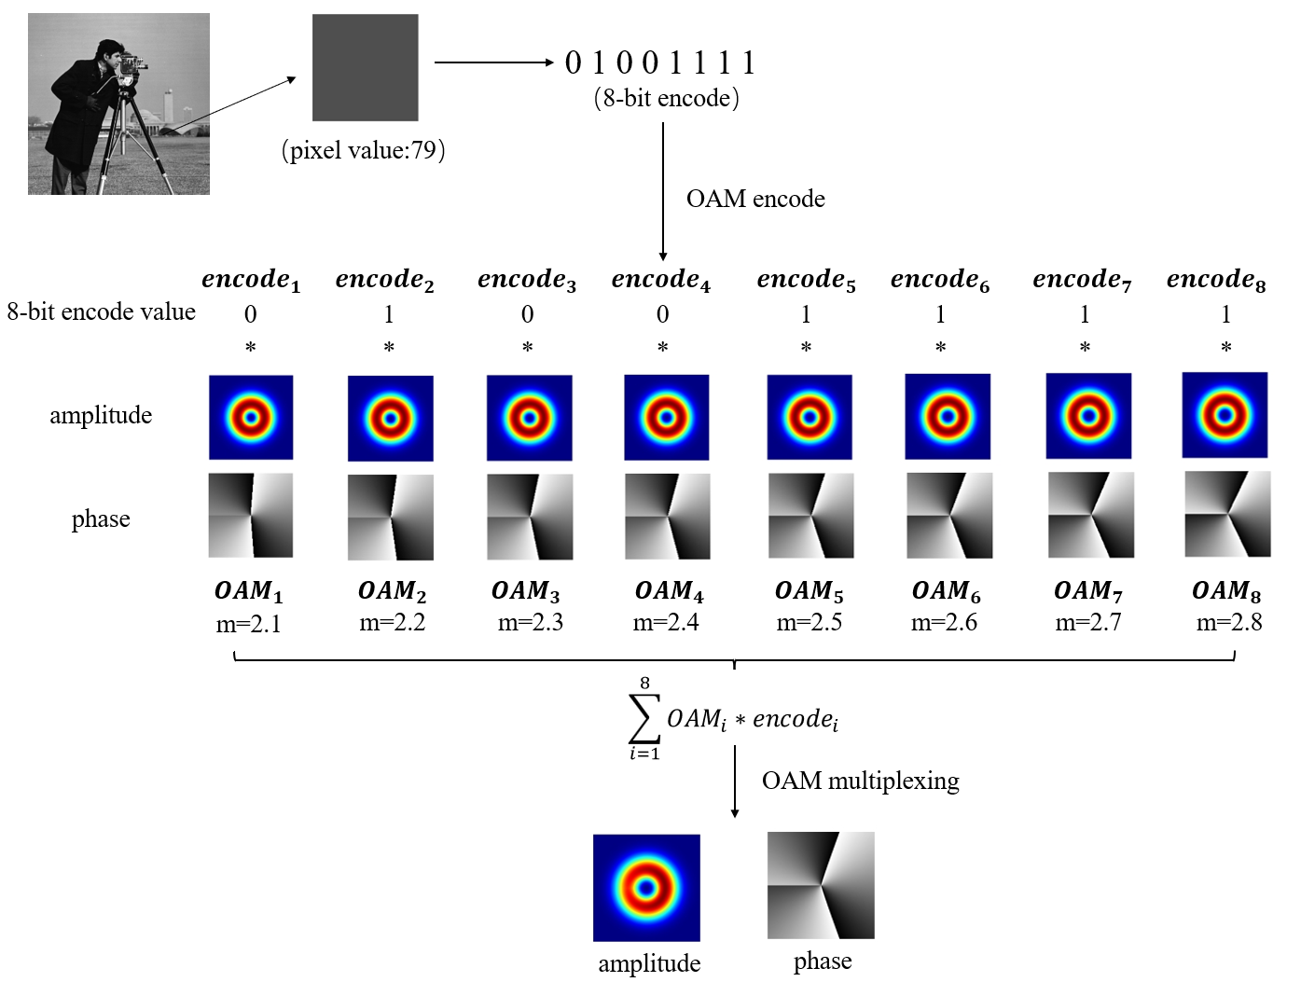
Fig. S5 The scheme of encoding 8-bit binary grayscale value with OAM beams of 2.1-2.8
Since the complex amplitude light field superimposed by the different OAM beams needs to be realized at the proximal end of the multimode fiber (MMF) as the input to obtain the corresponding speckle light field, it’s crucial to use a digital mirror device (DMD) which can only achieve binary modulation as a complex amplitude modulation device. For this purpose, we use an optimized Lee hologram method combined with a 4f spatial filtering system to achieve high-quality complex amplitude modulation^{2,3}. First, the complex amplitude is encoded into the corresponding binary computer-generated hologram (CGH) based on the following formula²:
where A represents the normalized amplitude, $φ\left(x,y\right)$ denotes the phase, $β$ is the designed carrier frequency, and $h\left(x,y\right)$ is the calculated CGH by the Lee method. Then, an error diffusion method is used to further optimize the CGH obtained in the previous step, so that it can achieve the goal of more precise complex amplitude modulation³. Since the final obtained CGH is the hologram formed by the interference of the complex amplitude light field of the target and the reference light with a specific carrier frequency, after passing through the first lens of the 4f system, three distinctly different diffraction orders (-1, 0, +1) will be generated on the Fourier plane. By using a spatial filter to select the -1 order, the corresponding complex amplitude modulation of the target is achieved after passing the second lens of the 4f system. Fig. S6 and Fig. S7 respectively show the method of using a DMD to achieve complex amplitude modulation and the experimental setup for realizing OAM multiplexing.
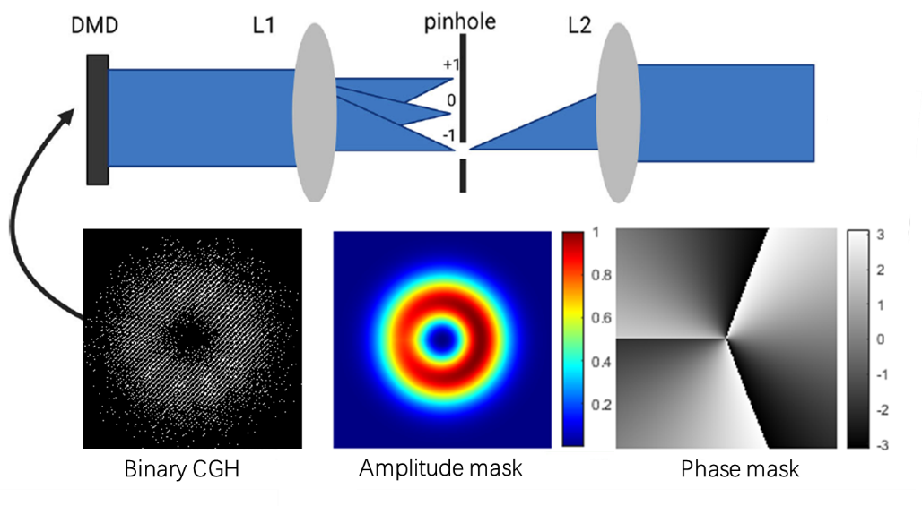
Fig. S6 The scheme for achieving complex amplitude modulation by a DMD
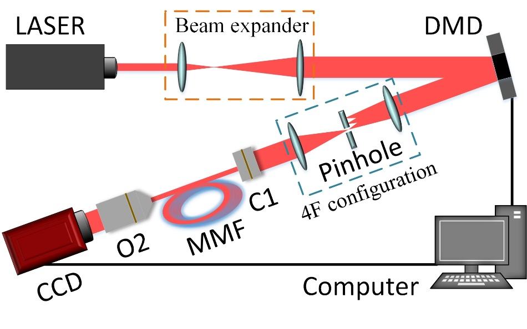
Fig. S7 Experimental setup for realizing OAM multiplexing
The light beam emitted from a 532 nm continuous-wave laser (EXLSR-532-300-CDRH, Spectra Physics, USA) undergoes expansion using a beam expander. The expanded beam is directed towards a DMD (DLP7000, Texas Instruments Inc, USA) where the beam is reflected and modulated before being relayed into a 4f system. The modulated beam is then coupled into an MMF (0.22 NA, 200 µm core diameter, SUH200, Xinrui, China) via a collimator (C1). The output field from the MMF is condensed via an objective (O2, 20X, NA=0.4, Olympus) and finally collected by a CCD camera. Based on the above system, the DMD loads the CGHs corresponding to gray pixel values ranging from 0 to 255, which is repeated 10 times. Subsequently, two spiral phase images of 100 × 100 pixels, each with topological charges of 1 and 5, respectively, were then encoded into 20,000 CGHs. To mitigate the impact of environmental noise, the CGHs associated with gray pixel values from 0 to 255 are once again captured in 10 repetitions after the transmission of the images. In summary, the training dataset consists of 5,120 intensity-label pairs, and the testing set comprises 20,000 CGHs corresponding to the transmitted images.

Supplementary Note 4: Recognizing the angle of axicons
Long-distance focused Bessel beams can be generated using an axicon. Axicons with different angles yield unique phase structures, enabling flexible controls of the beam's focal position according to the angle of the axicon. Thus, determining the axicon angle is essential for generating a specific long-distance focused beam. However, when light that carries the phase information of an axicon transmits through a multimode fiber, the information becomes disrupted. It remains unsettled for existing methods to extract the angle information of the axicon from speckles.
To further demonstrate the effectiveness of SMPDT, we designed a simulation to measure the angle of axicons of Bessel beams. Similar to the one described in the main text, we sampled several regions from the speckle field for intensity recording via the masked CCD camera. These intensity values were then used for network training and testing, and the neural network eventually outputs the extracted axicon angle information from the speckle field. Fig. S8 illustrates the generation of corresponding speckle patterns when light carrying various angle information of axicons passes through a scattering medium. In the simulation, the angle of the axicon varies from 0.1 to 10 degrees with an interval of 0.1. Note that a small portion of the axicon phase was deliberately removed in experiment. By rotating each axicon phase 50 times, we can obtain a more diverse dataset and improve the network's robustness. In the speckle field, 16 sample points of size 30 × 30 px were selected to measure and record the intensity value. Like in the main text, the experiment obtained 5,000 sets of intensity sequence, which was input into the network for training. The parameters of the neural network and the training process are listed in Table S1.
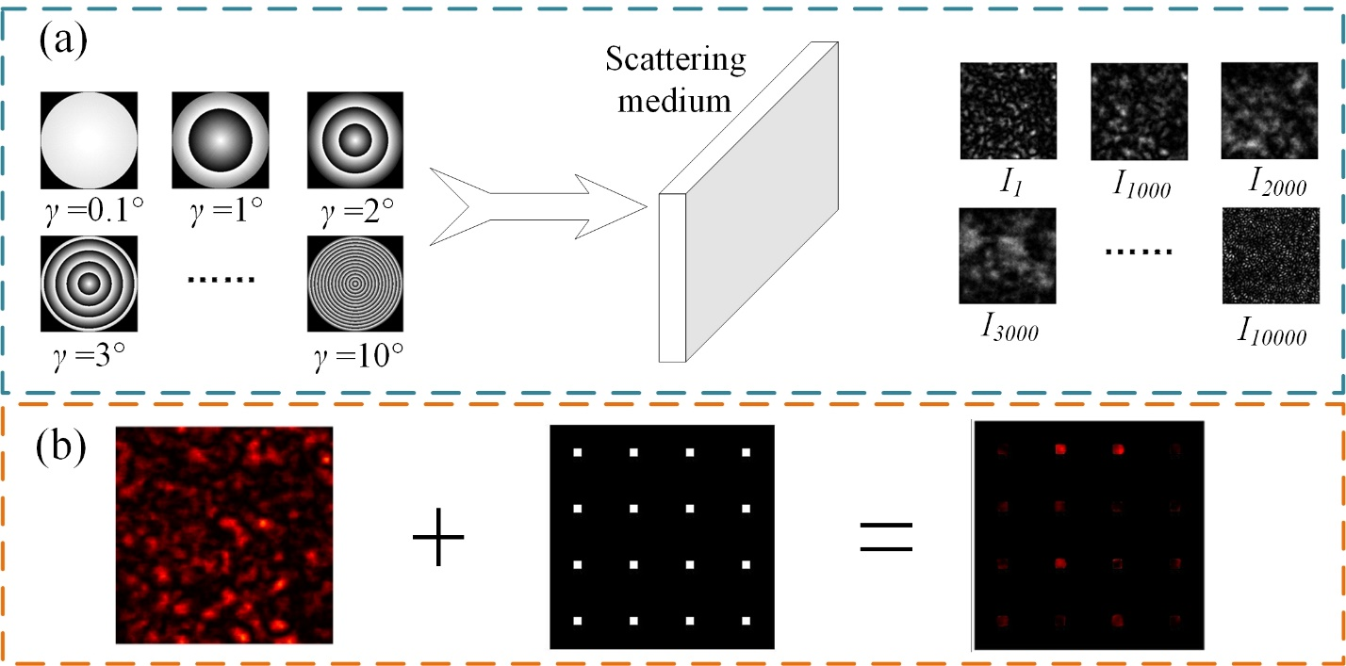
Fig. S8 (a) Bessel beams with different angles of axicon phases transmit through a scattering medium, forming speckle patterns. (b) Illustration of sampled detection of the speckle field with 4 × 4 SPDs.
Fig. S9 shows the evolution of the loss and accuracy during the network training process. By optimizing the learning rate, both loss function and recognition accuracy could be substantially improved. After 120 epochs, the network could achieve an accuracy of 88% on the validation set (Note: the validation set is used to determine the hyperparameters in the network model during the training process. Unless otherwise specified, the subsequent validation sets are assumed to have the same meaning). Finally, it achieved an accuracy of 88.25% on the testing set, which is used to test the performance of the neural network and not involved in the training process.
Fig. S9 The evolution curves of the loss and accuracy during the training process for recognizing the angle of axicons

References
- Kingma, D. P. Adam: A method for stochastic optimization. arXiv preprint arXiv:1412.6980 (2014).
- Lee, W. H. Binary computer-generated holograms. Appl. Opt. 18(21), 3661-3669 (1979).
- Hu, X. et al. Dynamic shaping of orbital-angular-momentum beams for information encoding. Opt. Express 26(2), 1796-1808 (2018).

