Supplementary Materials

Genome Interpretation of Peruvian Inca Empire Descendants Reveals Actionable Insights

Manuel Corpas^{1,2,3,*}, Segun Fatumo^{4,5}, Cesar Sánchez⁶, Omar Cáceres⁶, Carlos Padilla⁶, Julio Valdivia⁷, Heinner Guio^{6,8,9,*}

¹Life Sciences, University of Westminster, 115 New Cavendish Street, W1W 6UW London, UK; ²The Alan Turing Institute, London, UK; ³40 Gracechurch Street, EC3V 0BT, London, UK; ⁴Medical Research Council, Uganda Virus Research Institute and London School of Hygiene and Tropical Medicine (MRC/UVRI &LSHTM), Entebbe, Uganda; ⁵Precision Healthcare University Research Institute, Queen Mary University of London; ⁶Instituto Nacional de Salud, Lima, Peru; ⁷Universidad de Ingeniería y Tecnología (UTEC), Lima, Peru; ⁸Universidad de Huanuco, Huanuco, Peru; ⁹INBIOMEDIC Research and Technology Center, Lima, Peru

* Corresponding authors: Manuel Corpas; Heinner Guio

This Supplementary Materials Appendix provides extended context, methods, and results underpinning our main manuscript. We include historical demographic data on the Inca Empire descendants, additional methodological details on sample selection and sequencing, and extended analyses that illustrate the unique genetic architecture of Peruvian Indigenous and mestizo populations.

In the following sections, we first describe the historical background and rationale for including multiple coastal, highland, and Amazonian communities, along with the ethical and logistical considerations that governed sample collection. We then detail our variant calling pipeline and kinship analyses, which ensure robust quality control and reliable estimates of population structure. Extended tables and figures further document the frequency of high-impact variants, their functional annotations, and the inter-population differences in key pharmacogenes. Finally, we discuss limitations, outline how the data are shared under a community-led framework, and highlight avenues for future research to experimentally validate these potentially actionable findings. Taken together, these supplementary materials provide essential depth for readers seeking to replicate, evaluate, or build upon our study’s findings.

Shifting Demographics and Genetic Adaptations in Andean Communities
The Inca Empire, also known as Tawantinsuyu, was the largest empire in pre-Columbian America. Its administrative center was located in Cusco, present day Peru. At the height of the empire, it extended across the western part of South America, encompassing varied environments from the Pacific coast and the Andes down to the Amazonian rainforests. The Spanish conquest of the Inca Empire, beginning in 1532 with the arrival of Francisco Pizarro, had devastating effects on the indigenous populations of the empire, inadvertently introducing a number of diseases for which the indigenous populations had no immunity. Perhaps the deadliest of the pathogens introduced by Europeans was smallpox ¹, spreading faster than the Spanish conquest itself. While influenza was not as deadly as smallpox, it did also cause significant deaths among indigenous populations ². A number of catastrophic epidemics swept the region, killing the Inca leader Huayna Capac and his son. These waves of epidemic disease included smallpox, influenza, tuberculosis, measles, mumps, dysentery, typhus, and pneumonia ³.

The effects of newly introduced pathogens in indigenous populations of the Americas are explained by their isolation from the Eurasian continent for 23,000 years ⁴. Not having developed immunity to the diseases that were common in Europe and Asia led to a devastating reduction of the Inca population, from an estimated peak of 16 million to less than 2 million around the year 1600 when the population started to stabilize (Fig. 1). This led to a significant bottleneck in indigenous populations that has not recovered to this day. For populations with a genetic lineage tracing back to the Incas, the characterization of genetic factors contributing to infectious disease susceptibility may help explain some of the deadliest pandemics that affected the Americas before and after contact with Europeans. By tracing changes in frequency of certain genetic variants that might have offered a detrimental effect in the face of past epidemics, we can help address some of the historical health inequities that continue to affect indigenous populations in the continent.

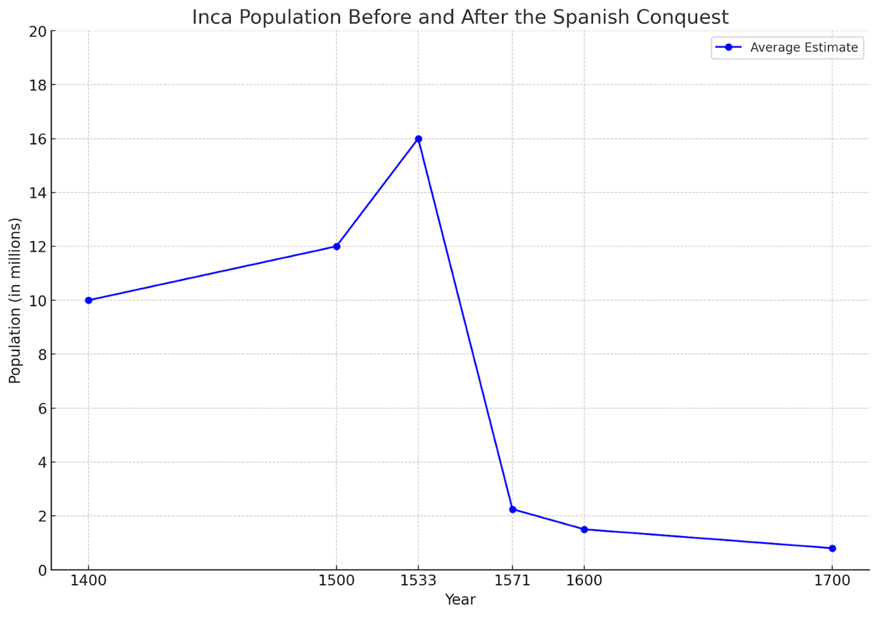
Figure 1. The impact of the arrival of Spanish conquistadors in the population of the Inca Empire. From an estimated peak of 16 million, it was reduced to less than 2 million around the year 1600 when the population started to stabilise. Source: ⁵.

The genetic impact of the colonial era is not just a matter of historical interest, it also has critical implications for present day medical research and healthcare delivery. Not only indigenous populations have been severely underrepresented in genetic research ^{6,7}, knowledge of their genetic adaptations involved in health can be a key advancement for ameliorating current health disparities ⁸. Therefore, for diseases that have historically affected the Inca population disproportionally such as pathogen-induced infections, identification of new relevant genetic associations may warrant innovative targeted interventions. These interventions could also help improve the population’s current health and its ability to adapt to new pandemics such as COVID-19. We note, for instance, that modern day Peru has the world’s greatest death rate per million population for COVID-19 disease ⁹.

With an ethos of community‐led engagement, our study investigates the genetic architectures of these historically marginalized groups to identify novel or clinically relevant variation. We emphasize newly discovered and rare variants of particular clinical or evolutionary interest, placing them in global context and exploring their potential roles in disease risk and pharmacogenomic response. By spotlighting the genetic landscape of Inca Empire descendants, we aim to inform precision medicine strategies and bring greater equity to healthcare in Andean and other underserved populations.

Clinical Significance of High-Impact Variants
All 150 genomes sequenced here reached an average depth of ~35× using Illumina HiSeq X10 technology, yielding high-confidence variant calls. After alignment of reads to the human reference genome (GRCh37/hg19) with BWA-MEM ¹⁰ and duplicate read marking with Picard ¹¹, variant calling was performed jointly on all samples using GATK ¹². We applied stringent quality filters – excluding any low-confidence variants flagged by the caller and removing sites with Phred quality <20 – to ensure robust downstream analysis. We then analyzed the 150 whole genomes using the Ensembl Variant Effect Predictor (VEP)​ ¹³. Out of 12,905,020 single nucleotide variants (SNVs) detected, 12,897,474 were identified as biallelic, and 1,638,862 (12.7%) were novel​.

Our results emphasize that only 6% of high-impact variants have any ClinVar ¹⁴ annotation (and that over half of those annotated are benign/likely benign). This suggests that many potentially important variants remain unreported or understudied in public databases (Table 1).

Variant Category | N variants
High Impact (protein truncation, loss of function or triggering nonsense mediated decay) | 1,210
Unknown (High Impact in Protein Coding) | 1,137
Benign/Likely Benign (High Impact in Protein Coding) | 35
Pathogenic/Likely Pathogenic (High Impact in Protein Coding) | 20
Uncertain Significance (High Impact in Protein Coding) | 7
Conflicting Evidence (High Impact in Protein Coding) | 11

Table 1. Classification of the 1,210 high-impact variants identified in 150 Peruvian genomes, highlighting their ClinVar annotation status. Nearly 94% (1,137 variants) had no existing clinical record, underscoring the high proportion of novel or uncharacterized variants in this cohort. Among the annotated fraction, 35 variants were benign or likely benign, 20 were classified as pathogenic or likely pathogenic, 7 as having uncertain significance, and 11 exhibited conflicting evidence of pathogenicity.

Benign or likely benign variants constituted the largest subset of ClinVar-annotated high-impact variants (35 variants, 2.9% of the total). Pathogenic or likely pathogenic variants were comparatively fewer in number (20 variants, 1.7% of the total). The remaining annotated high-impact variants were classified as variants of uncertain significance (VUS, 7 variants, 0.6%) or had conflicting interpretations of pathogenicity (11 variants, 0.9%) according to ClinVar. A binomial test confirmed that benign annotations were more frequent than pathogenic among these high-impact variants (p = 0.02), highlighting an unexpected skew given the severe predicted effect of these mutations.

Interpretation of High-Impact Rare Variants in Affected Genes
High‐impact ≥0.1 allele frequency (AF) biallelic variants in our Peruvian cohort that are rare or not present in gnomAD (AF<0.01) were selected for further analysis from the above 1,210 high impact variants. This frequency cutoff yielded 27 variants in as many GENCODE ¹⁵ version 19 affected genes from across the seven sequenced populations (Table 2). We note that several affected genes (e.g., FAM166A, LIN37, PSRC1) possess splice‐site variants present at or near 1.00 frequency across all populations. These changes, each with moderate to high CADD_PHRED ¹⁶ scores (≥14), suggest they are deeply embedded in the shared gene pool of contemporary Peruvians, potentially reflecting founder events or ancient drift that predates the genetic divergence among these groups. Their functional consequences remain unclear—further transcript and protein analyses will be required to clarify whether these splice‐site mutations produce truncated transcripts or alterindigenous isoforms.

Another highly prevalent affected gene, USP29 (Ubiquitin‐Specific Peptidase 29), is a deubiquitinating enzyme believed to promotes cellular antiviral responses and autoimmunity ¹⁷. In this dataset, it appears at an extremely high frequency (AF=0.99) across all Peruvian populations, yet carries a CADD_PHRED score of 34, suggesting a potentially disruptive (stop‐gained) mutation. Recent work has shown that USP29 plays a crucial role in SARS-CoV-2 immune evasion, specifically by preventing the proteasomal degradation of ORF9b—an accessory viral protein that suppresses type I interferon (IFN) and NF-κB signaling ¹⁸. This is an intriguing finding given that Peru has reported the highest COVID-19 death per million rate worldwide ¹⁹. Whether this variant contributed to Peru’s stark COVID-19 outcomes remains uncertain, as socioeconomic factors likely played a decisive role. Nonetheless, the extreme allele frequency observed warrants further investigation into how this deubiquitinase variant might influence antiviral defenses or shape susceptibility in these Peruvian communities.

Within the type I interferon cluster, a stop‐gained variant in IFNA10 emerged displayed relatively moderate allele frequencies in both indigenous and admixed communities (AF=0.23-0.40). Since interferon‐α genes orchestrate core antiviral defenses, this disruptive mutation might reduce type I interferon production, potentially modifying viral susceptibility. The variation in counts across populations points to distinct selective pressures or demographic events, such as founder effects in the Andes. Additionally, MOB3C and C14orf105 are associated with immune‐related expression ²⁰. Truncations in these genes—particularly the allele frequency difference in MOB3C between Cusco (AF=0.25) and Uros (AF=0.70)—could reflect adaptive shifts in cytokine signaling under varied highland vs. lake‐dwelling environments, despite both communities being geographically close to each other.

A stop‐lost mutation in NLRP8 (a member of the NOD‐like receptor inflammasome family) was identified across multiple groups (AF=0.75-0.84), suggesting partial conservation yet moderate differentiation among populations. Loss of the canonical stop codon could extend the NLRP8 protein, influencing pathways that govern inflammasome assembly and immune activation against bacterial or viral infections ²¹. Meanwhile, a splice disruption in ZNF419 (AF=0.69-0.94) points to a zinc‐finger transcription factor potentially regulating immune gene expression ²² in a high pathogen‐load across all environments (coast, Andes, Amazon jungle). This distribution strengthens the hypothesis of immune adaptations shaping variant patterns in these Peruvian subpopulations.

Two stop‐gained variants in OR2L8 and OR10X1— all at high or moderately high allele frequencies and annotated as olfactory receptor genes—stand out. Emerging evidence suggests certain olfactory receptors are also expressed in immune cells, supporting a possible immunomodulatory function rather than purely olfactory ^{23–25}. The loss of functional protein in these receptor genes could reduce chemical detection at the cell membrane, potentially altering responses to dietary toxins or local pathogens in different ecological niches. Meanwhile, a splice acceptor variant in CACNB2 was detected at low/moderate frequency in all populations (AF=0.04-0.15). CACNB2 encodes a subunit of voltage‐gated calcium channels central to T‐ and B‐lymphocyte activation ²⁶. Although the clinical significance remains ambiguous, the presence of this disruptive variant in multiple populations suggests a possible subclinical effect on immune cell excitability and underscores immune processes in these Peruvian groups.

Many other genes affected by high-impact rare variants (e.g., HLA‐DRB5, CACNB2, NPIPB5) show moderate frequencies across multiple populations, though each population often has a unique distribution. On Peru’s northern coast, both Moches and Trujillo exhibit relatively low AF for a UBE2NL stop‐gained mutation (AF=0.30-0.44), contrasting with higher frequencies elsewhere (AF=0.71-0.53). Because UBE2NL encodes a ubiquitin‐conjugating enzyme that regulates protein turnover of immune factors ²⁷, this coastal pattern could reflect distinct selective pressures near the ocean or a historical gene flow event that introduced or reduced this variant in the region. In addition, a stop‐gained mutation in C5orf20 stands out as most different in Matzes with 19 alleles (AF=0.79) in Matzes individuals—a moderately higher frequency compared to other populations (AF=0.32-0.62). This relatively high prevalence in a small, isolated Amazonian group may indicate that the allele rose in frequency through drift, reflecting the Matzes’ long‐term genetic isolation and smaller effective population size.

Notably, Lake Titicaca dwellers Uros show presence (AF=0.45) of an HLA‐DQB1 stop‐gain variant that appears at lower levels (AF=0-0.32) in other populations, marking it as most different in Uros. The Uros’ geographic and cultural isolation may have led them to gain this damaging HLA allele through a bottleneck or acquire it via gene flow ²⁸. In the non-mestizo groups (Matzes, Uros, Chopccas and Moches), a start‐lost mutation in SEL1L3 is relatively more frequent (AF=0.10-0.23), whereas the admixed (Iquitos, Cusco, Trujillo) carry no alleles or hardly any (AF=0.00-0.03). Because SEL1L3 contributes to protein folding and endoplasmic reticulum quality control ²⁹, losing the start codon might drastically reduce SEL1L3 levels, potentially altering immune cell secretion or stability. This variant underscores how isolated populations can fix unusual mutations that shape local immune phenotypes.

BIALLELIC VARIANT LOCATION (hg19) | GENE SYMBOL | CADD_PHRED | Consequence | MATZES  AF | UROS AF | CHOPCCAS AF | MOCHES AF | IQUITOS AF | CUSCO AF | TRUJILLO AF | TOTAL AF
9:140139757-140139757 | FAM166A | 16.6 | splice_donor_variant | 1.00 | 1.00 | 1.00 | 1.00 | 1.00 | 1.00 | 1.00 | 1.00
19:36243813-36243813 | LIN37 | 23.1 | splice_acceptor_variant | 1.00 | 1.00 | 1.00 | 1.00 | 1.00 | 1.00 | 1.00 | 1.00
1:109825360-109825360 | PSRC1 | 23.1 | splice_acceptor_variant | 1.00 | 1.00 | 1.00 | 1.00 | 1.00 | 1.00 | 1.00 | 1.00
1:248113026-248113026 | OR2L8 | 43 | stop_gained | 1.00 | 1.00 | 1.00 | 0.98 | 0.97 | 1.00 | 1.00 | 0.99
19:57642782-57642782 | USP29 | 34 | stop_gained | 1.00 | 1.00 | 1.00 | 1.00 | 0.94 | 0.97 | 1.00 | 0.99
1:11742074-11742074 | MAD2L2 | 16.98 | splice_acceptor_variant | 1.00 | 1.00 | 0.93 | 0.97 | 0.97 | 0.94 | 1.00 | 0.97
4:69687987-69687987 | UGT2B10 | 14.69 | splice_acceptor_variant | 0.92 | 0.97 | 0.95 | 0.82 | 0.84 | 0.94 | 0.97 | 0.91
19:58003580-58003580 | ZNF419 | 16.19 | splice_donor_variant | 0.92 | 0.67 | 0.90 | 0.93 | 0.69 | 0.94 | 0.88 | 0.84
19:56499279-56499279 | NLRP8 | - | stop_lost | 0.83 | 0.82 | 0.82 | 0.75 | 0.84 | 0.75 | 0.75 | 0.79
19:46145025-46145025 | C19orf83 | 21.8 | splice_donor_variant | 0.71 | 0.77 | 0.73 | 0.88 | 0.66 | 0.88 | 0.88 | 0.79
14:57948380-57948380 | C14orf105 | 26.9 | splice_acceptor_variant | 0.71 | 0.75 | 0.78 | 0.78 | 0.66 | 0.94 | 0.72 | 0.77
18:3262784-3262784 | MYL12B | 14.43 | splice_donor_variant | 0.92 | 0.52 | 0.63 | 0.70 | 0.84 | 0.75 | 0.66 | 0.68
X:142967468-142967468 | UBE2NL | 34 | stop_gained | 0.71 | 0.63 | 0.68 | 0.30 | 0.53 | 0.69 | 0.44 | 0.56
5:134782450-134782450 | C5orf20 | - | stop_gained | 0.79 | 0.32 | 0.50 | 0.53 | 0.56 | 0.53 | 0.63 | 0.52
1:47080679-47080679 | MOB3C | 33 | stop_gained | 0.46 | 0.70 | 0.50 | 0.47 | 0.50 | 0.25 | 0.53 | 0.51
16:85218723-85218723 | CTC-786C10.1 | - | splice_acceptor_variant | 0.33 | 0.60 | 0.38 | 0.37 | 0.41 | 0.59 | 0.41 | 0.45
1:158549492-158549492 | OR10X1 | 37 | stop_gained | 0.33 | 0.37 | 0.47 | 0.25 | 0.31 | 0.47 | 0.31 | 0.36
9:21207037-21207037 | IFNA10 | 36 | stop_gained | 0.25 | 0.23 | 0.40 | 0.35 | 0.31 | 0.22 | 0.34 | 0.31
6:32489731-32489731 | HLA-DRB5 | - | stop_gained | 0.29 | 0.23 | 0.35 | 0.23 | 0.25 | 0.28 | 0.31 | 0.28
6:32632638-32632638 | HLA-DQB1 | 73 | stop_gained | 0.00 | 0.45 | 0.23 | 0.13 | 0.16 | 0.13 | 0.19 | 0.21
X:2833605-2833605 | ARSD | 35 | stop_gained | 0.33 | 0.20 | 0.17 | 0.12 | 0.13 | 0.25 | 0.16 | 0.18
6:17606162-17606162 | FAM8A1 | 41 | stop_gained | 0.21 | 0.15 | 0.20 | 0.23 | 0.09 | 0.16 | 0.19 | 0.18
4:25864458-25864458 | SEL1L3 | 15.88 | start_lost | 0.17 | 0.10 | 0.23 | 0.20 | 0.03 | 0.00 | 0.00 | 0.12
10:18439810-18439810 | CACNB2 | 35 | splice_acceptor_variant | 0.04 | 0.15 | 0.12 | 0.13 | 0.06 | 0.09 | 0.06 | 0.11
7:92098549-92098549 | ERVW-1 | - | stop_gained | 0.21 | 0.17 | 0.00 | 0.10 | 0.09 | 0.09 | 0.13 | 0.10
1:1257286-1257286 | CPSF3L | 14.75 | splice_donor_variant | 0.04 | 0.15 | 0.08 | 0.13 | 0.09 | 0.03 | 0.09 | 0.10
1:12919891-12919891 | PRAMEF2 | 35 | stop_gained | 0.17 | 0.17 | 0.07 | 0.07 | 0.16 | 0.00 | 0.06 | 0.10

Table 2. High‐impact ≥0.1 allele frequency variants with total AF<0.01 or not present in gnomAD. Each row shows the genomic coordinate (hg19), gene symbol, CADD_PHRED score (an in silico estimate of variant deleteriousness), predicted consequence (e.g., stop‐gained, splice‐donor/acceptor mutation), and the predicted consequence. The numeric columns under each population (Matzes, Uros, Chopccas, Moches, Iquitos, Cusco, Trujillo) indicate the allele frequencies for that variant in that particular population, with TOTAL AF measuring frequencies across all 150 sequenced samples.

Pharmacogenetics Diversity Among Peruvian Genomes
The dataset reveals significant variability in pharmacogenomic diversity among genes. DPYD, CYP4A22, NAT2, SLCO1B1, and CYP2W1 exhibit the highest number of unique genotypes (Fig. 2A), suggesting a greater degree of allelic heterogeneity in these genes. This has direct clinical implications, particularly for DPYD, a critical gene in fluoropyrimidine metabolism (e.g., 5-FU and capecitabine) ³⁰, where multiple loss-of-function variants are associated with severe toxicity. The high diversity observed in NAT2 also suggests potential variability in isoniazid, hydralazine, and sulfonamide metabolism, which may influence adverse drug reactions or efficacy across individuals ³¹.

Conversely, several genes such as ABCB1, CYP2J2, CYP2R1, and CYP17A1 show fixed or highly prevalent genotypes, indicating either strong selection pressures or founder effects in the study population. ABCB1 (*2/*2) was the most frequent genotype, appearing in 100% of observed cases, suggesting a lack of variability in drug transporter function in this dataset. ABCB1 encodes P-glycoprotein, which regulates drug efflux for multiple medications, including chemotherapeutic agents, cardiovascular drugs, and antidepressants ³². A lack of variation in ABCB1 could suggest a homogeneous drug response profile in this Peruvian cohort, reducing the likelihood of altered drug absorption or resistance.

A significant portion of the dataset exhibits low-frequency genotypes, with 75% of genotypes appearing in ≤32% of individuals for a given gene (Fig. 2B). This suggests that while a few genotypes dominate specific genes, many rare variants exist that could influence individual drug responses. This pattern is consistent with pharmacogenomic studies where rare, functionally significant variants may have outsized clinical effects despite their low population frequency.

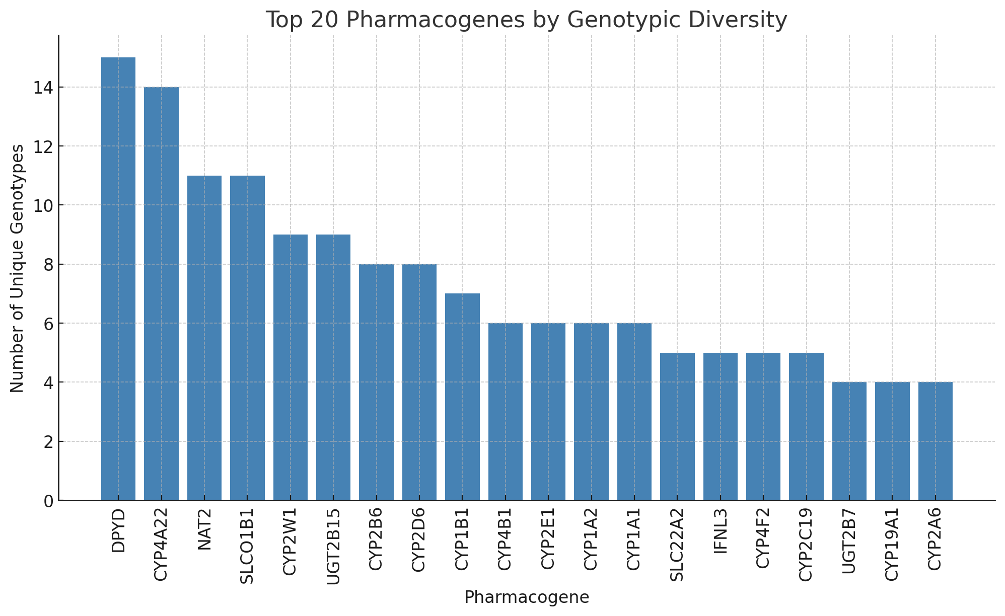
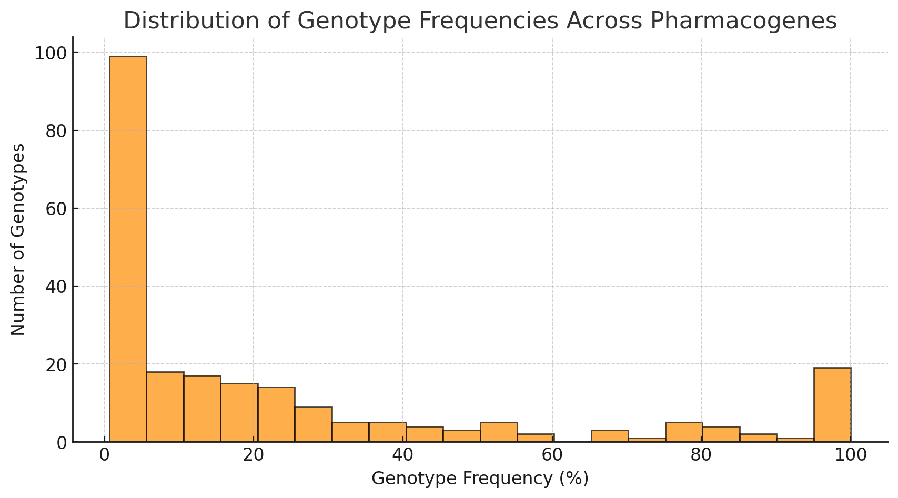
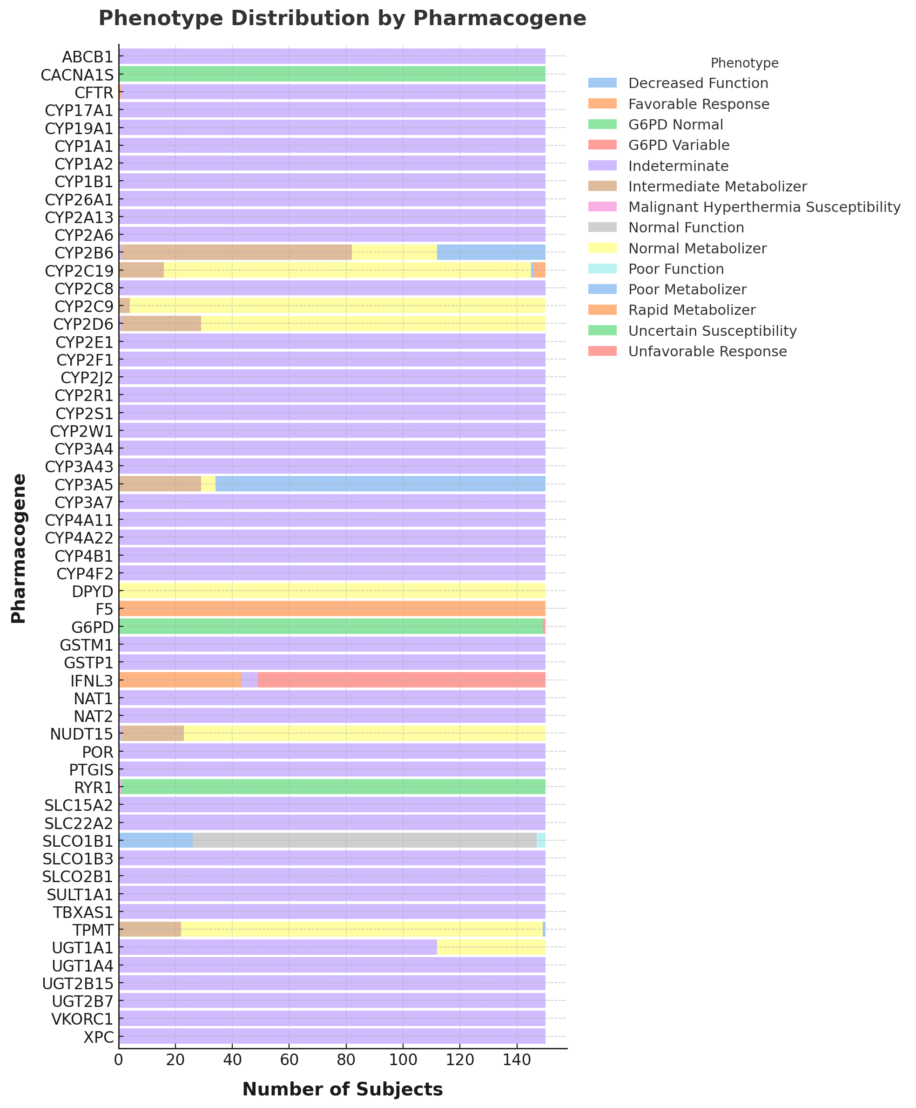

Figure 2: Pharmacogenomic Diversity and Phenotypic Distribution Across Peruvian Pharmacogenes. (A) Top 20 Pharmacogenes by Genotypic Diversity. This panel displays the 20 pharmacogenes with the highest number of unique genotypes in the dataset. Genes such as DPYD, CYP4A22, and NAT2 exhibit the greatest allelic diversity, suggesting significant inter-individual variability in drug metabolism and response. The number of unique genotypes per pharmacogene is a proxy for potential pharmacogenomic variability, with high-diversity genes requiring greater attention in precision medicine applications. (B) Distribution of Genotype Frequencies Across Pharmacogenes. This panel illustrates the frequency distribution of genotypes observed across all pharmacogenes. The majority of genotypes occur at low frequencies, with a right-skewed distribution indicating that a small number of genotypes dominate within certain genes. This pattern suggests that while most pharmacogenes exhibit some degree of allelic heterogeneity, a subset is characterized by one or a few common genotypes. The presence of rare genotypes underscores the potential for individualized dosing strategies in clinical pharmacogenomics. (C) Phenotype Distribution by Pharmacogene. This panel provides a stacked bar representation of pharmacogenomic phenotypes across different pharmacogenes. Each bar represents a pharmacogene, with color-coded segments indicating the proportion of individuals exhibiting different metabolizer statuses or functional classifications (e.g., poor metabolizer, normal metabolizer, intermediate metabolizer). Genes with a high proportion of poor metabolizers (e.g., CYP2C19, CYP2B6) indicate a greater need for pharmacogenetic testing, as altered metabolism may impact drug efficacy or toxicity risk. Genes with a predominance of normal metabolizers (e.g., ABCB1) suggest lower variability in drug response within this dataset. The large number of "Indeterminate" classifications suggests either limited genotype resolution or the presence of variants of uncertain significance, warranting further investigation.

Figure 2C presents the distribution of pharmacogenomic phenotypes across pharmacogenes, illustrating the diversity in metabolizer statuses and functional classifications observed within the sequenced cohort. The stacked bar plot displays the proportion of individuals classified under different phenotypic categories, such as normal metabolizer, poor metabolizer, intermediate metabolizer, and other functional annotations. This dataset includes a total of 8,400 phenotype observations across 56 pharmacogenes, with significant variability in phenotype prevalence. The most common phenotype classification is “Indeterminate”, which accounts for 74.6% of all observations (n = 6,270). This suggests that for many pharmacogenes, genotypic data alone may be insufficient to confidently assign a functional metabolizer status. Reasons for indeterminate phenotype include (a) limited clinical annotations or incomplete genotype interpretation, (b) variants of uncertain significance (VUS) and (c) structural or rare variants not captured in standard genotyping panels.

Among classified phenotypes, “Normal Metabolizer” (10.4%) is the most prevalent, followed by “Uncertain Susceptibility” (3.6%) and “Intermediate Metabolizer” (2.4%). The rarer classifications include “Poor Metabolizer” (1.9%), “Rapid Metabolizer” (0.05%), and “Poor Function” (0.04%), suggesting that high-risk pharmacogenomic variants may be less frequent in this population.

Pharmacogenes with the greatest number of distinct phenotype classifications observed per gene include CYP2B6 and CYP2C19 (4 distinct phenotypes each). This aligns with their well-characterized functional variability, affecting drugs like efavirenz (CYP2B6) and clopidogrel (CYP2C19). CYP2D6, CYP3A5, and SLCO1B1 (3 phenotypes each) are also highly variable, reflecting their key roles in drug metabolism and transport. NUDT15 and TPMT (3 phenotypes each) are also known for their impact on thiopurine metabolism, where poor metabolizers experience severe myelosuppression ³³, necessitating precise dose adjustments. Conversely, some pharmacogenes exhibit minimal phenotypic variation, indicating little functional diversity in this dataset. CYP3A4, CYP2R1, and CACNA1S each have a single phenotype classification, suggesting that genetic variation in these genes may have limited clinical relevance in this cohort.

Genes with high prevalence of poor or intermediate metabolizers include CYP2C19, which has one of the highest frequencies of poor metabolizers, reinforcing its clinical importance for clopidogrel response. CYP2B6 poor metabolizers are also well-represented, suggesting potential risks for efavirenz neurotoxicity in affected individuals. SLCO1B1 intermediate function variants are common, indicating that a subset of individuals may be at increased risk for statin-induced myopathy ³⁴.

There were rare phenotypes as well. “Rapid Metabolizer” (n = 4, 0.05%) was the least frequent classification, suggesting that ultrarapid drug metabolism is uncommon in this dataset. This has clinical implications for opioids and antidepressants, where ultrarapid metabolism can lead to subtherapeutic drug levels. “Poor Function” (n = 3, 0.04%) was observed in only a few cases, indicating that genes with severe loss-of-function variants may be underrepresented or rare. Malignant hyperthermia susceptibility (n = 1) was the rarest functional classification, reinforcing that RYR1 variants conferring susceptibility to malignant hyperthermia ³⁵ are infrequent in this cohort.

Notable genotype frequency differences between sequenced populations were observed in several genes. CYP2W1. This gene showed the most pronounced heterogeneity (p = 4.8×10⁻⁸). The CYP2W1 *6 allele was exceptionally frequent in the Uros population, where 56.7% of individuals were homozygous *6/*6 (and ~90% carried at least one *6 allele). In contrast, other groups had much lower *6 allele frequencies (approximately 10–30% of alleles), highlighting a significant genetic divergence in CYP2W1 for Uros versus the others. The glutathione S-transferase M1 gene (GSTM1) also varied markedly among populations (p = 2.3×10⁻⁴). The Amazonian Matzes were predominantly GSTM1 *A/*A (≈92% of individuals), whereas highland groups like Chopccas and Cusco were mostly *B/*B homozygotes (~70–75%). Other populations (e.g., Moches and Uros) showed intermediate or mixed genotypes (with some *A/*B heterozygotes), indicating distinct allele frequency landscapes across regions. The CYP2C19 pharmacogene displayed significant frequency differences (p = 0.0030). Notably, variant CYP2C19 alleles (e.g., *2 or *3 haplotypes) had higher prevalence in certain groups; for instance, one coastal population (Trujillo) showed a greater proportion of non-reference genotypes compared to the Andean groups (reflected in an overall uneven genotype distribution). Several additional loci involved in drug metabolism exhibited significant heterogeneity. These included CYP2B6 (p = 0.0039), NAT2 (p = 0.0039), UGT1A1 (p = 3.9×10⁻⁴), GSTP1 (p = 0.0013), and CYP1A1 (p = 0.0053), among others. In each case, the seven populations showed different genotype frequency profiles, underscoring substantial genetic structure even within Peru. For example, NAT2 haplotype combinations differed across groups (with varying proportions of *4, *5, *6, *7 alleles in each population), and UGT1A1 variant frequency was elevated in some coastal samples relative to the highland groups.

The CYP2B6 gene was the most frequently implicated in pharmacogenomic associations (n = 38), with Efavirenz being the most frequently matched drug (n = 38). The majority of identified cases (56 out of 73, 76.7%) involved individuals classified as poor metabolizers, highlighting a population at increased risk for altered drug metabolism and potential toxicity. Substantial variability in pharmacogenomic associations was observed across populations. Trujillo had the highest number of matches (n = 23), with a predominant representation of CYP2C19 poor metabolizers linked to drugs such as Clopidogrel, Citalopram, and Pantoprazole—all of which have FDA recommendations suggesting dose adjustments or alterindigenous therapy to mitigate adverse drug reactions. Similarly, individuals from the Moches and Uros populations were commonly identified as CYP2B6 poor metabolizers, primarily associated with Efavirenz, for which FDA guidelines highlight increased systemic drug concentrations and the associated risk of toxicity. The frequent occurrence of poor metabolizer phenotypes within our dataset suggests an increased risk for drug toxicity or suboptimal therapeutic outcomes if standard dosing guidelines are applied without genetic consideration.
The CYP2D6 gene – notorious for its high level of polymorphism – displayed multiple allelic variants in our cohort corresponding to indeterminate metabolizer, intermediate metabolizer and normal metabolizer. We identified known null alleles like CYP2D6 *4 (the most common poor metabolizer allele in Europeans) in some individuals, as well as reduced-function alleles like CYP2D6 *10 (common in East Asians) and *17 (common in Africans). The frequency of CYP2D6 poor metabolizer phenotype in our sample (those carrying two null or severely reduced alleles) was on the order of ~5%, which is within the range observed in many populations ³⁶. Based on these genotype counts, the Chopccas have a notably higher combined frequency of the CYP2D6 *4 allele—which is a well‐known non‐functional (loss‐of‐function) variant—than would typically be expected in broader reference populations. In the partial table shown, 4 out of the 30 Chopccas individuals carry *4 (as *1/*4 or *2/*4), amounting to a *4‐allele frequency of approximately 13%. While Cusco individuals also harbor *4, the overall *4‐allele frequency in Chopccas is slightly higher, consistent with a localized founder effect in this particular highland group. This heterogeneity in CYP2D6 aligns with global observations that it’s a highly variable gene; our data contribute information from a population (Indigenous/admixed Americans from Peru) that is usually not represented in such surveys​ ³⁷.

Genotype Frequency Differences in Peruvian Pharmacogenes vs. Global Populations
When comparing allele frequencies in the Peruvian populations to global reference populations, we focused on pharmacogenes with notable inter-population differences – CYP2W1, GSTM1, CYP2C19, NAT2. We highlight unique allele frequency patterns and consider implications for pharmacogenomics and population history. For a complete breakdown of genotype frequencies of genotype frequencies see Excel Supplementary Table 2.

CYP2W1 showed marked heterogeneity among the Peruvian groups. For example, one Amazonian group had an elevated frequency of the CYP2W1∗6 allele (Pro488Leu variant) whereas highland groups had more of the CYP2W1∗2 allele (Ala181Thr). These differences suggest diverse ancestral contributions or genetic drift in Peru. Notably, the CYP2W1*6 allele is much more common in East Asians (allele frequency ~36–37% in Japanese) but rare in Europeans (~6%)​ ³⁸. In contrast, the CYP2W1*2 allele is prevalent in Europeans (~21%) and almost absent in East Asians (~1.4%)​ ³⁸. The Peruvian findings suggests that groups with higher Indigenous American ancestry (genetically closer to East Asians) carry more *6, whereas those with more Spanish-European admixture show higher *2. These inter-population differences underscore how CYP2W1 allele distributions track with ancestry​ ³⁸. Populations enriched for the *6 variant (e.g. East Asians and some Peruvian Amerindian groups) might have altered enzyme activity, potentially affecting responses to experimental CYP2W1-activated prodrugs. Conversely, groups with mostly *1/*2 haplotypes (Europeans or mestizo Peruvians) may have different baseline activity.

The GSTM1 gene deletion (null allele, which abolishes enzyme activity) varied in frequency across Peru’s groups. Some Andean communities showed over 50% null genotype frequency, while others had moderately lower rates, possibly reflecting historical gene flow (e.g. African or European alleles lowering the null frequency in coastal populations). The overall trend was a high prevalence of the GSTM1 deletion in most Peruvian populations. The high null frequencies observed in Peruvians are consistent with global patterns – likely reflecting their predominantly East Asian/European ancestry mix (both components carrying high GSTM1 deletion rates) ³⁹. Any African genetic contribution (where GSTM1 deletion can be lower ³⁹) is minimal in most Peruvian highland/Amazon groups, so it has limited impact on lowering the null frequency. Therefore, the fact that ~half of many Peruvian individuals are GSTM1-null (similar to East Asians and Europeans) means they might, for instance, have reduced conjugation of certain chemotherapeutics or environmental chemicals. From a population genetics perspective, the ubiquity of the GSTM1 deletion across continents (with some variation) suggests it arose early and was largely tolerated, with Indigenous Americans retaining the high deletion frequency of their East Asian ancestors​ ⁴⁰.

We found significant differences in CYP2C19 pharmacogenetic allele frequencies among the seven Peruvian groups. The loss-of-function allele CYP2C19*2 (c.681G>A, rs4244285) varied widely – for example, an Amazonian group showed a high frequency of *2 (contributing to more poor metabolizers of CYP2C19), whereas a coastal mestizo group (with greater European admixture) had a lower *2 frequency. Such disparities impact the predicted rate of metabolizers (e.g. poor vs. extensive metabolizers of drugs like clopidogrel) in each community. The CYP2C19∗2 allele exhibits well-known ancestry-associated frequency differences. According to gnomAD data, *2 is very common in East Asians (~30% allele frequency) but less so in Europeans (~15%)​ ⁴¹. African populations have intermediate *2 frequencies (~13–18%)​ ⁴¹. South Asians are around ~16%, and Latino admixed Americans in gnomAD show ~10–15% (though this can vary with admixture)​. Notably, CYP2C19*2 is reported at higher prevalence in Indigenous American and Pacific Islander populations as well​ ⁴¹. In contrast, the CYP2C19*3 allele (another loss-of-function variant, c.636G>A) is almost exclusive to East Asia (allele ~6% in EAS, but ~0% in African, ~0.03% in European populations)​ ⁴¹. Thus, East Asian and Indigenous American populations tend to have a greater burden of nonfunctional CYP2C19 alleles (*2, *3), whereas Europeans and Africans have lower frequencies​ ⁴¹. For the Peruvian groups, Iquitos stands out with the highest proportion of CYP2C19*2 carriers—about 37.5% at the genotype level (*1/*2), which translates to roughly 19% of all CYP2C19 alleles in that group. Although still below the ~30% often reported in some East Asian populations, Iquitos clearly has the closest “East Asian–like” *2 allele frequency among these Peruvian samples, suggesting a stronger Indigenous‐American contribution that aligns with the higher prevalence of CYP2C19 loss‐of‐function alleles. These findings suggest that certain Peruvian groups (especially those of Indigenous heritage) might require alterindigenous antiplatelet strategies or dose adjustments for CYP2C19-substrates than other groups are closer to the European norm ⁴².

NAT2 genotype frequencies differed strikingly among the seven Peruvian populations, reflecting variability in slow vs. fast acetylator status ⁴³. For example, the Amazonian Matzes had over 40% of individuals homozygous for the NAT2*7 allele (AF=0.625), indicating a very high prevalence of slow acetylators in that group. In contrast, a coastal mestizo group (Moches) showed more NAT2*4/*5 heterozygotes and fewer *7 alleles, suggesting a faster acetylator profile on average. These differences in NAT2 haplotype distribution across Peru correlate with each group’s ancestral makeup and isolate history. NAT2 alleles show strong geographic structuring due to human migration and possibly local selection. The NAT2*7 allele (e.g. *7B defined by 857G>A, rs1799931), which confers a slow-acetylator phenotype (albeit substrate-dependent), is notably more frequent in East Asians and Indigenous Americans than in Europeans​ ⁴⁴. In contrast, the NAT2*6 allele (590G>A, rs1799930), another common slow allele, reaches its highest frequency in West Eurasian populations (Europeans and Near Easterners) and is less common in East Asians​ ⁴⁴. Europeans also carry NAT2*5 (341T>C) at moderate frequencies (~30–50% in many Western populations ⁴⁵), whereas East Asians have lower *5. Overall, Europeans tend to have a higher combined frequency of *5 and *6 (accounting for many slow acetylators in those populations), while East Asian and Indigenous groups rely more on *7 variants​ ⁴⁵. Sub-Saharan Africans harbor some unique alleles like NAT2∗14 (distinct slow variant largely found only in Africa)​ ⁴⁵. NAT2 is crucial for metabolism of drugs like isoniazid (for tuberculosis), sulfasalazine, and arylamine carcinogens. Populations dominated by slow-acetylator genotypes (e.g. the Matzes, or generally Europeans) are at higher risk of isoniazid-induced side effects and may require dose adjustments or closer monitoring. Conversely, fast-acetylator predominant groups could experience reduced drug efficacy.

The promoter polymorphism UGT1A1*28 – a TA repeat insertion that reduces UGT1A1 expression ⁴⁶ – showed significant frequency differences among the Peruvian populations (p = 3.9×10⁻⁴). In some predominantly Indigenous groups, the *28 allele was relatively rare, whereas in mestizo groups with European/African admixture, *28 was much more common. The UGT1A1∗28 allele is highly prevalent in African and European populations and much less common in East Asians ⁴⁷​. For example, the *28 allele frequency is ~39% in Europeans and ~45% in sub-Saharan Africans, but only ~10% (range 8–15%) in East Asians ^{48–50}​. Many admixed Latino populations have intermediate frequencies: for instance, Caribbean Hispanics (with mixed African-European ancestry) have quite high *28 rates, whereas Indigenous Americans (with East-Asian roots) have very low *28 ​ ^{50,51}. A study in Brazil illustrates this: UGT1A1∗28 homozygosity was ~3% in an Amazonian indigenous tribe (Parakanã), versus ~10–17% in Brazilians of European or African descent​ ^{50,51}. Our Peruvian data recapitulate this spectrum. The mostly Indigenous high-altitude and jungle groups (related to East Asians) have a low *28 frequency – some had virtually no individuals with two *28 alleles, mirroring East Asia and Indigenous tribes​ ⁵¹. On the other hand, coastal urban groups (with more European/African input) approach the higher frequencies seen in Iberian or African populations. This indicates indigenous heritage contributes the normal function predominance, while European/African heritage brings in the *28 allele.

Gene Enrichment Analysis
To determine whether particular pathways or biological processes were overrepresented among the high‐impact variants identified in our Peruvian genomes, we performed gene‐level enrichment analysis using DAVID ⁵². DAVID allows to check each gene from our list of disruptive rare high impact variants with ≥0.1 allele frequency variants (Table 3) against curated databases, including KEGG (Kyoto Encyclopedia of Genes and Genomes) ⁵³ and Gene Ontology (GO) ⁵⁴. Results revealed two main categories with statistically significant enrichment after multiple testing corrections (p < 0.05) (Fig. 3) shown below.

Infectious Disease Pathways
Several KEGG pathways related to pathogen defense (autoimmune thyroid disease, herpes simplex infection, influenza A, tuberculosis, Epstein–Barr virus infection) were enriched among genes harboring rare high‐impact variants (e.g., HLA‐DQB1, IFNA10, HLA‐DRB5). These findings align with our earlier observations that many disruptive mutations appear in immune‐associated loci, suggesting that historical pathogen pressures—particularly in Andean or Amazonian communities—may have shaped or maintained these variations. Notably, genes encoding MHC class II molecules (HLA‐DQB1, HLA‐DRB5) and interferon‐alpha (IFNA10) were frequently implicated, supporting the hypothesis that adaptive immune processes have been pivotal in Peruvian population histories.

General Immune Response and Inflammation Processes
Gene Ontology terms for “adaptive immune response,” “immune response,” and “peptide antigen binding” also showed significant overrepresentation. Many of these annotations again highlighted genes such as HLA‐DQB1, HLA‐DRB5, MICB, and IFNA10. These findings bolster the notion that rare, high‐impact alleles affecting immune function—potentially shaped by local disease ecology—are a defining feature of certain Peruvian groups. While some variants may represent beneficial adaptations to endemic pathogens, others could be neutral or slightly deleterious changes that drifted to higher frequencies in small, isolated populations.
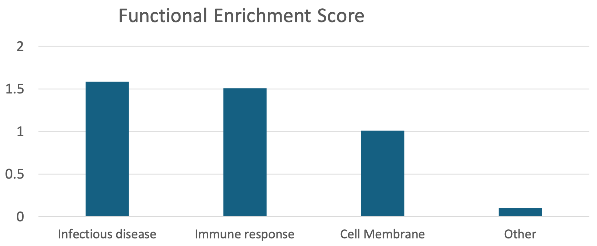

Figure 3. Functional enrichment scores for the gene sets carrying high‐impact variants identified in Peruvian populations using DAVID. Each bar represents the over‐representation of a particular biological category, with higher bars indicating stronger enrichment relative to a random expectation. “Infectious disease” and “Immune response” show statistically significant enrichment (marked with asterisks), driven primarily by genes involved in pathogen defense and inflammatory processes (e.g., HLA and IFN loci). “Cell Membrane” has a more modest enrichment, reflecting variants in membrane‐associated receptors or channels. The “Other” category comprises residual terms showing minimal enrichment. This distribution highlights that immune‐related pathways likely played a key role in shaping high‐impact variation within these Peruvian genomes.

Beyond these clearly immune‐focused signals, we noted a secondary trend (though not statistically significant after correction) toward genes involved in membrane function. Several high‐impact variants (e.g., in CACNB2 or certain olfactory receptors) mapped to cell‐surface or membrane‐associated proteins. While the enrichment in membrane terms was modest (fold enrichment ~0.8–1.0), it remains plausible that membrane proteins could indirectly influence infection dynamics or environmental interactions (e.g., recognition of pathogens or transport of nutrients). However, these signals were less definitive than those centered on pathogen defense and inflammatory pathways.

Overall, our enrichment analysis suggests that immune‐related genes bear the strongest signature of high‐impact variation in this Peruvian dataset. Whether these variants reflect historic selective advantages (e.g., immunity to local infections) or random fixation via drift is an open question—one that underscores the need for functional and epidemiological follow‐ups. Nevertheless, the clustering of disruptive mutations in immune pathways provides a compelling clue that local disease pressures have, in some cases, helped sculpt the genetic architecture of these geographically and ethnically diverse populations.

Allele Sharing Patterns and Gene Flow
Multiple significant allele-sharing signals emerge from the application of a D-statistic analysis to our cohort of merged samples (sequencing and array origin), pointing to historical gene flow between specific populations (see Extended Methods below). We considered |Z| > 3 (approximately p < 0.001) as evidence of a significant deviation of D from zero​. In our heatmap (Fig. 4A), several population pairs exhibit D-values that exceed this significance threshold, reflecting excess shared derived alleles beyond what would be expected under a strictly tree-like divergence. For example, a highland population from central Peru and a lowland Amazonian population show one of the strongest introgression signals (with D ≈ 0.25, Z ≈ 4.5, p < 10⁻⁵), indicating substantial gene flow across the Andean–Amazonian divide. Similarly, a northern Andean highland group and an Amazonian group in the north share a surplus of alleles (D ≈ 0.20, Z > 4, p < 0.001), consistent with historical admixture between these regions. These findings imply that significant migrations or gene flow events connected the Andes and Amazon in the central and northern parts of Peru. Importantly, all highlighted D-values are positive (excess ABBA pattern), suggesting that in each case one of the two comparison populations harbors ancestry from the third population that the other lacks​. In contrast, population comparisons that cross major geographic or cultural boundaries (e.g., highland vs. coastal in the far south) generally show D-statistics statistically indistinguishable from zero (|Z| < 2, p > 0.05), indicating an absence of detectable introgression. Overall, the allele-sharing patterns revealed by the D-statistic matrix reflect a complex population structure shaped by localized gene flow events: extensive admixture among several central and northern highland and Amazonian groups, but little exchange involving populations separated by the highest mountain ranges or long distances​.

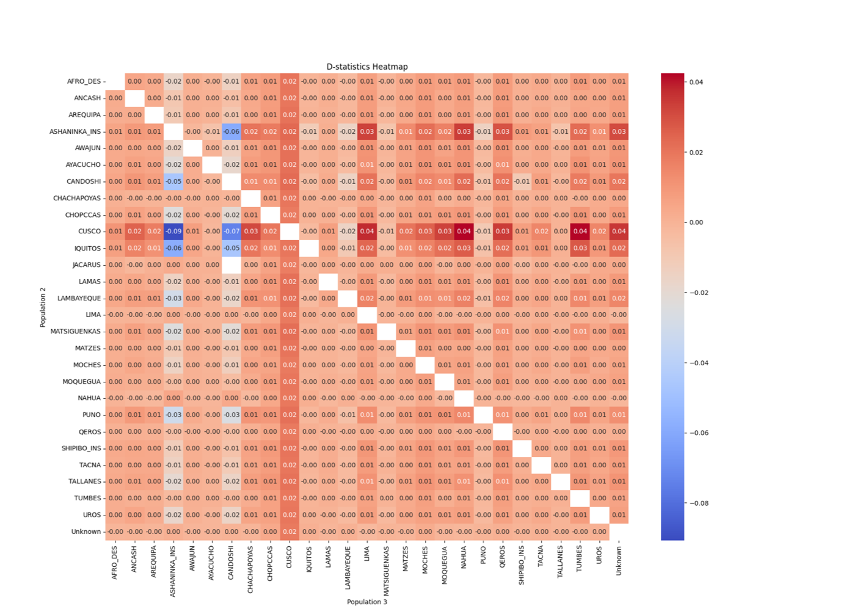
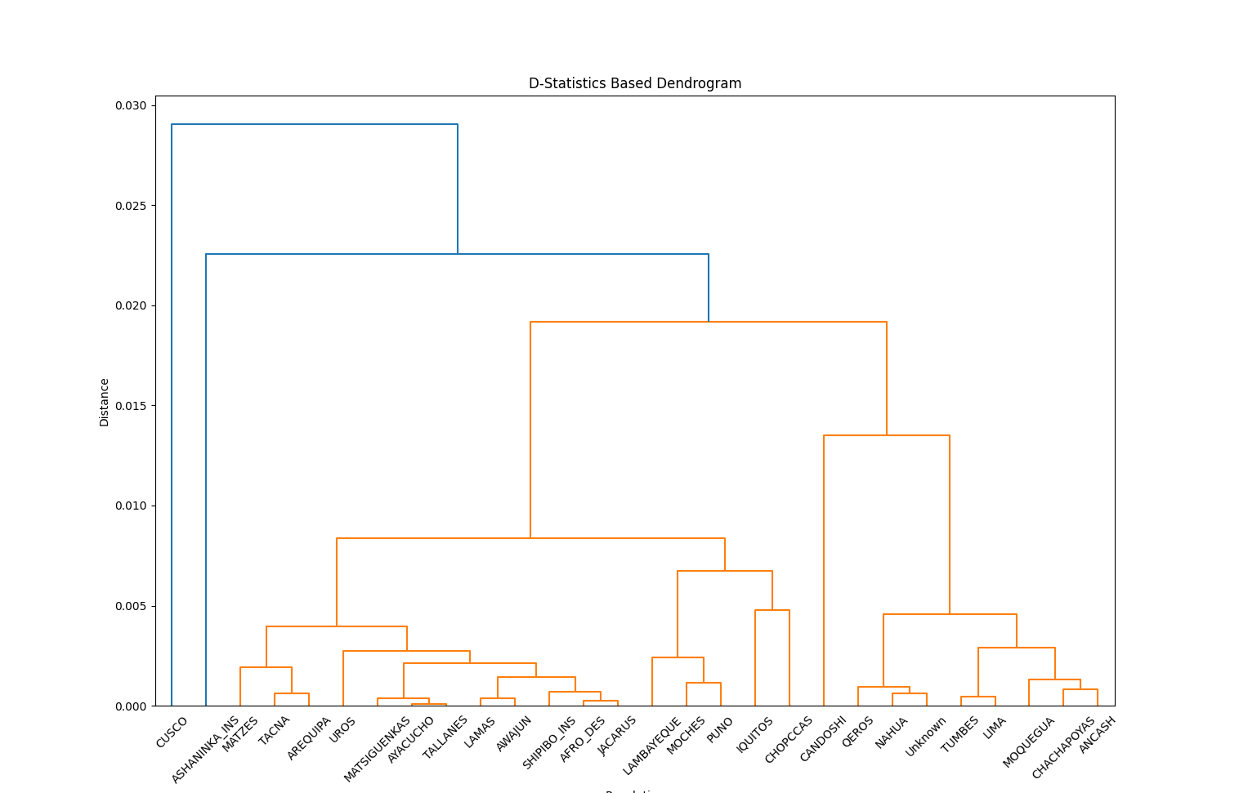
Figure 4. (A) Heatmap of Patterson’s D-statistic values, illustrating allele-sharing among the studied populations. Warmer colors indicate higher D-values (excess shared derived alleles) between population pairs, cooler colors indicate low or no excess sharing. The heatmap reveals a clear clustering of populations by their allele-sharing patterns. Notably, multiple populations form two main clusters with elevated mutual D-values, indicating they share significantly more alleles with each other than with populations outside their cluster. (B) This clustered structure is mirrored in the hierarchical clustering dendrogram of the same data, which groups populations with high allele sharing into the same branches. Populations from geographically proximate or historically connected regions tend to fall into the same cluster, reflecting underlying population structure shaped by gene flow. In contrast, populations separated by major geographic barriers show cool-colored cells (near-zero D-values) between them, consistent with little to no recent admixture.

The hierarchical clustering (UPGMA dendrogram) of populations based on D-statistic allele-sharing distances (Fig. 4B), denotes the Cusco population separately from all other groups. In the dendrogram, the Cusco population consistently emerges as an outgroup relative to the other Peruvian populations. Across all clustering analyses, Cusco is the first branch to split off, reflecting the fact that it shares comparatively few derived alleles with any of the other populations. This result is concordant with the heatmap (Fig. 4A): D-values involving Cusco and any other group are near zero and not significant (typically |Z| < 2), indicating no excess allele sharing in either direction. The outgroup position of Cusco suggests that it has remained genetically more isolated, with no strong evidence of the historical gene flow events that are observed among the other populations reaching Cusco. In terms of population structure, this implies an early divergence or limited admixture for the Cusco lineage, consistent with the idea that the high altitude and geographic isolation of the southern Peruvian Andes have restricted gene flow into this region​. This finding highlights a marked genetic differentiation for Cusco: while other regions of Peru show signs of inter-regional admixture, the Cusco population stands apart as a distinct branch, underscoring its unique ancestral legacy in the context of Peruvian genetic diversity.

Limitations of this Study
It is important to acknowledge the limitations of our study. First, while 150 high-coverage genomes and nearly a thousand genotyped individuals are a substantial start, they still capture only a fraction of the diversity of Peru. Some communities had very few representatives in our sample (e.g., Matzes no. = 12), and there are many other Peruvian indigenous groups not included, given that the Peruvian State recognizes 47 Indigenous languages spoken by 55 different peoples ⁵⁵, making Peru the second Latin American country with the greatest number of indigenous peoples (only after Mexico) ⁵⁶. In future work, we aim to sequence more individuals per community and include additional groups. This will help validate the novel variants we found and possibly discover more.

Another important limitation is our current lack of wet‐lab validation for the many high‐impact variants identified. While in silico tools (e.g., VEP, CADD) help prioritize candidates, they are not definitive proof of pathogenicity or functional effect. To address this, we plan to perform mechanistic assays—such as gene expression profiling, protein‐protein interaction studies, and cellular functional tests—to clarify precisely how these variants may alter immunological or pharmacological phenotypes in vivo. In parallel, although our findings suggest potential guidelines for more targeted pharmacogenomic screening, translating them into routine clinical use will require prospective clinical trials in Peruvian populations to assess efficacy, safety, and cost‐benefit of variant‐based interventions.

Extended Methods

Ethics and consent
The ethical process for collection, stewardship, and dissemination of data and results for gathered samples followed the Declaration of Helsinki for medical research involving human subjects. The information gathering strategy for sample collection began a month in advance before visiting each community. Communication materials consisted of: i) a brochure explaining the project written in simple language (Spanish or local indigenous language); ii) a poster reproducing what it means informed consent; iii) public informative face to face sessions aimed at the participating community; and iv) communication through local television, radio, and written press. The final decision for participation was made by the communities themselves who had to understand and consent to the ethical processes outlined. Subjects that matched the inclusion criteria were then contacted to participate, and informed consent and authorization were obtained to preserve their samples. All participants were offered the possibility of withdrawing from the study at any time with no need of explanation. All participants gave their informed consent in the presence of a translator to their mother-tongue traditional language and two local witnesses. A total of 22 individuals that matched the inclusion criteria decided not to participate in the study due to religious/cultural beliefs, and 2 recruited subjects left the study requesting their samples and data to be deleted. All procedures were evaluated and approve by Instituto Nacional de Salud del Perú (authorization no. OI-003-11 and no. OI-087-13).

Population Selection Criteria and Sample Collection
From the outset, we partnered closely with community leaders and local stakeholders to ensure that our research questions aligned with their priorities. Each Indigenous population, through consultations, influenced the sampling strategy and specific health concerns addressed by this project. In order to carry out a balanced recruitment and identification of population diversity criteria (as mandated by Instituto de Salud Nacional del Perú), we convened a panel of representatives including indigenous communities of Peru and the Peruvian Ministry of Culture. This panel allowed us to identify populations from across the coast, Andes, and Amazon jungle. We defined “indigenous individuals” as those whose parents and grandparents were born in the same indigenous community, have as mother tongue a language other than Spanish, have a distinctive cultural legacy, have no admixture with other communities and are in danger of extinction due to outside contact and changing environment or climate change. Based on this definition, the criteria for selection of indigenous populations from the Peruvian Genome Project included: a) representativeness (number of residents in each population), b) degree of isolation (days of journey from healthcare), and c) vulnerability to disappear (admixture/cultural absorption with other populations, displacement by migrations or difficult access). 17 indigenous populations and 13 mestizo populations were identified, spanning diverse locations and geographical distances. An initial breakdown of community participant individuals included 1,149.

Genotyping, Whole Genome (WGS) Sequencing and Variant Calling
723 Indigenous American and mestizo Peruvian individuals were genotyped on a 2.5M Illumina chip. The study analyzed 150 whole genomes from individuals representing 7 Peruvian populations: Matsés, Uros, Chopccas, Moches, Iquitos, Cusco and Trujillo. Each genome was sequenced at 35x coverage using the Illumina HiSeq X10 platform to ensure high accuracy in variant detection. Alignment of the sequencing data was conducted using BWA-MEM against hg19. Post alignment, Picard MarkDuplicates was used to identify and mark duplicate reads in order to minimize biases in variant calling. For variant calling the GATK UnifiedGenotyper tool was used to jointly identify biallelic single nucleotide variants (SNVs) across the nuclear and mitochondrial genome of individuals. This included identifying variants independently in each sample and the generating a comprehensive set of biallelic SNVs. To maintain the reliability of detected variants we excluded low quality variants flagged as LowQual or with a score <20. We then proceeded to perform a kingship analysis.

Kinship Analysis
Kingship analysis was performed using data from the 150 whole genomes using 12,897,474 variants. We calculated kingship coefficients, setting a coefficient threshold of 0,0442 to identify second-degree relatives or closer. Individuals exceeding this threshold were marked. PLINK’s –remove option was then used for those analyses requiring the exclusion of second relatives or lower. This dataset maintained the original 12,897,474 variants and 109 individuals.

Sample Merging and Identity-by-Descent Analysis
To combine whole‐genome and array‐based genotypes, we first identified the intersection of shared variants between the two platforms. The whole‐genome dataset initially consisted of 150 samples and ~13.05 million variants, while the array dataset included 722 samples and ~2.04 million variants. We computed the overlap of these SNP sets (common variants) and merged the data into a single cohort.

Next, we performed identity‐by‐descent (IBD) filtering to remove duplicate samples and close relatives. We used PLINK (version 1.9) to estimate pairwise IBD coefficients. The following steps outline our procedure:
- PLINK IBD Analysis. We invoked PLINK with the --genome flag on the merged dataset to calculate the pairwise IBD statistics (PI_HAT). A PI_HAT value close to 1.0 indicates near‐identical genotypes (e.g., duplicates or monozygotic twins), whereas values between ~0.25–0.5 suggest close familial relationships (e.g., siblings or parent–child pairs).
- Filtering Threshold. We set a threshold of PI_HAT > 0.95 to detect duplicates or effectively identical samples. In practice, any pair exceeding this threshold was flagged as duplicates, while other relationship thresholds (e.g., ~0.5 for first‐degree relatives) were also assessed to remove potential siblings or parent–child pairs.
- Generating Exclusion Lists. Using a Python script, we parsed the resulting .genome file from PLINK to identify sample IDs (both FID and IID) whose pairwise PI_HAT values exceeded 0.95. These sample IDs were then written to a “remove.txt” file.
- Removing Individuals. We re‐ran PLINK with --remove remove.txt, producing a new dataset (*_clean) that excluded the flagged duplicates or close‐relatives. This procedure ensured that only one representative from each closely related pair remained in the final cohort.
Through this IBD filtering, we eliminated 41 redundant or closely related genome samples and 95 array samples. The final IBD‐cleaned dataset comprised 109 genome samples and 627 array samples (736 total), each sharing 936,301 variants. This curated data was used for subsequent population analyses, ensuring no artificially inflated signals from duplicated or closely related individuals.

Variant Effect Predictor (VEP) Analysis of Whole Genome Sequencing Data
As part of the effort to characterize functionally relevant variants, we employed the Ensembl Variant Effect Predictor (VEP) on our biallelic SNV dataset derived from 150 Peruvian whole genomes (after quality control and kinship-based pruning). This decision was motivated by the need to prioritize genomic alterations most likely to affect protein structure or gene regulation. In particular, we aimed to (a) reduce downstream computational complexity, and (b) focus on putatively HIGH-impact variants—those with strong evidence of functional disruption (e.g., stop-gained, frameshift, splice acceptor/donor).

Each variant was keyed by its unique chromosome–position–reference–alternate combination. For loci exhibiting multiple transcript annotations and/or multiple predicted consequences, the pipeline retained only the most severe (highest-impact) annotation as ranked by Excel Supplementary Table 1. As a result, non-severe annotations for the same site or allele were excluded from the final variant table, ensuring consistency in subsequent analyses.
- Biallelic Subset. Although the initial dataset was filtered to include only biallelic variants, a subset of these had arisen from split multi-allelic sites; each alternate allele was treated independently. This approach sometimes introduced complexities, such as partially missing or mismatched allele records if the alternate allele did not align with the reference used by VEP.
- Excluding Common Variants. We further restricted our attention to variants with a global minor allele frequency (MAF) <1% in the 1000 Genomes Project. This filter aimed to identify candidate rare variants of potential clinical or population-genetic interest.
- Final Variant Selection. Ultimately, we chose only those variants annotated by VEP as having a HIGH impact. This decision significantly reduced the size of the annotated dataset, eliminating large numbers of low-impact or non-coding variants with limited clinical relevance.

A direct comparison between the table holding raw biallelic VCF uploads and the final VEP annotation table revealed that approximately 2,480,877 biallelic variants lacked corresponding VEP entries. Closer inspection identified several reasons for this discrepancy:
- Excluded Consequences. Many variants were assigned a MODERATE, LOW, or MODIFIER impact by VEP, and were not imported into the final table once we decided to keep only HIGH-impact results.
- Sex Chromosome Anomalies. Chromosomes X and Y showed notable differences in processed vs. annotated counts (on the order of 4,000 fewer variants for X and ~130 fewer for Y). This phenomenon can arise from pseudoautosomal boundaries, haploid/diploid representation in VCFs, or incomplete mapping references in VEP’s transcript database.
- Unrecognized Alternate Alleles. Certain entries contained ambiguous or reference-only alternates (e.g., “REF=ALT”) or multiple alternate alleles from which at least one was absent or unrecognized by VEP.
- Multi-Allelic Decomposition. Instances of complex multi-allelic calls being split into separate biallelic lines occasionally introduced mismatches in allele representation, which in turn prevented VEP from associating the record to a known functional annotation.

Of the approximately 12.9 million biallelic SNVs subjected to VEP, around 6.27 million were flagged as rare (<1% global MAF). From this pool, only a small fraction received a HIGH-impact designation (e.g., splice donor/acceptor, stop gain/loss, frameshift, start lost). These HIGH-impact sites represent the most functionally disruptive changes and are therefore prime candidates for exploring potential disease susceptibility, genotype–phenotype associations, and adaptive traits in Indigenous and admixed Peruvian populations.
- Clinical Significance Indicators. While CLIN_SIG annotations in ClinVar were not extensively represented, some variants carried “Pathogenic” or “Likely Pathogenic” tags.
- CADD and LOEUF Scores. Many high-impact variants also displayed elevated CADD_PHRED scores, underscoring their potential deleteriousness. Certain genes with lower LOEUF values—implying greater intolerance to loss-of-function—featured novel truncating variants within these populations, suggestive of interesting biology or disease relevance meriting further study.

Allele Count and Frequency Analysis
To assess allele distribution across the 150 WGS, we analyzed alternative allele population counts. This allows us to generate observed frequencies and distributions of specific variants across the populations compounding the dataset. Allele counts across the analyzed populations are then compared to global frequency data in order to identify population-specific patterns of genetic variation. An enrichment in certain deleterious variants for a particular gene may inform health, disease predisposition and evolutionary adaptations. For prioritization of deleterious variants, we only considered those whose frequency is less than 0.01 in the 1000 Genomes Project (1000G). Note that the 1000G also includes 96 Peruvians from Lima (PEL), which means that common variants in PEL would also be discarded for further analysis. We further applied the filter of selecting variants with a CADD PHRED score greater than 10 (which suggests deleteriousness), and variants that had counts exceeding 5 in at least one of the Peruvian populations (Matses, Uros, Chopccas, Moches, Iquitos, Cusco, Trujillo). The allele frequencies of these variants were assessed against the gnomAD AMR dataset as well (allele frequencies in Indigenous Americans) to identify differences that may point to unique population level genetic traits. Fisher’s exact test was employed for comparing allele proportions between Peruvian populations and the gnomAD AMR reference. This test’s application was crucial for small sample sizes and low frequency alleles.

Integrating PyPGx Phenotypes with FDA Pharmacogenomic Annotations
We developed a Python-based pipeline to reconcile PyPGx-derived metabolizer phenotypes with the U.S. Food and Drug Administration (FDA) Table of Pharmacogenetic Associations. The FDA’s table offers gene-drug interaction information framed around discrete “Affected Subgroups” (e.g., “poor metabolizers” or “intermediate metabolizers”), which can inform therapeutic decision-making for each genotype. In parallel, PyPGx infers an individual’s metabolizer status (e.g., poor, intermediate, or ultrarapid), creating a need to unify both sources for actionable insights.

First, our script parses each individual’s output—extracting the gene (e.g., CYP2C19) and phenotype (e.g., “poor metabolizer”). These textual descriptions are mapped to standardized categories, such as PM (poor), IM (intermediate), NM (normal/extensive), RM (rapid), or UM (ultrarapid), reflecting recognized pharmacogenetics guidelines. Concomitantly, the script ingests the FDA’s “Affected Subgroups” column, which describes which metabolizer subgroups (e.g., PM, IM, NM) are impacted by a specific gene-drug pair. By applying the same set of category definitions, we produce a structured representation of the FDA annotations.

To ensure both specificity and recall in matching, the script implements a two-tier approach:
- Direct Category Overlap: If an individual’s standardized metabolizer category (e.g., PM) appears among the FDA’s listed categories (e.g., “poor metabolizers, intermediate metabolizers”), the association is flagged as a robust match. This step prevents obvious contradictions (e.g., a “normal metabolizer” incorrectly matched to a “poor metabolizer only” indication).
- Fuzzy Text Matching (Threshold = 85): If no direct overlap emerges and the categories are not overtly contradictory, we use a fallback fuzzy matching method (partial string similarity). Specifically, we compare the exact phrasing of the subject’s phenotype (“poor to intermediate metabolism”) against the FDA’s “Affected Subgroups” text at an empirically validated threshold of 85% similarity. This captures less standardized or composite expressions (e.g., “mildly reduced metabolism”) that may not be parsed as a canonical category but still imply poor or intermediate function.
By combining explicit category alignment with targeted fuzzy text matching, our pipeline avoids spurious matches (e.g., “normal” mapped to “poor”) yet remains sensitive to variable or compound descriptors in the phenotype. For each verified match, we record the individual’s PyPGx phenotype, relevant FDA gene-drug association, and any dosage guidance or contraindications provided by the FDA. This results in a curated dataset linking a patient’s genotype-based metabolizer profile to the specific therapeutic considerations outlined in the Table of Pharmacogenetic Associations, thereby offering clinicians a more streamlined path to personalized prescribing decisions.

Pharmacogenomic Genotype Frequency Analysis
To characterize the distribution of pharmacogenomic genotypes within our dataset, we quantified genotype frequencies and their associated phenotypic classifications. This analysis aimed to determine the prevalence of key pharmacogenetic variants within the study population, providing insights into inter-individual variability in drug metabolism.
The dataset was obtained from PyPGx output and processed using Python (Pandas library). The raw data contained individual-level pharmacogenomic profiles, including information on the gene, genotype, and predicted phenotype. Prior to analysis, the script verified the presence of three essential columns—"Gene," "Genotype," and "Phenotype"—to ensure data completeness. Entries missing any of these fields were excluded from downstream processing.
Following data validation, the dataset was grouped by gene, genotype, and phenotype to determine the number of individuals exhibiting each unique genotype. For each gene, the absolute count of individuals carrying a specific genotype was computed and stored as the variable "No of Subjects with Genotype".

To account for differences in sample sizes across genes, genotype frequency was calculated within each gene as follows:
$$Genotype Frequency=\frac{No of Subjects with Genotype}{∑ All Genotypes for the Gene}​$$

This value was further converted into a percentage representation (Genotype Frequency (%)), allowing for easier cross-gene comparisons. Both the fractional and percentage-based frequency values were retained for reporting.

The final dataset was saved for compatibility with downstream statistical analysis and visualization tools. This dataset enables the characterization of population-level genotype distributions, facilitating insights into the genetic determinants of drug response.

Population-Specific Genotype Frequency Analysis of Pharmacogenes
To explore the distribution of pharmacogenomic variants across different Peruvian population groups, we calculated genotype frequencies stratified by gene and population for all analyzed 56 pharmacogenes. One of the key aspects of this analysis was the ability to differentiate the observed genotype frequencies for a given gene by population group. To determine how frequently each genotype appeared within a given population, the dataset was grouped by population, gene, and genotype. The number of individuals carrying each genotype was counted and used to compute:
- Genotype prevalence within the population: the total number of individuals carrying a particular genotype for each gene.
- Genotype frequency within each gene-population group, calculated as:

$$Genotype Frequency=\frac{No of Subjects with Genotype}{∑ All Genotypes for the Gene in that Population}$$

- Percentage representation of genotype frequency, expressed as:

$$Genotype Frequency (\%)=Genotype Frequency×100$$

This calculation ensures that genotype distributions are normalized within each population, allowing for direct comparisons across genes and demographic groups. This population-stratified genotype frequency calculations allow for comparative pharmacogenomic studies, providing insights into population-specific variability in drug response and genetic predisposition to adverse drug reactions.

Principal Component Analysis
We investigated genetic population structure by performing a principal component analysis (PCA) on a set of genotyped samples. First, we applied an identity-by-descent (IBD) filter to remove related individuals and ensure that only unrelated samples were retained. After this filtering step, a total of 936,301 variants and 747 samples—representing 28 populations—remained for downstream analyses.

We conducted the PCA using PLINK (v1.90) with the --pca option. Briefly, the input was a VCF file containing the common variants. PLINK computed allele frequencies and constructed the genetic relationship matrix among all samples. Eigenvalues (quantifying the variance explained by each principal component) and eigenvectors (the coordinates of each sample in the principal-component space) were then estimated. The output comprised two files, which were used to visualize the clustering patterns via scatter plots of the principal components (e.g., PC1 vs. PC2).

To further contextualize our Peruvian population samples within a global reference panel, we incorporated additional samples from the Simons Genome Diversity Project (SGDP) ⁵⁷ using PLINK (v1.90). We obtained a preprocessed dataset containing 34,418,131 variants and 345 individuals (179 males, 129 females, and 37 ambiguous sex assignments) from the publicly available SGDP resource. After loading the binary PLINK files (.bed, .bim, .fam), we recoded these data into a VCF format with the --recode vcf command.

Quality-control steps similar to those used for the Peruvian samples (e.g., ensuring correct sample sex annotations and handling haploid genotypes as missing) were performed. The SGDP VCF file was then ready to be merged with the Peruvian dataset in order to conduct joint PCA. This allowed for a comparative analysis of the Peruvian populations relative to a broad spectrum of globally distributed reference populations from the SGDP panel.

D-Statistic and Di Calculation
We assessed patterns of gene flow and population divergence using D-statistics computed through a custom analysis pipeline integrating ADMIXTOOLS ⁵⁸ and in-house Python scripts. The D-statistic approach is designed to detect excess allele sharing between pairs of populations (pop2, pop3) when compared to reference (pop1) and outgroup (pop4) populations. For example, in our analyses, we designated Cusco as the outgroup population in certain comparisons to test whether other populations showed evidence of historical admixture relative to this reference.

We began our analysis by assembling a filtered dataset of 747 samples and 936,301 SNPs in PLINK format (.bed, .bim, .fam). These samples had already been processed to minimize relatedness through IBD (identity-by-descent) filtering, ensuring that only unrelated individuals were included. Next, we employed a custom Python script (calc-di-stat.py) to convert these PLINK files into EIGENSTRAT format (.geno, .snp, .ind), which is required by ADMIXTOOLS. During this conversion, each individual was mapped to a corresponding population, and index files were created to record variant positions and track each sample’s assignment. Following additional quality-control steps—such as establishing thresholds for missing data and minor allele frequency—we narrowed the dataset down to a final set of 37,116 polymorphic SNPs for the D-statistic calculations. This focused subset balanced robustness with computational efficiency.

Because a reliable genetic linkage map was not available, we defined blocks of SNPs for jackknife estimation in D-statistics using a default physical distance of two megabases (2 Mb). While this approach did not explicitly account for recombination rates, it still provided a conservative way to estimate the variance of our computed statistics.

With our data prepared, we turned to the f2-based approach in ADMIXTOOLS (to calculate pairwise allele frequency differentiations. From these, we derived D-statistics of the form D(pop1, pop2, pop3, pop4), allowing us to test for excess allele sharing that might signal gene flow among specified population trios. In some of these analyses, we positioned the Cusco population as an outgroup (pop4) due to its distinctive genetic characteristics, thereby establishing a baseline to detect any admixture events in the remaining populations. For visualization, we generated heatmaps that highlighted these gene flow relationships. By focusing on the more variable populations (pop2 and pop3), we could illustrate how different pairs of groups shared alleles relative to a consistent set of references (pop1) and outgroups (pop4).

To complement these broader D-statistics, we also computed a standardized per-locus measure, Di​, to gauge how each SNP deviated from the genome-wide mean of a chosen metric (e.g., Fst​ or another summary statistic). A separate Python script read locus-specific Fst values, computed their mean and standard deviation, and then calculated Di= $\frac{Fst-\overline{Fst}}{σFst}$​​​. SNPs whose Di​ values lay well beyond the average range signaled unusually high divergence patterns. Although this does not definitively prove positive selection, these outlier loci merit additional scrutiny, potentially through analyses targeting local adaptation or the role of historical gene flow.

It is worth emphasizing that the D-statistic framework and any dendrograms derived from it should not be construed as depicting strict evolutionary relationships. Rather, they highlight relative levels of shared drift or admixture among populations. The decision to use Cusco as an outgroup, for instance, rests on the assumption that it reflects a unique ancestry component, but this may vary depending on historical gene flow events. Additionally, while these statistics can reveal pronounced patterns of allele sharing, identifying true signals of local adaptation or positive selection requires more specialized tests—such as examining haplotype structure or applying composite likelihood approaches—to verify any adaptive hypotheses suggested by our findings.

Overall, combining D-statistics, jackknife-based variance estimations, and standardized SNP-level measures (Di) allowed us to examine both broad-scale admixture patterns among Peruvian populations and potential local genetic outliers within each population’s genome.

Data Availability and Code Access
All genomic data generated from the Peruvian Genome Project (PGP) has been deposited in the European Genome-phenome Archive (EGA). The following datasets are accessible through the EGA:
- Whole genome sequences from 150 individuals (accession numbers: EGAD00010001958, EGAD00010001990).
- Genotypic data from 873 array-genotyped individuals (accession numbers: EGAD00010001991, EGAD00010001992).
Access to these datasets will be provided upon request and approval of a Data Access Committee (DAC), following the Declaration of Helsinki and local regulations. Researchers requesting data will need to:
- Submit a Data Access Request: Interested parties must complete a Data Access Request form, detailing the purpose of the research and any plans for data usage, including intentions for data sharing and publication.
- Adhere to Ethical Considerations: In line with the informed consent provided by the indigenous communities, access will only be granted to research that maintains participant confidentiality and respects community-specific agreements.
- Data Usage Restrictions: These data must be requested to answer the scientific objectives posed in the request form only. For any other changes of usage please submit a new application submission. Data must not be shared with any author or institution not explicitly mentioned and approved by the DAC.
All requests should be directed to the corresponding authors, and the DAC will review applications on a case-by-case basis to ensure alignment with the project’s mission of promoting equitable research while safeguarding participant rights. The datasets will be available under controlled access in accordance with the security protocols established by the EGA.

In accordance with ethical guidelines and local norms, we established a community‐led framework to govern if and how individual or group‐level findings are shared back with participants. We provided each participating community the option to receive aggregate summaries (e.g., frequency of certain high‐impact variants) and, where requested, have the opportunity to consult with local healthcare providers about individual results. Our protocol further stipulates that data sovereignty remains with each Indigenous community; any secondary analyses beyond the scope of this project require approval from both the institutional review board and community leaders. By respecting self‐determination in data use, we seek to avoid historical patterns of extractive research and ensure that community members retain a meaningful role in decision‐making around these genomic resources.

We have also made our primary data processing pipelines publicly available on GitHub at https://github.com/manuelcorpas/15-PERU, which includes step‐by‐step scripts and configuration files that replicate our workflow end‐to‐end. We encourage other researchers to leverage these resources for transparent and reproducible analyses.

References

1. Riedel, S. Edward Jenner and the history of smallpox and vaccination. Proc (Bayl Univ Med Cent) 18, 21–25 (2005).
2. Ehrenpreis, J. E. & Ehrenpreis, E. D. A Historical Perspective of Healthcare Disparity and Infectious Disease in the Native American Population. Am J Med Sci 363, 288–294 (2022).
3. The Impact of European Diseases on Native Americans | Encyclopedia.com. https://www.encyclopedia.com/science/encyclopedias-almanacs-transcripts-and-maps/impact-european-diseases-native-americans.
4. Harris, D. N. et al. Evolutionary genomic dynamics of Peruvians before, during, and after the Inca Empire. Proc Natl Acad Sci U S A 115, E6526–E6535 (2018).
5. Ochoa, D. Inca Population Estimates. How to Peru https://howtoperu.com/inca-population-estimates/ (2012).
6. Skantharajah, N. et al. Equity, diversity, and inclusion at the Global Alliance for Genomics and Health. Cell Genomics 3, 100386 (2023).
7. Corpas, M. et al. Bridging genomics’ greatest challenge: The diversity gap. Cell genomics 5, (2025).
8. Batai, K., Hooker, S. & Kittles, R. A. Leveraging genetic ancestry to study health disparities. Am J Phys Anthropol 175, 363–375 (2021).
9. COVID-19 deaths per capita by country. Statista https://www.statista.com/statistics/1104709/coronavirus-deaths-worldwide-per-million-inhabitants/.
10. Li, H. Aligning sequence reads, clone sequences and assembly contigs with BWA-MEM. Preprint at https://doi.org/10.48550/arXiv.1303.3997 (2013).
11. Picard Tools - By Broad Institute. https://broadinstitute.github.io/picard/.
12. DePristo, M. A. et al. A framework for variation discovery and genotyping using next-generation DNA sequencing data. Nat Genet 43, 491–498 (2011).
13. McLaren, W. et al. The Ensembl Variant Effect Predictor. Genome Biology 17, 122 (2016).
14. Landrum, M. J. et al. ClinVar: improvements to accessing data. Nucleic Acids Research 48, D835–D844 (2020).
15. Frankish, A. et al. GENCODE reference annotation for the human and mouse genomes. Nucleic Acids Research 47, D766–D773 (2019).
16. Rentzsch, P., Witten, D., Cooper, G. M., Shendure, J. & Kircher, M. CADD: predicting the deleteriousness of variants throughout the human genome. Nucleic Acids Research 47, D886–D894 (2019).
17. USP29 ubiquitin specific peptidase 29 [Homo sapiens (human)] - Gene - NCBI. https://www.ncbi.nlm.nih.gov/gene/57663.
18. Gao, W. et al. The Deubiquitinase USP29 Promotes SARS-CoV-2 Virulence by Preventing Proteasome Degradation of ORF9b. mBio 13, e0130022 (2022).
19. COVID-19 deaths per capita by country. Statista https://www.statista.com/statistics/1104709/coronavirus-deaths-worldwide-per-million-inhabitants/.
20. Salazar, G. et al. Gene expression profiling reveals novel protective effects of Aminaphtone on ECV304 endothelial cells. European Journal of Pharmacology 782, 59–69 (2016).
21. Jacobs, S. R. & Damania, B. NLRs, inflammasomes, and viral infection. J Leukoc Biol 92, 469–477 (2012).
22. Zhu, W. et al. A pan-cancer analysis of the oncogenic role of zinc finger protein 419 in human cancer. Front Oncol 12, 1042118 (2022).
23. Orecchioni, M., Matsunami, H. & Ley, K. Olfactory receptors in macrophages and inflammation. Front Immunol 13, 1029244 (2022).
24. Bryche, B., Baly, C. & Meunier, N. Modulation of olfactory signal detection in the olfactory epithelium: focus on the internal and external environment, and the emerging role of the immune system. Cell Tissue Res 384, 589–605 (2021).
25. Olfactory Receptors as an Emerging Chemical Sensing Scaffold | Biochemistry. https://pubs.acs.org/doi/10.1021/acs.biochem.2c00486.
26. Erdogmus, S. et al. Cavβ1 regulates T cell expansion and apoptosis independently of voltage-gated Ca2+ channel function. Nat Commun 13, 2033 (2022).
27. Lee, M. J. et al. UBE2N is essential for maintenance of skin homeostasis and suppression of inflammation. bioRxiv 2023.12.01.569631 (2023) doi:10.1101/2023.12.01.569631.
28. Arnaiz-Villena, A. et al. HLA genes in Uros from Titikaka Lake, Peru: origin and relationship with other Amerindians and worldwide populations. Int J Immunogenet 36, 159–167 (2009).
29. Hosokawa, N. et al. Human XTP3-B forms an endoplasmic reticulum quality control scaffold with the HRD1-SEL1L ubiquitin ligase complex and BiP. J Biol Chem 283, 20914–20924 (2008).
30. Dean, L. & Kane, M. Fluorouracil Therapy and DPYD Genotype. in Medical Genetics Summaries (eds. Pratt, V. M. et al.) (National Center for Biotechnology Information (US), Bethesda (MD), 2012).
31. Sim, E., Abuhammad, A. & Ryan, A. Arylamine N-acetyltransferases: from drug metabolism and pharmacogenetics to drug discovery. Br J Pharmacol 171, 2705–2725 (2014).
32. Skinner, K. T., Palkar, A. M. & Hong, A. L. Genetics of ABCB1 in Cancer. Cancers (Basel) 15, 4236 (2023).
33. Dean, L. Azathioprine Therapy and TPMT and NUDT15 Genotype. in Medical Genetics Summaries (eds. Pratt, V. M. et al.) (National Center for Biotechnology Information (US), Bethesda (MD), 2012).
34. SEARCH Collaborative Group et al. SLCO1B1 variants and statin-induced myopathy--a genomewide study. N Engl J Med 359, 789–799 (2008).
35. Rosenberg, H., Sambuughin, N., Riazi, S. & Dirksen, R. Malignant Hyperthermia Susceptibility. in GeneReviews® (eds. Adam, M. P. et al.) (University of Washington, Seattle, Seattle (WA), 1993).
36. Gaedigk, A., Sangkuhl, K., Whirl-Carrillo, M., Klein, T. & Leeder, J. S. Prediction of CYP2D6 phenotype from genotype across world populations. Genetics in Medicine 19, 69–76 (2017).
37. Gonzalez-Covarrubias, V. et al. Variation in Actionable Pharmacogenetic Markers in Natives and Mestizos From Mexico. Front. Pharmacol. 10, (2019).
38. (PDF) CYP2W1 Variant Alleles in Caucasians and Association of the CYP2W1 G541A (Ala181Thr) Polymorphism with Increased Colorectal Cancer Risk. ResearchGate (2025) doi:10.2217/pgs.10.66.
39. Saitou, M., Satta, Y. & Gokcumen, O. Complex Haplotypes of GSTM1 Gene Deletions Harbor Signatures of a Selective Sweep in East Asian Populations. G3 (Bethesda) 8, 2953–2966 (2018).
40. Hemlata et al. Comparative frequency distribution of glutathione S-transferase mu (GSTM1) and theta (GSTT1) allelic forms in Himachal Pradesh population. Egyptian Journal of Medical Human Genetics 23, 86 (2022).
41. Fernandez-Rhodes, L. et al. Importance of Genetic Studies of Cardiometabolic Disease in Diverse Populations. Circ Res 126, 1816–1840 (2020).
42. Nguyen, A. B., Cavallari, L. H., Rossi, J. S., Stouffer, G. A. & Lee, C. R. Evaluation of race and ethnicity disparities in outcome studies of CYP2C19 genotype-guided antiplatelet therapy. Front Cardiovasc Med 9, 991646 (2022).
43. Gutiérrez-Virgen, J. E. et al. NAT2 global landscape: Genetic diversity and acetylation statuses from a systematic review. PLOS ONE 18, e0283726 (2023).
44. (PDF) N-acetyltransferase 2: Slow, intermediate or fast? A booming question of the molecular epidemiology in cancer research. ResearchGate (2024) doi:10.4236/ojgen.2012.24028.
45. Pietro, G. D., Gadelha, S. R., Sousa, S. M. B., Melo, P. R. S. D. & Santos, F. R. N-acetyltransferase 2: Slow, intermediate or fast? A booming question of the molecular epidemiology in cancer research. OJGen 02, 221–235 (2012).
46. Ivanov, A. & Semenova, E. Gilbert’s Syndrome, Bilirubin Level and UGT1A1∗28 Genotype in Men of North-West Region of Russia. J Clin Exp Hepatol 11, 691–699 (2021).
47. Hulshof, E. C., Deenen, M. J., Guchelaar, H.-J. & Gelderblom, H. Pre-therapeutic UGT1A1 genotyping to reduce the risk of irinotecan-induced severe toxicity: Ready for prime time. European Journal of Cancer 141, 9–20 (2020).
48. Saeki, M. et al. Genetic polymorphisms of UGT1A6 in a Japanese population. Drug Metab Pharmacokinet 20, 85–90 (2005).
49. Zhang, D. et al. Characterization of the UDP glucuronosyltransferase activity of human liver microsomes genotyped for the UGT1A1*28 polymorphism. Drug Metab Dispos 35, 2270–2280 (2007).
50. Gagné, J.-F. et al. Common human UGT1A polymorphisms and the altered metabolism of irinotecan active metabolite 7-ethyl-10-hydroxycamptothecin (SN-38). Mol Pharmacol 62, 608–617 (2002).
51. Marques, S. C. & Ikediobi, O. N. The clinical application of UGT1A1 pharmacogenetic testing: Gene-environment interactions. Hum Genomics 4, 238–249 (2010).
52. Sherman, B. T. et al. DAVID: a web server for functional enrichment analysis and functional annotation of gene lists (2021 update). Nucleic Acids Research 50, W216–W221 (2022).
53. Ogata, H. et al. KEGG: Kyoto Encyclopedia of Genes and Genomes. Nucleic Acids Research 27, 29–34 (1999).
54. Gene Ontology Consortium. The Gene Ontology (GO) database and informatics resource. Nucleic Acids Research 32, D258–D261 (2004).
55. The Indigenous World 2023: Peru - IWGIA - International Work Group for Indigenous Affairs. https://iwgia.org/en/peru/5102-iw-2023-peru.html.
56. Indigenous Latin America. World Bank https://www.worldbank.org/en/region/lac/brief/indigenous-latin-america-in-the-twenty-first-century-brief-report-page.
57. Mallick, S. et al. The Simons Genome Diversity Project: 300 genomes from 142 diverse populations. Nature 538, 201–206 (2016).
58. Maier, R. uqrmaie1/admixtools. (2025).

