Supplementary Information

Precisely 3D printing of ultrastrong architected carbon with a bio-inspired superstructure

Ya Ren^{1†}, Li Zhang^{1†}, Donglin Ma^{2†}, Angxi Zhou¹, Haitao Peng¹, Boya Li¹, Haofan Liu¹, Jiamei Zhang¹, Yinchu Dong¹, Shuwei Ye³, Tao Li¹, Xide Dai¹, Maling Gou¹*

Affiliations:
¹ Department of Biotherapy Cancer Center and State Key Laboratory of Biotherapy, West China Hospital, Sichuan University, Chengdu 610041, China
² College of Physics and Engineering, Chengdu Normal University, Chengdu 611130, China.
³Department of Orthopedic Surgery, West China Hospital, Sichuan University, Chengdu 610041, Sichuan, China.
†These authors contributed equally to this work.
*Corresponding author. Email: goumaling@scu.edu.cn (M.G.)

This PDF file includes:
Supplementary Figures 1-17
References 1-41

Other Supplementary Materials for this manuscript include:
Supplementary Movies 1-4

Fig.S1. CT scan 3D reconstruction images of the starfish skeleton along the [111], [1$\overline{1}$0], and [11$\overline{2}$] directions.
Fig.S2. Geometric relationships of the starfish skeletal structure. (a-b) Schematic diagram of the starfish skeletal shell. (c) Analysis of the diamond structure of the starfish skeleton.α_{m}=β_{m}=109.5。L₁=L₂=L3=L₄=I.

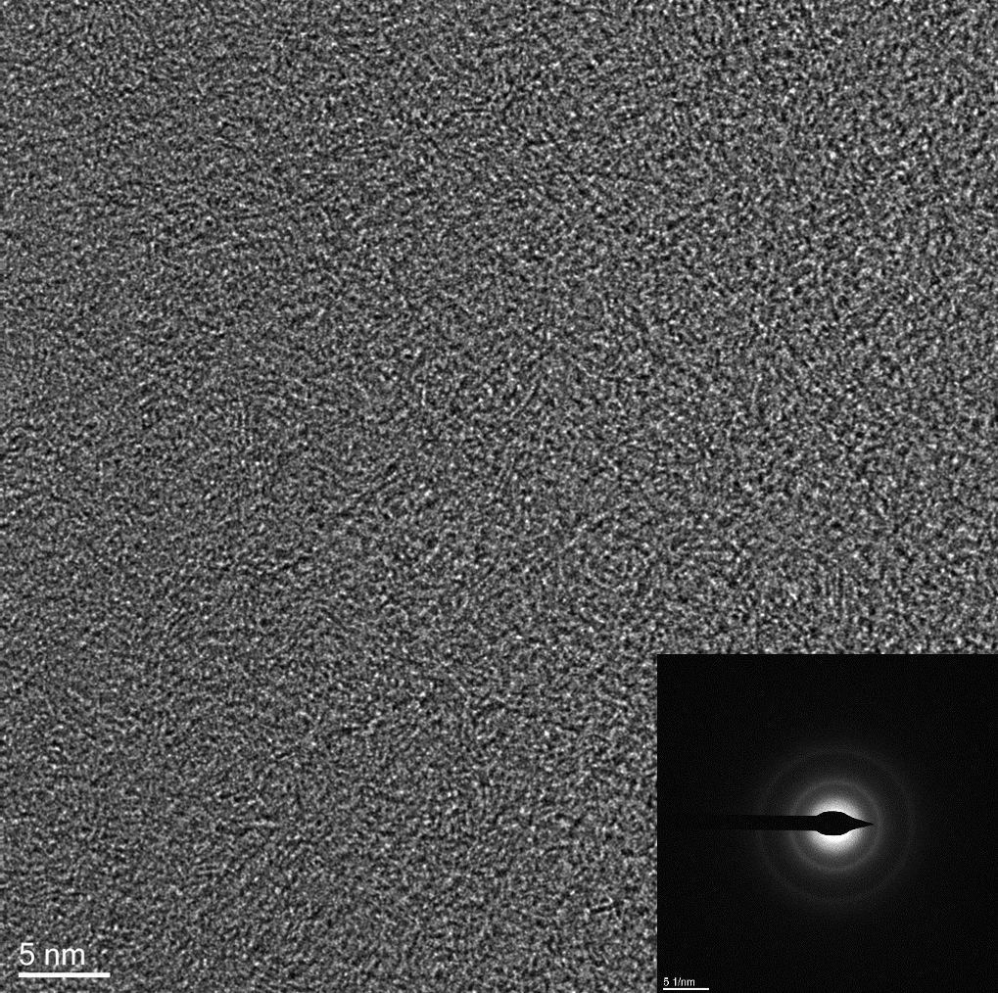
Fig.S3. TEM image and SAED of the microscopic architected carbon.

Fig.S4. Compressive modulus–density Ashby map of microscopic architected carbon.

Fig.S5. Pyrolysis analysis of the precursor resin material for architected carbon. (a) Gas pressure monitoring in the tubular furnace during pyrolysis. (b) Thermogravimetric analysis of the printed resin material.

Fig.S6. Analysis of the shrinkage rate during pyrolysis of architected carbon. (a) Pyrolysis conditions of architected carbon with dimensions of 2 mm, 5 mm, and 10 mm. (b) Measurement of the shrinkage rate of architected carbon with different dimensions along the [111], [11$\overline{2}$], and [1$\overline{1}$0] directions.

Fig.S7. Modular assembly of carbon, nylon, and polylactic acid materials.

Fig.S8. Raman analysis of architected carbon.

Fig.S9. XRD of architected carbon.

Fig.S10. Fourier-transform infrared of architected carbon.

Fig.S11. Carbon content analysis of architected carbon. (a) Mapping images of carbon, oxygen, and HAADF. (b) Mapping images of carbon and oxygen. (c) Mapping images of carbon. (d) Mapping images of oxygen.

Fig.S12. Compression mechanical property test of architected carbon.

Fig.S13. Non-superstructural architected carbon. (a) Triangular lattice structure model and its corresponding architected carbon. （b）Octahedral structure model and its corresponding architected carbon .（c-d）SEM images of triangular lattice architected carbon and octahedral architected carbon .

Fig.S14. Finite element analysis of non-superstructural structures. (a) Stress analysis of the triangular lattice structure. （b）Stress analysis of the octahedral structure.

Fig.S15. Preparation of macroscopic architected carbon. (a) Macroscopic non- superstructural architected carbon. (b) Macroscopic superstructural architected carbon.

Fig.S16. FIB-TEM testing of architected carbon. (a) Low-magnification SEM images of architected carbon after FIB treatment. (b) HAADF images of architected carbon by TEM. (c) High-magnification TEM images of architected carbon.

Fig.S17. Biosafety of carbon scaffolds in vivo.

Caption of Supplementary Movies
Movie S1: High-resolution CT scan image of knobby starfish skeleton. The movie demonstrates scanning along a specific lattice direction of the knobby starfish skeleton, followed by 3D reconstruction in the [111], [1$\overline{1}$0], and [11$\overline{2}$] microlattice directions.
Movie S2: In situ compression testing of nano-architected carbon. The movie demonstrates the ultrahigh compressive strength and fracture strain of the nano-architected carbon.
Movie S3: Fabrication of macro-sized architected carbon. The capability for precise fabrication of macro-sized architected carbon.
Movie S4: Compression test of macro-sized architected carbon. The mechanical property for precise fabrication of macro-sized architected carbon.

References
1. Liu, W., Janbaz, S., Dykstra, D., Ennis, B. & Coulais, C. Harnessing plasticity in sequential metamaterials for ideal shock absorption. Nature (2024)
2. Zheng, X. et al. Ultralight, ultrastiff mechanical metamaterials. Science 344, 1373–1377 (2014).
3. Cui, H. et al. Design and printing of proprioceptive three-dimensional architected robotic metamaterials. Science 376, 1287-+ (2022).
4. Li, Z. et al. Nanoporous amorphous carbon nanopillars with lightweight, ultrahigh strength, large fracture strain, and high damping capability. Nat Commun 15, 8151 (2024).
5. Zhang, X. et al. Carbon nanotube fibers with dynamic strength up to 14 GPa. Science 384, 1318–1323 (2024).
6. Bauer, J., Schroer, A., Schwaiger, R. & Kraft, O. Approaching theoretical strength in glassy carbon nanolattices. Nat. Mater. 15, 438-+ (2016).
7. Ye, J. et al. Ultra-low-density digitally architected carbon with a strutted tube-in-tube structure. Nat. Mater. 20, 1498-+ (2021).
8. Surjadi, J. U. et al. Lightweight, ultra-tough, 3D-architected hybrid carbon microlattices. Matter 5, 4029–4046 (2022).
9. Wang, Y., Zhang, X., Li, Z., Gao, H. & Li, X. Achieving the theoretical limit of strength in shell-based carbon nanolattices. Proc. Natl. Acad. Sci. U. S. A. 119, (2022).
10. Smith, P. et al. Additive Manufacturing of Carbon Using Commodity Polypropylene. Adv. Mater. 35, (2023).
11. Smith, P. et al. Accurate additive manufacturing of lightweight and elastic carbons using plastic precursors. Nat Commun S 15, (2024).
12. Lv, J.-Q. et al. Active hole formation in epithelioid tissues. Nat Phys 20, (2024).
13. Oran, D. et al. 3D nanofabrication by volumetric deposition and controlled shrinkage of patterned scaffolds. Science 362, 1281-+ (2018).
14. Bullock, R. & Kaae, J. Size Effect on the Strength of Glassy-Carbon. J. Mater. Sci. 14, 920–930 (1979).
15. Li, Q. et al. Mechanical nanolattices printed using nanocluster-based photoresists. Science 378, 768–773 (2022).
16. Wang, C. et al. A general method to synthesize and sinter bulk ceramics in seconds. Science 368, 521–526 (2020).
17. Smirnova, O. et al. Precise control over gas-transporting channels in zeolitic imidazolate framework glasses. Nat. Mater 23, 262–270 (2024).
18. Cheng, W. et al. Frictionless multiphasic interface for near-ideal aero-elastic pressure sensing. Nat. Mater 22, 1352–1360 (2023).
19. Zhang, M. et al. Hydrogel muscles powering reconfigurable micro-metastructures with wide-spectrum programmability. Nat. Mater 22, 1243–1252 (2023).
20. Chen, L. et al. A hyperelastic hydrogel with an ultralarge reversible biaxial strain. Science 383, 1455–1461 (2024).
21. Formery, L. et al. Molecular evidence of anteroposterior patterning in adult echinoderms. Nature 623, 555–561 (2023).
22. Lacalli, T. A radical body-plan makeover explained. Nature 623, 485–486 (2023).
23. Yang, T. et al. A damage-tolerant, dual-scale, single-crystalline microlattice in the knobby starfish, Protoreaster nodosus. Science 375, 647–652 (2022).
24. Zhang, L. et al. Theoretical strength and rubber-like behaviour in micro-sized pyrolytic carbon. Nat Nanotechnol 14,762-769. (2019)
25. Bauer, J. et al. Additive Manufacturing of Ductile, Ultrastrong Polymer-Derived Nanoceramics. Matter 1, 1547–1556 (2019).
26. Cheng, H. et al. Mechanical metamaterials made of freestanding quasi-BCC nanolattices of gold and copper with ultra-high energy absorption capacity. Nat Commun 14, 1243 (2023).
27. Zhang, J. et al. Plastic deformation in silicon nitride ceramics via bond switching at coherent interfaces. Science 378, 371–376 (2022).
28. Wang, Y., Yi, C., Tian, W., Liu, F. & Cheng, G. J. Free-space direct nanoscale 3D printing of metals and alloys enabled by two-photon decomposition and ultrafast optical trapping. Nat. Mater (2024) doi:10.1038/s41563-024-01984-z.
29. Zhang, X., Vyatskikh, A., Gao, H., Greer, J. R. & Li, X. Lightweight, flaw-tolerant, and ultrastrong nanoarchitected carbon. Proc. Natl. Acad. Sci. U. S. A. 116, 6665–6672 (2019).
30. Chen, J.-J. et al. Strengthening gold with dispersed nanovoids. Science 385, 629–633 (2024).
31. Wan, S. et al. Scalable ultrastrong MXene films with superior osteogenesis. Nature 634, 1103–1110 (2024).
32. Yan, J. et al. Anomalous size effect on yield strength enabled by compositional heterogeneity in high-entropy alloy nanoparticles. Nat Commun. 13, 2789 (2022).
33. Noronha, J. et al. Titanium Multi-Topology Metamaterials with Exceptional Strength. Adv. Mater. 36, 2308715 (2024).
34. Xu, H. et al. Contribution of boundary non-stoichiometry to the lower-temperature plasticity in high-pressure sintered boron carbide. Nat Commun. 14, 4889 (2023).
35. Lu, Y., Hu, J., Ng, K. W. J. & Hu, X. Micro-fabrication of glassy carbon with low shrinkage and high char yield using high-performance photocurable phthalonitrile (PN) resins. Addit Manuf 83, (2024).
36. Zhu, C. et al. Highly compressible 3D periodic graphene aerogel microlattices. Nat Commun 6, (2015).
37. C. M. Portela, B. W. Edwards, D. Veysset, Y. Sun, K. A. Nelson, D. M. Kochmann, J. R. Greer, Supersonic impact resilience of nanoarchitected carbon. Nat Mater 20, 1491–1497 (2021).
38. Fan, L., Chen, S., Yang, M., Liu, Y. & Liu, J. Metallic Materials for Bone Repair. Adv Healthc Mater 13, 2302132 (2024).
39. Koons, G. L., Diba, M. & Mikos, A. G. Materials design for bone-tissue engineering. Nat Rev Mater 5, 584–603 (2020).
40. Xiao, F. et al. Gradient gyroid Ti6Al4V scaffolds with TiO2 surface modification: Promising approach for large bone defect repair. Biomaterials Advances 161, 213899 (2024).
41. Eggeler, Y. M. et al. A Review on 3D Architected Pyrolytic Carbon Produced by Additive Micro/Nanomanufacturing. Adv Funct Materials 2302068 (2023).

