Supplementary Figures and Tables

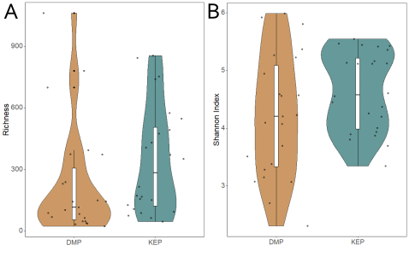
Figure S1: Alpha diversity measures indicate no significant differences by sampling locations. (A) Richness – ANOVA Fvalue=2.185, p=0.15. (B) Shannon index – ANOVA Fvalue=2.60, p=0.11.

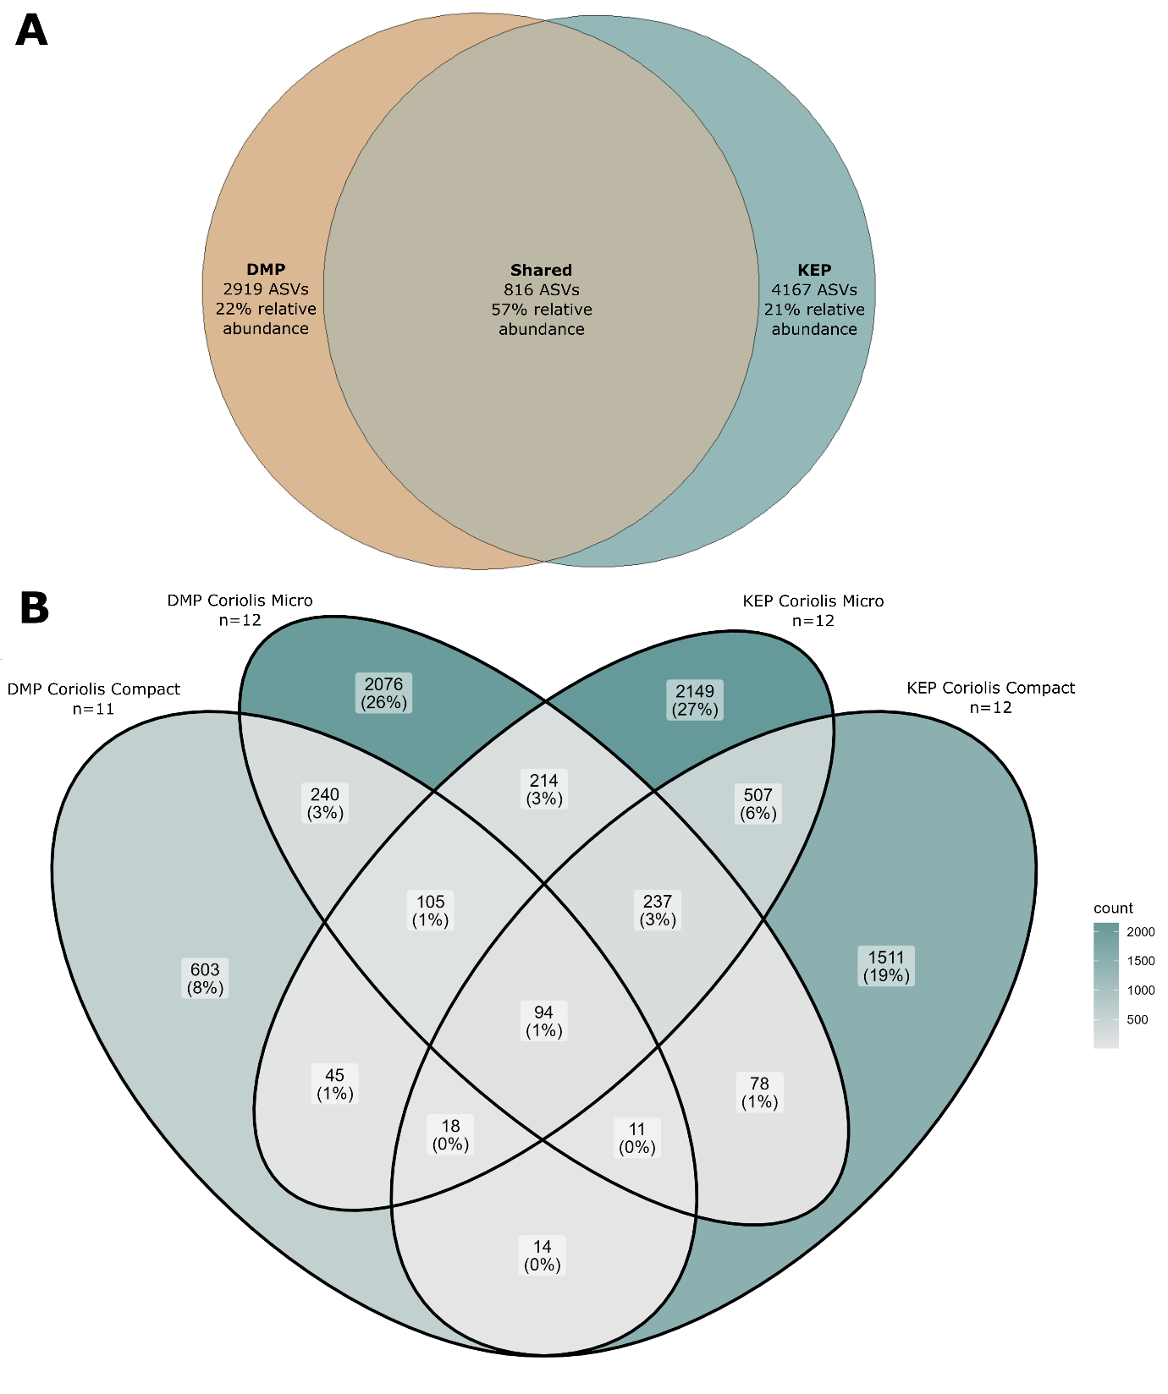
Figure S2: (A) Shared ASVs between each sample location (B) Shared ASVs between each sample location and instrument. The percentages indicate the proportion of the total number of ASVs assigned to each portion of the Venn diagram.

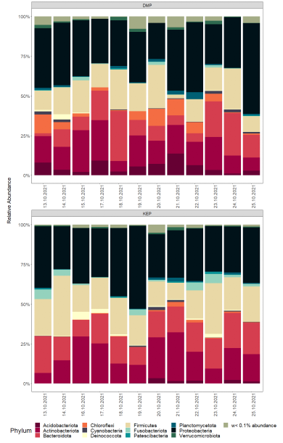
Figure S3: (A) Day to day relative abundance of bacteria at the phylum level differentiated by location.

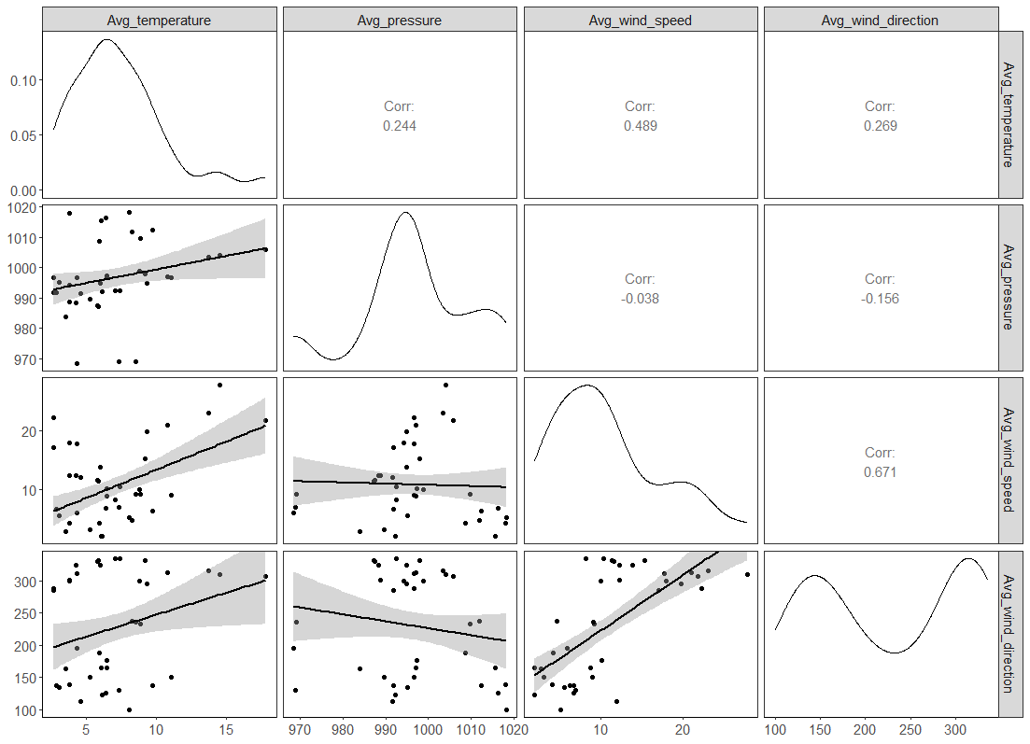
Figure S4: This figure shows pairwise scatterplots and Spearman correlations among four environmental variables. The diagonal panels display kernel density plots for the distributions of each variable. The lower triangle panels include scatterplots with linear regression fits and confidence intervals, highlighting potential trends. The upper triangle panels report Spearman correlation coefficients.

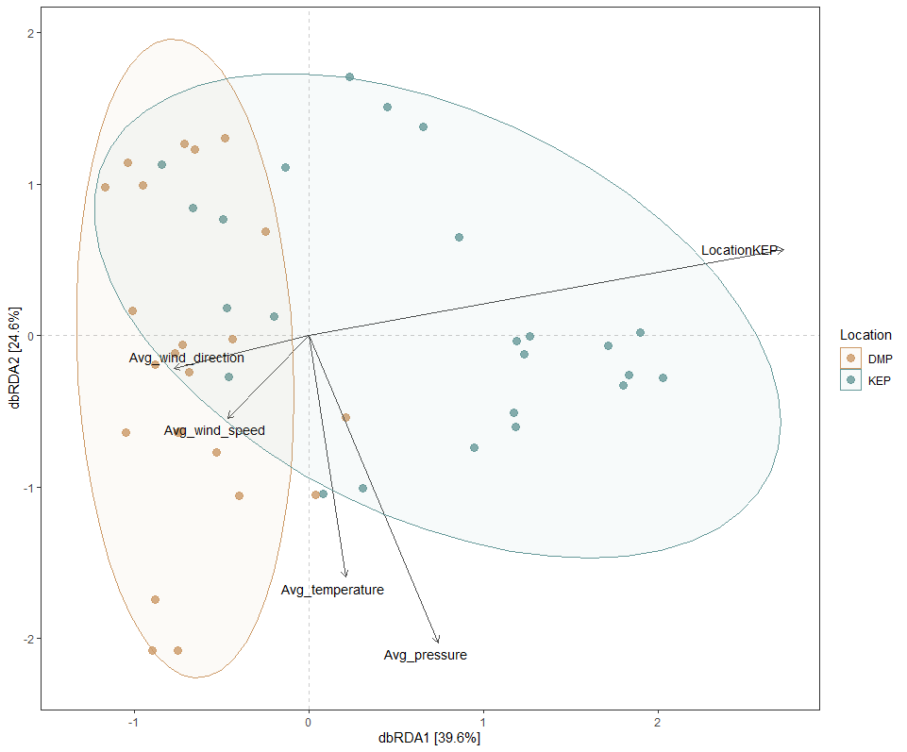
Figure S5: Distance based redundancy analysis showing the separation of samples by location and the influence of environmental variables

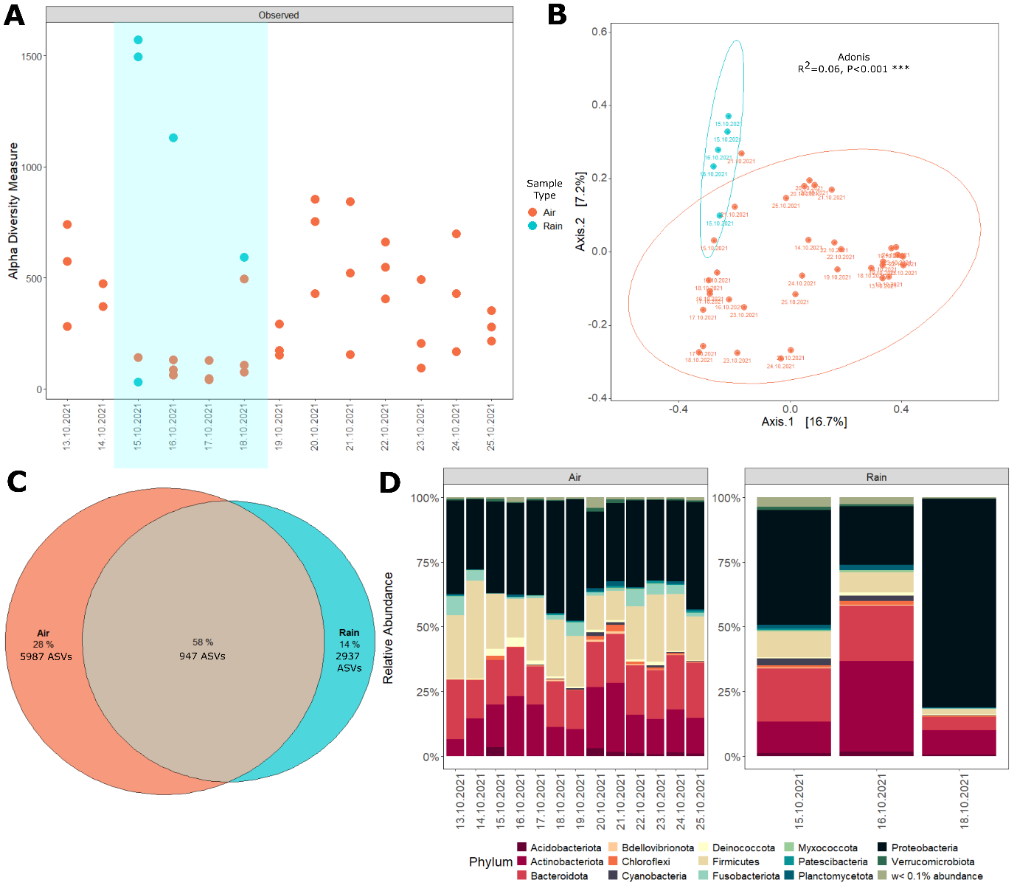
Figure S6: Precipitation events. (A) Richness by sample and sampling day. (B) PCoA (C) Venn diagram identifying shared ASVs. (D) Relative abundance of each sample, by sample type and sampling day.
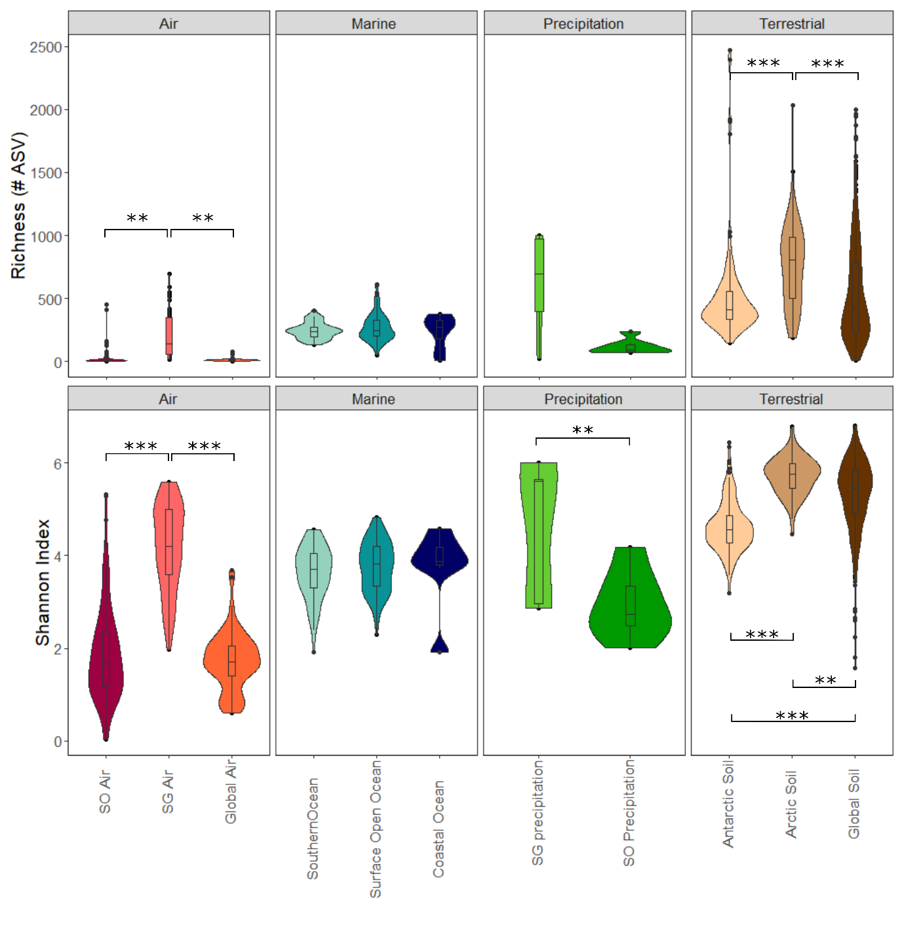
Figure S7: Alpha diversity metrics (Richness and Shannon Index). Differences were evaluated using ANOVA followed by Tukey's HSD test, with only statistically significant results displayed.
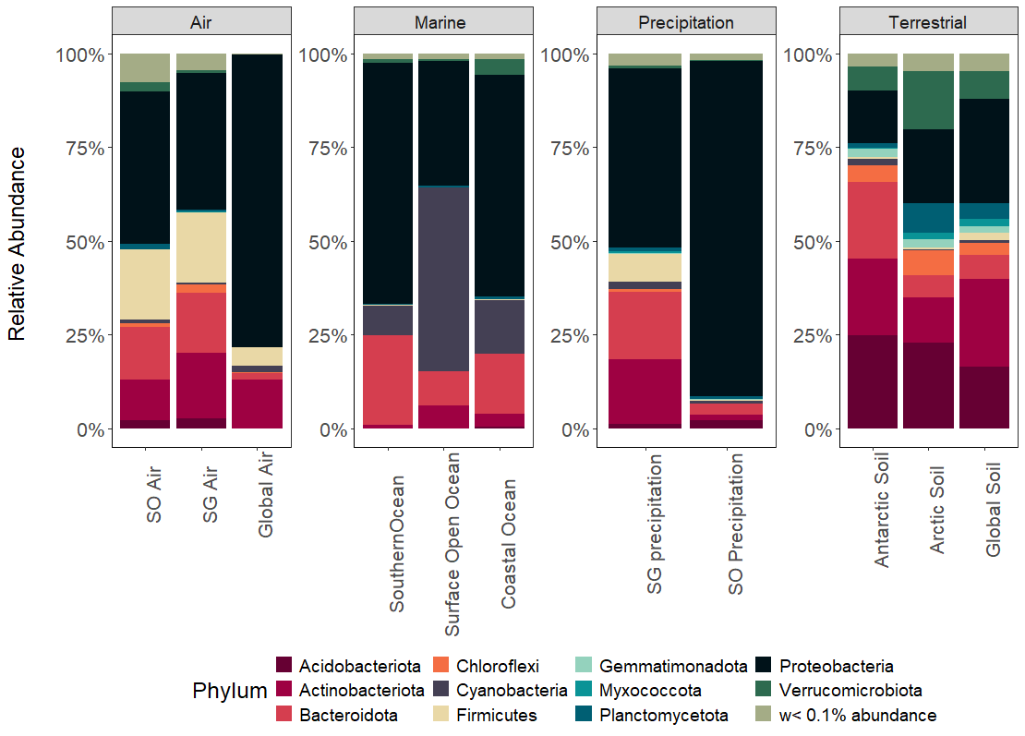
Figure S8: Relative abundance of bacteria at the phylum level for each sample type of the Global database. Phyla with less than 0.1% relative abundance are grouped together.

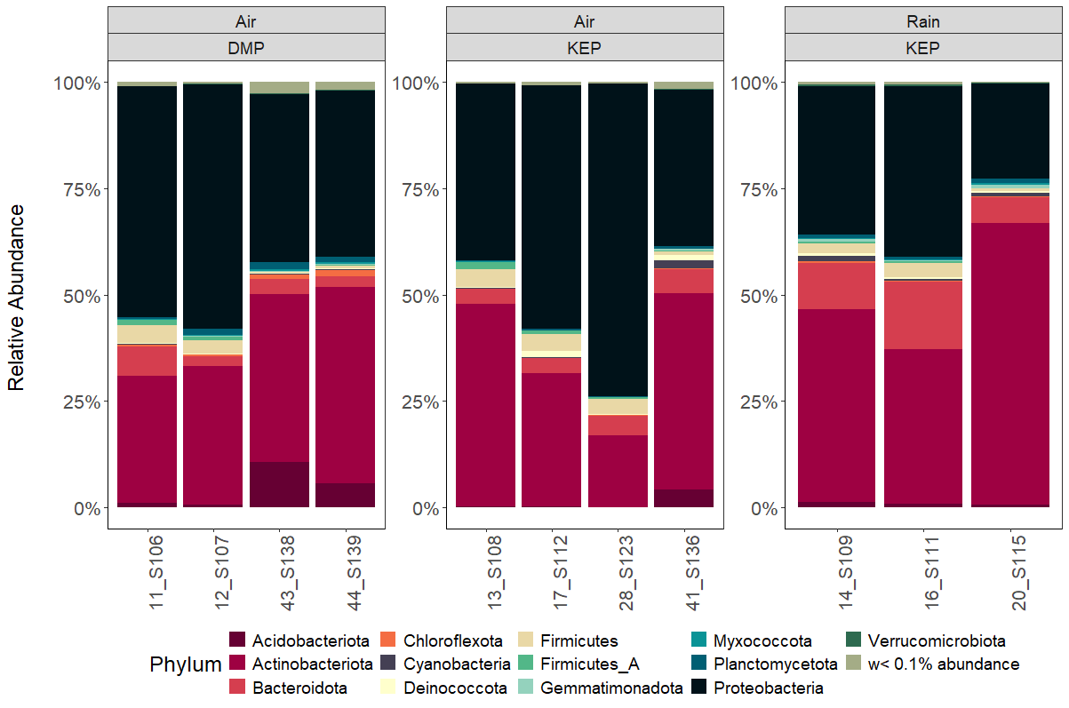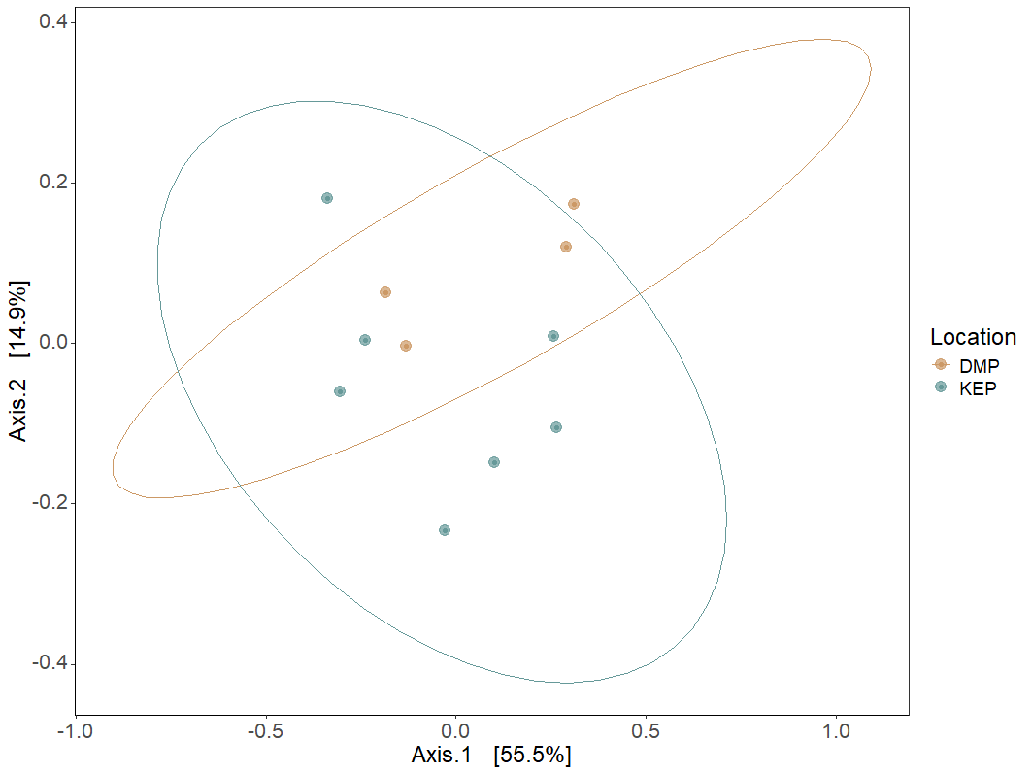
Figure S9: (A) Relative abundance of bacteria at the phylum level for each metagenomic sample by sample type. Phyla with less than 0.1% relative abundance are grouped together. (B) PCoA of the metagenomic samples.
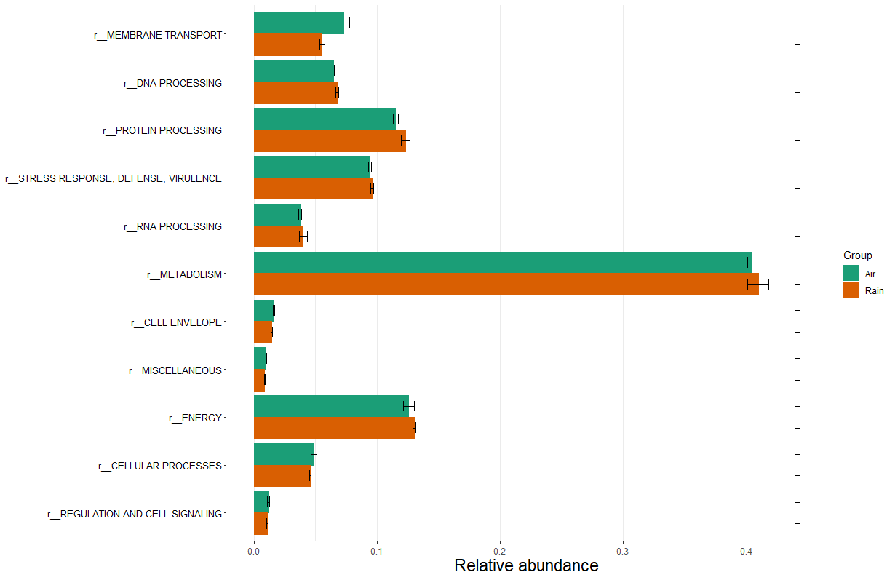
Figure S10: Differential analysis showing that no functional category is overrepresented between air samples and rain samples.

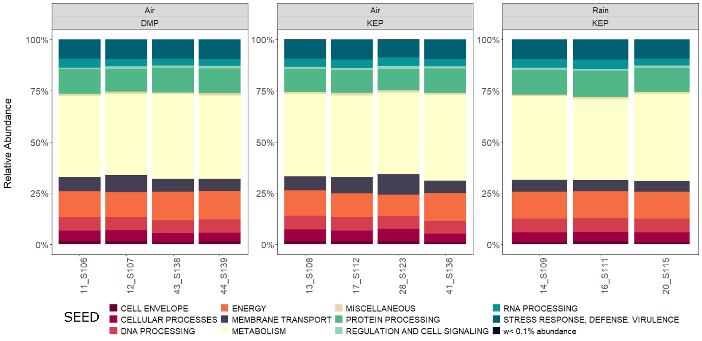
Figure 11: Relative abundance of functions, displayed for each sampling day and location and sample type.

Table S1: The relative abundance of ASVs per occurrence category, instrument and sampling location.
 | KEP |  | DMP
 | Coriolis Compact | Coriolis  Micro | Coriolis Compact | Coriolis  Micro
Common taxa | 5 | 9 | 7 | 6
Frequent taxa | 30 | 21 | 9 | 16
Occasional taxa | 30 | 35 | 28 | 36
Rare/Transient taxa | 35 | 35 | 56 | 42

Table S2: Distribution of ASVs across occurrence frequency categories, instruments and sampling site. The majority of ASVs fall into the Rare/Transient category, while only a few are classified as Common or Frequent.
 | KEP |  |  | DMP
 | Coriolis Compact | Coriolis  Micro | Shared | Coriolis Compact | Coriolis  Micro | Shared
Common taxa | 1 | 5 | 1 | 1 | 4 | 0
Frequent taxa | 28 | 21 | 30 | 2 | 35 | 1
Occasional taxa | 219 | 374 | 218 | 42 | 462 | 28
Rare/Transient taxa | 1682 | 2429 | 291 | 846 | 2315 | 210

