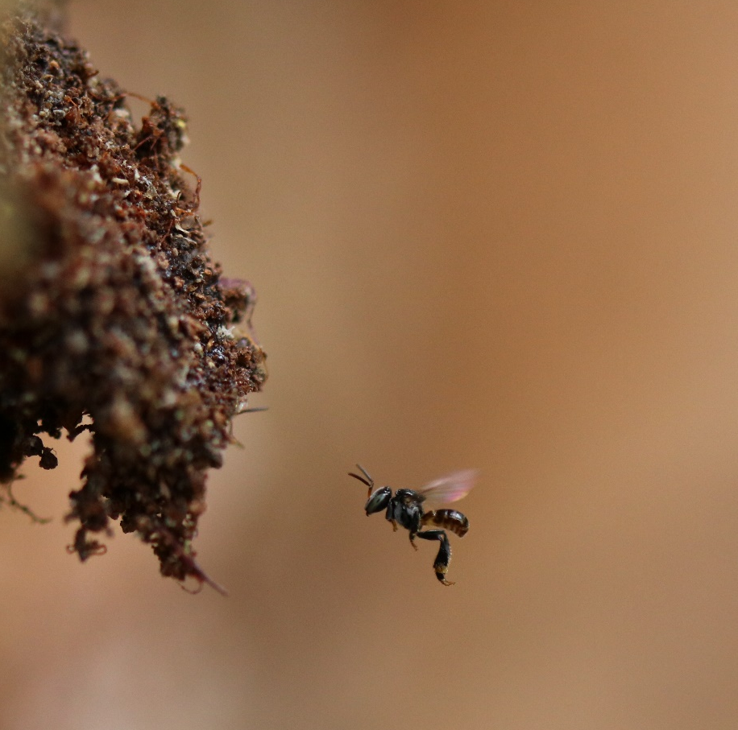

Plate. 1. T. iridipennisdisplaying iridescence
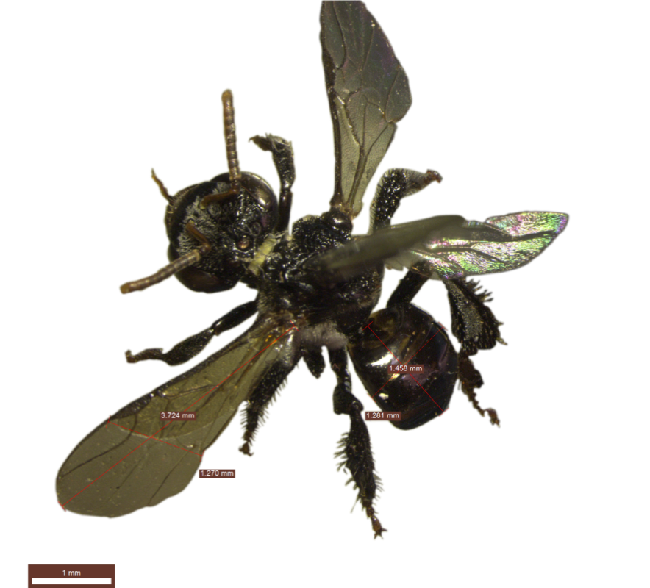

Plate. 2T. iridipennisunder Leica M 165C stereo microscope
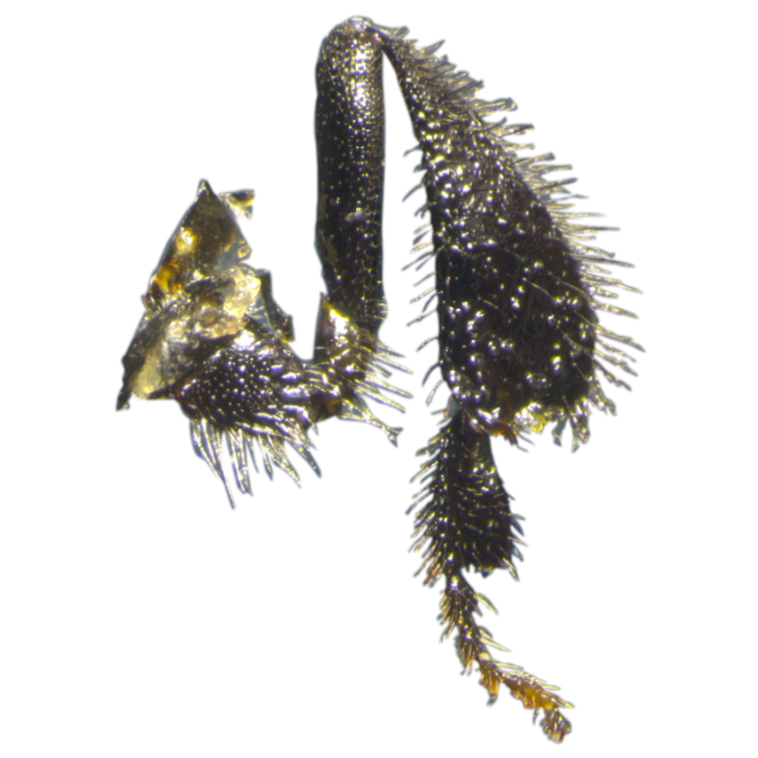

Plate 3.T. iridipennishind leg under Leica M 165C stereo microscope

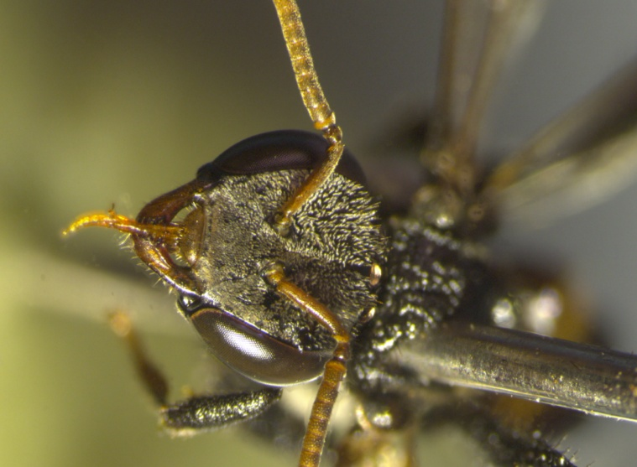

Plate 4. T. iridipennishead under Leica M 165C stereo microscope

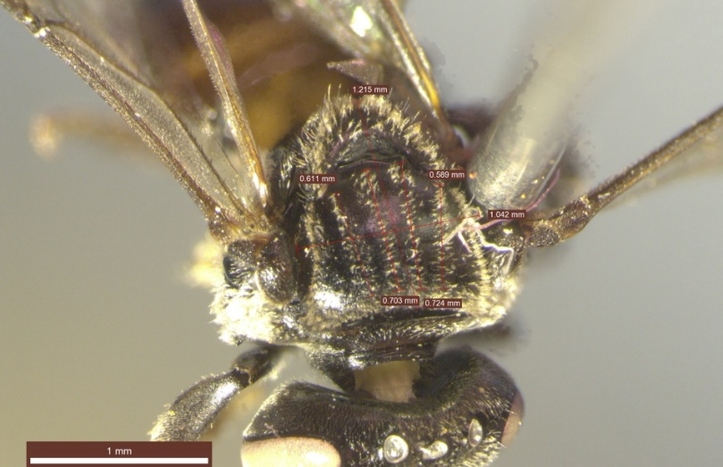

Plate 5. Four rows of hairy bands on dorsal surface of thorax region in T. iridipenni

Variable (Loadings)

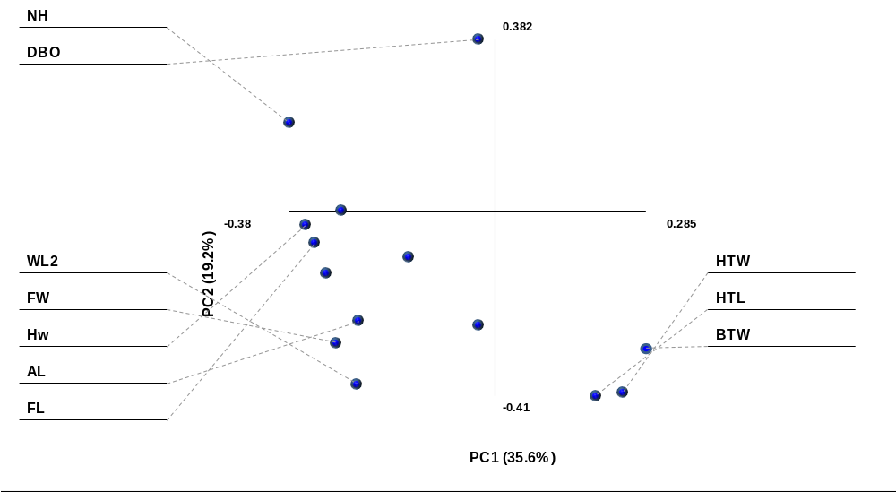

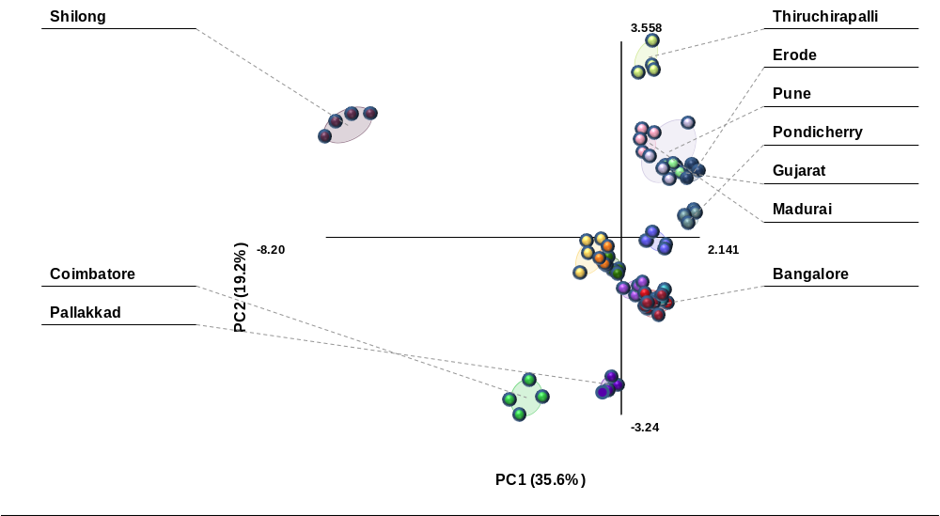
Sample (Score)

Plate 6. PCA of samples from seventeen locations

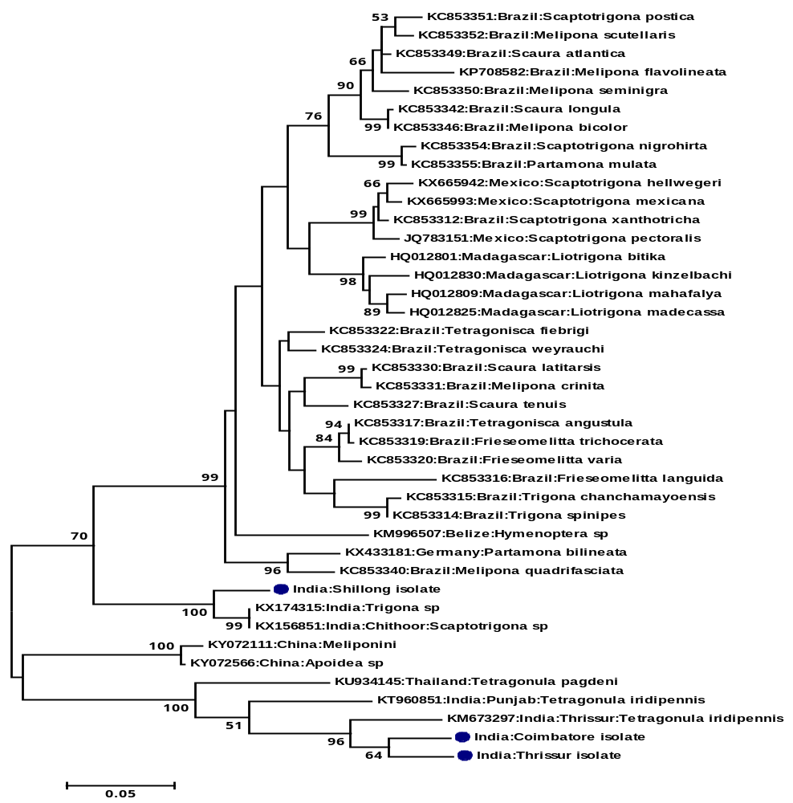
Plate 8. Phylogenetic analysis of Stinglessbees

