Supplemental Figure 1
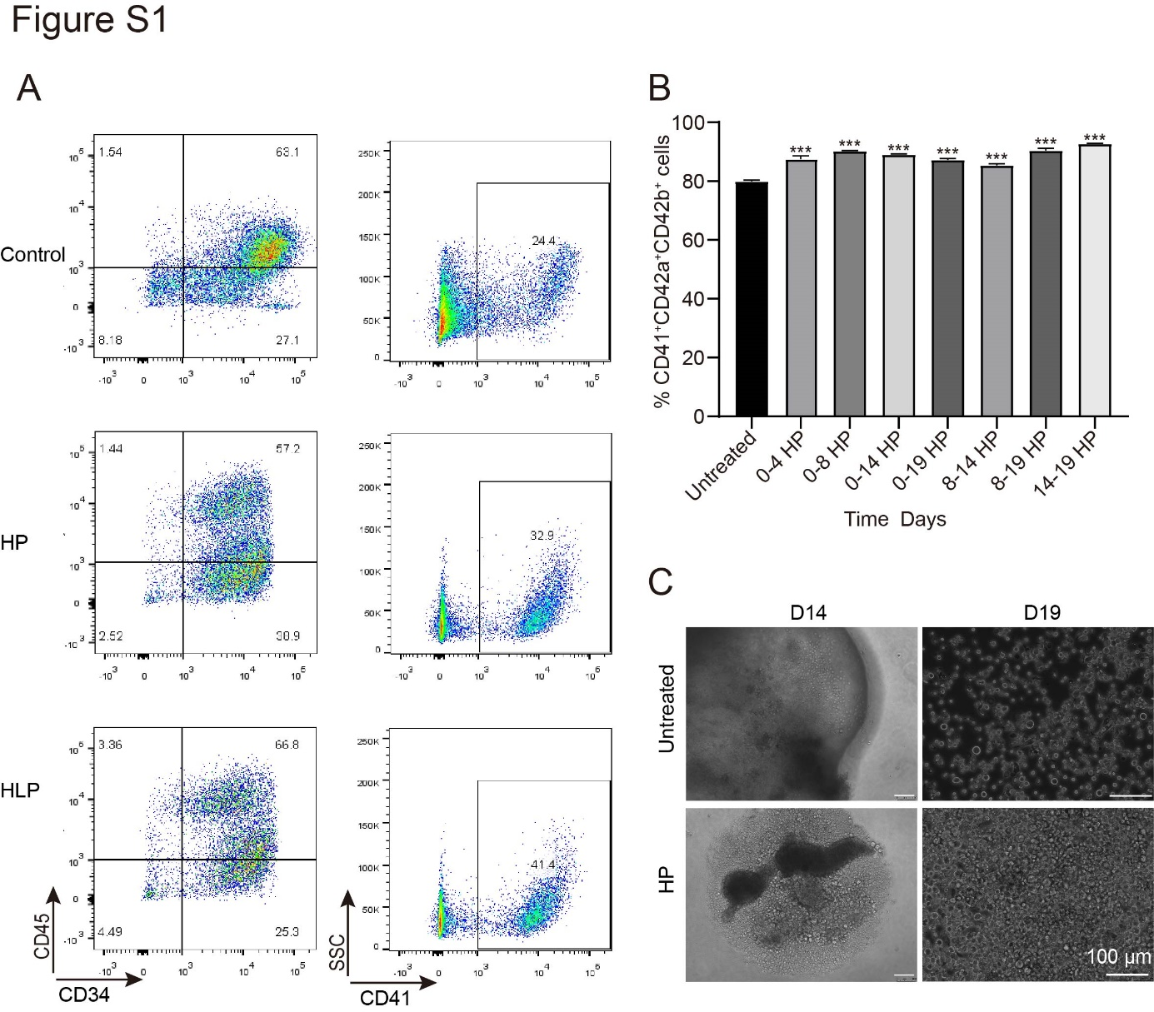
- Gating strategy for culture-derived CD34⁺CD45⁺, CD34⁺CD45⁻ and CD41⁺ cells on day 14, as analyzed by flow cytometry.
- The percentages of CD41⁺ CD42a⁺ CD42b⁺ cells produced in the untreated, 20% HP (days 0--4)-treated, 20% HP (days 0--8)-treated, 20% HP (days 0--14)-treated, 20% HP (days 0--19)-treated, 20% HP (days 8--14)-treated, 20% HP (days 8--19)-treated and 20% HP (days 14--19)-treated groups on day 19. (***P < 0.001)
- Representative images of EBs and cells released under a light microscope in the untreated and HP-treated groups on days 14 and 19. (Scale bar = 100 µm.)

Supplemental Figure 2
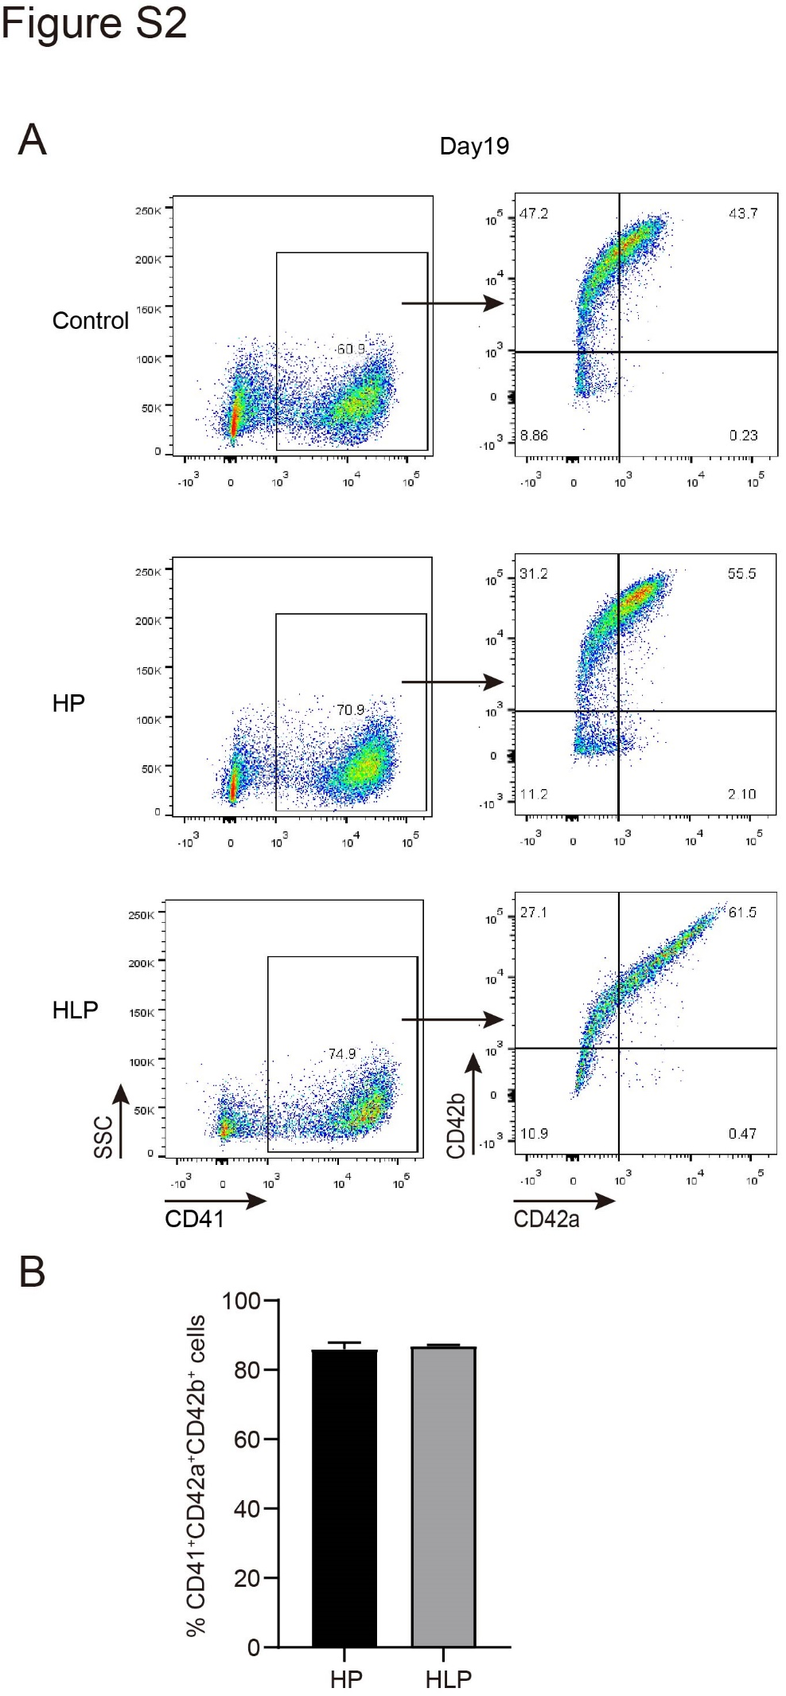
- Gating strategy for culture-derived CD41⁺, CD42a⁺CD42b⁻ and CD42a⁺CD42b⁺ cells on day 19, as analyzed by flow cytometry.
- The percentages of CD41⁺ CD42a⁺ CD42b⁺ cells produced in the HP-treated and HLP-treated groups on day 19.

Supplemental Figure 3
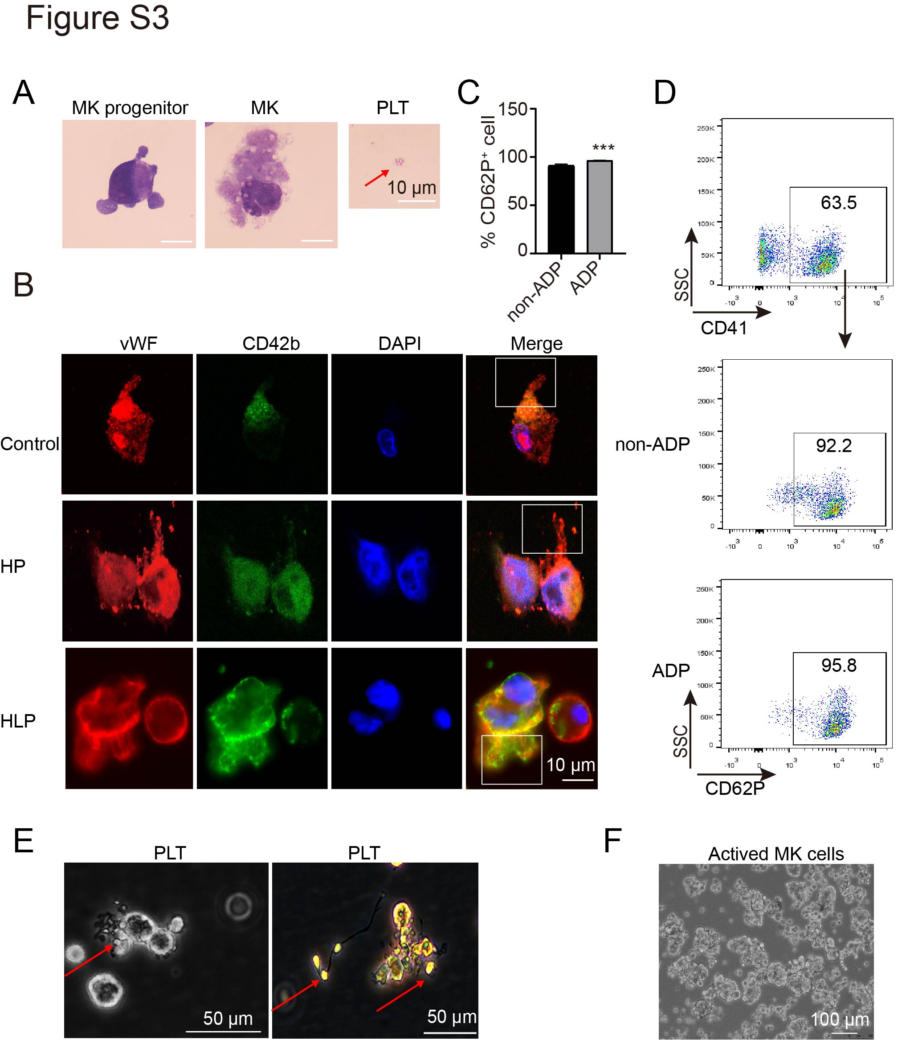
- Representative images of MKPs, MKs and platelet hiPSCs subjected to Wright‐Giemsa staining. (Scale bar = 10 µm.)
- Expression of vWF and CD42b in hiPSC-derived MKs in the control, HP-untreated and HLP-treated groups on day 19. The cells were stained with antibodies against vWF (red) and CD42b (green) and with DAPI (blue). (Scale bar = 10 µm.)
- The percentages of CD62P⁺ cells produced in the ADP-treated and non-ADP-treated groups on day 19. (***P < 0.001)
- Gating strategy for culture-derived CD62P⁺ cells on day 19, as analyzed by flow cytometry.
- The gray and color images of the platelets were observed under a light microscope under culture conditions. (Scale bar = 50 µm.)
- The aggregate cell mass was observed under a microscope. (Scale bar = 100 µm.)

Supplemental Figure 4
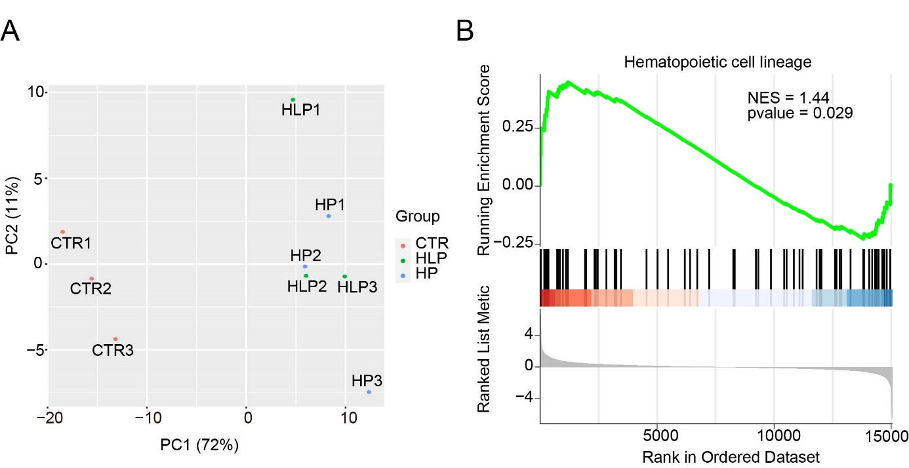
- PCA of gene expression in cells obtained from the control, HP-untreated and HLP-treated groups on day 14.
- Gene set enrichment analysis (GSEA, www.broadinstitute.org/gsea/).

Supplemental Figure 5
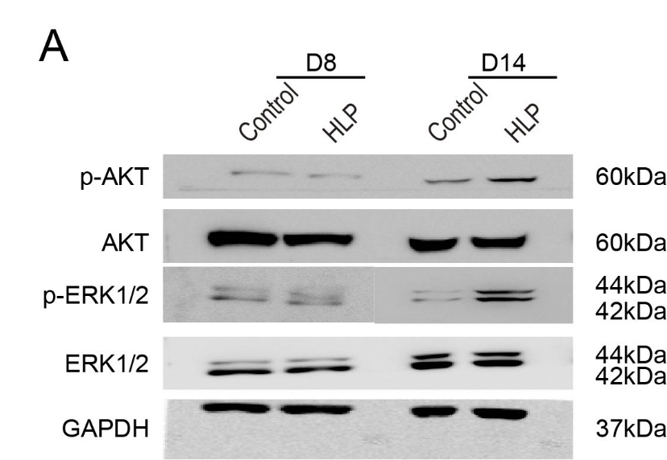
（A）Full-length blots of Figure 5A.

