Supplemental Materials

Self-lubricating properties of carbon filled oblique angle deposition porous TiN coating
Kai Le^{a,b} , Ke Li^{c}, Yuzhen Liu^{d}, Huijie Zhangª, Lina Gao^{a,b}, Yong Luo^{c*}, Shusheng Xu^{a,b*}
ª State Key Laboratory of Solid Lubrication, Lanzhou Institute of Chemical Physics, Chinese Academy of Sciences, Lanzhou 730000, China
^{b} Shandong Laboratory of Advanced Materials and Green Manufacturing at Yantai, Yantai 264000, China
^{c} China School of Chemical Engineering and Technology, China University of Mining and Technology, Xuzhou 221116, China
^{d} Department of Mechanical Engineering, Yonsei University, Seoul, 03722, Republic of Korea

*Corresponding author.
E-mail address: sulyflying@cumt.edu.cn (Y. Luo), ssxu@licp.cas.cn (S. Xu).

Fig. S1 Friction coefficient curves of DTC, OT_{0.8} and OTC_{0.8} coatings.

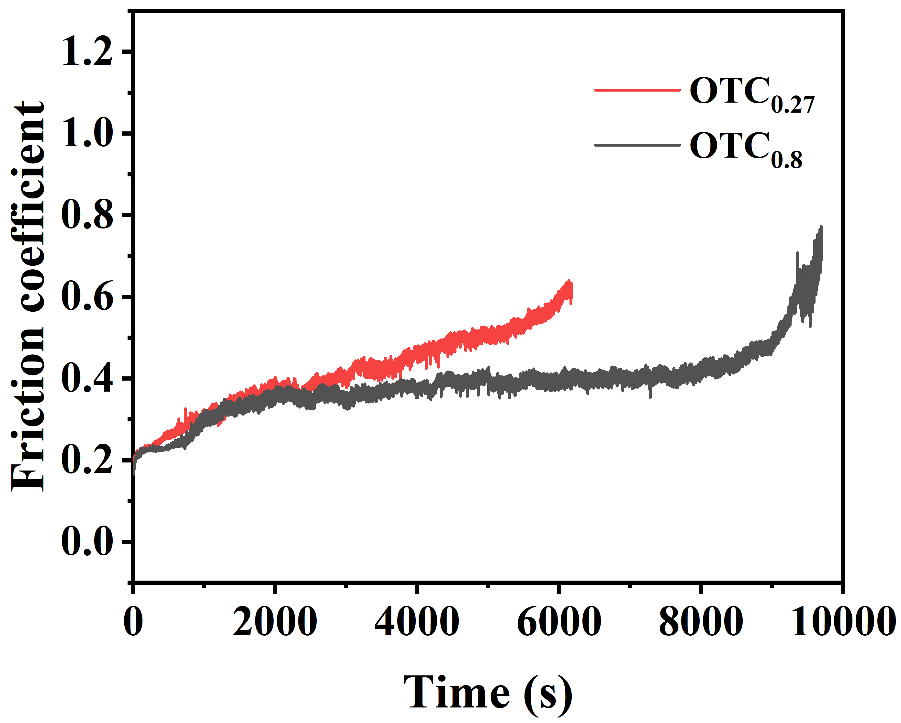
Fig. S2 Friction coefficient curves of OTC_{0.27} and OTC_{0.8} coatings.

