Supporting Information
Discovery of SARS-CoV-2 papain-like protease inhibitors through machine learning and molecular simulation approaches

Li Li¹, Jinyang Li¹, Quanling Zhang¹, Yifei Huang², Yongxin Bao ^{1,3,}*, Xiaowen Tang^{1,}*

¹ Department of Medicinal Chemistry, School of Pharmacy, Qingdao University, Qingdao 266071, China
² College of Life Sciences, Qingdao University, Qingdao 266071, China
³ Qingdao Women and Children's Hospital Affiliated to Qingdao University, Qingdao 266034, China

* Correspondence should be addressed to:
Y. Bao (byx285788575@163.com) or X. Tang (xwtang1219@qdu.edu.cn)

Table of contents
Table S1…………………………………………………………………………….S2
Table S2…………………………………………………………………………….S3
Table S3…………………………………………………………………………….S4
Table S4…………………………………………………………………………….S5
Table S5…………………………………………………………………………….S6
Figure S1……………………………………………………………………………S7
Figure S2……………………………………………………………………………S8
Figure S3……………………………………………………………………………S9
Table S1. The full name, bits, and source of the fingerprints and descriptors.
Abbreviation | Full name | Bits | Source
MorganFP | Extended Connectivity Fingerprints | 1024 | https:// doi.org/10.1021/ci100050t
E-stateFP | Estate Fingerprints | 78 | https://doi.org/10.1021/ci00028a014
Atom-PairFP | Atom-Pair fingerprints | 167 | https://rdkit.org/docs/index.html
MACCSFP | Molecular Accession System Keys fingerprints | 167 | https://doi.org/10.1021/ci010132r
AvalonFP | Avalon fingerprints | 512 | https://rdkit.org/docs/index.html
RDKit-Des | RDKit descriptors | 2048 | https://doi.org/10.1186/s13321-020-00456-1

Table S2. Performance for classification models in internal validation.
Algorithm | Fingerprint | Accuracy | precision | recall | Specificity
Random Forest  (RF) | MACCS | 0.82 | 0.77 | 0.82 | 0.97
Random Forest  (RF) | Atom-Pair | 0.82 | 0.77 | 0.82 | 0.96
Random Forest  (RF) | E-state | 0.85 | 0.83 | 0.85 | 0.99
Random Forest  (RF) | Avalon | 0.85 | 0.86 | 0.85 | 0.99
Random Forest  (RF) | RDKit-Des | 0.82 | 0.78 | 0.82 | 0.98

Table S3. Performance for classification models in external validation.
Algorithm | Fingerprint | Accuracy | precision | recall | Specificity
Random Forest  (RF) | MACCS | 0.98 | 0.98 | 0.98 | 0.99
Random Forest  (RF) | Atom-Pair | 0.94 | 0.91 | 0.94 | 0.98
Random Forest  (RF) | E-state | 0.96 | 0.96 | 0.96 | 0.98
Random Forest  (RF) | Avalon | 0.96 | 0.95 | 0.96 | 0.98
Random Forest  (RF) | RDKit-Des | 0.85 | 0.86 | 0.86 | 0.89

Table S4. The molecular docking scores of 44 compounds. Two positive control compounds are highlighted in bold, while the remaining 42 compounds are sourced from the ZINC database and the COVID Moonshot platform.
Name | Score
ZINC000003875393 | -7.10
ZINC000008552123 | -7.08
ZINC000000005423 | -6.98
MAR-UNI-c84db004-17 | -6.97
ZINC000000601283 | -6.95
ZINC000096942202 | -6.86
ZINC000096942201 | -6.84
ZINC000003787097 | -6.81
ZINC000005733652 | -6.72
ZINC000000049153 | -6.44
ZINC000001530968 | -6.29
ZINC000003812865 | -6.09
ZINC000013585233 | -6.00
ZINC000004228257 | -5.98
ZINC000019168887 | -5.48
ZINC000000020243 | -5.23
ZINC000003831475 | -4.86
ZINC000001532526 | -4.85
ZINC000003831474 | -4.63
ZINC000003831477 | -4.58
ZINC000000002028 | -4.30
ZINC000005133378 | -4.26

Name | Score
Jun12682 | -9.57
ZINC000003986735 | -9.38
ZINC000003794794 | -8.49
ZINC000072267023 | -8.41
ZINC000003990451 | -8.40
ZINC000021297660 | -8.13
ZINC000043207238 | -8.09
ZINC000001529323 | -7.99
ZINC000003798734 | -7.88
ZINC000030691760 | -7.82
SAL-UNI-60119594-9 | -7.79
ZINC000003952881 | -7.70
ZINC000004693575 | -7.45
ZINC000003830986 | -7.39
ZINC000040899447 | -7.37
ZINC000003875392 | -7.35
GRL0617 | -7.32
ZINC000003831490 | -7.31
ZINC000000599734 | -7.30
ZINC000004693574 | -7.23
ZINC000000000751 | -7.21
ZINC000030691763 | -7.21

Table S5. The occupancy and residues involved in hydrogen bonding with ligand molecules in the four protein–ligand complex systems were analyzed during the 100 ns simulation trajectory.

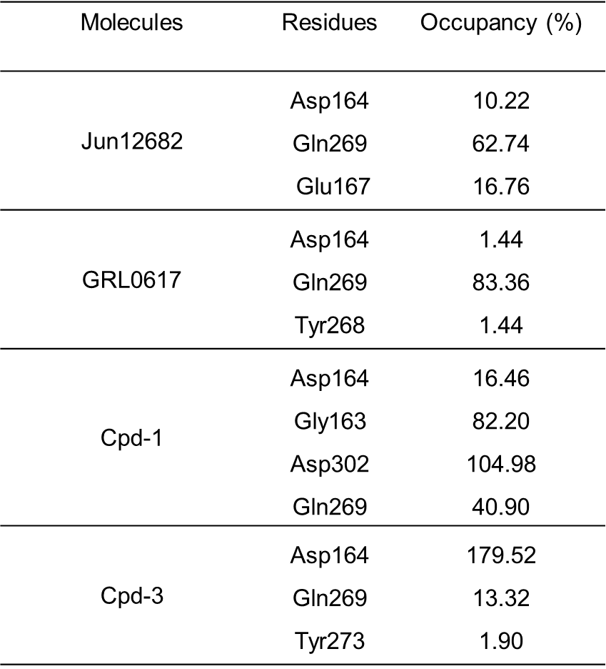

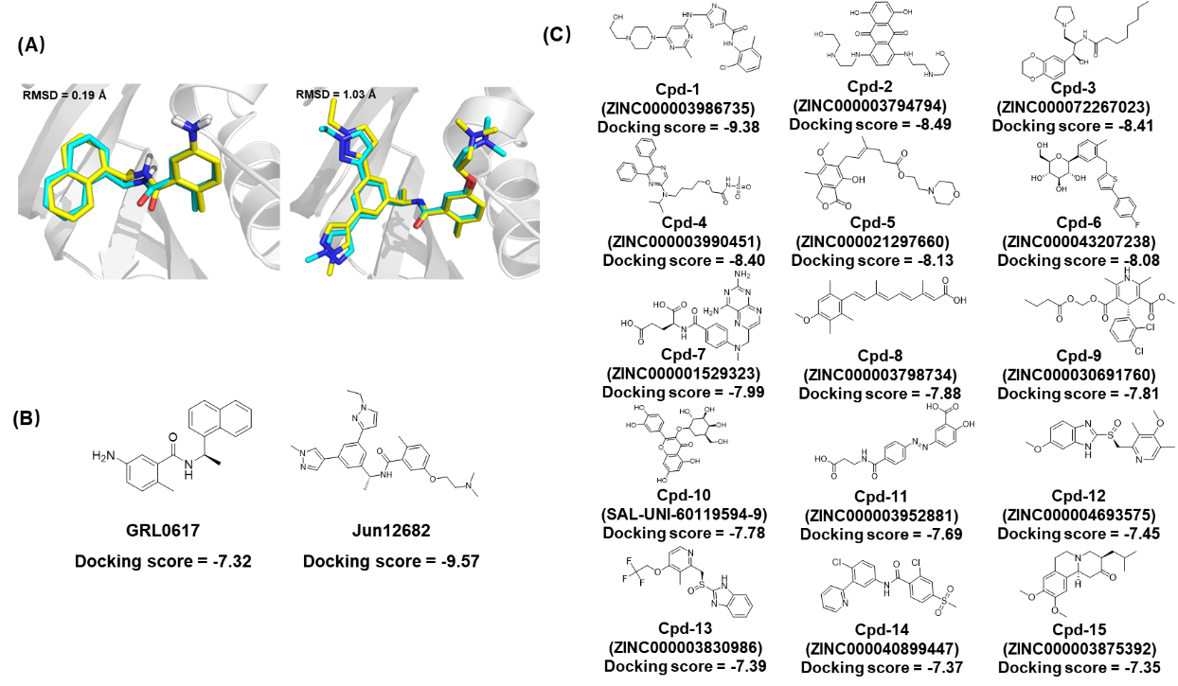
Figure S1. Redocking conformation superposition of GRL0617 and Jun12682 (A). Yellow represents the crystal molecule, while cyan represents the re-docked molecule. Chemical structures and docking scores (kcal/mol) of GRL0617, Jun12682 (B), and the top 15 compounds (C).

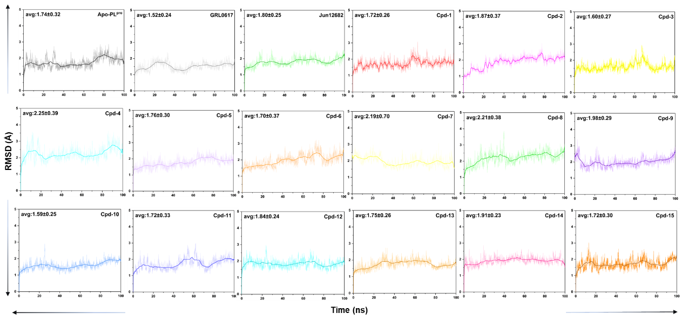
Figure S2. RMSD analysis of 17 systems, including PLpro in the free state (7CJM), PLpro-GRL0617, PLpro-Jun12682, and selected inhibitors (Cpd-1 to Cpd-15), over a 100 ns simulation time.

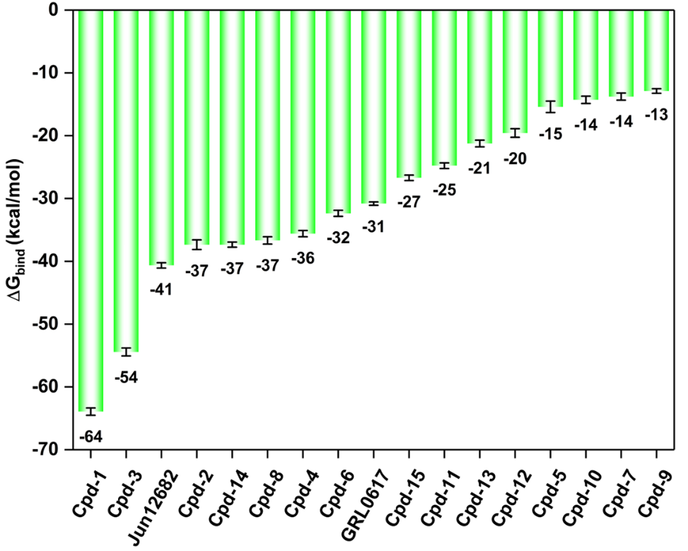
Figure S3. Binding free energy (kcal/mol) for the top 15 compounds. GRL0617 and Jun12682 are serve as positive controls.

