Supporting Information

Scalable Synthesis of Self-Assembling Monodisperse Phosphorescent Nanospheres Enabling Multi-Mode Angle-Dependent and Thermal-Responsive Photonic Gels

Changxing Wang, Yayun Ning, Yifan Yue, Guoli Du, Yuechi Xie, Jianing Li, Nazia Bibi, Xiaoxiang Wen, Jianing Li, Sen Yang,* Xuegang Lu*

Table of Contents

Supplementary Fig. 1 Diameter distribution of RTP SiO₂ NPs
Supplementary Fig. 2 Morphology and diameter of uncalcined glucose doped SiO₂ NPs
Supplementary Fig. 3 Distribution of chemical elements of pure SiO₂ NPs
Supplementary Fig. 4 The morphology and diameter distribution of RTP SiO₂ NPs with different particle sizes
Supplementary Fig. 5 Fluorescence excitation dependence of RTP SiO₂ NPs
Supplementary Fig. 6 Afterglow photographs of RTP SiO₂ NPs powders
Supplementary Fig. 7 Temperature dependence of afterglow properties of RTP SiO₂ NPs
Supplementary Fig. 8 Luminescence stability of RTP SiO₂ NPs
Supplementary Fig. 9 Morphological characterization of RTP SiO₂ NPs after self-assembly
Supplementary Fig. 10 Optical characterization of PCs constructed from RTP SiO₂ NPs with different particle sizes
Supplementary Fig. 11 Photographs of three optical morphologies of multimode PCs
Supplementary Fig. 12 Angle-dependent reflection spectra of multimode PCs
Supplementary Fig. 13 FL and RTP characteristics of multimode PCs assembled with different particle sizes of RTP SiO₂ NPs
Supplementary Fig. 14 Afterglow photos of multimode PCs
Supplementary Fig. 15 Morphology and particle size distribution of CDs generated in situ inside SiO₂ NPs
Supplementary Fig. 16 Calcination temperature dependent RTP characteristics of RTP SiO₂ NPs
Supplementary Fig. 17 Relationship between RTP lifetime of RTP SiO₂ NPs and calcination temperature
Supplementary Fig. 18 Relationship between FL lifetime of RTP SiO₂ NPs and calcination temperature
Supplementary Fig. 19 Quantum yield of RTP SiO₂ NPs
Supplementary Fig. 20 The degree of crystallization of in situ CDs in RTP SiO₂ NPs
Supplementary Fig. 21 FT-IR spectra of RTP SiO₂ NPs
Supplementary Fig. 22 High-resolution Si 2p results of RTP SiO₂ NPs
Supplementary Fig. 23 High-resolution C 1s results of RTP SiO₂ NPs
Supplementary Fig. 24 High-resolution O 1s results of RTP SiO₂ NPs
Supplementary Fig. 25 Absorption characteristic of RTP SiO₂ NPs
Supplementary Fig. 26 Three CDs calculation models based on HR-TEM and chemical characterization
Supplementary Fig. 27 Quantum chemical calculations for three kinds of CDs models
Supplementary Fig. 28 Results of the validation of the universality of the method
Supplementary Fig. 29 Physical microstructure characterization of multimode PC gels
Supplementary Fig. 30 Angle-dependent PBGs of R-PC gel
Supplementary Fig. 31 Multimode angle-dependent chromatic properties of disordered micro-structured R-PC gel
Supplementary Fig. 32 Angle-dependent PBGs of B-PC gel and G-PC gel
Supplementary Fig. 33 Multimode angle-dependent chromatic properties of G-PC gel
Supplementary Fig. 34 Multimode angle-dependent chromatic properties of B-PC gel
Supplementary Fig. 35 Optical behavior of the incident angle of excitation light on R-PC gel
Supplementary Fig. 36 Variation of RTP lifetime on the incident angle of excitation light
Supplementary Fig. 37 Thermal transition properties of transparent states and scattering states of R-PC gel
Supplementary Fig. 38 Enhanced behavior of UV excited light in the scattered state
Supplementary Fig. 39 FL Lifetime of R-PC gel in refractive index matched state and mismatched state
Supplementary Fig. 40 Optical properties of RTP SiO₂ NPs
Supplementary Fig. 41 RTP thermochromic properties of R-PC gel
Supplementary Fig. 42 Scattering enhancement at low temperatures leads to PBG destruction

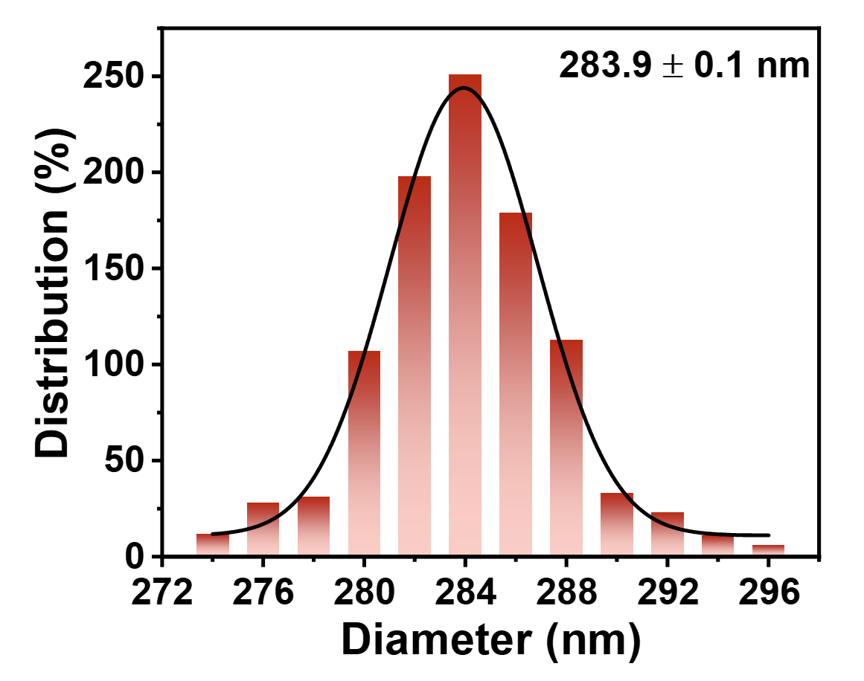
Supplementary Fig. 1 Particle size distribution of RTP SiO₂ NPs measured by TEM.

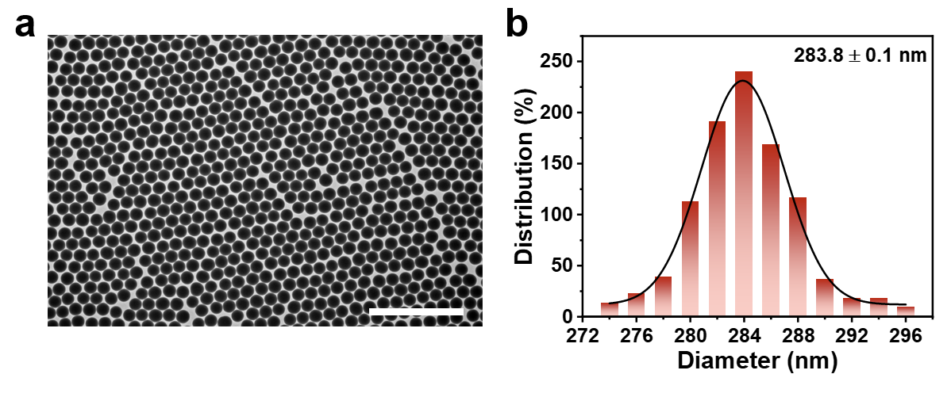
Supplementary Fig. 2 a TEM image of uncalcined glucose molecules doped SiO₂ NPs (Scale bar: 2 µm). b The particle size distribution of uncalcined glucose molecules doped SiO₂ NPs.

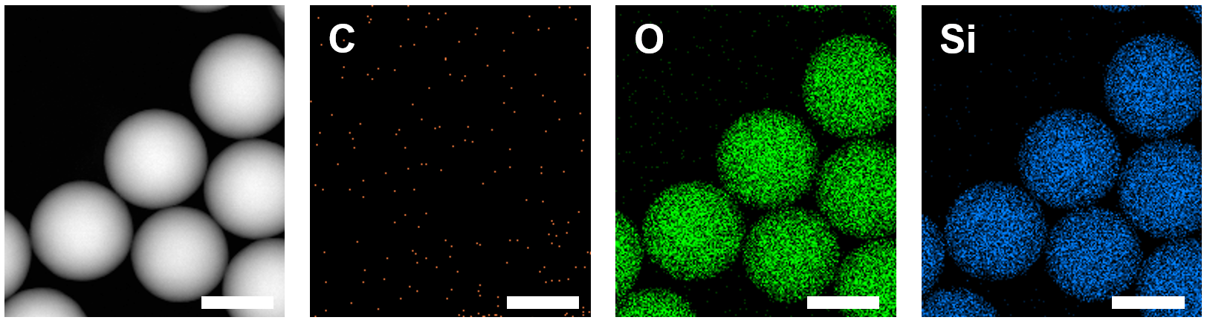
Supplementary Fig. 3 HAADF-STEM and EDS elemental mapping images of pure SiO₂ NPs (Scale bar: 200 nm).

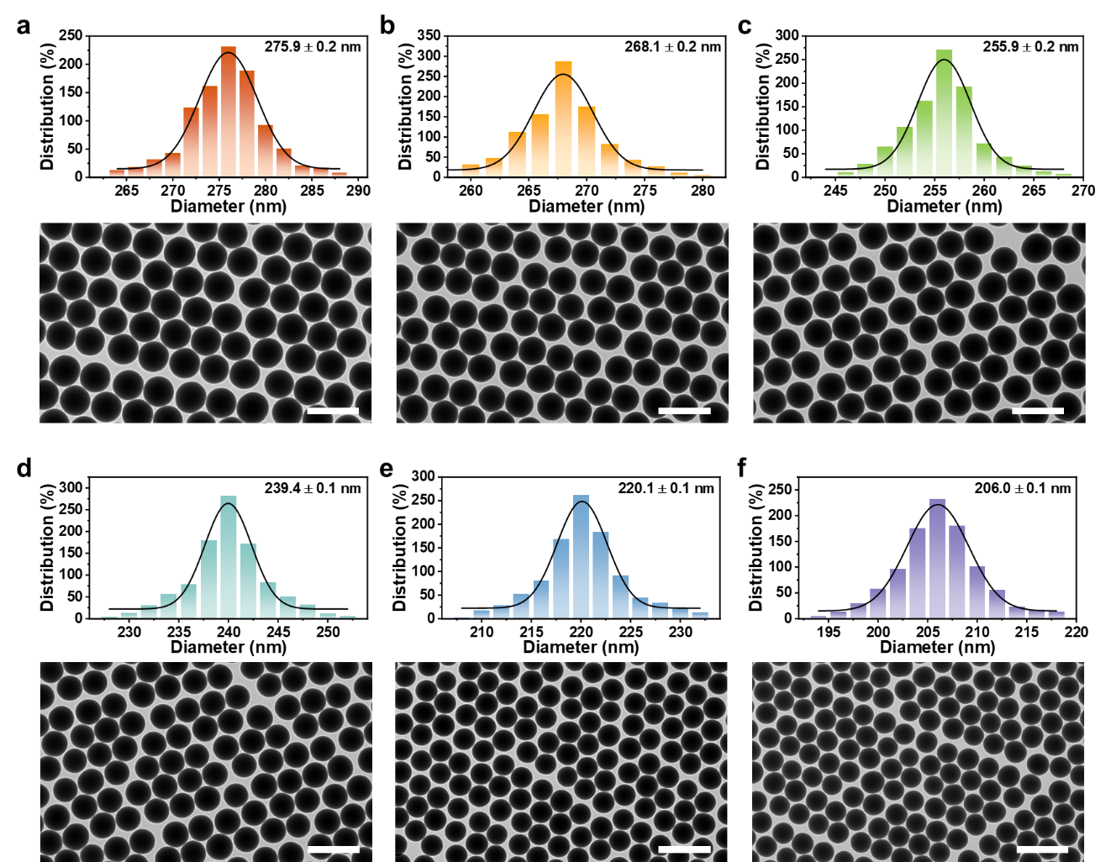
Supplementary Fig. 4 TEM images of synthesized RTP SiO₂ NPs with different particle sizes and corresponding particle size distribution (Scale bar: 500 nm).

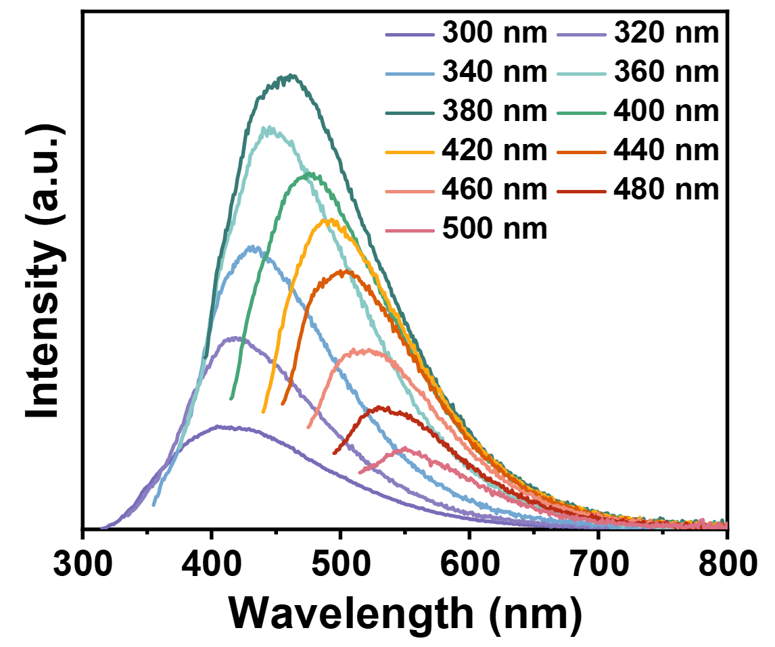
Supplementary Fig. 5 Excitation-dependent FL spectra of RTP SiO₂ NPs.

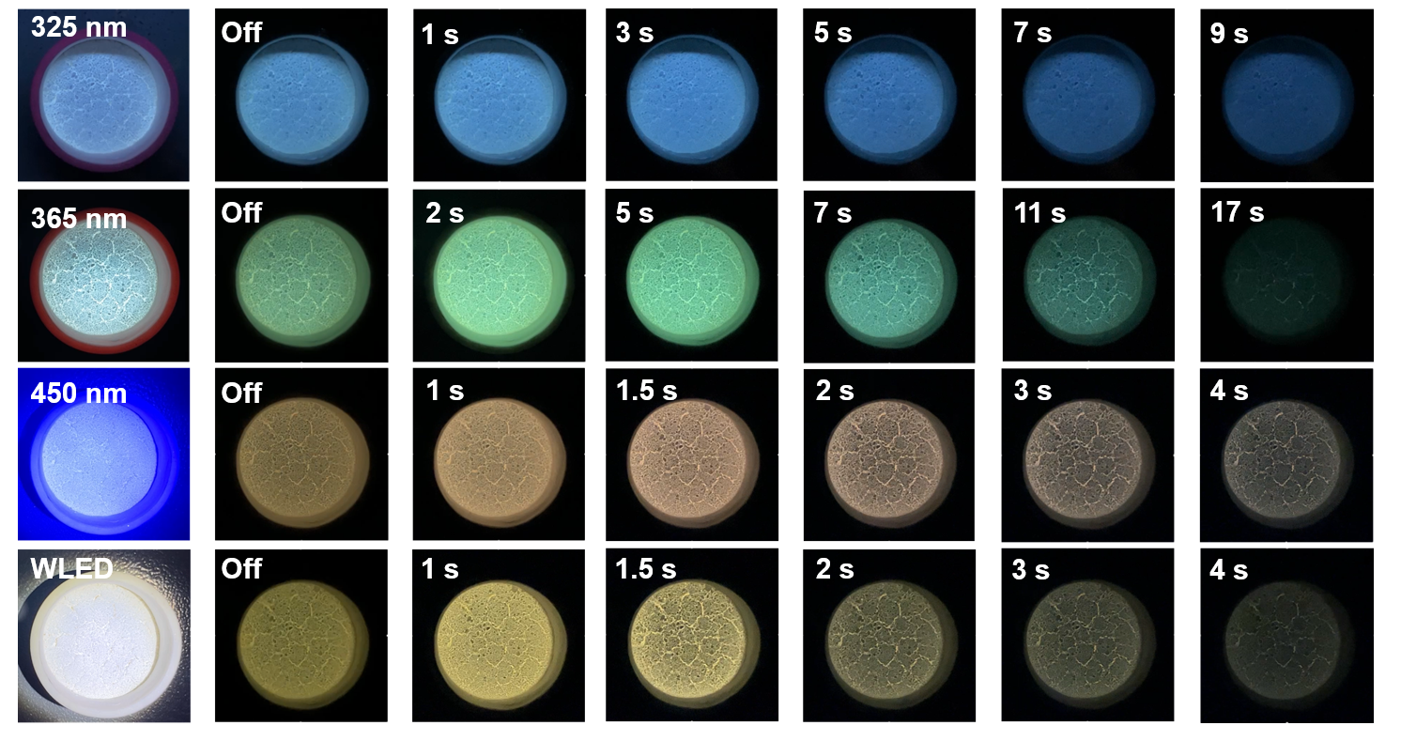
Supplementary Fig. 6 The afterglow photographs of RTP SiO₂ NPs taken at different time delay intervals and different excitation.

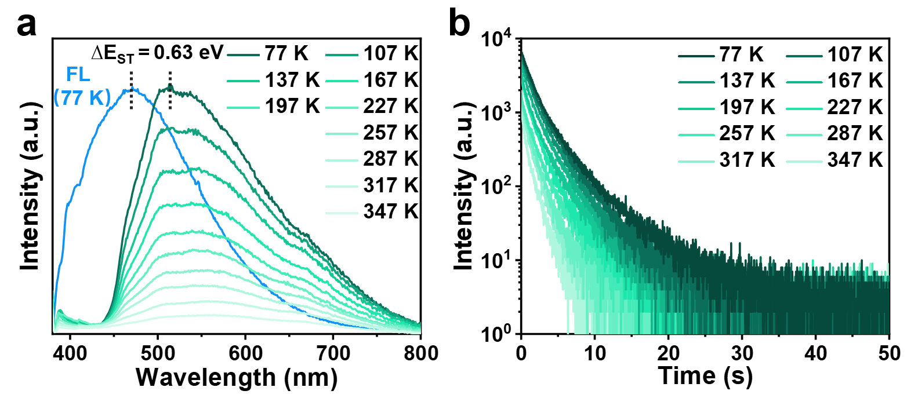
Supplementary Fig. 7 a Temperature-dependent afterglow spectra and b Temperature-dependent time-resolved afterglow decay spectra of RTP SiO₂ NPs under 365 nm excitation.

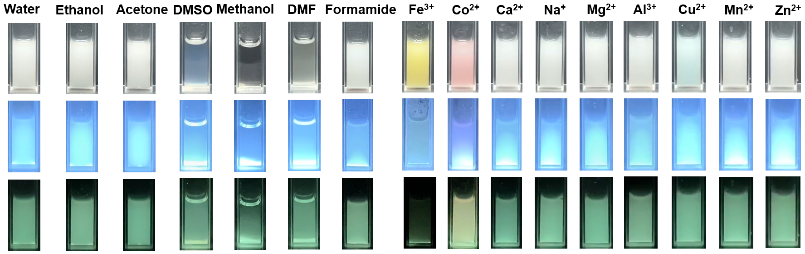
Supplementary Fig. 8 The afterglow photographs of RTP SiO₂ NPs dispersed in different organic solvents and metal ion solutions (1 M).

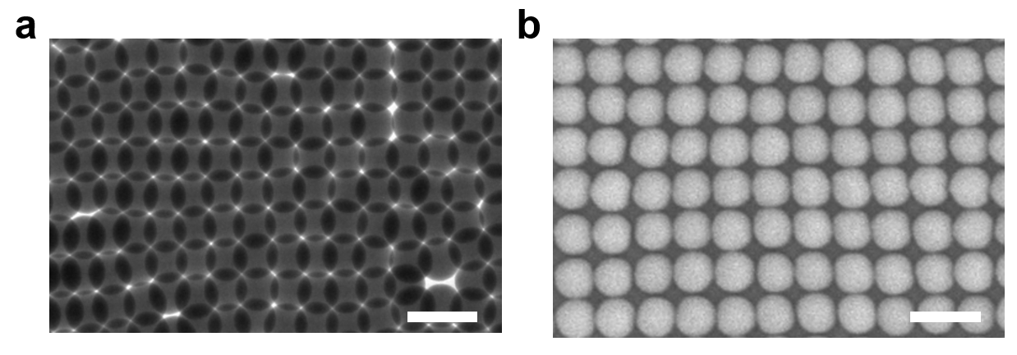
Supplementary Fig. 9 a TEM and b SEM images of RTP SiO₂ NPs in the simple cubic close-packed state (Scale bar: 500 nm).

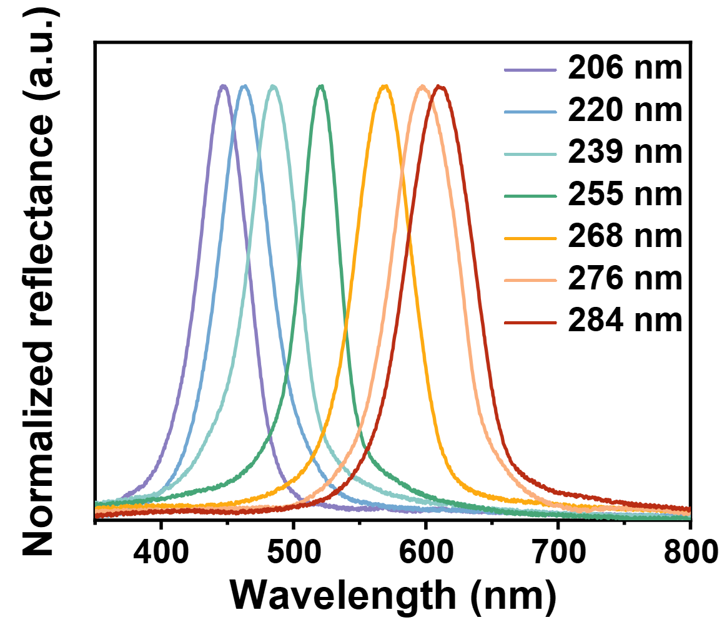
Supplementary Fig. 10 The normalized reflection spectra of the multimodal PCs assembled by RTP SiO₂ NPs with different diameters, θ=90º.

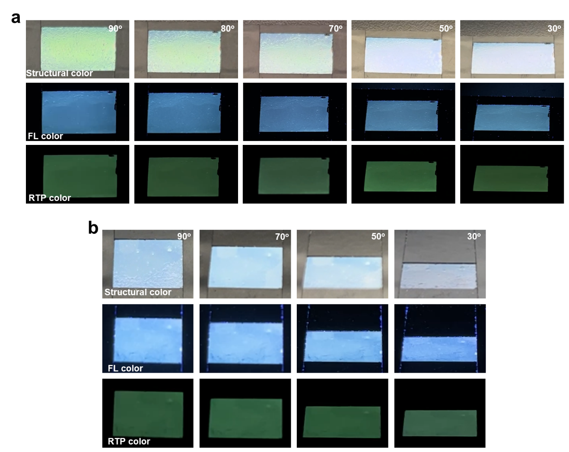
Supplementary Fig. 11 The photographs of the angle-dependent structural colors, FL and RTP of the multi-modal PCs self-assembled by NPs diameter of a 239 nm and b 220 nm under daylight, 365 nm UV lamp on and off, respectively.

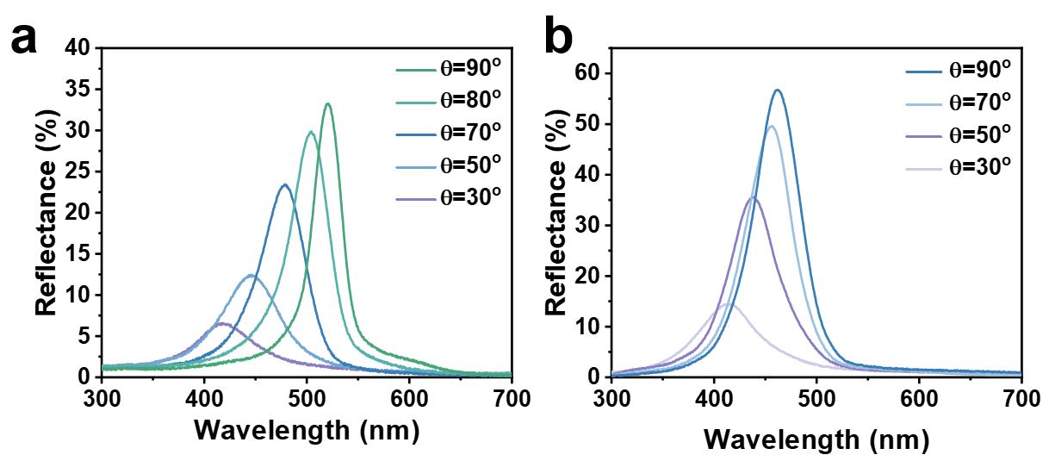
Supplementary Fig. 12 Angle-dependent reflection spectra of the multi-modal PCs self-assembled by RTP SiO₂ NPs with diameter of a 239 nm and b 220 nm.

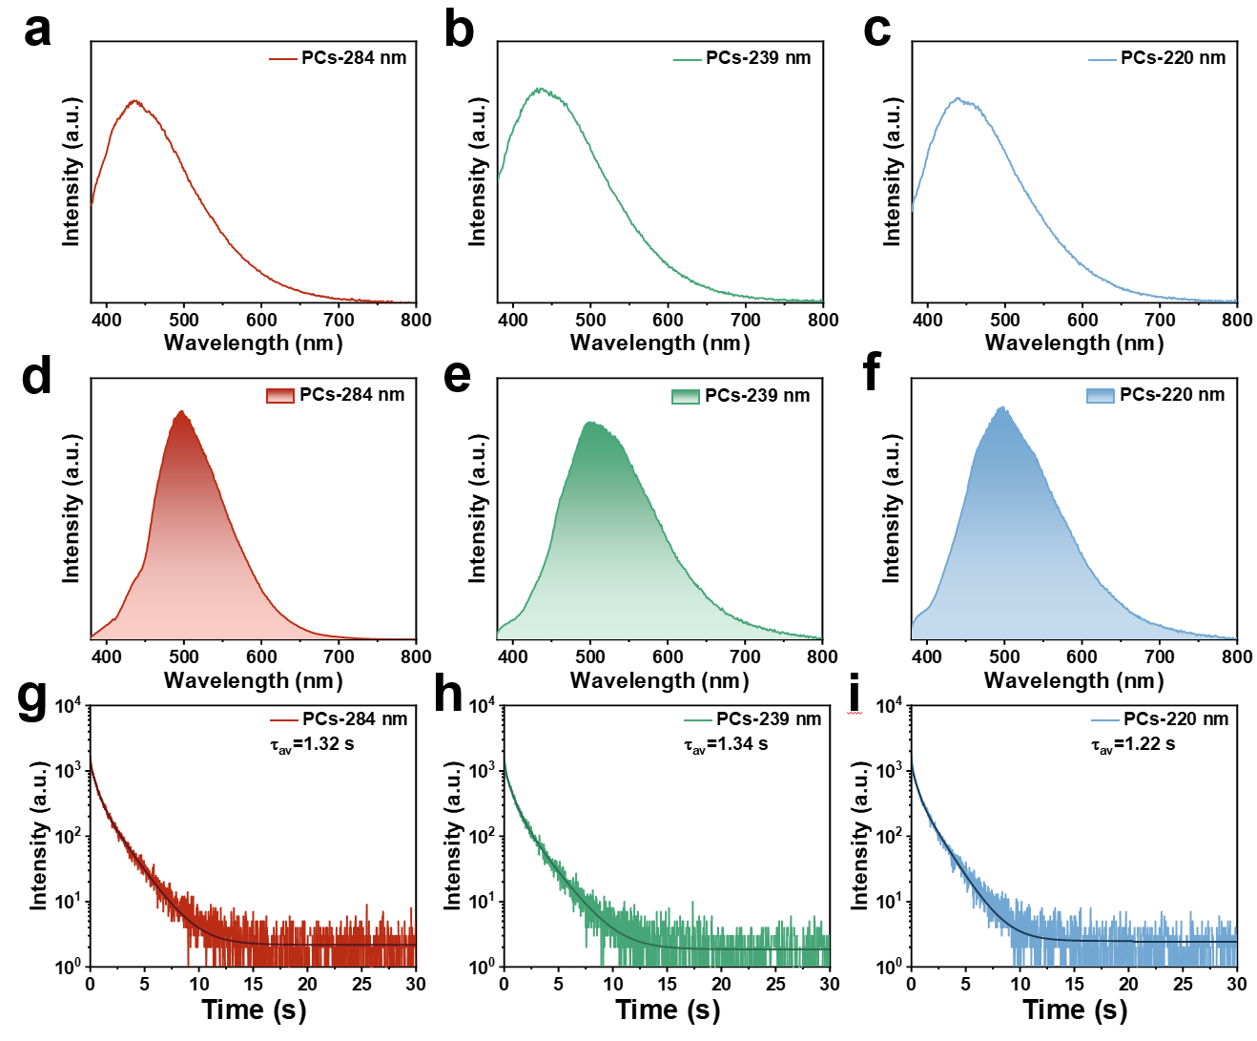
Supplementary Fig. 13 a-c The FL spectra of the multi-modal PCs self-assembled by RTP SiO₂ NPs with different diameter. d-f The RTP spectra of the multi-modal PCs self-assembled by RTP SiO₂ NPs with different diameter. g-h The RTP lifetime decay profile of the multi-modal PCs self-assembled by RTP SiO₂ NPs with different diameter.

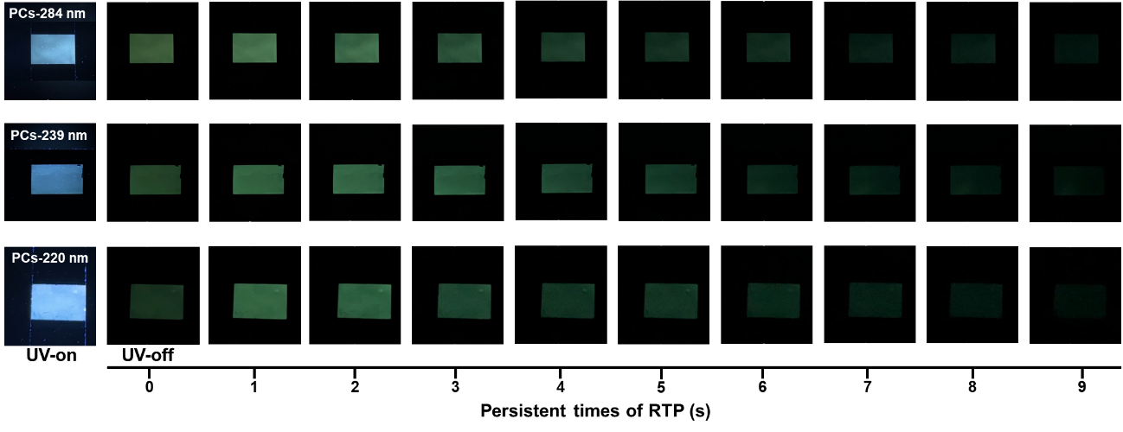
Supplementary Fig. 14 The afterglow photographs of multi-modal PCs self-assembled by RTP SiO₂ NPs with different diameter taken at different time delay intervals.

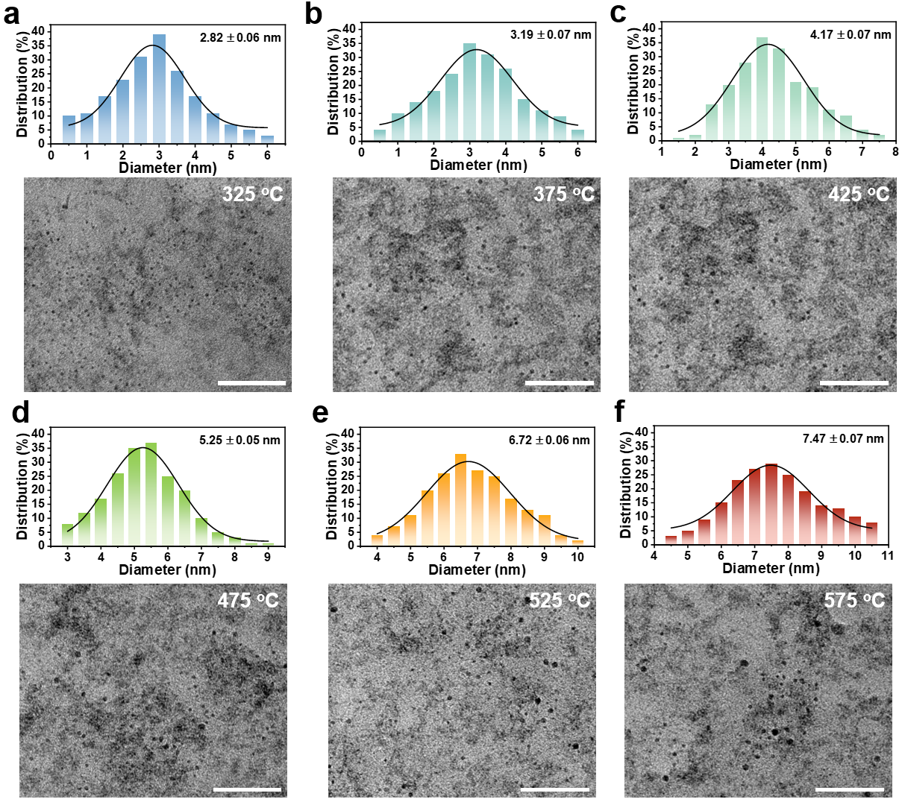
Supplementary Fig. 15 The TEM images of the RTP SiO₂ NPs generated at different calcination temperatures after hydrofluoric acid etching, as well as the histograms of the particle size distribution of CDs summarized from the TEM (Scale bar: 50 nm).

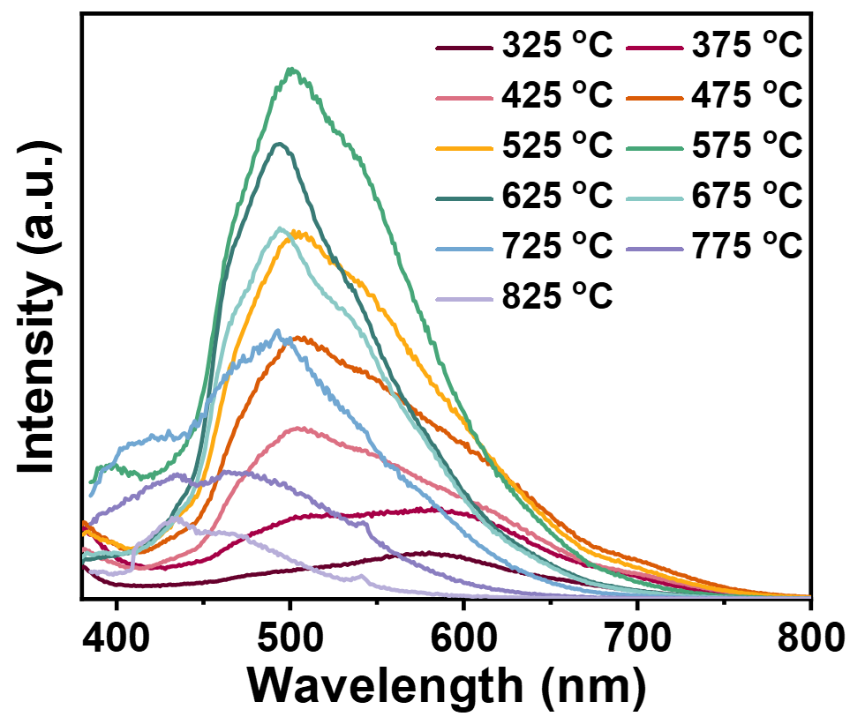
Supplementary Fig. 16 The RTP spectra of RTP SiO₂ NPs obtained at different calcination temperatures.

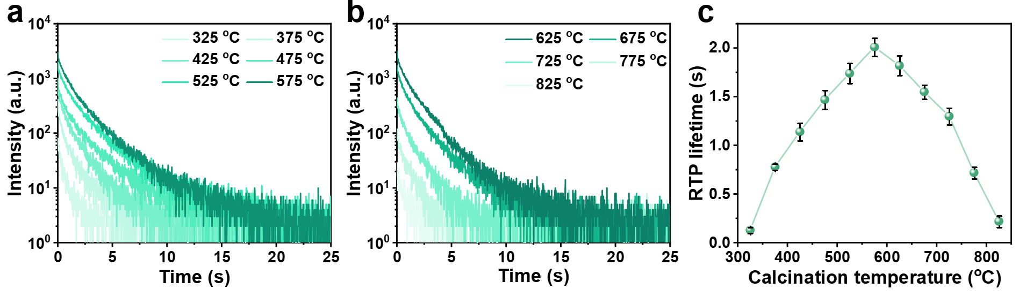
Supplementary Fig. 17 a-b The RTP lifetime decay spectra of RTP SiO₂ NPs obtained at different calcination temperatures (diameter: 284 nm). c The relationship between RTP lifetime and calcination temperature.

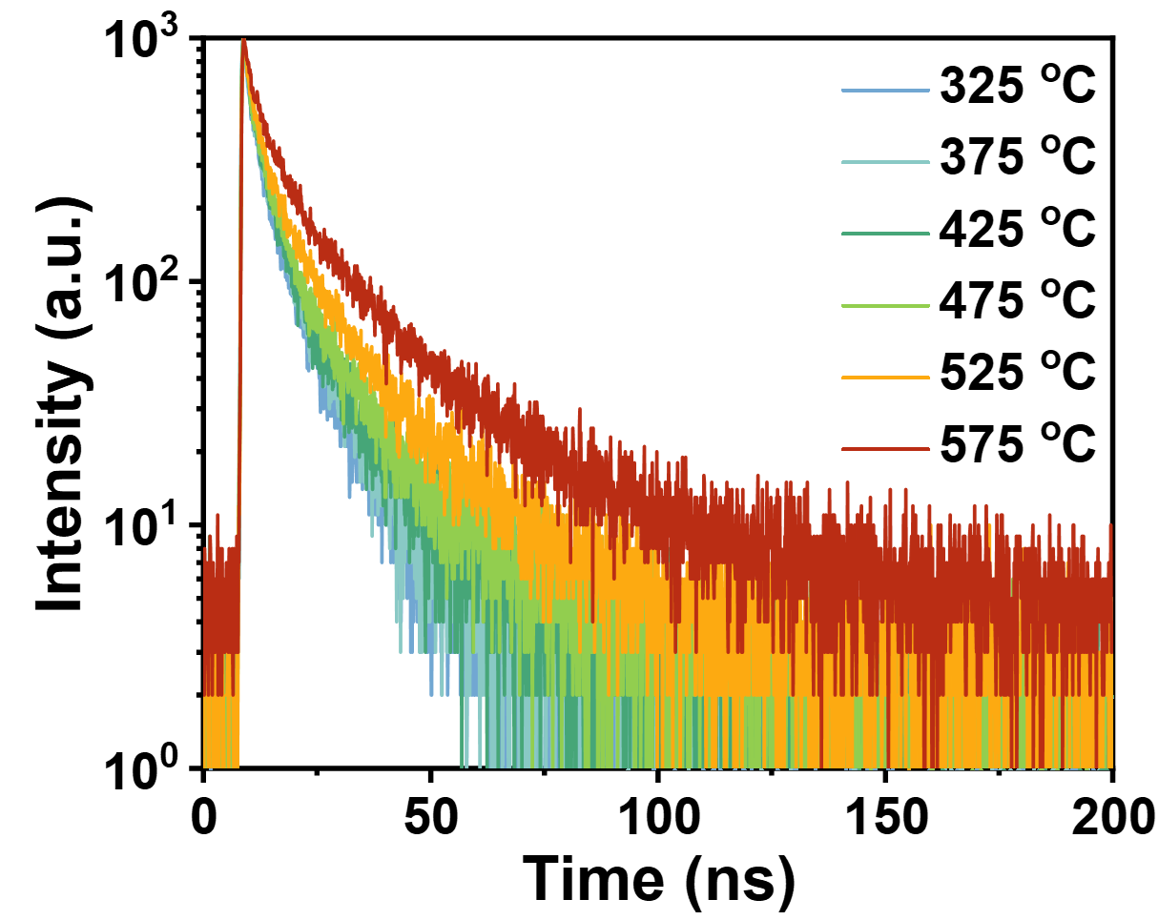
Supplementary Fig. 18 The FL lifetime decay spectra of RTP SiO₂ NPs obtained at different calcination temperatures (diameter: 284 nm).

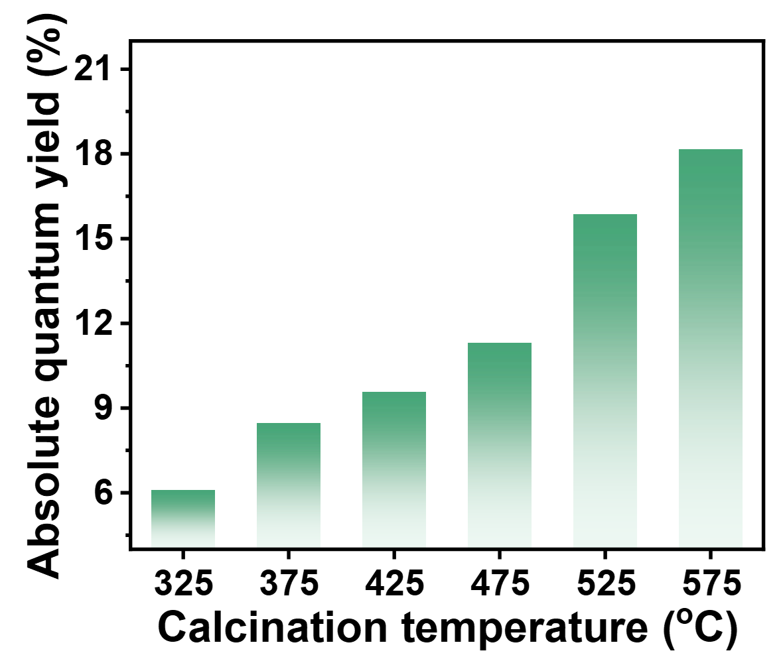
Supplementary Fig. 19 The relationship between the absolute quantum yield and calcination temperatures.

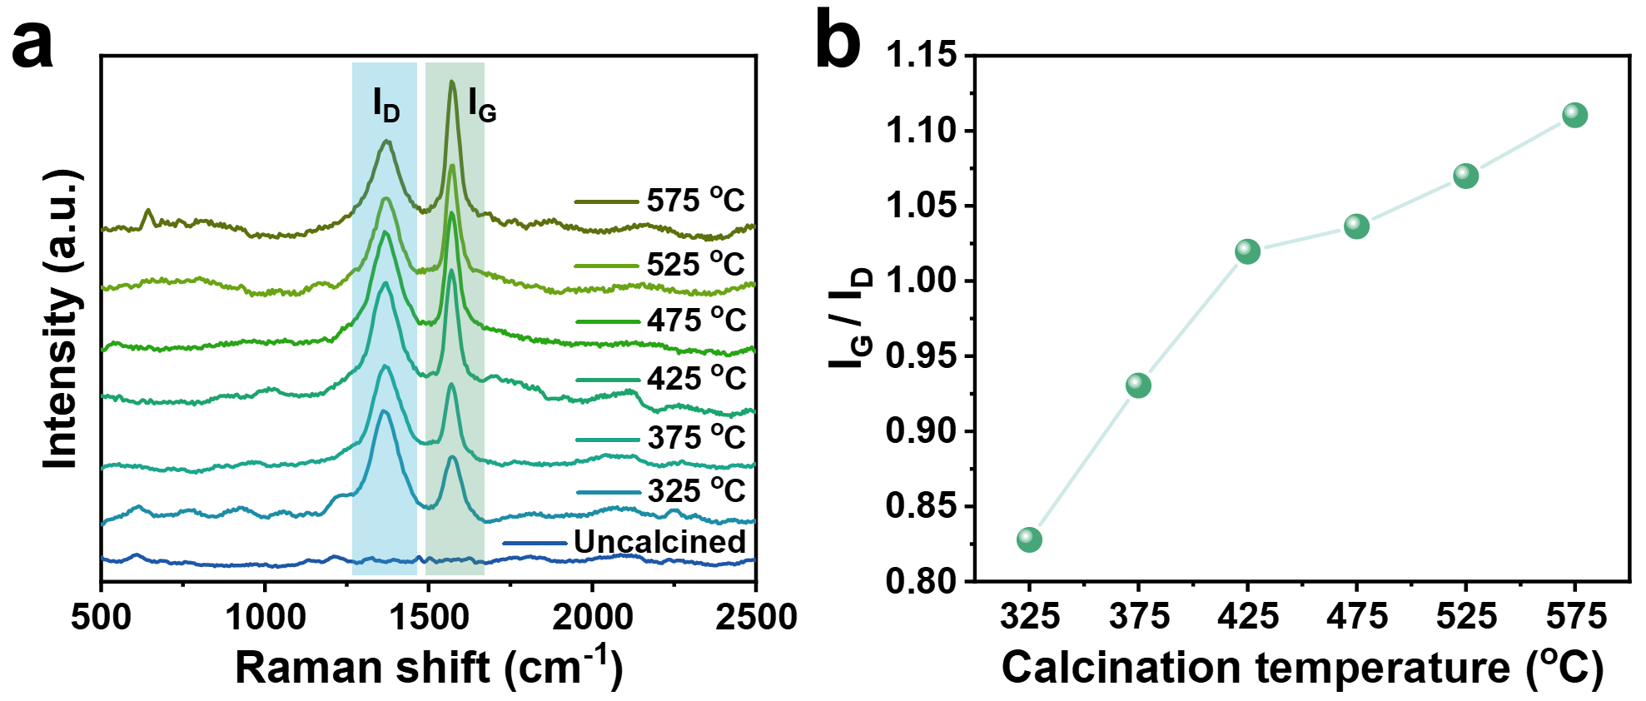
Supplementary Fig. 20 a The Raman spectra of RTP SiO₂ NPs obtained at different calcination temperatures. b The relationship between I_{G}/I_{D} and calcination temperatures.

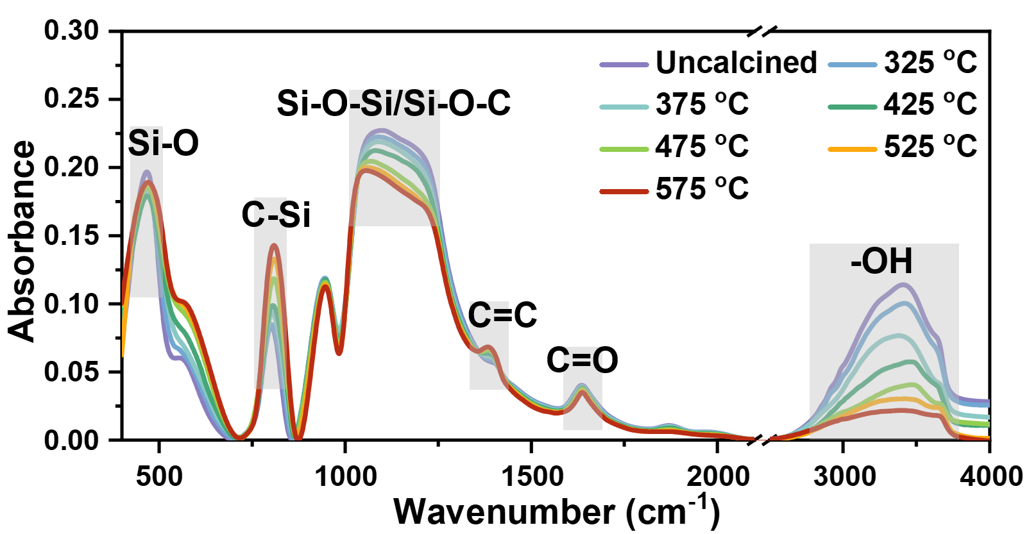
Supplementary Fig. 21 The FT-IR spectra of RTP SiO₂ NPs obtained at different calcination temperatures.

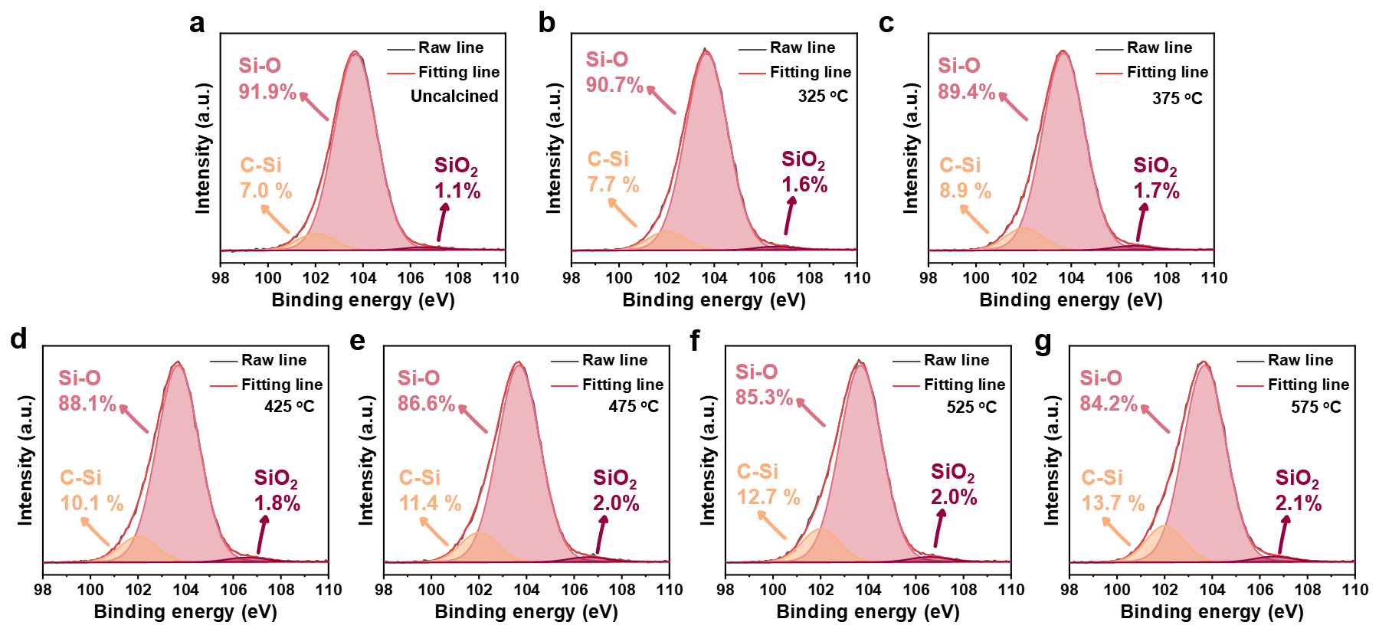
Supplementary Fig. 22 The high-resolution Si 2p results of RTP SiO₂ NPs obtained at different calcination temperatures.

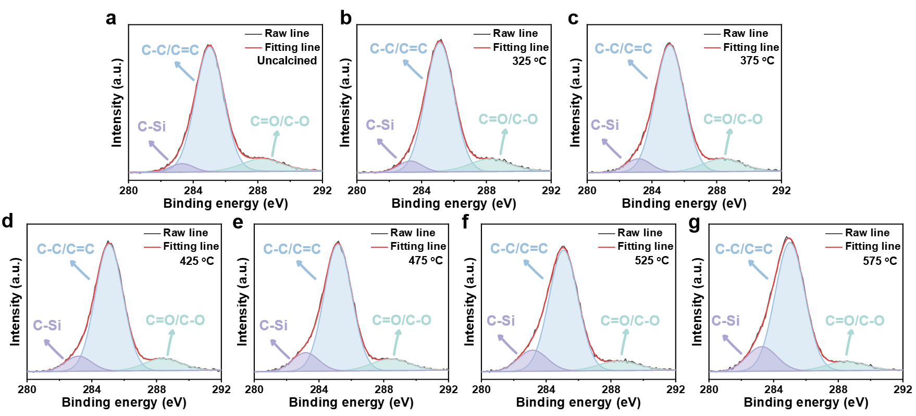
Supplementary Fig. 23 The high-resolution C 1s results of RTP SiO₂ NPs obtained at different calcination temperatures.

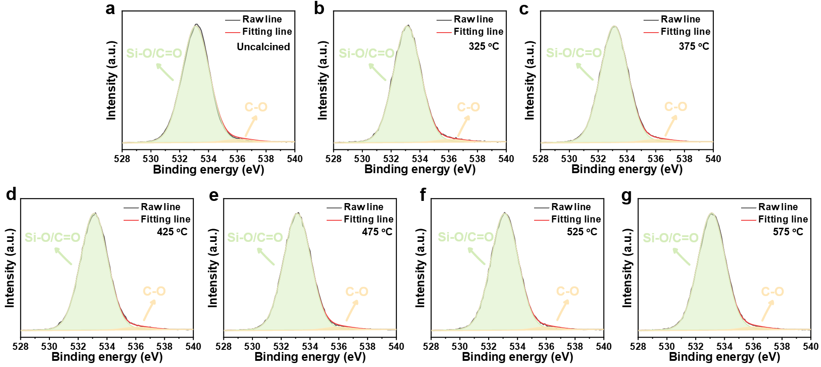
Supplementary Fig. 24 The high-resolution O 1s results of RTP SiO₂ NPs obtained at different calcination temperatures.

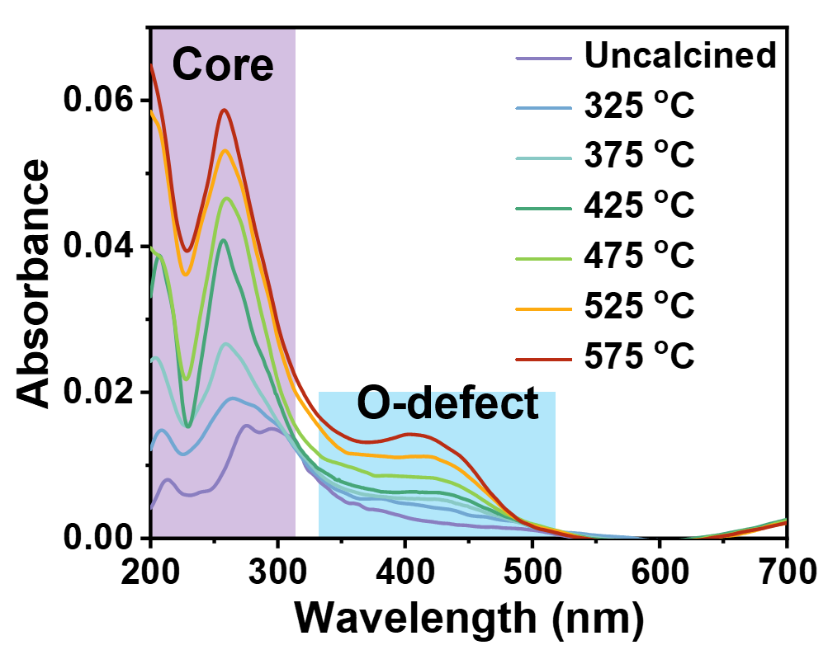
Supplementary Fig. 25 UV-vis absorption spectra of RTP SiO₂ NPs obtained at different calcination temperatures.

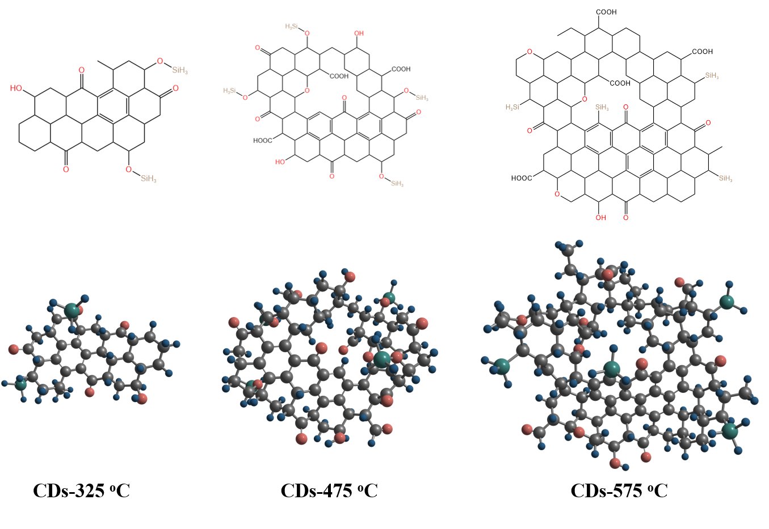
Supplementary Fig. 26 Calculation model for CDs generation under calcination at 325 ºC, 475 ºC and 575 ºC based on HR-TEM and FT-IR results, where black-gray represents carbon atoms, orange-red represents oxygen atoms, dark green represents silicon atoms, and cyan-blue represents hydrogen atoms.

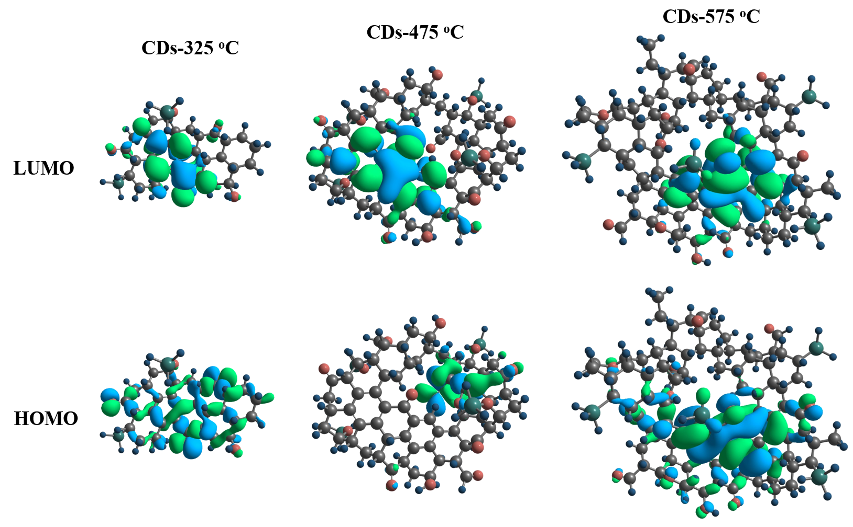
Supplementary Fig. 27 Quantum chemical calculations of HOMO and LUMO distributions for the models of CDs-325 °C, CDs-475 °C and CDs-575 °C. The light green and light blue balloons represent bonding and anti-bonding orbitals in the lowest unoccupied molecular orbital, respectively.

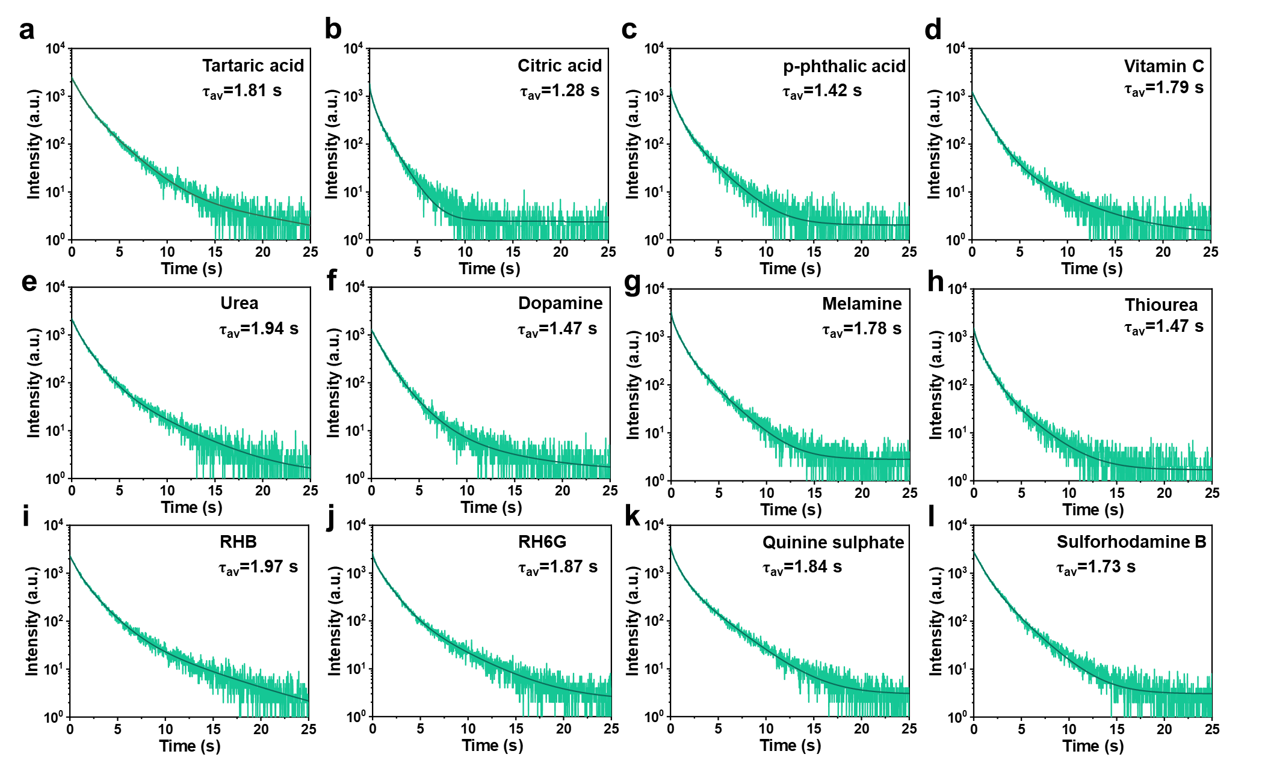
Supplementary Fig. 28 RTP lifetime decay spectra of RTP SiO₂ NPs with diverse doped types of organic small molecule.

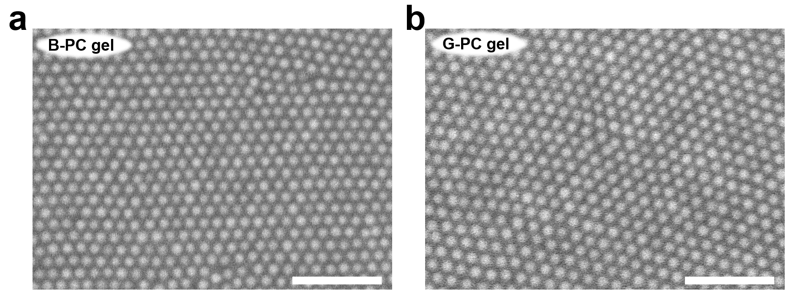
Supplementary Fig. 29 The SEM images of a B-PC gel and b G-PC gel prepared by 220 nm and 255 nm diameter of RTP SiO₂ NPs, respectively (Scale bar: 2 µm).

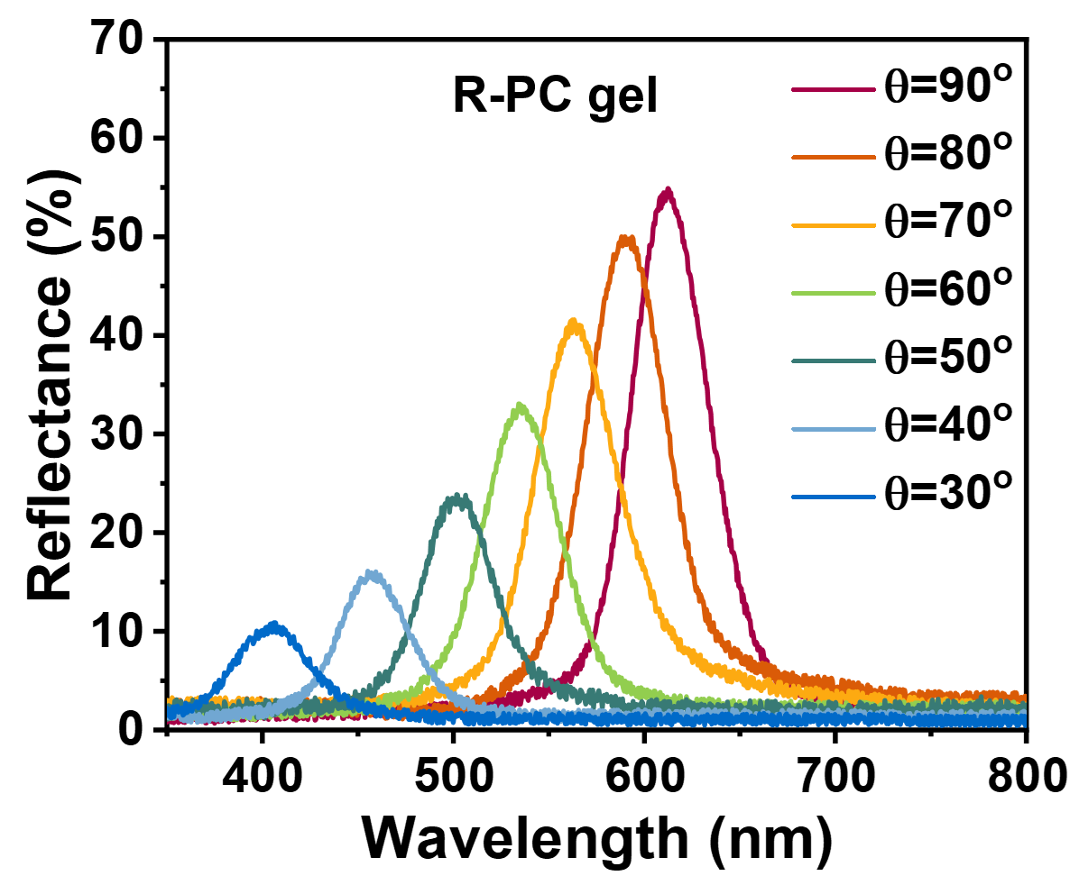
Supplementary Fig. 30 Angle-dependent reflection spectra of the R-PC gel self-assembled by RTP SiO₂ NPs with diameter of 284 nm.

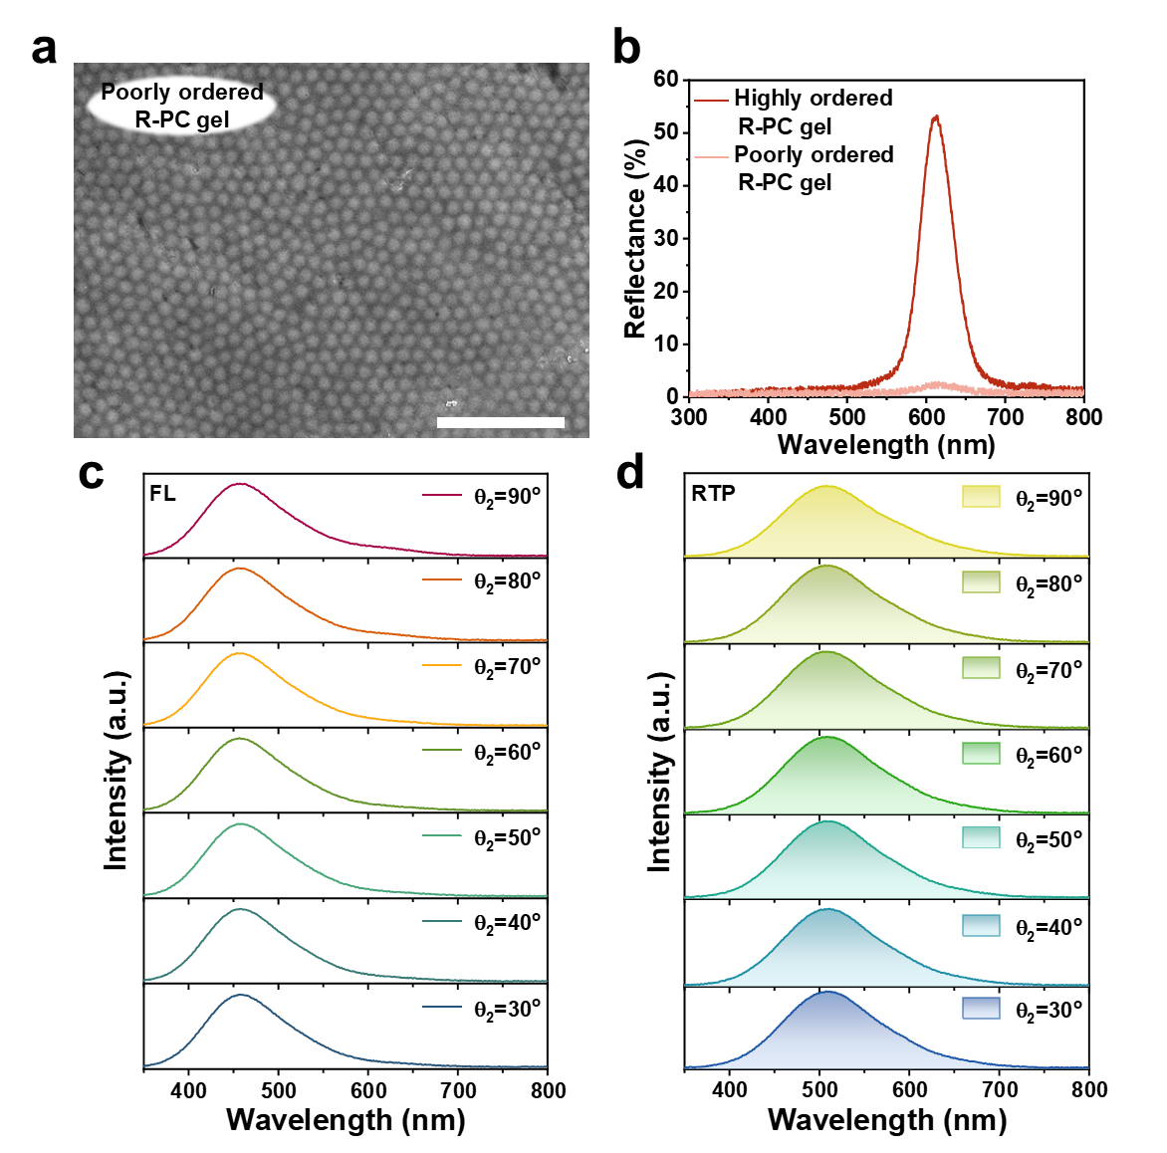
Supplementary Fig. 31 a The SEM images of poorly ordered R-PC gel prepared by 284 nm RTP SiO₂ NPs (Scale bar: 2 µm). b The reflection spectra of highly ordered and poorly ordered R-PC gel, θ₁=90º and θ₂=90º. c and d Angle-dependent FL and RTP spectra of poorly ordered R-PC gel.

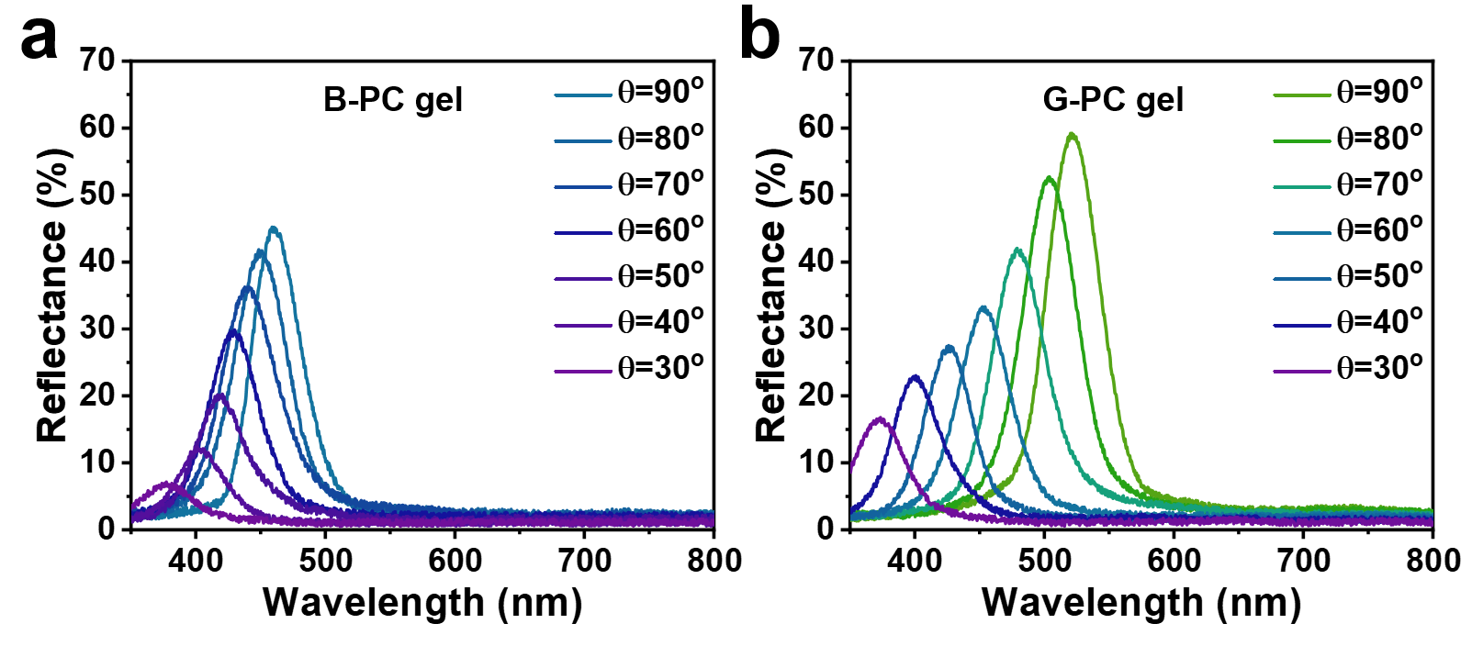
Supplementary Fig. 32 Angle-dependent reflection spectra of a B-PC gel and b G-PC gel self-assembled by RTP SiO₂ NPs with diameter of 220 nm and 239 nm, respectively.

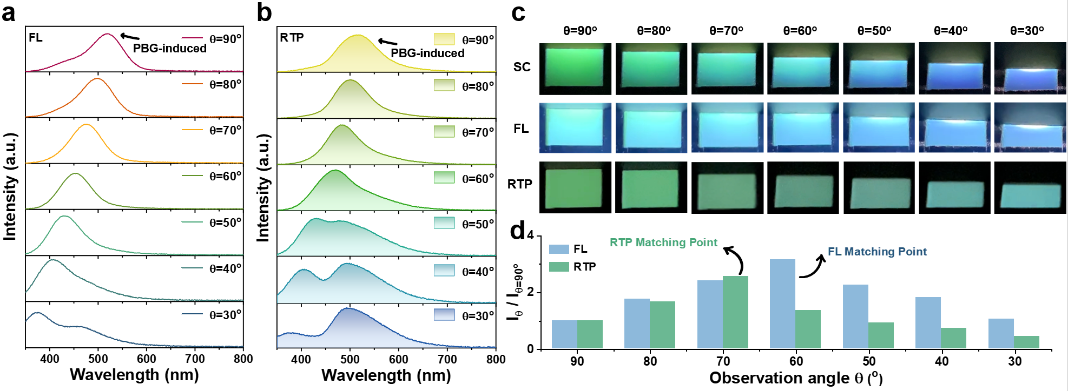
Supplementary Fig. 33 a and b Angle-dependent FL and RTP spectra of G-PC gel. c The photographs of the angle-dependent SC, FL and RTP of the G-PC gel under daylight, 365 nm UV lamp on and off, respectively. e The relationship between the intensities of FL and RTP of G-PC gel and the observed angle, where I is the intensity at different θ₂ and I₉₀ is the intensity at θ₂=90º.

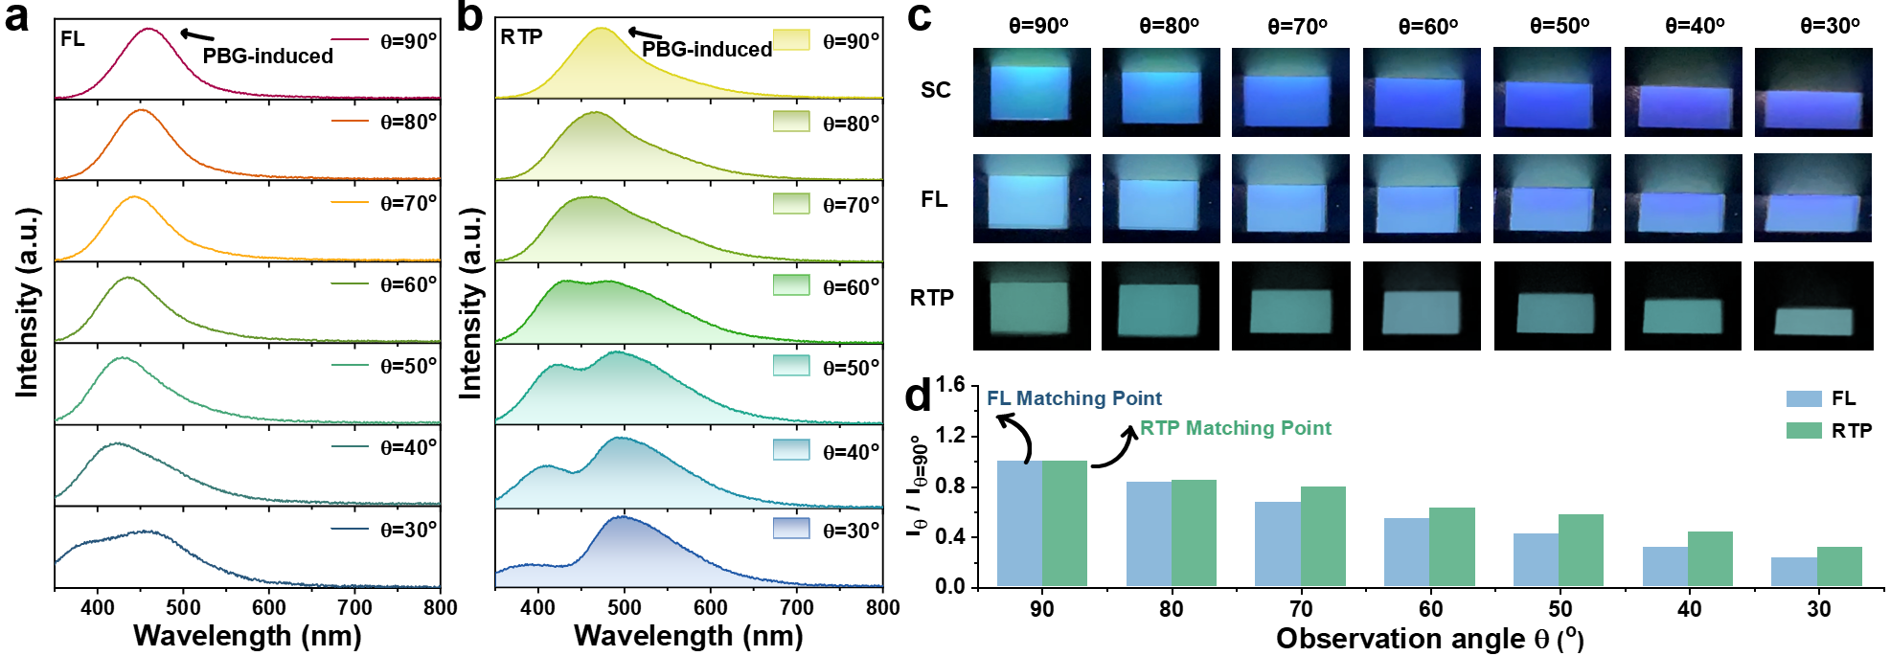
Supplementary Fig. 34 a and b Angle-dependent FL and RTP spectra of B-PC gel. c The photographs of the angle-dependent SC, FL and RTP of the B-PC gel under daylight, 365 nm UV lamp on and off, respectively. e The relationship between the intensities of FL and RTP of B-PC gel and the observed angle, where I is the intensity at different θ₂ and I₉₀ is the intensity at θ₂=90º.

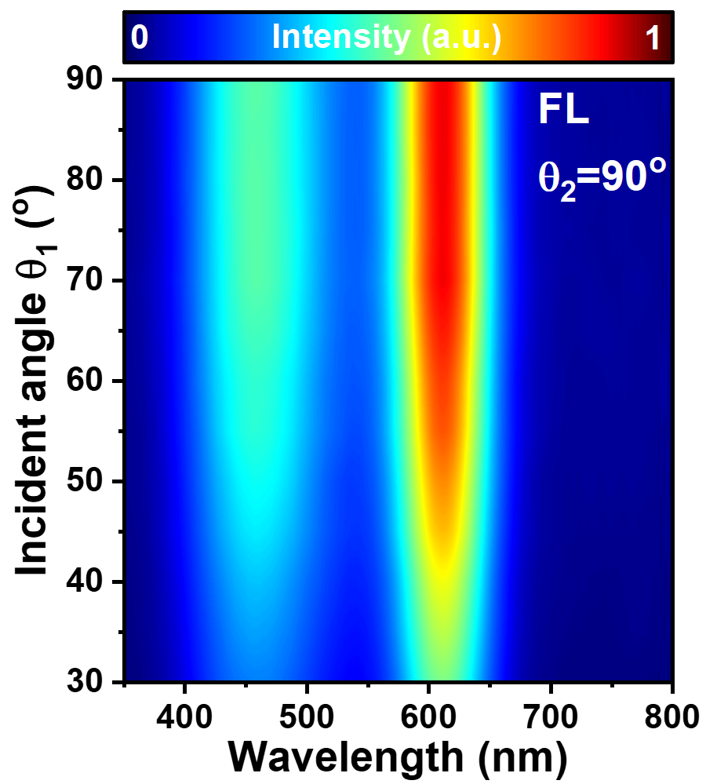
Supplementary Fig. 35 Scanning θ₁-dependent two-dimensional FL spectra of R-PC gel.
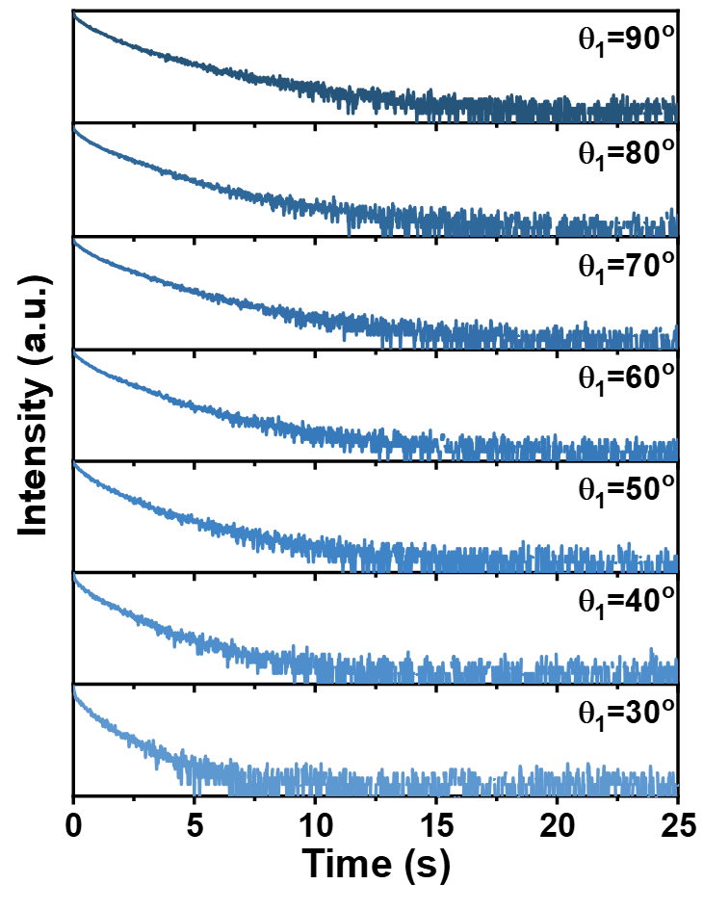
Supplementary Fig. 36 RTP decay lifetime measured at different θ₁.

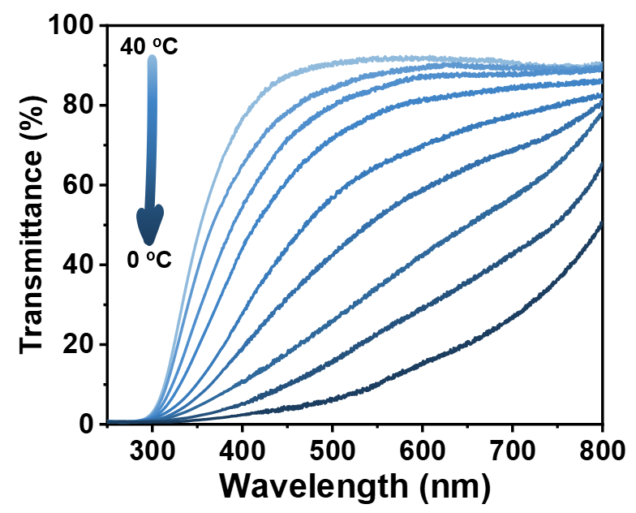
Supplementary Fig. 37 Temperature-dependent transmission spectra of R-PC gel.

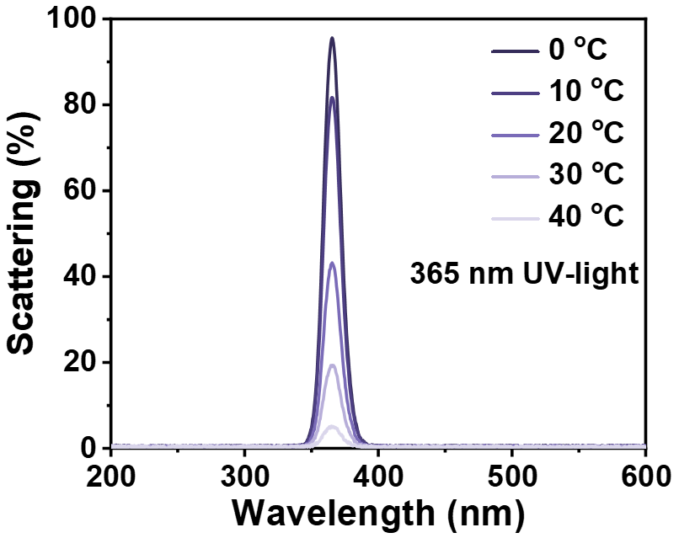
Supplementary Fig. 38 Scattering spectra of excitation light incident on the R-PC gel at different temperature.

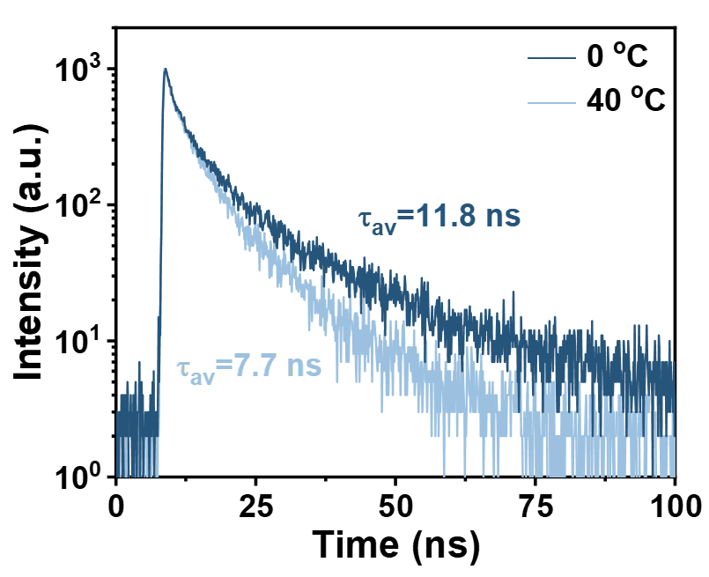
Supplementary Fig. 39 The FL lifetime decay spectra of R-PC gel at 0 ºC and 40 ºC, respectively.

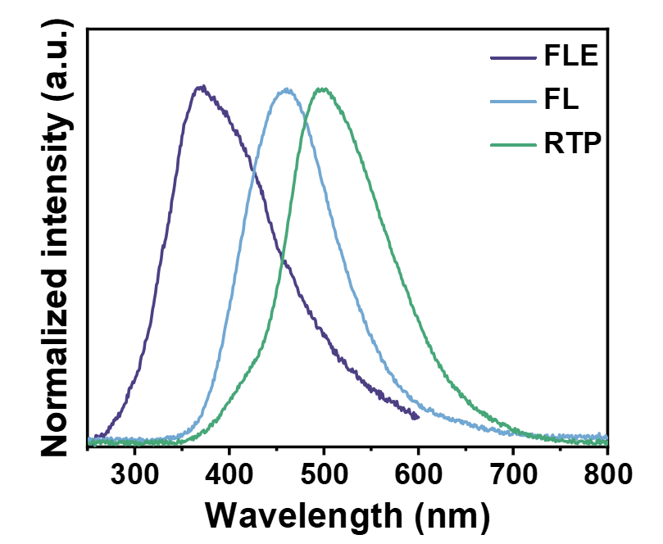
Supplementary Fig. 40 The excitation spectra, FL and RTP spectra of RTP SiO₂ NPs in R-PC gel.

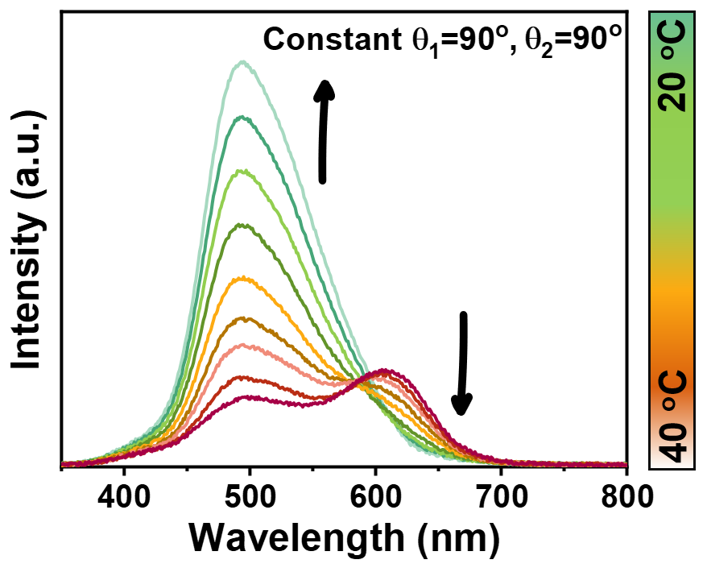
Supplementary Fig. 41 Temperature-dependent RTP spectra of R-PC gel, θ₁=90º and θ₂=90º.

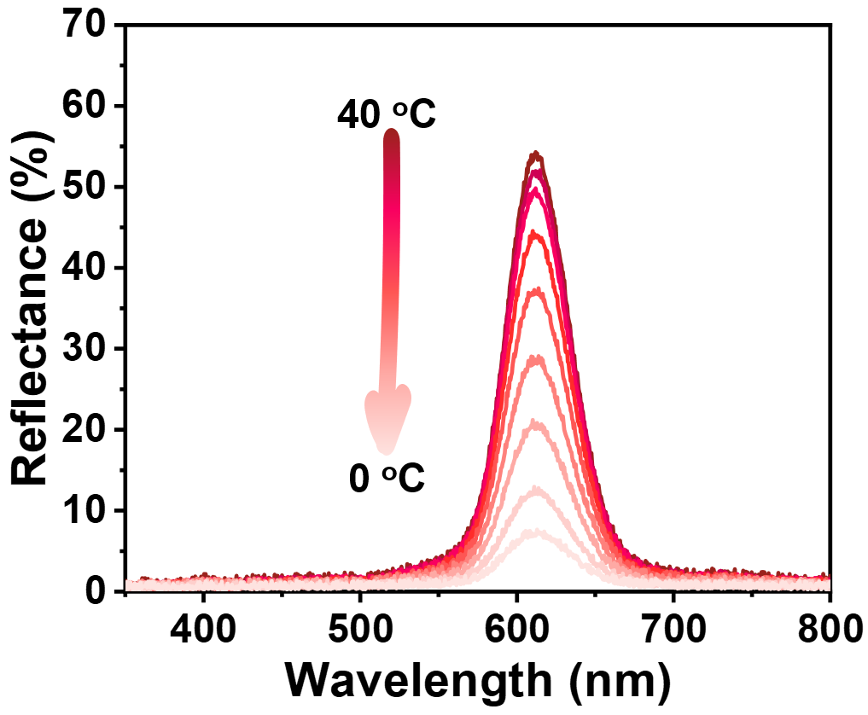
Supplementary Fig. 42 Temperature-dependent reflection spectra of R-PC gel, θ₁=90º and θ₂=90º.

