Supplementary Information for
Wood-based Oriented Object Deposition

Yeonsoo Kim^{†1}, Donghyeok Kang^{†1}, Sungchul Shin^{*1,2,3}

†These authors contributed equally: Yeonsoo Kim, Donghyeok Kang
¹ Department of Agriculture, Forestry, and Bioresources, Seoul National University, Seoul 08826, Republic of Korea
² Department of Biosystems and Biomaterials Science and Engineering, Seoul National University, Seoul 08826, Republic of Korea
³ Research Institute of Agriculture and Life Sciences, Seoul National University, Seoul 08826, Republic of Korea
*e-mail: sungssc@snu.ac.kr

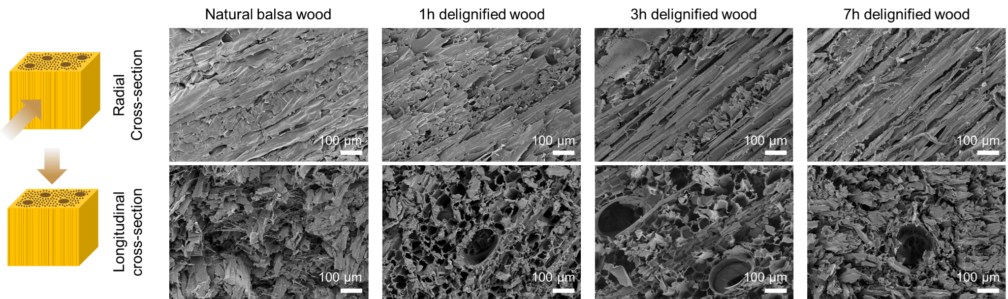
Supplementary Figure 1. SEM images of natural balsa wood and delignified wood treated for 1, 3, and 7 hours, showing cross-sections in the radial (top) and longitudinal (bottom) directions.
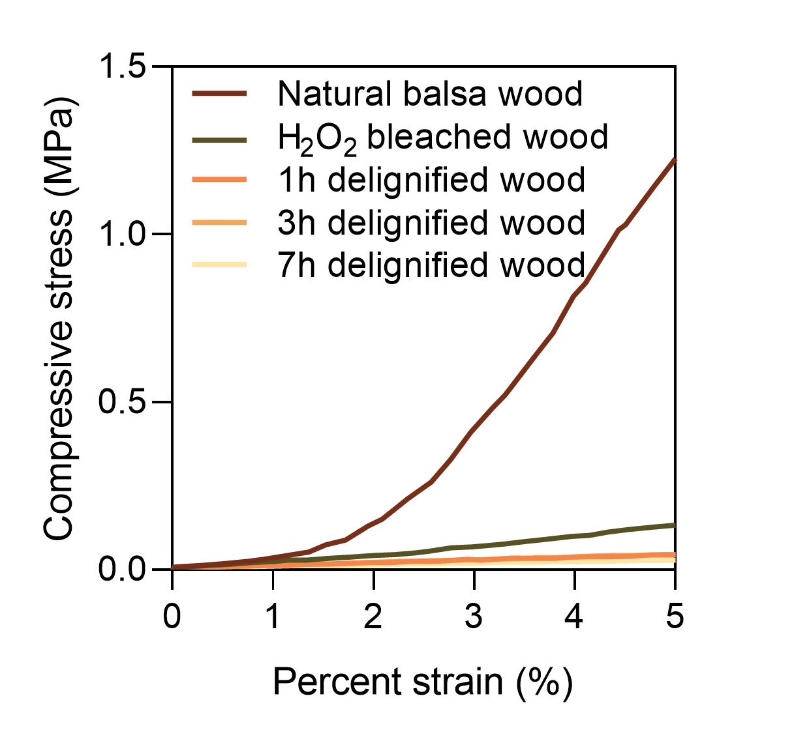
Supplementary Figure 2. Compressive stress–strain curves of natural balsa wood and delignified wood treated for 1, 3, and 7 hours.
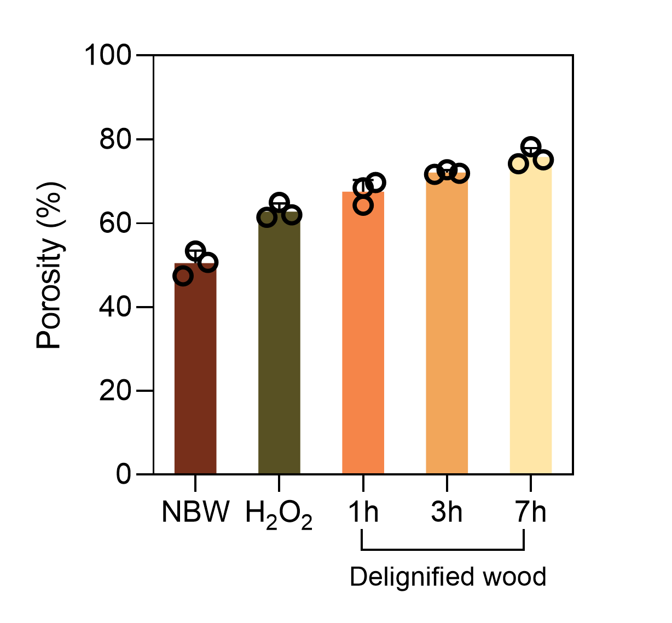
Supplementary Figure 3. Porosity analysis of natural balsa wood (NBW), H₂O₂-bleached wood, and delignified wood treated for 1, 3, and 7 hours, based on cross-sectional CLSM images.
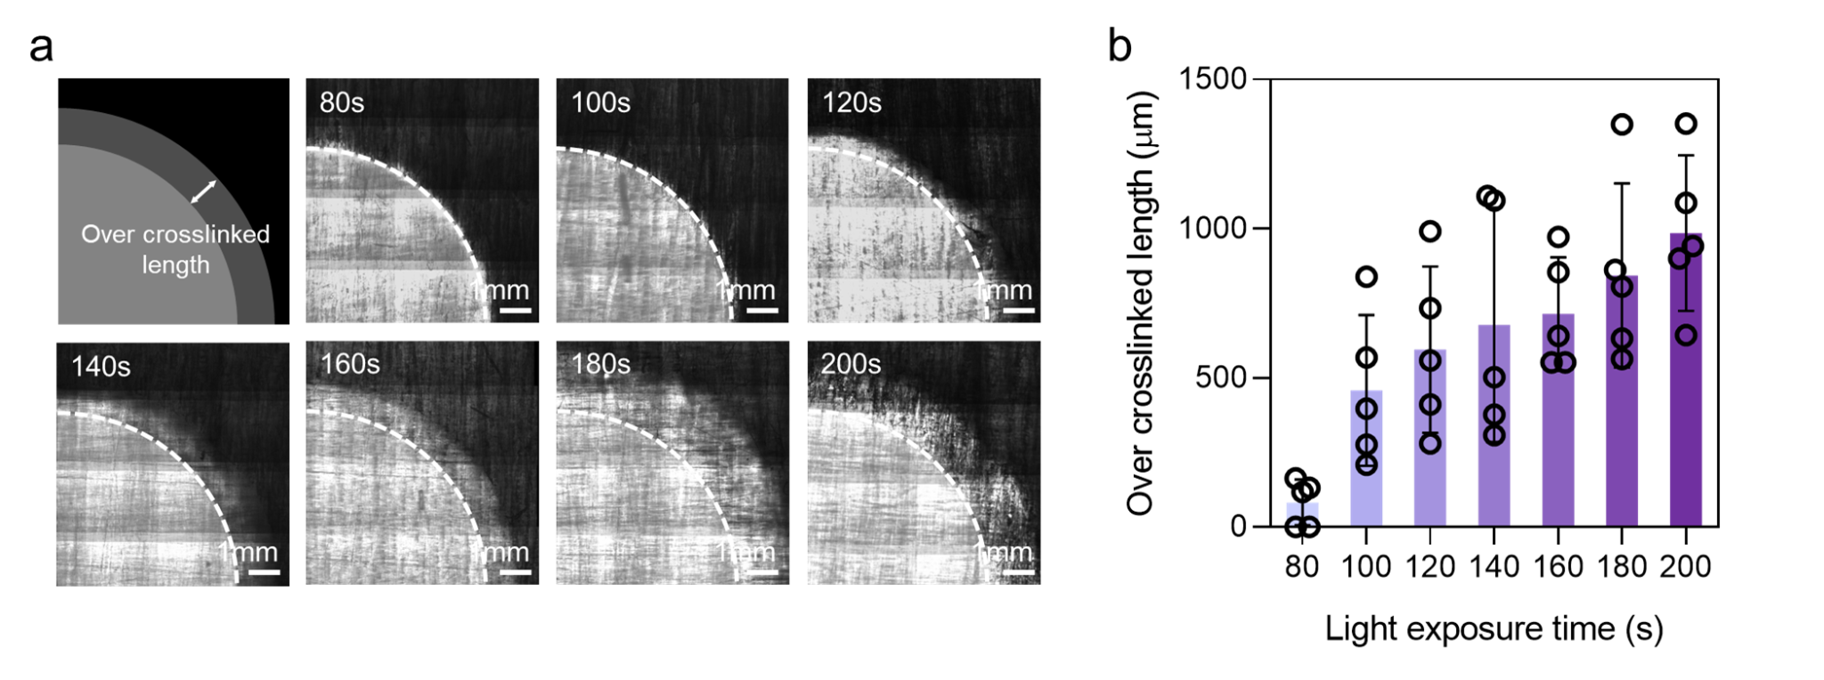
Supplementary Figure 4. (a) Optical images showing the over-crosslinked region in PEGDA-impregnated delignified wood (7 h) under varying light exposure times (80–200 s). Dashed lines indicate the designed light-exposed area. (b) Over-crosslinked length beyond the designed exposure area as a function of exposure time.
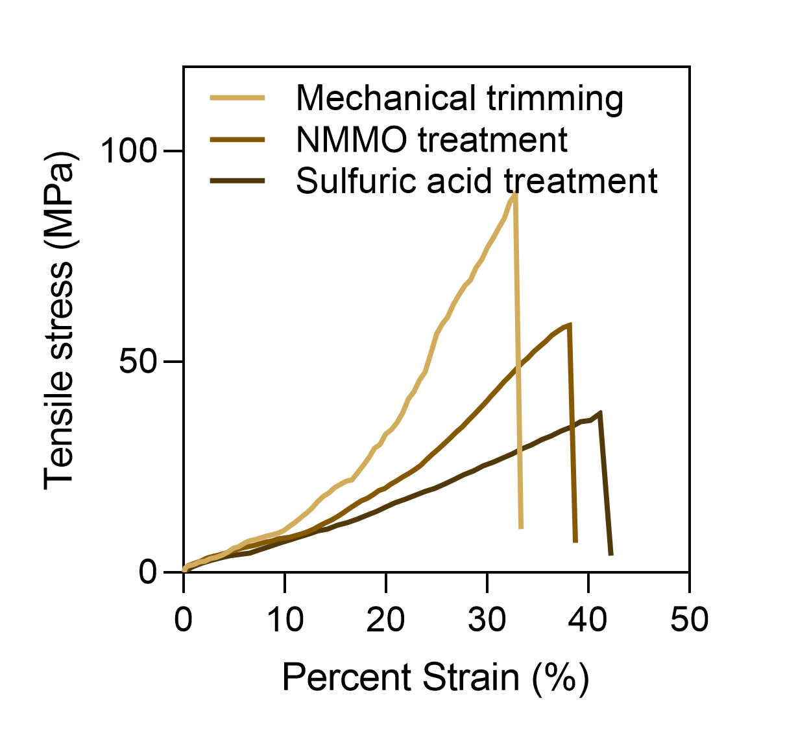
Supplementary Figure 5. Tensile stress–strain curves of wood composites subjected to different post-processing methods: mechanical trimming, NMMO treatment, and sulfuric acid treatment.
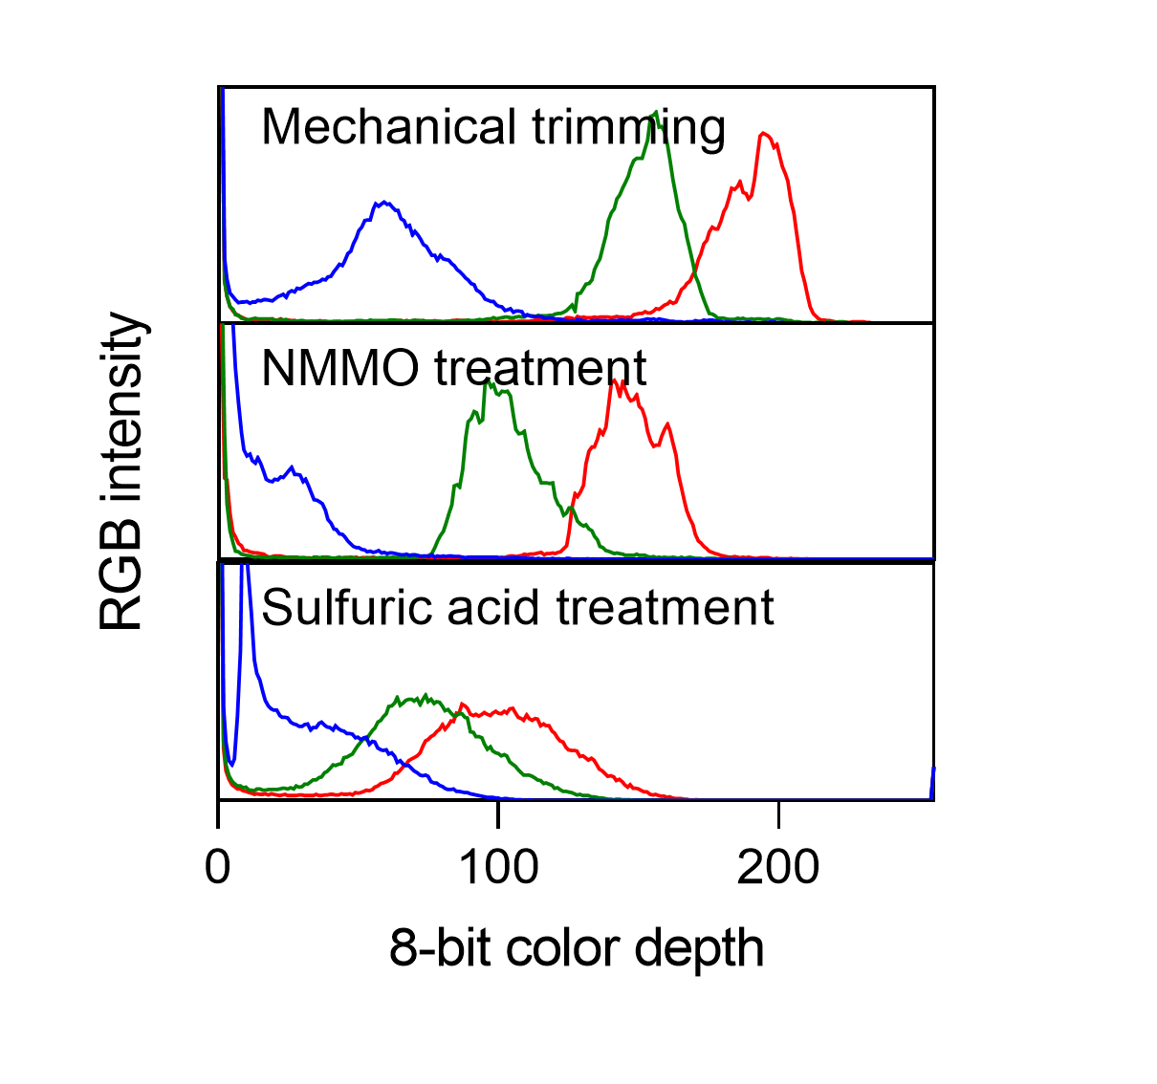
Supplementary Figure 6. RGB intensity profiles of wood composites after different post-processing methods including mechanical trimming, NMMO treatment, and sulfuric acid treatment, showing color changes based on the 8-bit color depth distribution for red, green, and blue channels.
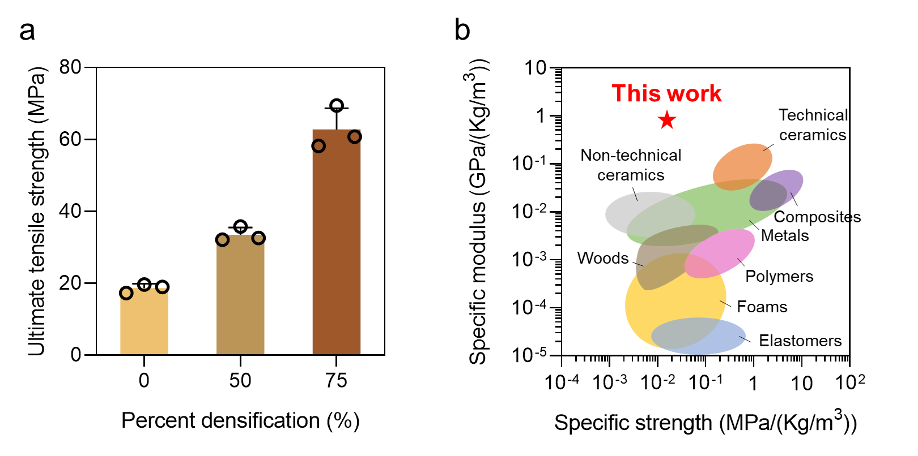
Supplementary Figure 7. (a) Ultimate tensile strength of wood composites as a function of densification. (b) Ashby plot comparing the specific modulus and specific strength of the 75% densified wood composite with those of various engineering materials.
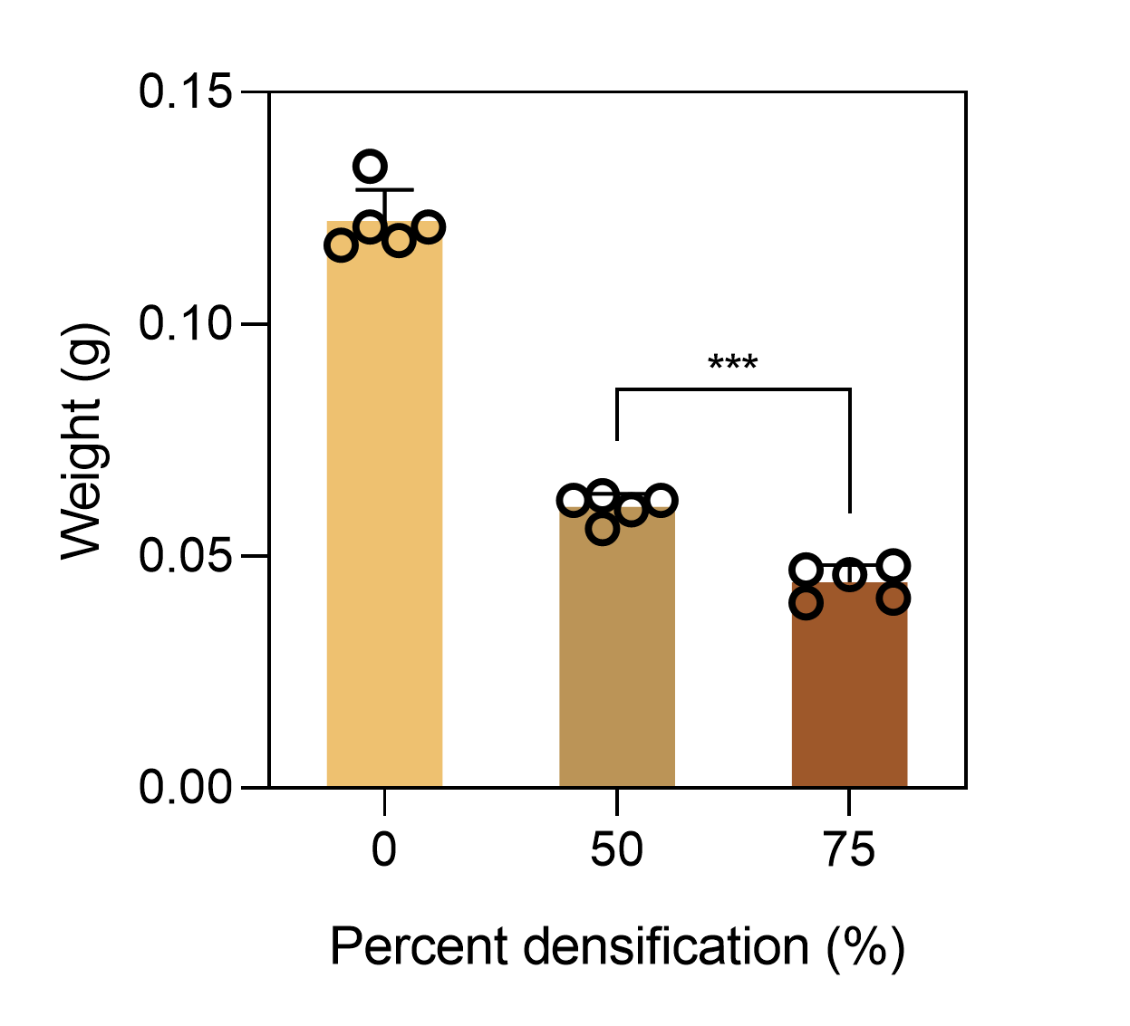
Supplementary Figure 8. Weight change of wood composites, prepared in 1 cm × 1 cm size, as a function of percent densification.
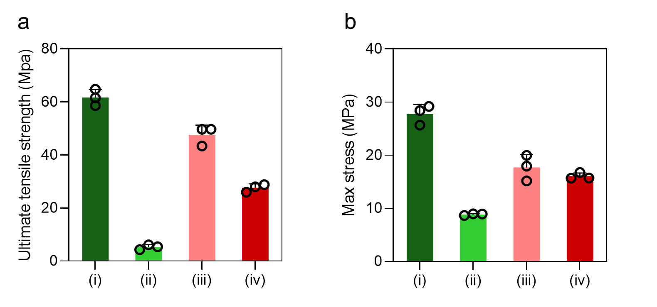
Supplementary Figure 9. (a) Ultimate tensile strength and (b) maximum bending stress of wood composites tested in different directions relative to fiber orientation. For unidirectionally layered structures, tests were conducted parallel (i) and perpendicular (ii) to the fiber direction. For cross-ply layered structures, tests were conducted along the top-layer fiber direction (iii) and at a 45° angle (iv) to the fiber stacking axis.
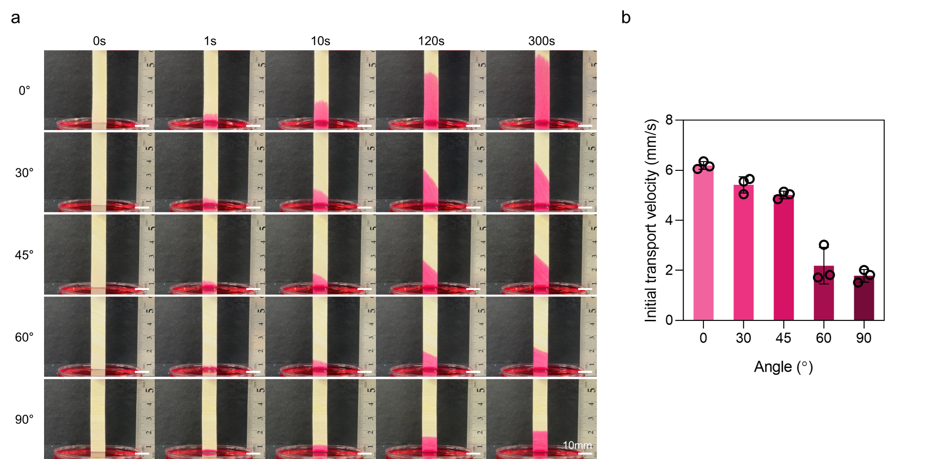
Supplementary Figure 10. (a) Time-lapse images showing fluid transport in delignified wood samples with varying fiber alignment angles. (b) Initial fluid transport velocity as a function of fiber alignment angle.
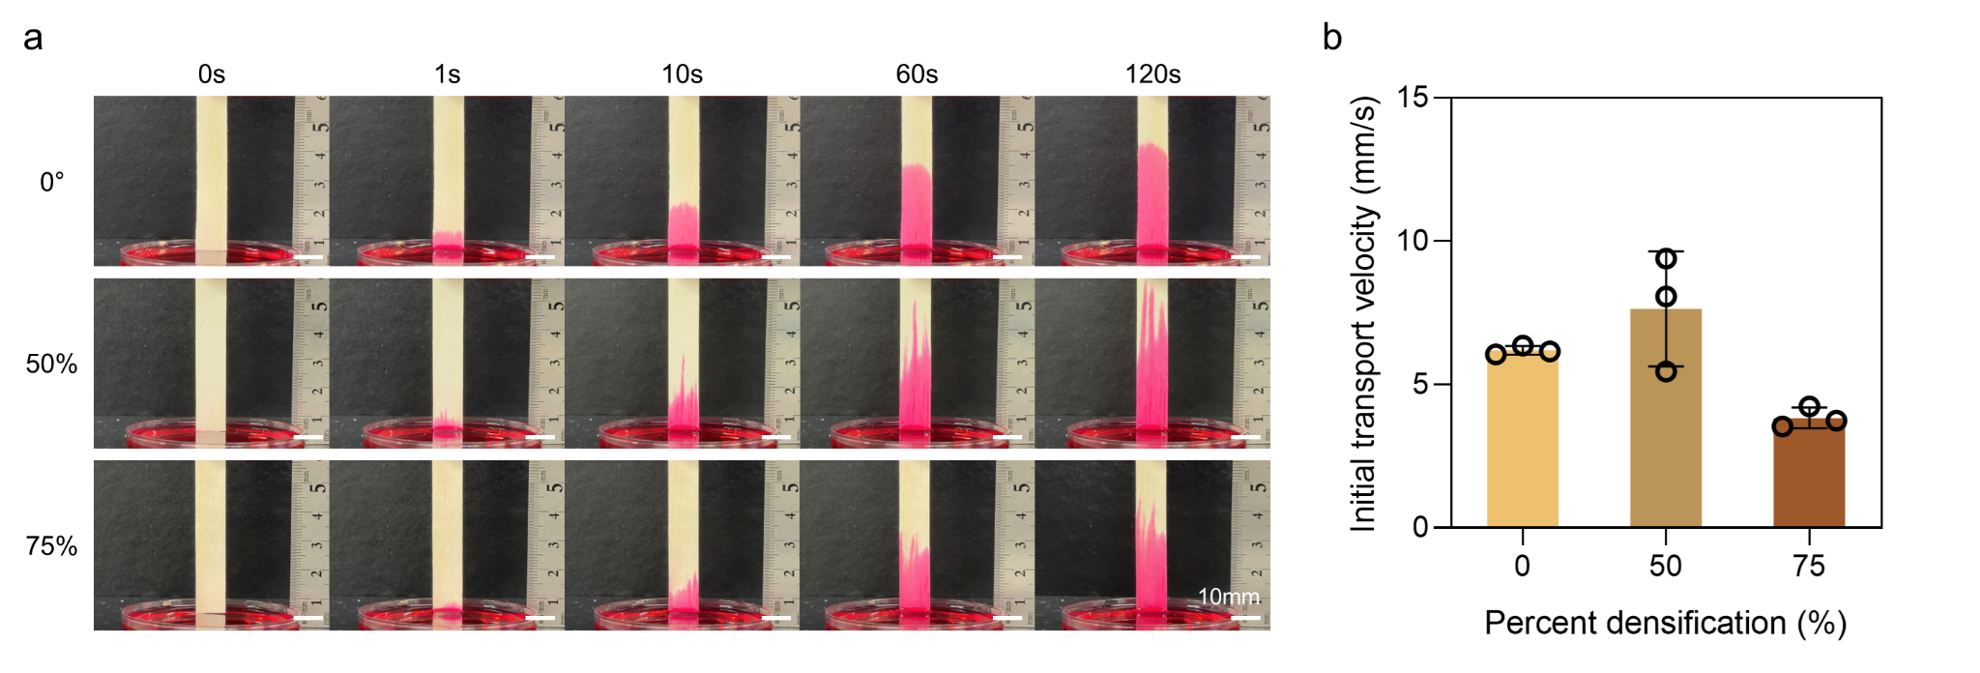
Supplementary Figure 11. (a) Time-lapse images showing fluid transport in delignified wood samples with varying percent densification. (b) Initial fluid transport velocity as a function of percent densification.

