Support information
Table S1: Criteria for S-mol Selection in the Chembridge Fragment Library
Fragment Library Attribute | Value
Molecular Weight | 150 to 300
H-donors | <=3
H-acceptors | <=3
cLogP | <=3
Rotatable Bonds | <=3
cLogSw | >=-2.50
tPSA | <=120

Figure S1. Supplementary analysis of molecular dynamics simulations, showing structural stability and interaction characteristics of Candidate PROTAC compounds with the Wnt3a-CRBN complex. RMSF (Root Mean Square Fluctuation) analysis reveals low fluctuation in key residues, while Rg (Radius of Gyration) and SASA (Solvent Accessible Surface Area) analyses indicate changes in compactness of the complex, suggesting the stabilizing effect of PROTAC compounds upon binding.
Supplementary Information Figure S1 presents additional molecular dynamics (MD) simulation data, providing deeper insights into the structural stability and interaction profiles of the Candidate PROTAC compounds with the Wnt3a-CRBN complex. The data reveal fluctuations in specific residues and changes in compactness across the simulations. Notably, RMSF (Root Mean Square Fluctuation) analysis shows that key residues involved in binding exhibit low fluctuation values, indicating stable interactions. Additionally, Rg (Radius of Gyration) and SASA (Solvent Accessible Surface Area) analyses indicate a gradual compaction of the complex, supporting the hypothesis that the PROTAC compounds promote structural stability upon binding. These supplementary analyses reinforce the main findings, highlighting the favorable binding characteristics of the PROTAC candidates and their ability to stabilize the protein complex.

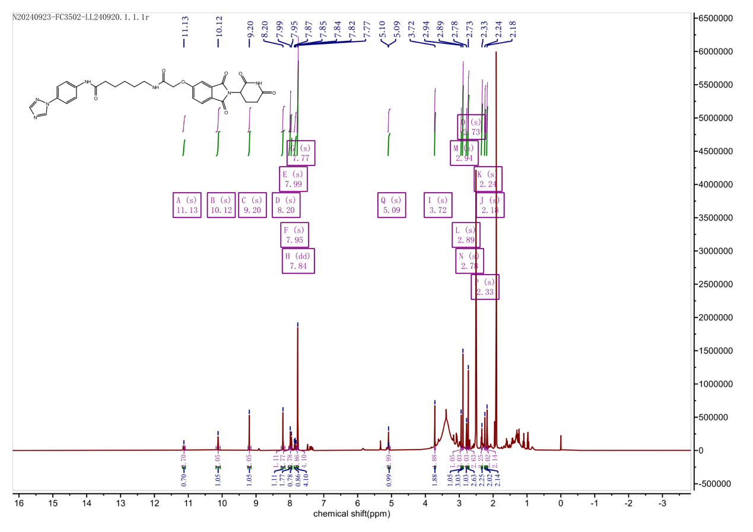
Figure S2. Chemical Synthesis of Candidate Compound 1
Candidate Compound 1: ¹H NMR (400 MHz, DMSO-d6) δ 11.13 (s, 1H), 10.12 (s, 1H), 9.20 (s, 1H), 8.20 (s, 1H), 7.99 (s, 2H), 7.95 (s, 1H), 7.84 (dd, J = 10.2, 8.3 Hz, 1H), 7.77 (s, 4H), 5.09 (s, 1H), 3.72 (s, 2H), 2.94 (s, 1H), 2.89 (s, 3H), 2.78 (s, 1H), 2.73 (s, 3H), 2.33 (s, 2H), 2.24 (s, 2H), 2.18 (s, 2H).
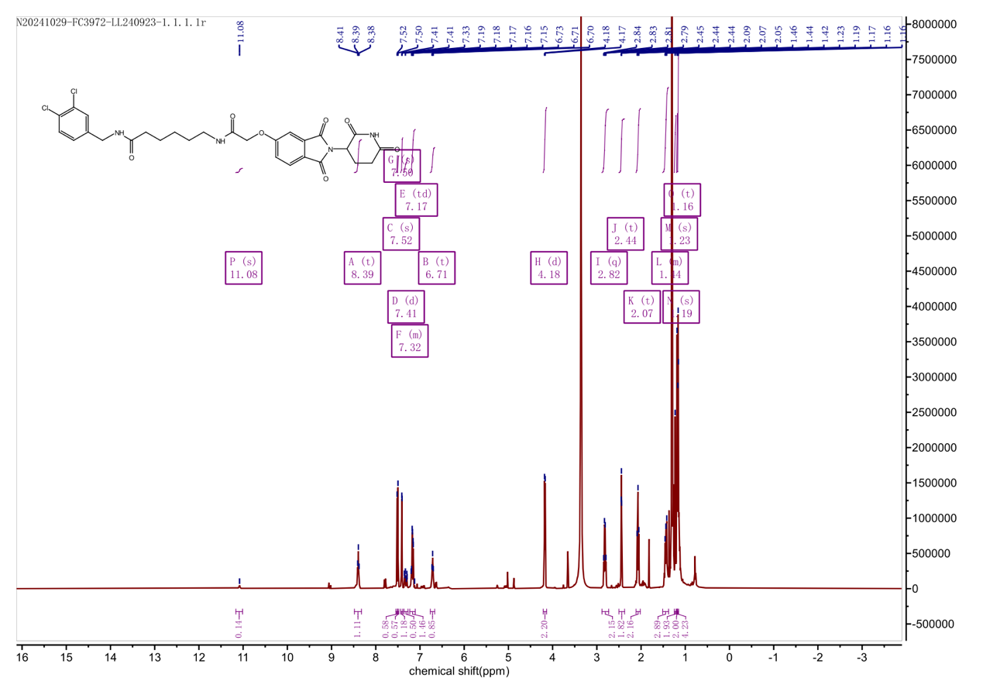
Figure S3. Chemical Synthesis of Candidate Compound 2
PROTAC 2: ¹H NMR (400 MHz, DMSO-d6) δ 11.08 (s, 1H), 8.39 (t, J = 6.1 Hz, 1H), 7.52 (s, 1H), 7.50 (s, 1H), 7.41 (d, J = 2.0 Hz, 1H), 7.36 – 7.27 (m, 1H), 7.17 (td, J = 8.4, 2.3 Hz, 2H), 6.71 (t, J = 5.8 Hz, 1H), 4.18 (d, J = 6.0 Hz, 2H), 2.82 (q, J = 6.7 Hz, 2H), 2.44 (t, J = 1.9 Hz, 2H), 2.07 (t, J = 7.4 Hz, 2H), 1.51 – 1.38 (m, 3H), 1.23 (s, 2H), 1.19 (s, 2H), 1.16 (t, J = 2.3 Hz, 4H).

