Supplementary Information

Biomimetic Design of Manganese-Doped Carbon Dot Nanozymes with Ultrahigh SOD-Like Activity for ALS Management
Yaxin Hou^{1,10}, Xuejiao J. Gao^{4,10}, Jing Li², Guoheng Tang^{1,3}, Qizhi Wang^{3,7}, Wenwen Yang⁵, Qing Xie², Ran Xu^{1,3}, Dong Liu⁵, Liming Wang⁸, Yujing Ren⁹, Lei Li⁷, Qing-Ying Luo^{5,*}, Cui Liu^{2,*} and Kelong Fan^{1,3,6,*}
1 State Key Laboratory of Biomacromolecules, Institute of Biophysics, Chinese Academy of Sciences, Beijing 100101, China
2 Chongqing Key Laboratory of Natural Product Synthesis and Drug Research, Innovative Drug Research Center, School of Pharmaceutical Sciences, Chongqing University, Chongqing, 400044, P. R. China.
3 University of Chinese Academy of Sciences, Chinese Academy of Sciences, Beijing, 100408, China.
4 College of Chemistry and Materials, Jiangxi Normal University, Nanchang 330022, China.
5 School of Food and Drug, Shenzhen Polytechnic University, Shenzhen 518055, P. R. China.
6 Nanozyme Laboratory in Zhongyuan, Zhengzhou, Henan, 451163, China.
7 State Key Laboratory of Organ Regeneration and Reconstruction, Beijing Institute for Stem Cell and Regenerative Medicine, Institute of Zoology, Chinese Academy of Sciences, Beijing, 100101, China
8 CAS Key Laboratory for Biomedical Effects of Nanomaterials and Nanosafety, Institute of High Energy Physics, Chinese Academy of Sciences, Beijing 100049, P. R. China.
9 Interdisciplinary Research Center of Biology & Catalysis, School of Life Sciences, Northwestern Polytechnical University, Xi’an, 710072, China.
10 These authors contributed equally: Yaxin Hou, Xuejiao Gao.
*Corresponding authors: E-mail: fankelong@ibp.ac.cn; liucui@cqu.edu.cn; Luoqingying@szpu.edu.cn
The Supplementary Information includes:
32 Supplementary Figures
5 Supplementary Tables
Supplementary Figures
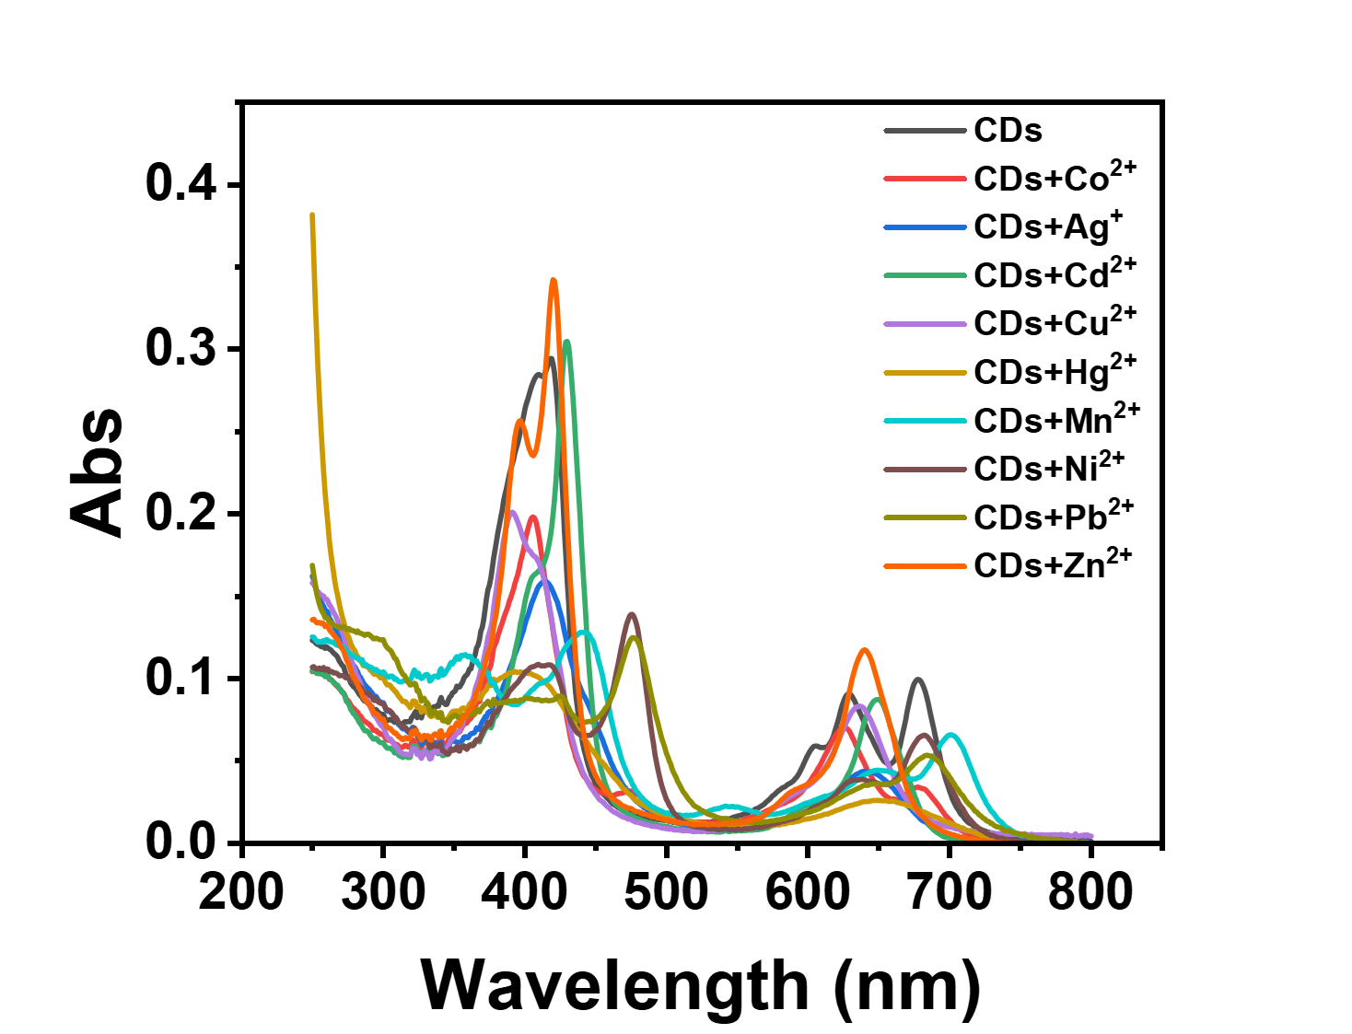
Supplementary Figure 1. UV‒vis absorption spectra of the CDs at a final concentration of 10 μg/mL in the presence of metal ions at a final concentration of 1 mM. Source data are provided as a Source Data file.

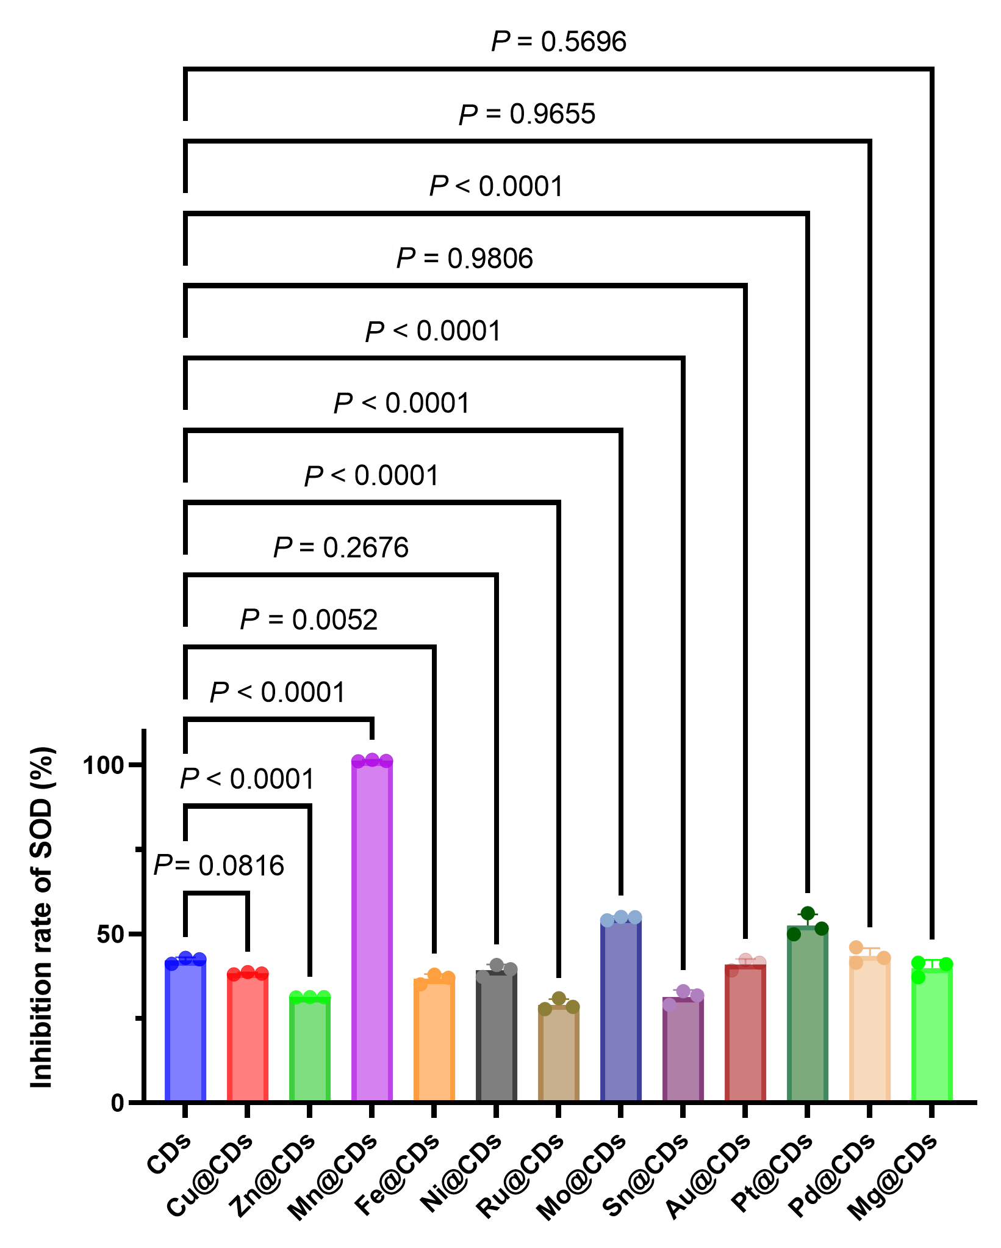
Supplementary Figure 2. The SOD-like activities of CD nanozymes (with final concentration of 2.6 μg/mL) doped with Cu, Zn, Mn, Fe, Ni, Ru, Mo, Sn, Au, Pt, Pd, or Mg. Data represent mean ± SDs. P values are determined with one-way ANOVA Tukey’s multiple comparisons test. Source data are provided as a Source Data file.

We selected the appropriate metal to dope CDs based on two aspects of consideration: (i) Whether the metal can significantly enhance the SOD-like activity of CDs; and (ii) whether the metal can be stably loaded in the CDs. These two factors collectively determine the efficiency of metal doping in regulating the SOD-like activity of CDs.
Specifically, the first category of metals (Cu, Zn, Fe, Ru, Mg) can be loaded stably in CDs in large quantities (with a wt% > 1% when the metal salt dosage was 10 mg (Supplementary Table 1)). However, they did not significantly improve the SOD-like activity of CDs and even reduce the SOD activity, thus these metals were excluded. The second category of metals (Ni, Mo, Sn, Au, Pt, Pd) cannot be stably loaded in CDs (with a wt% < 0.4% at a metal salt dosage of 10 mg). Readers may note that Mo-doped CDs (Mo@CDs) can significantly enhance SOD activity at a wt% of ~0.2% (there was a statistically significant difference in SOD activity between pristine CDs and Mo@CDs, P < 0.0001). It is hypothesized that if the Mo salt dosage is increased to make the wt% of Mo in Mo@CDs similar to the Mn weight percentage of Mn@CDs, Mo@CDs might exhibit higher SOD-like activity than Mn@CDs. However, when the metal salt dosage was as high as 10 mg, the loading amount of Mo in Mo@CDs and other metal-doped CDs (Ni@CDs, Sn@CDs, Au@CDs, Pt@CDs, Pd@CDs) remained below 0.4%. This indicated that the loading amounts of these metals in CDs are saturated, or stable coordination bonds could not be formed. The metal salt dosage was already excessive, and CDs cannot load additional metal ions, making it impossible for these metals to further regulate the SOD-like activity.
Based on the above two reasons, we selected Mn as the doped metal, as it not only achieved a high loading amount in CDs but also significantly enhanced the SOD-like activity of CDs.

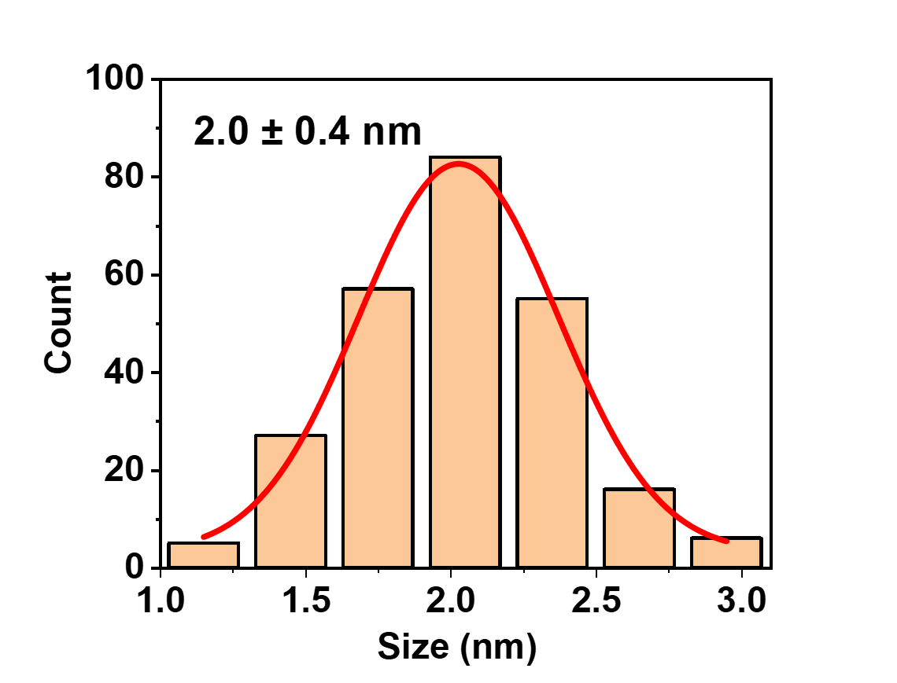
Supplementary Figure 3. The size distribution of typical Mn@CDs. Source data are provided as a Source Data file.

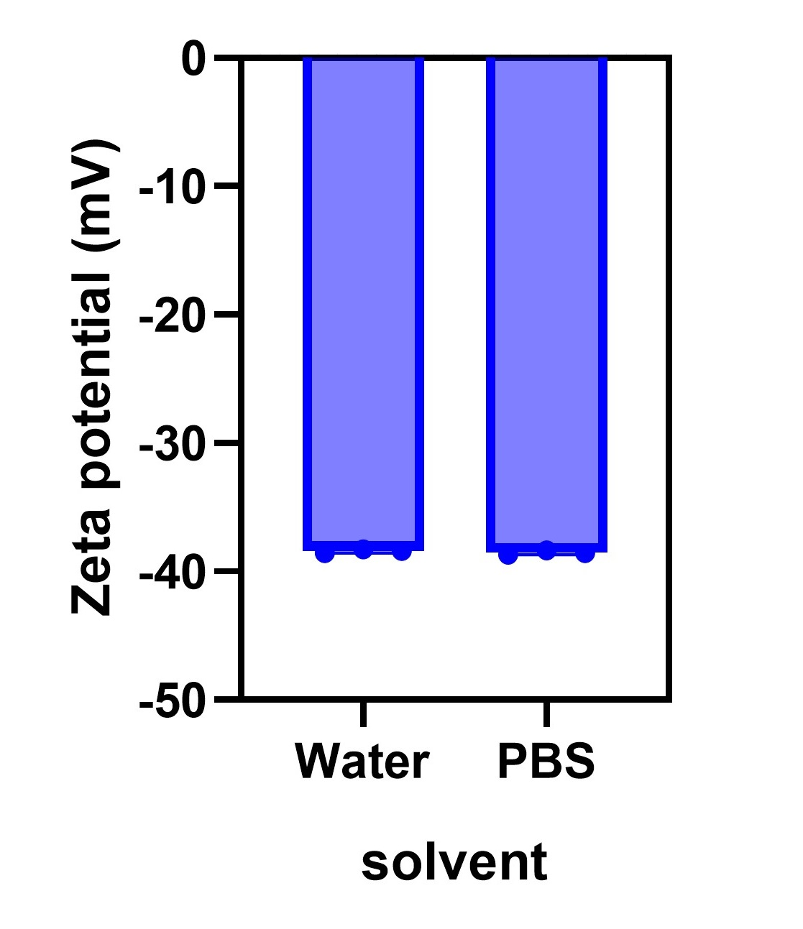
Supplementary Figure 4. Zeta potential of Mn@CDs in water or PBS. Source data are provided as a Source Data file.

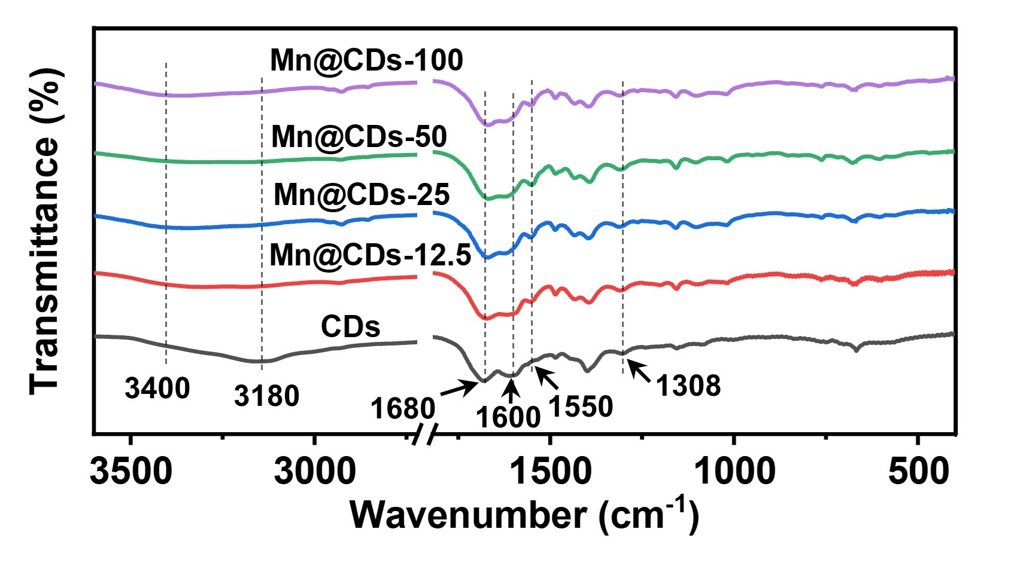
Supplementary Figure 5. The FT-IR spectra of CDs and Mn@CDs as indicated. Source data are provided as a Source Data file.

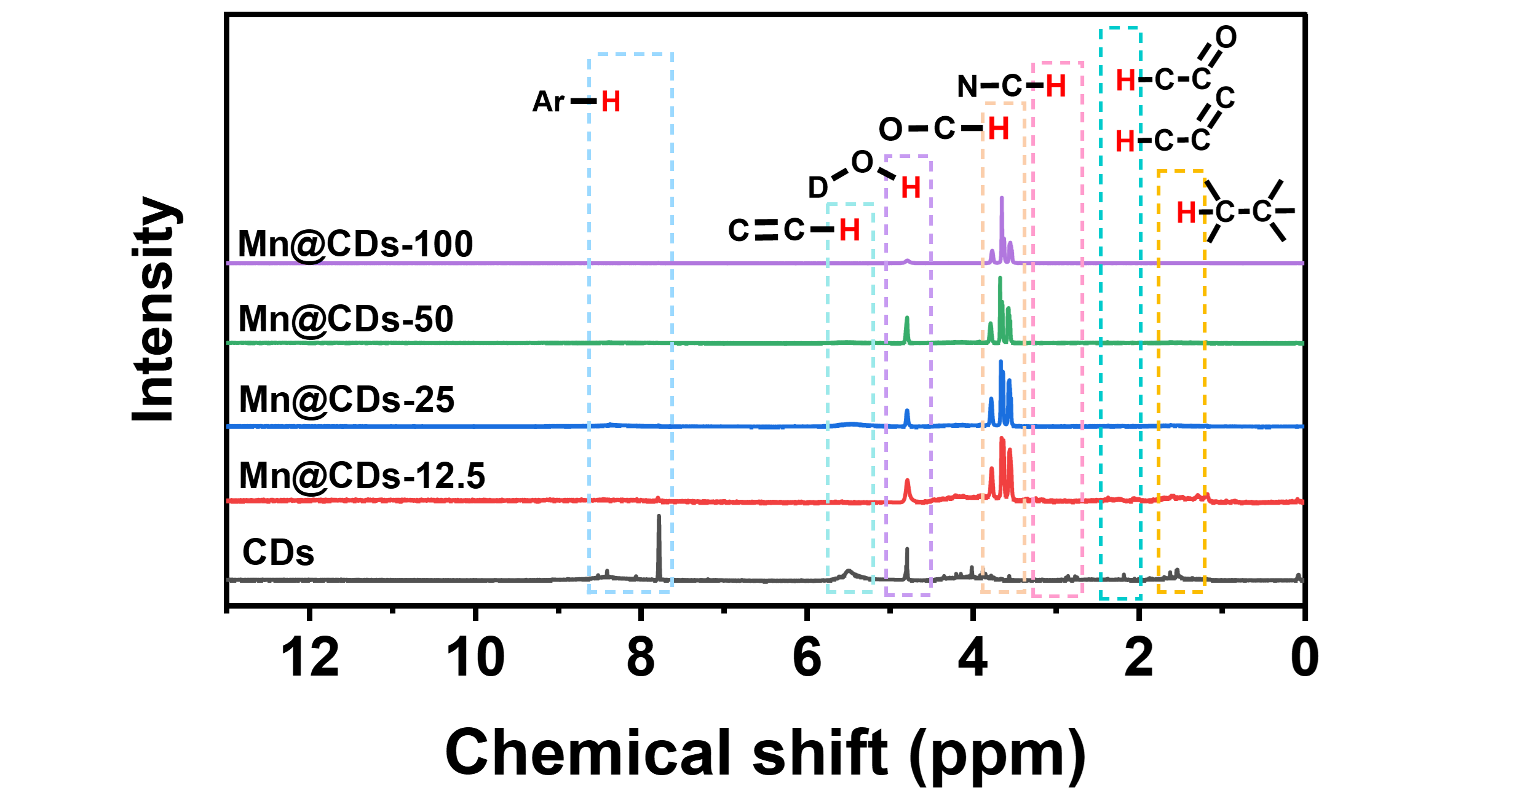
Supplementary Figure 6. The ¹H-NMR spectra of CDs and Mn@CDs as indicated. Source data are provided as a Source Data file.

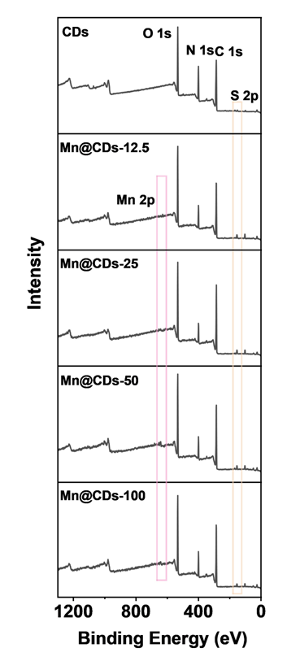
Supplementary Figure 7. XPS survey spectra of CDs and Mn@CDs prepared with Mn(ClO₄)₂·6H₂O doses of 12.5 mg, 25 mg, 50 mg, and 100 mg. Source data are provided as a Source Data file.

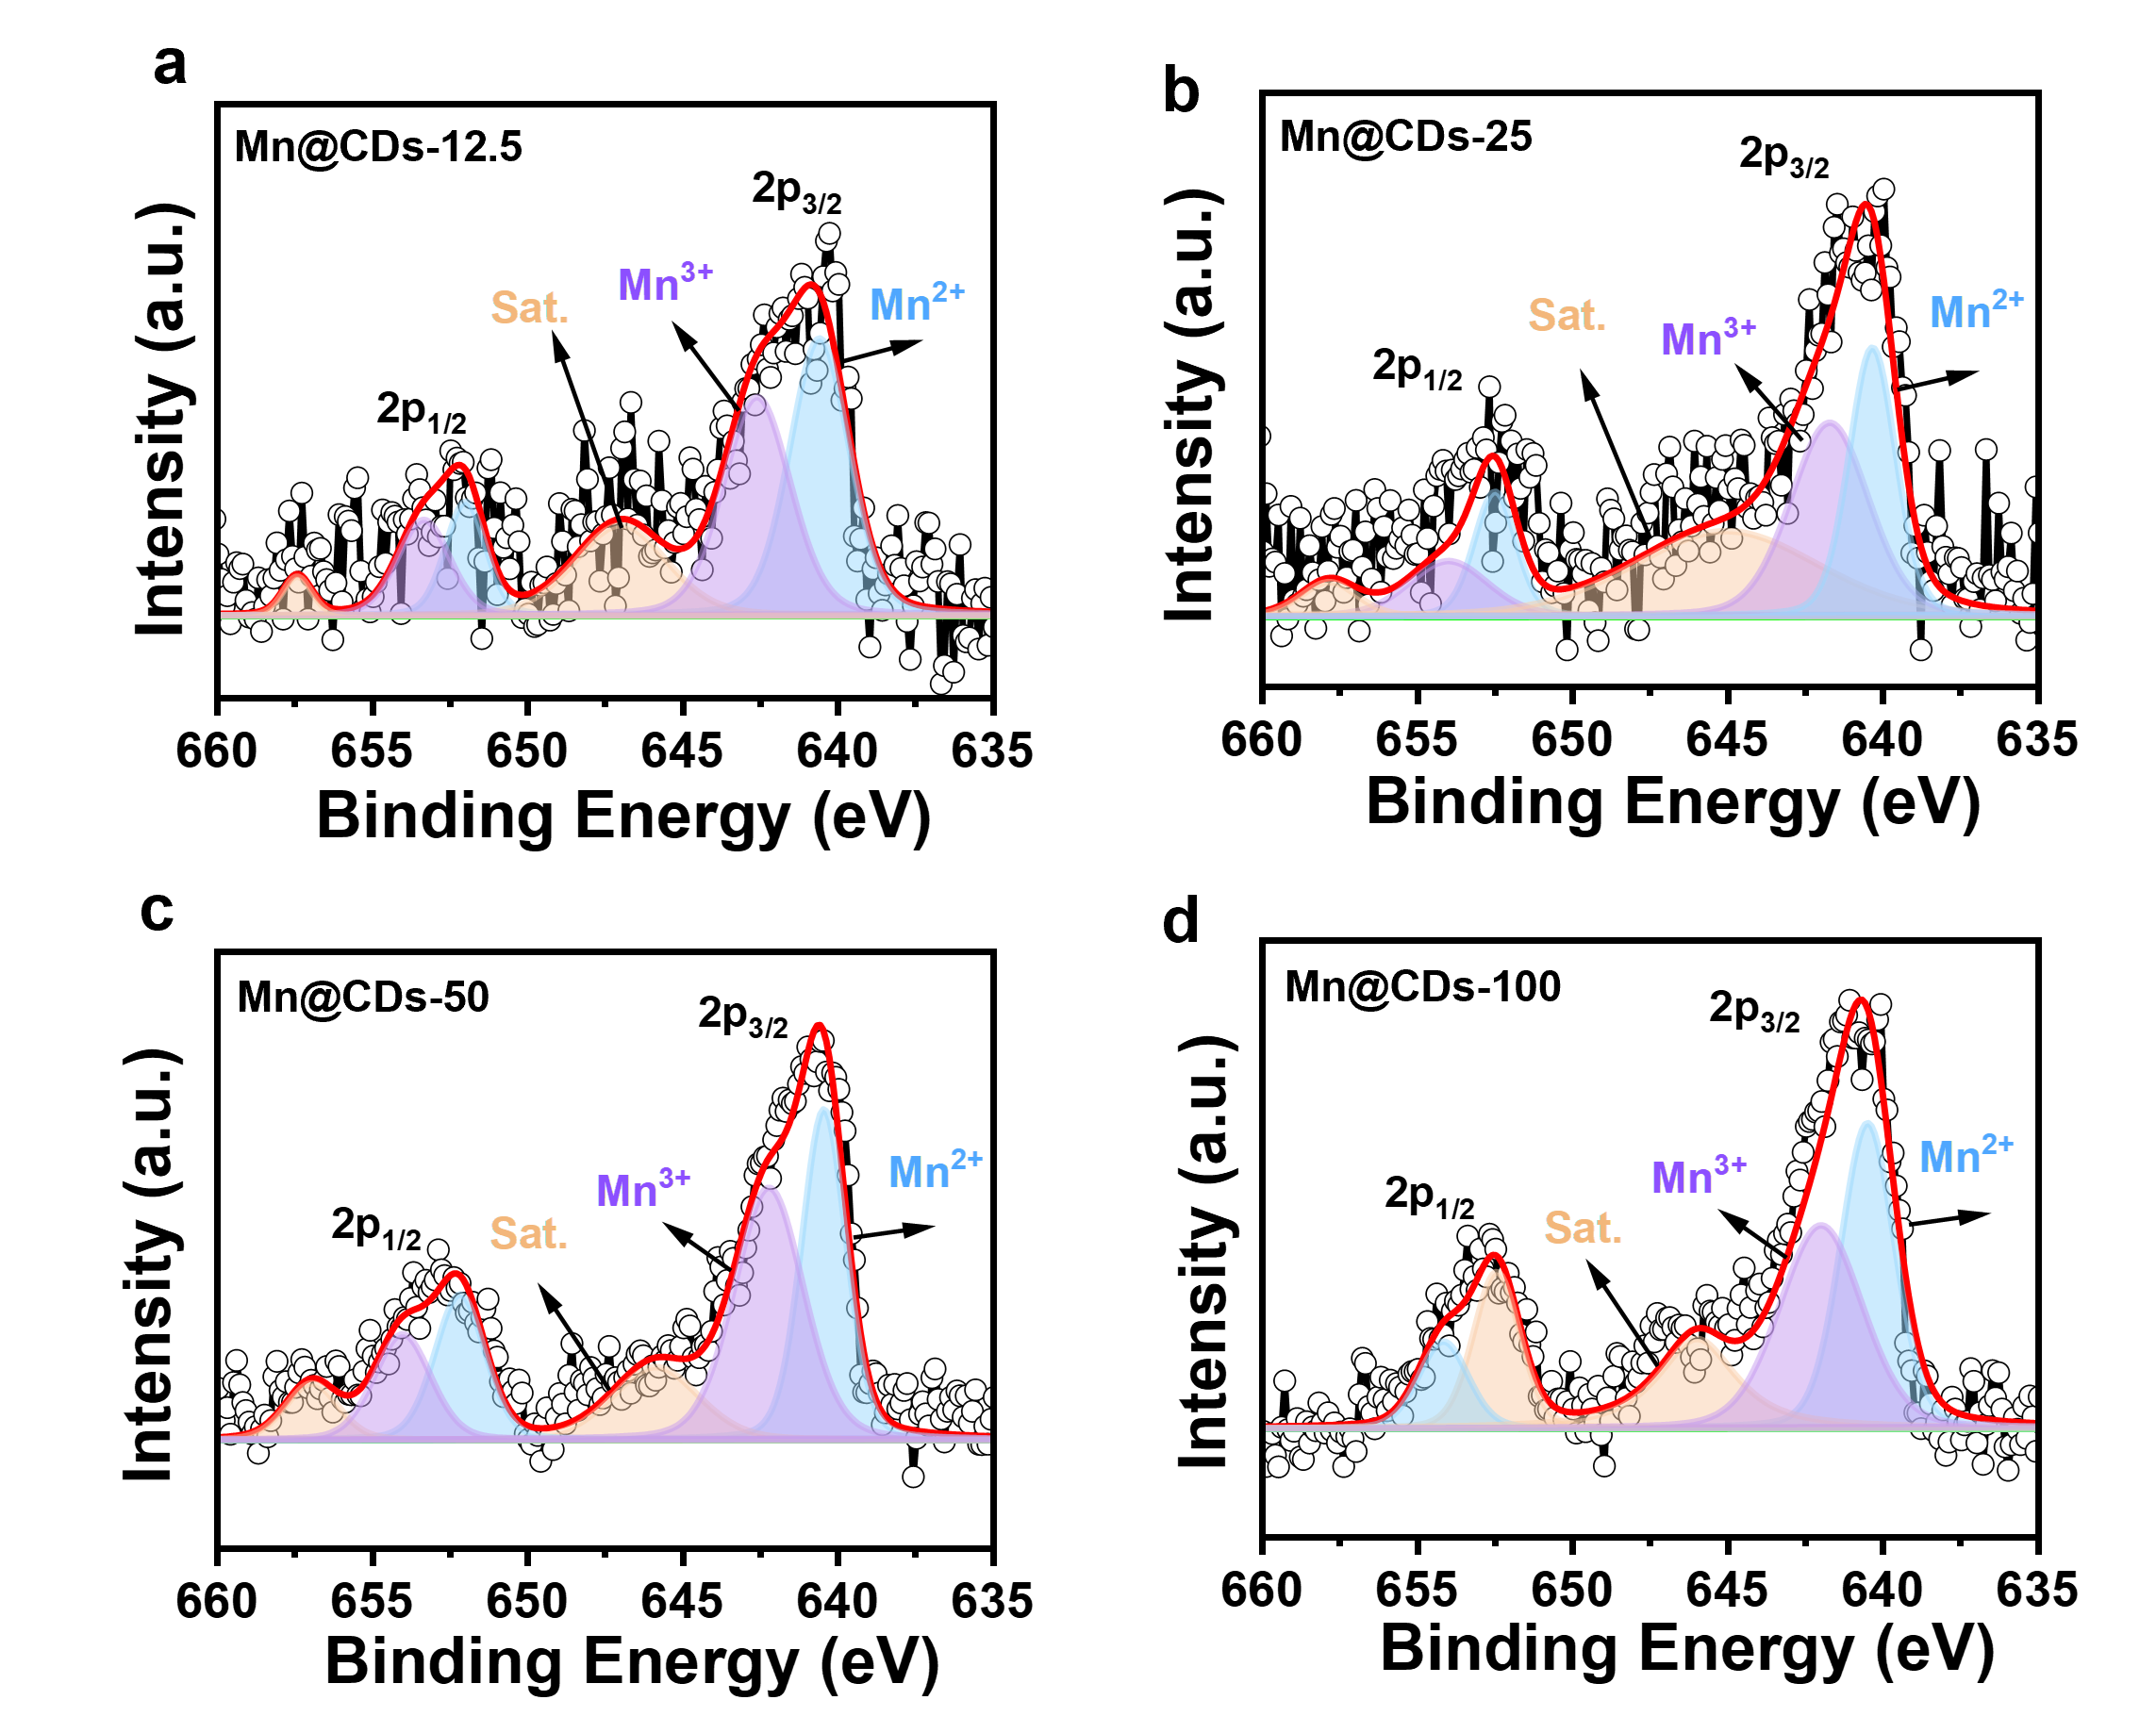
Supplementary Figure 8. HR Mn 2p spectra of Mn@CDs prepared with Mn(ClO₄)₂·6H₂O doses of 12.5 mg (a), 25 mg (b), 50 mg (c), and 100 mg (d). Source data are provided as a Source Data file.
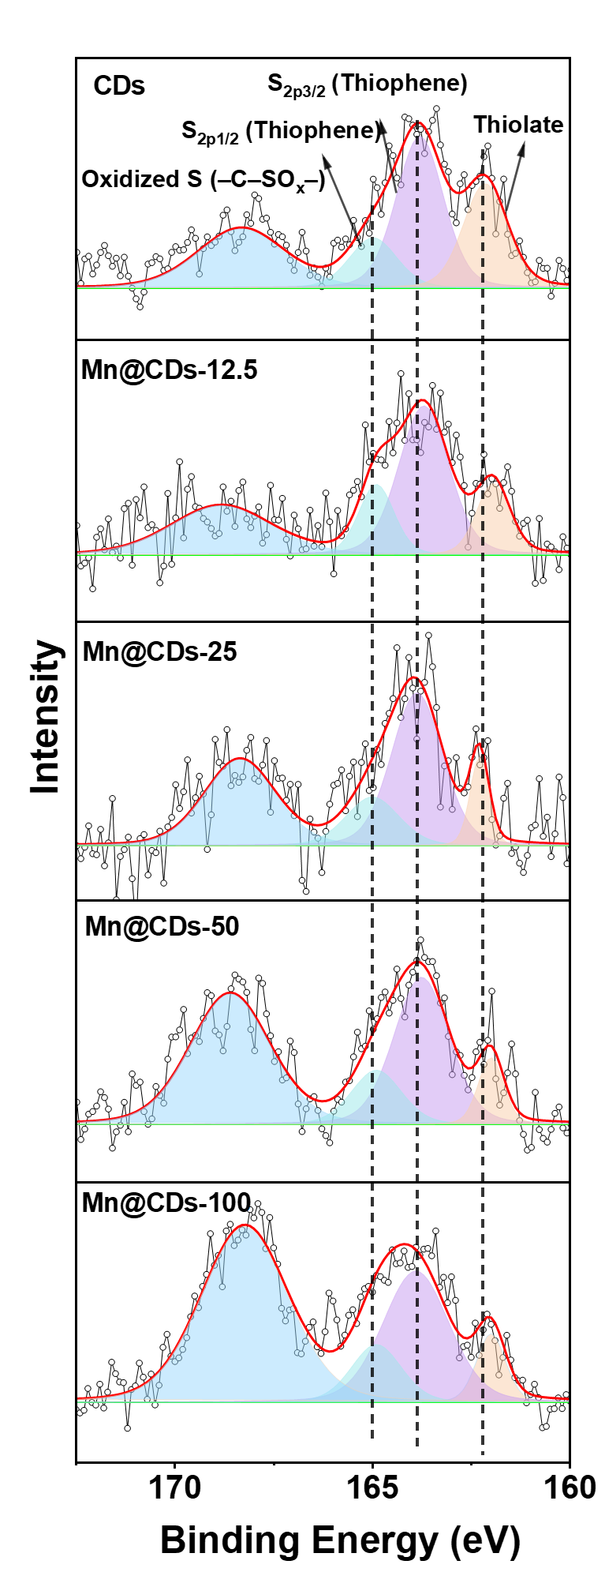
Supplementary Figure 9. HR S 2p spectra of of CDs and Mn@CDs prepared with Mn(ClO₄)₂·6H₂O doses of 12.5 mg, 25 mg, 50 mg and 100 mg. Source data are provided as a Source Data file.

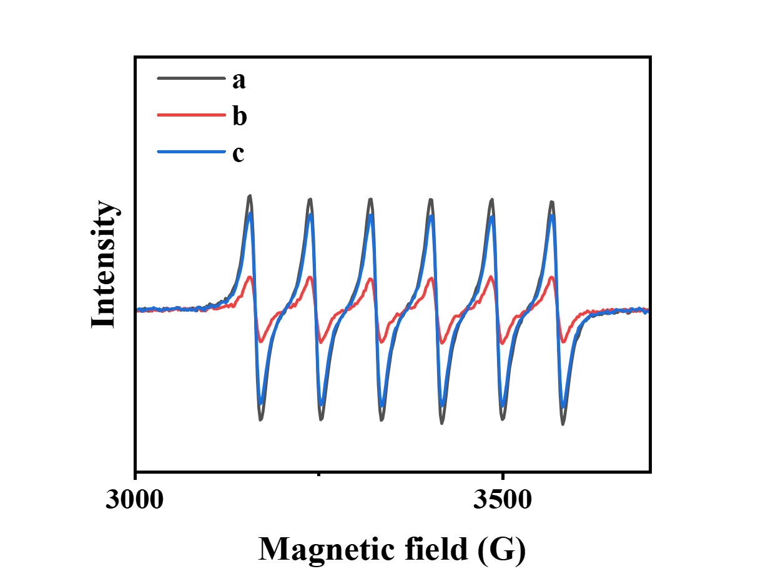
Supplementary Figure 10. ESR spectra of Mn²⁺ in a (Mn@CDs + xanthine), b (Mn@CDs + xanthine + xanthine oxidase, immediately after mixing and detection), and c (Mn@CDs + xanthine + xanthine oxidase, after 10 min of incubation and detection), the final concentrations of Mn@CDs, xanthine, and xanthine oxidase were 250 μg/mL, 2 mM, and 0.2 U/mL, respectively.

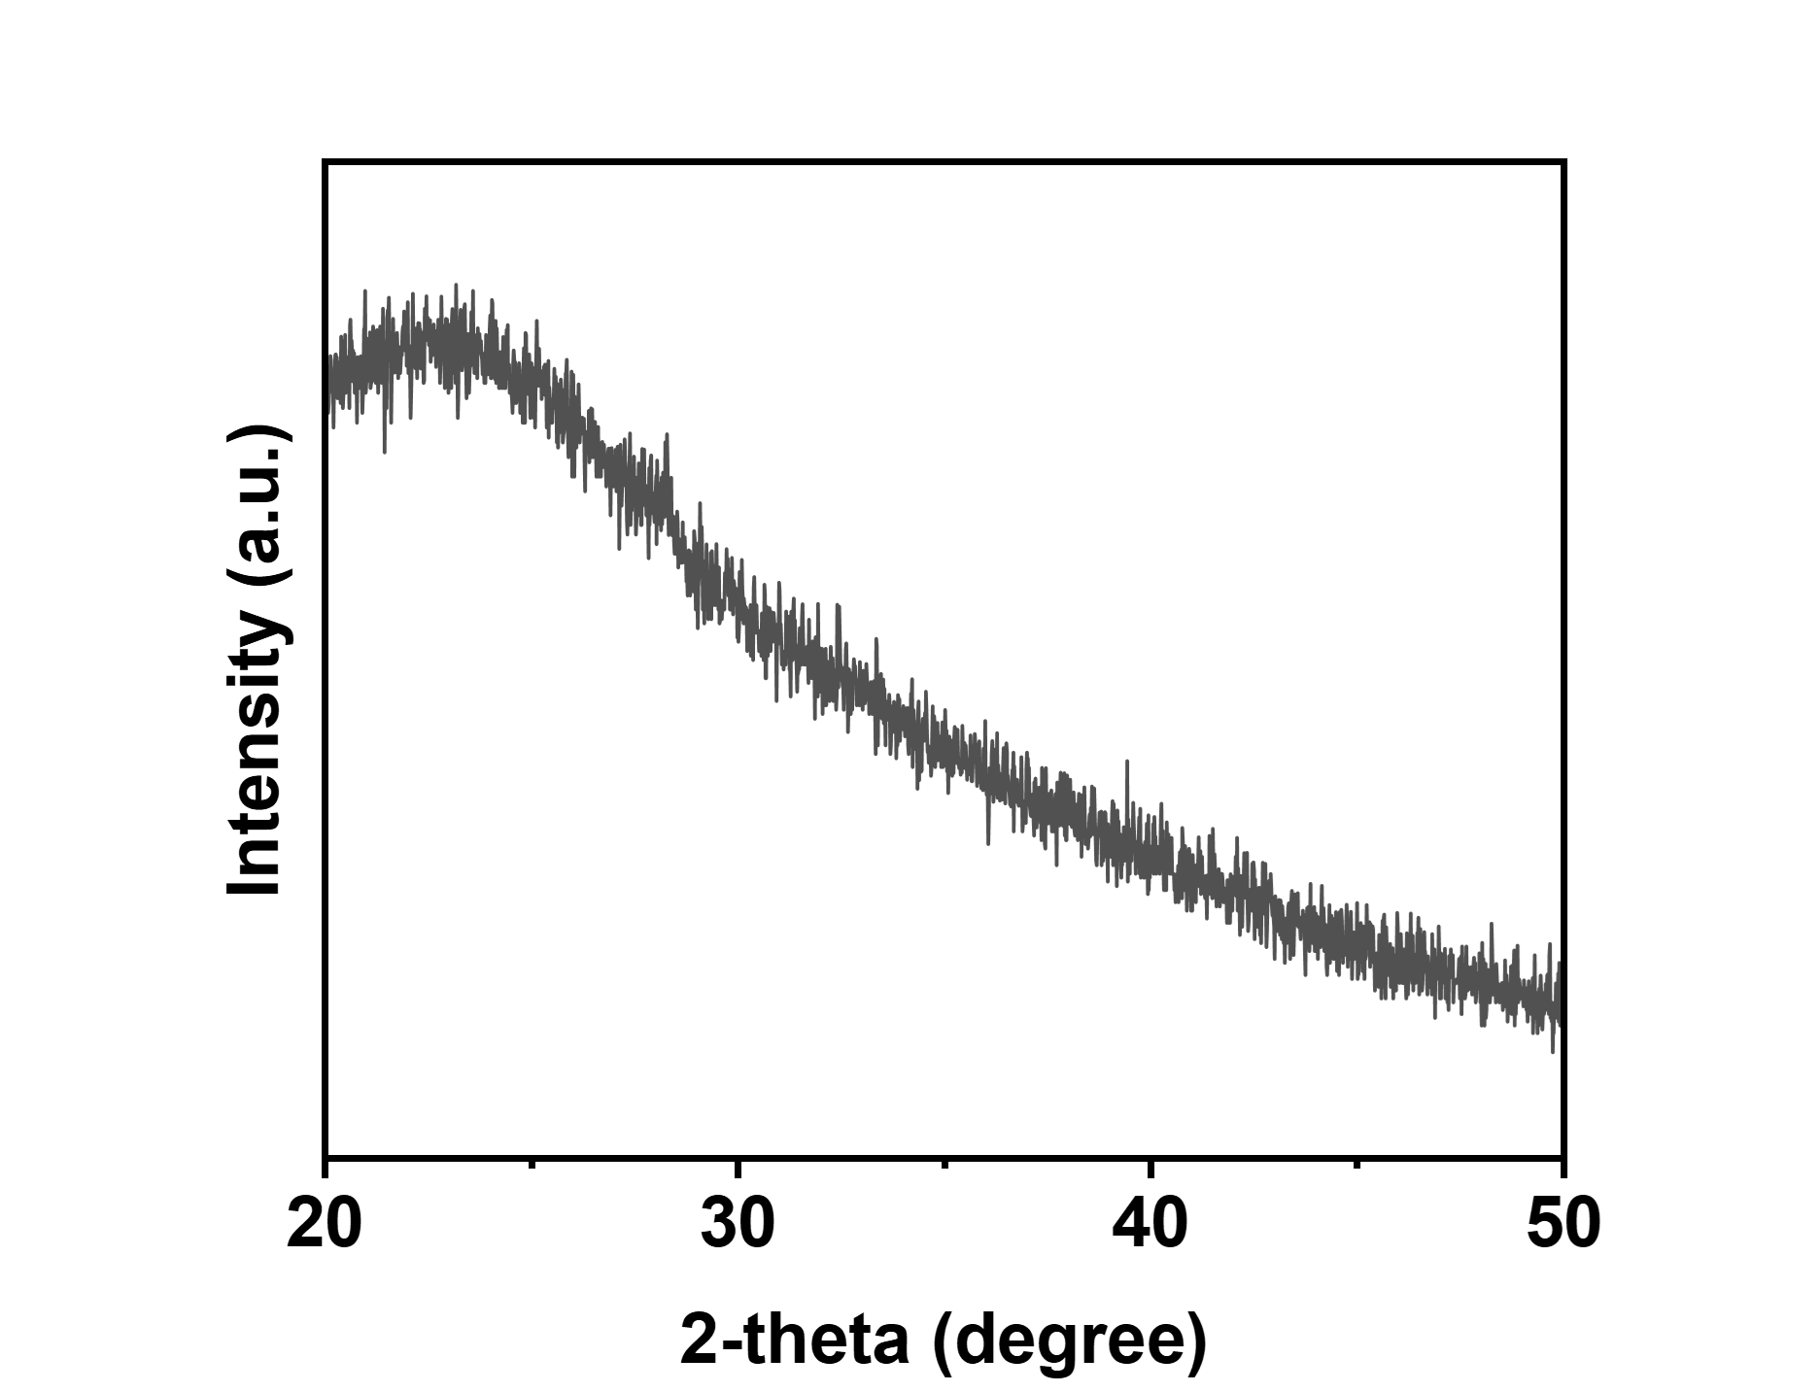
Supplementary Figure 11. XRD pattern of Mn@CDs with the largest loaded Mn (Mn(ClO₄)₂ dose of 100 mg). Source data are provided as a Source Data file.

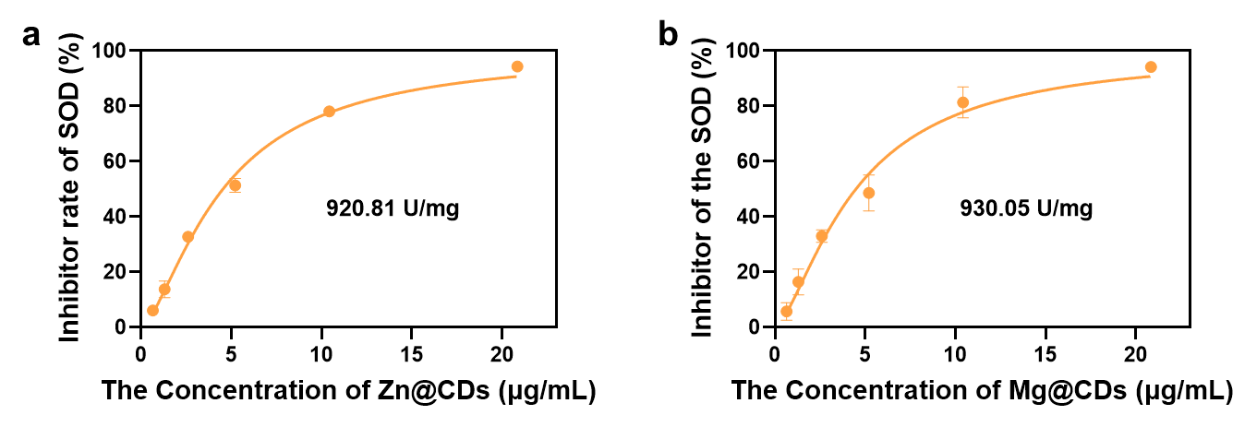
Supplementary Figure 12. The SOD-like activity of (a) Zn@CDs and (b) Mg@CDs. Source data are provided as a Source Data file.

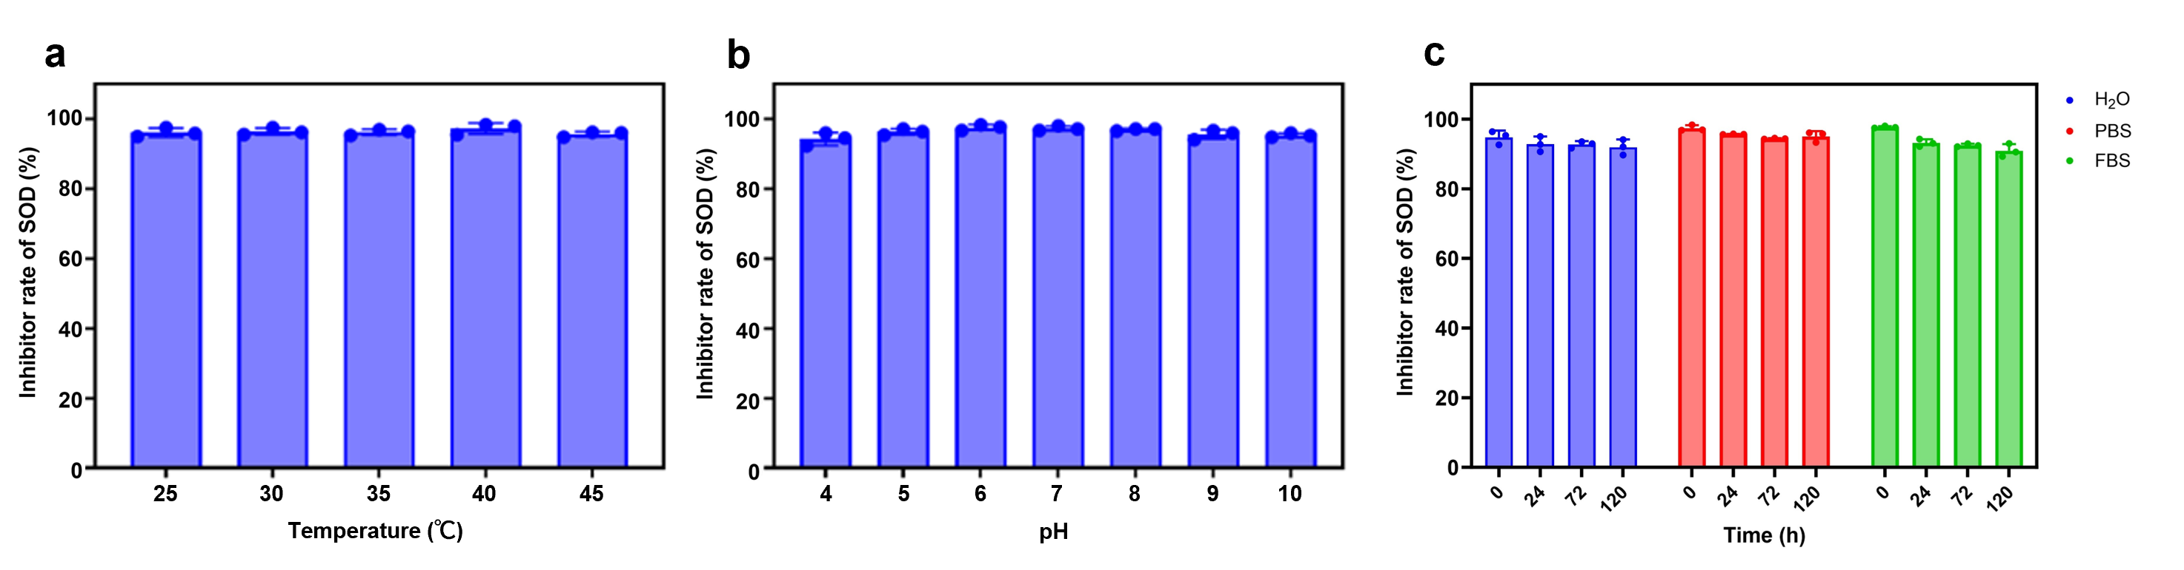
Supplementary Figure 13. SOD-like activity of Mn@CDs at different temperatures (a) and pH values (b). (c) SOD-like activity of Mn@CDs in different medium within 5 days (120 h). Source data are provided as a Source Data file.
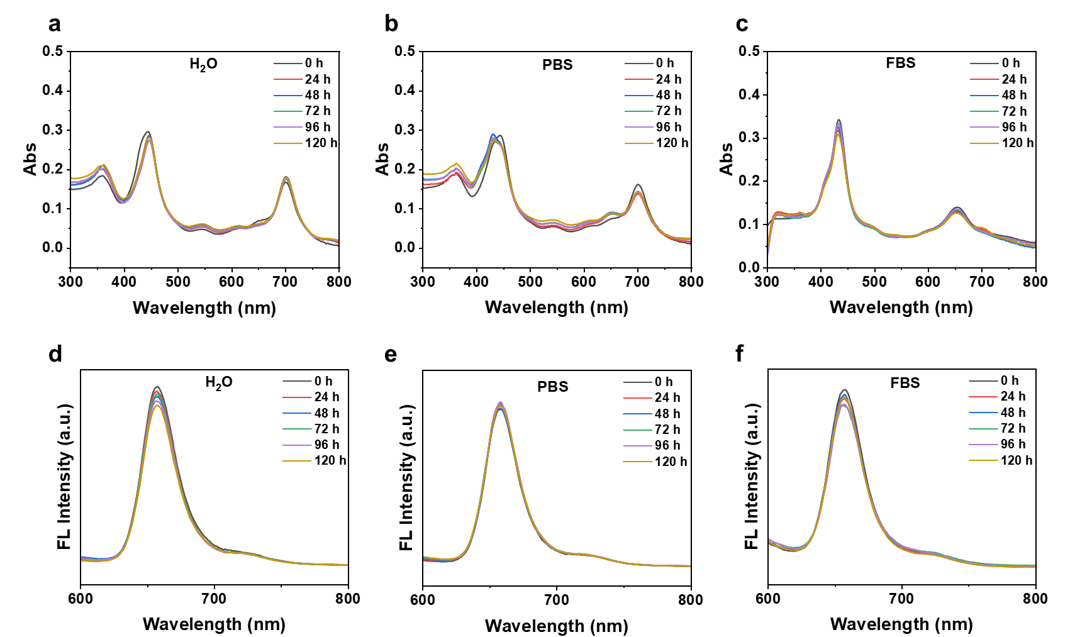
Supplementary Figure 14. The UV-vis absorption (a-c) and fluorescence (d-f) spectra of Mn@CDs in ultrapure water, PBS, and FBS within 5 days (120 h) as indicated. Source data are provided as a Source Data file.
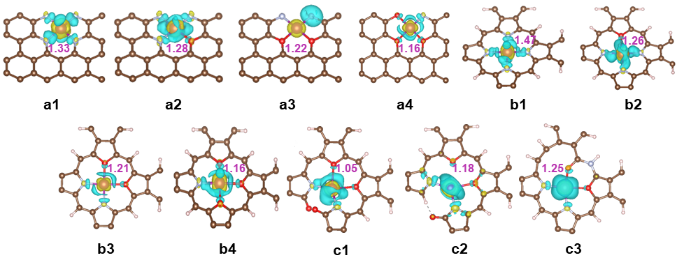
Supplementary Figure 15. Calculated charge density distribution diagram and Bader charge of the central Mn atom.

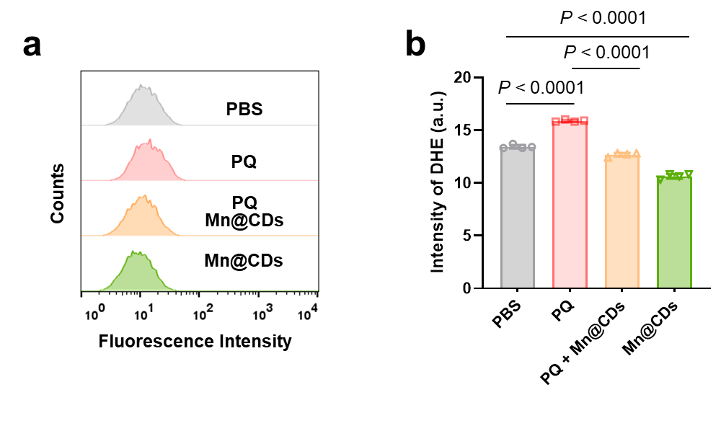
Supplementary Figure 16. Flow cytometry analysis of O₂^{•−} levels (a) and quantification of fluorescence intensity (b) in SH-SY5Y cells subjected to different treatments detected by DHE (n = 4). The quantified data are presented as the means ± SDs, and the P value was determined via one-way ANOVA. Source data are provided as a Source Data file.

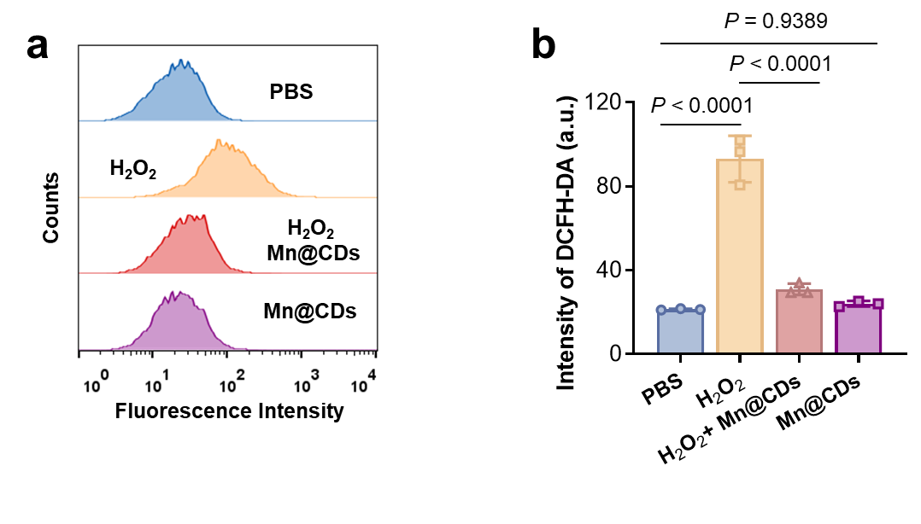
Supplementary Figure 17. Flow cytometry analysis of ROS levels (a) and quantification of the fluorescence intensity (b) in NSC-34 cells subjected to the indicated treatments detected by DCFH-DA (n = 3). The quantified data are presented as the means ± SDs, and the P value was determined via one-way ANOVA. Source data are provided as a Source Data file.

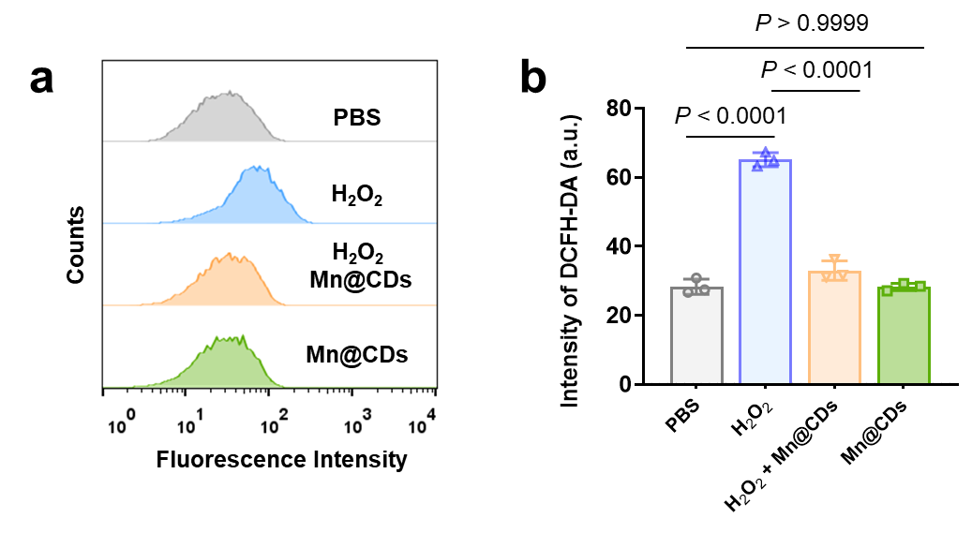
Supplementary Figure 18. Flow cytometry analysis of ROS levels (a) and quantification of fluorescence intensity (b) in SH-SY5Y cells subjected to different treatments and stained with DCFH-DA (n = 3). The quantified data are presented as the means ± SDs, and the P value was determined via one-way ANOVA. Source data are provided as a Source Data file.

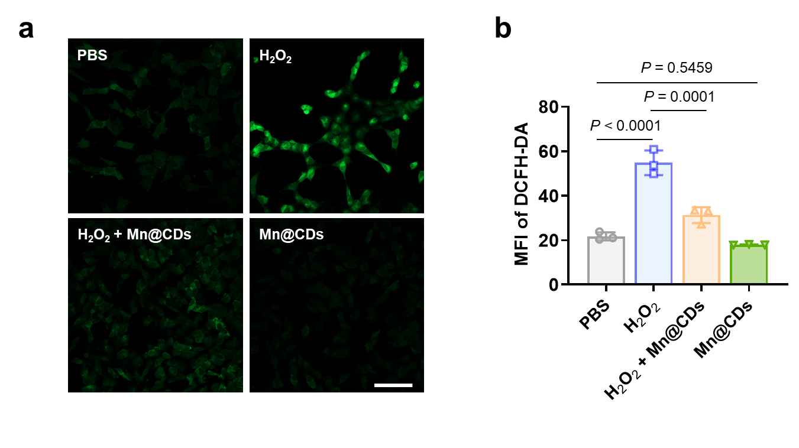
Supplementary Figure 19. Representative fluorescence images of the ROS levels (a) and quantification of the fluorescence intensity (b) in SH-SY5Y cells subjected to the indicated treatments stained with DCFH-DA (n = 3). Scale bar = 200 μm. The quantified data are presented as the means ± SDs, and the P value was determined via one-way ANOVA. Source data are provided as a Source Data file.

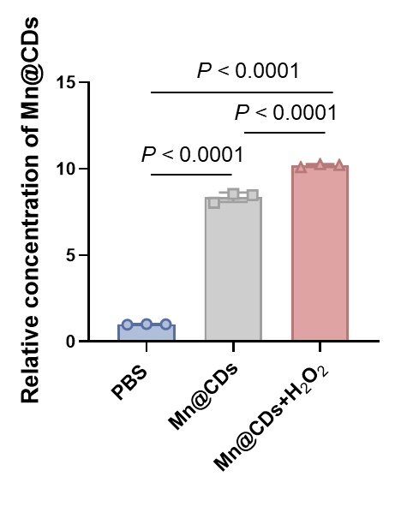
Supplementary Figure 20. Enhancement of Mn@CD cellular uptake upon 400 μM H₂O₂ stimulation in NSC-34 cells detected by inductively coupled plasma‒mass spectrometry (ICP‒MS) (n = 3). The data are presented as the means ± SDs, and the P value was determined via one-way ANOVA. Source data are provided as a Source Data file.

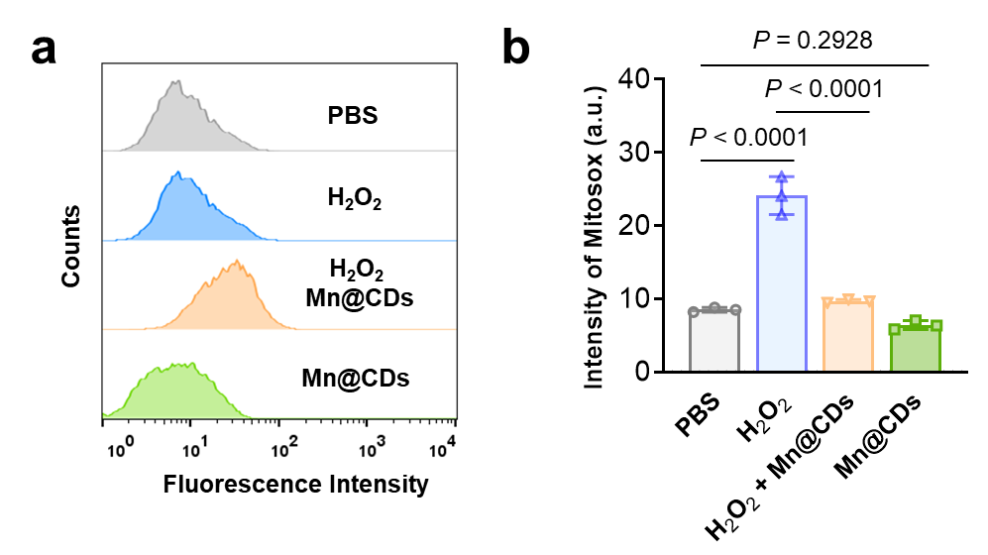
Supplementary Figure 21. Flow cytometry analysis of mitochondrial ROS levels (a) and quantification of fluorescence intensity (b) in SH-SY5Y cells subjected to different treatments with MitoSOX Green (n = 3). The quantified data are presented as the means ± SDs, and the P value was determined via one-way ANOVA. Source data are provided as a Source Data file.

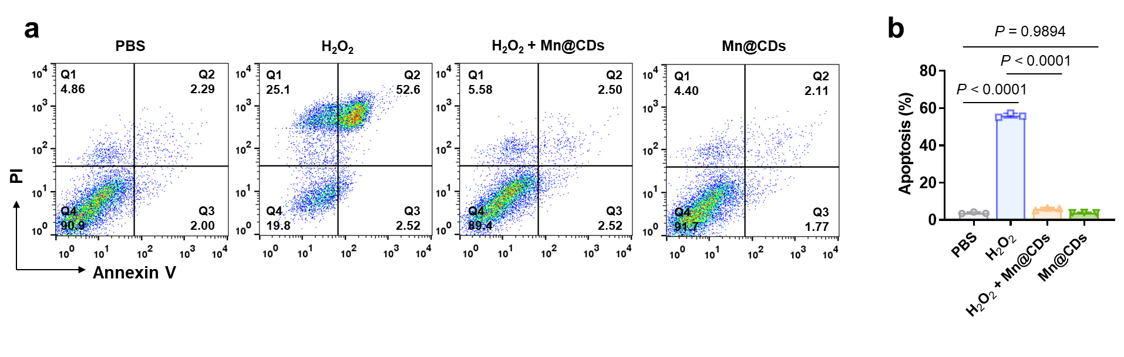
Supplementary Figure 22. Flow cytometry analysis of cell apoptosis (a) and quantification of the apoptosis rate (b) in SH-SY5Y cells subjected to the indicated treatments via Annexin V-FITC/PI staining (n = 3). The quantified data are presented as the means ± SDs, and the P value was determined via one-way ANOVA. Source data are provided as a Source Data file.

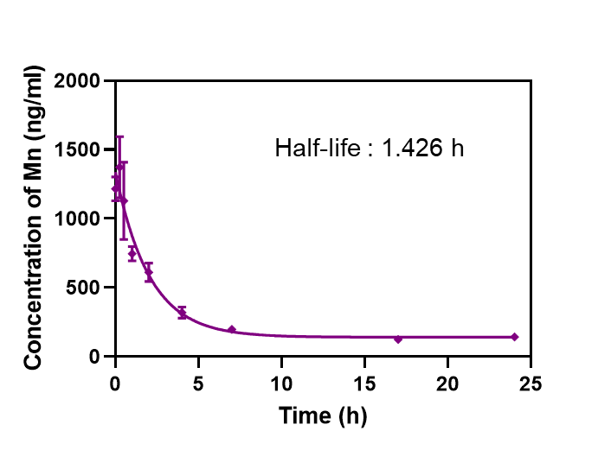
Supplementary Figure 23. Blood circulation curve of intravenously injected Mn@CDs (n = 3). The data are presented as the means ± SDs. Source data are provided as a Source Data file.

Supplementary Figure 24. Excretion of Mn@CDs in urine and feces post administration (n = 3). The data are presented as the means ± SDs. Source data are provided as a Source Data file.

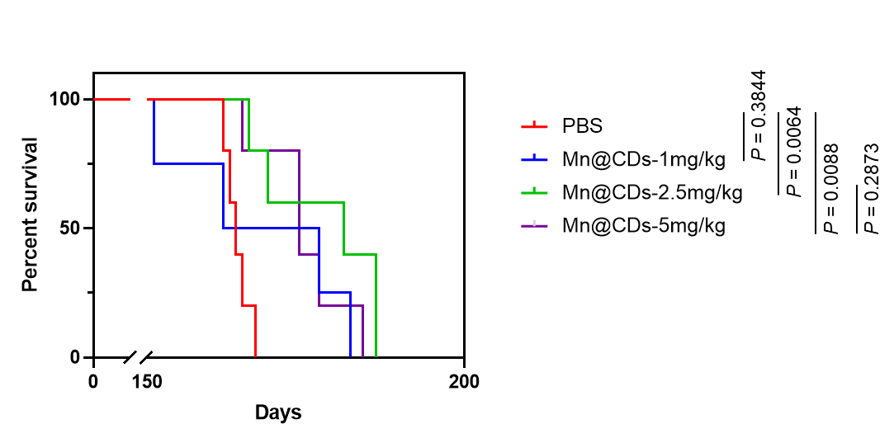
Supplementary Figure 25. Survival analysis of mice subjected to Mn@CD treatment with different doses (n = 5). P values were determined via Kaplan‒Meier analysis with the log-rank test.

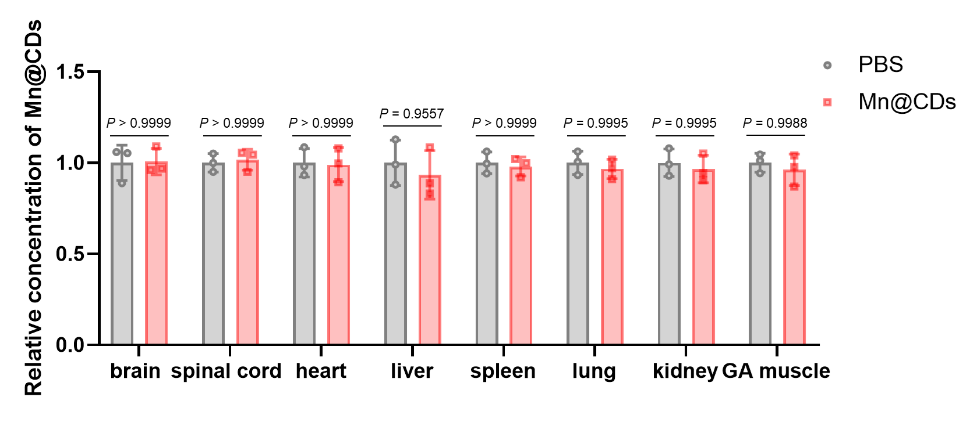
Supplementary Figure 26. Evaluation of the Mn accumulation in tissues of brain, spinal cord, heart, liver, spleen, lung, kidney, and GA muscle of the mice received long-term administration of Mn@CDs via ICP-MS. The quantified data are presented as the means ± SDs, and the P value was determined via two-way ANOVA. Source data are provided as a Source Data file.

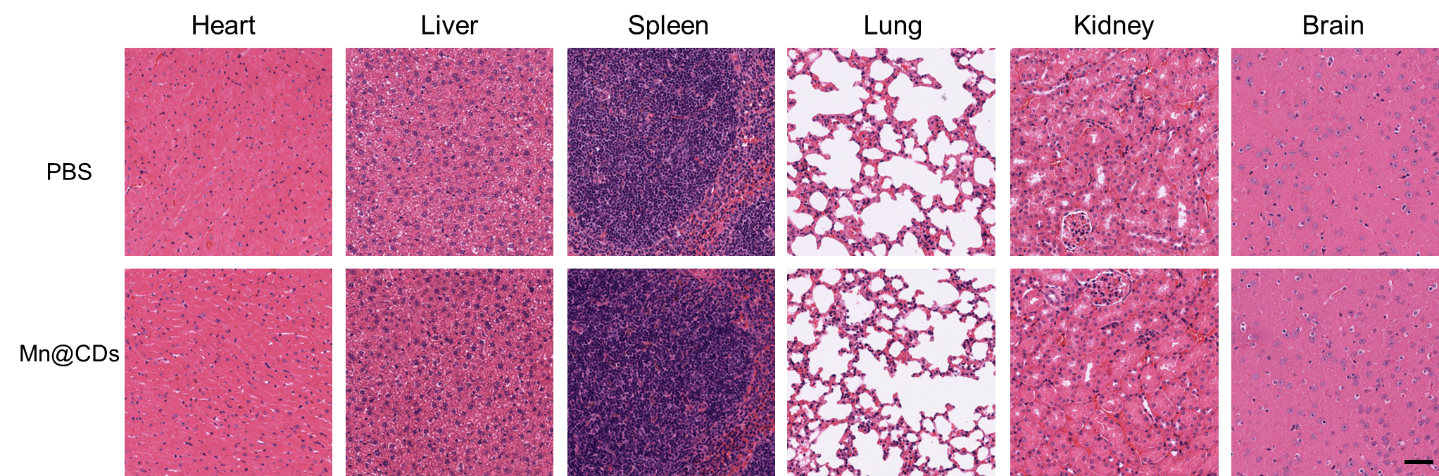
Supplementary Figure 27. Representative H&E staining images of tissue sections from the major organs of the mice treated with PBS or Mn@CDs. Scale bar = 50 μm.

Supplementary Figure 28. Changes in the body weights of the mice treated with PBS or Mn@CDs (n = 3). The data are presented as the means ± SDs. Source data are provided as a Source Data file.

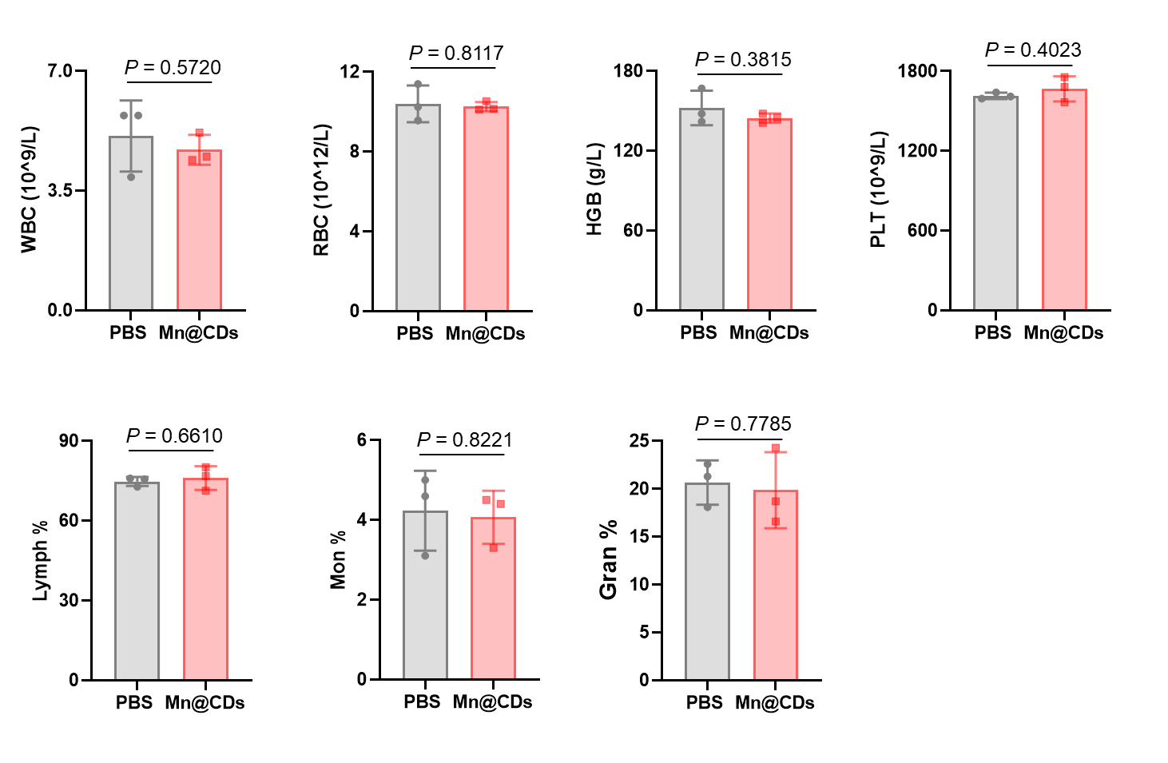
Supplementary Figure 29. Routine blood tests of the mice treated with PBS or Mn@CDs (n = 3). The data are presented as the means ± SDs, and P values were determined via Student’s t test. Source data are provided as a Source Data file.

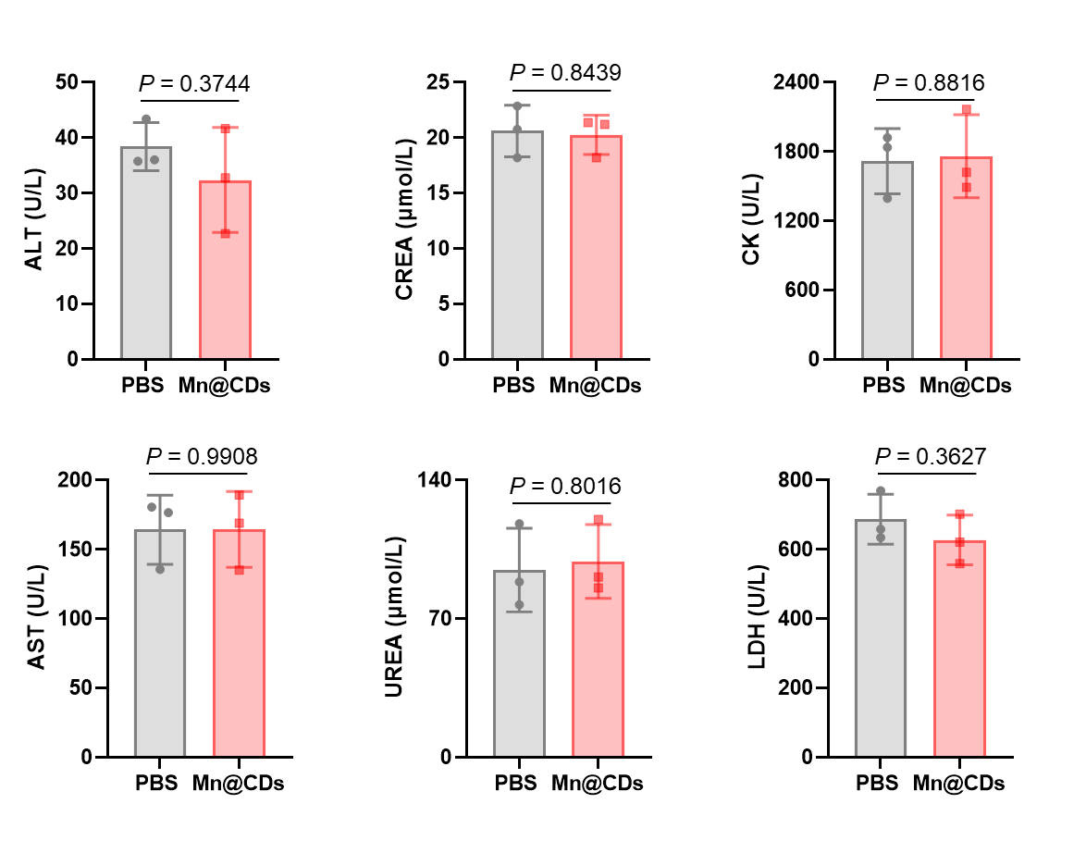
Supplementary Figure 30. Blood biochemical analysis of the mice treated with PBS or Mn@CDs (n = 3). The data are presented as the means ± SDs, and P values were determined via Student’s t test. Source data are provided as a Source Data file.
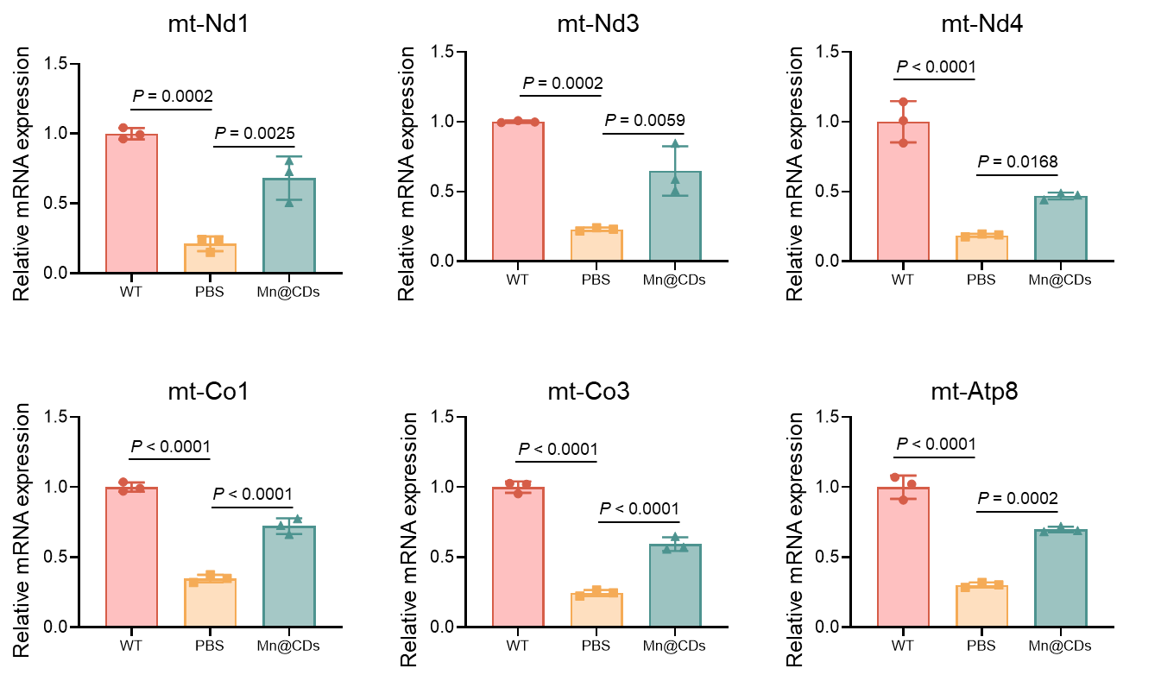
Supplementary Figure 31. qPCR analysis of the mRNA levels of representative mitochondrially encoded genes in the lumbar spinal cord lysates of the mice in the different groups. The ACTIN gene was used as an internal control (n = 3). The quantified data are presented as the means ± SDs, and the P value was determined via one-way ANOVA. Source data are provided as a Source Data file.

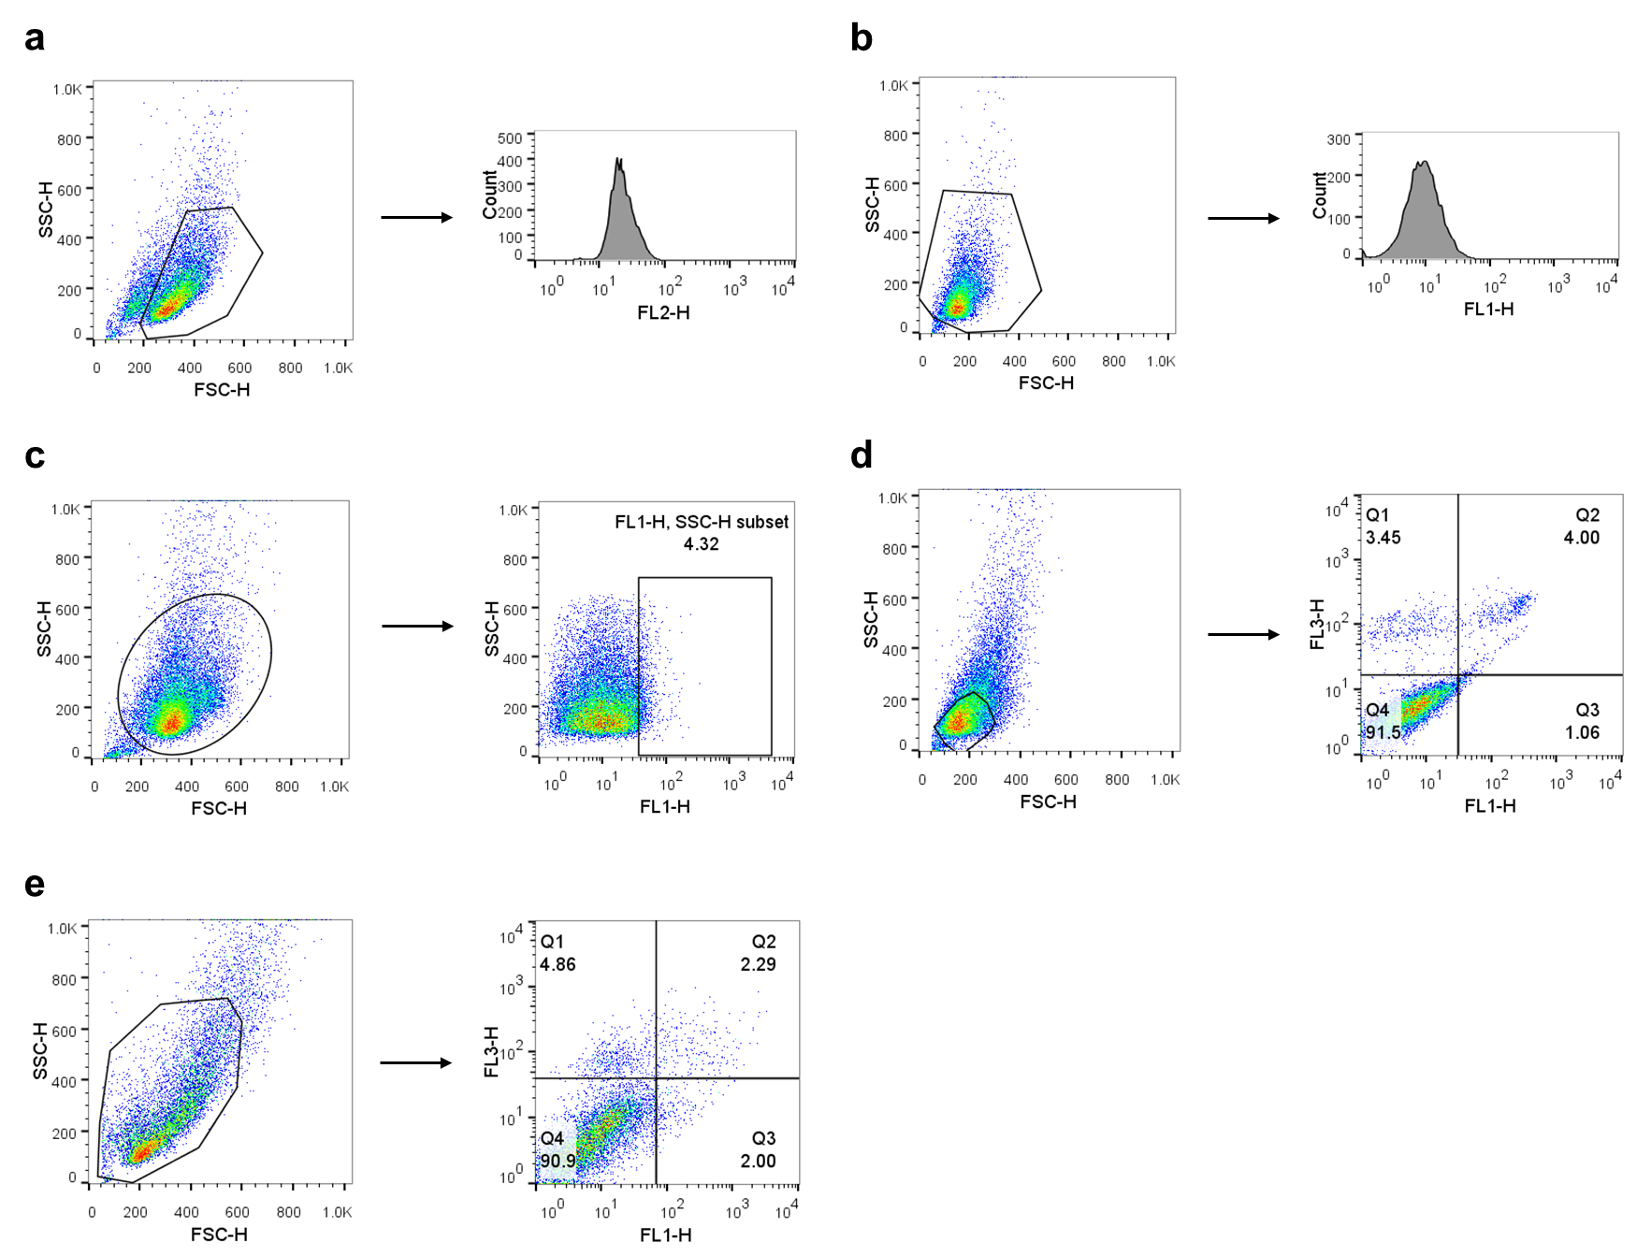
Supplementary Figure 32. Flow cytometry gating strategies for DHE staining (a), MitoSOX green staining and DCFH-DA staining (b), Fluo-4 AM staining (c), Annexin V-FITC/PI staining in NSC-34 cells (d), and Annexin V-FITC/PI staining in SH-SY5Y cells (e).

Supplementary Tables

Supplementary Table 1. Metal content of metal-doped CDs determined by ICP-OES.
Sample | Types of Measured Metals | Content (%) | RSD (%)
Cu@CDs | Cu | 1.18 | 0.54
Zn@CDs | Zn | 4.00 | 0.26
Fe@CDs | Fe | 2.19 | 2.23
Ni@CDs | Ni | 0.02 | 3.03
Ru@CDs | Ru | 1.04 | 3.50
Mo@CDs | Mo | 0.22 | 1.79
Sn@CDs | Sn | 0.05 | 2.43
Au@CDs | Au | 0.03 | 2.23
Pt@CDs | Pt | 0.38 | 1.58
Pd@CDs | Pd | 0.02 | 3.62
Mg@CDs | Mg | 1.59 | 0.47

Supplementary Table 2. Dose of Mn(ClO₄)₂·6H₂O used in the synthesis process and the corresponding amount of Mn in the Mn@CDs
Dose of Mn (ClO₄)₂ ·6H₂O (mg) | The ratio of Mn in Mn@CDs (%)
12.5 | 1.578
25 | 2.582
50 | 3.873
100 | 5.386

Supplementary Table 3. Contents of N, C, H, and S in CDs and Mn@CDs-100.
Sample | N (%) | C (%) | H (%) | S (%)
CDs | 21.27 | 37.19 | 4.06 | 0.54
Mn@CDs-100 | 11.57 | 38.11 | 5.17 | 0.57

Supplementary Table 4. The unit cell parameters for all the models in Fig. 4a.
Models | a (Å) | b (Å) | c (Å) | alpha | beta | gamma
a1 | 9.99781 | 8.40799 | 14.33868 | 89.9883 | 90.0662 | 89.9998
a2 | 10.01183 | 8.40765 | 14.31922 | 89.9713 | 90.0761 | 90.1000
a3 | 10.01857 | 8.41774 | 14.29239 | 89.9834 | 90.0578 | 90.0023
a4 | 10.02607 | 8.42244 | 14.27375 | 89.9821 | 90.0890 | 90.0825
b1 | 10.85336 | 10.85456 | 13.15360 | 90.0000 | 90.0000 | 89.9014
b2 | 10.85447 | 11.10951 | 12.85042 | 90.0000 | 90.0000 | 89.9078
b3 | 10.89713 | 10.89449 | 13.05274 | 90.0000 | 90.0000 | 89.9306
b4 | 10.86431 | 10.96107 | 13.01264 | 90.0000 | 90.0000 | 89.9341
c1 | 10.94465 | 10.95938 | 12.92044 | 89.8197 | 89.6863 | 90.7366
c2 | 11.09243 | 11.48561 | 12.19453 | 90.0000 | 90.0000 | 94.1229
c3 | 11.08233 | 10.98738 | 12.75754 | 90.1159 | 89.9214 | 85.9787

Supplementary Table 5. Sequences of the RT‒qPCR primers.
Gene | Primer sequence (5’-3’)
mt-Nd1 | F: CAACCATTTGCAGACGCCAT  R: GGGTGTGGTATTGGTAGGGG
mt-Nd2 | F: AGGGGCATGAGGAGGACTTA  R: TGAGTAGAGTGAGGGATGGGT
mt-Nd3 | F: GCATTCTGACTCCCCCAAAT  R: AATGGTAGACGTGCAGAGCTT
mt-Nd4 | F: CCTCAGACCCCCTATCCACA  R: GTTTGGTTCCCTCATCGGGT
mt-Co1 | F: ACACATGAGCAAAAGCCCAC  R: AGTCTGAGTAGCGTCGTGGT
mt-Co2 | F: GCTCTCCCCTCTCTACGCAT  R: AGCAGTCGTAGTTCACCAGG
mt-Co3 | F: GCCTTTTCAGCCCTCCTTCTA  R: CAATAGGAGTGTGGTGGCCTT
mt-Atp6 | F: TGCCTCATTCATTACCCCAACA  R: AGGCGTTTTGAGGATGGGAA
mt-Atp8 | F: TGGCACCTTCACCAAAATCAC  R: TTGGGGTAATGAATGAGGCAAAT
Actin | F: GATCAGCAAGCAGGAGTACGA  R: GGGTGTAAAACGCAGCTCA

