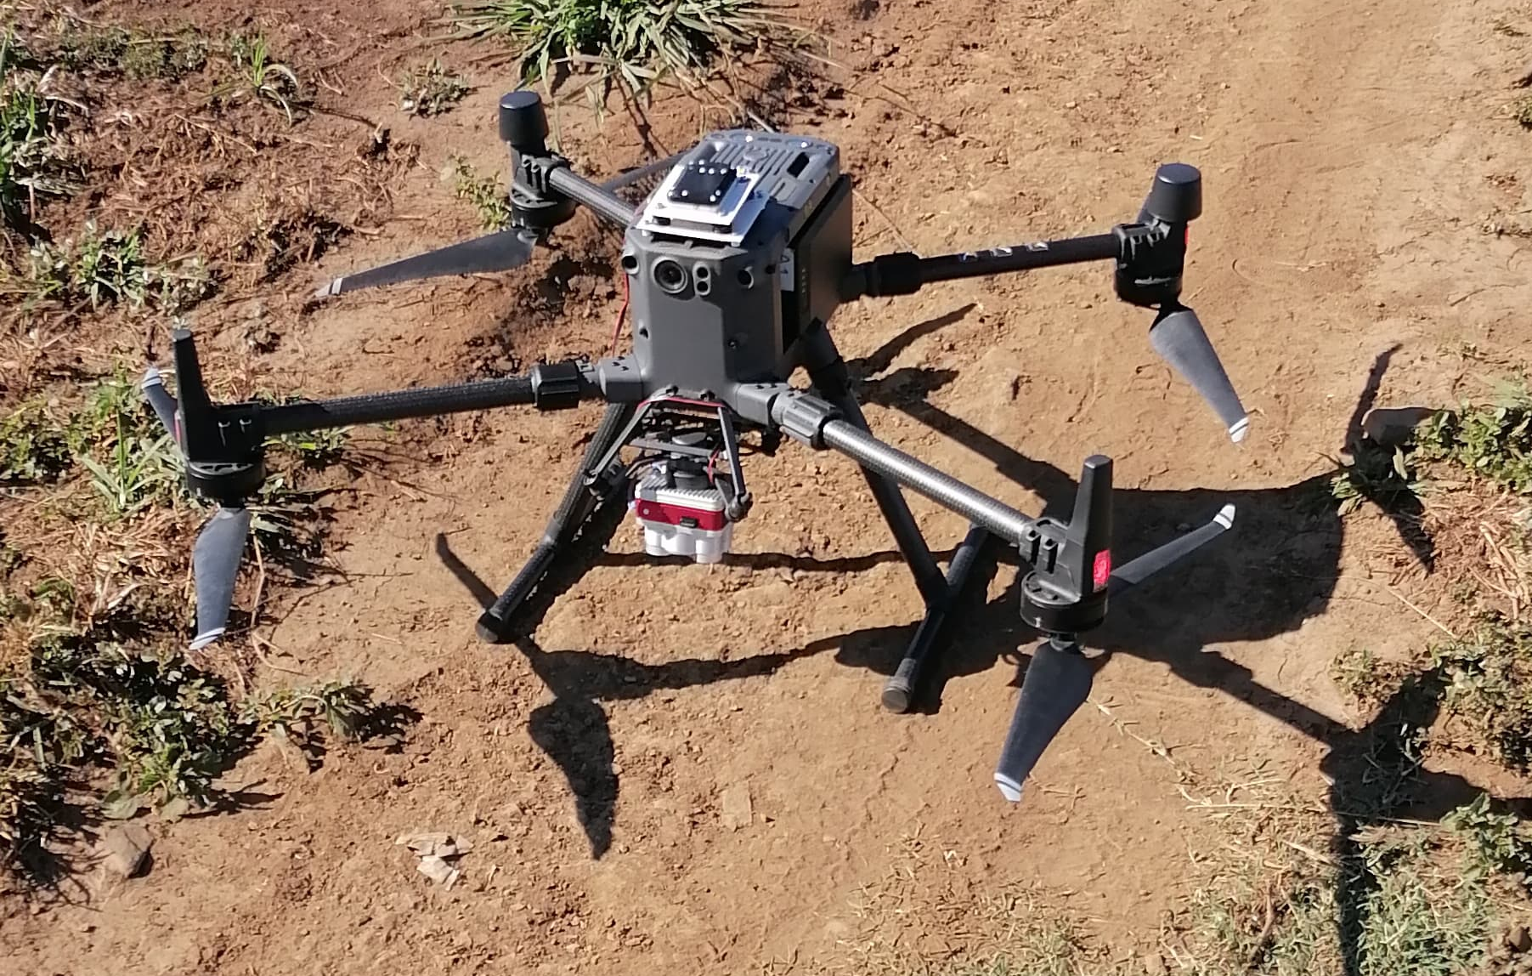
Plate 1: DJI Matrice 300 series drone with mounted MicaSense Altum camera, used for imagery acquisition over the growing season

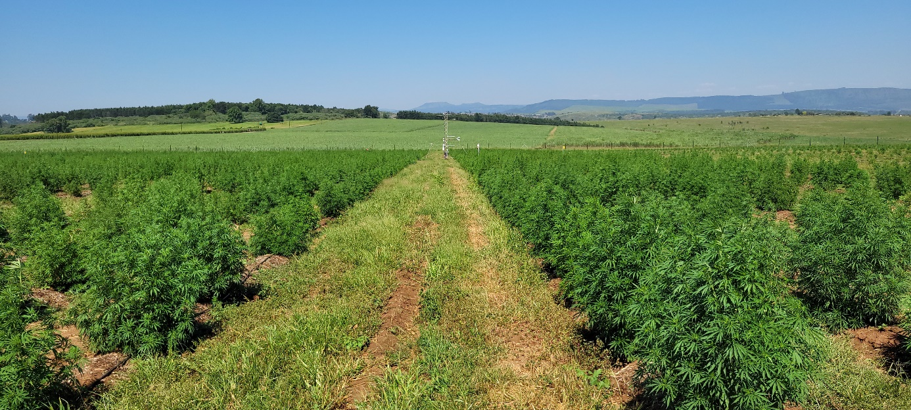

Plate 2: The South field (January 2023) after weeding between the plants. A grass and weed cover was established in the tramline and mown to reduce competition. The research tower can be seen in the background

