Supplementary Information for:

Enhanced warming in net-zero scenarios that balance fossil fuel CO₂ emissions with CO₂ removals through reforestation
Alexander J. MacIsaac*^{1,2}, Kirsten Zickfeld¹, Pierre Etienne Banville¹, H. Damon Matthews³,
¹ Simon Fraser University, Vancouver, Canada
² St. Francis Xavier University, Antigonish, Canada
³ Concordia University, Montreal, Canada
* corresponding author: alexander_macisaac@sfu.ca

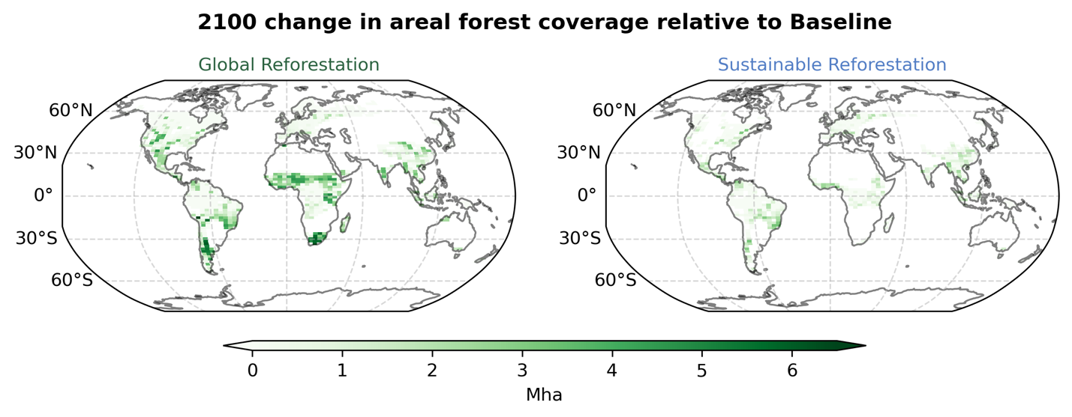Supplementary Figure 1: 2100 change in areal forest coverage (Mha) relative to the Baseline. In our model, the majority of global reforestation occurs in the tropics for the Global Reforestation (left) and Sustainable Reforestation (right) cases.

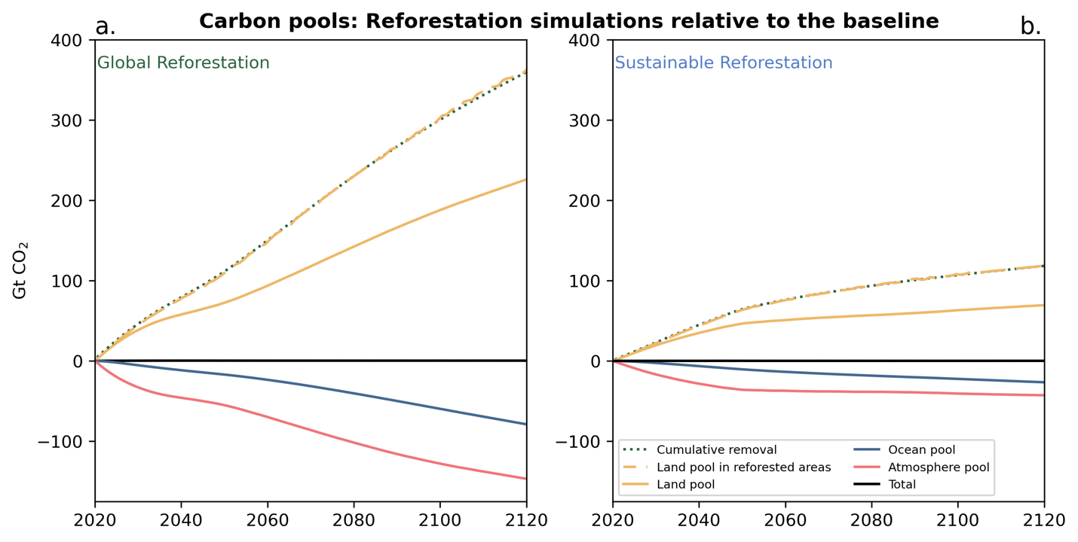Supplementary Figure 2: Change in the carbon pools for the Reforestation simulations relative to the Baseline. Changes in carbon pools for the Global (a.) and Sustainable (b.) Reforestation simulations. Green dotted lines represent the cumulative reforestation-based CO₂ removal, which is equivalent to the change in land carbon in reforested areas relative to the Baseline (yellow dashed lines) in the Reforestation simulations.
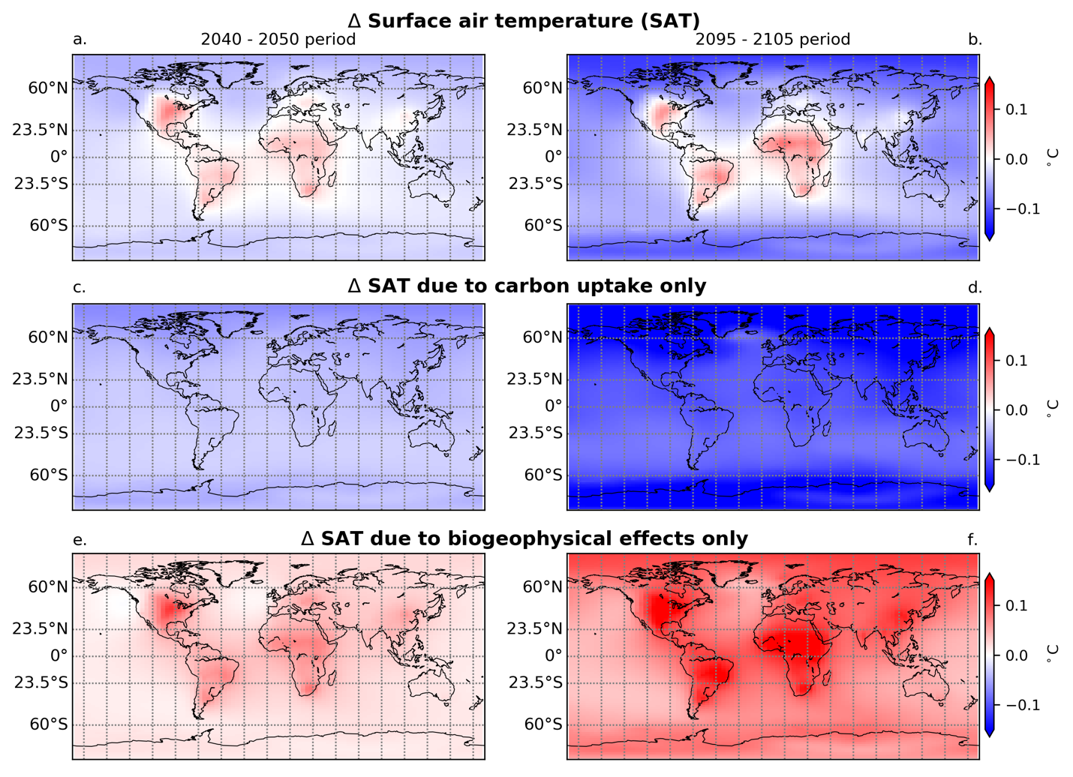Supplementary Figure 3: Change in SAT relative to the Baseline due to carbon and biogeophysical effect, carbon effects only, and biogeophysical effects only. The change, relative to the Baseline is shown over two decadal periods (2040-2050, left & 2095-2105, right), for SAT (top), for SAT due to carbon uptake (middle), and for SAT due to biogeophysical effects (bottom) for the Global Reforestation simulation.
The change in SAT relative to Baseline due to both carbon and biogeophysical effects of reforestation shows strong regional differentiation between warming and cooling. Regions that show warming correspond to regions with high warming from biogeophysical effects. The carbon uptake effect on SAT from reforestation, meanwhile, is cooling across the globe, with amplification towards the poles owing to climate feedbacks. The impact of biogeophysical effects on SAT is warming across the globe with the highest impact over or near reforested areas. Biogeophysical effects exhibit a non-local impact on SAT due to advection of warmer air to regions beyond reforested areas and associated climate feedbacks.
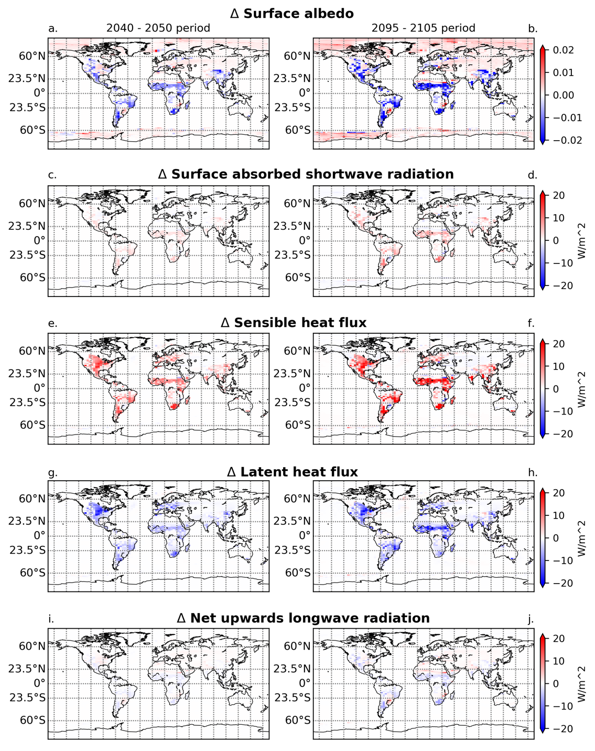
Supplementary Figure 4: The change relative to the Baseline in surface energy balance components. Results are shown over two decadal periods (2040-2050, left & and 2095-2105, right) for the Global Reforestation simulation. All fluxes are shown in W/m² over the same scale. Shown are surface albedo (top row), absorbed shortwave radiation at the surface (2nd row), upwards sensible heat flux (3rd row), upwards latent heat of evaporation (4th row), and net upward longwave radiation (upwards longwave radiation from the surface minus downwards longwave radiation from the atmosphere; bottom row).
Land cover change from reforestation causes a decrease in surface albedo of up to 0.02 (or 2 percentage points) in areas of high tree growth. This result is similar to that reported in Matthews et al. (2022)¹. The changing land cover reduces the latent heat flux of evaporation, due to higher water use efficiency of trees in comparison to grasses. The sensible heat flux, meanwhile, increases to offset the decrease in the latent heat flux and as a response to both the increase in absorbed shortwave radiation at the surface and the increase in surface roughness from new canopy growth. In combination, the increase in the sensible heat flux into the atmosphere is greater than the decrease in the latent heat flux, which, after advection into the atmosphere, leads to regional warming of SAT over reforested areas (Supplementary Figure 3).

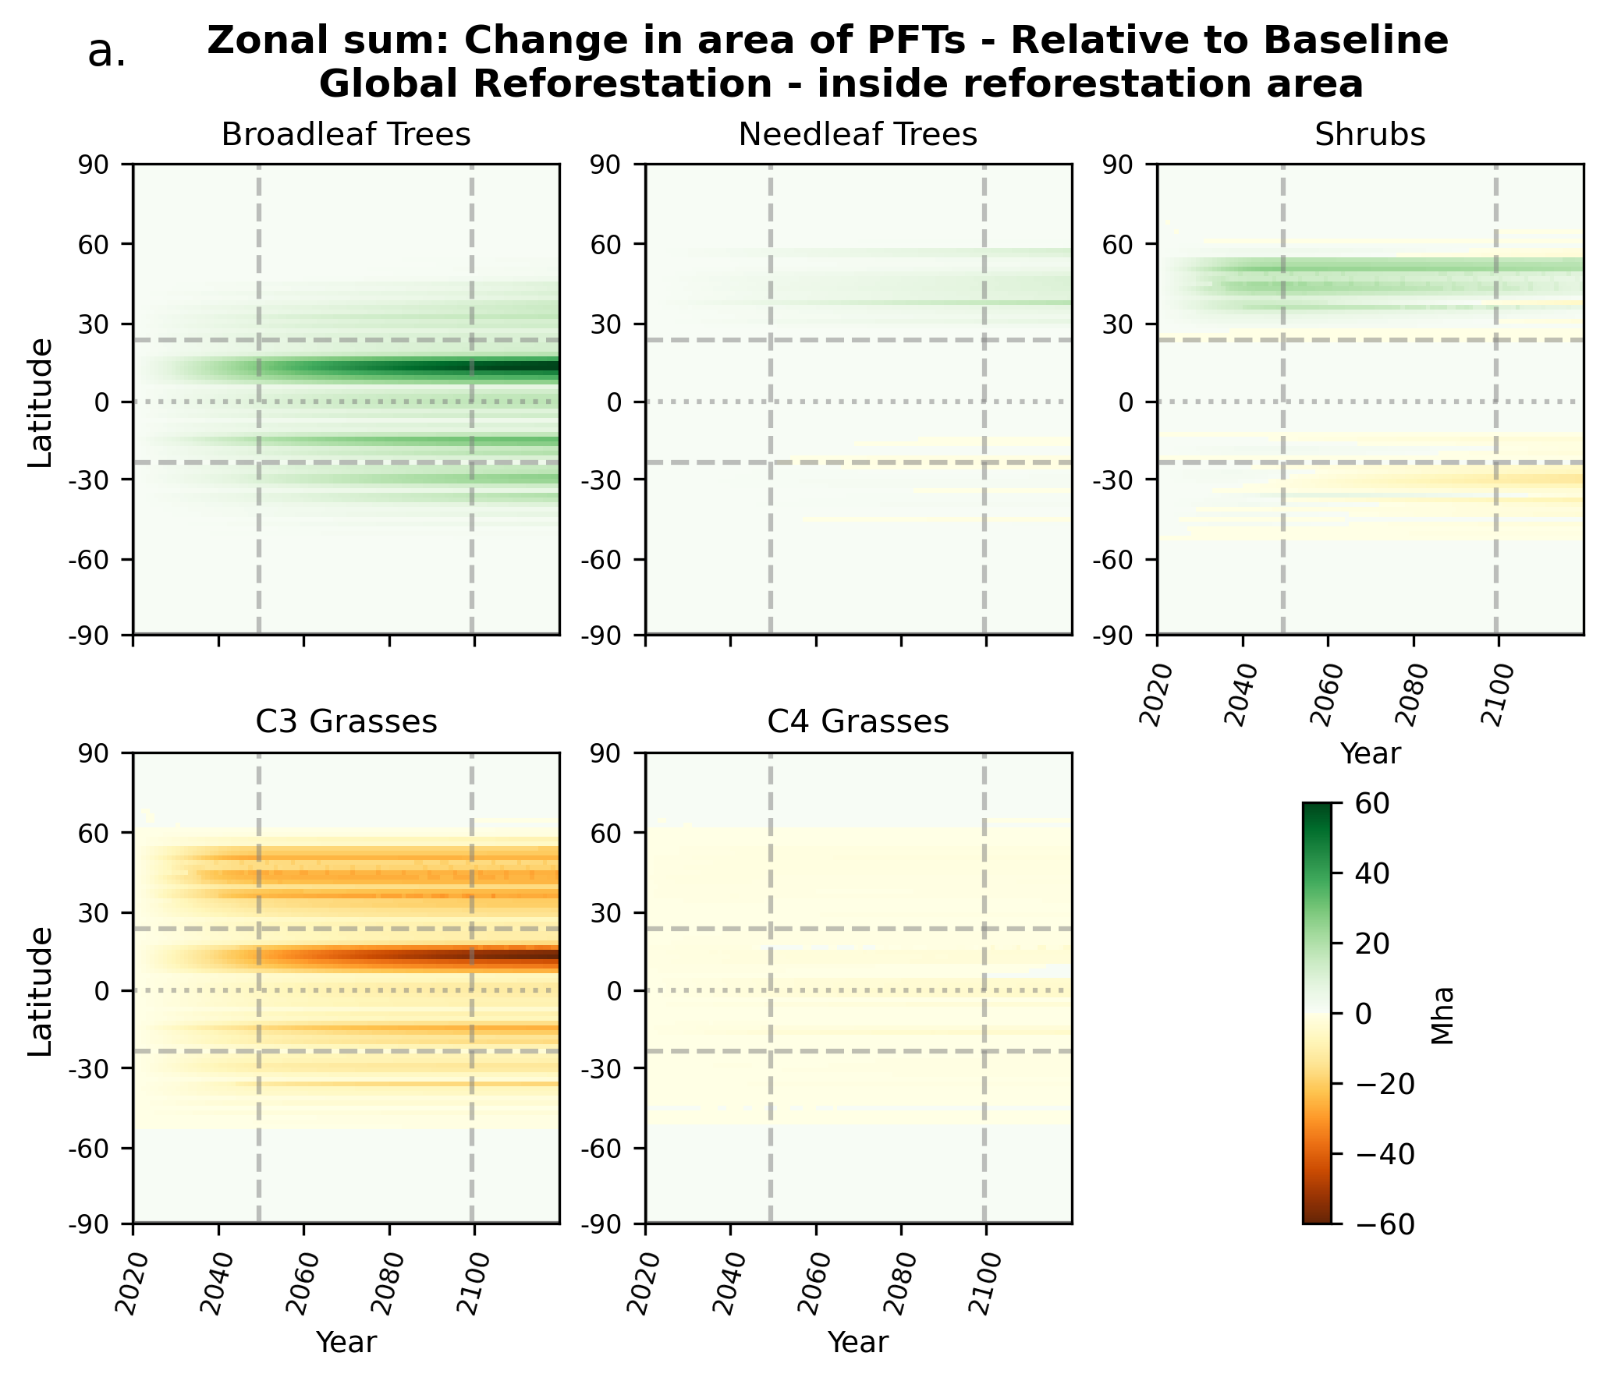Supplementary Figure 5: Zonal sum of the change in area of plant functional types. Change in area of PFTs relative to the Baseline for the Global Reforestation simulation within reforestation areas.
In the first half of this century, when reforestation is ongoing, C3 grasses are replaced by broadleaf trees in the tropics and shrubs and needleleaf trees in the higher latitudes, especially in the Northern hemisphere.

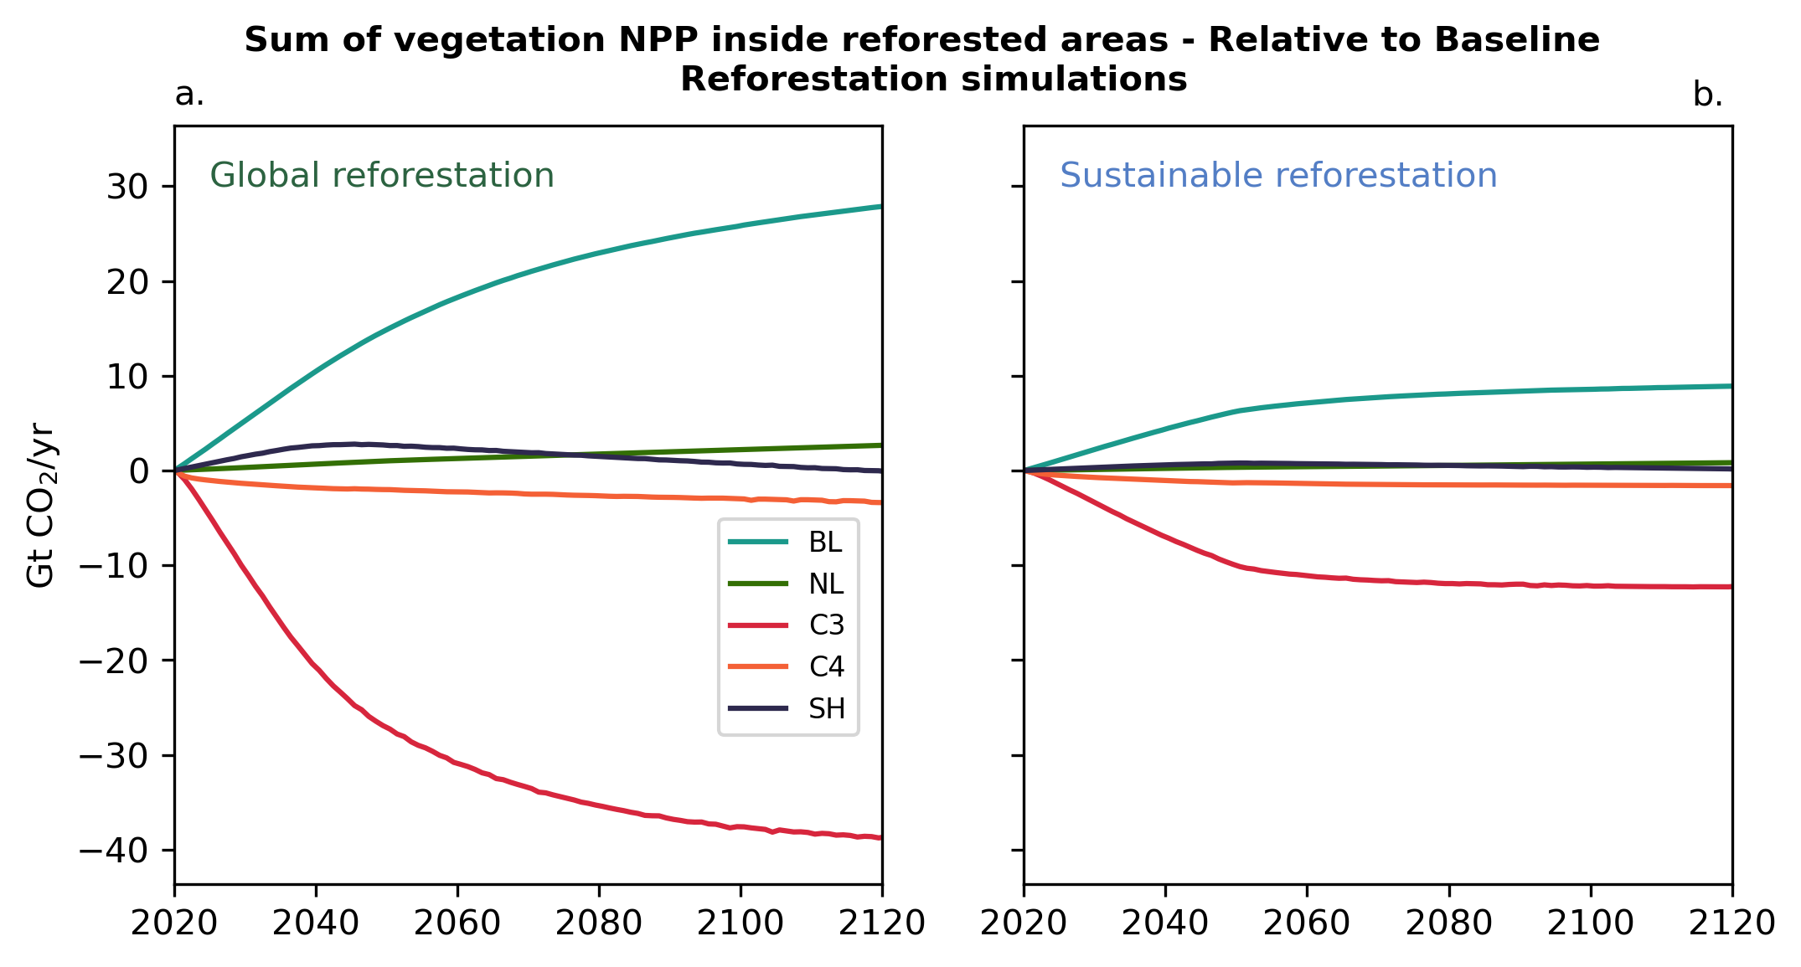Supplementary Figure 6: Net primary productivity per plant functional type for the Reforestation simulations. BL = broadleaf trees; NL = needleleaf trees. C3 = C3 grasses; C4 = C4 grasses; SH = shrubs.
As trees, mostly broadleaf trees, regrow in agricultural areas (wherein only grasses can grow), the NPP of C3 grasses rapidly declines. This is countered, though not matched, by an increase in NPP in broadleaf trees. Hence, NPP declines in the first half of this century when trees are growing back under reforestation.

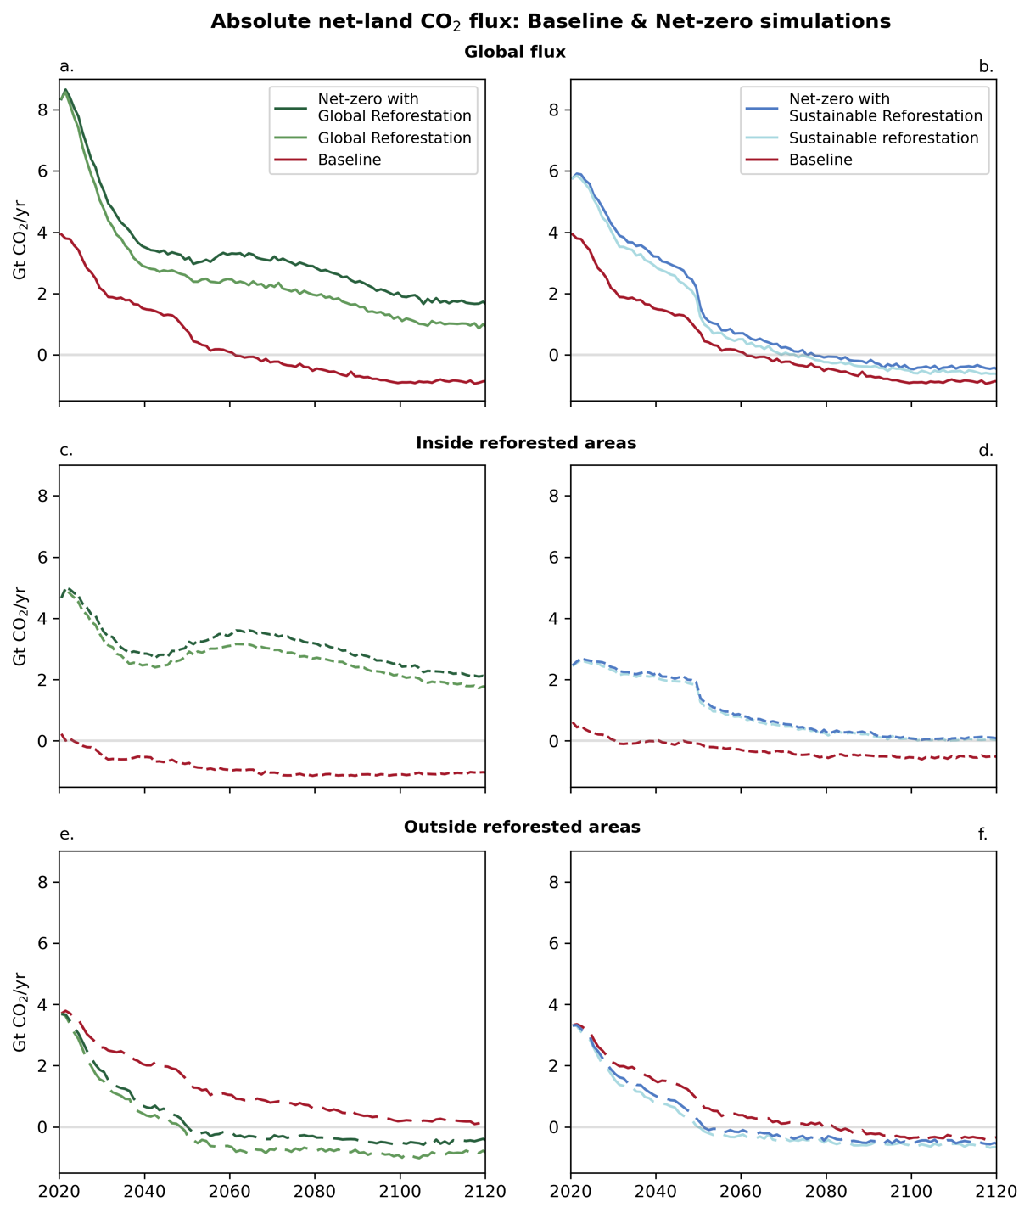
Supplementary Figure 7: The net land CO₂ flux, globally, inside reforested areas, and outside reforested areas. Results from the Net-zero simulations shown in dark green (with Global Reforestation) and blue (with Sustainable Reforestation) with results from the Reforestation simulations shown in light green and blue. The global net land CO₂ flux (top row) is smaller than the flux in reforested areas (middle row) starting around 2040 in both the Global and Sustainable Net-zero simulations. Outside reforested areas (bottom row) this flux becomes a CO₂ source to atmosphere by 2040 at the latest and is less than this flux in Baseline throughout the simulations. This difference is a result of the response of the land system to changes in atmospheric CO₂ and SAT resulting from reforestation and additional fossil fuel CO₂ emissions.
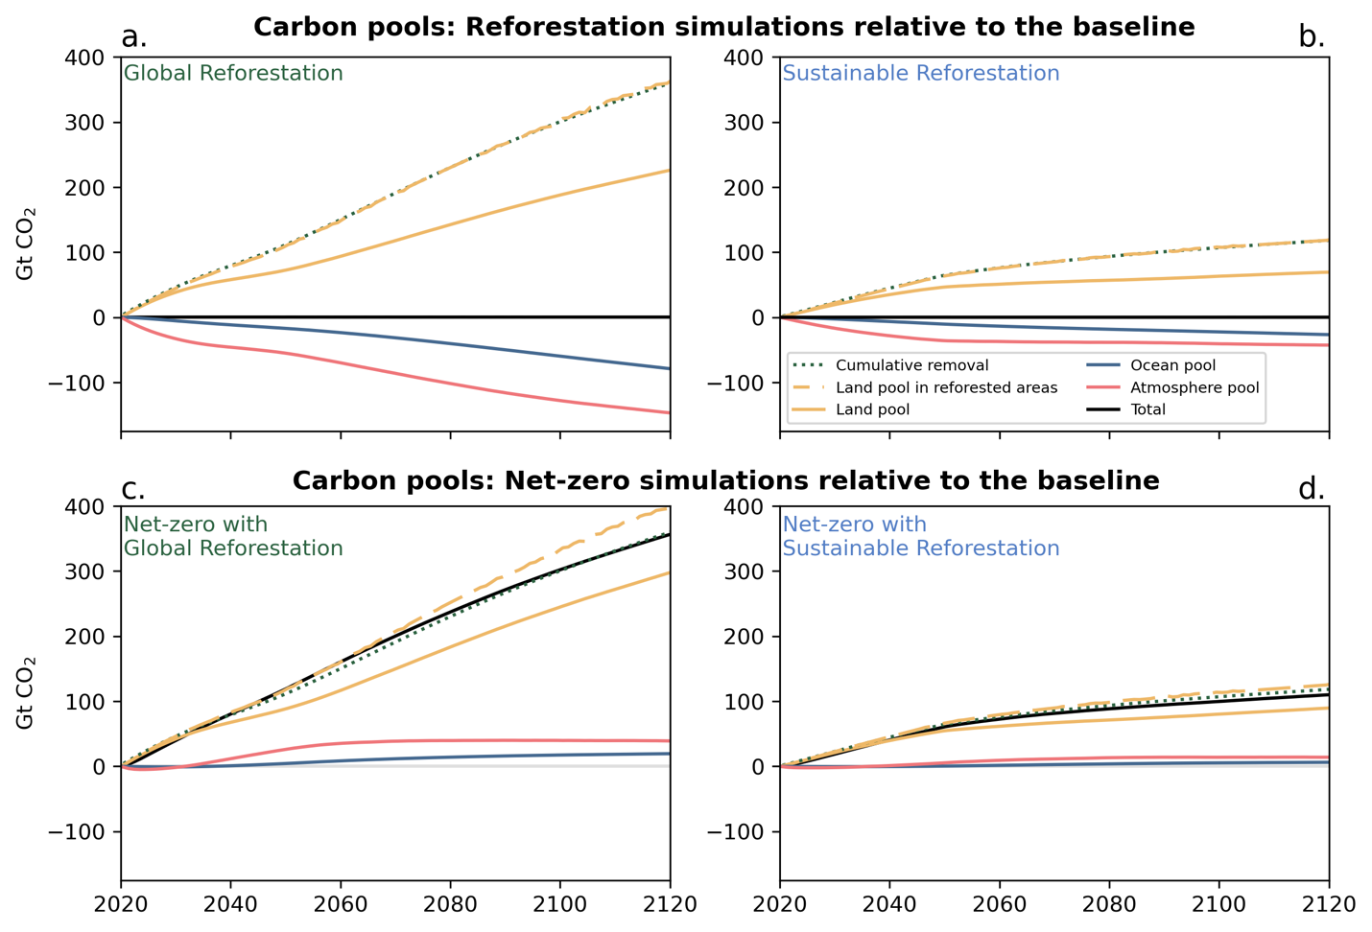Supplementary Figure 8: Change in the carbon pools for the Reforestation and Net-zero simulations relative to the Baseline. Changes in carbon pools for the Global (left) and Sustainable (right) Reforestation simulations (top row) and the Net-zero simulations (bottom row). Green dotted lines represent the cumulative reforestation-based CO₂ removal, which is equivalent to the change in land carbon in reforested areas relative to the Baseline (yellow dashed lines) in the Reforestation simulations. Dashed yellow lines in the Net-zero simulations, meanwhile, show that the change in land carbon in reforested areas relative to Baseline increases with additional CO₂ emissions in the Net-zero simulations.

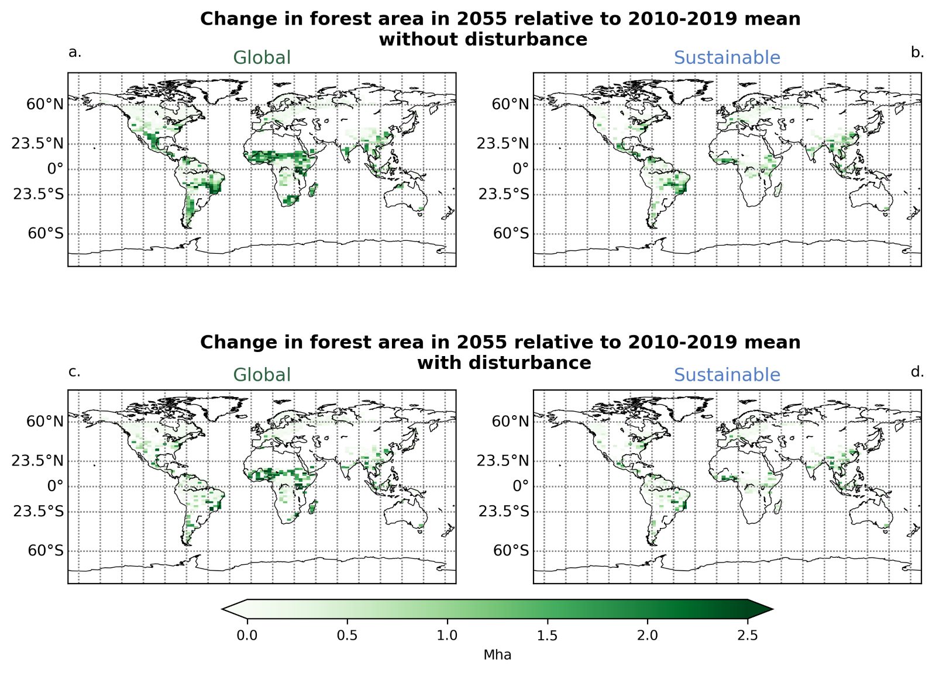Supplementary Figure 9: Maps of disturbance events. Top; change in forest area (Mha) in the year 2055 relative to the 2010-2019 average for the Global (left) and Sustainable (right) Net-zero simulations. Bottom; change in forest area in the year 2055 relative to the 2010-2019 average for Global (left) and Sustainable (right) Net-zero simulations with disturbance (i.e. deforestation) applied to half of the reforested grid cells. Maps are shown for the year 2055 as this is the final year in the deforestation ramp-up.

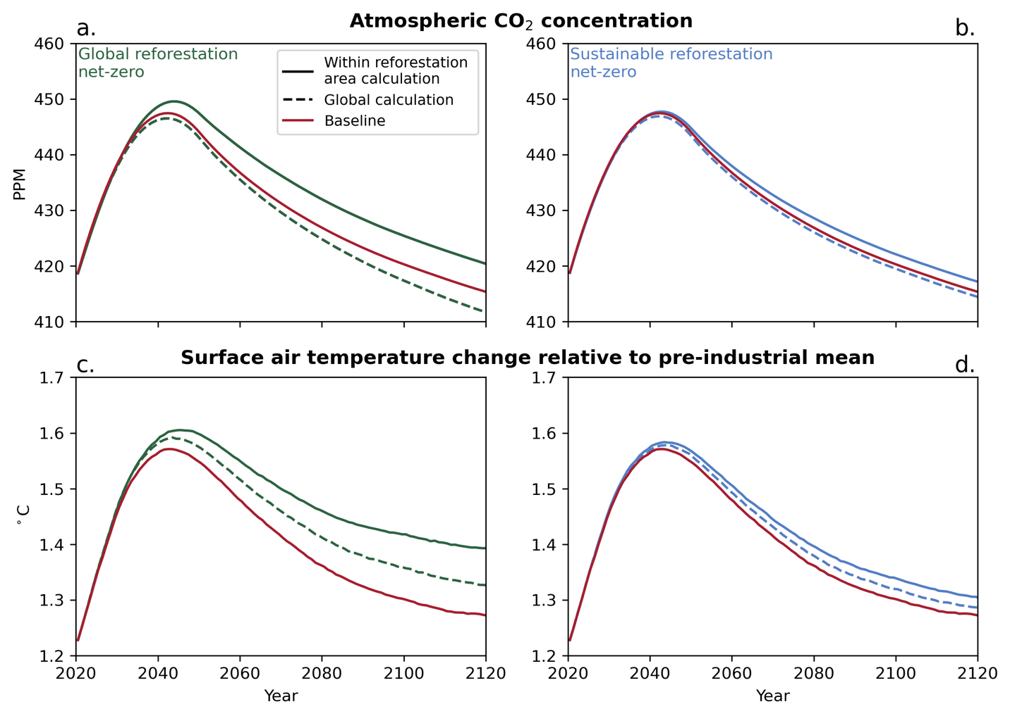Supplementary Figure 10: Sensitivity experiment where the reforestation-based CO₂ removal was calculated via the global net land CO₂ flux relative to the Baseline. Atmospheric CO₂ concentration (a. & b.) and surface air temperature relative to the pre-industrial (1850-1900) mean (c. & d.) for the Global and Sustainable Net-zero simulations. Solid lines show results from the Net-zero simulation, as in Figure 3, while dashed lines show sensitivity analysis using the global net land CO₂ flux to calculate the reforestation-based CO₂ removal.

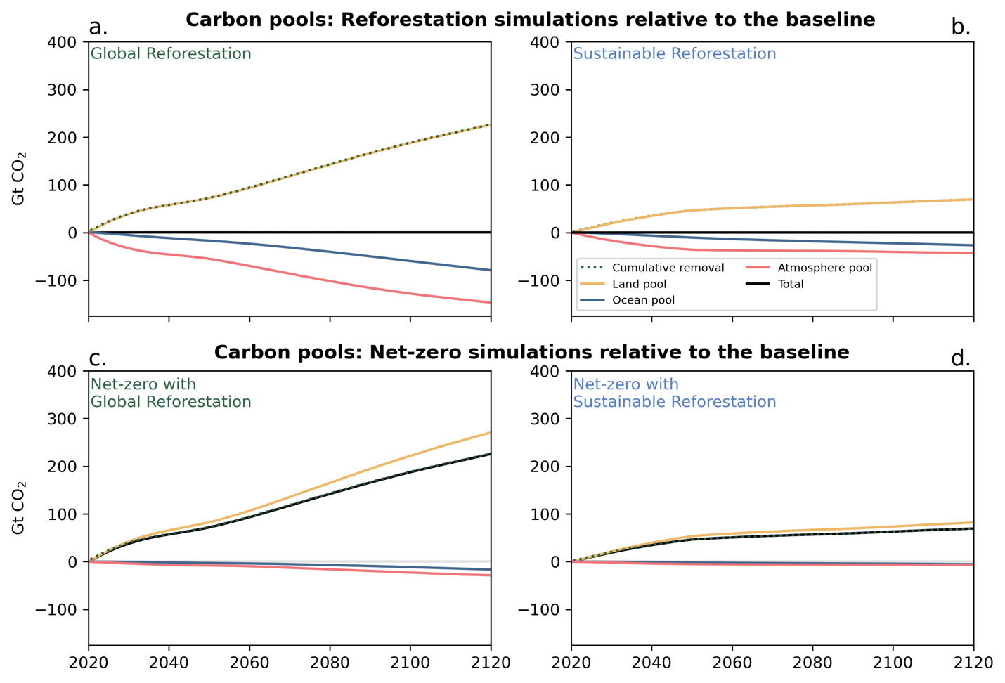Supplementary Figure 11: Change in the carbon pools for the Reforestation and Net-zero simulations, with reforestation-based CO₂ removal calculated from the global net land CO₂ flux, relative to the Baseline. Here, the cumulative reforestation-based CO₂ removal (green dotted lines) is equivalent to the change in land carbon (yellow lines) in the Reforestation simulations (a. & b.) relative to the Baseline. Land carbon relative to the Baseline in the Net-zero simulations becomes higher than the cumulative removals as a result of the CO₂ fertilization effect from the additional emissions, leading to a reduction in atmospheric CO₂ relative to the Baseline (orange lines).

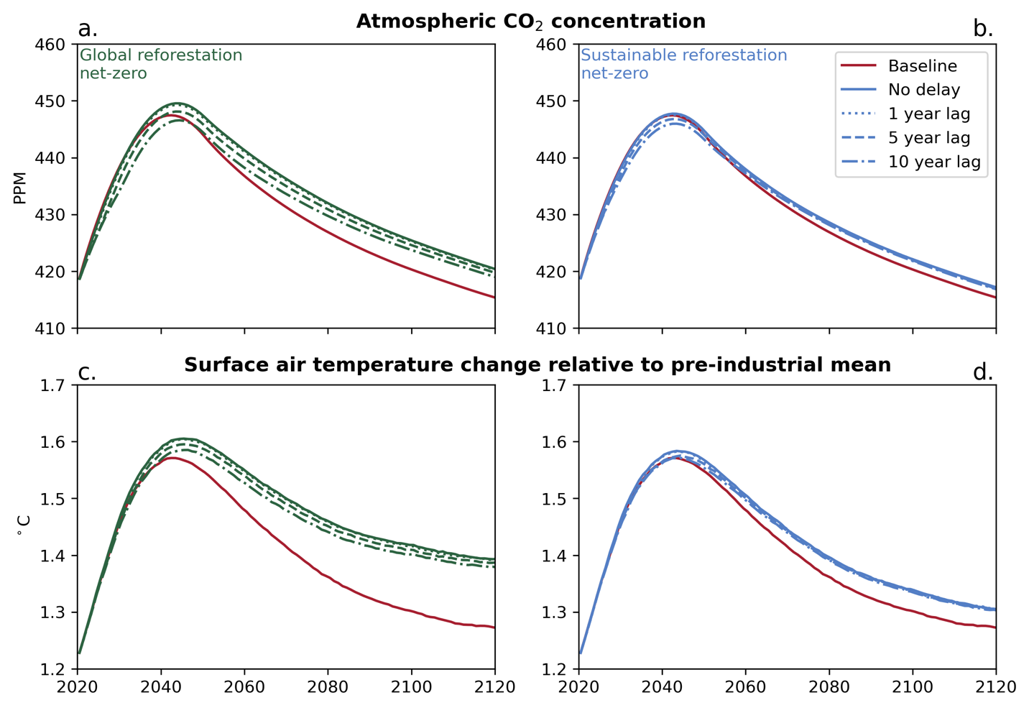Supplementary Figure 12: Sensitivity analysis of the effect of the delay between removals and emissions on atmospheric CO₂ concentration and SAT. Increasing the delay between when reforestation-based CO₂ removals occur and when equivalent fossil fuel CO₂ emissions are released can reduce peak atmospheric CO₂ (a. & b.) and SAT (c. & d.). By end-of-century, there is minimal difference from increasing the delay between removals and emissions.

Supplementary References
- Matthews, H. D. et al. Temporary nature-based carbon removal can lower peak warming in a well-below 2 °C scenario. Communications Earth & Environment, 3(1), 1–8 (2022). https://doi.org/10.1038/s43247-022-00391-z
- Boysen, L. R. et al. Global climate response to idealized deforestation in CMIP6 models. Biogeosciences, 17, 5615-5638 (2020). https://doi.org/10.5194/bg-17-5615-2020

