Supporting information

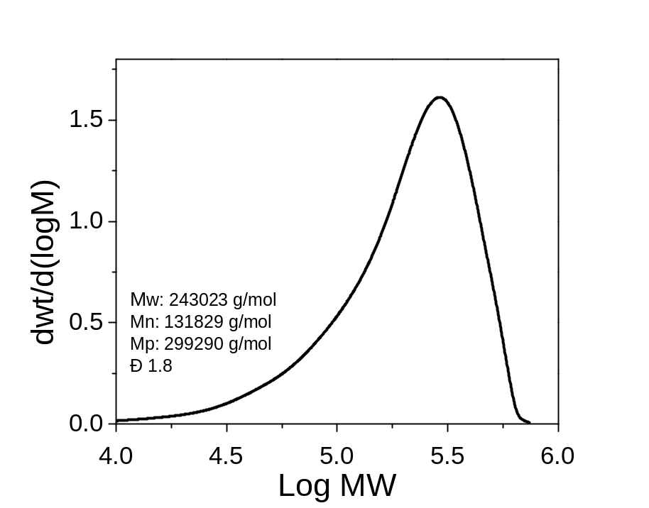
Figure S1. GPC Chromatogram of γ-PGA.

a) | 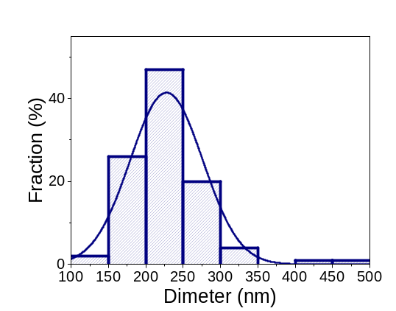  b)
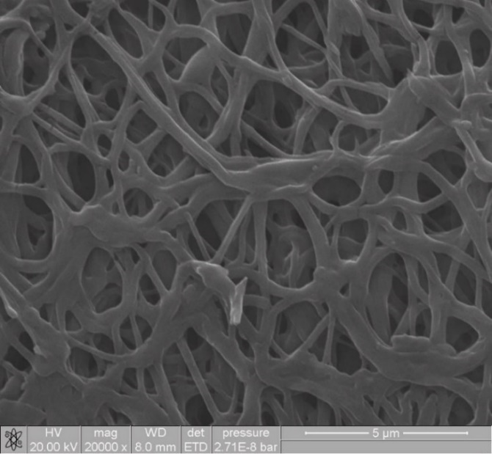 | 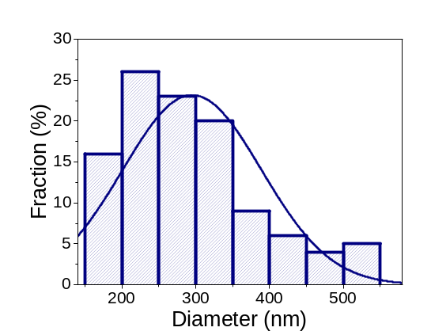  d)

Figure S2. SEM micrographs of The PVAnanofiber, obtains by electrospun with and without crosslinking (a) and c), respectively. Diameter size distribution for nanofiber with and without crosslinking (b), d), respectively.

a) | 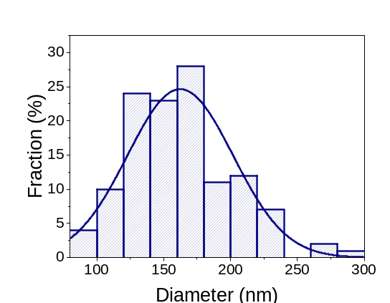  b)
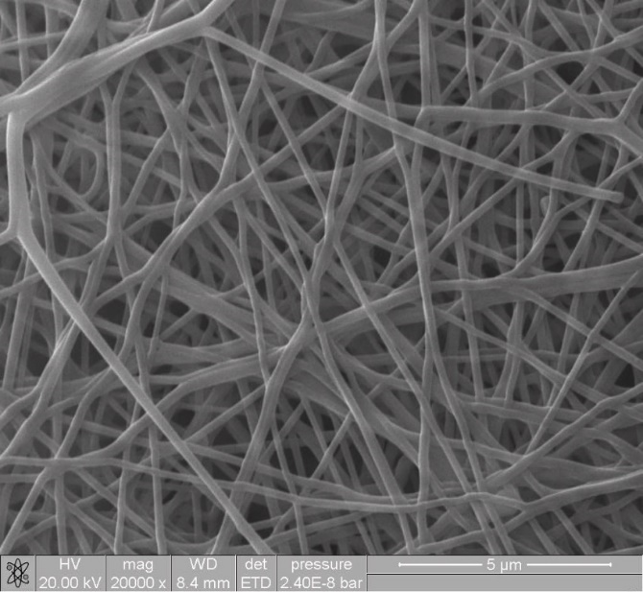  c) | 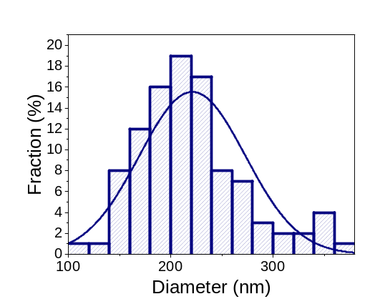  d)
c)
Figure S3. SEM micrographs of The PVA/γ-PGA, 5 % nanofiber, obtains by electrospun with and without crosslinking (a) and c), respectively. Diameter size distribution for nanofiber with and without crosslinking (b), d), respectively.

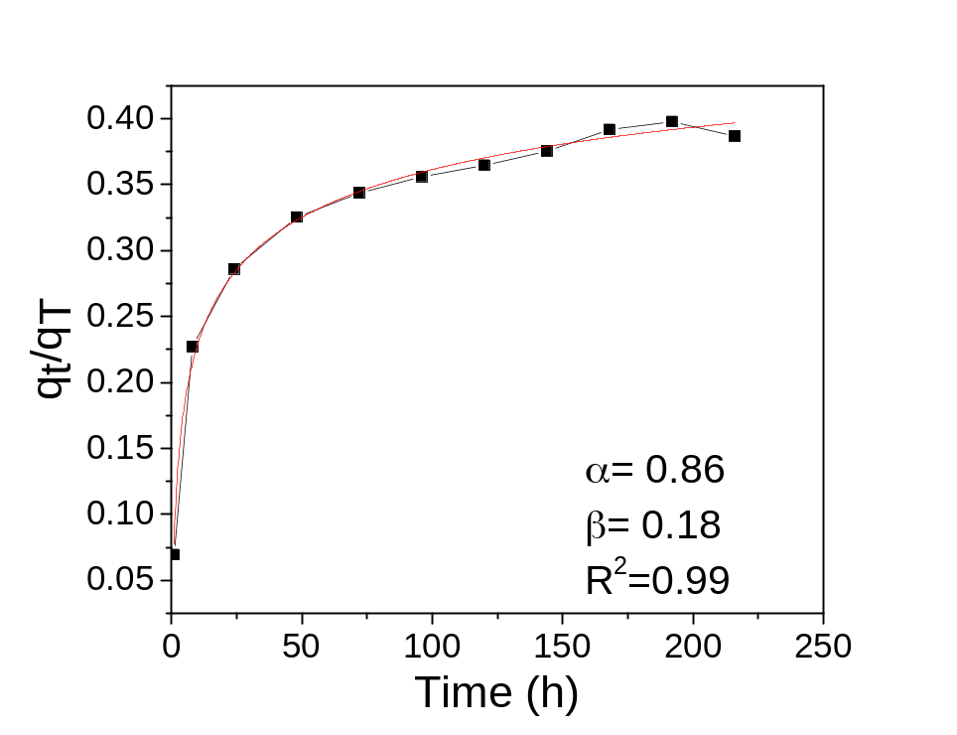
Figure s4. Weibull model for PVA.

Table S1. Average pore size for PVA, PVA/γ-PGA 5% and PVA/γ-PGA 10 %.
Sample | Average (nm)
PVA/γ-PGA 10 | 299 ± 118
PVA/γ-PGA 5 | 439 ± 168
PVA | 723 ± 244

