Supplemental materials
Supplementary Table 1
Table 1 Primer used for real-time quantitative polymerase chain reaction.
Genes | Forward primers | Reverse primers | Annealing
GAPDH | GCAAGTTCAACGGCACAG | GCCAGTAGACTCCACGACA | 60℃, 30s
Col2a1 | GAGGGCAACAGCAGGTTCAC | GCCCTATGTCCACACCAAATTC | 60℃, 30s
aggrecan | TCTGGAGTGGGAGACTTG | GCACAGTGATGTCCTCTATTC | 60℃, 30s
tenascin-C | CCACCTCTGGCCTCTATAC | GCATAGGCCTTCCAGTTTC | 60℃, 30s
Col10a1 | CCTGTCAAGCTCATCCTAATC | CACTATTGCTGCTCACTCTT | 60℃, 30s
PTHLH | CTTCCAAGGACACGTTACAG | TGACCCATGTGCAGTTTC | 60℃, 30s
ERG | AGTGGGCAGTGAAAGAATAC | GGTAGTGGAGATGTGAGAGA | 60℃, 30s
GAPDH = glyceraldehyde 3-phosphatedehydrogenase, Col2a1 = α1 chain of type II collagen gene, Col10a1 = α1 chain of type X collagen gene, PTHLH = Parathyroid Hormone Like Hormone, ERG = ETS related gene.
Supplementary Fig. 1
Supplementary Fig. 2
Supplementary Fig. 3
Supplementary Fig. 4
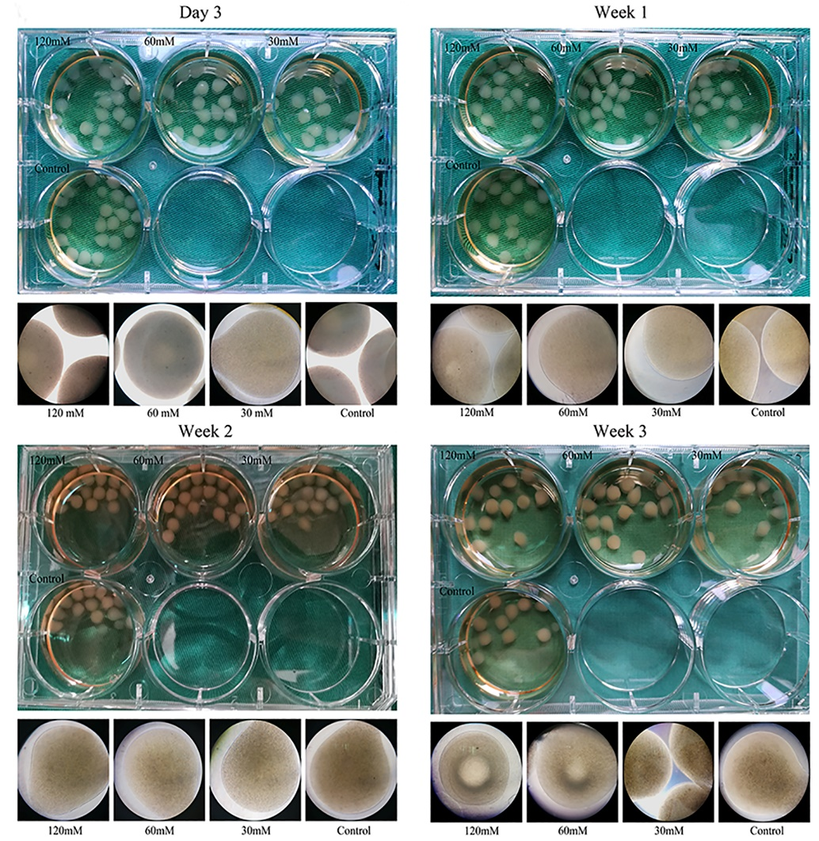

Supplementary Fig. 5
Supplementary Fig. 6

