Supplementary material to:
Intraslab reverse faulting adjacent to the hypocenter of the 1923 Kanto earthquake: The Mw 5.0 western Kanagawa earthquake in eastern Japan on 9 August 2024

*Yasunori Sawaki^{1,2}, Takahiro Shiina¹, and Takahiko Uchide¹

¹Geological Survey of Japan, National Institute of Advanced Industrial Science and Technology (AIST), Tsukuba, Japan
²Present at College of Science and Engineering, Ritsumeikan University, Kusatsu, Japan
Correspondence to Yasunori Sawaki (sawaki-y@fc.ritsumei.ac.jp)

Introduction
This supplementary material consists of a text (Text S1), five tables (Table S1–S5), and seven figures (Figs. S1–S7). Tables S1, S2, S4, and S5 are in the additional files 2–5 in CSV format, respectively.

Texts

Text S1: Hypocenter clustering for identifying fault planes
We applied the hypocenter clustering method “FaultNVC” developed by Sawaki et al. (2025a, 2025b). Following their instructions, we extracted planar fault planes.
In STEP 1, we calculated point-cloud normal vectors (PCNVs) that reflect the local surface geometry. The computation of PCNVs consists of three parts: (1) extracting $k^{NV}$ nearest neighbors in a radius of $r^{NV}$ km for each hypocenter, (2) performing principal component analysis (PCA) for selected neighbors, and (3) extracting an eigenvector with the smallest eigenvalue (PC3) to be PCNV. Small $k^{NV}$ would lead to the instability of PCA, but large $k^{NV}$ would fail to capture local structures. Thus, we extracted at most 150 nearest neighbors within the radius ($r^{NV}$) of 0.5 km, considering the spatial extent of point cloud data. To control the quality of PCNVs, we selected ones with planarity of 1.5 or greater. PCNVs were shown in Fig. S6.
In STEP 2, we preformed HDBSCAN for PCNVs and hypocenter positions. We used the same parameters with Sawaki et al. (2025b): $m_{pts}=m_{clSize}=5$. Unlike their study, the clustering result when $ε$ was initially set to 0.0 showed primary structures without tiny clusters. Thus, we did not increase $ε$.
In STEP 3, we controlled the quality of each plane. The median angular difference between the plane normal and PCNVs ($θ^{EV}$) rejects inconsistent planes to PCNVs. We observed the gap of $θ^{EV}$ around 30$°$–45$°$ (Fig. S7), so the threshold of maximum $θ^{EV}$ was set to 30$°$. Additionally, we rejected small-sized clusters. We applied the minimum number of points in a cluster ($N_{min}$) of 10, the double of $m_{clSize}$.
A list of the parameters used for clustering was summarized in Table S1.

Tables and table descriptions
Table S1 Seismic station list used in this study (cf. Additional file 2).
Table S2 The relocated hypocenters using hypoDD (cf. Additional file 3).
Table S3 Parameters used for calculating PCNVs, clustering, and controlling the quality of fault planes.
Steps | Notation | Description | Values
STEP 1:  PCNV | $$k^{NV}$$ | Number of nearest neighbors for performing PCA | 150
STEP 1:  PCNV | $$r^{NV}$$ | Maximum radius to find nearest neighbors for performing PCA | 0.5 km
STEP 2:  Clustering  (HDBSCAN) | $$m_{pts}$$ | Number of nearest neighbors to calculate a core distance | 5
STEP 2:  Clustering  (HDBSCAN) | $$m_{clSize}$$ | Minimum size to be considered a cluster | 5
STEP 3:  Quality control | $$θ^{EV}$$ | Angular threshold to preserve the consistency between PCNVs and the fault normal | 30$°$
STEP 3:  Quality control | $$N_{min}$$ | Minimum number of points in a cluster | 10
Table S4 Clustering result with hypocenters for each cluster (Additional file 4 in CSV format).
Table S5 Clustering result with fault parameters of the extracted fault planes (Additional file 5 in CSV format).

Figures
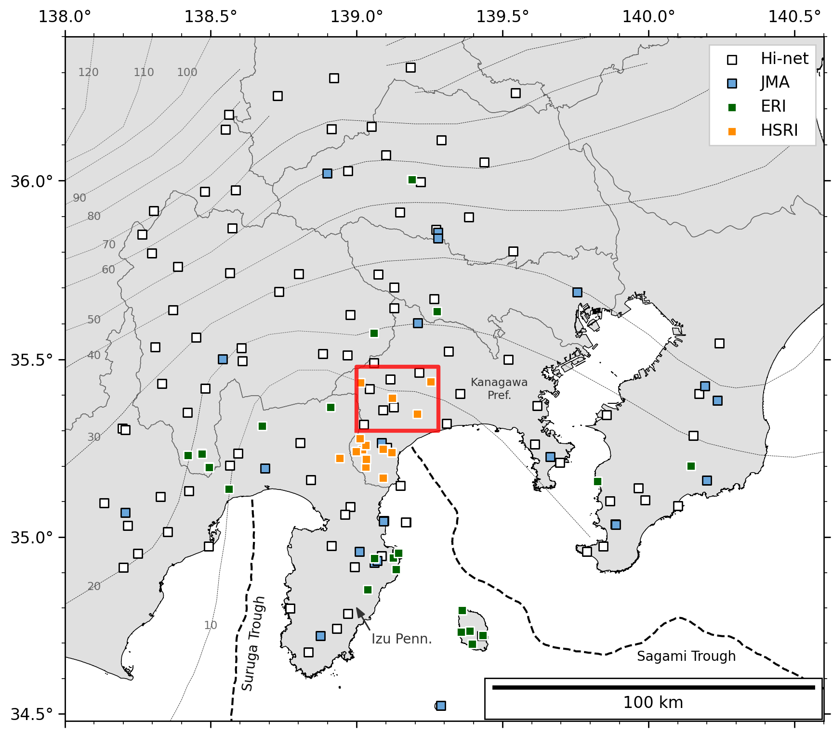
Fig. S1 Map showing seismic stations used in this study. White, blue, green, and orange squares denote stations from the National Research Institute for Earth Science and Disaster Resilience (NIED) Hi-net (NIED 2019), the Japan Meteorological Agency (JMA), Earthquake Research Institute, the University of Tokyo (ERI), and Hot Springs Research Institute of Kanagawa Prefecture (HSRI), respectively. The list of stations in this study is in Table S1. Black and gray dashed lines denote the top surface of PHS from Hirose et al. (2008b, a) and Nakajima et al. (2009), respectively. The red box is the same as that shown in Fig. 1a.
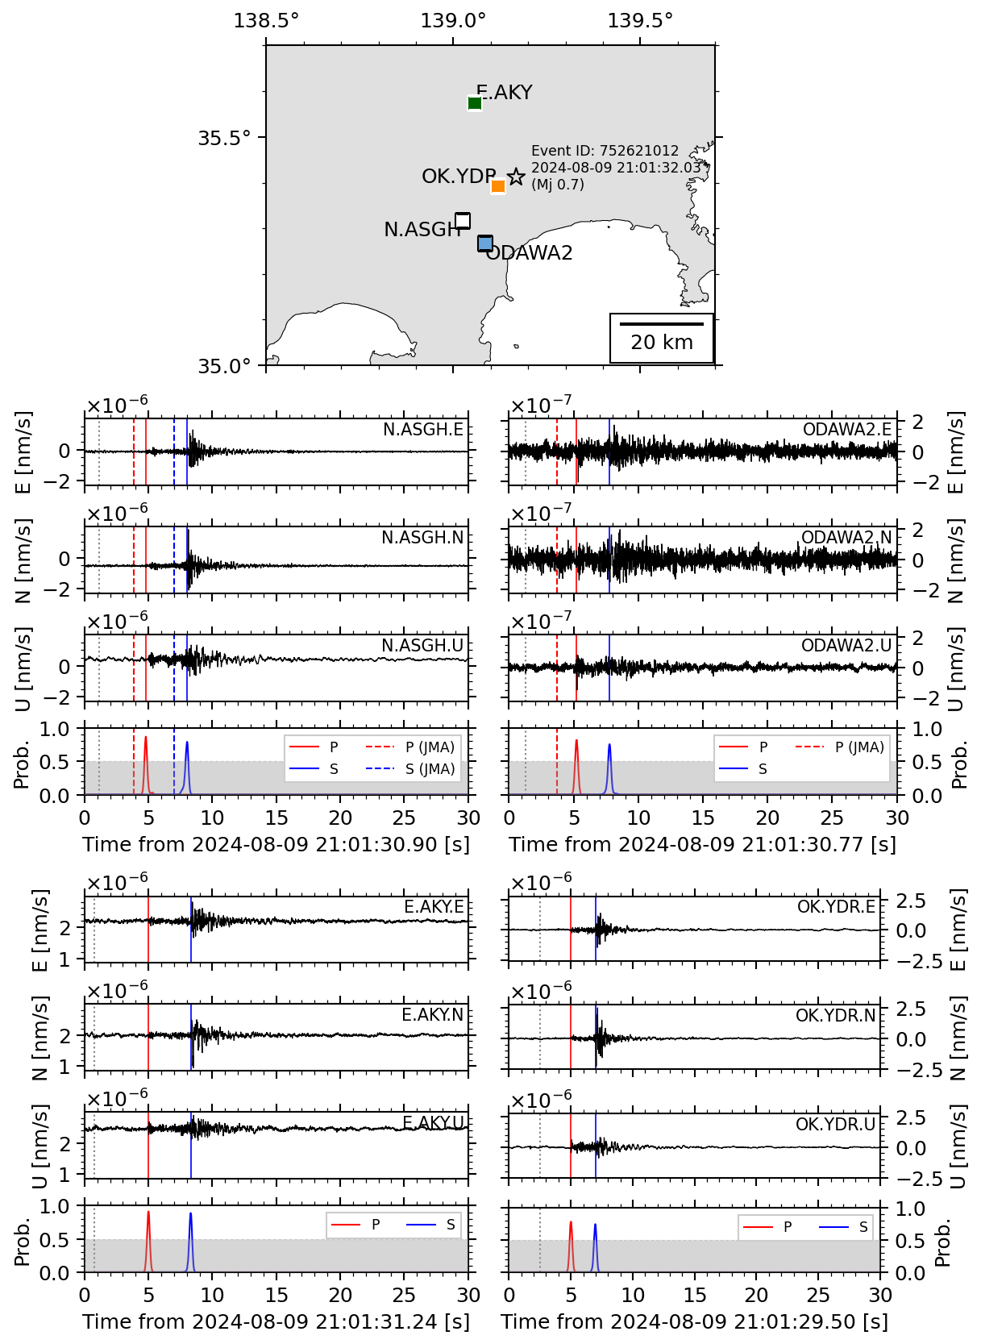
Fig. S2 Phase pick examples using PhaseNetWC (Naoi et al. 2024), which originated from Zhu and Beroza (2019). This example is an Mj 0.7 aftershock that occurred on 9 August 2024 at 9:01:32 pm JST. The seismic stations from NIED Hi-net, JMA, ERI, HSRI are N.ASGH, ODAWA2, E.AKY, and OK.YDR, respectively, as shown in the top subfigure. For each station, three-component waveforms in a 30-second window are shown without applying any filter. The red and blue solid lines in each bottom panel denote the PhaseNetWC probability of P and S phases, respectively. Solid and dashed lines over the waveforms indicate the onset times for PhaseNetWC and JMA picks, respectively: N.ASGH and ODAWA2 for case (C), and E.AKY and OK.YDR for case (A). The gray dotted line corresponds to the origin time.
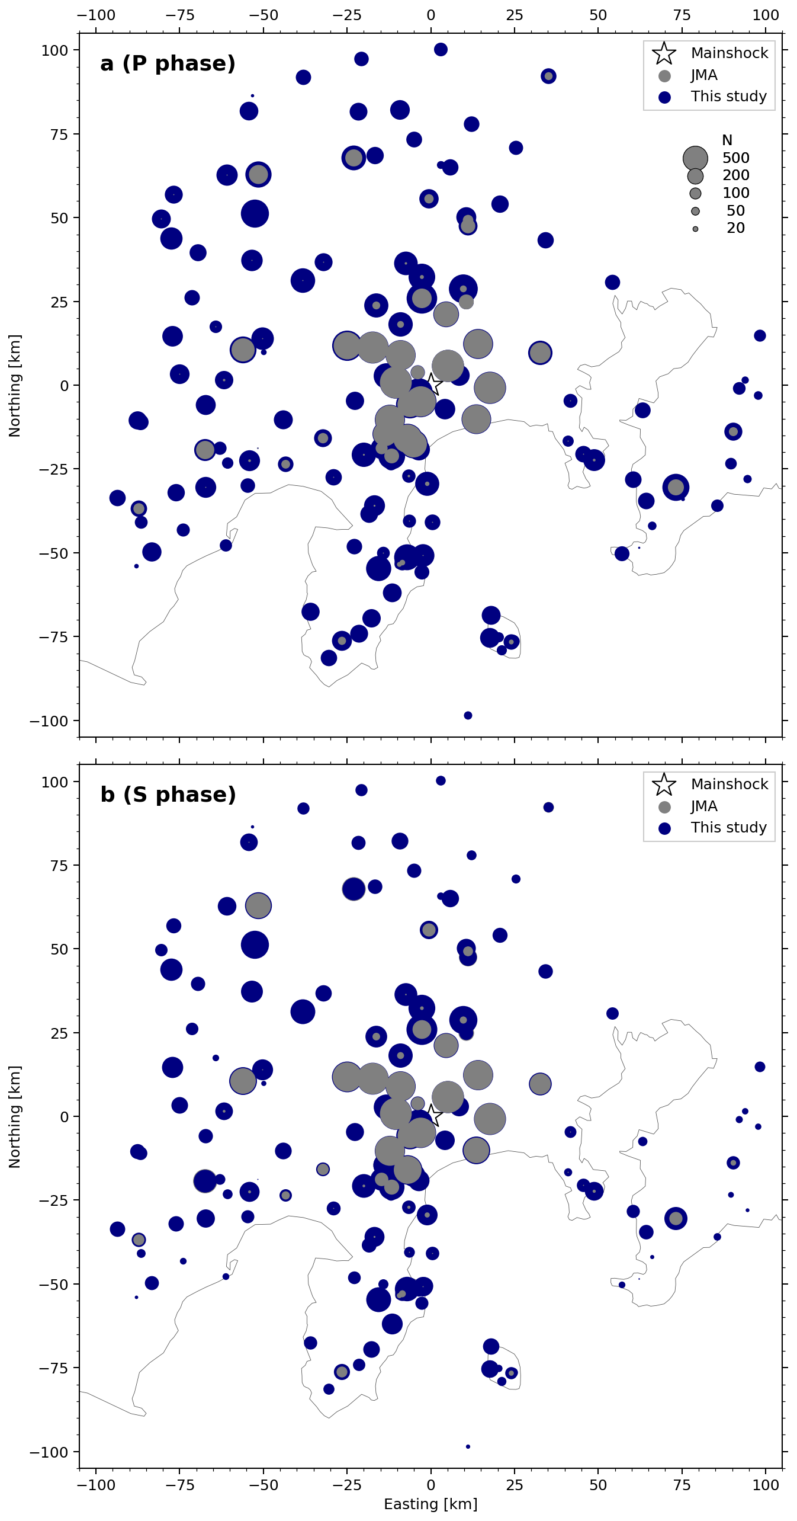
Fig. S3 Map showing the total number of picks (gray) by JMA and (navy) in this study for (a) P and (b) S phases in each station. The radius of a circle corresponds to the number of picks.
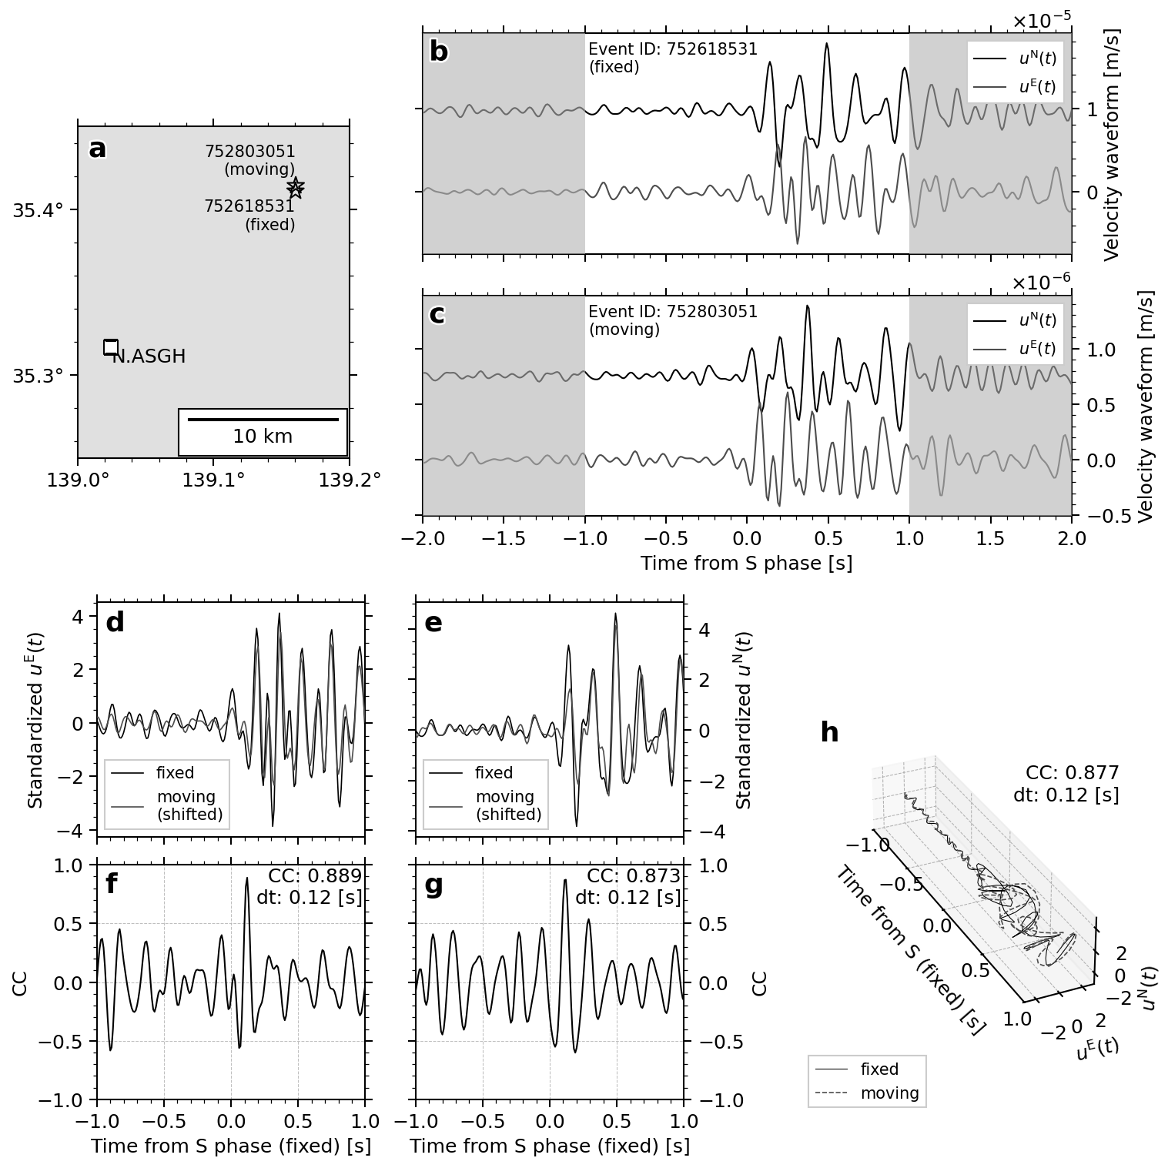
Fig. S4 Comparison of the horizontal-component cross correlation between two event waveforms. (a) Map showing the station (N.ASGH) and target events. (b, c) Waveforms around the S phase for (b) fixed and (b) moving events, respectively. Black and gray waveforms correspond to N- and E-component waveforms, respectively. (d, e) Standardized E- and N-component waveforms, respectively. Black and gray waveforms are for fixed and moving (time shift applied) events, respectively. (f, g) CC functions for E and N components, respectively. (h) The particle motion over time.
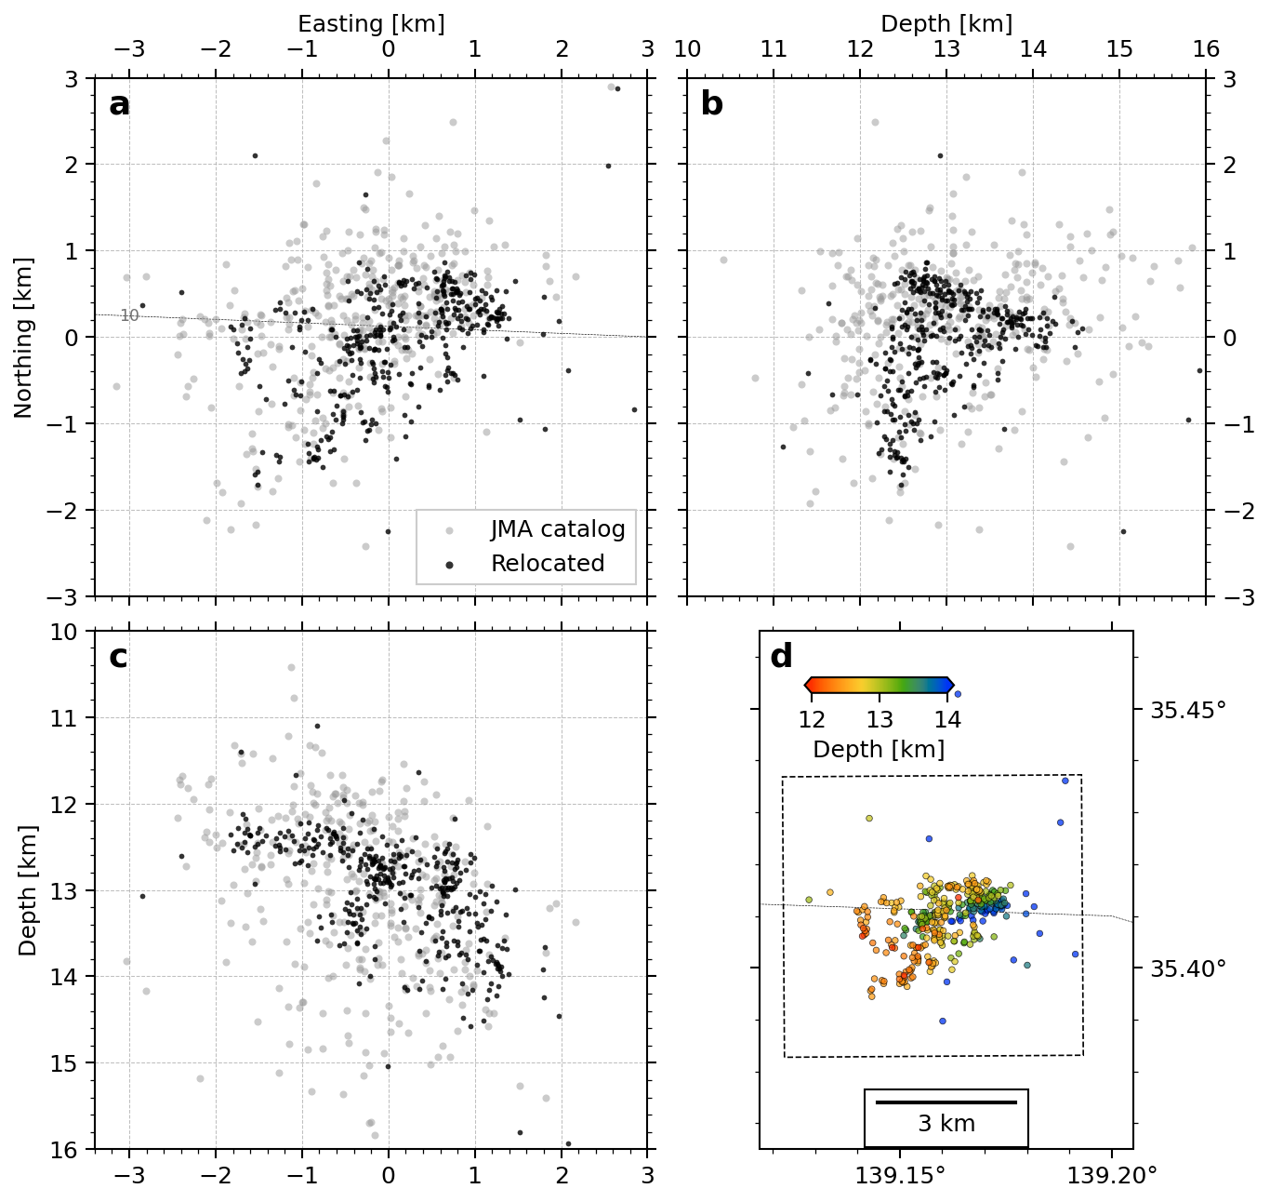
Fig. S5 (a) Map view and (b, c) depth sections of the relocated (black) and original (gray) hypocenters after 9 August 2024 at 6 pm (JST), respectively. The dashed line denotes the PHS top surface depth contour of 10 km from Hirose et al. (2008b, a). (d) Geographic map view of relocated hypocenters with colors coded by depth.
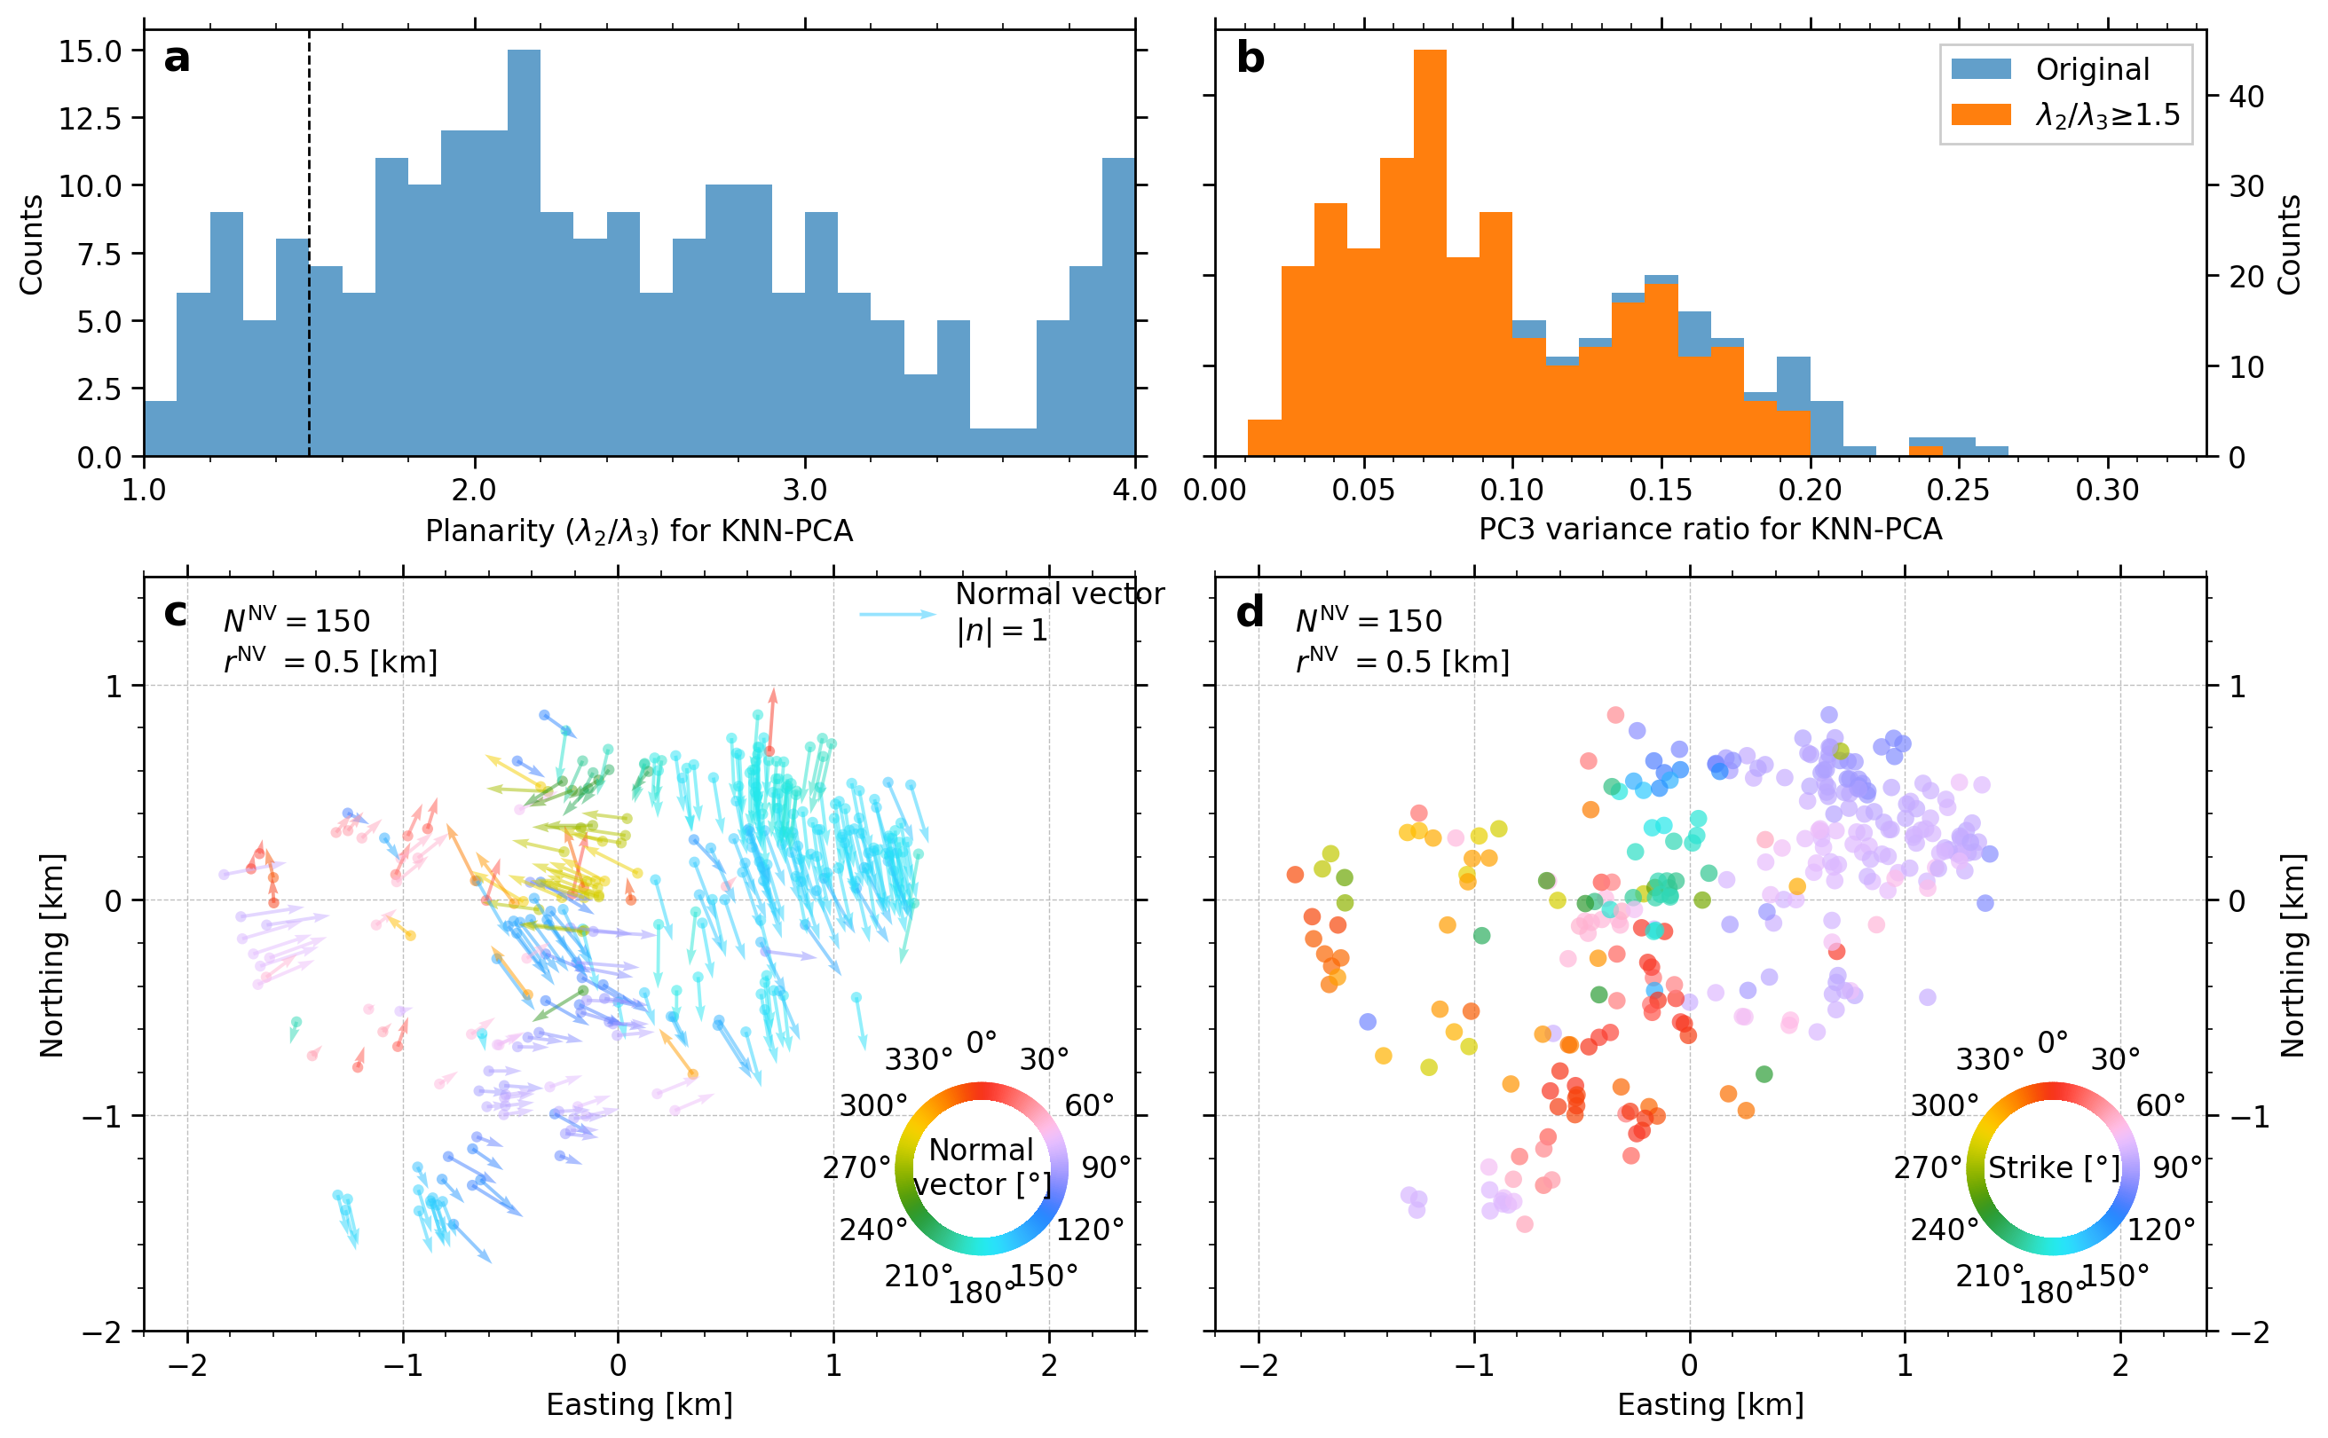
Fig. S6 Distribution of PCNVs. (a) Histogram showing planarity of PCNVs. The dashed line denotes the threshold, below which PCNVs were discarded. Note that planarity greater than 4.0 is not shown. (b) Histogram showing variance ratio for PC3 component. Blue and orange bars for all data and data selected by planarity control, respectively. (c) Calculated PCNVs with colors coded by horizontal azimuths. Arrow lengths represent the horizontal size of PCNVs. (d) Apparent strike converted from horizontal azimuth of PCNVs. It is defined by the horizontal azimuth of PCNV counterclockwise rotated by 90 degrees.
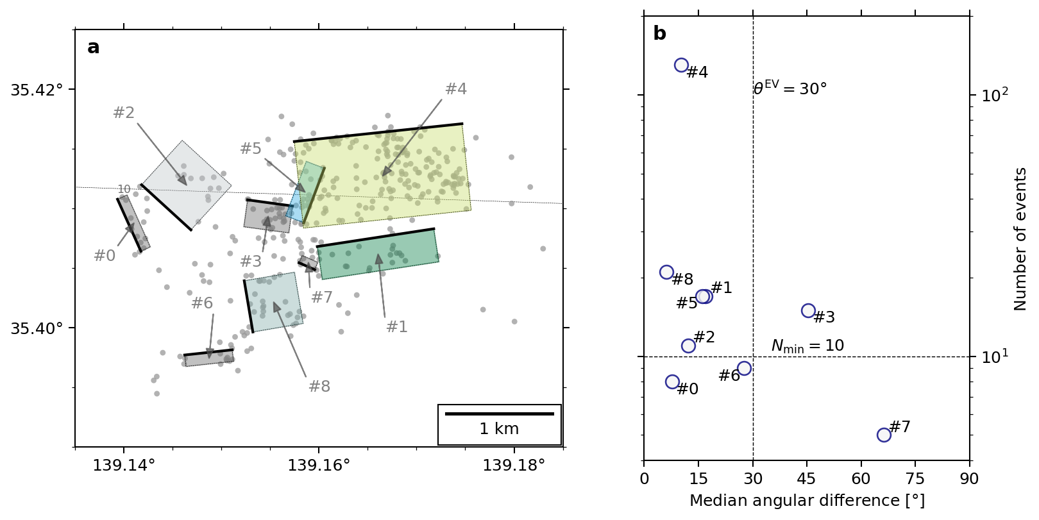
Fig. S7 Hypocenter clustering result with all clusters. (a) Fault plane for each cluster. Planes with dark gray (#0, #3, #6 and #7) were rejected clusters by quality control, shown in (b).

References​
Hirose F, Nakajima J, Hasegawa A (2008a) Three-dimensional seismic velocity structure and configuration of the Philippine Sea slab in southwestern Japan estimated by double-difference tomography. J Geophys Res Solid Earth 113:B09315. https://doi.org/10.1029/2007JB005274
Hirose F, Nakajima J, Hasegawa A (2008b) Three-Dimensional Velocity Structure and Configuration of the Philippine Sea Slab beneath Kanto District, Central Japan, Estimated by Double-Difference Tomography [in Japanese with English abstract]. Zisin (Journal of the Seismological Society of Japan 2nd ser) 60:123–138. https://doi.org/10.4294/zisin.60.123
Nakajima J, Hirose F, Hasegawa A (2009) Seismotectonics beneath the Tokyo metropolitan area, Japan: Effect of slab-slab contact and overlap on seismicity. J Geophys Res 114:B08309. https://doi.org/10.1029/2008JB006101
Naoi M, Tamaribuchi K, Shimojo K, et al (2024) Neural phase picker trained on the Japan meteorological agency unified earthquake catalog. Earth, Planets and Space 76:150. https://doi.org/10.1186/s40623-024-02091-8
National Research Institute for Earth Science and Disaster Resilience (2019) NIED Hi-net. https://doi.org/10.17598/nied.0003
Sawaki Y, Sato Y, Uchide T (2025a) FaultNVC: Earthquake Fault Plane Extractor through Point-Cloud Normal Vector Clustering for Hypocenter Distributions. Open-File Report of the Geological Survey of Japan, AIST no. 759. https://www.gsj.jp/publications/pub/openfile/openfile0759.html
Sawaki Y, Shiina T, Sagae K, et al (2025b) Fault Geometries of the 2024 Mw 7.5 Noto Peninsula Earthquake from Hypocenter-Based Hierarchical Clustering of Point-Cloud Normal Vectors. J Geophys Res Solid Earth 130:e2024JB030233. https://doi.org/10.1029/2024JB030233
Zhu W, Beroza GC (2019) PhaseNet: A Deep-Neural-Network-Based Seismic Arrival Time Picking Method. Geophys J Int 216:261–273. https://doi.org/10.1093/gji/ggy423

