Databases (n = 1 – Web of Science)
Search Dates (August 2023 and January 2024)
Registers (n = 3443 + 62 = 3505)
Records screened (Title and Abstract) (n = 3505)
Records excluded*
(n = 2681)
Reports sought for retrieval
(n = 824)
Reports not retrieved
(n = 0) *All found
Reports assessed for eligibility (round1) (n = 824)
Reports excluded:
Reason 1 (n = 452 Exclusion criteria)
Reason 2 (n = 14 Repeated)
Studies included
n = (67 - 4*) = 63
Identification of studies via databases and registers
Identification
Screening
Included
*Did not met Inclusion criteria
Reports assessed for eligibility (round2) (n = 358)
Reports excluded:
Reason 1 (n = 222 No Reply)
Reason 2 (n = 11 Data lost)
Reason 3 (n = 5 Unwilling to share)
Reason 4 (n = 34 Exclusion criteria)
Reason 5 (n = 17 Repeated)
Reason 6 (n = 2 Data issues)
Reason 7 (n = 4 Later exclusions*)
*See Supplementary Table 2

Fig. S1. PRISMA 2020 (36) flow diagram showing the steps for searching, screening, and filtering studies used in this meta-analysis.

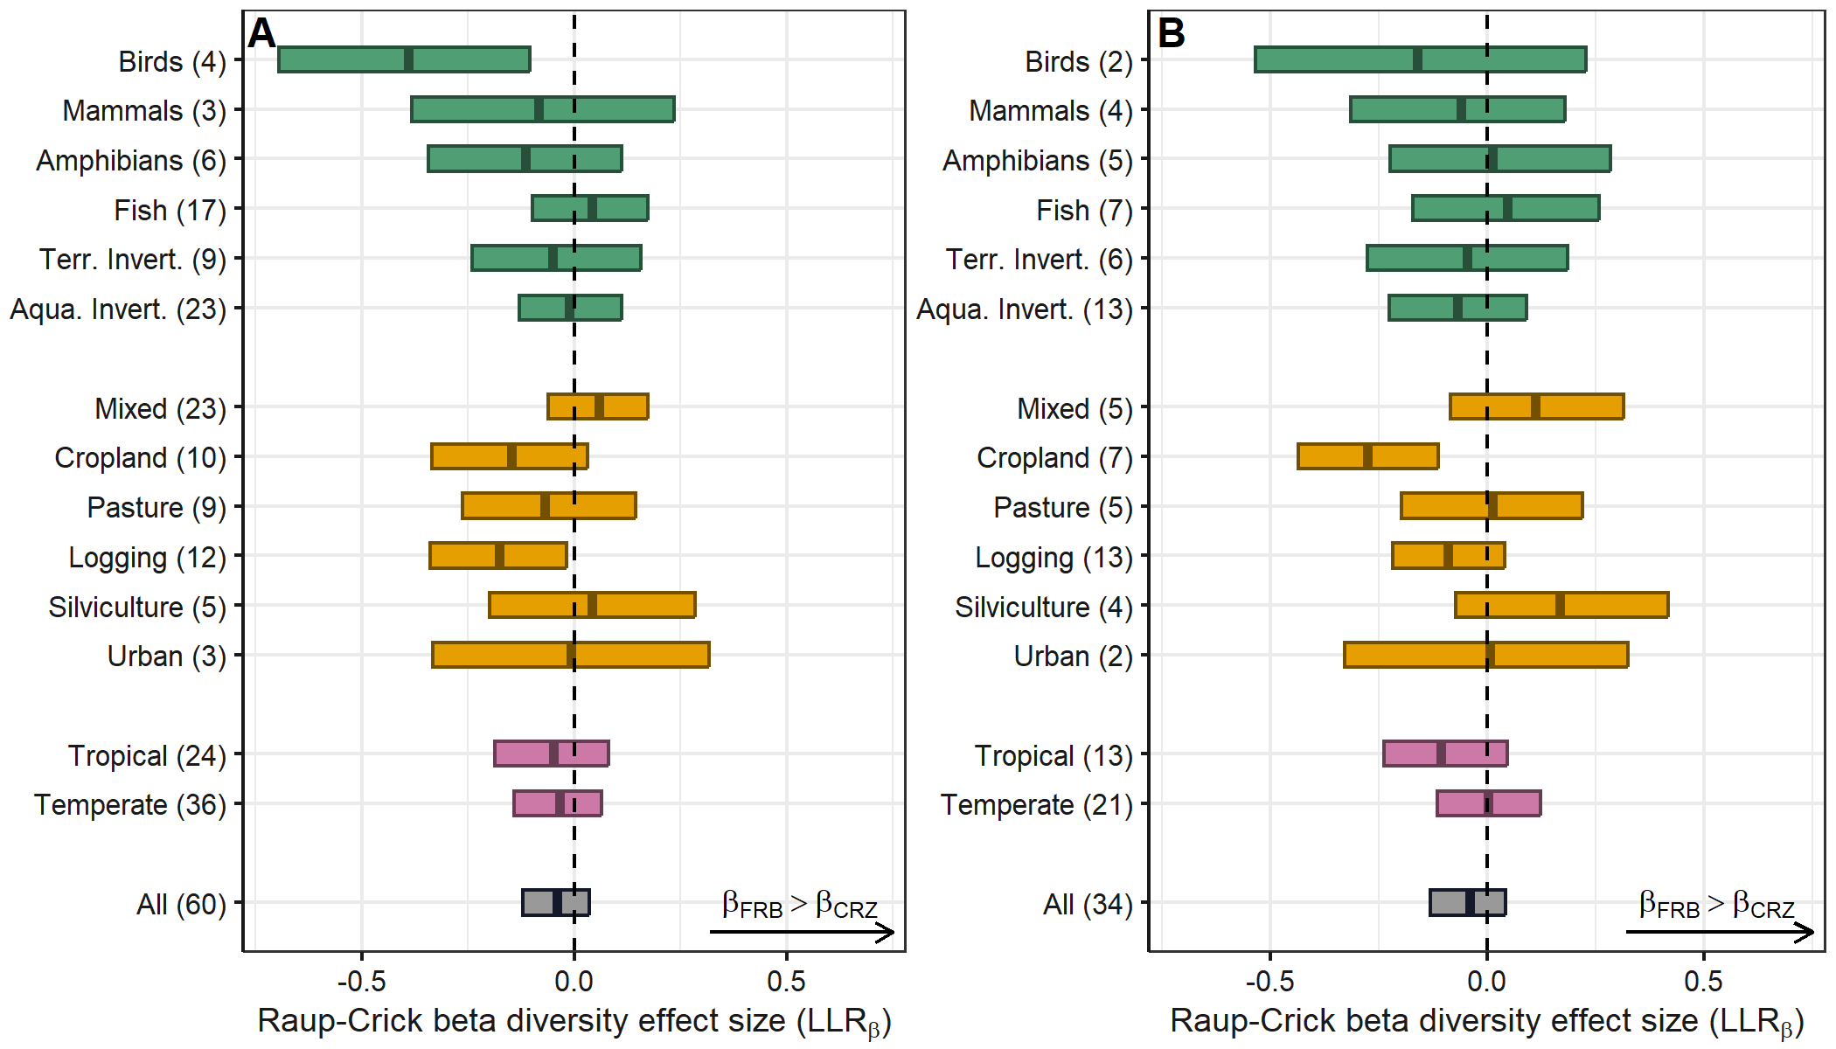

Fig. S2. Effect sizes (LRR) for Raup-Crick beta diversity calculated as log-response ratio comparing beta diversity values between riparian reserve (FRB) vs. converted riparian zones (CRZ). Both the overall community (A) and a reference species subset (B) found in riparian buffers surrounded by continuous forest were tested. Lines within boxplots are means and width of notches show the 95% CIs. A better support for differences is found in factors with CIs not overlapping zero. Number of studies is presented within parentheses in the y-axis.

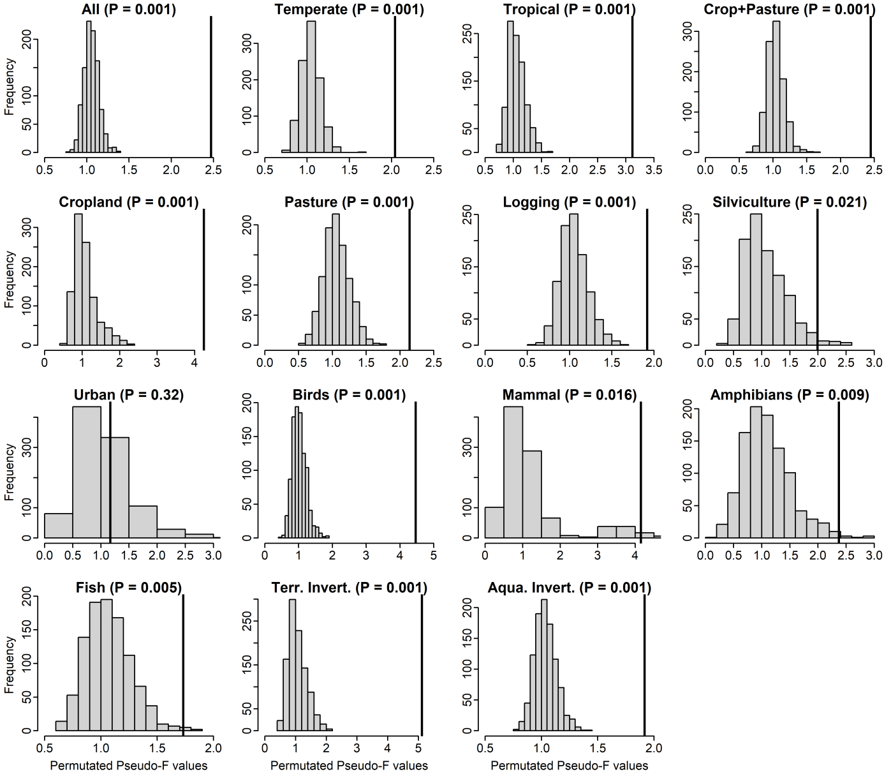Fig. S3. Observed Pseudo-F values generated by comparing community dissimilarity between riparian reserves (buffer) and converted riparian (no buffer) (black vertical line), and the probability of observing these values in a permutated distribution of Pseudo-F values given a null model. The null model assumed that communities occurring in buffers could, by chance, occur in non-buffer riparian areas and vice-versa. Each plot corresponds to a separate test run for every explanatory variable used in the meta-analysis models (Fig. 4). Notice that Pseudo-F is the same statistics used to compare communities in permutational multivariate analysis of variance (permMANOVA), but in this case, we adapted it to calculate a within dataset Pseudo-F and averaged the values across all datasets.

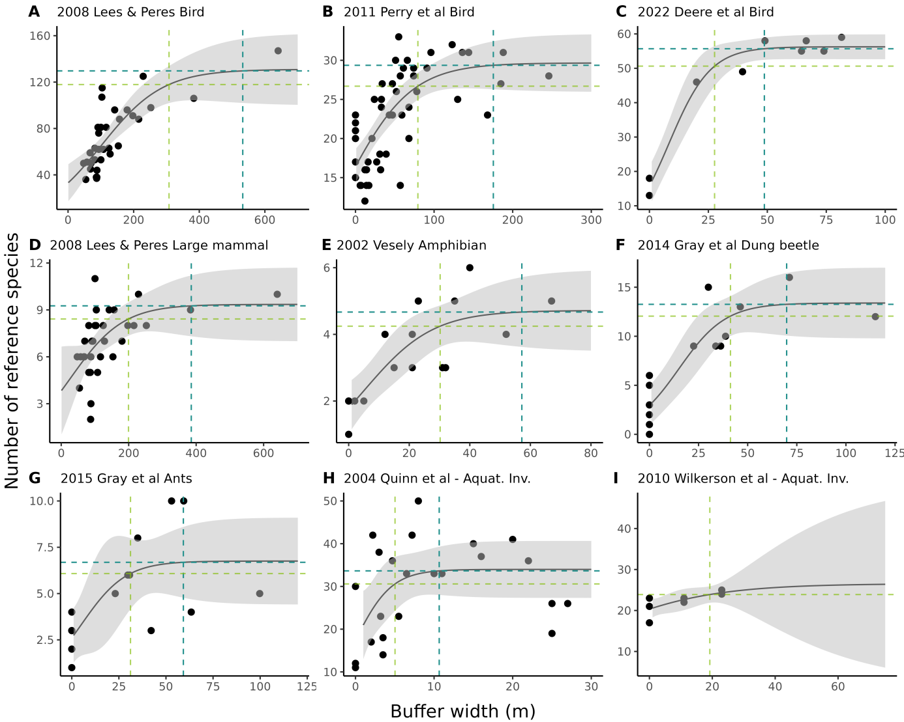
Fig. S4. Reference species richness predicted by riparian forest width for birds (A-C), mammal (D), amphibian (E), terrestrial invertebrates (F, G), and aquatic invertebrates (H, I). Logistic models fitted describing the relationship between the number of reference species found in riparian areas with different forest reserve widths, by study. Light and dark green are 90% and 99% asymptote thresholds, respectively. Absence of 99% estimate in (I) is due to the large CI. Values for each analysis are found in Table S13 and study references are found in Table S16.

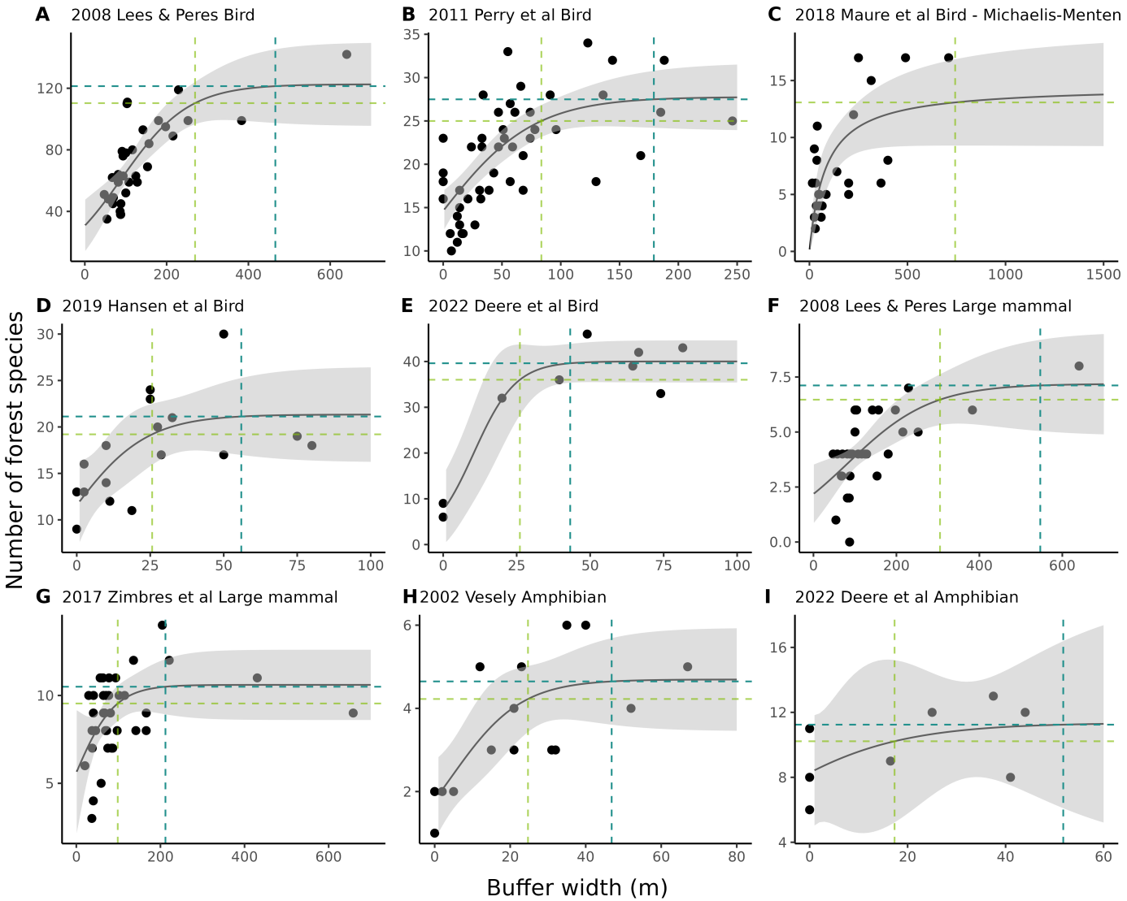

Fig S5. Forest species richness predicted by riparian forest width for birds (A-E), mammal (F, G), amphibian (H, I). Logistic or Michaelis-Menten model were fitted for predicting the number of forest dependent species as a function of riparian forest widths, by study. Light and dark green are 90% and 99% asymptote thresholds, respectively. Absence of 99% estimate in (C) is due to the large CI. Values for each analysis are found in Table S13 and study references are found in Table S16.

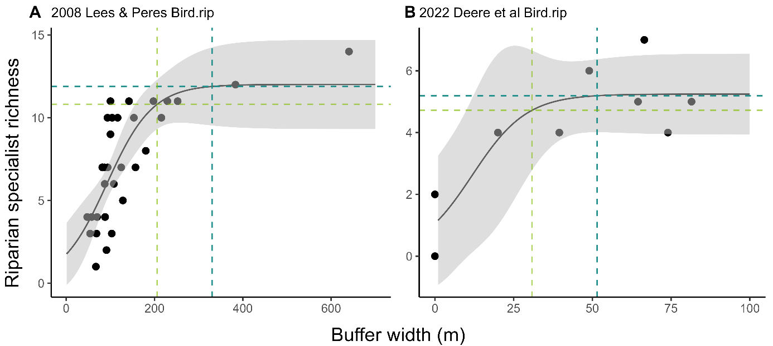
Fig. S6. Bird riparian specialists predicted by riparian forest width, fitted with logistic models, by study. Light and dark green are 90% and 99% asymptote thresholds, respectively. Values for each analysis are found in Table S13 and study references are found in Table S16.

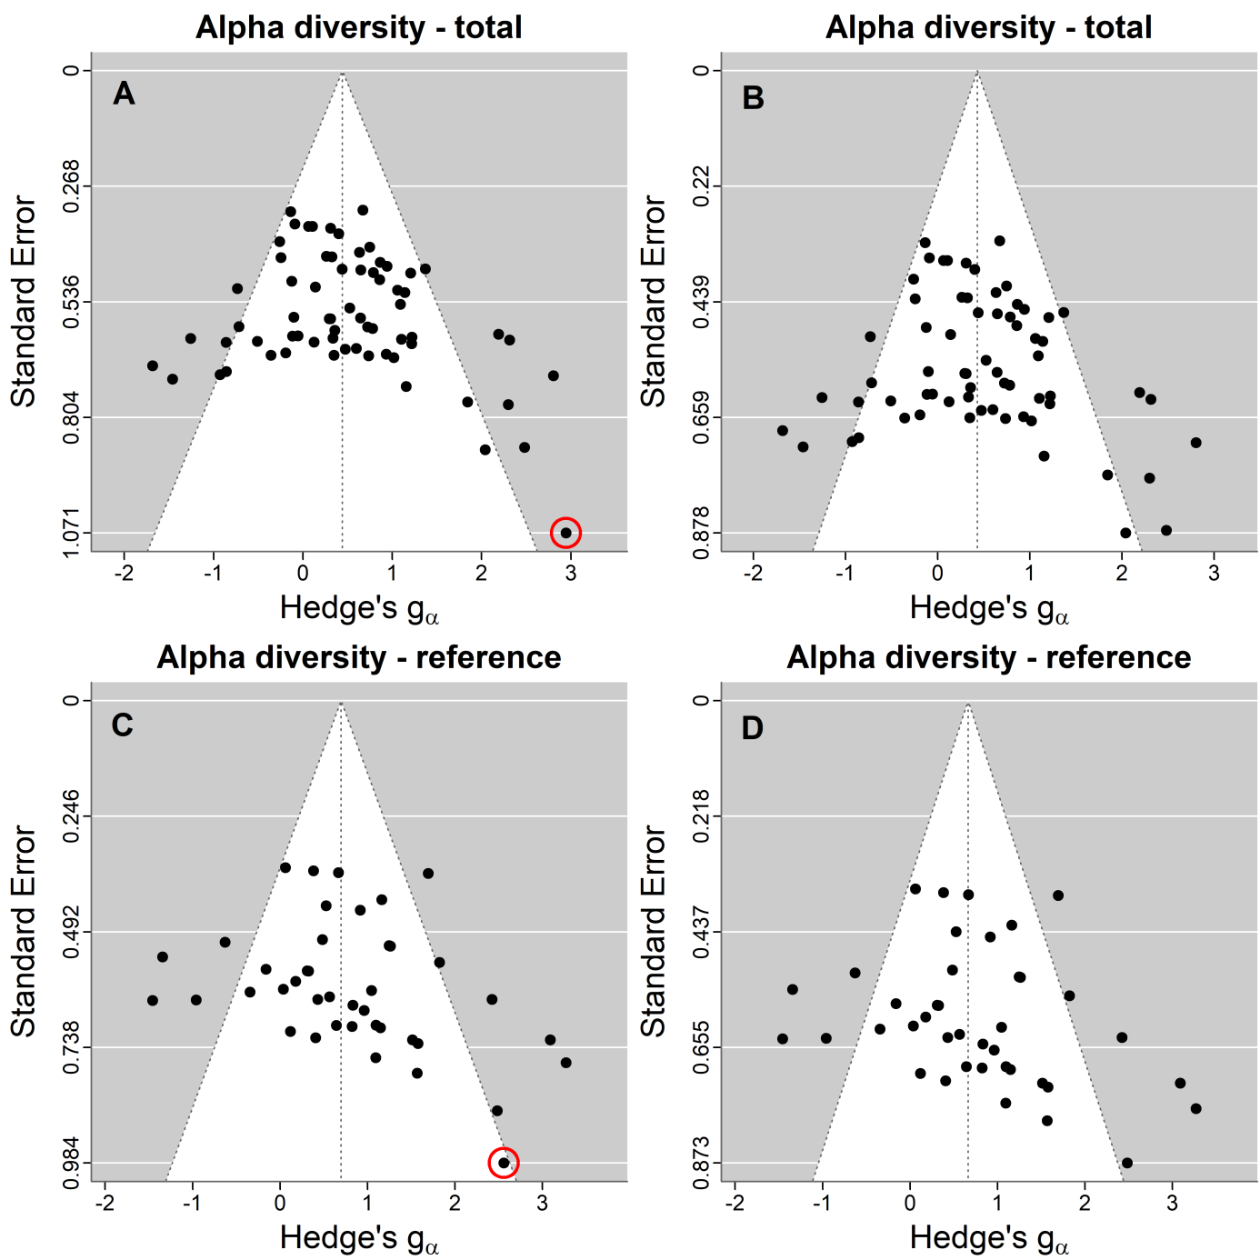
Fig. S7. Funnel plots respective to the meta-analysis models ran for alpha diversity using all species (A, B) and reference specie subset (C, D), depicting a measure of study precision (SE) versus effect sizes for each forest riparian buffer (FRB) vs. converted riparian buffer (CRB) pairwise comparisons. An outlier (A, C) was removed, and funnel plots were verified again (B, D). Effect sizes remained virtually equal even after removing this outlier.

