Supplementary index
Medline search
Database(s): Ovid MEDLINE(R) ALL 1946 to May 06, 2020
Search Strategy: accessed 7-5-20 12.45 am

# | Searches
1 | corona.mp.
2 | (virus or viruses or viral).mp.
3 | 1 and 2
4 | wuhan.mp.
5 | 2 and 4
6 | COVID.mp.
7 | COVID19.mp.
8 | COVID-19.mp.
9 | nCOV*.mp.
10 | SARS2.mp.
11 | SARS-2.mp.
12 | SARS-CoV-2.mp.
13 | SARS-CoV*.mp.
14 | 2019-corona*.mp.
15 | 2019-nCOV*.mp.
16 | 3 or 5 or 6 or 7 or 8 or 9 or 10 or 11 or 12 or 13 or 15
17 | thrombosis.mp. or Thrombosis/
18 | exp Thromboembolism/ or thromboembolism.mp.
19 | venous thrombosis.mp. or exp Venous Thrombosis/
20 | venous thromboembolism.mp. or exp Venous Thromboembolism/
21 | deep vein thrombo*.mp.
22 | deep venous thrombo*.mp.
23 | pulmonary embolism.mp. or exp Pulmonary Embolism/
24 | pulmonary emboli*.mp.
25 | lung embolism.mp.
26 | lung emboli*.mp.
27 | arterial thrombo*.mp.
28 | exp Cerebrovascular Disorders/ or cerebrovascular dis.mp.
29 | stroke.mp. or exp Stroke/
30 | (brain* or cere* or cerebell* or intracran* or intracerebral *).mp.
31 | (isch?emi* or infarct* or thrombo* or emboli*).mp.
32 | exp Myocardial Infarction/ or myocardial infarct*.mp.
33 | heart infarct*.mp.
34 | heart attack.mp.
35 | 17 or 18 or 19 or 20 or 21 or 22 or 23 or 24 or 25 or 26 or 27 or 28 or 29 or 30 or 31 or 32 or 33 or 34
36 | 16 and 35

Embase search
No.
Query
#35
#34 AND (2019:py OR 2020:py)
#34
#15 AND #33
#33
#16 OR #17 OR #18 OR #19 OR #20 OR #21 OR #22 OR #23 OR #24 OR #25 OR #26 OR #29 OR #30 OR #31 OR #32
#32
heart AND attack
#31
'heart infarction'
#30
myocardial AND infarction
#29
#27 AND #28
#28
isch?emi* OR infarct* OR thrombo* OR emboli*
#27
brain* OR cere* OR cerebell* OR intracran* OR intracerebral*
#26
stroke
#25
'cerebrovascular accident'
#24
'cerebrovascular disease'
#23
'artery thrombosis'
#22
'lung embolism'
#21
'pulmonary embolism and thrombosis'
#20
'deep vein thrombosis'
#19
venous AND thrombosis
#18
'thromboembolism'
#17
'vein thrombosis'
#16
'thrombosis'
#15
#4 OR #5 OR #6 OR #7 OR #8 OR #9 OR #10 OR #11 OR #12 OR #13 OR #14
#14
'2019 ncov'
#13
'2019 corona'
#12
'sars coronavirus'
#11
'sars cov 2'
#10
'sars 2'
#9
sars2
#8
ncov*
#7
'covid 19'
#6
covid*
#5
#2 AND #3
#4
#1 AND #3
#3
virus OR viruses OR viral
#2
wuhan
#1
corona

Risk of bias assessment
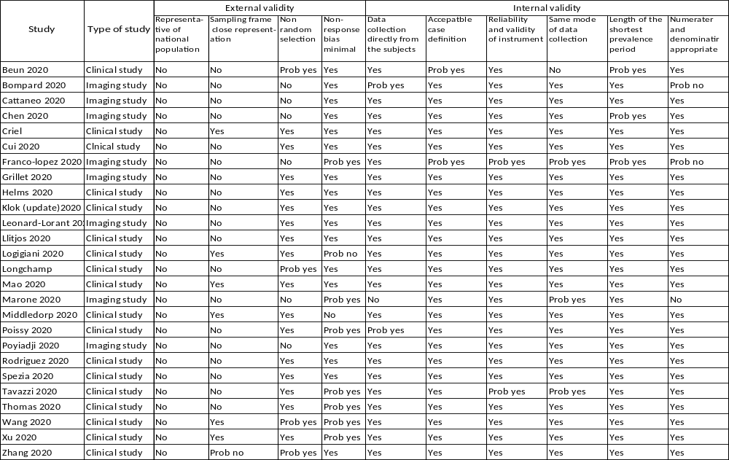

Flow Diagram
Records identified through database searching
Medline (n = 395)
Embase (n= 320)
Scopus (n=47) total 762
Studies included in quantitative synthesis (meta-analysis)
(n = 26)
Records excluded
(n = 934)
Records screened
(n =1126)
Records after duplicates removed
duplicate = 389+125 =514 (n = 2299)

Identification

Eligibility

Included

Screening
Additional records identified through other sources
Google Scholar (n = 1138)
MedRxiv (n=48)
SSRN (n=2)
Full-text articles excluded, with reasons
n = 170
44 case report or series
7 comments
6 Duplicate
4 guidance
12 not relevant
32 no incidence reported
64 review
1 full text unavailable

Studies included in qualitative synthesis
(n = 26)
Full-text articles assessed for eligibility
(n =192)
Figure S1 The pooled incidence of PE from clinical studies in the ICU setting

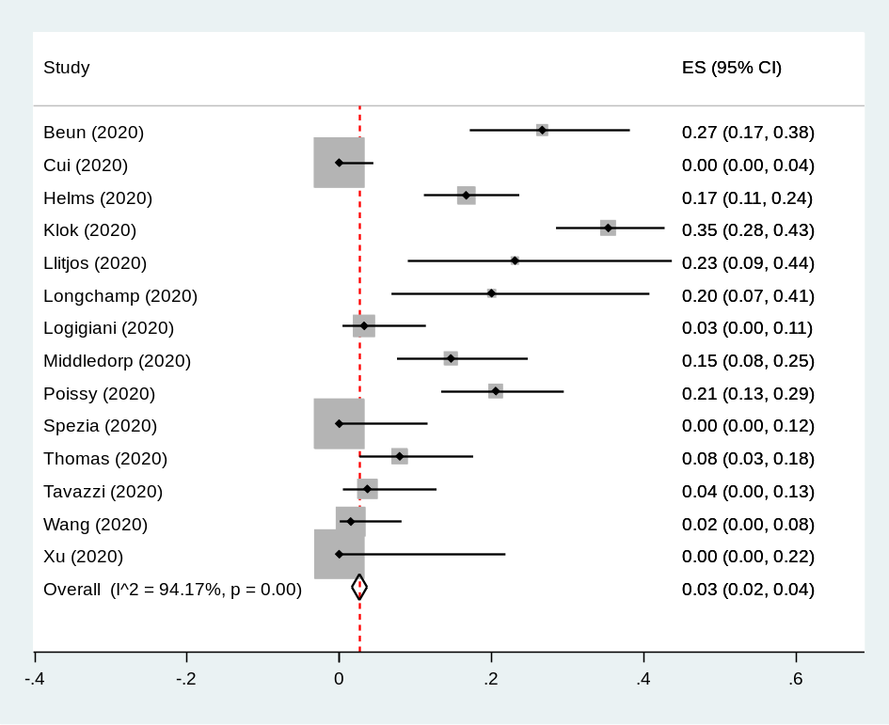

Figure S2 The pooled incidence of DVT from clinical studies in the ICU setting

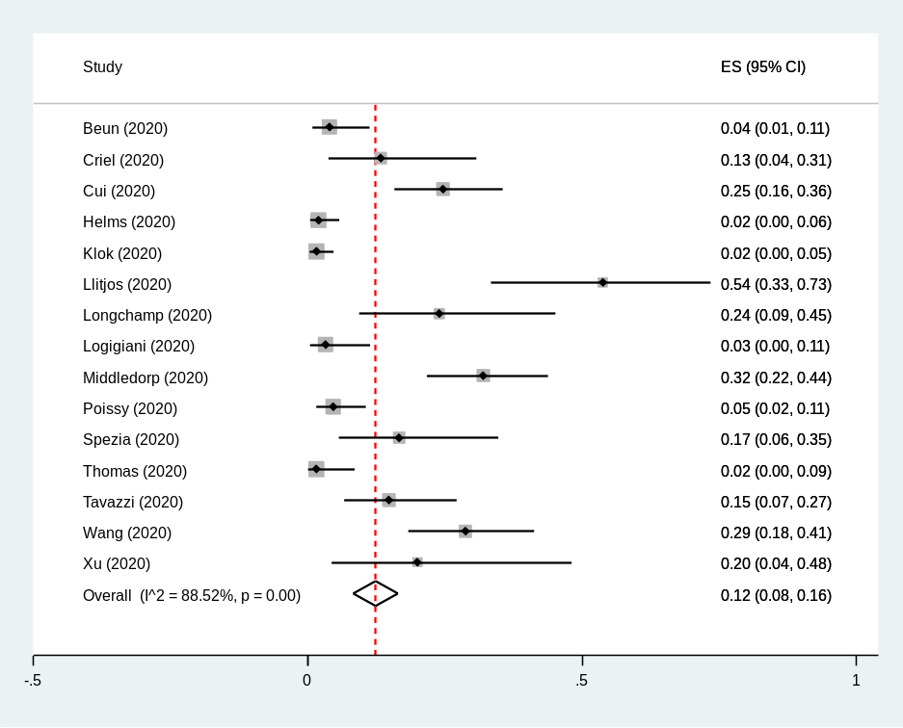

Figure S3 Subgroup analysis of the pooled incidence of VTE from clinical studies in the ICU setting by anticoagulant prophylaxis

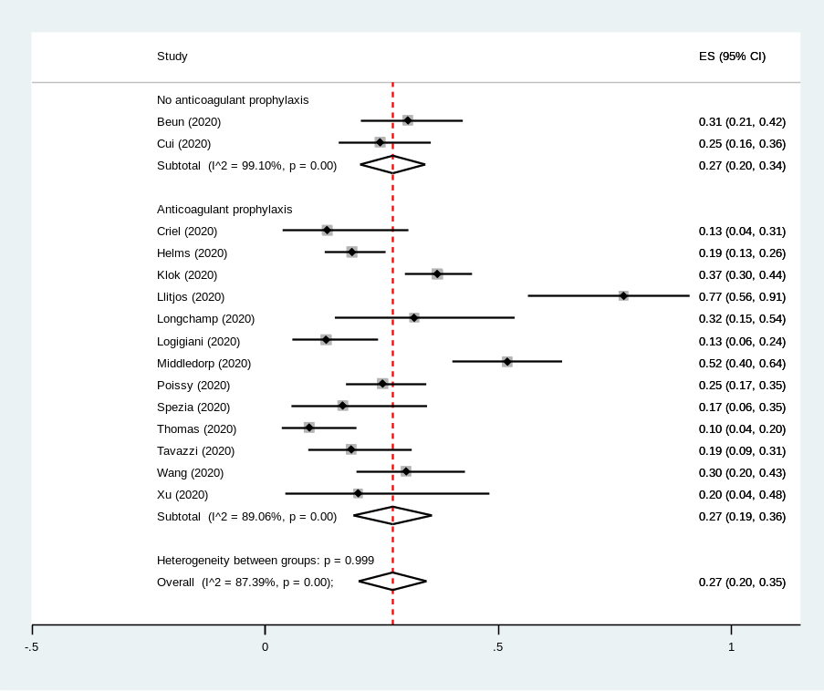

Figure S4 Subgroup analysis of the pooled incidence of VTE from clinical studies in the ICU setting by western or eastern country

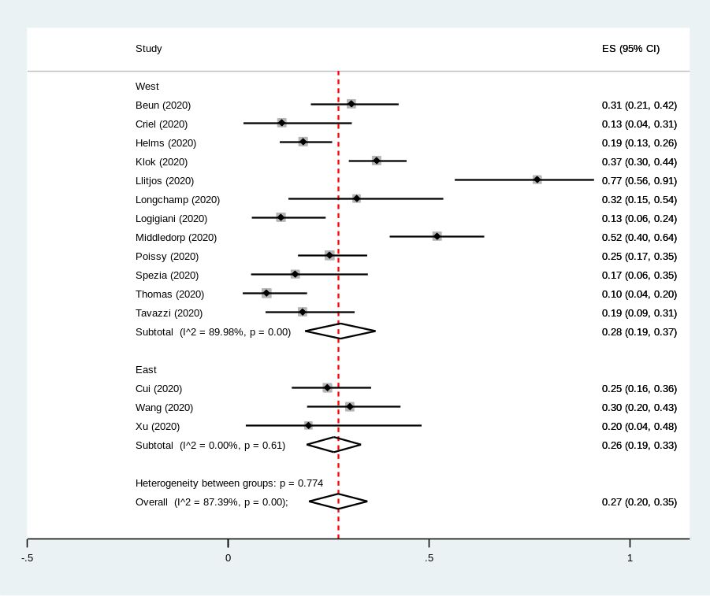

Figure S5 The pooled incidence of VTE from clinical studies in the ICU setting by CUS screening

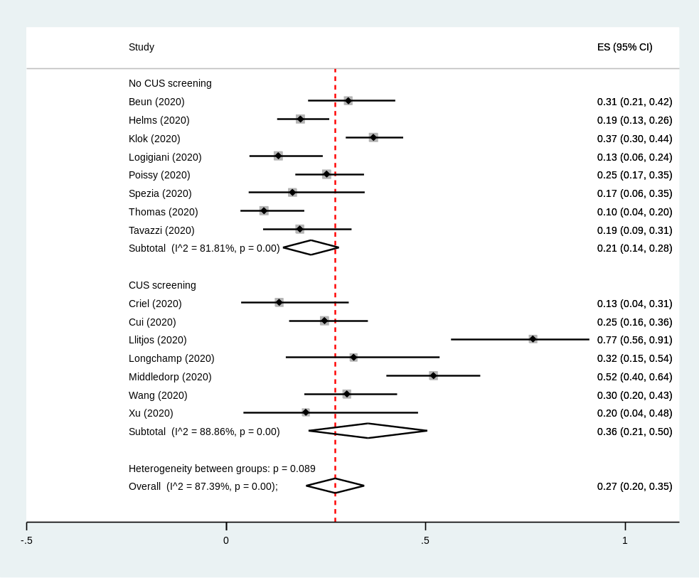

Figure S6 The pooled incidence of VTE from clinical studies in the non- ICU setting

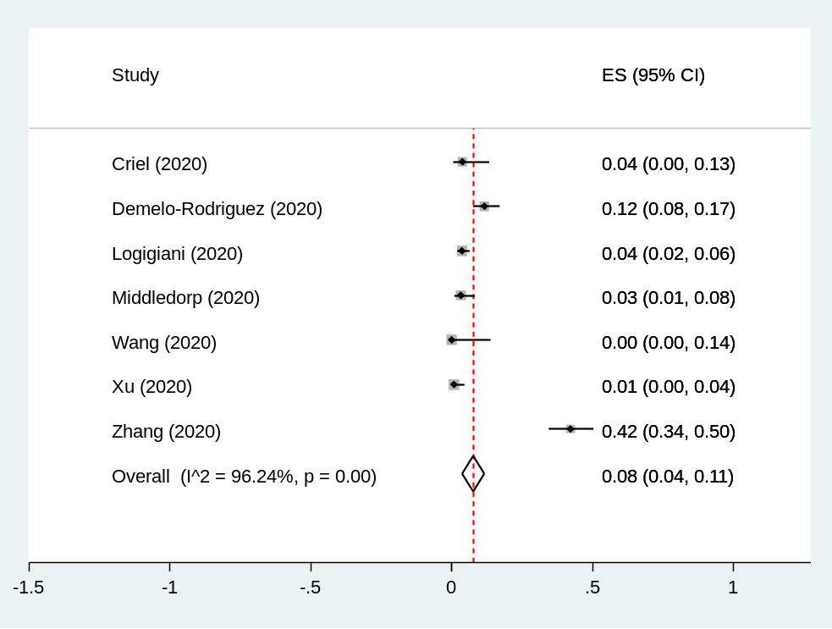

Figure S7 The pooled incidence of PE from clinical studies in the non- ICU setting

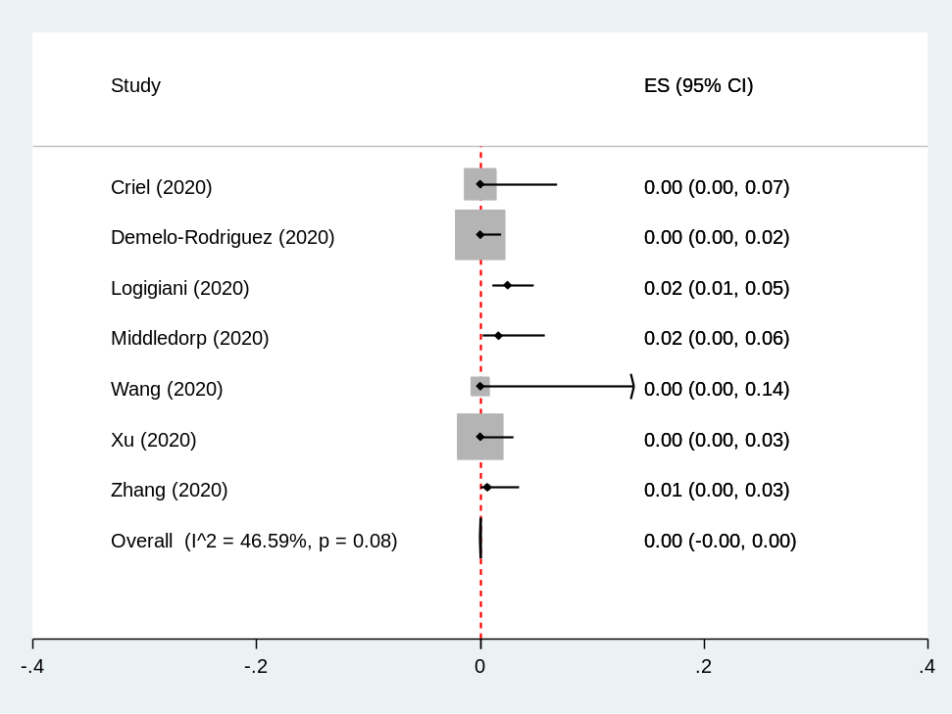
Figure S8 The pooled incidence of DVT from clinical studies in the non- ICU setting

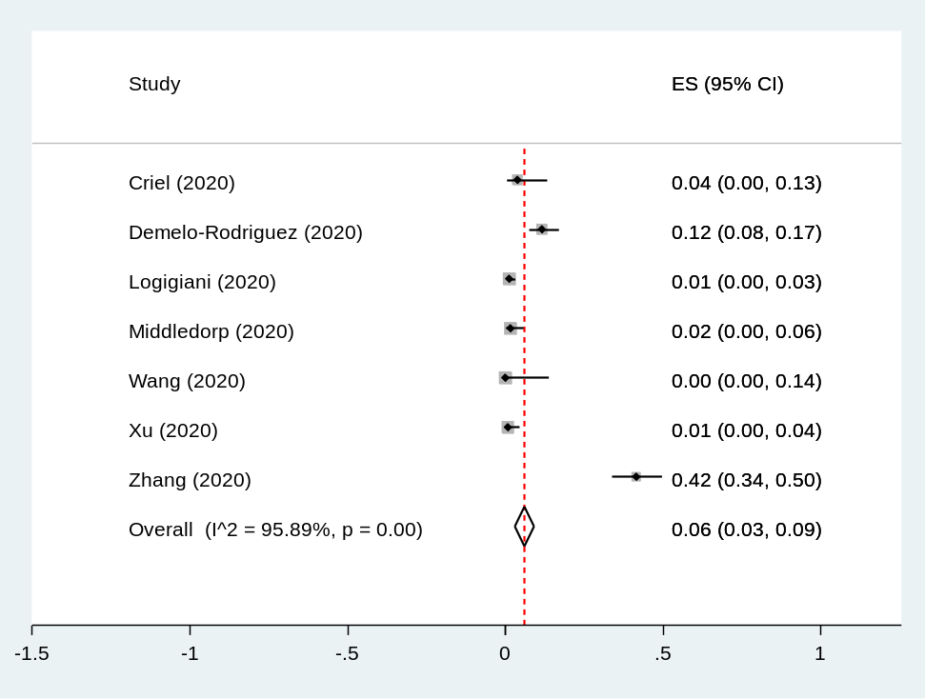

Figure S9 The pooled incidence of VTE in from clinical studies in the non- ICU setting based on western or eastern country

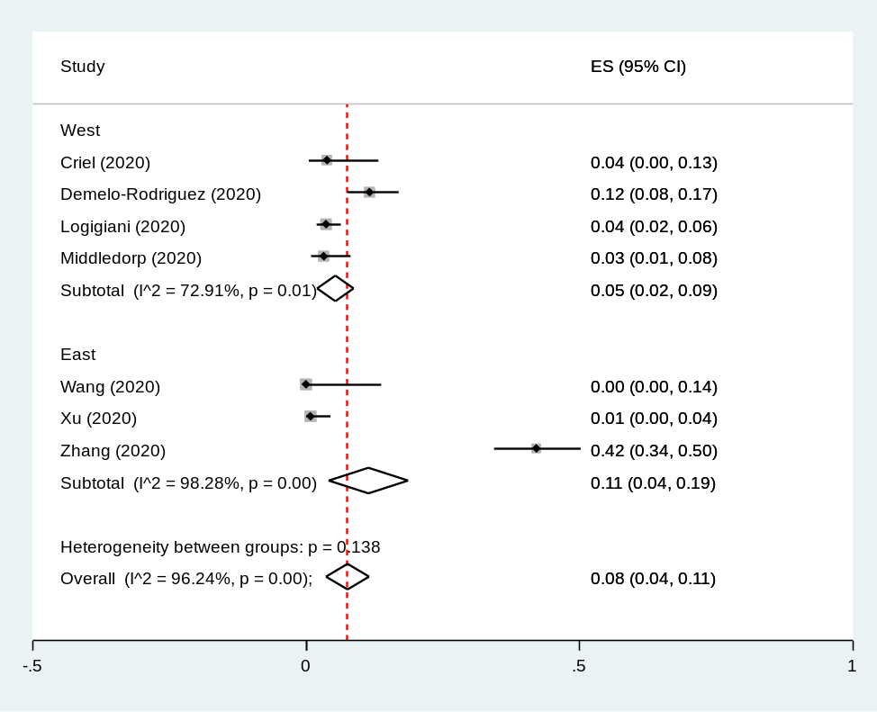
Figure S10 The pooled incidence of VTE in from clinical studies in the non- ICU setting based on CUS screening

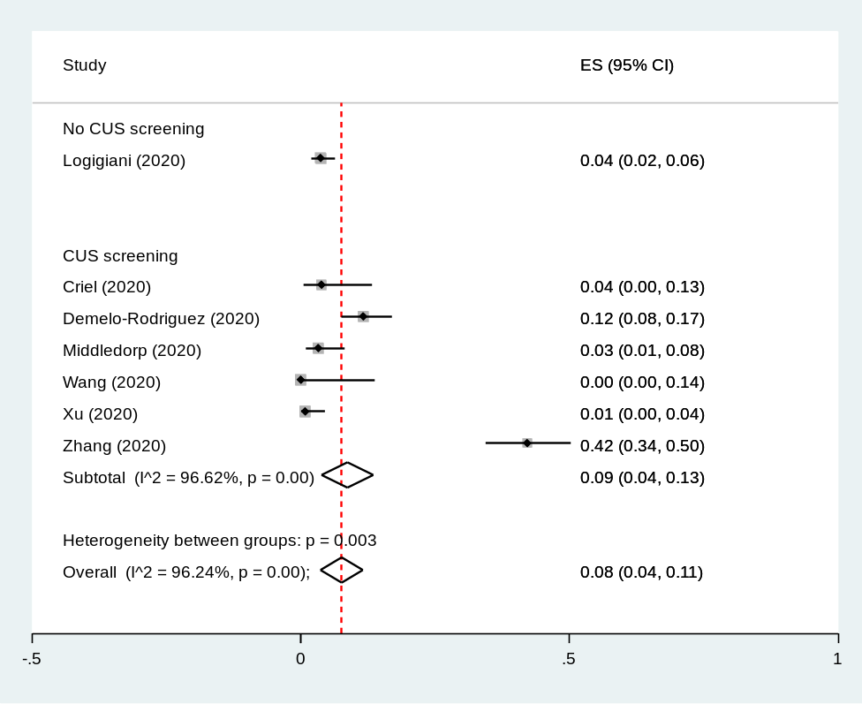

Figure S11 The pooled incidence of arterial thrombosis from clinical studies in the ICU setting

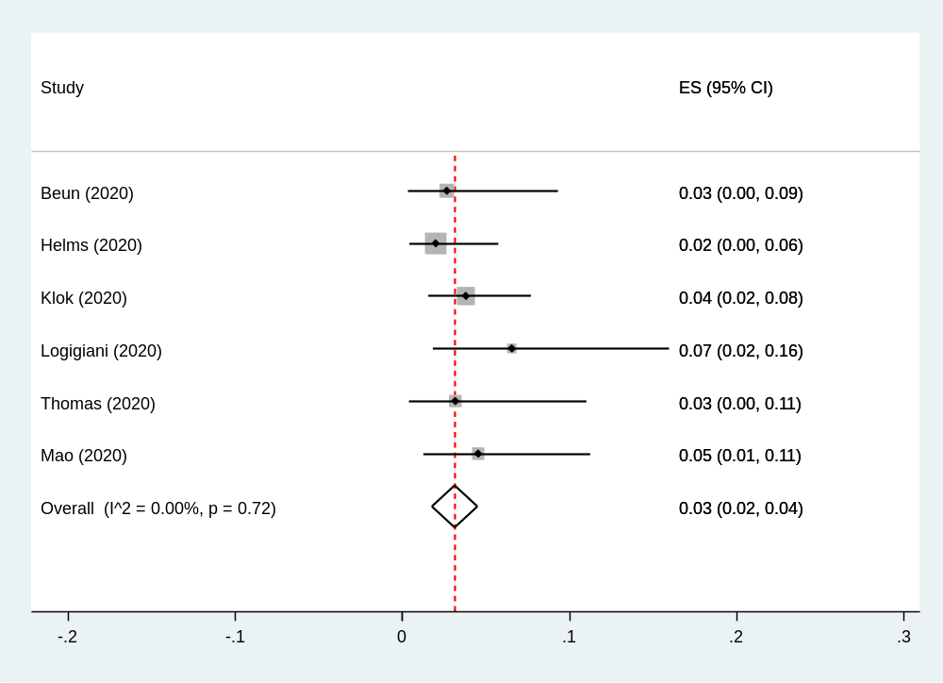

Figure S12 The pooled incidence of arterial thrombosis in the non-ICU setting

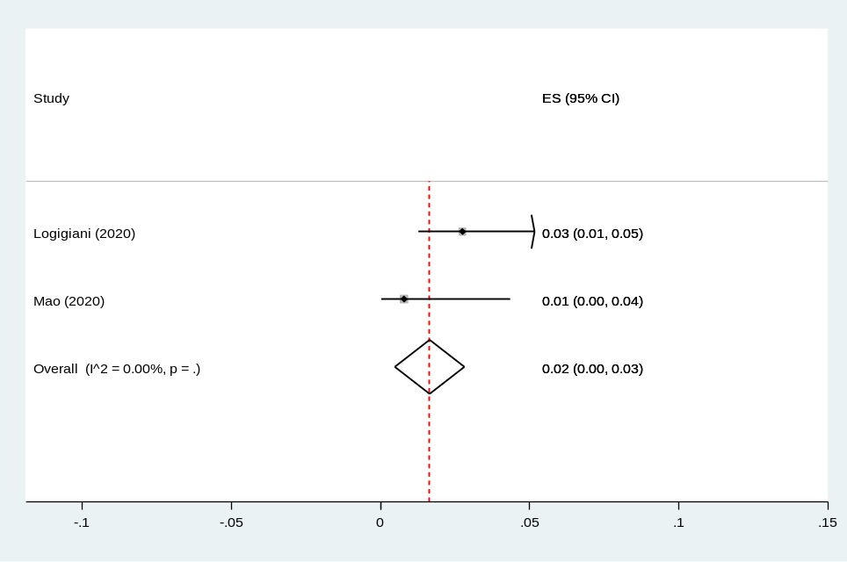

Figure S13 The pooled incidence of VTE with death in the ICU setting

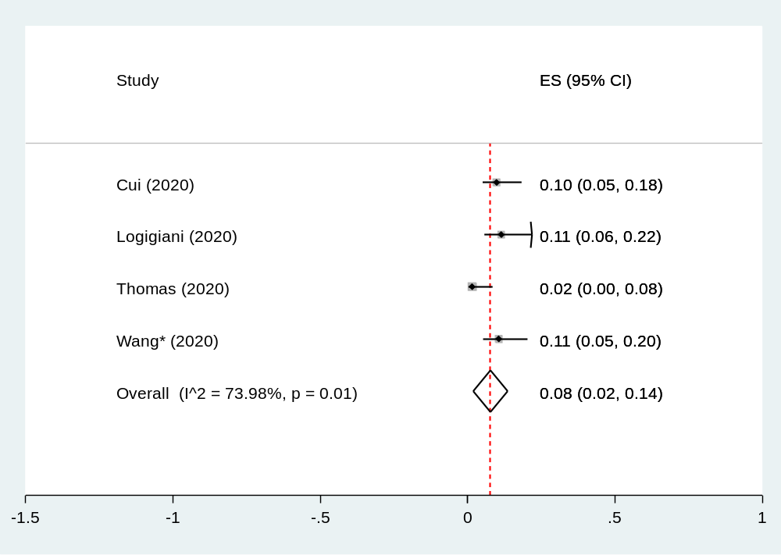

Figure S14 The pooled incidence of total VTE in imaging studies

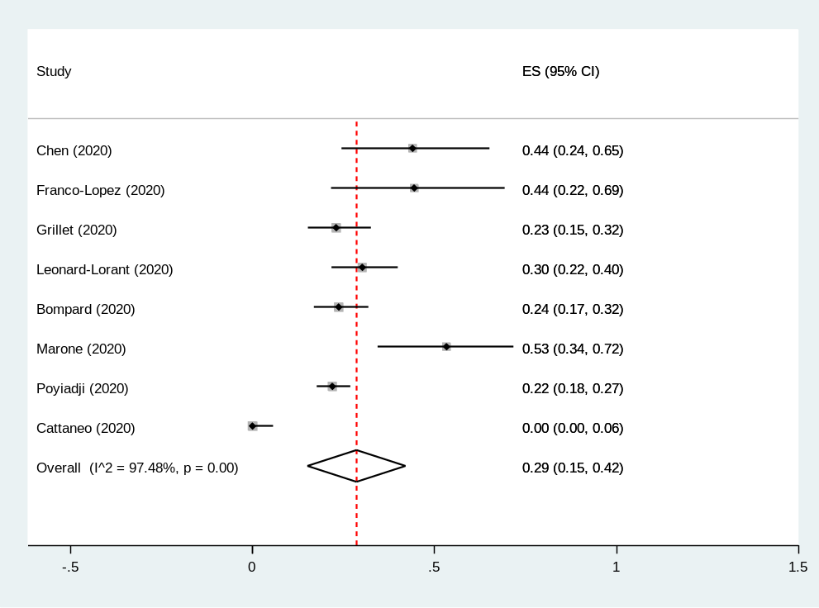

Figure S15 The pooled incidence of PE in imaging studies focusing on CUS

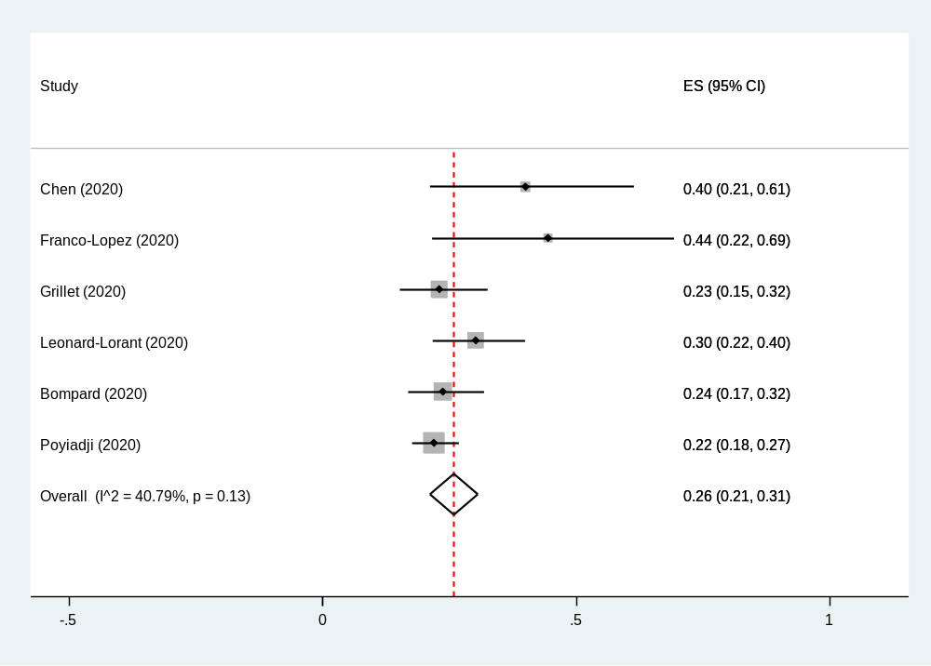

Figure S16 The pooled incidence of DVT in imaging studies focusing on CUS

