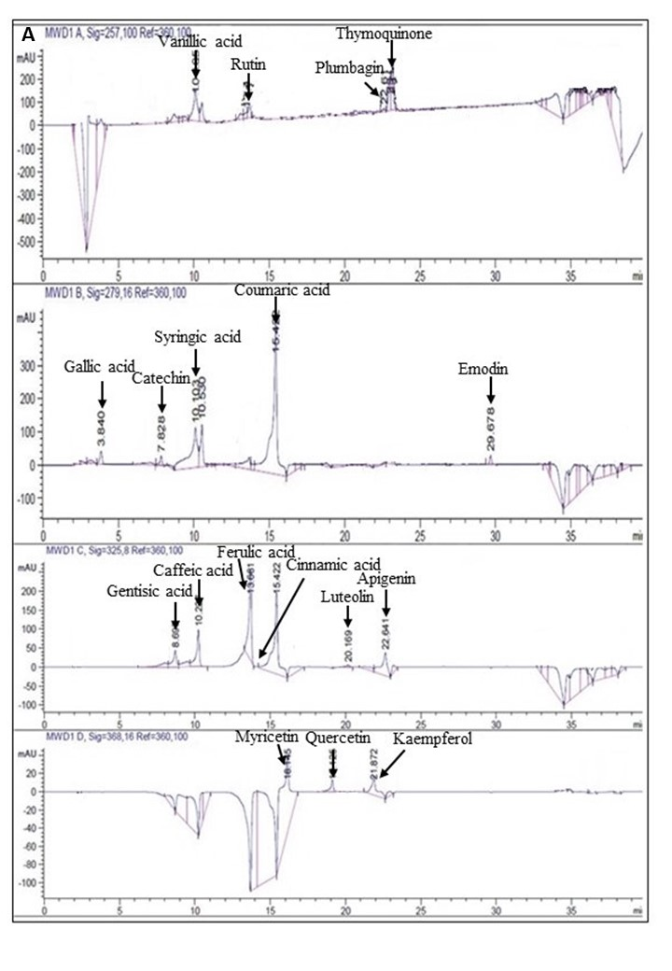
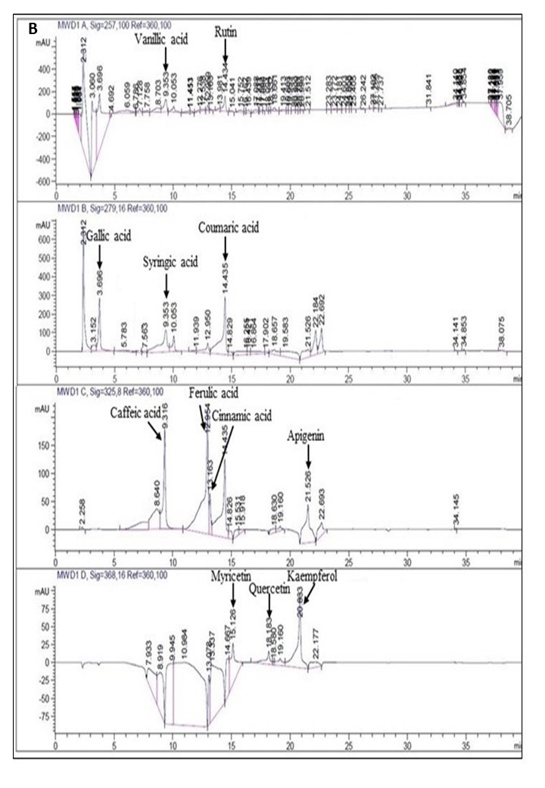
Supplementary Figure 1 RP-HPLC chromatograms for quantification of polyphenols in crude extracts of Ajuga bracteosa. (A) Mixed standard compounds. (B) Crude extract of transgenic line 3 of A. bracteosa (ABRL3)

