Supplementary materials to:

The global high-temperature on-axis hydrothermal fluid and element flux to the modern ocean
*Alexander Diehl^{1,2} and Wolfgang Bach^{1,2}
¹ MARUM Center for Marine Environmental Sciences, University of Bremen, Leobener Straße 8, 28359 Bremen, Germany
² Faculty of Geosciences, University of Bremen, Klagenfurter Straße 2‑4, 28359 Bremen, Germany
*Corresponding author: Alexander Diehl (diehl@uni-bremen.de)

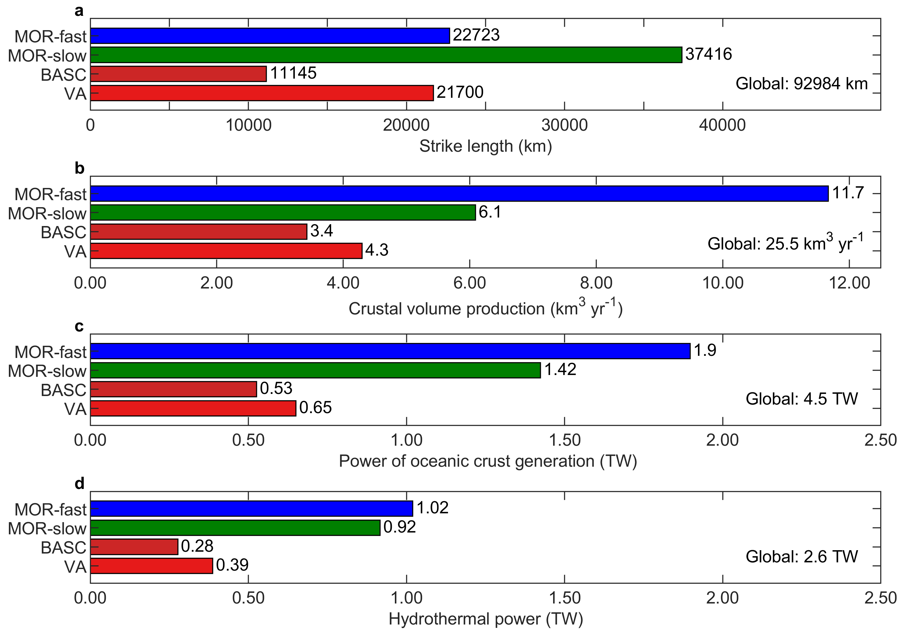
Supplementary Figure 1. a: Strike length of plate boundaries considered in this study. b: Global oceanic crustal volume production of plate boundaries assuming length-weighted average spreading rates and average crustal thicknesses for the different boundaries. c: Power of oceanic crust generation calculated from an energy balance and the oceanic crustal mass production rate. d: Hydrothermal power of high-temperature fluid fluxes for the different plate boundary types.
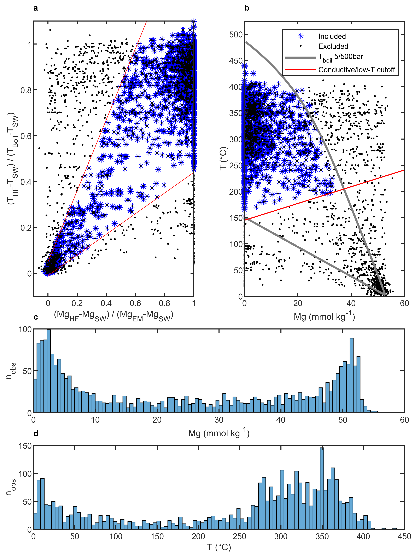
Supplementary Figure 2. a: Dilution factor of hydrothermal fluids by magnesium concentration vs dilution factor by temperature (assuming a boiling fluid and cold seawater entrainment). A fluid cooled by mixing with cold seawater follows the slope of one with intercept zero. Fluids that strongly deviate from this mixing line are excluded (fluids that pass this filter are marked by blue stars). b: Magnesium vs temperature for all hydrothermal vent fluids and end members in the database. Mixing lines for boiling fluids (or theoretical extension of boiling curve) and cold seawater at 5 (500 bar) are shown as guide for useful Mg vs T ratios of conductively unaffected hydrothermal fluids at different pressures. c: Histogram of Mg concentrations for hydrothermal fluid samples. Note the bimodal distribution of vent fluids being either close to the zero Mg endmember or close to seawater. d: Histogram of temperatures for hydrothermal fluid samples and endmembers given in the vent fluid database. Note again a strong bimodal character with the majority of fluids being colder than ~50°C or significantly hotter than ~200°C.
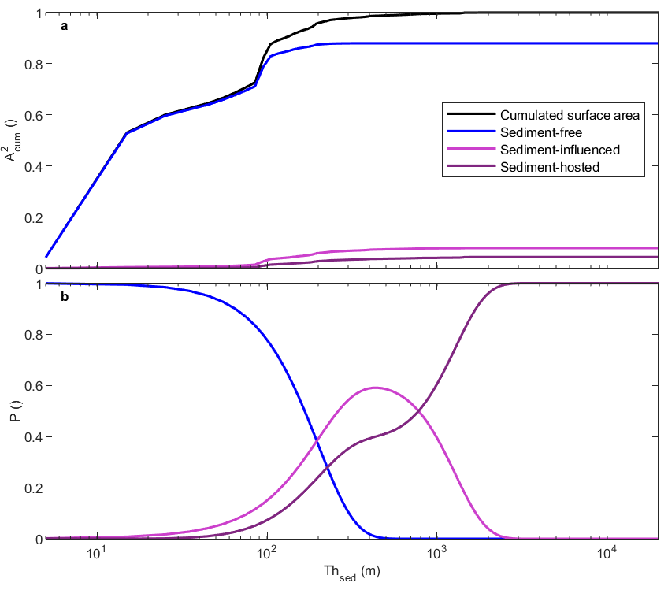
Supplementary Figure 3. a: Cumulated surface area after sediment thickness for 0–1 Ma old lithosphere. b: Probability function for the occurrence of sediment-related hydrothermal systems.
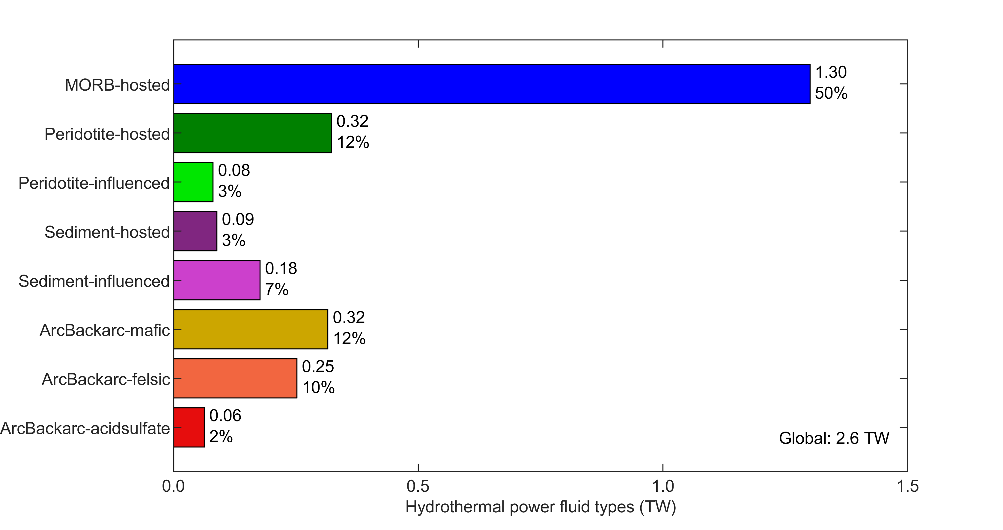
Supplementary Figure 4. Hydrothermal power for the fluid types defined in this study. The upper (lower) values denote the absolute (relative) powers per vent fluid type.
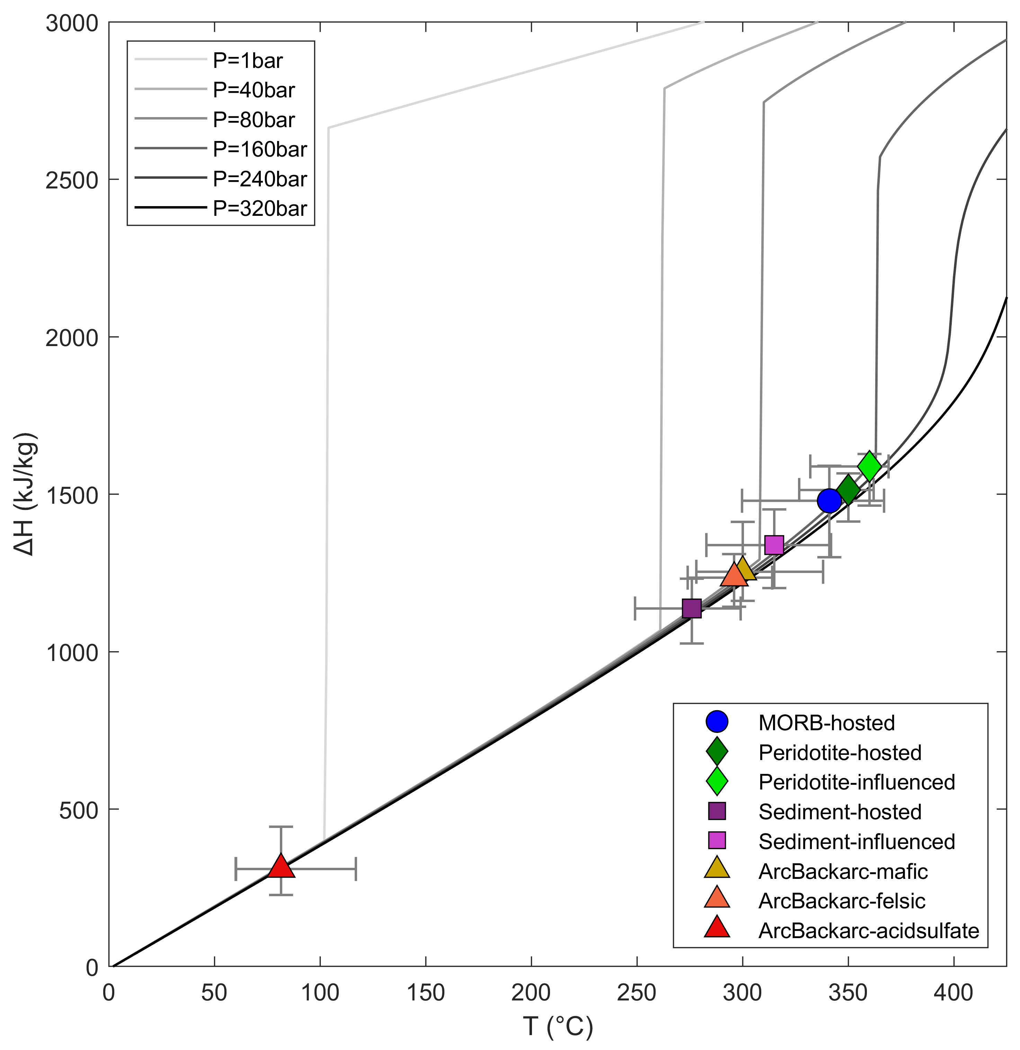
Supplementary Figure 5. a: Enthalpy differences to cold seawater for different fluid types calculated from the median temperatures of the fluid classes. Crosshairs mark the interquartile ranges based on fluid temperatures in individual fluid samples. Grey lines show enthalpies for heated seawater for different pressures. Note: The sharp increases in seawater enthalpies mark the boiling temperatures at the respective pressures.

