Supplemental information

Novel subgroups of prediabetes and the associations with outcomes in health professionals: a data-driven cluster analysis

Apinya Surawit^{1,2}, Phongthana Pasookhush^{1,2}, Sureeporn Pumeiam¹, Pichanun Mongkolsucharitkul¹, Sophida Suta¹, Bonggochpass Pinsawas¹, Suphawan Ophakas¹, Nutchavadee Vorasan³, Parit Voharnsuchon⁴, Korapat Mayurasakorn^{1,2*}

¹Siriraj Population Health and Nutrition Research Group, Research Department, Faculty of Medicine Siriraj Hospital, Mahidol University
² Siriraj Center of Research Excellence for Diabetes and Obesity (SiCORE-DO), Faculty of Medicine Siriraj Hospital, Mahidol University, Bangkok, Thailand
³Genetic Epidemiology Group, Department of Biochemistry, Faculty of Medicine Siriraj Hospital, Mahidol University
⁴Postgraduate Education Devision, Faculty of Medicine Siriraj Hospital, Mahidol University

Supplementary
Table of Contents
Figure S1: Participant selection flow diagram, related to Table 1 | 1
Method 1: Determination of cluster number | 2
Figure S2: Visualization of cluster distributions and the optimal number of clusters | 2
Table S1. Mean and standard deviation (SD) of Jaccard from 1,000 resampling iteration | 3
Figure S3: Pairwise comparisons of the cluster feature variables. | 3
Table S2: Cohen’s d estimates of cluster comparisons of variables in prediabetes at baseline, related to Figure S3 | 4
Method 2: Genetic imputations | 5
Figure S4: Quality control (QC) and imputation workflow for SNP genotyping in this study, related to Figure S6 | 5
Figure S5: Workflow of QC and performance for imputation with IMPUTE5 | 6
Method 3: Evaluation of published T2D PRS models | 7
Table S3: Comparison of polygenic risk scores for type 2 diabetes based on rsID match rate and association strength | 7
Table S4: SNPs summary statistics of PGS004106 for type 2 diabetes risk prediction | 8
Method 4: Statistical analysis | 9
Table S5: The Comparison of the AIC between the Cox Proportional Hazard Model and Parametric Model | 10
Table S6: Summarize the incidence of type 2 diabetes and cardiovascular disease (CVD) across four clusters | 11
Table S7: Comparisons of incident type 2 diabetes, and cardiovascular disease between clusters by using different clusters as reference groups, related to Figure 2 | 12
Table S8: Transitions from prediabetes clusters at baseline to normal glucose regulation (NGR), prediabetes clusters | 12
Figure S6: Change in cluster variables over time | 13
Table S9: Genetic risk score analysis | 14
Figure S7: Manhattan and QQ plots of GWAS. | 15

4,976 participants examined at baseline
Merging
SNPs QC (n=3,879)
for analyzing polygenic Scores (PGS) and the subsequent division of the dataset into two groups
Control
(n=3,505)
T2D
(n=374)
1,041 subjects with prediabetes
3,935 were excluded including:
3,446 with normal glycemic status (HbA1c < 5.7% or fasting plasma glucose <100 mg/dL)
176 self-report T2D or drug T2D or type 2 diabetes (T2D)
or HbA1c ≥ 6.5%
103 diagnosed T2D at baseline
1 with cardiovascular diseases (CVD), at baseline
209 with uncertain self-report T2D and missing data
1,097 Missing genotype data

25 were excluded for missing data in biochemical detection and physiological measurement at follow up

1,016 subjects with prediabetes included in the analysis

15 were analyzed for incident cardiovascular disease at follow-up
(Diagnosis ICD10 code: I20 - I25 and I60 - I64)
122 were analyzed for incident T2D at follow-up
(119 diagnosis ICD10 code: E119 - E14 and 3 from HbA1c ≥ 6.5% 3 times)

Figure S1. Participant selection flow diagram, related to Table 1

Method 1 : Determination of cluster number
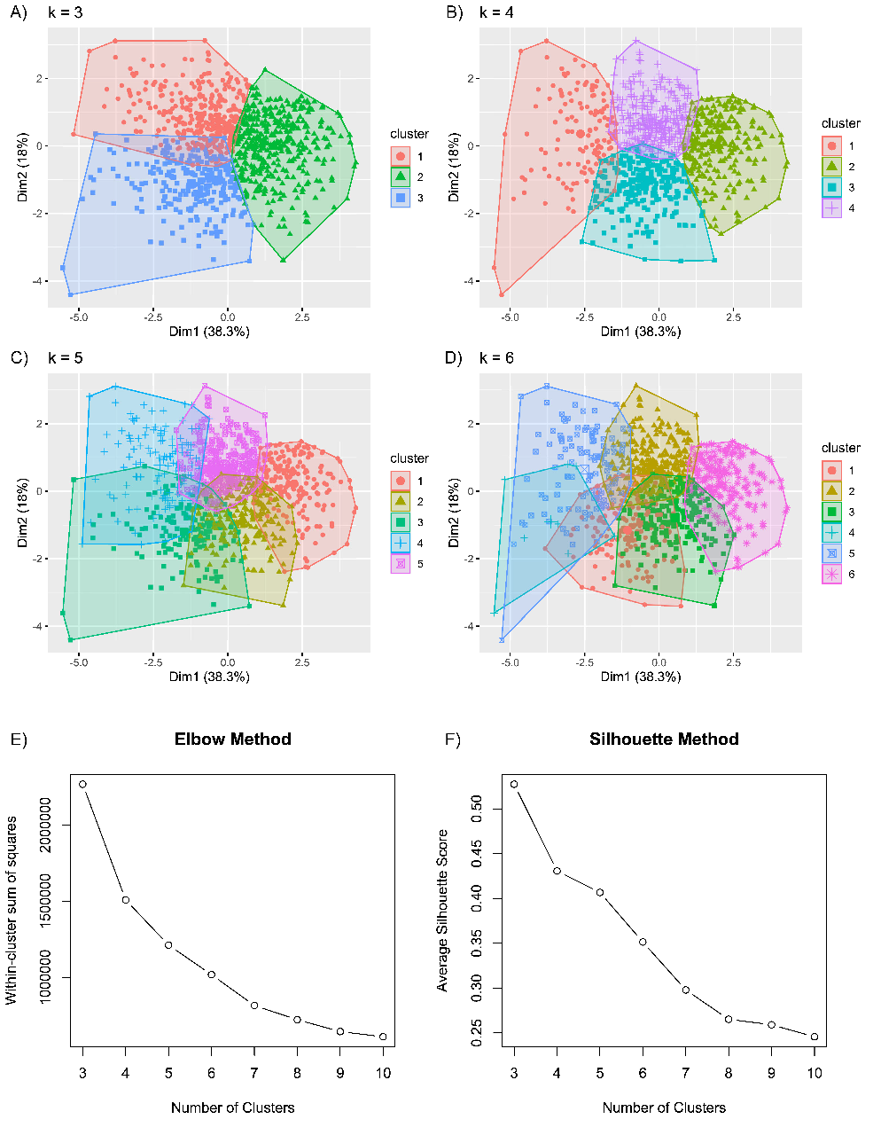
Consensus clustering is a method of unsupervised cluster has been widely used for high-dimensional data. The clustering algorithm is to maximize the number of clusters meanwhile maintaining high cluster consensus. We set a prespecified number of clusters K=3, …, 6, for each number of clusters and repeated 10000 times. To determine the optimal number of clusters, we first used UMAP-based dimensionality reduction to visualize the resulting cluster distributions. We then applied the Elbow method and silhouette width (1) for clustering, varying the number of clusters from three to ten. Next, we assessed cluster stability using the Jaccard bootstrap approach (2), implemented via the clusterboot function (from the fpc package, v.2.2-12) with 1,000 resampling iterations.

Figure S2. Visualization of cluster distributions and the optimal number of clusters
As shown in Table S1, focusing on the Mean_Jaccard value (the higher, the better) and the SD_Jaccard (the lower, the more consistent the Jaccard values across bootstrap runs) demonstrates that K = 4 achieves the highest mean Jaccard similarity (Mean=0.889, SD=0.067). This indicates that partitioning the data into four clusters yields the greatest stability in the bootstrap-based Jaccard calculation compared to the other cluster solutions.
Table S1. Mean and standard deviation (SD) of Jaccard from 1,000 resampling iteration
K | Mean_Jaccard | SD_Jaccard
3 | 0.76814 | 0.14385
4 | 0.88930 | 0.06765
5 | 0.80385 | 0.06495
6 | 0.76421 | 0.08002
7 | 0.66269 | 0.08529
8 | 0.73510 | 0.03101
9 | 0.71302 | 0.10766
10 | 0.69411 | 0.09879

Figure S3. Pairwise comparisons of the cluster feature variables.
Bonferroni correction was applied with *p < 0.05, **p < 0.01, ***p < 0.001 as statistical significance. The blue or red color presented the Cohen’s d values that indicated the standardized difference between the two means. Most differences achieved Bonferroni adjusted statistical significance (p < 0.001), and half of them showed small or negligible differences when tested using Cohen’s d value. BMI, body mass index; WC, Waist circumference; FPG, Fasting blood glucose; HbA1C, Hemoglobin A1c; HDL-C, high-density lipoprotein cholesterol; TG, triglyceride. MORPD, mild obesity-related prediabetes; LORPD, Low risk prediabetes; MESPD, metabolic syndrome prediabetes; MARPD, mild age-related prediabetes. See also Table S2.

Table S2. Cohen’s d estimates of cluster comparisons of variables in prediabetes at baseline, related to Figure S3
Comparison groups | Age | BMI | WC | FBG | HbA1c | HDL-C | TG
Cluster 1 vs Cluster 2 | -0.069 | 1.972 | 2.255 | 0.463 | 0.181 | -1.835 | 0.786
p-value | 0.817 | 0.000 | 0.000 | 0.000 | 0.407 | 0.000 | 0.000
Cluster 1 vs Cluster 3 | -0.041 | -1.540 | -1.611 | -1.337 | -1.507 | 0.891 | -0.925
p-value | 0.983 | 0.000 | 0.000 | 0.000 | 0.000 | 0.000 | 0.000
Cluster 1 vs Cluster 4 | -1.534 | 0.615 | 0.565 | -1.205 | -1.467 | -0.329 | -0.169
p-value | 0.000 | 0.000 | 0.000 | 0.000 | 0.000 | 0.002 | 0.421
Cluster 2 vs Cluster 3 | 0.031 | -3.275 | -3.423 | -1.633 | -1.658 | 2.267 | -1.305
p-value | 0.988 | 0.000 | 0.000 | 0.000 | 0.000 | 0.000 | 0.000
Cluster 2 vs Cluster 4 | -1.248 | -1.411 | -1.723 | -1.591 | -1.592 | 1.360 | -0.948
p-value | 0.000 | 0.000 | 0.000 | 0.000 | 0.000 | 0.000 | 0.000
Cluster 3 vs Cluster 4 | -1.457 | 2.058 | 2.051 | 0.260 | -0.034 | -1.026 | 0.766
p-value | 0.000 | 0.000 | 0.000 | 0.010 | 0.972 | 0.000 | 0.000
BMI, body mass index; WC, Waist circumference; FPG, Fasting blood glucose; HbA1C, Hemoglobin A1c; HDL-C, high-density lipoprotein cholesterol; TG, triglyceride.

Method 2 : Genetic imputations
The process begins with 659,184 variants and 3,956 samples. After excluding variants based on autosomal QC, duplicate variants, low call rates, and Hardy-Weinberg equilibrium (HWE) violations, 609,901 variants remain. For the samples, 41 are excluded due to sex discrepancy issues, and those with a call rate below 0.03 are also removed, leaving 3,879 samples. Imputation is then performed using the Genome Asia reference data, initially imputing 15,408,335 variants. After further filtering based on INFO > 0.8, HWE > 1e-06, minor allele frequency (MAF> 0.01), and king>0.086, 3,080,191 variants remain in the final dataset, along with 3,768 high-quality samples.
Exclusion
- Autosomal chr 32,270 variants
- 5,889 variants
Select good-quality samples
(n=3,879; 609,901 variants)
Exclusion HWE (1x10⁻⁶)
- 2,986 variants
Call rate <0.03
(n=3,879)
HWE
(609,901 variants)
Post-QC data
SNPs QC
(659,184 variants)
Initial data
(659,184 variants)
Sample QC
(n=3,956)
Sex discrepancy
(n=3,915)
Call rate <0.10
(645,157 variants)
Exclusion SNPs
- Sex problems (n=41)
Remove duplicate
(653,295 variants)
Data Imputation
(n=3,768; 3,080,191 variants)
Exclusion SNPs and subjected
- INFO > 0.8, HWE>1e-06, MAF > 0.01, king>0.086
(12,328,144 variants)

Imputation reference data: Genome Asia
(n=3,879; 15,408,335 variants)
Exclusion
- 8,138 variants

Figure S4. Quality control (QC) and imputation workflow for SNP genotyping in this study, related to Figure S5
GWAS analysis
Imputation
Quality check (QC)
Raw SNPs data format file
: R, PLINK (bed, bim, fam)

Data imputation
Study data

Phenotype outcomes
: R (*.pheno)
Convert to VCF
: PLINK(*.vcf.gz)
Discordant sex info
: PLINK(*.sexchek)
Preparation
Covariates: age, sex and other
: R (*.covar)

(Clinical data)
Strand fixing (hg38 > Fixref.)
: BCFtools

Pre-phase
Subject QC
Subject call rate
: PLINK(*.imiss)

Duplicated/related individual
: PLINK(*.mibs)
Computing
Principal component analysis of genome-wide SNP variation
: PLINK(*.txt)
Haplotype phasing
: SHAPEIT5

Reference data
(Genome Asia)
SNP QC
Missing rate
: PLINK(*.missing)
Difference of MAF by plates
: R
Missing genotype
: PLINK(*.lmiss)
Duplicated/related variant
: PLINK(*.dupvar)
Hardy-Weinberg equilibrium
: PLINK(*.hwe)
Minor allele frequency
: PLINK(*.maf)
Phasing
Single variant association test
Mixed Linear model / Logistics model
: R
Association
Imputations using
: IMPUTE5
Cutoff HWE, MAF and kinship
: PLINK(*.vcf.gz)

GWAS summary statistics
Output: VCF file

Merge data
: PLINK(*.bed, *.bim, *.fam)

Figure S5. Workflow of QC and performance for imputation with IMPUTE5
Method 3 : Evaluation of published T2D PRS models
In total, 146 T2D polygenic scores (PGSs) were evaluated and 70% showed significant association with T2D status. The characteristics of the 15 best-performing PGSs summarized in Table S3.
Table S3. Comparison of polygenic risk scores for type 2 diabetes based on rsID match rate and association strength
PGS Author | GWAS Weight Source Study | PGS Development Method | Total Number rsID | PGS Variants  (% Match) | OR | (95%C) | P-value | AUROC | (95% CI)
PGS000032  Vassy JL et al. Diabetes (2014) | GCST005047 | Genome-wide significant variants | 20 | 16  (80.0) | 3.76 | (1.42, 9.95) | 0.008 | 0.688 | (0.658, 0.717)
PGS000033  Vassy JL et al. Diabetes (2014) | GCST005047 | Genome-wide significant variants | 10 | 8  (80.0) | 20.48 | (3.52, 119.86) | 0.001 | 0.690 | (0.661, 0.720)
PGS000848  Aly DM et al.  Nat Genet (2021) | GCST007517 | Genome-wide significant variants | 6 | 5  (83.3) | 6.83 | (1.02, 45.45) | 0.047 | 0.689 | (0.659, 0.719)
PGS000849  Aly DM et al.  Nat Genet (2021) | GCST007517 | Genome-wide significant variants | 3 | 3  (100.0) | 2.11 | (0.58, 7.67) | 0.256 | 0.686 | (0.656, 0.716)
PGS000852  Aly DM et al.  Nat Genet (2021) | GCST007517 | Genome-wide significant variants | 8 | 7  (87.5) | 1.51 | (0.55, 4.08) | 0.421 | 0.686 | (0.656, 0.716)
PGS000853  Aly DM et al.  Nat Genet (2021) | GCST007517 | Genome-wide significant variants | 21 | 17  (81.0) | 1.53 | (1.02, 2.28) | 0.037 | 0.688 | (0.658, 0.718)
PGS000855  Aly DM et al.  Nat Genet (2021) | GCST007517 | Genome-wide significant variants | 18 | 14  (77.8) | 1.12 | (1.02, 1.23) | 0.021 | 0.689 | (0.659, 0.719)
PGS000856  Aly DM et al.  Nat Genet (2021) | GCST007517 | Genome-wide significant variants | 5 | 3  (60.0) | 1.13 | (0.96, 1.34) | 0.141 | 0.687 | (0.657, 0.717)
PGS000857  Aly DM et al.  Nat Genet (2021) | GCST007517 | Genome-wide significant variants | 4 | 3  (75.0) | 0.72 | (0.51, 1.02) | 0.063 | 0.688 | (0.658, 0.717)
PGS000858  Aly DM et al.  Nat Genet (2021) | GCST007517 | Genome-wide significant variants | 6 | 6  (100.0) | 1.06 | (0.88, 1.27) | 0.566 | 0.687 | (0.657, 0.716)
PGS004106  Monti R et al. Am J Hum Genet (2024) | GCST004773 | pt_clump.auto | 35 | 25  (71.4) | 1.87 | (1.35, 2.59) | 0.000 | 0.692 | (0.663, 0.722)
PGS000125  Qi Q et al. Diabetes (2017) | GCST002128 | Genome-wide significant variants | 80 | 61  (76.3) | 1.04 | (1.02, 1.07) | 0.001 | 0.690 | (0.660, 0.719)
PGS004225  Liu J et al. Nutrients (2023) | GCST001351 | Genome-wide significant SNPs | 46 | 37  (80.4) | 1.24 | (1.08, 1.44) | 0.003 | 0.689 | (0.659, 0.719)
PGS004226  Liu J et al. Nutrients (2023) | GCST001351 | Genome-wide significant SNPs | 50 | 36  (72.0) | 1.52 | (1.18, 1.98) | 0.001 | 0.689 | (0.659, 0.718)
PGS002277 Siddiqui MK et al. Diabetologia (2022) | GCST007515 | Partitioned polygenic score | 8 | 7  (87.5) | 0.04 | (0.00, 15.58) | 0.292 | 0.686 | (0.656, 0.716)
There were significant differences in PGS scores between the T2D group (n=374) and the control group (n=3,505), as indicated by the p-values. PGS: polygenic risk score, GWAS: genome-wide association study, AUROC: area under the receiver operating characteristic, OR: odds ratio, CI: confidence interval. Adjected for age, sex, and the first 10 principal components (PC1-10).

Table S4 reveals the inclusion of several important SNPs associated with type 2 diabetes risk. SNPs in the TCF7L2 gene (e.g., rs7903146, rs7079711, rs10885410) have higher weights, suggesting a strong association with increased diabetes risk. In contrast, some SNPs, such as rs1399627, rs3843467, rs4565329, rs810517, rs10882063, rs10882101, rs12245680, rs756852, rs1061810, and rs11263763, remain unmatched in reference datasets.
Table S4. SNPs summary statistics of PGS004106 for type 2 diabetes risk prediction by Monti R et al. Am J Hum Genet (2024)
rsID | Effect allele | Weight | Location | Chr | Locus | Match
rs7578597 | C | -0.130 | THADA | 2 | Missense Variant | matched
rs1399627 | G | 0.072 | Non-genic region | 2 | NC_000002.11:g.227083411A>C | unmatched
rs7615580 | C | -0.150 | Non-genic region | 3 | NC_000003.11:g.12027240T>C | matched
rs17036160 | C | 0.140 | PPARG | 3 | Intron Variant | matched
rs11708067 | G | -0.110 | ADCY5 | 3 | Intron Variant | matched
rs4402960 | G | -0.140 | IGF2BP2 | 3 | Intron Variant | matched
rs734312 | G | -0.094 | WFS1 | 4 | Missense Variant | matched
rs3843467 | G | -0.098 | C5orf67 | 5 | Intron Variant | unmatched
rs6931514 | G | 0.170 | CDKAL1 | 6 | Intron Variant | matched
rs4565329 | C | -0.073 | CENPW | 6 | Intron Variant | unmatched
rs1635852 | C | -0.092 | JAZF1 | 7 | Intron Variant | matched
rs3802177 | G | 0.110 | SLC30A8 / LOC105375716 | 8 | 3 Prime UTR Variant /  Intron Variant | matched
rs4977756 | G | -0.073 | CDKN2B-AS1 | 9 | Intron Variant | matched
rs10811661 | C | -0.130 | Non-genic region | 9 | NC_000009.11:g.22134094T>A | matched
rs7018475 | G | 0.120 | Non-genic region | 9 | NC_000009.11:g.22137685T>G | matched
rs810517 | C | 0.089 | ZMIZ1 | 10 | Intron Variant | unmatched
rs10882063 | G | 0.077 | Non-genic region | 10 | NC_000010.10:g.94199337G>C | unmatched
rs10882101 | C | -0.130 | Non-genic region | 10 | NC_000010.10:g.94462427T>A | unmatched
rs7079711 | G | 0.170 | TCF7L2 | 10 | Intron Variant | matched
rs7903146 | C | -0.290 | TCF7L2 | 10 | Intron Variant | matched
rs12245680 | C | 0.140 | TCF7L2 | 10 | Intron Variant | unmatched
rs10885410 | G | 0.100 | TCF7L2 | 10 | Intron Variant | matched
rs11196229 | G | 0.086 | TCF7L2 | 10 | Intron Variant | matched
rs6585827 | G | 0.085 | PLEKHA1 | 10 | Intron Variant | matched
rs756852 | G | 0.090 | KCNQ1OT1/KCNQ1 | 11 | Non Coding Transcript Variant/  Intron Variant | unmatched
rs163184 | G | 0.090 | KCNQ1/LOC107987412 | 11 | Intron Variant | matched
rs2237896 | G | 0.220 | KCNQ1 | 11 | Intron Variant | matched
rs1061810 | C | -0.080 | HSD17B12 | 11 | 3 Prime UTR Variant | unmatched
rs11603334 | G | 0.095 | ARAP1 | 11 | Non Coding Transcript Variant | matched
rs11063069 | G | 0.098 | CCND2-AS1 | 12 | Intron Variant | matched
rs1215451 | G | 0.085 | LOC105370275 | 13 | Intron Variant | matched
rs7178572 | G | 0.082 | HMG20A | 15 | Intron Variant | matched
rs17817449 | G | 0.120 | FTO | 16 | Intron Variant | matched
rs11263763 | G | 0.078 | HNF1B | 17 | Intron Variant | unmatched
rs4420638 | G | -0.110 | APOC1 | 19 | 500B Downstream Variant | matched
Method 4 : Statistical analysis
The Siriraj Healthy Study (SIH), conducted at Siriraj Hospital, Mahidol University, is a longitudinal study involving various healthcare professionals such as doctors, nurses, pharmacists, and medical technicians, as well as support staff, including drivers, engineers, security officers, clerks, and academic personnel. Participants were recruited during their annual health check-ups between September 2017 and December 2020. The initial screening involved 4,976 participants, but 3,935 were excluded for several reasons: 3,659 had normal glycemic status, 161 were diagnosed with type 2 diabetes, 94 had self-reported or drug-treated diabetes, and 21 had pre-existing cardiovascular diseases. This resulted in a cohort of 1,041 participants with pre-diabetes. After excluding 25 individuals due to missing data, 1,016 pre-diabetic participants were included in the final analysis. In order to compare the parametric and semi-parametric models, the Akaike Information Criterion (AIC) was applied. AIC is a measure of goodness of fit, and a smaller value indicates that the proposed model fits the data well. The following formula was used to calculate AIC:
AIC = -2 Log likelihood+ 2p, (1)
In the above formula, p is the number of parameters (3). In additional AIC criteria method, a graphical method which use to evaluate for overall goodness of fit after fitting models to survival data. When the survival function has been estimated, the Cox-Snell residuals defined as:
r_{Ci} = H ^(ti)= -log (S ^(t_{i})), (2)
where H ^(t_{i}) and S ^(t_{i}) are empirical cumulative hazard function and survival empirical hazard function, respectively. A perfectly fitting model would generate a plot that lies directly on top of the diagonal line (4). Proportional hazards test, semi-parametric Cox regression and parametric models (exponential, Weibull, Log-Logistic, Log-Normal, Gompertz, Generalized Gamma) were performed. For assessing the PH assumption, we calculated the correlation between ranking of individual failure times and the Schoenfeld residuals. If the PH assumption is met, then the correlation should be near zero (5). For assessing effect of each variable, Hazard Ratio (HR) was estimated for each model.
All statistical analyses were performed using Stata (Intercooled, version 17, Stata Corp, College Station, TX) and R 4.3.3. p-value less than 0.05 was considered as statistically significant.
Table S5. The Comparison of the AIC between the Cox Proportional Hazard Model and Parametric Model
Model | Number of parameters | Log- likelihood | AIC | BIC
Cox | 14 | -716.41 | 1460.83 | 1529.51
Exponential | 15 | -365.51 | 761.03 | 834.61
Weibull | 16 | -341.77 | 715.54 | 794.03
Gompers | 16 | -342.67 | 717.35 | 795.84
Log-normal | 16 | -342.61 | 717.21 | 795.70
Log-logistic | 16 | -342.04 | 716.08 | 794.58
Gamma | 15 | -346.44 | 722.88 | 796.47

Before using the Cox regression model, the proportional hazards (PH) assumption for each variable was investigated. The results of the Schoenfeld test indicated that none of the variables violated the PH assumption (p > 0.05), allowing the use of the Cox proportional hazards model in this study. The AIC criterion for the Cox model was the highest (1460.83), while among the parametric models, the Weibull model had the lowest AIC (715.54), with slight differences. Therefore, we conclude that parametric models specifically the Weibull models provided a better fit for these data.

Associations of prediabetes clusters with major diseases
Table S6 summarize the incidence of type 2 diabetes and cardiovascular disease (CVD) across four clusters. For type 2 diabetes, Cluster 3 (MESPD) had the highest number of diagnoses (46 cases) and the highest incidence proportion at 32.86%. It also exhibited the highest incidence rate, with 86.9 cases per 1,000 person-years, over a median follow-up of 3.93 years. Cluster 4 (MARPD) followed with 45 diagnoses and an incidence rate of 41.3 cases per 1,000 person-years, with a median follow-up of 4.45 years. In contrast, Cluster 1 (MORPD) and Cluster 2 (LORPD) had lower incidence proportions at 1.54% and 0.79%, respectively, and lower incidence rates of 15.4 and 7.9 cases per 1,000 person-years.
For cardiovascular disease (CVD), Cluster 4 (MARPD) had the highest incidence rate at 7.4 cases per 1,000 person-years, with 7 case diagnoses and an incidence proportion of 0.65%. Cluster 3 (MESPD) recorded 3 diagnoses, an incidence proportion of 0.57%, and an incidence rate of 5.7 cases per 1,000 person-years. In contrast, Clusters 1 (MORPD) and 2 (LORPD) had lower figures, with 3 and 2 diagnoses, incidence proportions of 0.21% and 0.18%, and incidence rates of 2.1 and 1.8 cases per 1,000 person-years, respectively. The median follow-up duration was relatively consistent across clusters, ranging from 3.92 to 4.38 years.
Table S6. Summarize the incidence of type 2 diabetes and cardiovascular disease (CVD) across four clusters
Events | N | Cluster 1 MORPD | Cluster 2 LORPD | Cluster 3 MESPD | Cluster 4 MARPD
Type 2 Diabetes | Case diagnoses | 22 | 9 | 46 | 45
Type 2 Diabetes | Incident proportion (%) | 1.54% | 0.79% | 8.69% | 4.13%
Type 2 Diabetes | Total follow-up time (year) | 1424 | 1137 | 529 | 1089
Type 2 Diabetes | Median follow-up duration (year) | 4.37 | 4.36 | 3.93 | 4.45
Type 2 Diabetes | Incident rate (case per 1,000 person-year) | 15.4 | 7.9 | 86.9 | 41.3
CVD | Case diagnoses | 3 | 2 | 3 | 7
CVD | Incident proportion (%) | 0.21% | 0.18% | 0.57% | 0.65%
CVD | Total follow-up time (year) | 1423 | 1137 | 525 | 1080
CVD | Median follow-up duration (year) | 4.37 | 4.36 | 3.92 | 4.38
CVD | Incident rate (case per 1,000 person-year) | 2.1 | 1.8 | 5.7 | 6.5

Based on the results from Table S7, which compares the incidence of type 2 diabetes (T2D) and cardiovascular disease (CVD) across different clusters using various reference groups, the findings are as follows:
Type 2 Diabetes: When Cluster 1 (MORPD) was used as the reference group, Cluster 3 (MESPD) showed a significantly higher risk of developing T2D, with a hazard ratio (HR) of 3.37 (95% CI: 1.91–5.93). Cluster 4 (MARPD) also demonstrated an increased risk, with an HR of 2.51 (95% CI: 1.39–4.52), while Cluster 2 (LORPD) did not show a significant difference in diabetes risk (HR: 0.57, 95% CI: 0.25–1.29). When Cluster 3 (MESPD) was used as the reference group, Cluster 2 (LORPD) showed a significantly lower risk, with an HR of 0.17 (95% CI: 0.07–0.39), as did Cluster 1 (MORPD), with an HR of 0.29 (95% CI: 0.16–0.52). These results indicate clear differences in diabetes risk between the clusters.
Cardiovascular Disease (CVD): The comparisons reveal more variability but none of the differences between clusters reach statistical significance. This suggests that the risk of developing cardiovascular disease is relatively similar across the different clusters.

Table S7. Comparisons of incident type 2 diabetes, and cardiovascular disease between clusters by using different clusters as reference groups, related to Figure 2
Outcome | Cluster 1 MORPD | Cluster 2 LORPD | Cluster 3 MESPD | Cluster 4 MARPD
Type 2 diabetes†
Cluster 1 MORPD | 1.00 (reference) | 1.74 (0.77 - 3.94, p=0.186) | 0.29 (0.16 - 0.52, p<0.001) | 0.39 (0.22 - 0.72, p=0.002)
Cluster 2 LORPD | 0.57 (0.25 - 1.29, p<0.183) | 1.00 (reference) | 0.17 (0.07 - 0.39, p<0.001) | 0.23 (0.10 - 0.51, p<0.001)
Cluster 3 MESPD | 3.37*** (1.91 - 5.93, p<0.001) | 5.86 (2.54 – 13.51, p<0.001) | 1.00 (reference) | 1.34 (0.77 - 2.35, p=0.303)
Cluster 4 MARPD | 2.51** (1.39 – 4.52, p=0.002) | 4.36 (1.96 – 9.73, p<0.001) | 0.74 (0.43 - 1.30, p=0.303) | 1.00 (reference)
Cardiovascular disease‡
Cluster 1 MORPD | 1.00 (reference) | 0.42 (0.06 - 3.10 p=0.390) | 0.54 (0.84 – 3.49, p=0.521) | 0.61 (0.13 – 2.78, p=0.524)
Cluster 2 LORPD | 2.38 (0.32 – 17.60, p=0.395) | 1.00 (ref.) | 1.29 (0.15 – 11.35, p=0.815) | 1.46 (0.23 – 9.17, p=0.689)
Cluster 3 MESPD | 1.84 (0.28 – 11.79. p=0.521) | 0.77 (0.09 - 6.75 p=0.814) | 1.00 (reference) | 1.12 (0.18 – 6.79, p=0.899)
Cluster 4 MARPD | 1.63 (0.36 – 7.42, p=0.524) | 0.69 (0.11 - 4.32 p=0.671) | 0.89 (0.15 – 5.37, p=0.899) | 1.00 (reference)
*p < 0.05, **p < 0.01, ***p < 0.001. HR, hazard ratio; 95% CI, 95% confidence interval.
†Adjusted for baseline age at inclusion, sex, current smoker, alcohol consumption, hypertension, dyslipidemia, systolic blood pressure (SBP), diastolic blood pressure (DBP), low density lipoprotein cholesterol (LDL-C), total cholesterol (TC) and siMS score.
‡ Adjusted for baseline self-reported family history of heart disease, age at inclusion, sex, current smoker, alcohol consumption, hypertension, dyslipidemia, systolic blood pressure (SBP), diastolic blood pressure (DBP), low density lipoprotein cholesterol (LDL-C), total cholesterol (TC), and MAU/Urine Cr ratio.
MORPD, mild obesity-related prediabetes; LORPD, low risk prediabetes; MESPD, metabolic syndrome prediabetes; MARPD, mild age-related prediabetes.

At follow-up, the outcomes among the prediabetes clusters varied notably. Clusters 1 and 2 showed the best results, with a majority of participants—especially in Cluster 2 (88.3%)—returning to normal glucose regulation. In contrast, Cluster 3 had the poorest outcome, with only 40.6% normalizing and a high 35.9% progressing to type 2 diabetes. Cluster 4 presented intermediate results, with less than half achieving normal regulation and a moderate percentage advancing to type 2 diabetes in Table S8.

Table S8. Transitions from prediabetes clusters at baseline to normal glucose regulation (NGR), prediabetes clusters and type 2 diabetes clusters at follow-up.
Prediabetes at baseline | NGR  at follow-up |  | Prediabetes at follow-up |  | T2D  at follow-up
Prediabetes at baseline | n | (%) | n | (%) | n | (%)
Cluster 1 MORPD at baseline | 245 | (75.9) | 56 | (17.3) | 22 | (6.8)
Cluster 2 LORPD at baseline | 219 | (88.3) | 20 | (8.1) | 9 | (3.6)
Cluster 3 MESPD at baseline | 52 | (40.6) | 30 | (23.4) | 46 | (35.9)
Cluster 4 MARPD at baseline | 111 | (45.7) | 87 | (35.8) | 45 | (18.5)

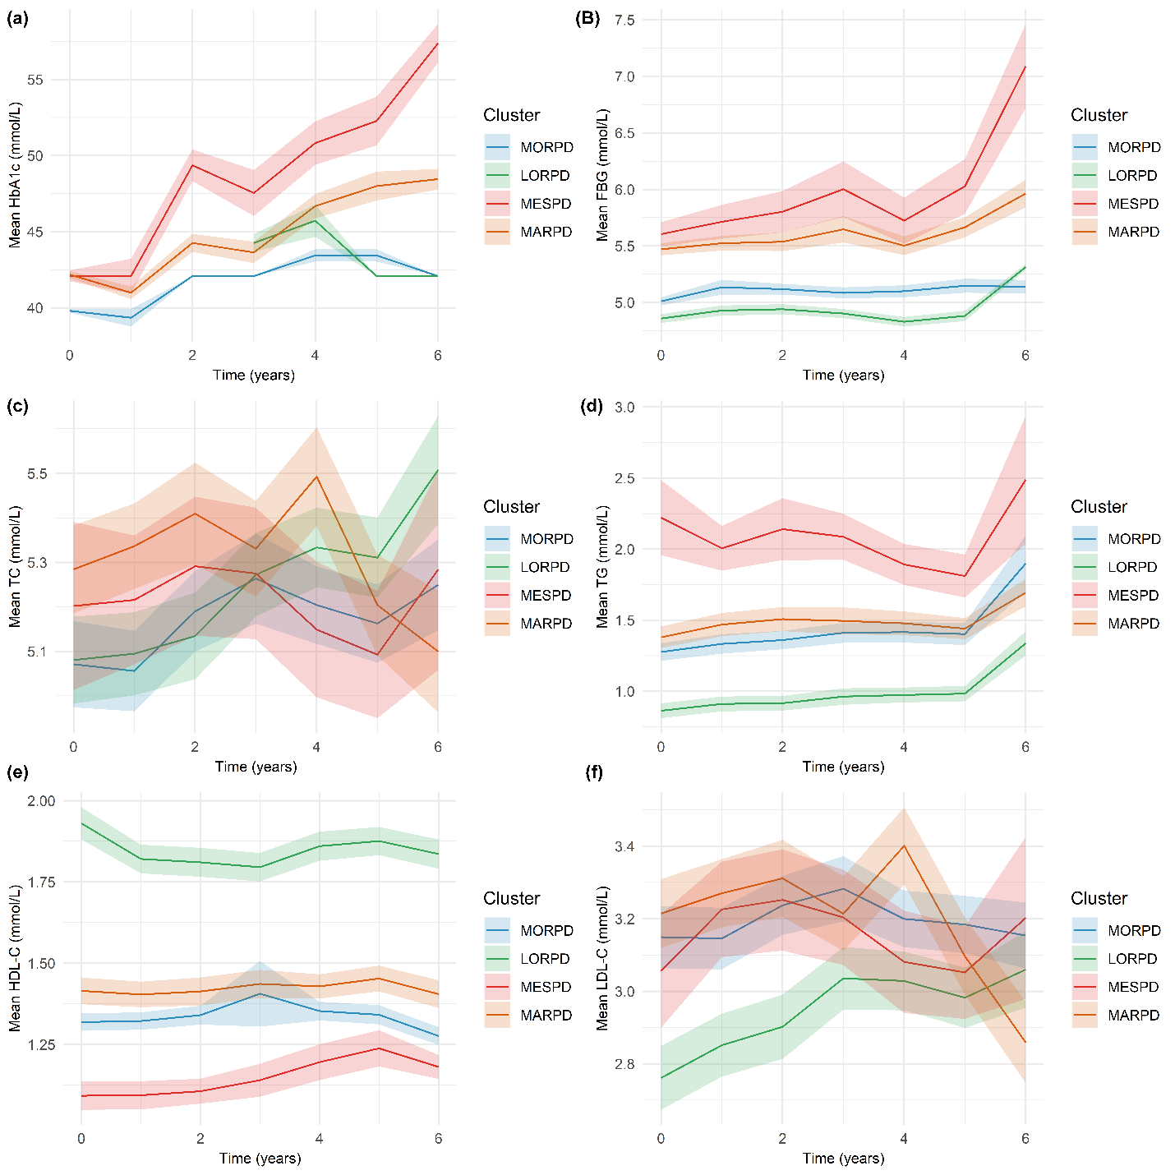

Figure S6. Change in cluster variables over time
Figure S6 shows change in hemoglobin A1c; HbA1c (a), fasting blood glucose; FBG (b), Total Cholesterol; TC (c), triglyceride; TG (d) high density lipoprotein cholesterol; HDL-C (e) and LDL Cholesterol; LDL-C (f) during follow-up by cluster.

Genetic risk score analysis
Table S9 analyzes the relationship between a polygenic risk score (PRS) for type 2 diabetes (T2D) and different stages of diabetes across various patient groups. The mean PRS is generally higher in the pre-diabetes (Pre-DM) and T2D groups compared to the no diabetes group across different patient categories (MORPD, LORPD, MESPD, MARPD). A significant difference in PRS distribution between the Pre-DM and T2D groups is observed in the LORPD category (p = 0.042). The four clusters (MORPD, LORPD, MESPD, MARPD) in the fourth quartile have a higher risk of increased T2D PRS compared to no-diabetes group in the low-risk quartile.

Table S9. Genetic risk score analysis
PGS004106 | No diabetes | MORPD |  |  | LORPD |  |  | MESPD |  |  | MARPD
PGS004106 | No diabetes | Pre-DM | T2D | All | Pre-DM | T2D | All | Pre-DM | T2D | All | Pre-DM | T2D | All
PGS004106 | (n=2199) | (n=261) | (n=17) | (n=278) | (n=214) | (n=6) | (n=220) | (n=70) | (n=38) | (n=108) | (n=117) | (n=37) | (n=214)
Polygenic risk score (PRS)
Mean  (SD) | 1.13 (0.345) | 1.17 (0.346) | 1.17 (0.227) | 1.17 (0.340) | 1.17 (0.341) | 1.42 (0.206) | 1.17 (0.340) | 1.26 (0.299) | 1.19 (0.313) | 1.24 (0.305) | 1.17 (0.351) | 1.23 (0.343) | 1.18 (0.350)
Median  [Min,  Max] | 1.14  [-0.06, 2.26] | 1.19 [0.20, 2.17] | 1.13 [0.79, 1.60] | 1.19 [0.21, 2.17] | 1.15 [0.17, 2.16] | 1.44 [1.13, 1.73] | 1.15 [0.17, 2.16] | 1.32 [0.32, 2.07] | 1.23 [0.31, 1.77] | 1.27 [0.31, 2.07] | 1.13 [0.16, 1.99] | 1.25 [0.59, 2.02] | 1.17 [0.16, 2.02]
P-valueª |  | 0.962 |  |  | 0.042* |  |  | 0.210 |  |  | 0.367
ªThe PRS distribution between pre-DM and DM was signiﬁcantly different in datasets (* Mann Whitney U-Test p-value <0.05; ** Mann Whitney U-Test p-value <0.01; *** Mann Whitney U-Test p-value < 0.0001)

Genome-wide association studies in type 2 diabetes
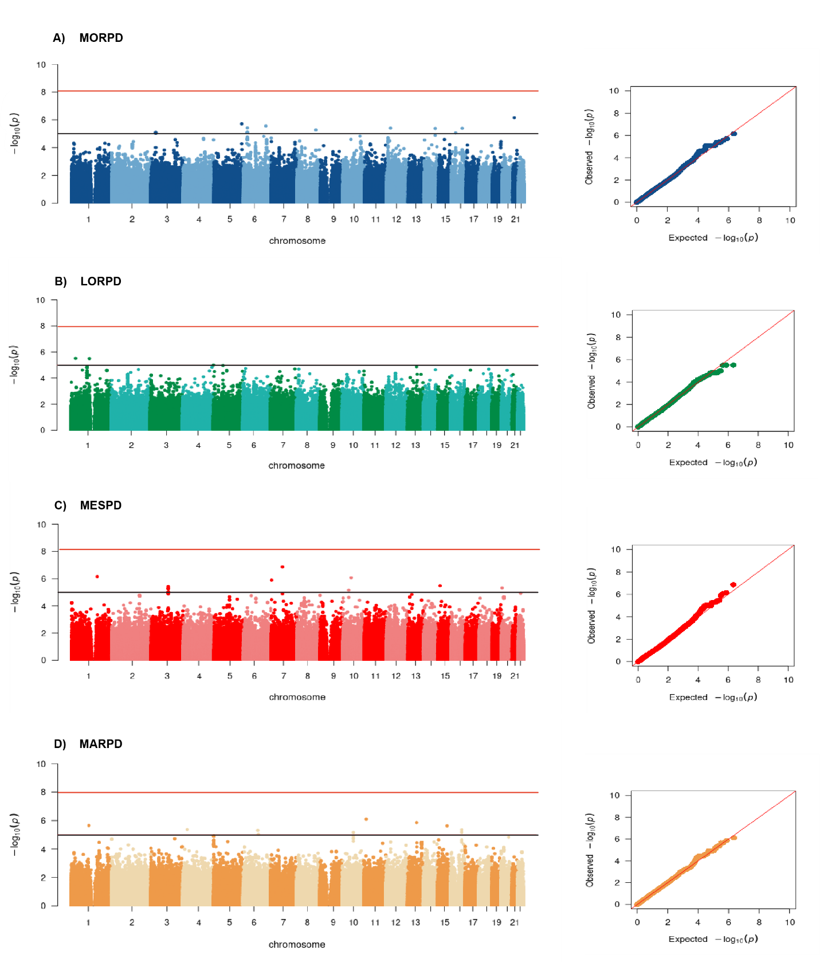
Figure S7. Manhattan and QQ plots of GWAS.
MORPD (panel A), LORPD (panel B), MESPD (panel C), and MARPD (panel D). The red line indicates the genome-wide significance threshold (p < 5 ×10-08) and the black line suggestive association (P< 10-05).
Reference
1. Rousseeuw PJ. Silhouettes: A graphical aid to the interpretation and validation of cluster analysis. Journal of Computational and Applied Mathematics. 1987;20:53-65.
2. Hennig C. Cluster-wise assessment of cluster stability. Computational Statistics & Data Analysis. 2007;52(1):258-71.
3. Klein JP, Van Houwelingen HC, Ibrahim JG, Scheike TH. Handbook of survival analysis: CRC Press Boca Raton, FL:; 2014.
4. Ansin E. An evaluation of the Cox-Snell residuals. 2015.
5. Kleinbaum DG, Klein M, Kleinbaum DG, Klein M. Competing risks survival analysis. Survival Analysis: A self-learning text. 2012:425-95.

