Appendix

Data Source and Search Strategy
We searched the World Health Organization (WHO) International Clinical Trials Registry Platform (ICTRP) to identify registered DHI trials. ICTRP is a globally-oriented platform by accumulating clinical trial data from multiple clinical trial registries worldwide (https://www.who.int/clinical-trials-registry-platform/about). The Data Providers of the ICTRP Search Portal include:
- Australian New Zealand Clinical Trials Registry (ANZCTR)
- Brazilian Clinical Trials Registry (ReBec)
- Chinese Clinical Trial Register (ChiCTR)
- Clinical Research Information Service (CRiS), Republic of Korea
- ClinicalTrials.gov
- Clinical Trials Information System (CTIS), European Medicines Agency
- Clinical Trials Registry - India (CTRI)
- Cuban Public Registry of Clinical Trials (RPCEC)
- EU Clinical Trials Register (EU-CTR), European Medicines Agency
- German Clinical Trials Register (DRKS)
- Iranian Registry of Clinical Trials (IRCT)
- International Standard Randomised Controlled Trial Number (ISRCTN)
- International Traditional Medicine Clinical Trial Registry (ITMCTR)
- Japan Primary Registries Network (JPRN/jRCT)
- Lebanese Clinical Trials Registry (LBCTR)
- Overview of Medical Research in the Netherlands (OMON)
- Pan African Clinical Trial Registry (PACTR)
- Peruvian Clinical Trials Registry (REPEC)
- Sri Lanka Clinical Trials Registry (SLCTR)
- Thai Clinical Trials Register (TCTR)

Registered DHI trials were identified by using the following search strategy via the ICTRP Search Portal:
(digital health) OR (mobile health) OR eHealth OR e-Health OR mHealth OR m-health OR telehealth OR tele-health OR telemedicine OR tele-medicine OR telerehabilitation OR tele-rehabilitation OR (smartphone application) OR (smartphone app) OR (smart phone app) OR (mobile phone application) OR (mobile app) OR (mobile application) OR (virtual consultation) OR (virtual medicine) OR (virtual health) OR wearable OR "Fitness tracker*" OR "Activity tracker*" OR "Apple watch*" OR "internet-of-things" OR “videoconference*” OR (SMS message) OR “text messag*” OR “short messag*”

DHI Classification
In this study, we referred to the NICE Evidence Standards Framework for Digital Health Technologies to define and categorize all trials based on their expected functions and objectives. The DHI was categorized into three main types based on the classification standards used in this study.
Tier A: System service
DHTs intended to release costs or staff time, or to improve efficiency.
Description：Unlikely to have direct health outcomes measurable for individual service users.
Tier B: Communicating about health and care
Communicating with health and care professionals or others, to help service users to manage their health and care.
Description：Allows 2-way communication between service users and professionals, carers, third-party organisations or peers.
Tier B: Health and care diaries
Health and care diaries to help service users to manage their own health and wellness.
Description：Allows service users to record information to create health diaries. Information and data stay with the service user and are not automatically shared with others for review.
Tier B: Promoting good health
Population-level information to help people and service users to maintain healthy lifestyles and manage conditions.
Description：Provides non-personalised information and resources to service users. May encourage behaviours that promote good health and address issues such as smoking, eating and exercise. May also provide information about specific conditions.
Tier C: Inform clinical management
Description：DHTs that record and calculate data and transmit the data to a professional, carer or third-party organisation, to inform clinical management decisions in the future. Also, DHTs that provide personalised information or guidance to end users to promote healthy living. Information provided by the DHT will not trigger an immediate or near-term action by clinical or care staff.
Tier C: Drive clinical management
Description：Information provided by the DHT will be used to aid in treatment, aid in diagnoses, to triage or identify early signs of a disease or condition, or will be used to guide next diagnostics or next treatment interventions.
Tier C: Diagnose a condition
Description：Information provided by the DHT will be used to take an immediate or near-term action to diagnose, screen or detect a disease or condition.
Tier C: Treat a condition
Description：Information provided by the DHT will be used to take an immediate or near-term action to treat, prevent or mitigate by means of providing therapy to a human body.

Supplementary Result Tables
Supplementary table 3-1: Frequency of registered DHI trials by development levels
 | High income | Upper middle income | Lower middle income | Low income
2005 | 9 | 0 | 0 | 0
2006 | 8 | 0 | 0 | 0
2007 | 3 | 0 | 0 | 0
2008 | 15 | 0 | 2 | 0
2009 | 15 | 0 | 0 | 0
2010 | 16 | 1 | 2 | 0
2011 | 33 | 3 | 3 | 0
2012 | 58 | 2 | 8 | 1
2013 | 92 | 5 | 12 | 0
2014 | 128 | 8 | 13 | 0
2015 | 149 | 14 | 28 | 3
2016 | 227 | 18 | 31 | 4
2017 | 263 | 18 | 38 | 1
2018 | 261 | 42 | 43 | 3
2019 | 200 | 42 | 48 | 1
2020 | 266 | 41 | 64 | 2
2021 | 406 | 44 | 103 | 5
2022 | 440 | 76 | 120 | 5

Supplementary table 3-2. Frequency of registered DHI trials by country

Country | Frequency | %
Australia | 901 | 24.45%
United States of America | 480 | 13.03%
United Kingdom | 241 | 6.54%
Unknown | 228 | 6.19%
India | 188 | 5.10%
Germany | 182 | 4.94%
Iran | 172 | 4.67%
Multi country | 154 | 4.18%
China | 129 | 3.50%
Japan | 113 | 3.07%
South Korea | 97 | 2.63%
New Zealand | 94 | 2.55%
Canada | 64 | 1.74%
Brazil | 61 | 1.66%
Iran | 54 | 1.47%
Spain | 51 | 1.38%
Thailand | 51 | 1.38%
Turkey | 28 | 0.76%
Malaysia | 26 | 0.71%
Switzerland | 24 | 0.65%
Sweden | 23 | 0.62%
France | 21 | 0.57%
Norway | 20 | 0.54%
Netherlands | 19 | 0.52%
Kenya | 16 | 0.43%
Nigeria | 16 | 0.43%
Singapore | 16 | 0.43%
Ireland | 15 | 0.41%
Denmark | 13 | 0.35%
Pakistan | 13 | 0.35%
Indonesia | 11 | 0.30%
Italy | 10 | 0.27%
Tanzania | 10 | 0.27%
Finland | 9 | 0.24%
Saudi Arabia | 9 | 0.24%
Israel | 8 | 0.22%
Poland | 8 | 0.22%
Portugal | 7 | 0.19%
Sri Lanka | 7 | 0.19%
Uganda | 7 | 0.19%
Bangladesh | 6 | 0.16%
Belgium | 6 | 0.16%
Ethiopia | 6 | 0.16%
Chile | 5 | 0.14%
Argentina | 3 | 0.08%
Colombia | 3 | 0.08%
Ghana | 3 | 0.08%
Greece | 3 | 0.08%
Jamaica | 3 | 0.08%
Jordan | 3 | 0.08%
Malawi | 3 | 0.08%
Nepal | 3 | 0.08%
Peru | 3 | 0.08%
Philippines | 3 | 0.08%
Vietnam | 3 | 0.08%
Madagascar | 2 | 0.05%
Myanmar | 2 | 0.05%
Syrian Arab Republic | 2 | 0.05%
Armenia | 1 | 0.03%
Bolivia | 1 | 0.03%
Burkina Faso | 1 | 0.03%
Cambodia | 1 | 0.03%
Cameroon | 1 | 0.03%
Cyprus | 1 | 0.03%
Czechia | 1 | 0.03%
Egypt | 1 | 0.03%
Guinea-Bissau | 1 | 0.03%
Kazakhstan | 1 | 0.03%
Kuwait | 1 | 0.03%
Latvia | 1 | 0.03%
Liechtenstein | 1 | 0.03%
Lithuania | 1 | 0.03%
Mexico | 1 | 0.03%
Palestinian Territory | 1 | 0.03%
Puerto Rico | 1 | 0.03%
Qatar | 1 | 0.03%
Romania | 1 | 0.03%
Russian Federation | 1 | 0.03%
Serbia and Montenegro | 1 | 0.03%
Slovenia | 1 | 0.03%
Tajikistan | 1 | 0.03%
Ukraine | 1 | 0.03%
United Arab Emirates | 1 | 0.03%
Zambia | 1 | 0.03%
Zimbabwe | 1 | 0.03%
Total | 3685 | 100.00%

Supplementary table 3-3. DH Technology Utilization by Disease categories
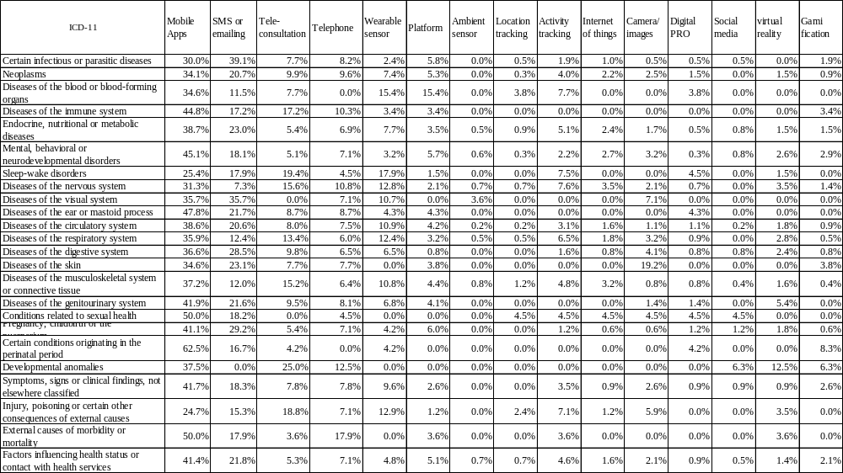

Supplementary figures
Supplementary fig. 4-1 Time trends of registered trials by DHI categories

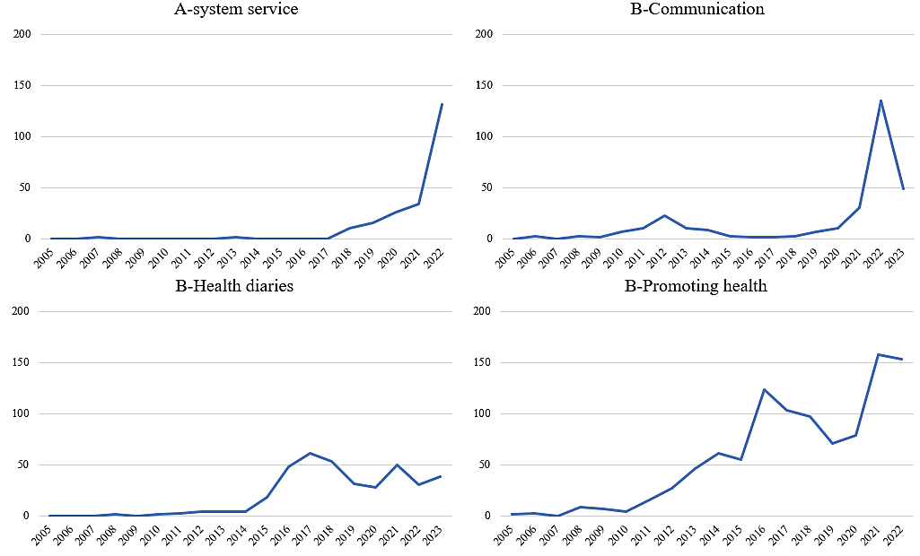
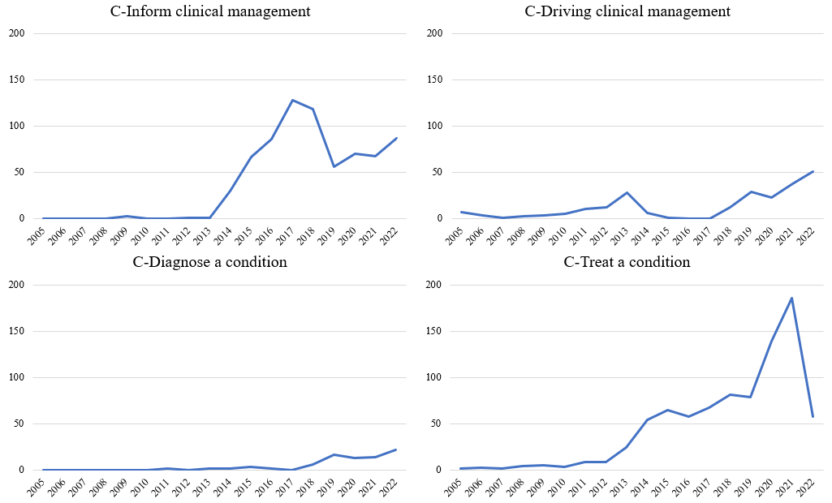

Supplementary fig. 4-2 Time Trends of digital technologies used in registered trials

