Vegetation growth carryover and lagged climatic effect at different scales: from tree rings to the early growth season of xylem
Jiuqi Chen ^{a, b, c}, Yonghui Wang ^{a*}, Tongwen Zhang ^{c*}, Kexiang Liu ^{b, c}, Xiaoxia Gou ^{b, c}, KaiLong Guo ^{a, b, c}, Tianhao Hou ^{a, b, c}, Jinghui Song ^{b, c}, Zhihao He ^{b, c}, Beihua Liang ^{a, b, c}
ª School of Geography and Tourism, Xinjiang Normal University, Urumqi 830054, Xinjiang, China.
^{b} Institute of Desert Meteorology, China Meteorological Administration, Urumqi 830002, China.
^{c} Key Laboratory of Tree-ring Physical and Chemical Research, China Meteorological Administration, Urumqi 830002, China.
Corresponding author
Yonghui Wang, School of Geography and Tourism, Xinjiang Normal University, Urumqi 830054, Xinjiang, China;
Tongwen Zhang, Key Laboratory of Tree-ring Physical and Chemical Research, China Meteorological Administration, Urumqi 830002, China;
Email address:
Yonghui Wang, wyhsd_3011@xjnu.edu.cn
Tongwen Zhang, zhangtw@idm.cn

Contents
Fig. S1. Augmented Dickey-Fuller, ADF.

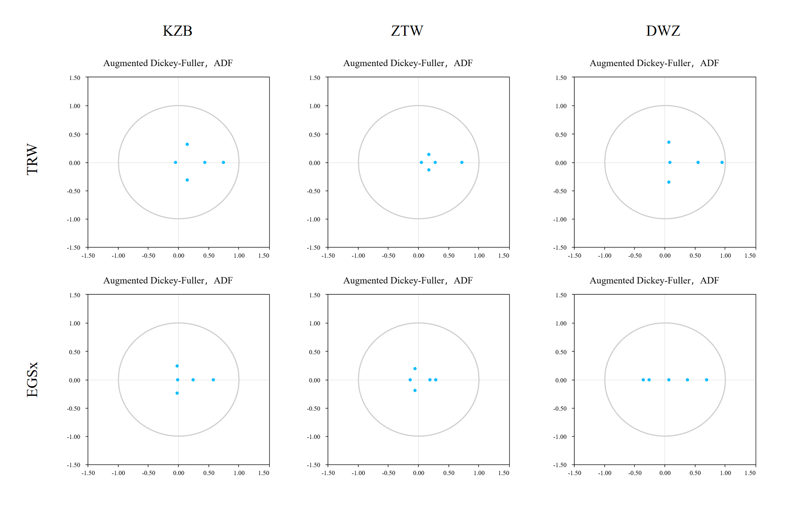
Fig. S1. Augmented Dickey-Fuller plot of TRE and EGSx data series. If all eigenvalues are in the unit circle, that is, all points are in the circle, then the model is stable. If the feature roots appear outside the unit circle, it means that the model may not have long-term sustained stability.

Fig. S2. The order of the lag term is determined.
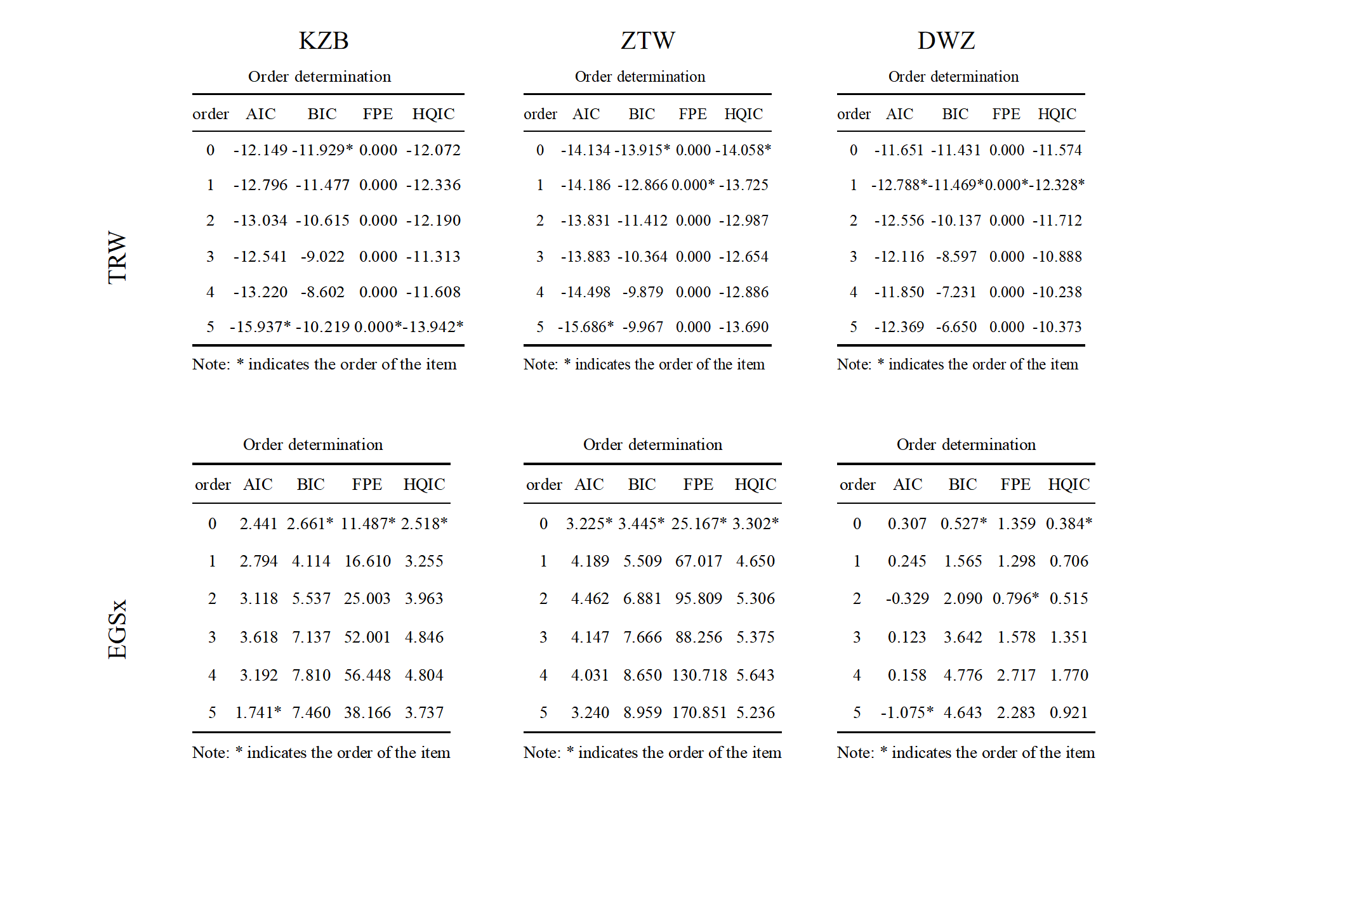
Fig. S2. The order of the lag term is determined. There are four information criteria：Akaike Information Criterion, AIC. Bayesian Information Criterion, BIC. Final Prediction Error, FPE. Hannan-Quinn Information Criterion, HQIC. The order principle is the information criterion (such as AIC) the smaller the better; In general, the smaller the lag order, the better; The order corresponding to the minimum value of the four index values is taken as the order of the fixed order. The minimum values of the four criteria appear to be less than 1, so the VAR model is finally constructed with order 1.
Table S1. Growth parameters simulated by VS model
Table S1 Growth parameters simulated by VS model
Argument | Description | Sampling size
Argument |  | KZB | ZTW | DWZ
T₁ | Min temperature/℃ | 5 | 3 | 8
T₂ | Temperature/℃ | 12 | 7 | 9.5
T₃ | Temperature/℃ | 20 | 17.5 | 10.5
T₄ | Maximum temperature/℃ | 32 | 27.5 | 27
P_{MAX} | Maximum daily precipitation of saturated soil /mm | 30 | 22 | 28
D_{root} | Root depth/mm | 550 | 450 | 550
C₁ | The coefficient of infiltration of precipitation into the soil | 0.53 | 0.51 | 0.05
C₂ | First coefficient for calculation of transpiration | 0.06 | 0.07 | 0.1625
C₃ | Second coefficient for calculation of transpiration | 0.19 | 0.19 | 0.04
W₀ | Initial soil moisture | 0.065 | 0.05 | 0.05
W₁ | Minimum soil moisture content for growth | 0.065 | 0.145 | 0.0975
W₂ | Lower limit of optimum growth soil moisture content | 1 | 0.5 | 0.3
W₃ | Upper limit of moisture content of soil suitable for growth | 0.325 | 0.3 | 0.1
W₄ | Maximum humidity for plant growth | 0.55 | 0.45 | 0.35
C_{d} | Coefficient of soil drainage | 0.03 | 0.03 | 0.01
T_{beg} | Temperature sum Tbeg/℃ | 90 | 91 | 102

