Supplementary material

Online questionnaire (attached file)

Table S1: Oncologists’ characteristics

 | Physicians  N=69 | Other  N=19 | Total
Age, years, median (IQR) | 50.5 (40.75-59.25) | 54 (40.5-61.75) | 51 (40.25-60)
Female sex | 25 (36%) | 12 (63%) | 37 (42%)
Patient association | 11 (16%) | 3 (16%) | 14 (16%)
Hospital place of work | 63 (94%) | 13 (72%) | 76 (89%)
Research affiliation | 19 (27%) | 10 (53%) | 29 (33%)
Health authority expert | 4 (6%) | 1 (5%) | 5 (6%)
Cooperative group member | 16 (23%) | 2 (10%) | 18 (20%)
Ethics committee member | 0 | 2 (10%) | 2 (2%)
Clinical trial participation | 66 (96%) | 9 (47%) | 75 (85%)
Investigator of clinical trial | 61 (92%) |  | 61 (92%)
Conflicts of interest | 43 (62%) | 2 (10%) | 45 (59%)

Table S2: First occurrences of related words to innovation, with 10 examples in each group

Physicians | Other | Total
New, 29 occurrences  Progress, 27 occurrences  Survival, 11 occurrences  Improvement, 11 occurrences  Revolution, 8 occurrences  Research, 5 occurrences  Quality of life, 4 occurrences  Class, 4 occurrences  Evolution, 3 occurrences  Target, 3 occurrences | New, 6 occurrences  Advance, 5 occurrences  Progress, 5 occurrences  Break, 4 occurrences  Beneficial, 3 occurrences  Cure, 2 occurrences  Quality of life, 2 occurrences | New, 35 occurrences  Progress, 32 occurrences  Improvement, 12 occurrences  Survival, 11 occurrences  Revolution, 8 occurrences  Research, 6 occurrences  QoL, 6 occurrences  Advance, 6 occurrences  Break, 6 occurrences  Evolution, 4 occurrences
CAR-T cells, 55 occurrences  Bispecific antibodies, 24 occurrences  IBTK°, 16 occurrences  Antibodies, 12 occurrences  Vaccine RNA, 11 occurrences  Inhibitors, 11 occurrences  Immunotherapy, 11 occurrences  Target, 6 occurrences  Gene therapy, 5 occurrences  Venetoclax****, 5 occurrences | CAR-T cells, 6 occurrences  Hepatitis, 4 occurrences  Sofosbuvir*, 4 occurrences  Onasemnogene abeparvovec**, 3 occurrences  Immunotherapy, 2 occurrences  Vaccine RNA, 2 occurrences  rVSV-EBOV***, 2 occurrences  MTI, 2 occurrences  Target, 2 occurrences  HCV, 1 occurrence | CAR-T cells, 61 occurrences  Bi-specific, 25 occurrrences  IBTK°, 18 occurrences  Vaccine RNA, 13 occurrences  Antibodies, 12 occurrences  Immunotherapy, 10 occurrences  Target, 8 occurrences  Venetoclax****, 5 occurrences  Gene therapy, 5 occurrences  Daratumumab$, 4 occurrences
HCV, hepatitis C virus
° Bruton tyrosine kinase inhibitors; * anti HCV; **gene therapy; *** vaccine against Ebola; ****BCL-2 inhibitor; $ monoclonal antibody.

Figure S1: Likert plot of the respondent’s perception of innovation development

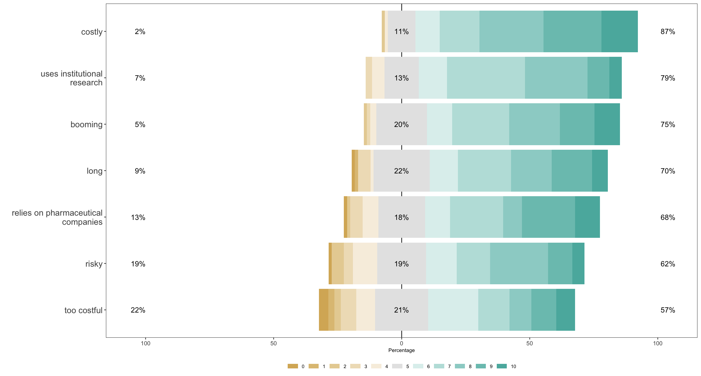

Figure S2: Schematic representation of the Principal Component Analysis, with three clusters of individuals based on specific features of response. Their differences are plotted below.
