Supplementary Information 1: The process of hierarchical k-means
The process of H-K-means clustering mainly involves three steps:
- Hierarchical clustering is firstly performed to create a dendrogram that represents the nested groups of the data points. A Euclidean distance matrix is computed from the datapoints following the formula:
$$ⅆ\left(x,y\right)=\sqrt{\sum_{i=1}^{n}{{\left(x_{i}-y_{i}\right)}^{2}}}$$
where $x$ and $y$ are datapoints, and $n$ is the number of dimensions.

- The dendrogram is then cut at a specified level to form a pre-defined number of clusters (k), serving as initial clusters for k-means.
- The initial cluster centroids are served as the starting points for k-means clustering, which refines the clusters by minimising the within-cluster sum of squares (WSS) following the below formular:
$$WSS=\sum_{i=1}^{k}{\sum_{x∈C_{i}}{{\left\|x-μ_{i}\right\|}^{2}}}$$
where $k$ is the number of clusters, $C_{i}$ is the $i$th cluster, $x$ is a data point, and $μ_{i}$ is the centroid of cluster $C_{i}$.

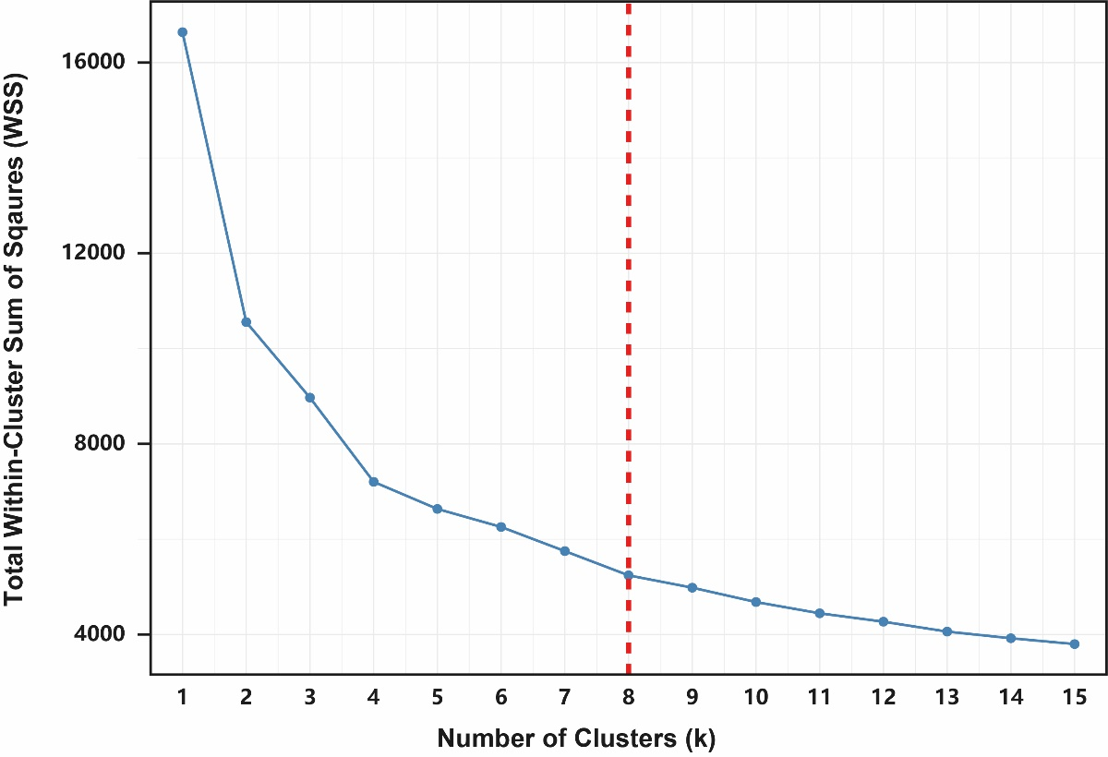
Supplementary Fig 1 The WSS for the possible k values ranging from 1 to 15. k = 8 was detected that balance meaningful differentiation between clusters with practical interpretability. This resulted in eight distinct vibrancy modes per pandemic period, representing unique temporal travel patterns across NYC taxi zones.
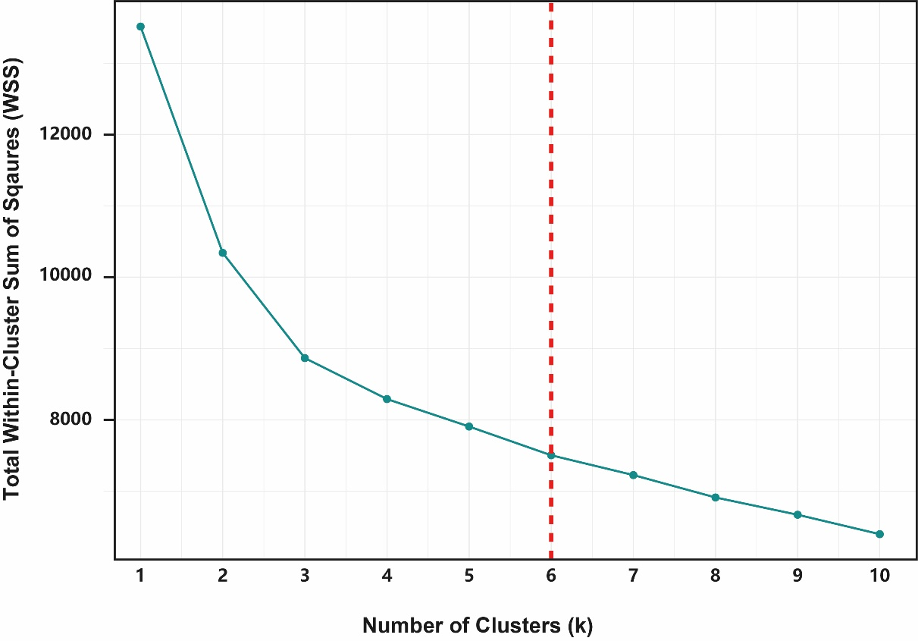
Supplementary Fig 2 The WSS for the possible k values ranging from 1 to 10. k = 6 was detected as an optimal value for the number of clusters for geodemographic classification.
Supplementary Information 2: Geodemographic Classification Pen Portraits
Cluster A: Suburban Aging Families
This cluster, encompassing the largest number of taxi zones in NYC, is predominantly situated in Staten Island, eastern Queens, and central-southern Brooklyn. It is characterised by ageing population, with large proportions of residents aged 64 and above. Households are typically family-oriented, consisting of more than three or four members, with many being native English speakers. Households rely heavily on private vehicles, commonly owning three or more cars and spend very long time on daily commuting. Household median income is around the NYC average, with most live in detached or attached houses built between 1940 and 1999, holding their home ownership. The land use is predominantly residential, complemented by open spaces, and the buildings are characterised by very low floor area ratios and a sparse density of landmarks, reflecting their spacious and suburban nature.
Cluster B: Hard-Pressed Living
Cluster B is concentrated in taxi zones within northern Manhattan, western and central Bronx, and central Brooklyn. These areas predominantly are home to Black and Hispanic/Latino populations, many of whom have limited English proficiency. A significant proportion of residents are young, aged 5 to 24, and face socio-economic challenges such as high unemployment rates and low median income. Educational attainment is generally low, with many residents having no formal qualifications or only completing high school. Most households rent apartments and lack access to private vehicles, contributing to long commute times despite proximity to public transport infrastructure. The built environment features older buildings constructed before 1940, with land use dominated by public facilities and institutional spaces, reflecting the struggles of these economically and socially marginalised communities.
Cluster C: Asian Struggling Workers
Cluster C is concentrated in taxi zones across southwestern Brooklyn, central Queens, and the southernmost Bronx, predominantly home to Asian communities. Households in these areas are typically large, with four or more members, and many cannot speak English well. Educational attainment is generally low, with most individuals having no formal qualifications or only completing high school. Employment is primarily in elementary labour-intensive occupations, such as construction, maintenance, and transportation. Despite owning one or two vehicles, households endure very long commutes, reflecting challenges associated with their suburban location and employment demands. The built environment features attached residential buildings, dominated by residential land use with very low floor area ratios and sparse landmark density, illustrating a dense but modestly developed community setting.
Cluster D: Metropolitan Elite Enclaves
Cluster D encompasses taxi zones exclusively located in the urban cores and southernmost parts of Manhattan, representing the epitome of modern, high-density urban living. These areas are home to a diverse population dominated by working-age residents (25-44), primarily White, Asian, and other non-Hispanic ethnic groups. The majority of households consist of single individuals, reflecting a lifestyle geared towards professional ambitions and convenience. Residents enjoy high educational attainment and are employed in well-paid professions, including management, business, science, and the arts. With the highest averaged median income, residents typically rent apartments in high-rise skyscrapers constructed between 1980 and 2019. The urban landscape is characterised by commercial office spaces, mixed-use developments, and floor area ratios over four times the NYC average. Landmark density exceeds the city average by sixfold, underscoring the vibrant and dynamic environment of these urban hubs, where accessibility eliminates the need for personal vehicles and commutes are remarkably short.
Cluster E: Modern Mixed-Use Dwellers
Cluster E comprises taxi zones situated on the periphery of Manhattan's urban cores and in northwestern Brooklyn, reflecting a lifestyle of convenience and modernity. Predominantly White, this cluster's residents are middle-aged (25-44) and primarily live in one- or two-person households. With high educational attainment-master’s degrees or higher—and employment in management, business, science, and arts occupations, residents often enjoy high median incomes. Living in newly constructed apartments built after 2000, these households rely on excellent urban accessibility, as most do not own vehicles but experience moderate commute times. The urban landscape features mixed-use developments, alongside relatively high floor area ratio and landmark densities. These areas exemplify compact, multifunctional urban living in locations that are central yet distinct from the densest cores of Manhattan.
Cluster F: Revitalised Industrial Edges
Cluster F encompasses taxi zones scattered across the outer edges of NYC, including the northern and southern Bronx, western Brooklyn, and most prominently, western Queens near Manhattan. This cluster is a hallmark of urban regeneration, transforming former industrial brownfields into revitalised and functional urban spaces. The population's age distribution (20-44) aligns closely with the NYC average, and educational attainment primarily includes both high qualification and no qualification. The cluster’s defining characteristic is its modern built environment, with buildings constructed after 2020, underscoring significant redevelopment efforts. Land use is predominantly industrial, interspersed with transport infrastructure and open spaces, and is marked by considerably lower floor area ratios and landmark densities compared to citywide norms.

