Supporting Information
Additional supporting information may be found online in the Supporting Information section at the end of the article
Figure S1 Detection of tomato plants inoculated with ToCV (Note: M: DNA marker; 1-10: Tomato samples; P: Positive control; N: Negative control)
Figure S2 Preference of B. tabaci after validamycin treatment (a: The plant at the center was infected tomato treated with water, and those at the four corners were healthy tomato plants; b: The plant at the center was infected tomato plant treated with validamycin, and those at the four corners were healthy tomato plants.)
Table S1 The time spent by B. tabaci in various feeding activities when it fed on tomato plants for 8h. Values are the mean (±SE) of 20 biological replicates. Different lowercase letters indicate significant differences between genotypes determined by using a nonparametric Mann-Whitney U test at P<0.05

Fig S1
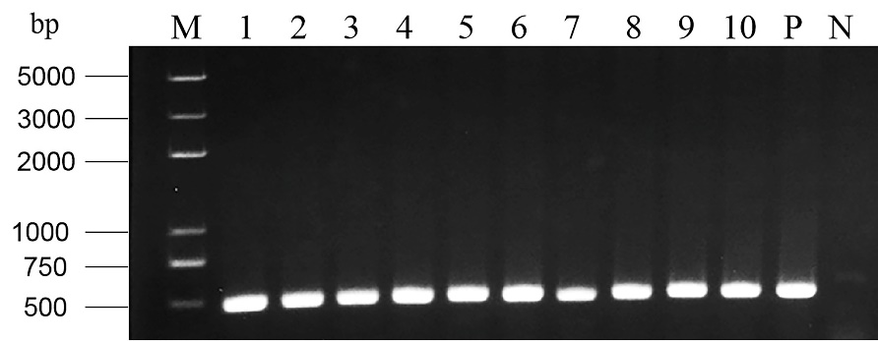
Fig S2
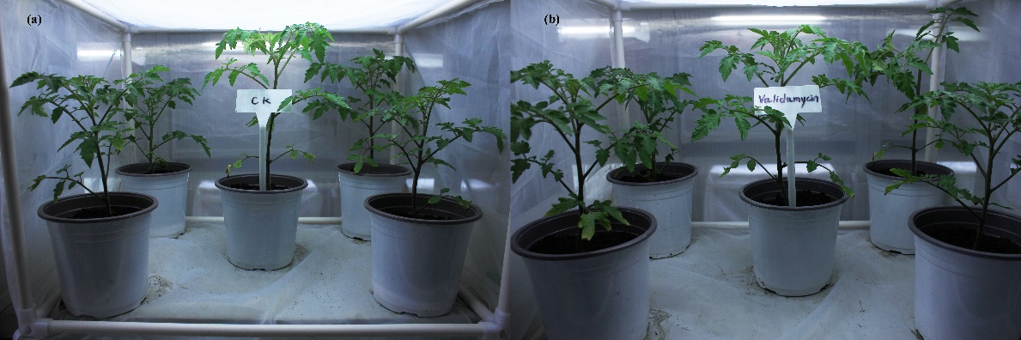
Table S1
Recording time of B.tabaci feeding behavior | Non-viruliferous(CK) | Non-viruliferous(Inhibitor) | P | Viruliferous(CK) | Viruliferous(Inhibitor) | P
Recording time of B.tabaci feeding behavior | (Mean±SE) | (Mean±SE) | P | (Mean±SE) | (Mean±SE) | P
Total duration of NP | 141.855±60.838a | 293.143±53.485b | 0.000 | 115.681±73.440a | 319.649±38.990b | 0.000
Total duration of C | 233.312±62.201a | 173.784±46.542b | 0.000 | 249.943±114.083a | 159.451±38.467b | 0.007
Duration of first probe | 6.193±2.521a | 17.091±2.457b | 0.024 | 22.746±10.159a | 38.355±9.1393b | 0.023
Time from first probe to first E(pd) | 172.207±110.076a | 413.893±127.627b | 0.000 | 132.920±34.675a | 421.139±91.228b | 0.000
Total duration of E(pd)1 | 3.016±1.367a | 1.314±1.120a | 0.134 | 2.290±1.382a | 0.175±0.0451b | 0.001
Total duration of E(pd)2 | 101.790±58.812b | 11.770±2.371b | 0.000 | 111.723±93.704a | 5.20±0.311b | 0.000

