Supplemental Table 1. Recording effort summary. Recording start and end dates, as well as position and depth, for each instrument package in each tracking array. Deployment naming convention is region (SOCAL), site, deployment number, instrument position in array (E for east, W for west, S for south). 4-channel systems are denoted by an additional “C4” at the end of the deployment name.
Deployment Name | Recording Start (UTC) | Recording End (UTC) | Lat (°N) | Lon (°W) | Depth (m)
SOCAL_W_01_WE_C4 | 30 Jul 2021 | 15 Jan 2022 | 33°32.249’ | 120°14.951’ | 1252
SOCAL_W_01_WS_C4 | 30 Jul 2021 | 17 Jan 2022 | 33°31.941’ | 120°15.254’ | 1250
SOCAL_W_01_WW | 29 Jul 2021 | 22 Jan 2022 | 33°32.384’ | 120°15.489’ | 1378
SOCAL_W_02_WE_C4 | 09 Mar 2022 | 27 May 2022 | 33°32.221’ | 120°14.856’ | 1237
SOCAL_W_02_WS_C4 | 10 Mar 2022 | 28 May 2022 | 33°31.883’ | 120°15.097’ | 1237
SOCAL_W_02_WW | 10 Mar 2022 | 27 Mar 2022 | 33°32.445’ | 120°15.550’ | 1375
SOCAL_W_03_WE_C4 | 27 May 2022 | 14 Oct 2022 | 33°32.249’ | 120°14.855’ | 1242
SOCAL_W_03_WS_C4 | 27 May 2022 | 14 Oct 2022 | 33°31.926’ | 120°15.125’ | 1245
SOCAL_W_03_WW | 27 May 2022 | 14 Oct 2022 | 33°32.470’ | 120°15.553’ | 1384
SOCAL_W_04_WE_C4 | 18 Oct 2022 | 15 Apr 2023 | 33°32.281’ | 120°15.008’ | 1272
SOCAL_W_04_WS_C4 | 19 Oct 2022 | 15 Apr 2023 | 33°31.966’ | 120°15.311’ | 1259
SOCAL_W_04_WW | 17 Oct 2022 | 15 Apr 2023 | 33°32.447’ | 120°15.598’ | 1388
SOCAL_W_05_WE_C4 | 16 Apr 2023 | 24 Sept 2023 | 33°32.368’ | 120°15.068’ | 1301
SOCAL_W_05_WS_C4 | 16 Apr 2023 | 24 Sept 2023 | 33°32.073’ | 120°15.282’ | 1284
SOCAL_W_05_WW | 16 Apr 2023 | 25 Sept 2023 | 33°32.451’ | 120°15.554’ | 1385
SOCAL_H_72_HE | 06 Jun 2021 | 19 Dec 2021 | 32°51.670’ | 119°8.110’ | 1283
SOCAL_H_72_HS_C4 | 01 Jul 2021 | 18 Dec 2021 | 32°51.391’ | 119°8.328’ | 1249
SOCAL_H_72_HW_C4 | 01 Jul 2021 | 23 Oct 2021 | 32°51.727’ | 119°8.556’ | 1263
SOCAL_H_73_HE | 21 Dec 2021 | 23 May 2022 | 32°51.655’ | 119°8.116’ | 1271
SOCAL_H_73_HS_C4 | 20 Dec 2021 | 22 May 2022 | 32°51.376’ | 119°8.337’ | 1246
SOCAL_H_73_HW_C4 | 20 Dec 2021 | 22 May 2022 | 32°51.696’ | 119°8.609’ | 1257
SOCAL_H_74_HE | 23 May 2022 | 15 Oct 2022 | 32°51.654’ | 119°8.118’ | 1272
SOCAL_H_74_HS_C4 | 10 Jun 2022 | 15 Oct 2022 | 32°51.354’ | 119°8.363’ | 1244
SOCAL_H_74_HW_C4 | 10 Jun 2022 | 15 Oct 2022 | 32°51.673’ | 119°8.597’ | 1254
SOCAL_H_75_HE | 16 Oct 2022 | 18 Apr 2023 | 32°51.730’ | 119°8.112’ | 1285
SOCAL_H_75_HS_C4 | 16 Oct 2022 | 17 Apr 2023 | 32°51.359’ | 119°8.354’ | 1248
SOCAL_H_75_HW_C4 | 17 Oct 2022 | 17 Apr 2023 | 32°51.678’ | 119°8.605’ | 1256
SOCAL_E_63_EE_C4 | 15 Mar 2018 | 05 Jul 2018 | 32°39.523’ | 119°28.627’ | 1326
SOCAL_E_63_ES | 15 Mar 2018 | 11 Jul 2018 | 32°39.207’ | 119°29.073’ | 1329
SOCAL_E_63_EW_C4 | 15 Mar 2018 | 05 Jul 2018 | 32°39.388’ | 119°29.289’ | 1330
SOCAL_N_68_NE | 29 Apr 2020 | 15 Oct 2020 | 32°22.185’ | 118°33.875’ | 1298
SOCAL_N_68_NS_C4 | 27 May 2020 | 15 Oct 2020 | 32°21.895’ | 118°34.105’ | 1338
SOCAL_N_68_NW_C4 | 27 May 2020 | 15 Oct 2020 | 32°22.185’ | 118°34.335’ | 1343

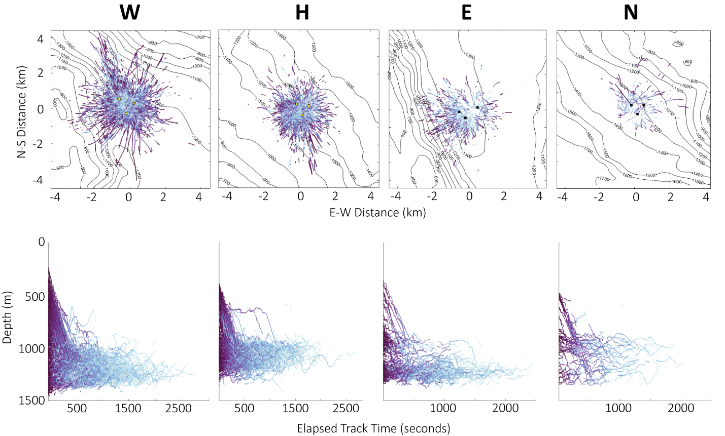
Supplemental Figure 1. Spatial view of all tracked whales per site. Columns represent site, and rows represent the XY view (top) and the Z view (bottom). Tracks are colored by normalized track time, with the start of the track in purple and the end of the track in blue. Contour lines every 100 meters indicate bathymetry, square markers represent 4-channel arrays and circle markers represent single-channel hydrophones. Black markers are used at sites with only one deployment, yellow markers are used at sites with multiple deployments. Yellow markers denote the array position of the first deployment; see also Supplemental Figure 3.
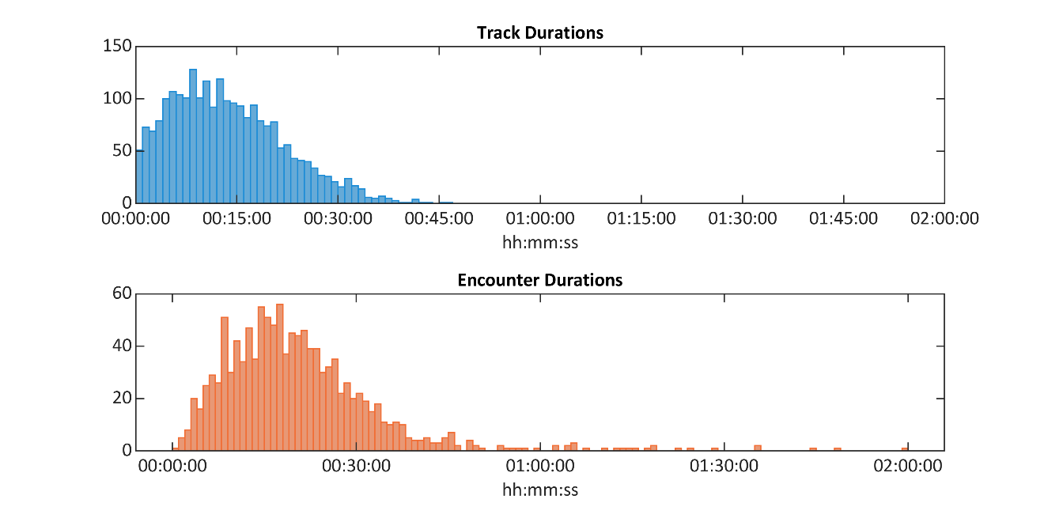Supplemental Figure 2. Track and encounter duration histograms. Track durations represent the time that an individual goose-beaked whale was tracked, and encounter durations represent the time that an encounter of whales was tracked. Detections were considered as part of the same encounter if there were no gaps in detections exceeding 30 minutes.
Supplemental Table 2. Dunn post-hoc test p-values from pairwise comparisons for median distance above the seafloor per site.
Pairwise Comparison (site) | p-value
W – H | < 0.001
W – E | < 0.001
W – N | 0.518
H – E | < 0.001
H – N | < 0.001
E – N | < 0.001

Supplemental Table 3. Dunn post-hoc test p-values from pairwise comparisons for median swim speeds at depth per site.
Pairwise Comparison (site) | p-value
W – H | < 0.001
W – E | < 0.001
W – N | 0.175
H – E | 0.219
H – N | 0.561
E – N | 0.143

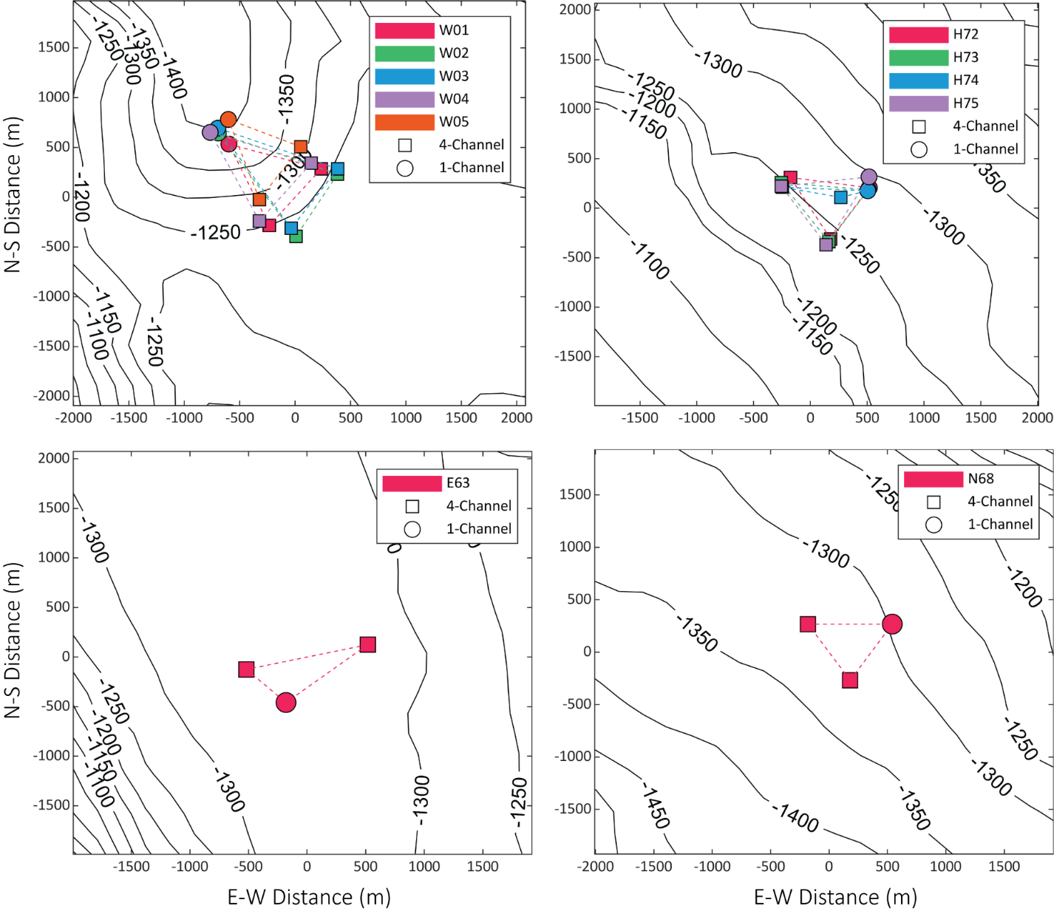
Supplemental Figure 3. Instrument positions for all deployments at all sites.

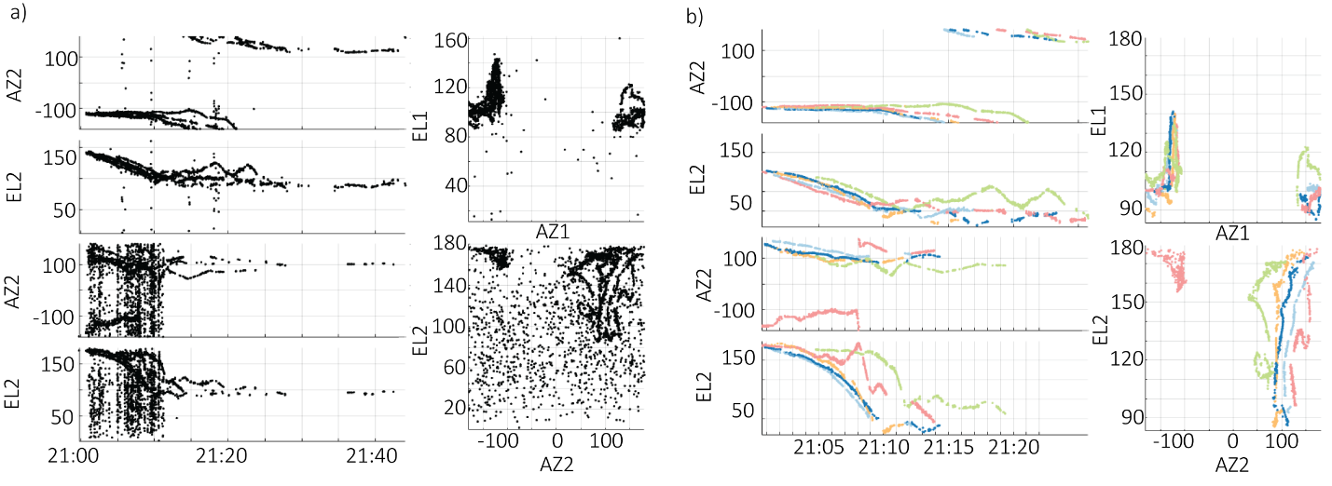
Supplemental Figure 4. Before (a) and after (b) track cleaning on the brushDOA interface in the Where’s Whaledo software package (Snyder et al., 2024). Dots represent detections, black dots are unlabeled and colored dots have been assigned a whale number. This encounter was recorded at site W on September 5th, 2023.

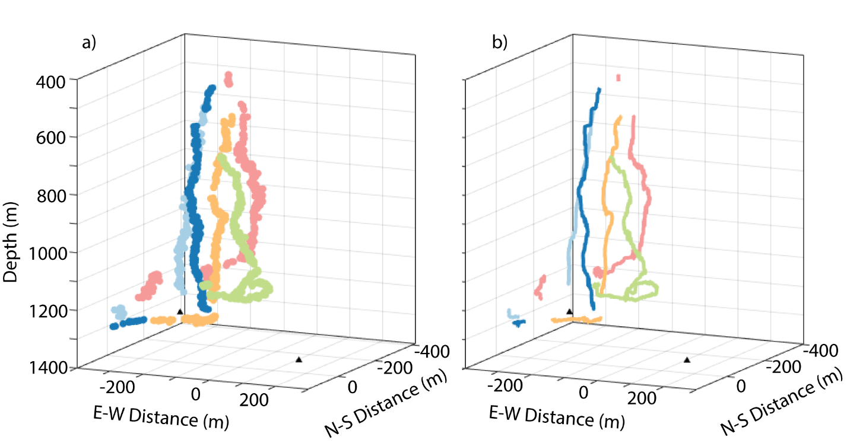
Supplemental Figure 5. Track smoothing results for 3D whale tracks. Points represent localized echolocation clicks, colors denote individuals (a). Lines represent smoothed whale locations from the Kalman filter approach, colors denote individuals (b). This encounter was recorded at site W on September 5th, 2023; see Supplemental Figure 4 for the azimuth-elevation view of this encounter.

Supplemental GIFs. Tracking results for a few encounters per site. Individual whales are denoted by separate colors. Solid lines indicate tracked positions, dashed lines indicate data gaps. Black or white squares denote the position of the 4-hydrophone arrays. Gray gradient surface represents bathymetry.

