Supplementary Information

Investigating the Effect of Screen-Printed Structured Graphite Electrodes with Low Tortuosity for High-Capacity and Fast-Charging Lithium-Ion Batteries
H. R. K. M. Emani et al.

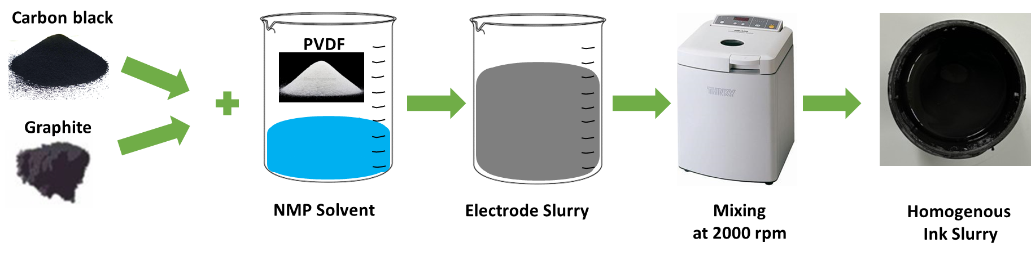
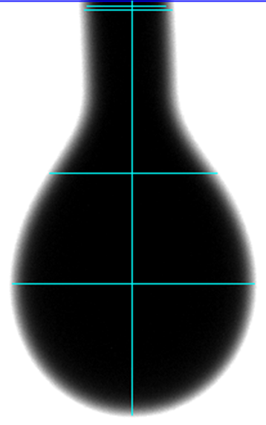
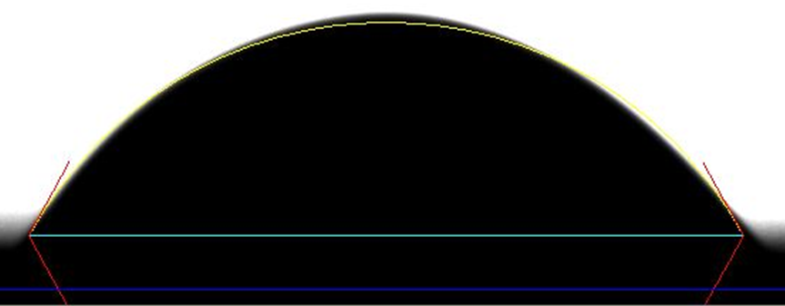
(a)
(b)
Fig. S1: (a) Schematic of ink preparation, (b) surface tension and (c) contact angle measurements of the ink.
(c)
Dispensing Tip
Graphite Ink
Graphite Ink
Copper Substrate

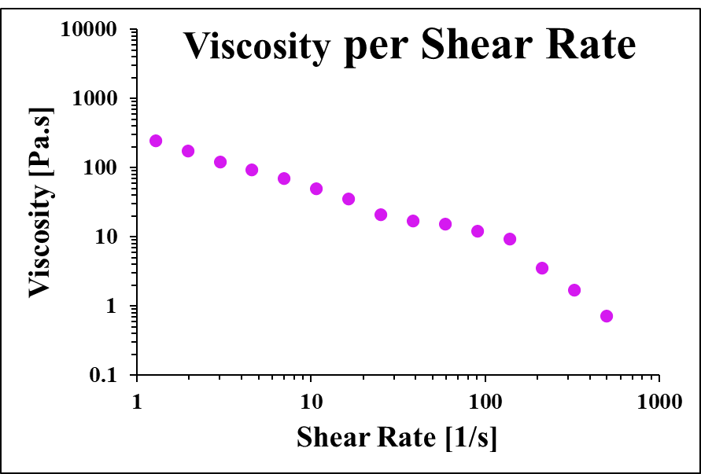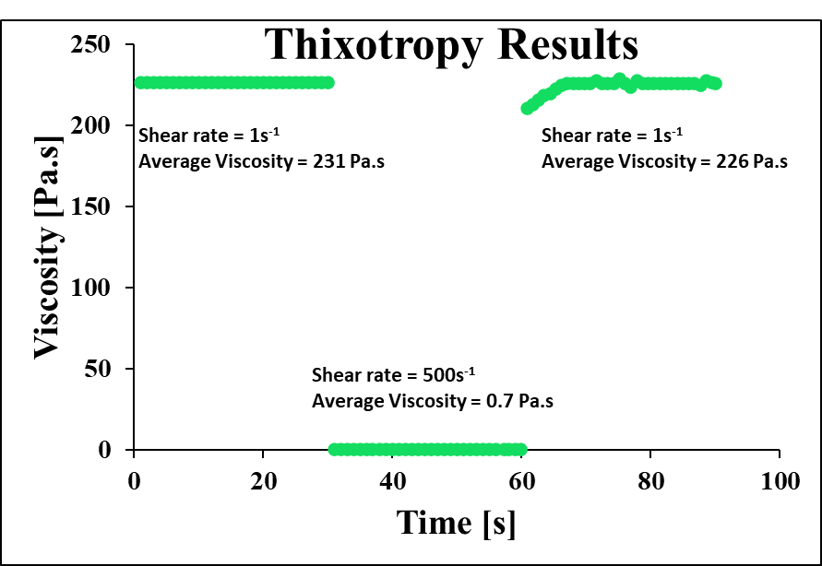
Fig. S2: Developed graphite anode ink showing (a) shear-thinning behaviour when subjected to varying shear rates, and (b) thixotropic results at room temperature.
(a)
(b)

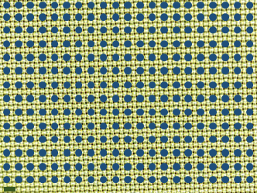
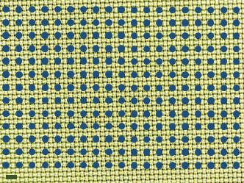
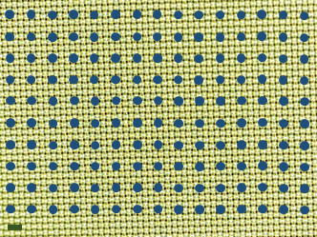
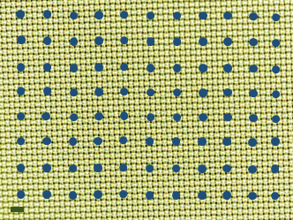
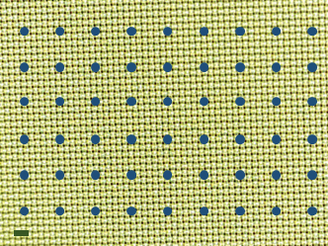
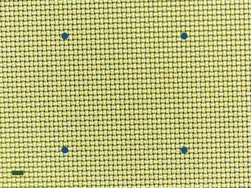
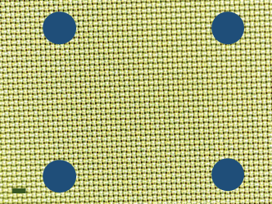
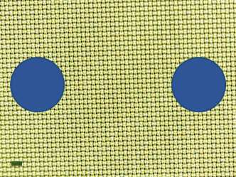
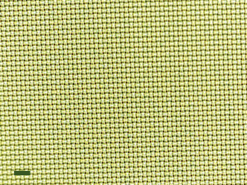
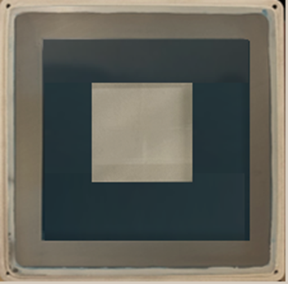
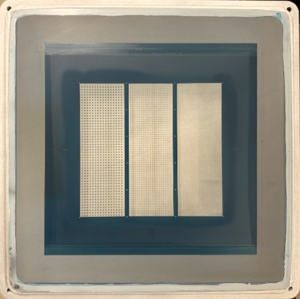
MS-22 emulsion which does not allow ink transfer onto the substrate.
SPNs are created in the region where emulsion is present on the screen
(a)
(b)
(c)
(d)
(e)
(f)
(g)
(h)
(i)
Fig. S3: Fabricated screens (a) without SPNs, (b) with SPNs; screen designs for (c) Electrode-A, (d) Electrode-B, (e) Electrode-C, (f) Electrode-D, (g) Electrode-E, (h) Electrode-F, (i) Electrode-G, (j) Electrode-H, and (k) Electrode-I.
Note: Scale bar is 200 µm for all the microscopic images, (Ø) represents the pore diameter of the SPNs
1000 µm (Ø)
2000 µm
500 µm (Ø)
2000 µm
100 µm (Ø)
2000 µm
100 µm (Ø)
400 µm
100 µm (Ø)
300 µm
100 µm (Ø)
200 µm
100 µm (Ø)
150 µm
100 µm (Ø)
100 µm
Screen mesh opening that permits ink transfer onto the substrate
(j)
(k)
Screen
Print region (Mesh)

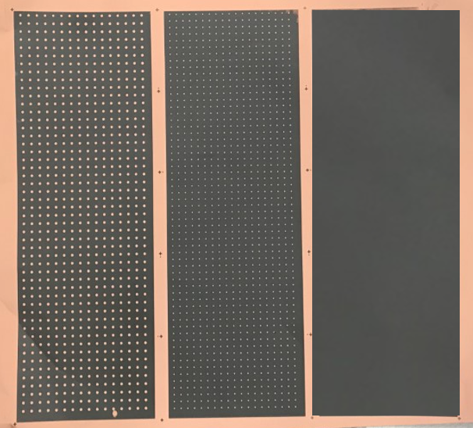

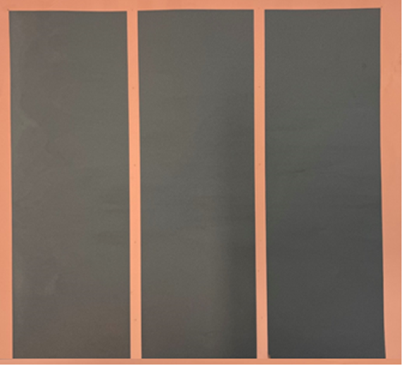
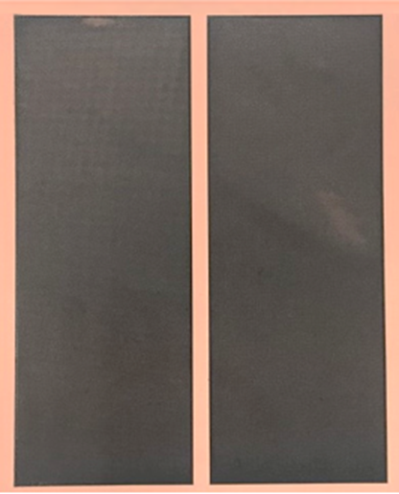
(a)
(b)
(c)
(d)
Fig. S4: Fabricated screen-printed graphite anode electrodes of (a) solid block, (b) 1000 µm SPN, 500 µm SPN, 100 µm SPN with 2 mm ETE distance, and 100 µm SPN with ETE distance between the pores of (c) 400 µm, 300 µm, 200 µm, and (d) 150 µm and 100 µm.
Note: The printed sample size for Fig. (a, b, c) is 6 x 6 inches and the sample size for Fig.(d) is 6 x 4 inches

Electrode-A
(Reference Electrode)
Electrode-B
Electrode-C
Electrode-D
Electrode-E
Electrode-F
Electrode-G
Electrode-H
Electrode-I
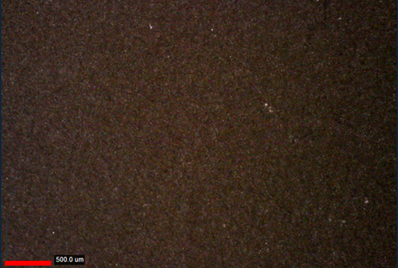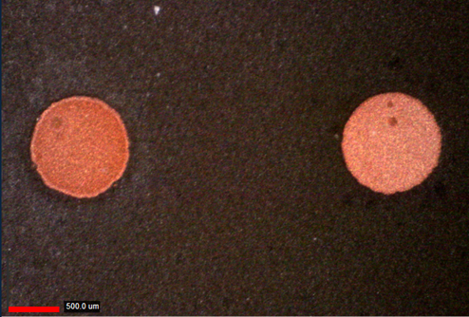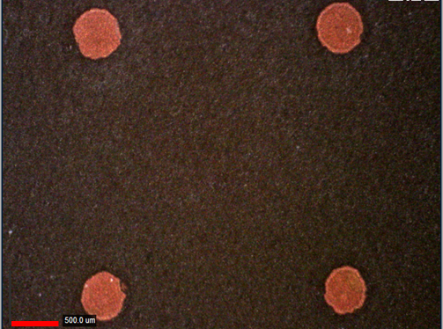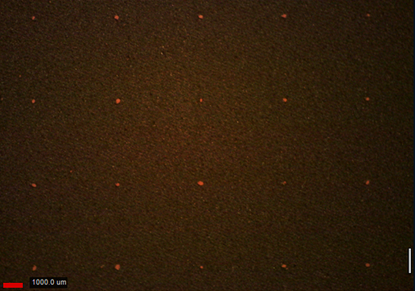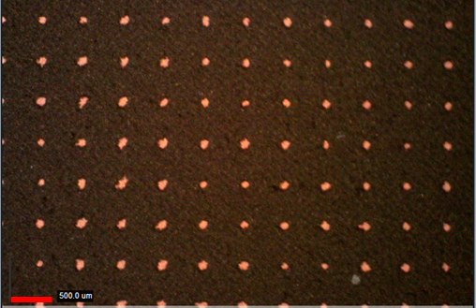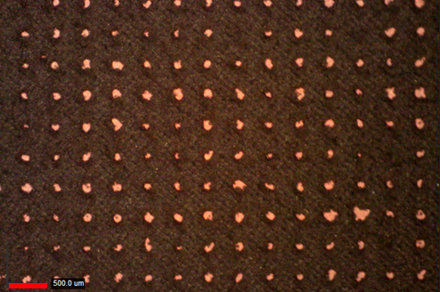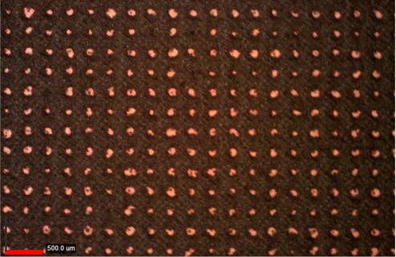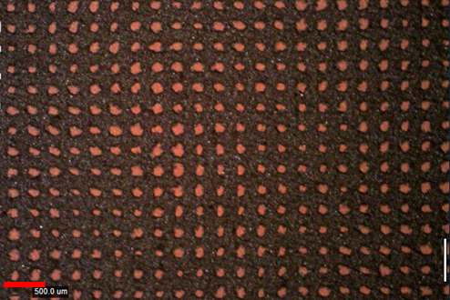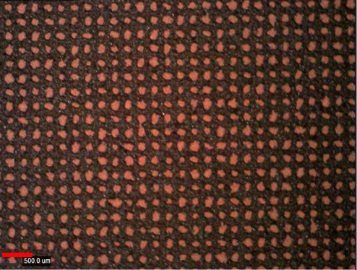
(a)
(b)
(c)
(d)
(e)
(f)
(g)
(h)
(i)
Fig. S5: Optical microscopic pictures of (a) Electrode-A, (b) Electrode-B, (c) Electrode-C, (d) Electrode-D, (e) Electrode-E, (f) Electrode-F, (g) Electrode-G, (h) Electrode-H, and (i) Electrode-I.
Note: Scale bar is 500 µm for all the microscopic images.

Porosity (ε):
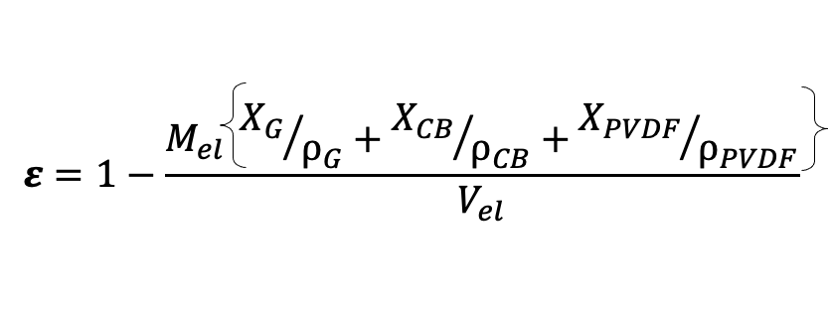
Eq. S1 [1]
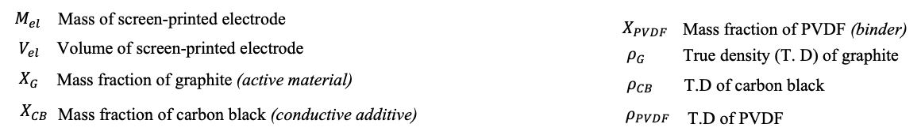
Mass fraction: 92:2:6

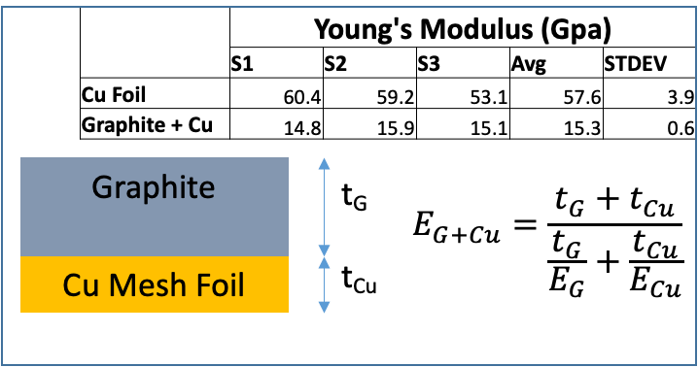
t_{G} = Thickness of graphite
t_{Cu} = Thickness of copper substrate
E_{G} = Young’s modulus of graphite
E_{Cu} = Young’s modulus of copper substrate
Table S1: Young’s modulus for the graphite film and copper film measured using Instron 4301 tensile tester
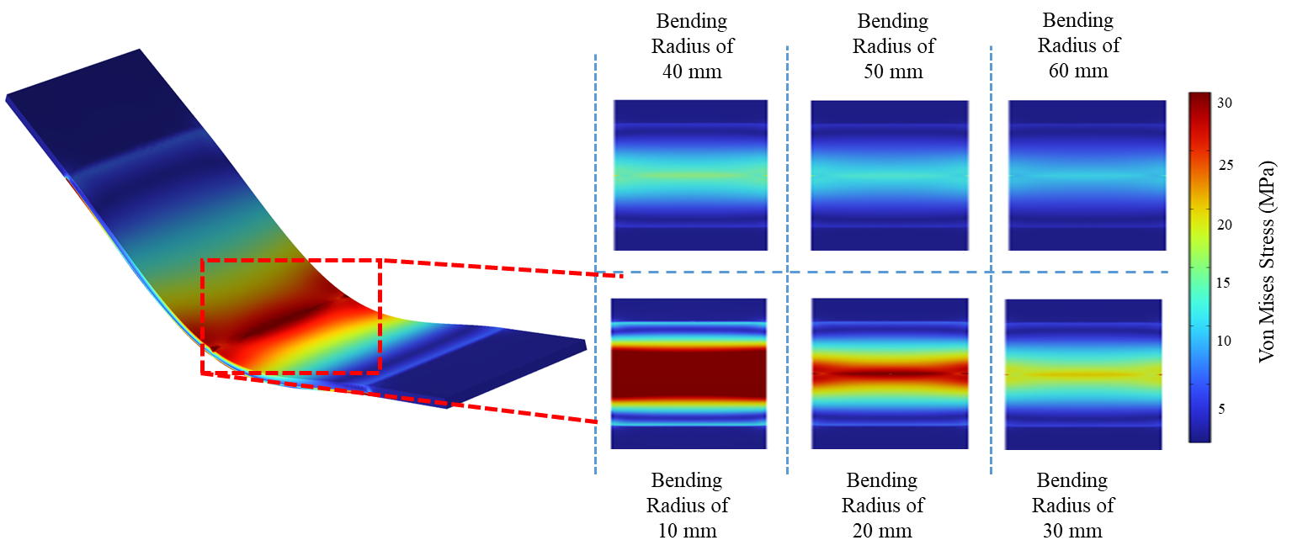
Fig. S6: COMSOL simulations of electrode-A to investigate the effect of bending radius on average stress distribution.

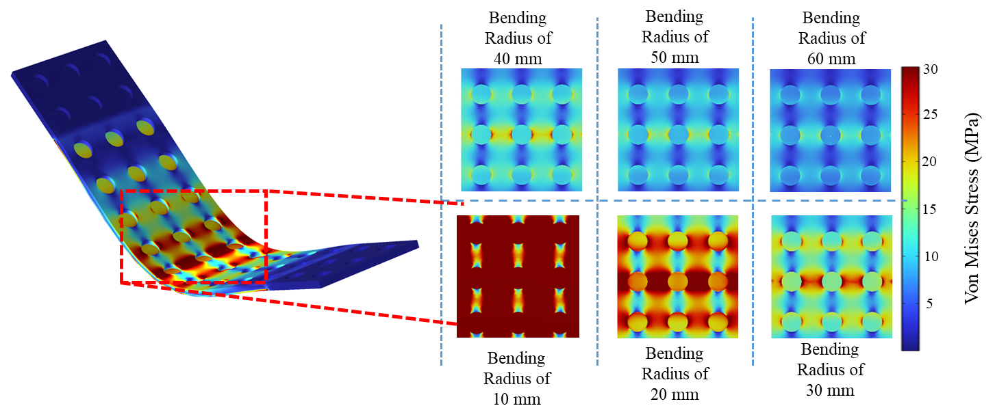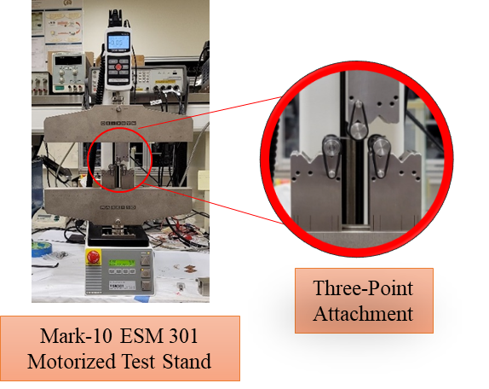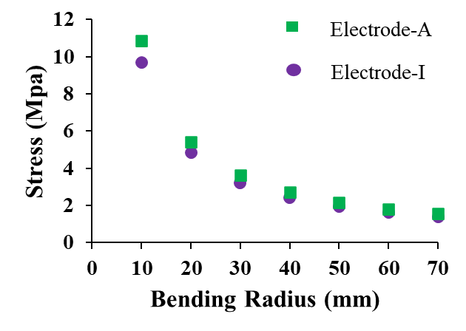
(a)
(b)
Fig. S7: (a) COMSOL simulations of electrode-I to investigate the effect of bending radius on average stress distribution, (b) Summarized plot of average Von Mises stress (MPa) at different bending radius from 10 mm to 60 mm, and (c) Experimental setup for performing mechanical testing on the fabricated electrodes A and I using three-point attachment at bending radius of 10 mm for 100 cycles.
(c)

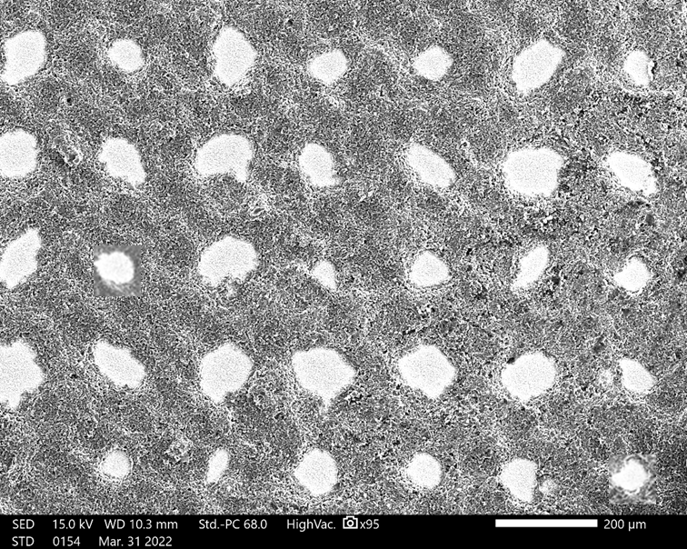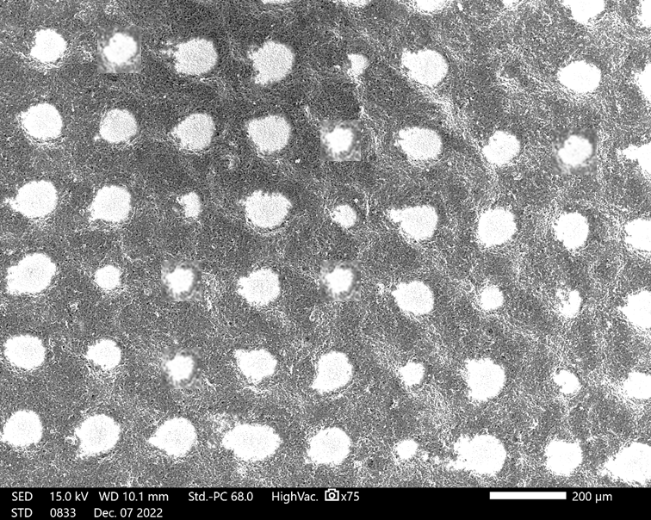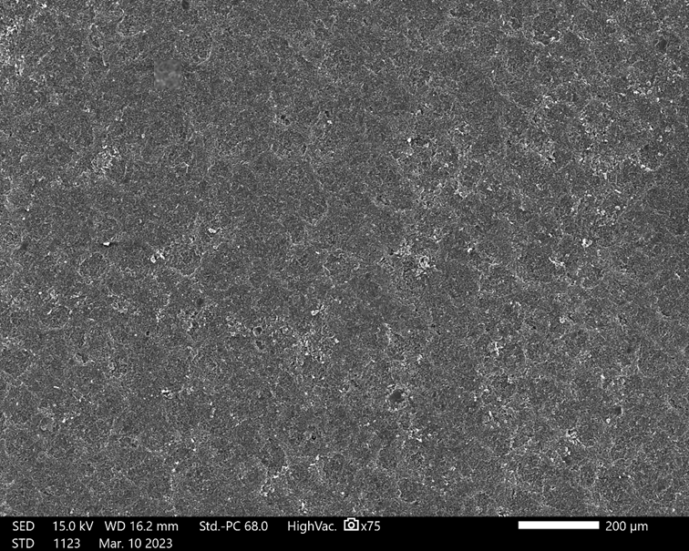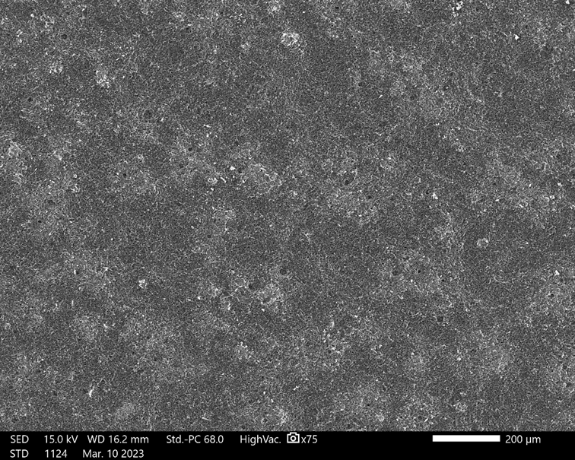
(a)
(b)
Fig. S8: SEM images of electrodes A and I (a, c) before, and (b, d) after performing mechanical testing. No cracks were observed on the surface of the printed electrodes.
(Note: Scale is 200 µm for all the SEM images).
(c)
(d)
Before
Before
After
After
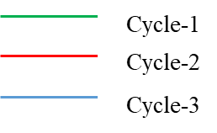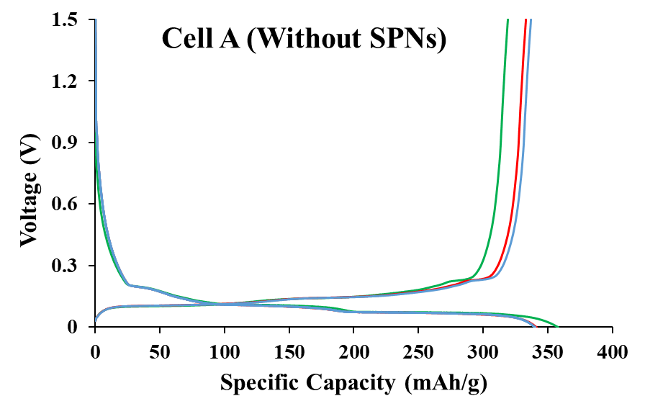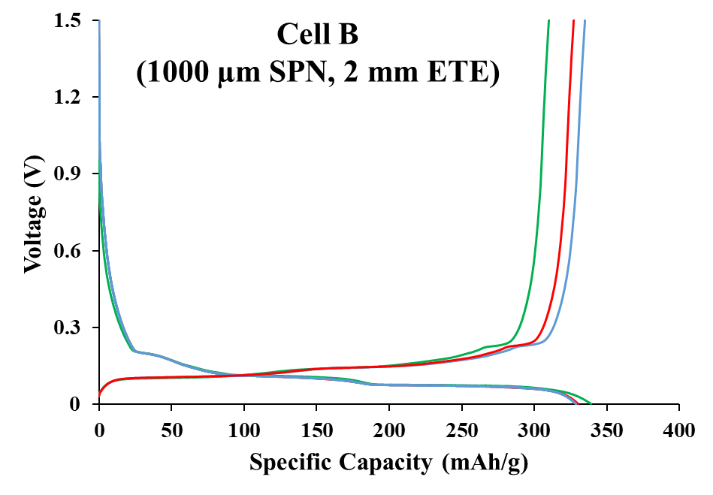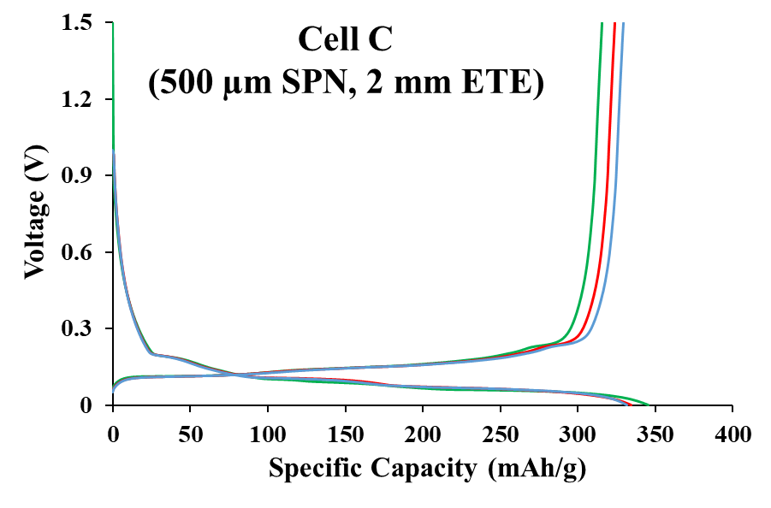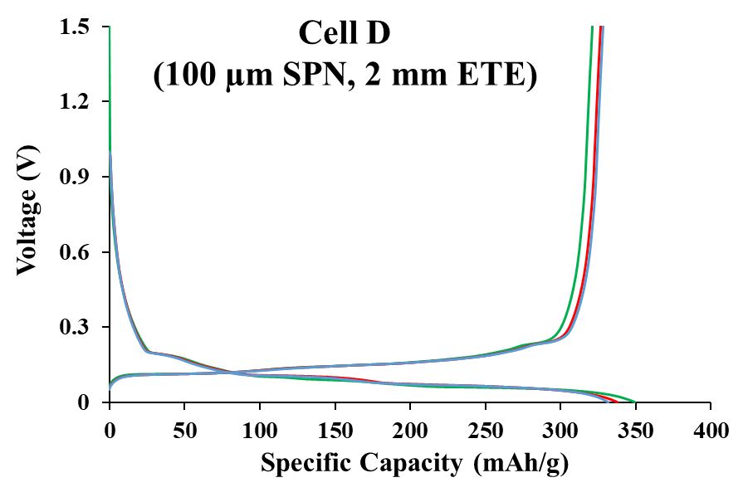
(a)
(b)
(c)
(d)
Fig. S9: Voltage profile of the formation test at 0.1C for (a) Cell A, (b) Cell B, (c) Cell C, and (d) Cell D.

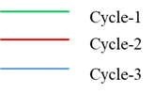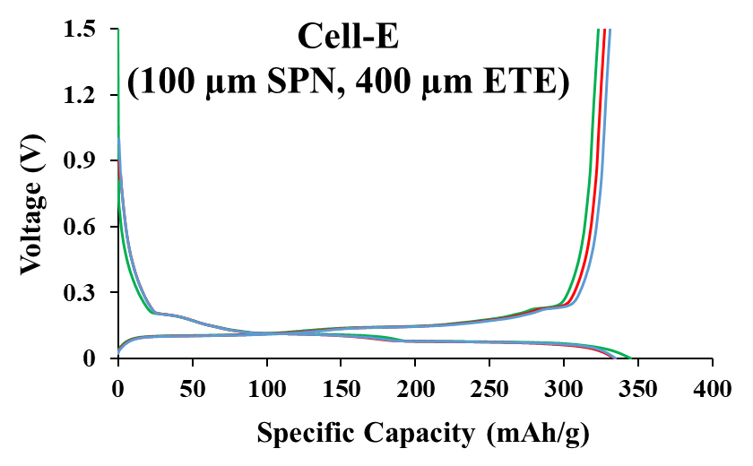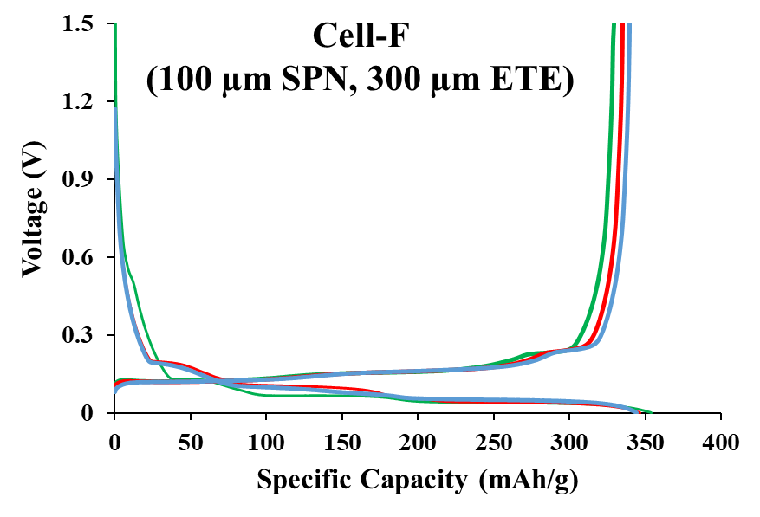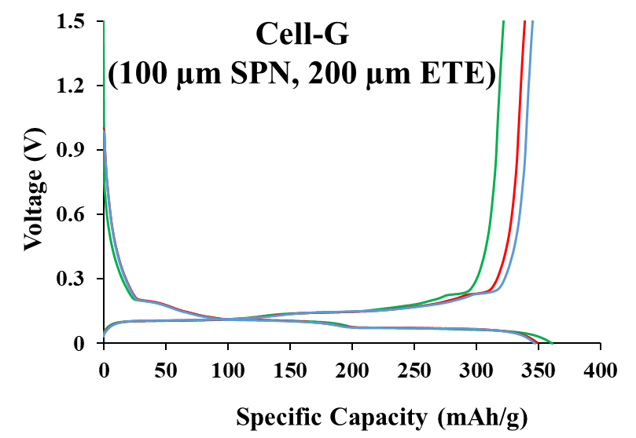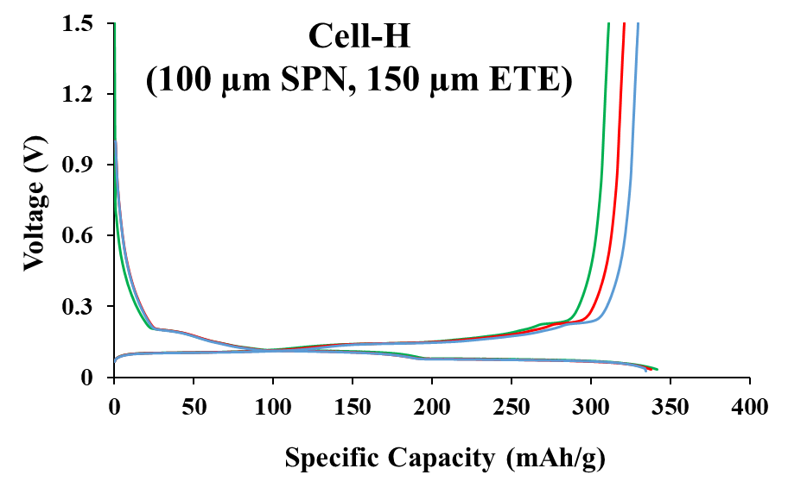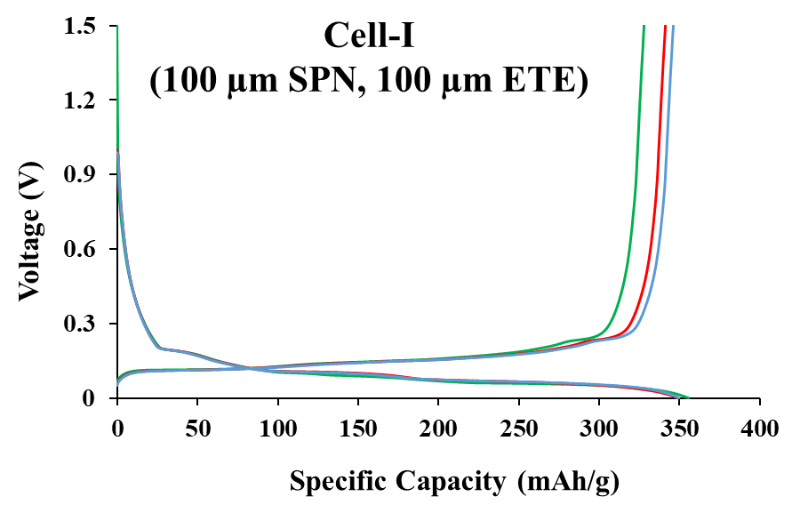
(a)
(b)
(c)
(d)
(e)
Fig. S10: Voltage profile of the formation test at 0.1C for (a) Cell-E, (b) Cell-F, (c) Cell-G, and (d) Cell-H, and (e) Cell-I.
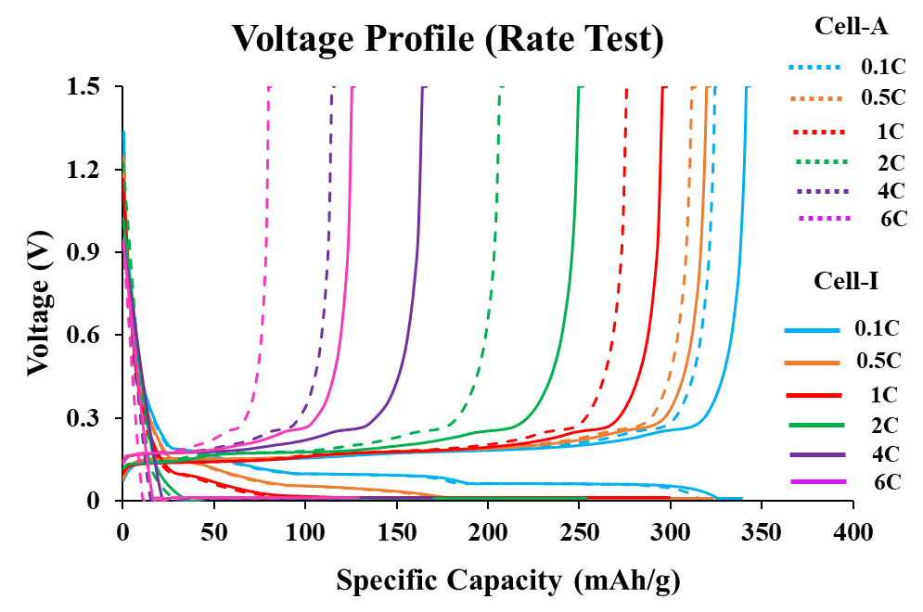
Fig. S11: Voltage profile of cells A (without SPNs) and I (with SPNs) at different C-rates.
Note: The solid curve represents voltage profile of cell-I (100 µm SPN 100 µm ETE) and dotted curve represents the same for cell-A (without SPNs)

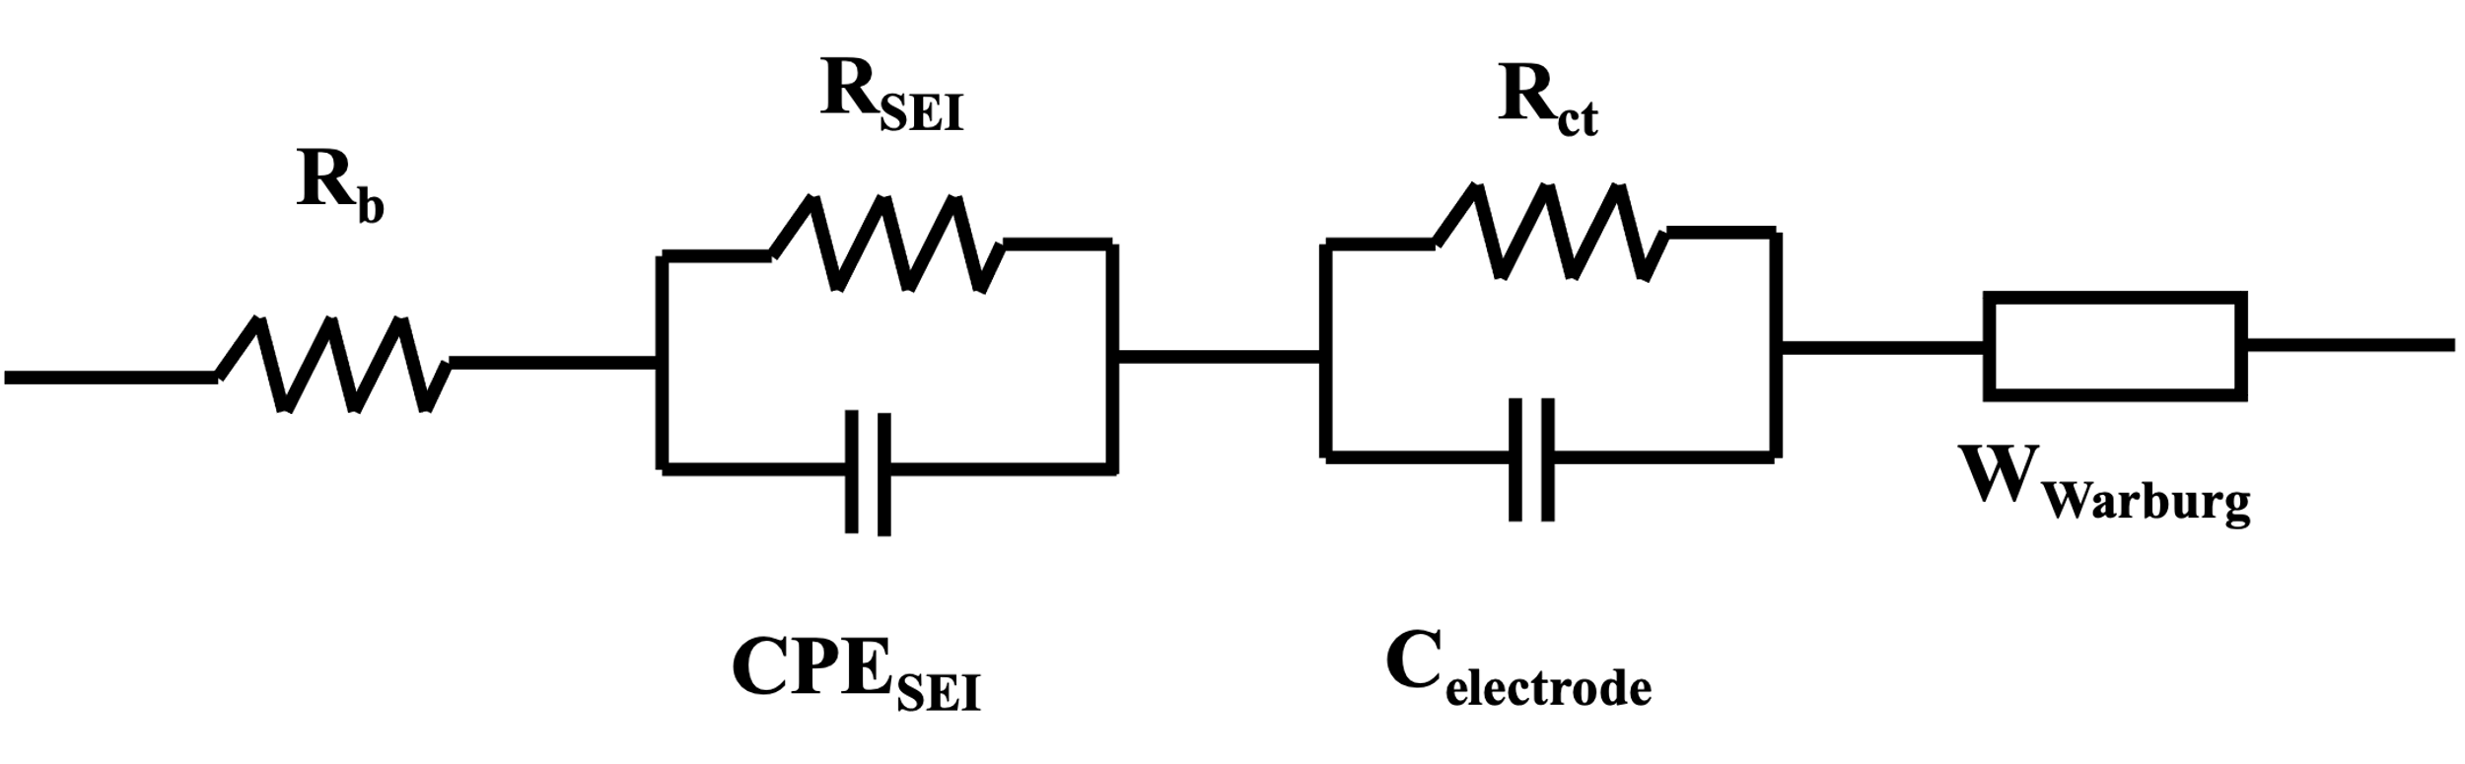
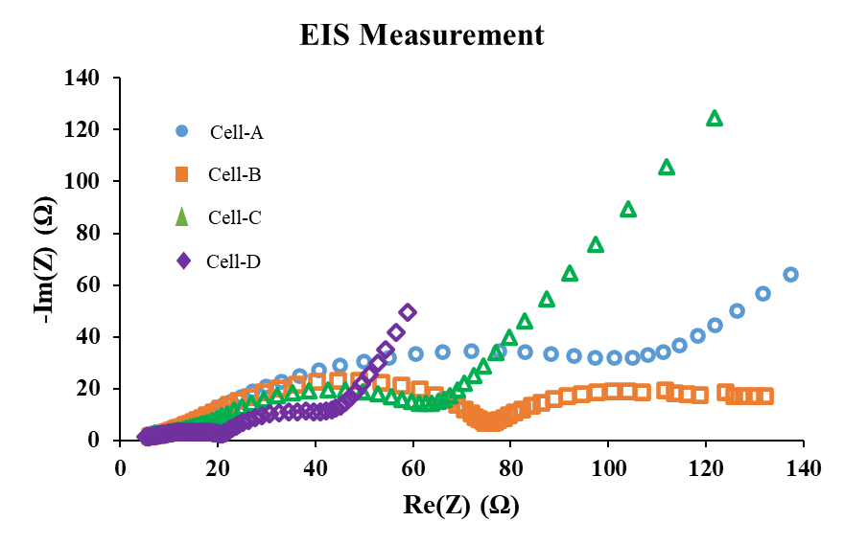
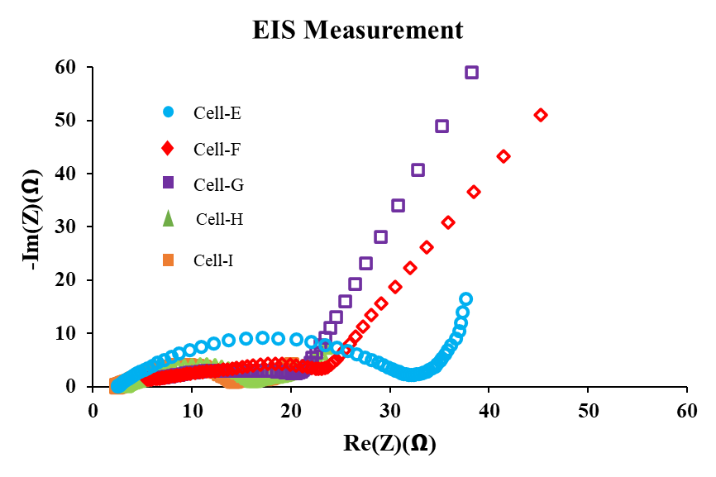
(a)
(b)
(c)
Fig. S12: EIS measurements showing Nyquist plots for (a) Cells A-D, (b) Cells E-I, and (c) Equivalent circuit for fitting impedance spectra.

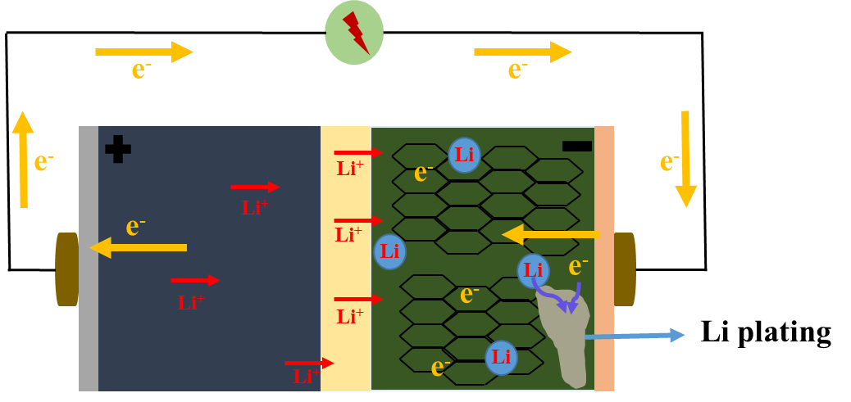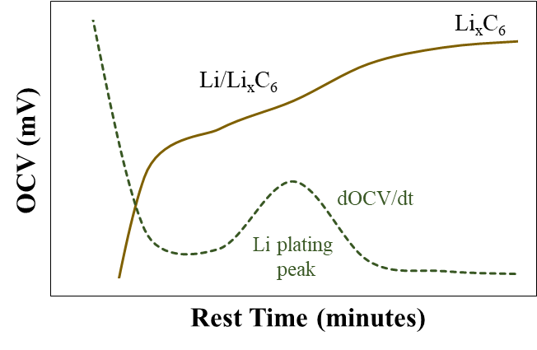
Cathode
Anode
Separator
(a)
(b)
Fig. S13: Schematic of (a) LIB charging with graphite anode representing the undesired lithium plating which occurs at high current rates, and (b) OCV and dOCV curves representing the plating onset of chemical intercalation of lithium during rest.
xLi⁺ + xe⁻ + C₆
Li_{x}C₆
0 ≤ x ≤ 1

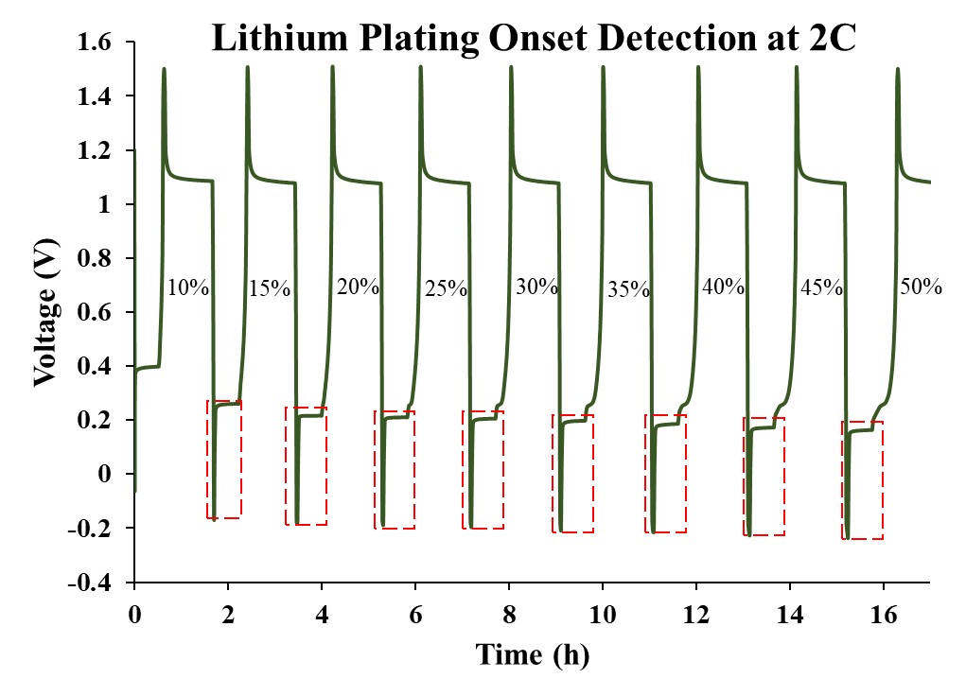
Fig. S14: Cycling protocol at 2C-rate between SOC of 10% to 50% to detect the lithium plating onset on graphite anode.
Note: The red highlighted region denotes the rest period of the cells.

Figure S15 (a-b) and (c-d) (please see the supplementary information) shows the OCV and dOCV plots of cell A at 2C-rate from 10% to 95% SOC, respectively. At 2C-rate, no significant plating was observed from 10% to 50% SOC (Fig. S15(a)). A similar trend was observed until 95% SOC. A significant plateau was observed close to 95% SOC which was highlighted using a green marker in Fig. S15(b-d), indicating the lithium-plating intercalation onset in both the OCV and dOCV curves. Similarly, OCV and dOCV curves for cell I are shown in Fig. S16 (a-b) and (c-d), respectively (please see the supplementary information). There were no significant voltage plateaus indicating lithium intercalation on the anode surface of printed electrode-I (with SPNs) at 2C-rate. This reveals that the printed electrode with SPNs was able to successfully suppress lithium plating at 2C rate when compared to electrodes without SPNs. This can also be correlated to the better cycling stability of cell I in comparison to cell A.
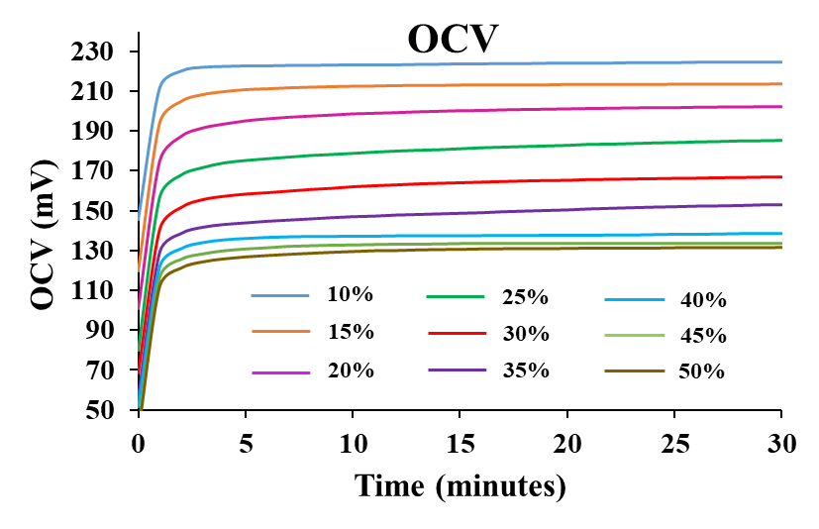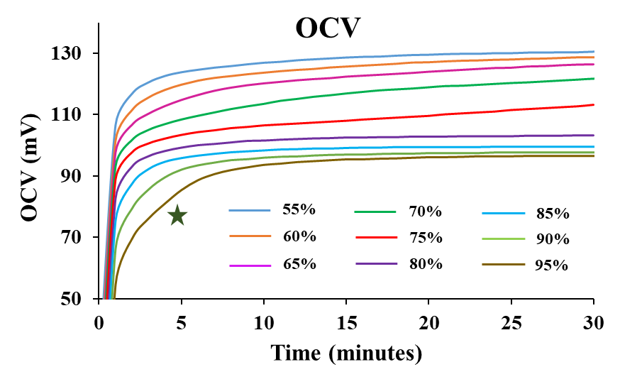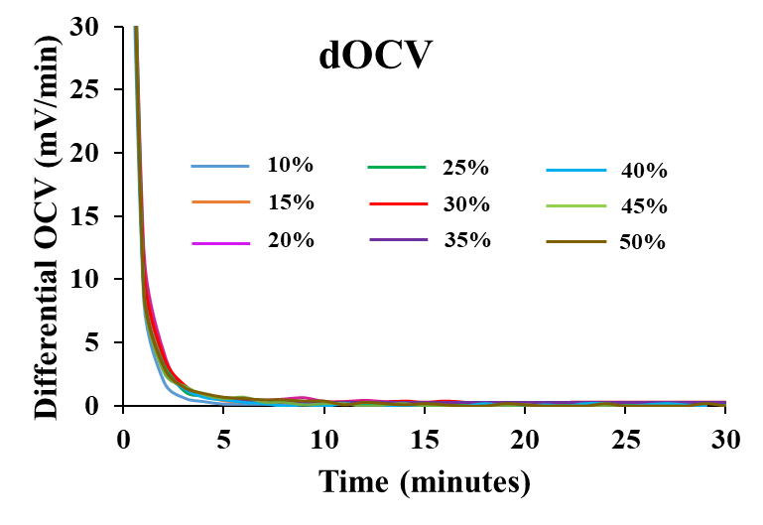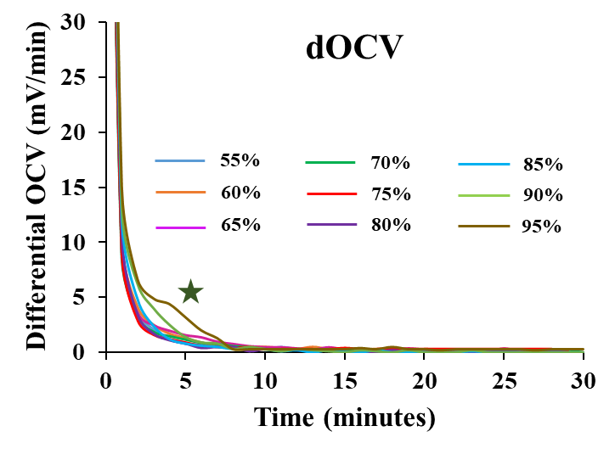
(c)
(d)
(b)
(a)
Fig. S15: (a, b) OCV and (c, d) dOCV analysis at 2C-rate from 10% to 95% SOC for cell-A. Lithium intercalation was significant at 95% SOC.
Cell A – 2C
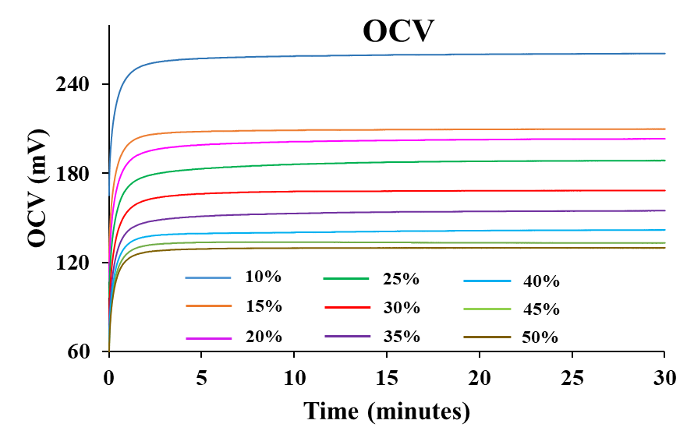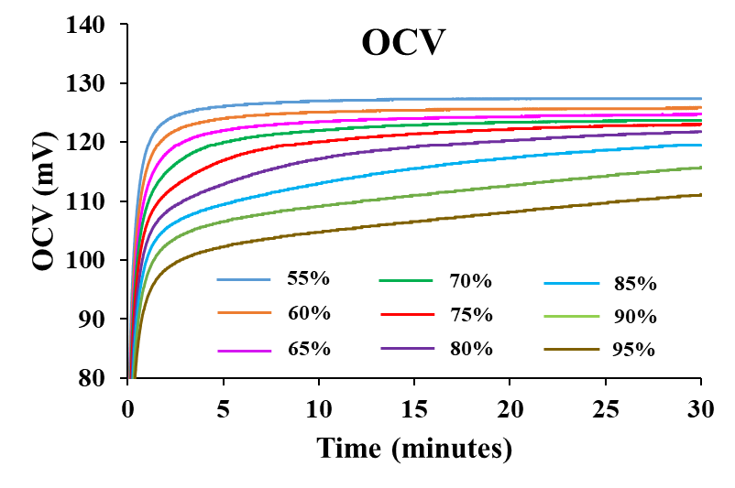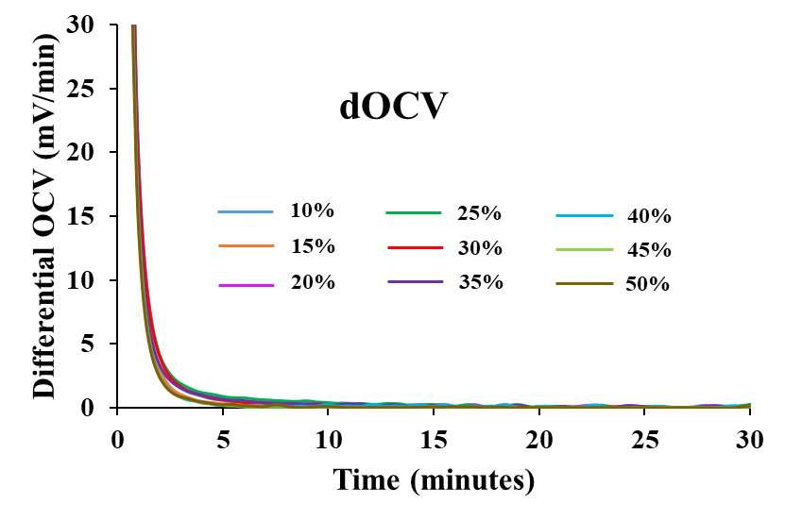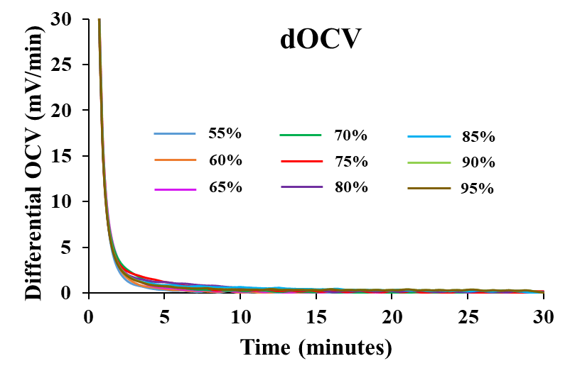
Cell I – 2C
Fig. S16: (a, b) OCV and (c, d) dOCV analysis at 2C-rate from 10% to 95% SOC for cell-I. No significant lithium intercalation peak was observed at 2C-rate for cell I.
(a)
(b)
(c)
(d)

Figure S17 (a-b) and (c-d) represent the OCV and dOCV curves for electrode-A at 4C-rate (please see the supplementary information). There was no significant lithium intercalation observed at lower SOCs until 50% SOC (Fig. S17(a, c)). The first sign of lithium intercalation plateau was observed close to 60% SOC as shown in Fig. S17(b). The plateau became more significant as the SOC increased from 60% to 95%. Figure S17(d) represents the dOCV analysis from 55% to 95% SOC where the lithium plating peaks were obvious and more prominent starting from 60% to 95% SOC. Figure S18 (a-b) and (c-d) (please see the supplementary information) represent the OCV and dOCV curves for cell I at 4C-rate. The first sign of lithium intercalation at 4C occurred between 80% to 85% SOC (close to 85%) and was prominent until 95% SOC which was also observed during the dOCV analysis where lithium plating peaks were significant between 85% to 95% SOC. From the OCV curves, it is clear that as the C-rate increased from 2C to 4C, electrode-A degradation is much faster due to the chemical interaction of lithium than electrode I, which did not show any significant voltage plateaus until 80% SOC.
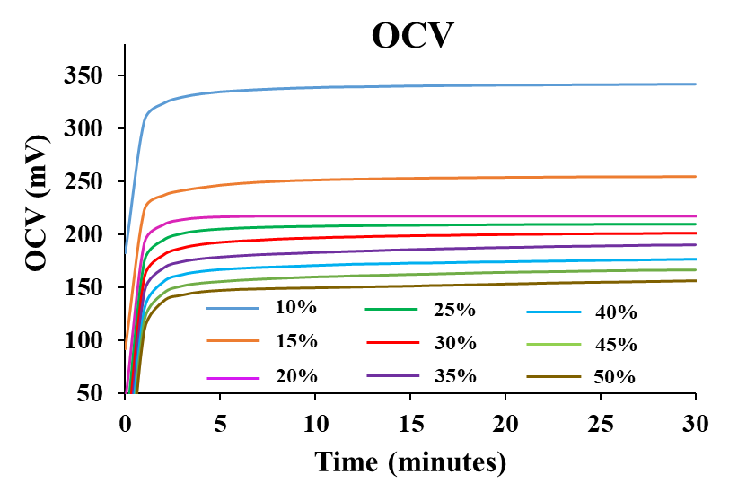
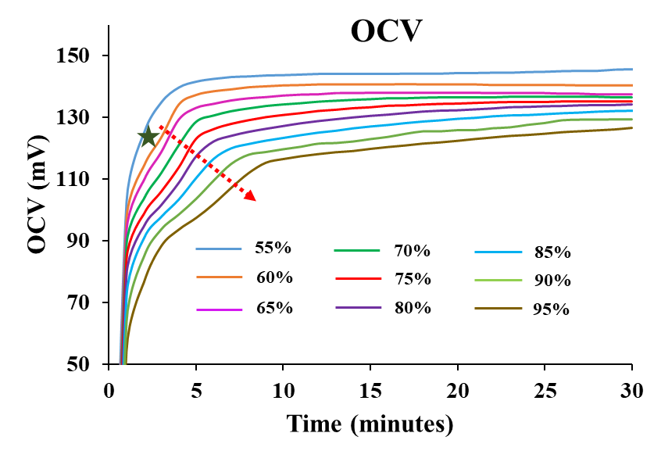
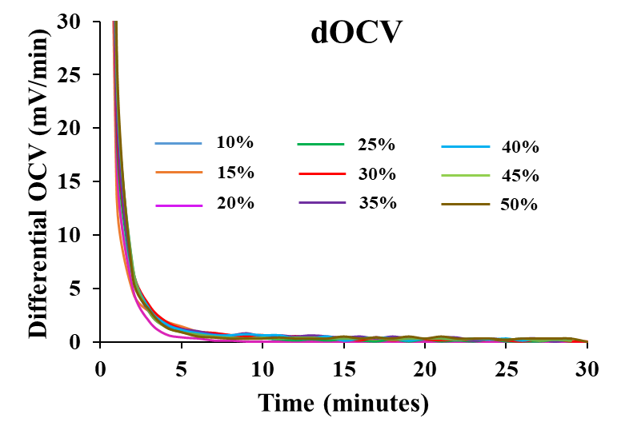
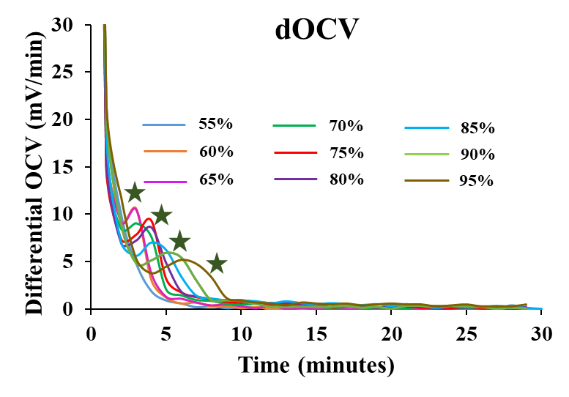
Cell A – 4C
(a)
(b)
(c)
(d)
Fig. S17: (a, b) OCV and (c, d) dOCV analysis at 4C-rate from 10% to 95% SOC for cell-A. Lithium intercalation was significant starting around 60% SOC and became more prominent as the SOC was increased to 95%.

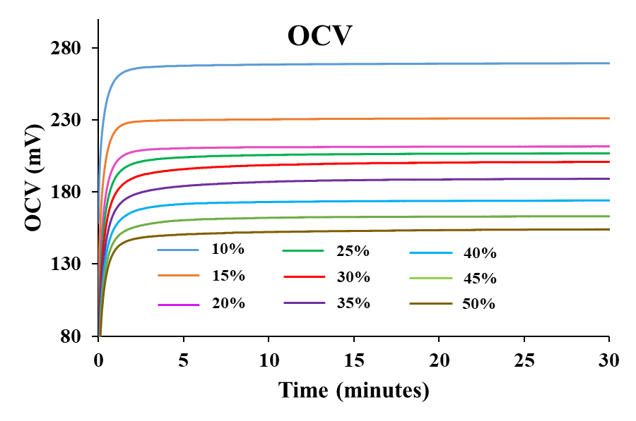
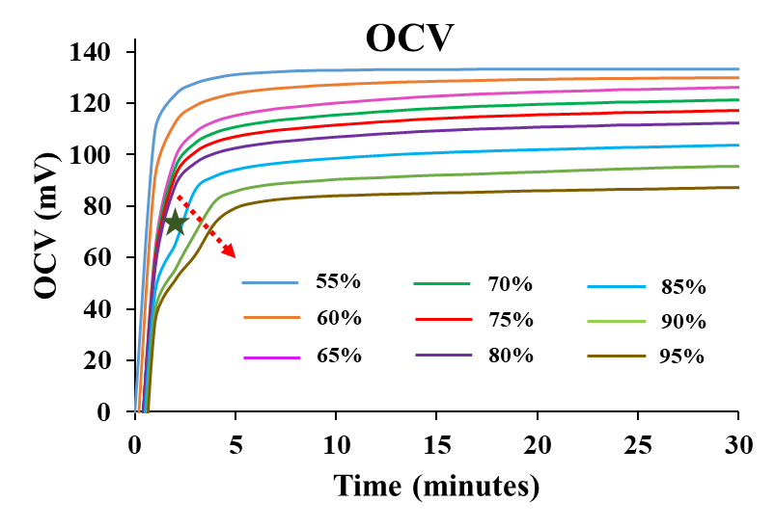
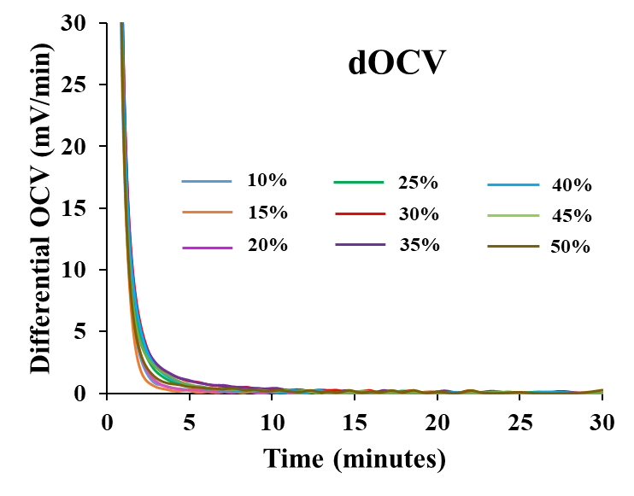
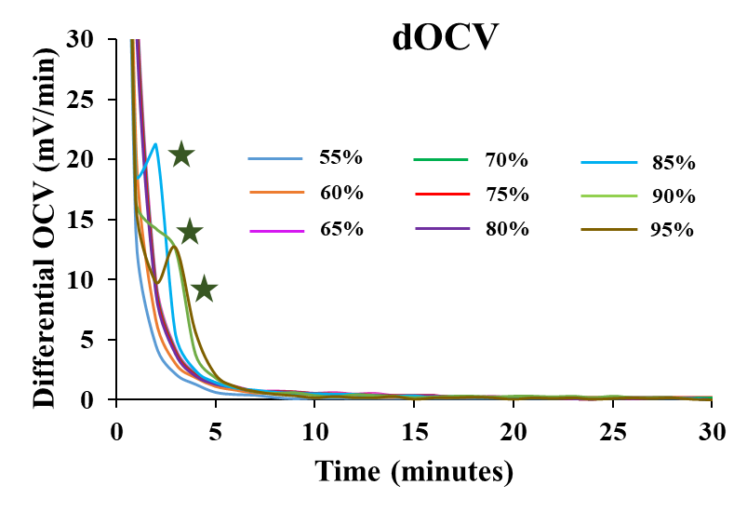
Cell I – 4C
(a)
(b)
(c)
(d)
Fig. S18: (a, b) OCV and (c, d) dOCV analysis at 4C-rate from 10% to 95% SOC for cell-I. Lithium plating peaks were prominent from 85% to 95% SOC.

A similar trend was also observed at 6C for the lithium plating onset test between 10% to 95% SOC (Fig. S19 and S20) (please see the supplementary information). Cell A had significant lithium intercalation and plating peaks in both OCV and dOCV curves starting around 50% SOC (Fig. S19(a, c)), when compared to cell I, which was able to suppress the lithium plating up to 75% SOC (Fig. S20(b, d)). This could be due to shallow destructive conditions in electrode A at lower SOCs which eliminate the feasibility of prior nucleated lithium that could advance early plating in the succeeding cycles [32]. These lithium plating onset tests demonstrated the SPN’s impact in suppressing the formation of lithium plating on anode surface even at very high C-rates such as 4C and 6C, resulting in prolonged cycling life with the ability to achieve higher capacities. Table S2 (please see the supplementary information) shows the summary of lithium plating onset for cells A and I at fast-charging C-rates such as 2C, 4C, and 6C. From the table, it is evident that significant lithium plating is more prominent at higher SOCs greater than 50% for electrode A. Whereas, the screen-printed SPNs were able to suppress the formation of plating for a longer duration even at high current rates.

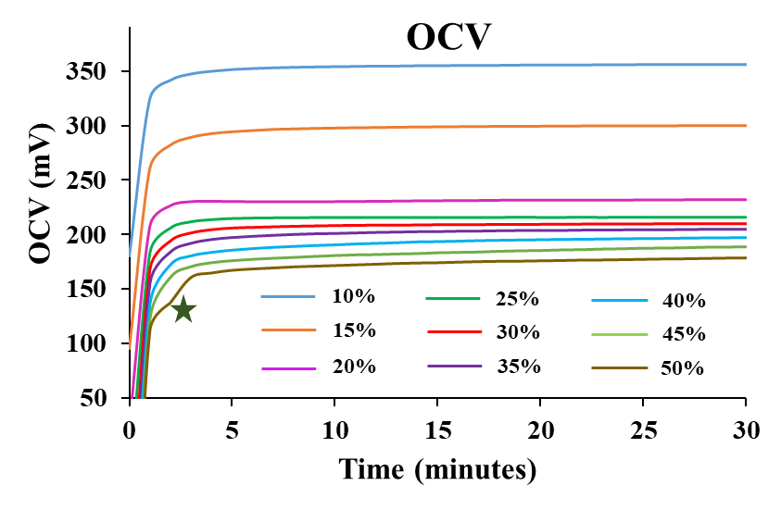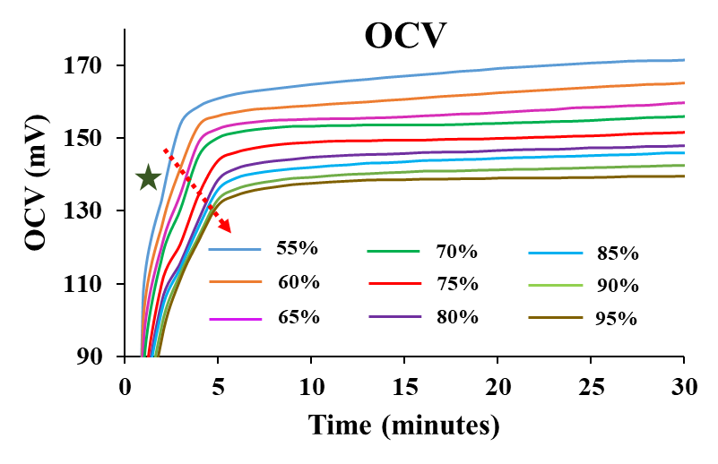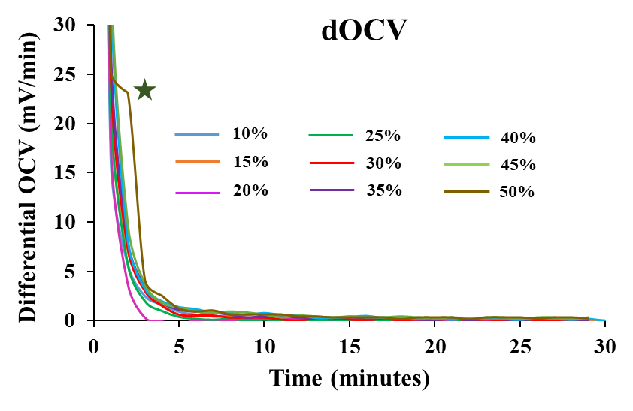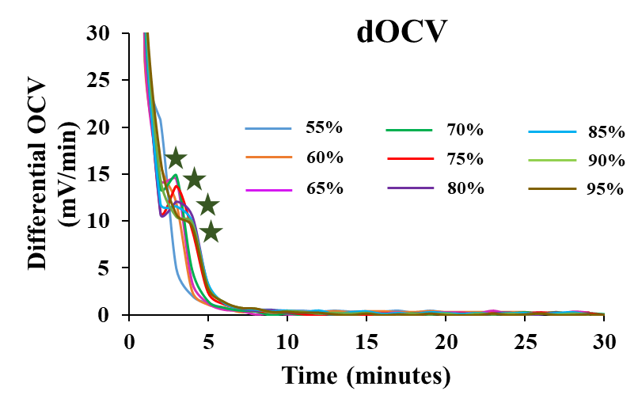
Cell A – 6C
(a)
(b)
(c)
(d)
Fig. S19: (a, b) OCV and (c, d) dOCV analysis at 6C-rate from 10% to 95% SOC for cell-A. Lithium intercalation was significant starting from 50% SOC until 95% SOC.
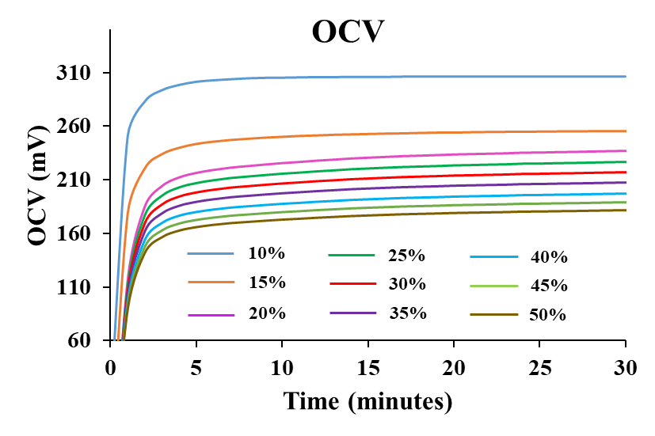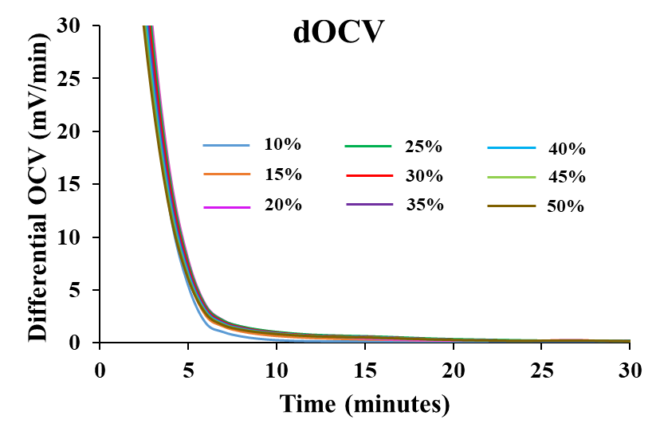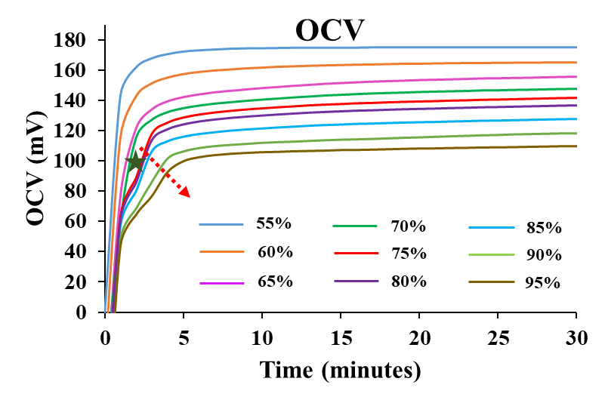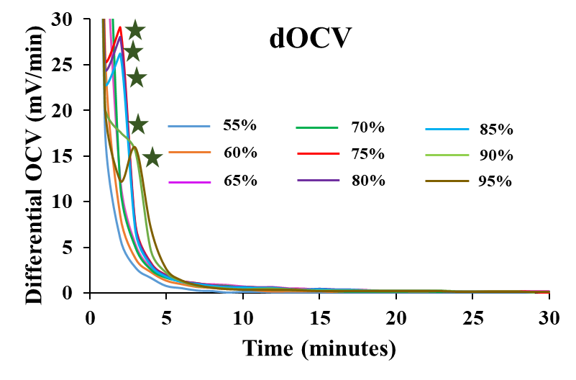
Cell I – 6C
(a)
(b)
(c)
(d)
Fig. S20: (a, b) OCV and (c, d) dOCV analysis at 2C-rate from 10% to 95% SOC for cell-I. Lithium intercalation was significant starting from 75% SOC until 95% SOC.

C- Rate | Cell-A | Cell-I
2C | 90-95%  (Close to 95%) | NA
4C | 60-65%  (Close to 65%) | 80-85%  (Close to 85%)
6C | 45-50%  (Close to 50%) | 70-75%  (Close to 75%)
Table S2: Summary of lithium plating onset for electrode A and electrode I at C-rates such as 2C, 4C, and 6C.

Finally, the lithium plating electrochemical test was performed on a different set of coin cells A & I. Figure S21 represents the voltage curves for cell A (Fig. S21(a)) and I (Fig. S21(b)) (please see the supplementary information). The cells were discharged at different C-rates such as 0.1C, 0.5C, 1C, 2C, 4C, and 6C without any cut-off voltage. After each discharge, the cells were charged to 1.5V at a C/3 current rate. The cells were rested for 10 minutes in between the cycles. With the help of this test, the change in voltage profiles of the cells was observed at higher C-rates in the form of voltage ripples constantly occurring during the discharge process at negative voltages. A huge drop in voltage values was observed for cell A with irregular ripples in negative voltage less than -1 V especially at 6C (Fig. S21(a)). A shift in the voltage dip to lower SOCs was observed with an increase in current rates from 2C to 6C. This voltage dip with irregular ripples indicates lithium plating. On the other hand, cell I did not display any form of irregular voltage plateaus even at negative voltages during fast-charging C-rates such as 2C, 4C, and 6C (Fig. S21(b)). A minor plateau was observed for cell I around -0.25 V and -0.5 V at 4C and 6C, respectively which were followed by a linear voltage profile until the end of the discharge cycle.

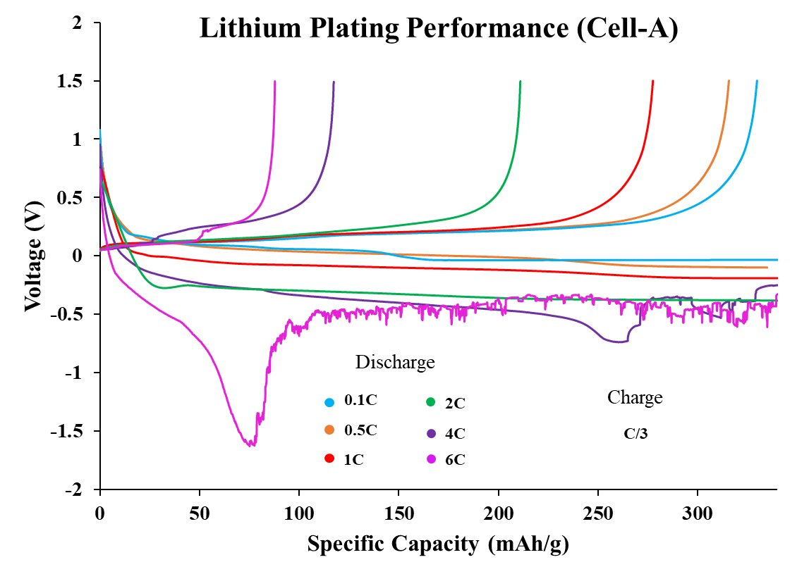
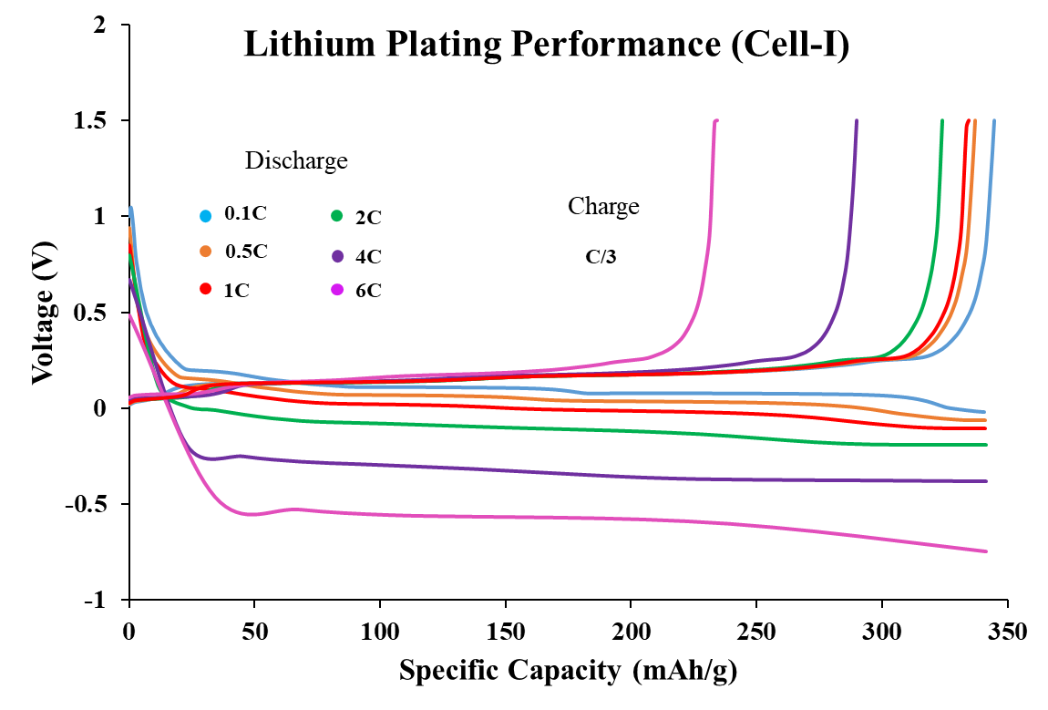
(a)
(b)
Fig. S21: Lithium plating electrochemical test without cut-off voltage at different C-rates for (a) cell-A, and (b) cell-I.

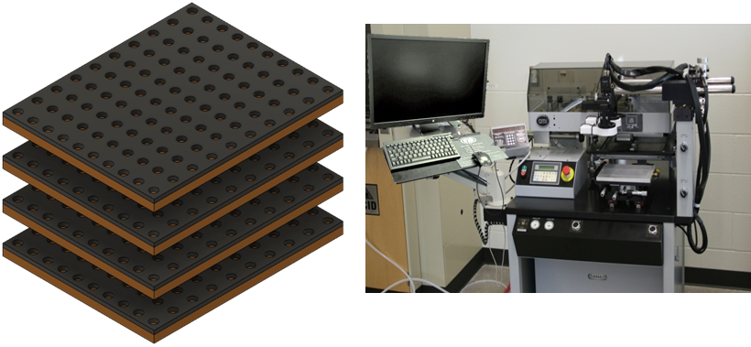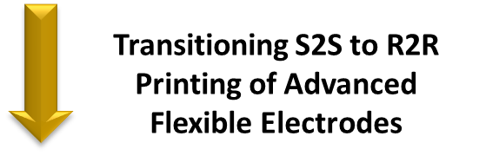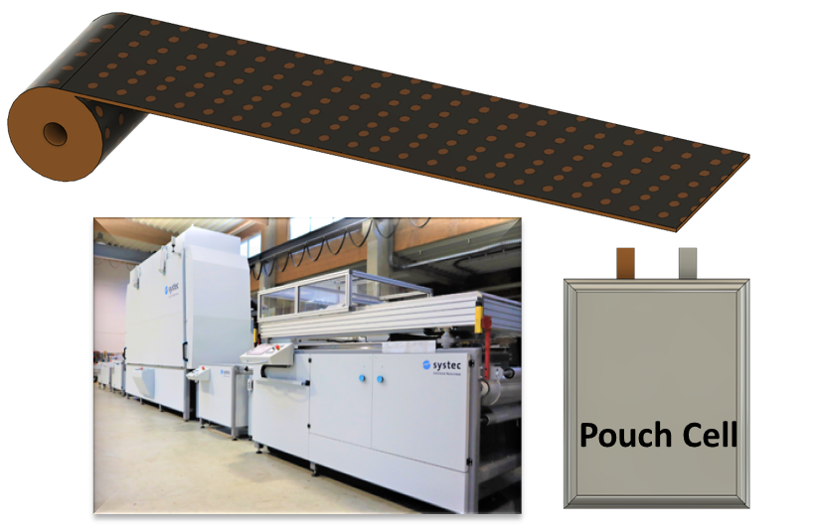
(a)
(b)
Fig. S22: Schematic representation of transition that will be made in fabrication process for printing flexible LIB electrodes from (a) Sheet-to-sheet (S2S) printing to, (b) Roll-to-roll (R2R) printing and pouch cell assembly will R2R printed electrodes.

Transitioning S2S to R2R printing
of advanced flexible electrodes
REFERENCES
[1] Primo, Emiliano N., Mehdi Chouchane, Matthieu Touzin, Patricia Vázquez, and Alejandro A. Franco. "Understanding the calendering processability of Li (Ni0. 33Mn0. 33Co0. 33) O2-based cathodes." Journal of Power Sources 488 (2021): 229361. https://doi.org/10.1016/j.jpowsour.2020.229361

