Supplementary Material

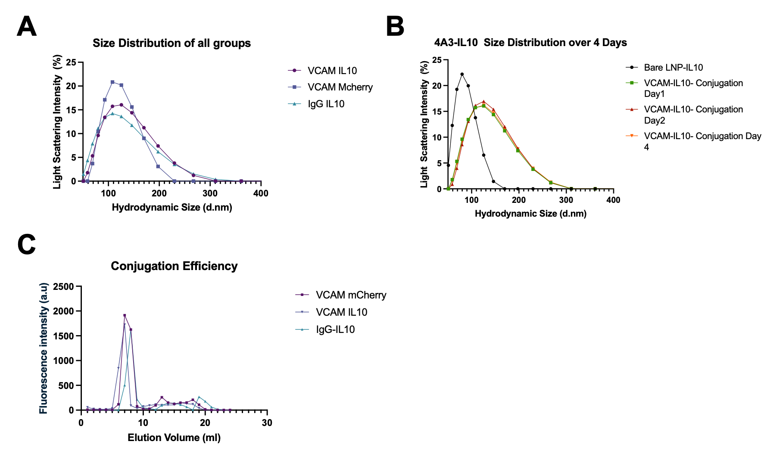

Supplementary Figure 1. Characterization of LNP formulation. (A) Dynamic light scattering, DLS, analysis shows similar size distribution across all LNP formulations used in this manuscript. (B) DLS shows that LNPs remain stable in size over 4 days. (C) We measured the efficiency of the conjugation of targeting moieties to LNPs by tracing fluorescently labeled antibodies on LNPs (first peak) and free antibody (second peak).

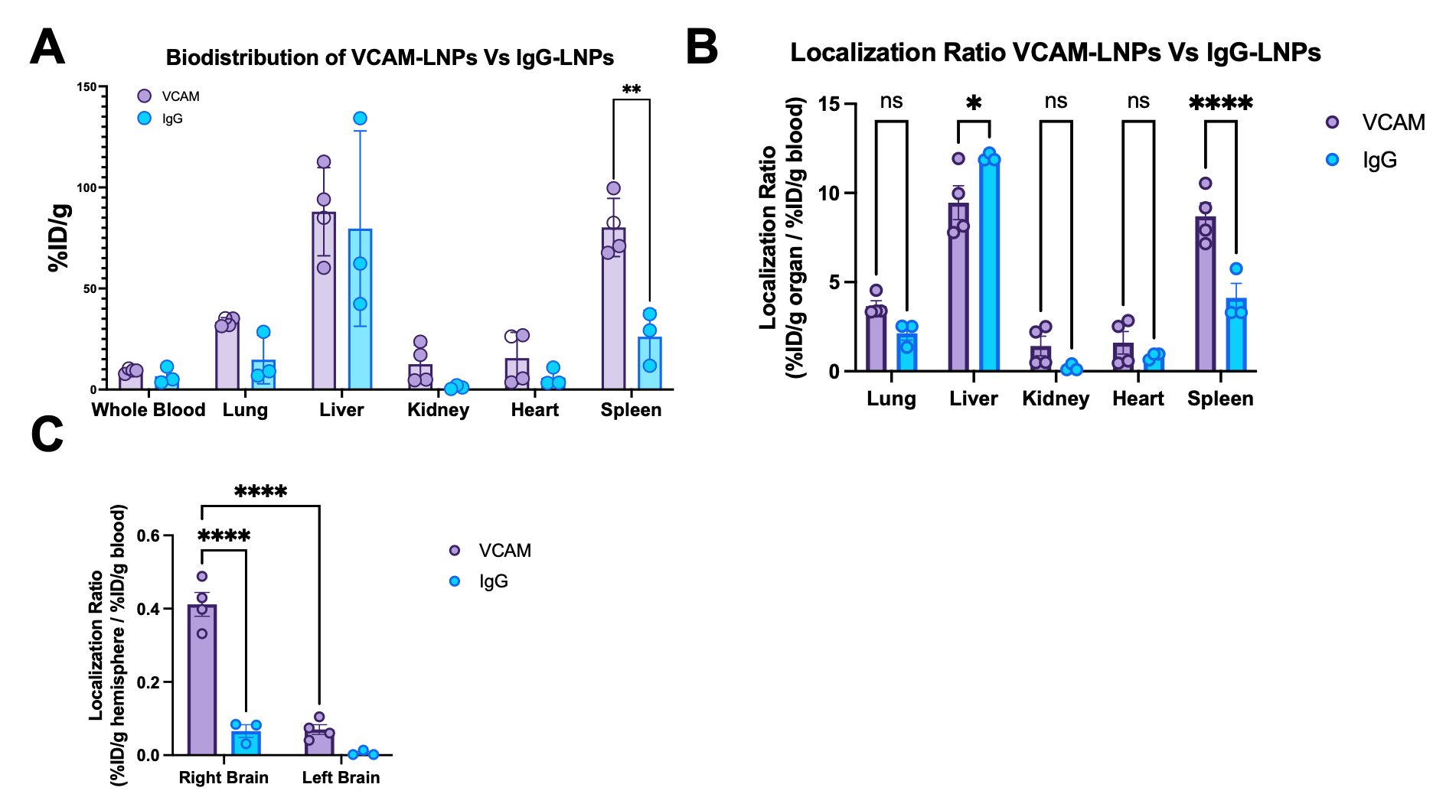

Supplementary Figure 2. (A) Systemic biodistribution of VCAM-LNPs vs IgG-LNPs. Systemic delivery is comparable between LNP groups across organs, except for significantly elevated spleen delivery of VCAM-LNPs. (B) When normalized to blood biodistribution, the localization ratio of LNPs reveals significantly higher levels for VCAM LNPs in spleen and for IgG LNPs in liver. (C) Localization ratio analysis showed significantly higher distribution of VCAM-LNPs in the right (injured) hemisphere compared to the left and to non-specific IgG-LNP treated groups. For all figures, data represent mean ± SEM, **p < 0.01, ***p < 0.001, ****p < 0.0001, ns = not significant.

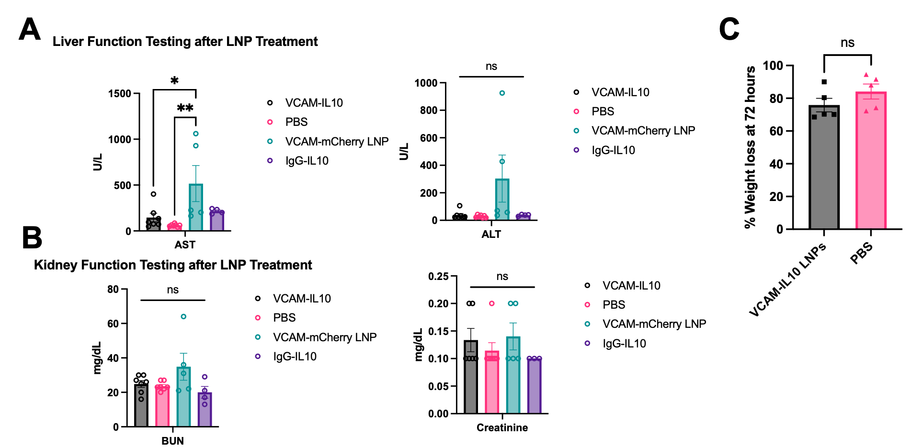

Supplementary Figure 3. We screened for systemic toxicity of LNP treated mice. (A) When compared to PBS treated mice, only VCAM-mCherry-LNP group had elevated liver enzymes. (B) No difference in kidney function testing among LNP treated groups when compared to PBS control. (C) No difference in weight among the experimental group, VCAM-IL10-LNP, when compared to PBS treated control.

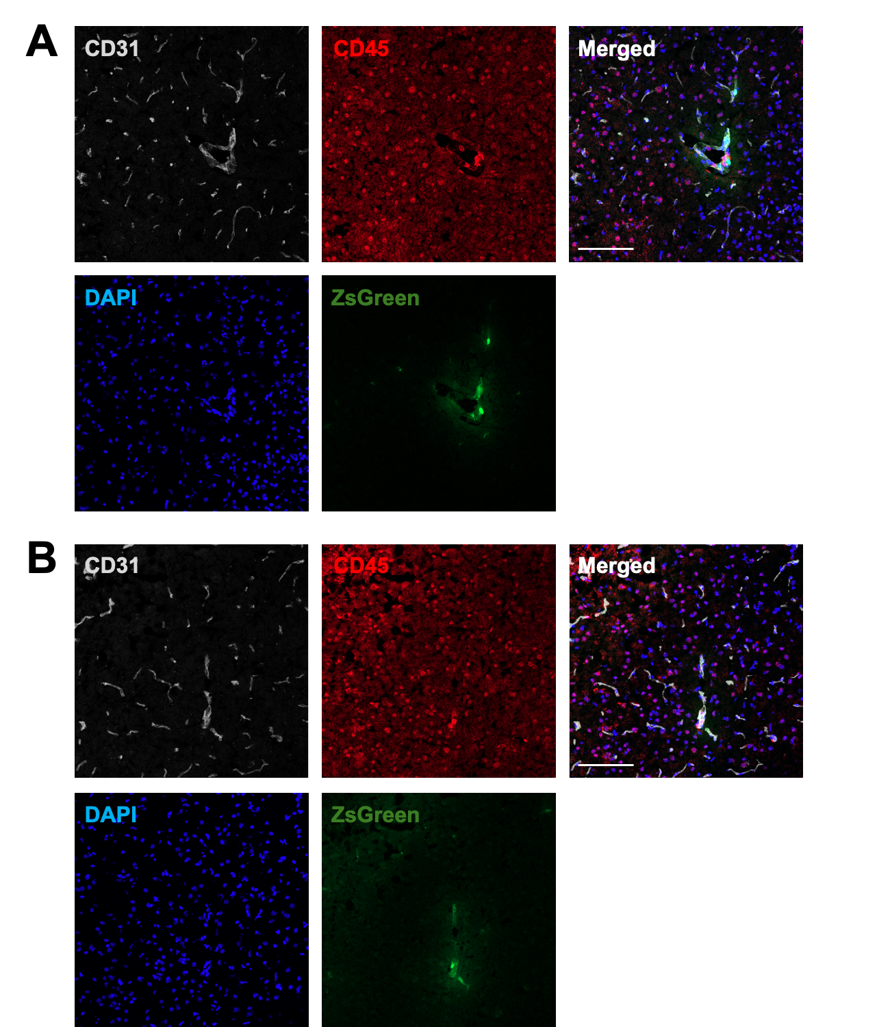

Supplementary Figure 4. Immunohistochemistry of Ai6 mouse brain subjected to ICH surgery and treated with daily VCAM-LNPs containing cre-recombinase mRNA. ZsGreen signal is mostly associated to blood vessels. CD31 is an endothelial marker. CD45 is a pan-leukocyte marker. ZsGreen represents the cargo that is expressed after LNP uptake and expression via the Ai6 experimental paradigm outlined in Figure 4A. Scale bar is 100um.
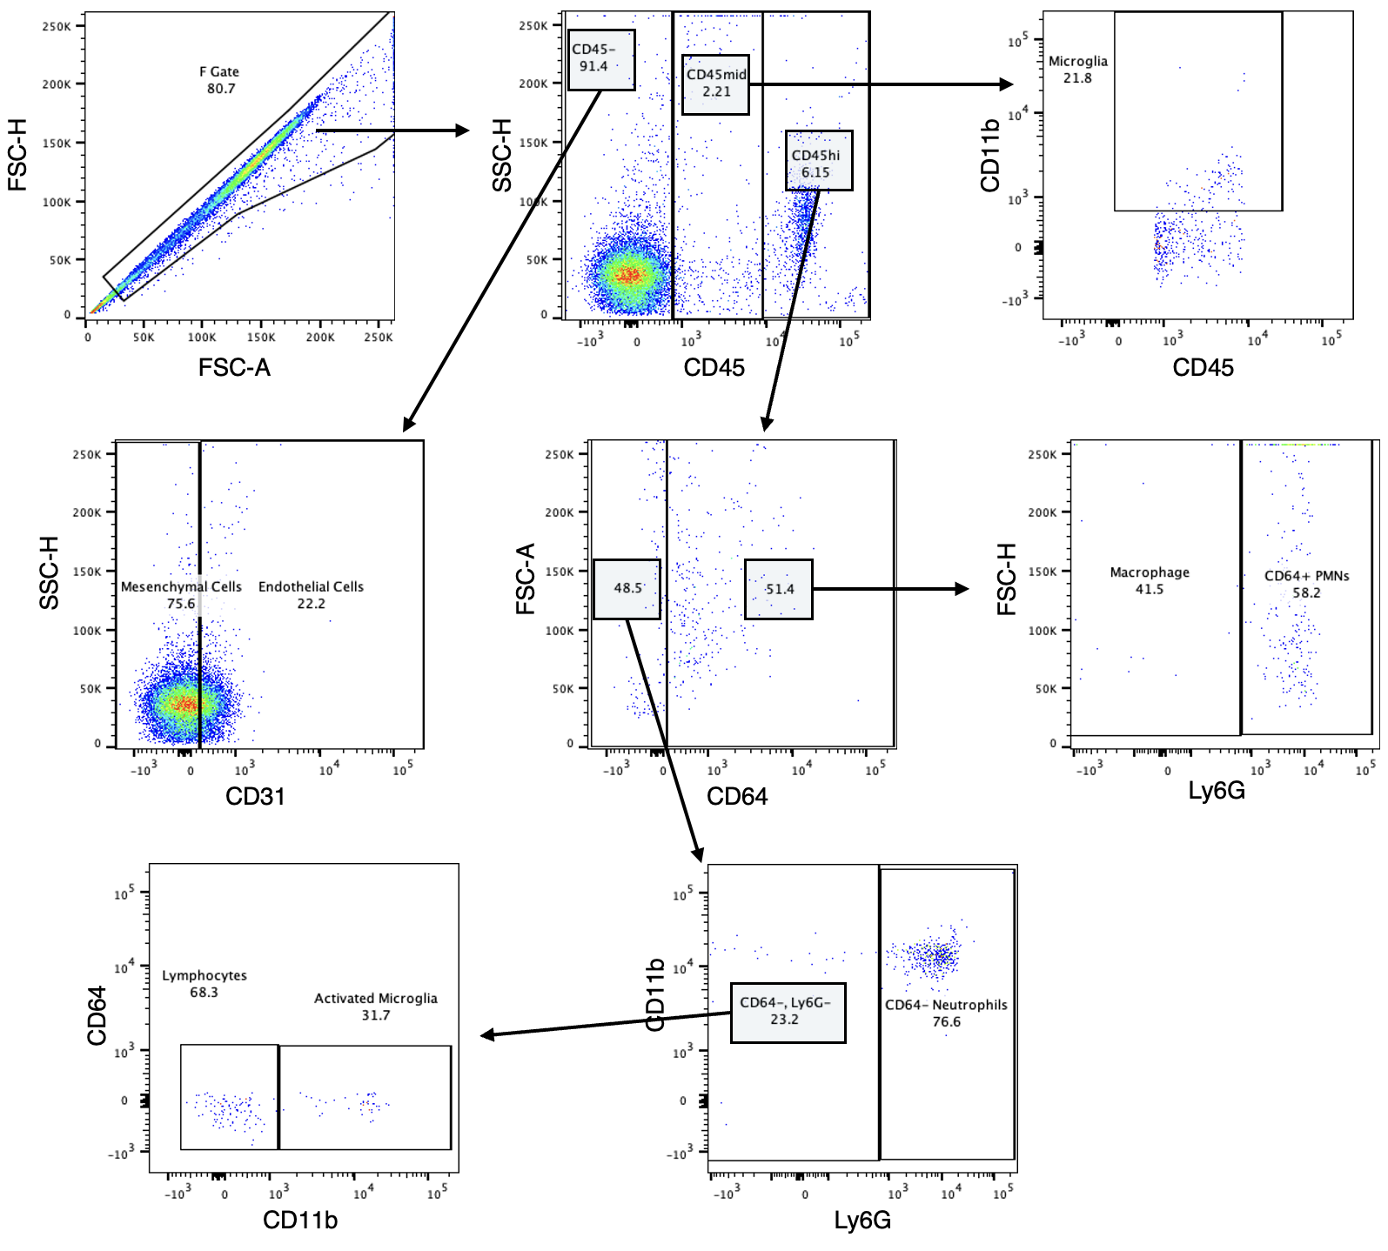
Supplementary Figure 5. Gating strategy for identification of cell types in brain flow cytometry data.

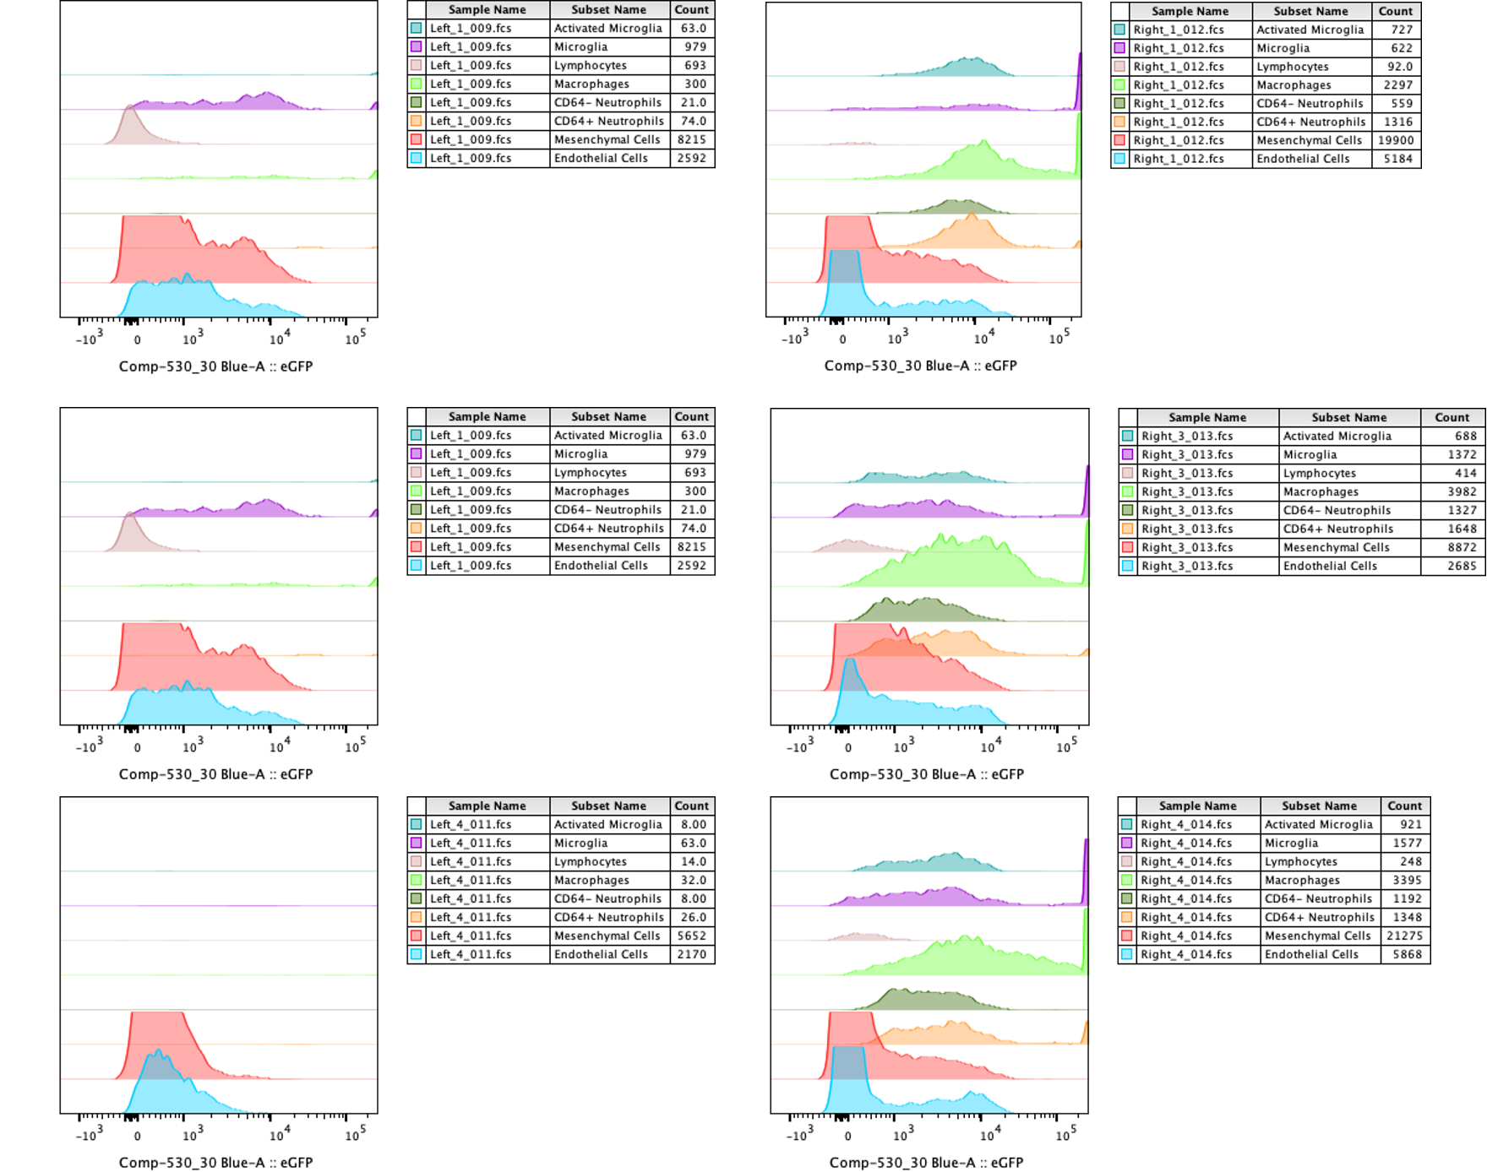

Supplementary Figure 6. Individual flow cytometry histograms from Ai6 mice subjected to ICH surgery and daily VCAM-LNP treatment with cre-recombinase mRNA, as outlined in Figure 4. Individual animal data shown here is also summarized in panels in Figure 4C-D and Figure 5C-D.

