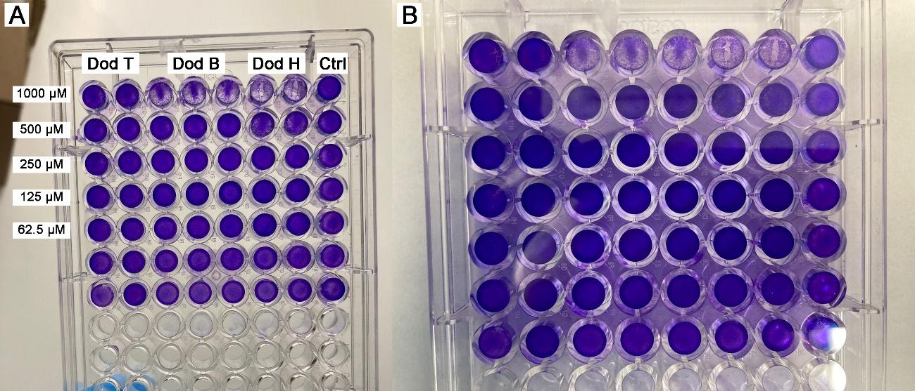
Figure S1. 96-well plate of the cytotoxicity assay.

Figure S2. Molecular docking of the interaction between analogs and the peptidyl-prolyl isomerase receptor. Orange = Dod B; Yellow = Dod H; Green = Dod T; Magenta = active site of the receptor.

