Reactive cement pellet media including drinking water treatment and mine drainage residuals for phosphorus removal in agricultural runoff

Beth Kondro*¹, Michael A. Holly¹,
¹University of Wisconsin-Green Bay, 2420 Nicolet Dr, Green Bay, WI, 54311, United States
*kondrob@uwgb.edu, (920) 465-2503

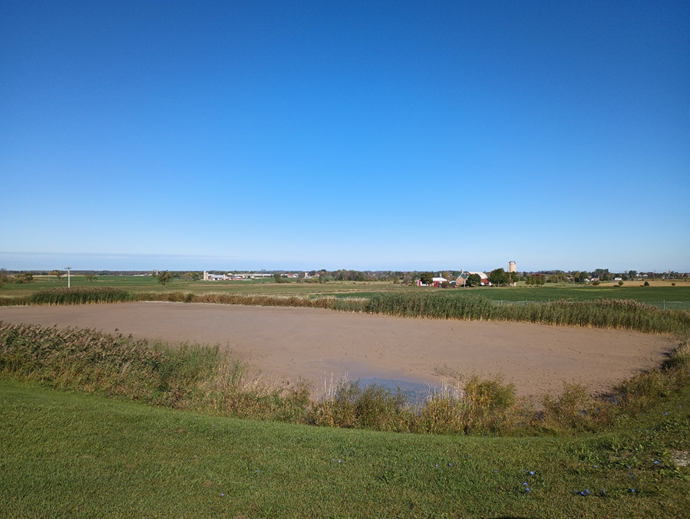
Figure S1 Source of drinking water treatment residual at Green Bay Water Utility (Green Bay, WI)

Table S1. Different binder ratios (wt/wt) for two binder types. PC = Portland cement. * Denotes the binder ratio that was most effective.
Binder Type | Binder Ratio
AlCl₃ | 1 AlCl₃ : 9 DWTR/AMD
AlCl₃ | 2 AlCl₃ : 23 DWTR/AMD
AlCl₃ | 1 AlCl₃ : 4 DWTR/AMD
Cement Mixture | 1 PC : 4 DWTR/AMD
Cement Mixture | 1 Lime : 4 DWTR/AMD
Cement Mixture | 1 PC : 2 Sand : 3 DWTR/AMD
Cement Mixture | 1 Lime : 2 Sand : 3 DWTR/AMD
Cement Mixture | 1 Lime : 1 PC : 2 Sand : 4 DWTR/AMD
Cement Mixture | 1 Lime : 1 PC : 2 Sand : 2 DWTR/AMD*

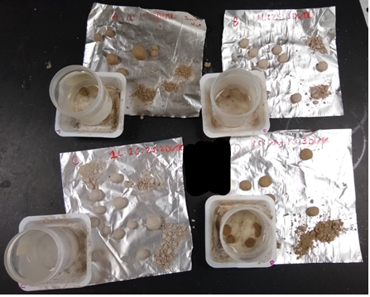
Figure S2 Dried test pellets after compression and soaking.
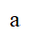
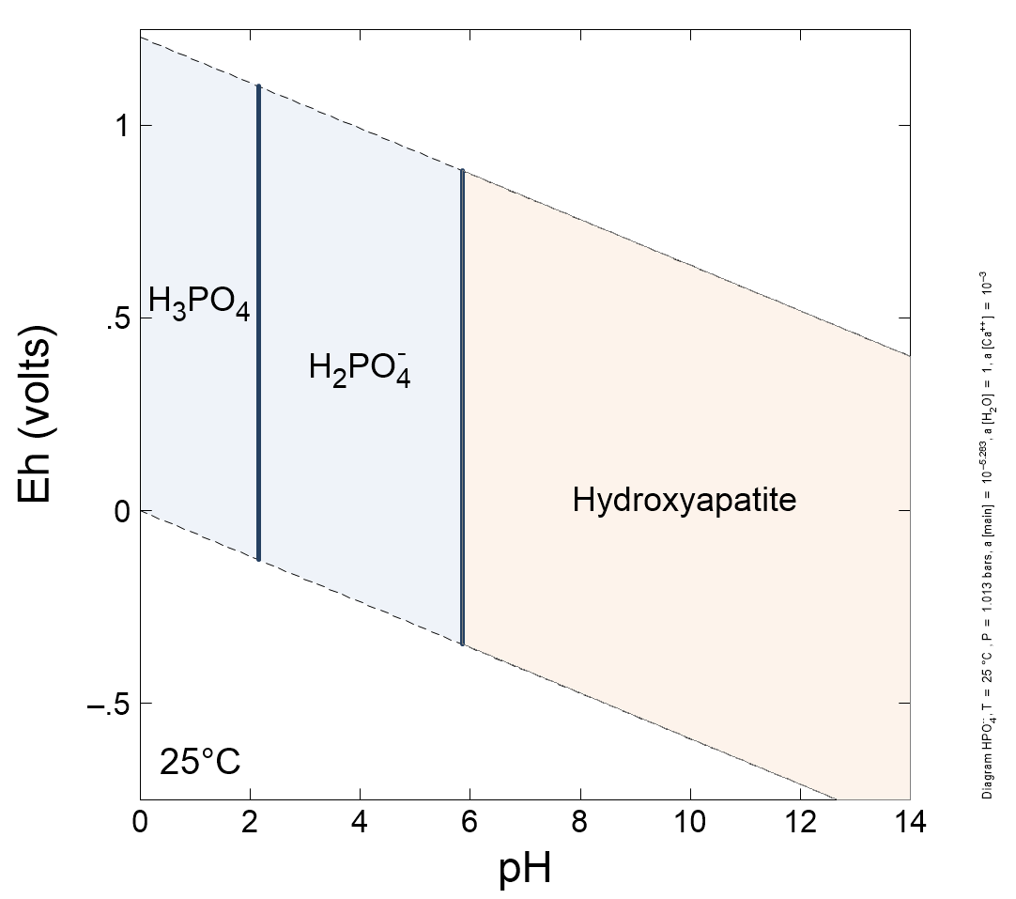
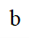
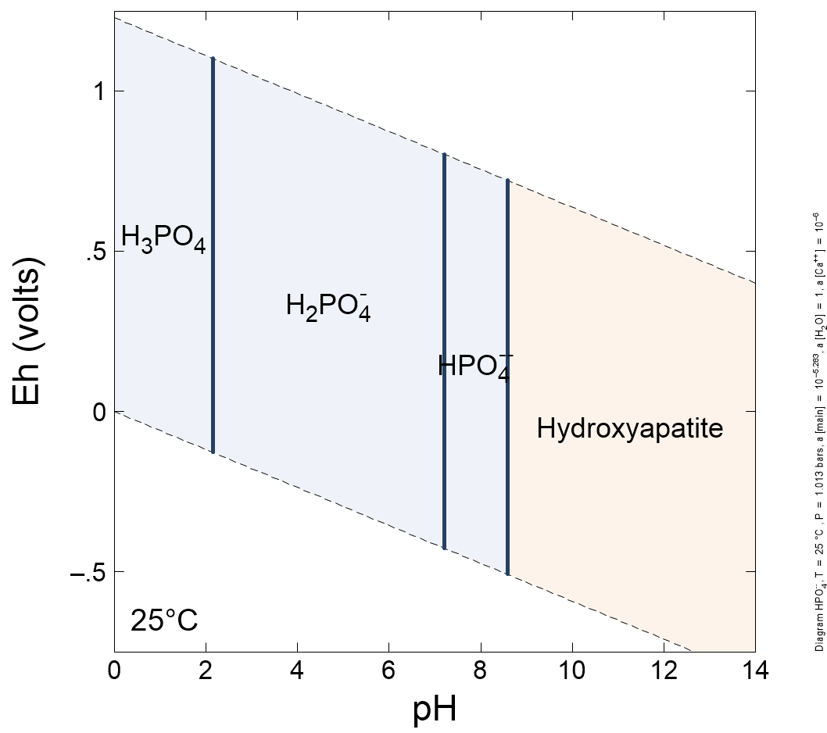
Figure S3. Stability diagram of HPO₄²⁻ ([HPO₄²⁻] = 5.21x10⁻⁶ in 6a and 6b) in the presence of Ca ([Ca] = 1x10⁻³ in 6a and [Ca] = 1x10⁻⁶ in 6b).

Calculations for cost estimate:
Using the cement pellet (CEM) as an example.
- Mass of CEM required to treat a P load of 7 kg:
- P removal capacity of CEM = 1,397 mg P/kg
  - P removal capacity of CEM adjusting for inefficiency of P removal from agricultural runoff (18% for CEM) $=\frac{1,397\frac{mg P}{kg}}{1.18} =1,184 \frac{mg P}{kg}$
- P load after 3 years = 7x10⁶ mg P
  - Mass required = 7x10⁶ mg P x $\frac{kg}{1,184 mg P} =5,912 kg CEM$

- Cost of materials required to make 5,912 kg CEM:
  - Cost of Portland cement = $0.36/kg
  - Cost of lime = $0.72/kg
  - Cost of sand = $0.41/kg
  - Cost of pyrolysis = $0.08/kg
  - Pellet ratio = 1 cement : 1 lime : 2 sand
    - Mass of cement in pellet = $\frac{ 5,912 kg}{4}$ = 1,478 kg
      - Cost of cement = 1,478 kg x $0.36 = $532
    - Mass of lime in pellet = $\frac{5,912 kg}{4}$ = 1,478 kg
      - Cost of lime = 1,478 kg x $0.72/kg = $1,064
    - Mass of sand = $\frac{5,912 kg}{2}$ = 2,956 kg
      - Cost of sand = 2,956 kg x $0.41/kg = $1,212

  - Total cost:
    - Cement + lime + sand = total cost
    - $532 + $1,064 + $1,212 = $2,808

Using the pyrolyzed cement pellet (CEMC) as an example.
- Mass of CEM-P required to treat P load of 7 kg:
- P removal capacity of CEM-P = 2,270 mg P/kg
  - P removal capacity of CEM-P adjusting for inefficiency of P removal from agricultural runoff (13% for CEM) $=\frac{2,270\frac{mg P}{kg}}{1.13}=2,009 \frac{mg P}{kg}$
- P load after 3 years = 7x10⁶ mg P
  - Mass required = 7x10⁶ mg P x $\frac{kg}{2,009 mg P} =3,484 kg CEMC$

- Cost of materials required to make 3,484 kg CEM-P:
  - Cost of Portland cement = $0.36/kg
  - Cost of lime = $0.72/kg
  - Cost of sand = $0.41/kg
  - Cost of pyrolysis = $0.08/kg
  - Pellet ratio = 1 cement : 1 lime : 2 sand
    - Mass of cement in pellet = $\frac{3,484 kg}{4}$ = 871 kg
      - Cost of cement = 871 kg x $0.36 = $314
    - Mass of lime in pellet = $\frac{3,484 kg}{4}$ = 871 kg
      - Cost of lime = 871 kg x $0.72/kg = $627
    - Mass of sand = $\frac{3,484 kg}{2}$ = 1,742 kg
      - Cost of sand = 1,742 kg x $0.41/kg = $714
    - Mass of CEMC pyrolyzed = 3,484 kg
      - Cost of pyrolysis = 3,484 kg x $0.08/kg = $279

  - Total cost:
    - Cement + lime + sand + pyrolysis = total cost
    - $314 + $627 + $714 + $279 = $1,934

